Wanda Allen Kerbs
24 November 1918

Part I

My father, James Bird Allen went on a mission to England were he served from 1906-1908. My mother, Alice Isabel Cushion joined the Church in England in 1907 when she was 21 years old. She was the only one at that time to join the Church. Her family was very upset when she told them she was going to set sail and come to America. It was especially difficult on her father. She set sail on January 11, 1915 on the SS Scandinavian. She had a very pleasant voyage. She came for her religion. She stayed with friends in Brigham City, Utah who had came previously from England. Mother married James Bird Allen of Smithfield, Utah on June 15th 1915 in Salt Lake City. They came to Burley, Idaho to live where Pop had homesteaded a eighty acre farm three miles West of Burley.
I, Wanda Allen Kerbs was born November 24, 1918 in Starr's Ferry, Burley Idaho, the daughter of Alice Isabel Cushion and James Bird Allen. I was the third child of nine children. We lived three miles West and one quarter mile North down by the Snake River. I had a very enjoyable childhood. Being a large family, we had a lot of trials and trouble. Mable was the oldest child, when she was little she fell on the stove and burned both of her hands real bad. Lloyd, my brother was a year older than I. Then Mona was born on May 7, 1924, Pert, another sister, died as a small child. Then came my little brother, Jim was born on December 31st, 1925. Then came Charles in 1929, who died when he was only two years old from Pneumonia. Then Willard was born in May of 1932, he was my youngest brother and sibling.
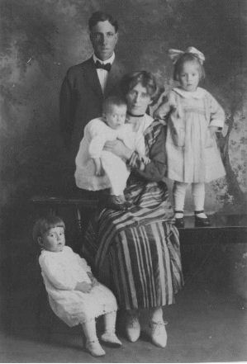Pop and Mother Allen. Lloyd is seated in the little chair, Mable is standing on the table. Wanda is the baby in her mother's arms.
Wanda was baptized on February 13, 1927 by W. Garnett Kidd and confirmed a member of the Church of Jesus Christ of Latter-day Saints the same day by Robert C. Church.
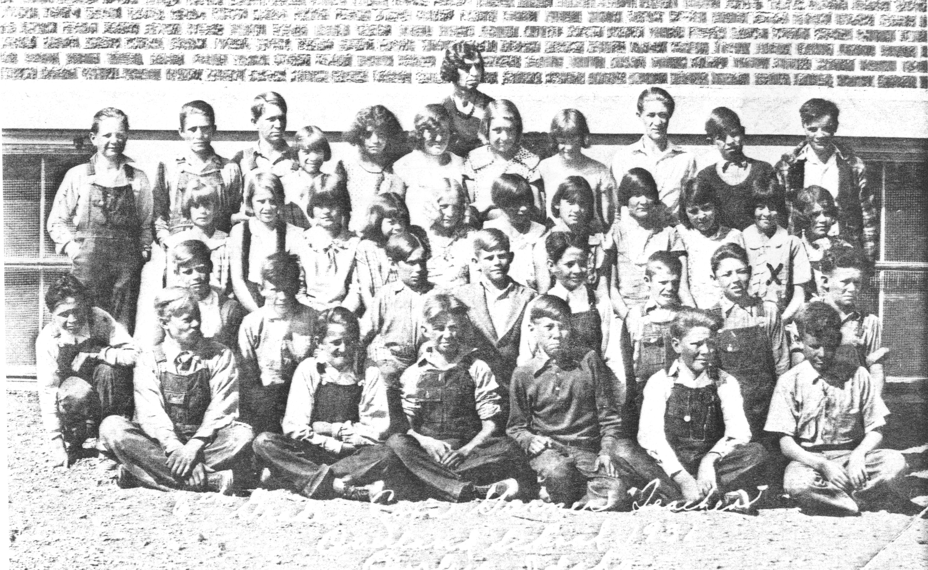Wanda's elementary school class picture. She is the second from the right on the third row (marked with an X)
Willard and I had a lot of fun together. We would go down to a pond by the river and catch frogs. I guess that is why I like frogs so well. We would catch mice in the grainery. We would bait our fish hooks in the evening then get up early in the morning and go see how many fish we had caught. Sometimes our poles would be gone if they weren't anchored down good. Other times we caught quite a few fish, mostly suckers, chubs and perch. One day Lloyd and I decided to go fishing all day. We tied a gunny sack around our waist and started out at our place. Our 80 acre farm ran one half mile along the river east of the house. It was a long way up and back. We were wading through the water all the way. By the time we got back we had all the fish we could carry.
When I was really small, about four years old, Vern Tilley, our neighbor, got a tricycle for Christmas, it was quite a hard winter. Vern and I went down to the river to ride on his trike on the ice because it was nice and smooth. He would ride and I would walk. We would go around these big dark green air holes, sometimes they would even bubble a little and we would stop and look. We just kept on going across the river, it was such a beautiful day and we saw no danger. We were almost across the river when we could hear our mothers calling at us to come back. But we just took our time and didn't see any danger. We finally wound our way back. Sometimes the ice would crack under us and it would make such a loud noise. Our folks were very upset with us. We got a good licking for crossing the river by ourselves and had to go home and go to bed and that was so awful.
When I was five years old we had a hired man working for us. He was harnessing the horses. I was barefooted, standing in back a little way, when the man got mad at the horse. He jerked the bridle real hard and scared the horse and it reared over me landing on the big toe, crushing it real bad. Mom and Pop rushed me into Burley to the Fremstead Hospital where they had to take off my big toe. They didn't tell my mother as she was pregnant at the time, she did not know until the bandage was taken off. I got along real well, I didn't even limp but I got called “Broken Toe” a lot.
We had no electricity. We used the oil lamp, many times just a torn rag dipped in lard to burn for a light. No car, just a horse drawn buggy and wagon. We had to get wood to burn to heat the house from willows along the river or sagebrush. So many times we spent long hours in the fall and winter and on Saturdays getting wood. Lloyd, Mable and I, and Alice would get up early Saturday morning, harness the horses, hitch up the wagon, take a lunch and go out on the desert about five miles away and work six or eight hours chopping and loading sagebrush. The sun would just be setting when we got home. We would stack the wood up like a haystack.
We had a water pump just a little way from the house, a lot of time it would go dry. So we would have to carry the water up from the river. It was quite a steep hill to climb to the house. We would have to carry all the water to wash our clothes and bathe, which we did only once a week. It seemed Alice and I had the task most of the time to fetch the water from the river. We would take a big tub and two buckets. We would get so tired and silly. Sometimes we would almost get to the top of the hill and we would spill it. Then we had to start all over again.
When the pump did work and I was real small my, Mother and Father would go pump the water and I would stand too close to that big iron knob on the end of the handle. They would jerk the handle up and it would hit me in the head and knock me down. My head would be cut wide open. Then after a time, it would just get healed up when the same thing would happen to me again. If I didn't get hit on one side, I got it on the other.
My father farmed about eighty acres. We did most of the work. It seemed that Pop was always late getting the crops in. He was very poor at making decisions on when to sell the potatoes. I remember when the harvest was on, Lloyd and I would be hauling spuds long after midnight. It seemed during harvest we always had to work on Sunday. Pop would say if would pick so many rows of potatoes we could have the rest of the day off. So the Tilley's would come and help us. We would work real fast. Then Pop would think we could do a lot more, so he would dig a lot more rows out, then we would be working after dark. Pop was not very ambitious himself, but all of us children have learned how to work. It seemed Mother had all the worry.
We would stack all our hay with a derrick and Jackson fork. I can remember one time I was running the horse on the derrick. I was to pull my father up on the stack but the horse went so fast that I pulled him clear to the top of the boom. It gave a big jerk, it almost jerked him off. He sure did have a good vocabulary of swear words and did I ever get it.
Pop was not very considerate of us children. He never gave us a hug or kiss or said we could do anything well. My father and mother were never in harmony with each other. They could never agree on when to sell anything. We were very poor but we were happy about it all. I can remember sometimes we never had much food. We had a milk cow, we would milk it many times a day. Sometimes all we had was fried potatoes. We would think it a great treat if we had a gallon of syrup or honey.
The Tilley's lived right across the street from us. We did everything together. Mrs. Tilley did a lot of canning. We thought she was quite a mean person but she was an angel to my mother. She came and delivered all of us children, sometimes with no doctor. She wouldn't take any payment and would bathe the baby every day for a while.
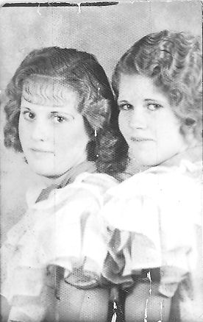Wanda with Reva Tilley
Reva Tilley and I were good friends. We really had a lot of fun, we were a lot like Yutonna and Connie Rucker. We did just about the same things. The Tilley's had a large orchard so we ate a lot of good apples. I can remember Reva and I getting real hungry, so we would get an idea. We would go take a loaf of her moms nice fresh baked bread and go to their cellar and get a jar of strawberry jam and butter and go down by the river and get all filled up. Sometimes we would get some sugar, cream, a fry pan and go down to the river and make candy and was it good!
There was one winter when Lloyd and Jim got a new sled for Christmas. It was on a Sunday afternoon that all the Tilley's and us went down to the river to ice skate and sled. This day, Lloyd was pushing Jim on the sled along the side where it was frozen. We were all watching when the sled turned and went out to the center of the river where the ice had thawed. We all thought that Jim and the sled would go right out in the water. We were all horrified. No one said a word, we all froze in our tracks and said a silent prayer that Lloyd could crawl out on his knees and get a hold of that sled and pull it back to shore, which he did. We all were so thankful.
I can remember another time in the summer, we would swim the river a lot. This was the time I almost lost my life. We had been swimming in the river. We had been racing and I was tired. We had the cellar door out in the river for a raft. The raft was quite a ways out in the river when they all said lets all go out to the raft. I thought I could make it but I was too tired. I thought I could touch bottom which I tried to do but I was so weak I couldn't make it up. I got a mouthful of water and was choking on it and I just couldn't keep on top. Lloyd could see the trouble I was in so he rushed the raft to where I was and threw me on the raft with my face down. They took me to shore and laid me down on the ground. I was turning black and blue. It took me a long time to get over it. My mother had a feeling that day that something was going to happen at the river. After that experience I have been afraid of deep water.
I was very thin and underweight. They always called me the Long Legged Shidepoke. (A shidepoke is another name for herons, birds with long skinny legs.) Even though we did not have much we were happy children. We always had a very good Christmas. Mom and Pop always waited for the last minute to do their Christmas shopping, always just the day before Christmas. We always got a plenty. On the 4th of July, Pop always said he would take us to Rupert to celebrate but he never did it. Mother would have to get us kids ready. We walked about a mile to flag down the passenger train to ride to Rupert. I can remember I was so afraid of the train when it would stop for us I would run away and the conductor would have to run me down. We had a lot of fun at the celebration. We thought it was great if we had a whole dollar to spend.
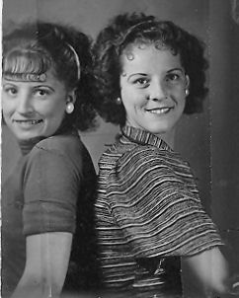Mable and Alice
We were never forced to go to church, we went because we wanted to. We always had to walk, we didn't have a car to get to Primary, Sunday School, or MIA. We had to walk about a mile and a quarter. If the folks went to town for groceries, it was in a wagon with a team of horses. We would listen for that old rattle of the wagon. We could hear it when it was about one and one half miles from home.
How we loved to sit out on the step and watch the lightening over the mountain and listen to mother tell about some of her experiences in England. Mable was quite a storyteller. She would read a good book, then tell it to us in the dark. The three of us girls slept in one bed. The boys, Lloyd. Jim, and Willard in the other. We all slept in one room. We had a riot at times, especially when we were full of nonsense.
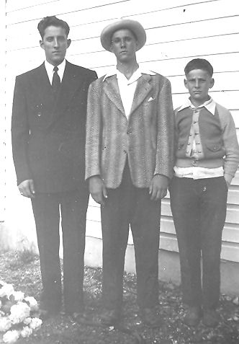Lloyd, Jim, and Willard
I can remember Alice and I were to watch the cows in the pasture and not to let them get in the cellar and eat the potatoes, but we forgot and the cows got in the cellar. One cow got a big spud in its throat so I ran and told Pop. So he got a rope and tied up the cow and took a broom handle and shoved it down the cows throat. Well, I guess he shoved it up in its head and the cow went plum crazy. There it was running into everything. You weren't even safe in the yard. It ran into the trees. Pop had to get the shotgun and shoot it, so we got the blame.
Another time a cow bloated in the summertime when the flies were bad. It got maggots in it so we had to paint it with Kreso dip (an insecticide and disinfectant). So, it had to wear a sheet around it all summer. If that black cow didn't look funny. Then this one takes the cake. We had a calf that bloated while the folks were gone. We didn't know what to do, so we ran and told John Tilley that we have a bloated calf and it was down already. He said just go and get a butcher knife and stick it in the belly , do we did but we stuck it on the wrong side, and do you know that cow lived. Enough for cow stories.
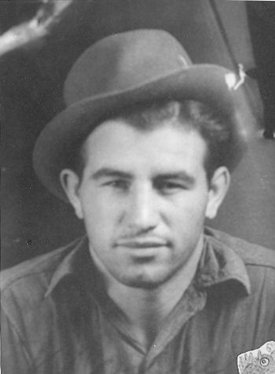Emanuel Kerbs in 1935
On Sunday afternoons we would walk with the Tilley's. Sometimes we crossed the river on the ice and went over to Emerson School and then into Burley. Alice had a thing for Fred McCord at that time. We had a lot of fun walking. A lot of times we would walk into Burley, that was about three and a quarter miles. One Sunday, when I was about fifteen we all walked to Burley, the Tilley's and us. I think it was Reva, I, Mable, Mildred, Norma, Alice, and Afton. It was getting toward evening and it began to rain as we were walking down the street, there sat a Model A Ford with three or four boys in it. They honked at us. We started to talk to them. The asked if they could drive us home. Well, we thought that was a lot better then walking, so they took us home. That was the first time I met Emanuel Kerbs, he was about seventeen and I was about fifteen, his brother George was with him. I don't remember who the others were. We all piled in, some in the rumble seat. Manuel told a big yarn that he was married, then the other girls told Mother I was with a married man, then I got the dickens for it.
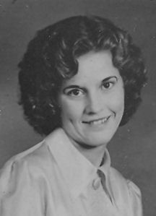Wanda's senior portrait 1936
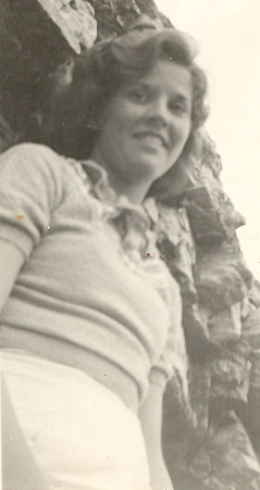Wanda in about 1936
That little 1929 Model A Ford came out quite often. It didn't have a muffler, so we could hear it when it left Burley. Emanuel would often come and meet us after Sacrament meeting. We could see them peeking in the back windows of the Church during the meeting. We had a lot of fun in our courting days. We would steal chickens from Emanuel's sister Millie and go on a Chick a Rie. One time we put three or four chickens under a tub and they all died, did they ever stink. We were cooking them one time at Mollie's, Manuals sister's place, and they came home and helped us eat them. That was the time we became acquainted with Mr. Koch, he even got to eat some chicken. Mr. Koch was manager of Enterprise Land Co.
Emanuel and I went together off and on for about three years. Manuel had some fine qualities that I liked. We did a lot of singing around a campfire on our dates. He always treated me like a gentleman. I never had any problems with boys, they seemed to always respect me. Maybe I didn't give them a chance at times. Manual would go to Rexburg, then return. Pop always said, if a boy likes you, he'll be back. I went with other boys but they did not impress me. Emanuel's brother George thought he was going to catch me by double crossing Manual but He did not succeed.
One day I sluffed school in my senior year. Mother called the school to see if I was in school and the teacher said yes, but I was not. Emanuel's brother George had a car and Manual did not so he said he and Emanuel would take us to Twin Falls if we'd sluff school, so I did, but Manual was not there. George thought he'd have me to himself. I was so mad that I thought Manual was the best of the two. It was that day, I think, that George rolled the Model A and I was in it.
We moved from the ranch in the spring of 1936. Pop lost the farm, it went back to Holland Bank to pay for back taxes and water. The depression was real bad at that time. So the folks bought an acre on South Overland in Burley where we moved. It was great to have electricity. I worked for Mrs. Hall after we moved to town. She gave me a lot of nice clothes. Alice got married in November of 1936.
By that time Manual and I were thinking of farming. Mr. Koch said if we got a loan from FHA he would rent us a farm, so we applied for a loan. Manual had to lie about his age, he should have been 21to get the loan, but he had just turned 20. So we put that he was 21 because he had no birth certificate to prove otherwise. The farm loan went through so we decided to get married on February 14, 1937, a Sunday, by Bishop Olverson at his home in Burley. Mable (Wanda's sister) and George Kerbs were witnesses. Mother and Pop were not there. I wish we had waited until we moved to our home, but we stayed with Emanuel's relatives until the house was ready, which was awful. When we got married Manual borrowed $15.00. I had a gas bill that we had to pay. I had to borrow money for a dress so we got married on a shoestring. I think the suit Manual had on was borrowed. (Wanda dropped out of high school to get married about 3½ months short of graduating)
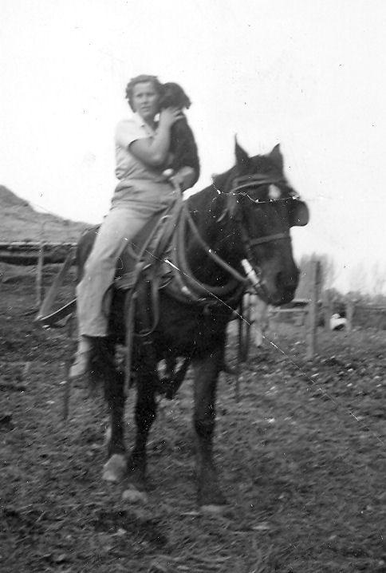Wanda with Nigger on Snoops on the place in unity
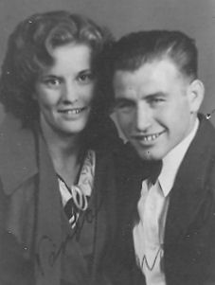Wanda and Emanuel on their wedding day
The winter of 1937 was terrible. The place we were to farm was South of Burley. (About 225 South on 150 East.) I think we moved out the last of February or the first part of March. We could drive our Model A Ford over the tops of the snowdrifts. We had a lot of fun. Our loan from FHA was $1167.00. That bought the machinery, horses, cows, furniture for the house, and feed for the livestock. Mr. Koch was real good to us. He took us everywhere, to Salt Lake City, and Boise. He took us fishing and paid all the expenses, our motel and food. He had our house all painted the colors that we liked and it was real pretty. We lived on the place for one year, then we moved over where Manuel's sister, Mollie and Gus Moser, lived.
We lived there (350 South on 250 East, ¾ south of the Unity Church) for seven years. We had our share of problems. Our horses got brain fever and died. We lost some cows too. The depression was on, but we were real happy. We kept our chin up and worked hard together. Our car wore out so we had no car and we walked everywhere we went. Then we went on horseback over to his sister's place and wherever we needed to go.
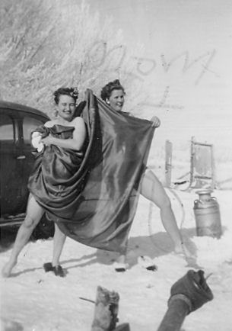Emanuel's sister, Millie, and Wanda goofing off, January 19, 1942
Then we went into the Pig business, where we got quite an education. We had quite a bunch of pigs but not enough feed to feed them. So we fed them beet pulp which make them grow big pot bellies. Did they ever look funny. I remember one morning Manuel went out to feed the pigs. He used a hoe to knock them away form the trough so he could put the feed in. He hit one of the pigs in the head and it fell over dead. He ran to the house and said, “Oh, Wanda, I was feeding the pigs and I hit one and it's dead. What shall I do?” I asked him how big it was. He said about 100 pounds.” I said, “Hurry, take a knife and cut its throat. I'll put on some boiling water and scald it and we will just eat it.” So Manuel cut its throat and brought it over to the garage. By the time the water was hot, the pig was cold. We scalded the pig but the hair would not come off. So I said to Manuel to go and get your razor and we'll shave shave the pig and it worked great. We had quite a laugh. Manuel had seen his father butcher so he knew how to do it. It was good eating.
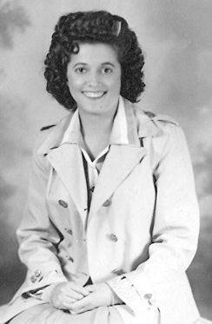Mona in 1942 at age 18
Then our neighbor, Bishop Harris who just lived up about a quarter of a mile, had a big bore that was always at our place. Manuel got so tired of it being there that one day he was at the haystack feeding the cows, Manuel had the pitchfork in his hand and there was that big bore, so he threw the pitchfork at the pig and the fork landed about four inches deep in the pigs back with the handle sticking straight up. Manuel said, “What am I going to do now? “I can't let that pig go home with that fork in its back.” So there was Manuel running after that big bore pig trying to get his pitchfork back. He had a long run down the drain ditch and up again trying not to let the pig go home. Finally the fork fell out. What a laugh we had.
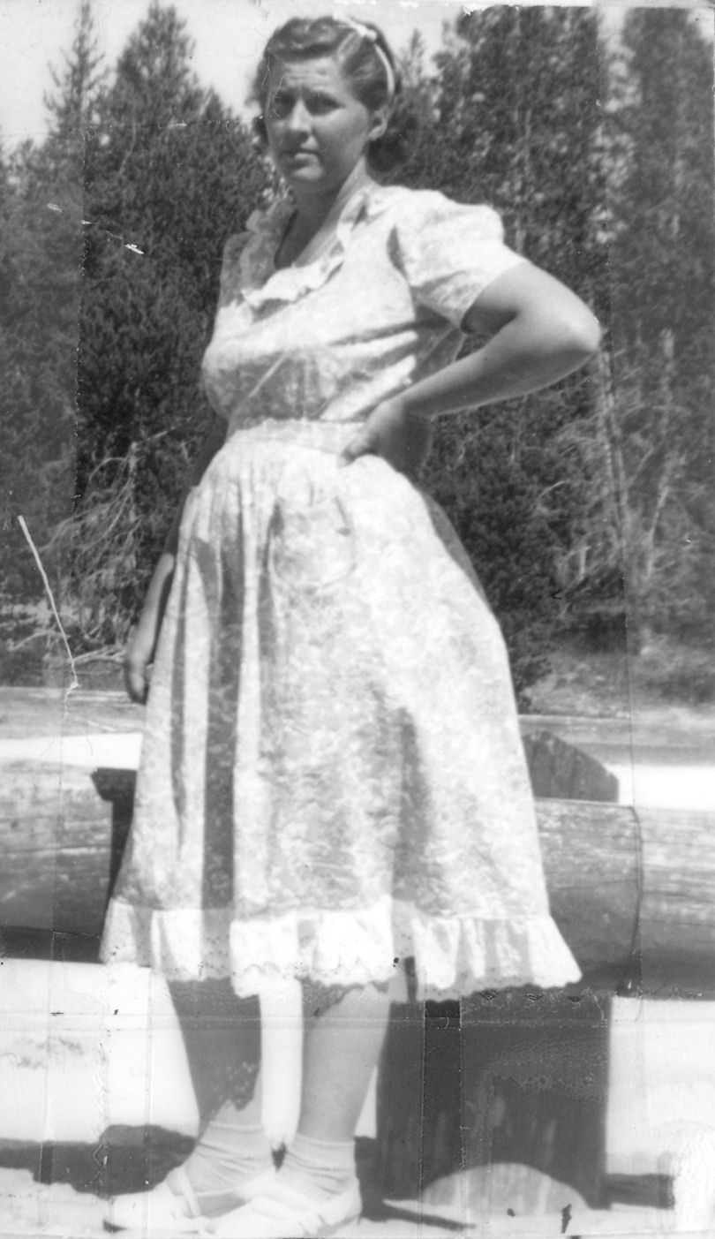Wanda in Yellowstone Park
There are a couple of bird stories I won't forget either. A bird came down through the chimney into the fireplace and proceeded to stagger its smoldering self onto the carpet and into the kitchen. Years later, another bird came down into the house through a vent and came out through the toilet.
We had so much fun. We learned how to save our pennies and budget what we had. I kept a good record of everything that came in and where it went.
When we had a car again, we had to go to Emerson, to Aunt Alice's home and get a bore. We put the pig in the back turtle of the car. (A turtle back was a style of sedan.) We were on our way home going along pretty good when all at once the lid come open and out fell the pig, right on his nose. The pig's nose was just pushed into its head, it looked so funny, we just had to laugh. And you know that pigs nose just stayed that way. Every time we went to feed it we thought we would die laughing, it was always so comical.
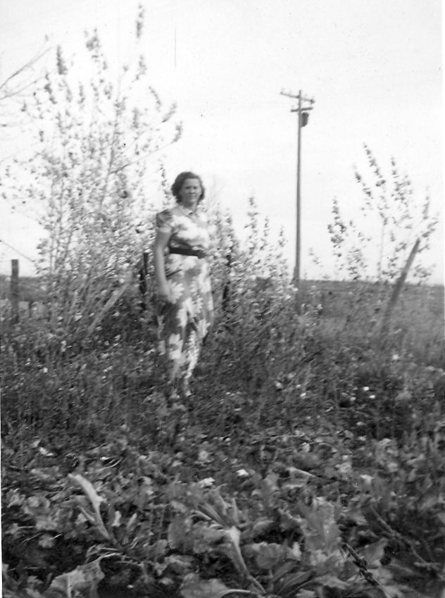Wanda in a beet field
Then another time, we were going along, we were almost home when the back wheel came off the car. There we were, going along and there was the tire going along ahead of us. The tire finally hit a telephone pole and bounced back. Then we finally realized it was off our car and we had another laugh.
I worked alongside of Manuel for seven years. We didn't have any children yet. I could do anything on the farm that a man could do, I worked so hard. We went to the doctor to see if we could have children. The doctor said that I should not work so hard and maybe that would help us to have a baby. Emanuel smoked some. He was beginning to realize that maybe he was not in tune with the Lord. We went to church occasionally. The missionaries came to our home. Manual started to read a lot from the scriptures and other things concerning the gospel that I left laying around. He became very interested in the Church. At times we went to his sister's Church but he could not accept it. He could understand the things the Mormons believed and they made more sense to him. So he decided one day that maybe the Lord would bless us with a child if he would quit his smoking. Emanuel never was a heavy smoker. I knew that he could quit. After more study, he made up his mind and promised the Lord if he would bless our home with a child he would quit smoking, so he quit, just like that.
I went to a chiropractor and had a few treatments. He said that I would get pregnant next time, which I did. I just didn't believe it. I didn't feel any different as time went on. I began to realize it was to be and we were so happy looking forward to our baby being born. How we planned and fixed to get ready for our little one. Manuel was very good to me. I had pulled my shoulders out cultivating potatoes, so I had to be careful.
By this time Manuel was thinking of joining the Church. He had gained a testimony of the gospel. We just did everything together. We never went to our folks if we had a problem. We just prayed to Heavenly Father. We were real good friends with Millie and Jake. I took care of Millie when she had her baby boys. Our friendship came to a close when Manuel got interested in the Church. The gospel meant so much more.
We were expecting our baby in February 1944. Everything went well until the time for the delivery. I was going to have the baby at home but it didn't work our that way. I went into labor for three days, I had such severe pains that I was just worn out. The doctor came and said that I would have to go to the hospital and have it cesarean. Mable had Kay that way, so I was worried. But the doctor said that there was a certain pill if it worked, it might be born normally. The ambulance came and took me to the hospital. They got me ready for the C-section, then they gave me the little pill. I began to vomit dark green. The nurses began to run for the doctor. He said, “She is doing just what we want.” Then I began to get the right kind of pain. Joanne was born February 23, 1944. She was born breech, feet first. They thought maybe they had pulled her hips out of the sockets but things worked out fine. She was a beautiful baby. We were so happy. During the labor I pulled my shoulders out again, the pain was terrible. I had to stay in the hospital for ten days. Joanne was a great baby. We were so happy to have her after waiting so long to have a child. The doctor said that we should wait at least three years before we had any more children. I thought that five years wouldn't be a bit too soon.
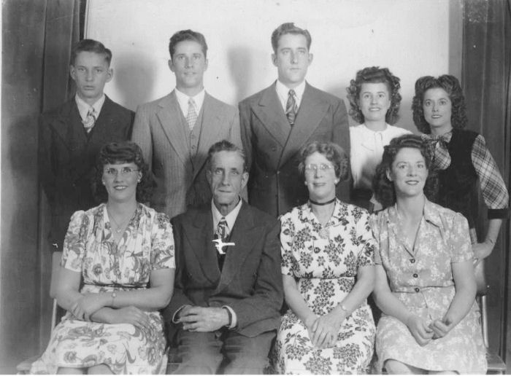The Allen Family standing: Willard, Jim, Lloyd, Alice, Mona. seated: Wanda, Pop, Mother, Alice
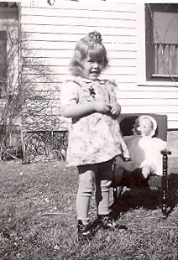Joanne, spring 1946
We moved from Unity to Heyburn on Abe Jone's place. It was in the Heyburn Ward that Manuel joined the Church, but the missionary work was done in Unity. (Emanuel was baptized on March 31, 1945.) The next few years were very happy ones for us.
It was in 1945 and 1946 that Joanne would have fainting spells. That worried me to no end. We took her to Dr. Terhune, he said that she had Undulant Fever (Brucellosis) so we pasteurized all of our milk. Then the doctor said maybe it was epileptic fits. Then that did upset me. I never prayed so hard in my life. To think that little child was given to me, then to have something like that. But I didn't give up. Joanne still kept fainting, it was when she was tired. When she was about 2 years old, she was in the hospital with Bronchitis. She had 56 shots of penicillin. Then we finally took her to a special doctor in Twin Falls. He burned up in her nose. He said she had Rheumatic Fever and to take her back to our doctor and that she had a heart murmur. After that, she never fainted again. We felt our prayers had been answered.
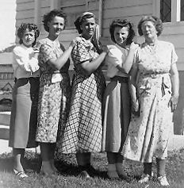Mona, Alice, Wanda, Mable, and Mother; 1949
We moved to the Tex Calcote place in1946 and 1947, then moved back to Heyburn in 1948. Then we moved to the Edith Moncher place. It was there that Yutanna was born. Joanne was so happy to think she was going to have a brother or sister.
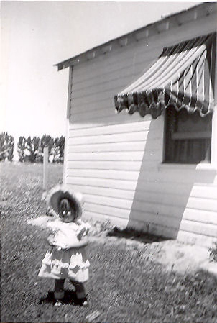Yutanna at the Moncher place
Wanda and Manuel were sealed for time and eternity in the Salt Lake Temple on August 26, 1948. At the same time Joanne was sealed to them. Wanda was pregnant with Yutanna at the time.
That was the hardest winter we ever had. We had just moved to the Moncher place. Yutanna was to be born about the 14th of January. I was hanging wallpaper and putting up the curtains when it began to snow. And did it ever snow, about a foot in 2 or 3 hours. We began to get worried if we could make it in to the hospital if I had to go, Emanuel called Alex, his brother. I think he had to come and get me. So I packed everything and we left about midnight. We went to Grandmother's place. The folks had just moved into their new home that Willard and Jim built. Just think, a bathroom in the house. I and Joanne stayed until Yutanna was born. That was on the 21st of January 1949.
I went into the hospital, the nurses said it would take a long time. So, when I got a pain I'd pull on Manuel's arm. Before you knew it, Yutanna was on her way. The nurses came running, put me on a stretcher and Yutanna was born going down the hall. I told the nurses, “Do the best you can.” They put a clamp on Yutanna and we waited for the doctor to come. It took him about 15 minutes. It would have been a lot better if I hadn't pulled and waited for the doctor. But she was a beautiful black haired, dark baby who looked like Joe Louis. (Joe Louis was an African American boxer.) Yutanna was such a good natured plump little fat baby. Joanne took such good care of her.
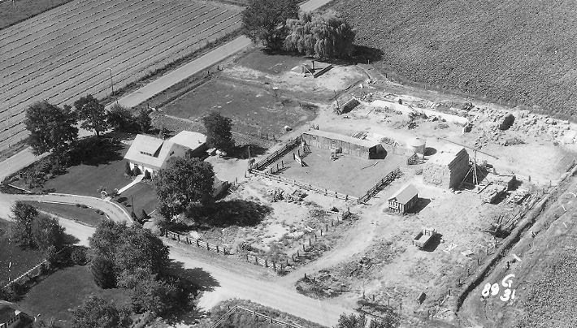The farm - 1960
Then in 1950 we moved down to the Wilkins place. When we were on the Wilkins place, Dad and I were gone, Joanne came home from school and was going to fix supper. She put a fry pan on the stove with a great big spud in it with a lid on it, then laid down and fell asleep. We got quite a kick out of it.
Mrs. Hatch was trying to get us to buy her place. (80 acres at 200 N 300 W of Rupert.) She kept on asking us. Finally Manuel asked, “What do you need down?” She said, “$7,000.00.” So we sold everything we had; cows, hay, crops, and collected $7,000.00. We paid the balance in rent. When we sold our hay, cattle, and everything we still lacked about $1200.00 so the church loaned us the money. We paid it back but they would take no interest on it. We were so grateful to have them help us. We told no one. Then we drew up the final papers and bought the Hatch place for $26,000.00. We called her Aunt Ida, we loved her so much and we love our home. We have taken good care of it. We moved in on December 7th 1951 on Emanuel's birthday.
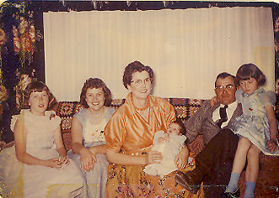The Kerbs family 1958: Yutanna, Joanne, Wanda and Bonnie, Emanuel and Ellen
We moved in December and on March 12th, 1952 Ellen was born. She had a lot of loving. Joanne was 8 and Yutanna was 3. Ellen was a good baby. When she got talking, you couldn't shut her up. We enjoyed her. Then in 1953, Emanuel and I were called on a stake mission. We served 2 years. That put a lot of responsibility on Joanne and Yutanna. We were released on May 2nd, 1955. We had a lot of fun and went on trips to Southern Utah and California saw Knott,s Berry Farm.
We thought maybe there should be a baby brother but I could only think of girls. Then on April 9th, 1958 Bonnie came along. She was a doll. How we all enjoyed her. I think we all did the thinking for her, She was good – maybe a little spoiled.
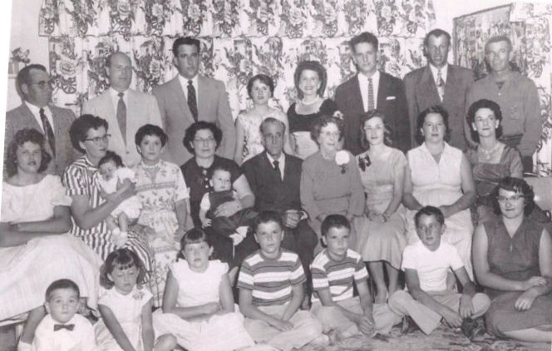The Allen Family in 1958. Wanda is the second from The left on the second row, holding Bonnie, Joanne is to her left. Emanuel is behind them. Ellen and Yutanna are the second and third from the left on the front row.
Manuel decided he wanted a fertilizer operation on the farm here. The year was about 1963. So he worked real hard all winter. I told him I felt it would be a mistake to do it. But he felt so strongly about it, that it was the thing to do, so I kept still. He worked very hard all winter on the shed. The day came for the grand opening of the warehouse fertilizer business. US Steel had a grand opening with fertilizer the same day. Hardly no one came to our grand opening. He was real deflated. He got so that he could not remember. I took him to LDS Hospital in Salt Lake. The doctors thought he had a brain tumor. They took all kinds of tests but could find nothing. They decided it was a nervous breakdown. They treated him for a while then he came home. Joanne was 19, Yutanna 14, Ellen was 11 and Bonnie was 5. I tried to explain to the children that Dad was sick and that he needed our help.
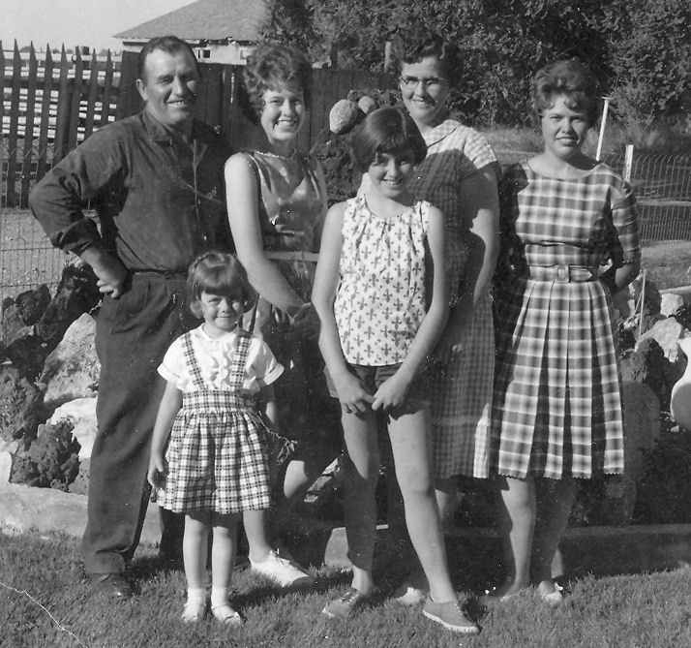The Kerbs family - 1961 Manuel, Bonnie, Yutanna, Ellen, Wanda, and Joanne
He came home for a while then got worse. I talked to the Bishop. He advised me to take him to Blackfoot, which I did. (State Hospital South in Blackfoot was a state mental institution.) He was there a short time. He came home and began to get better day by day with our faith and prayers and the help of the Lord. I know I made some mistakes. I tried my best. I took care of the farm and all of the fertilizer business. I took care of all of the cattle, we had a coral full. I had to give some shots and feed them, No one helped me. I figured the Lord would give me no more than I could bear. So I worked real hard. Manuel got his old self back again.
Joanne attended college at BYU the fall 1962 and 1963. Then she decided to fill a mission. She was called to the Northern States Mission headquartered in Chicago. She left on August 22, 1966.
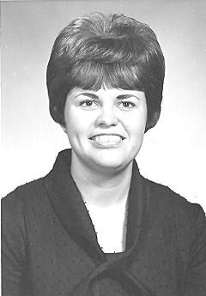Joanne as a missionary
Yutanna was busy with her music. When Yutanna was real small, we got her a little electric organ. She showed that she had some some talent in music. So we bought her a large piano when she was 6 or 7 years old. She could play most of the church songs by ear. Then we decided she needed to have a teacher and learn by notes. I had such a desire for my children to be able to make music. I thought she showed all the ability. So we started her with Cleo King, then Mrs. Ralls. When I worked with her, she would cry but I still insisted she keep going she was doing real well. Then she took lessons from Abbie Mathers for a while, from who she learned a lot. Then she took lessons from Mrs. Culberston. Then we bought a large new home Hammond organ. Yutanna was practicing at the church before we got the organ, We paid $3200.00 for it. It took quite a few years to pay for it. Then she took lessons from Marlene Bean at Burley.
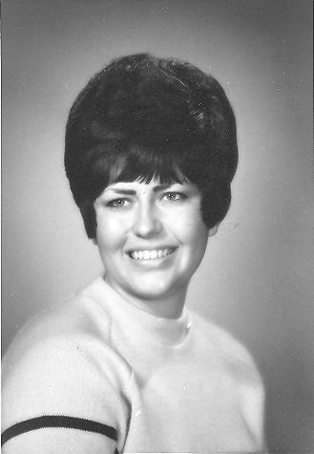Yutanna at BYU
The missionaries always came to our home a lot. We called our home the Missionary Rest Home. So on diversion days they were always here, singing, eating, playing, having mud fights, swimming on the lawn and having water fights when the water was on it. There was one elder that had a lot of talent in music. It was Elder Olschefkie. Could he play the piano. Yutanna learned a lot from him. We had our piano tuned with our organ. One would play the piano and one the organ. They sure had a lot of fun and how we enjoyed it.
Emanuel really loved music. We felt our dreams were coming true. Then Yutanna took lessons from Robert Hamlin in Burley. Then the next summer she went to Salt Lake and stayed with Arvilla Robbins and took lessons from Dr. Asper. Yutanna had a key to the church, she would go early in the morning lock herself in and stay all day. Once Yutanna got to play the Tabernacle Organ. Yutanna then went to Ricks College. Her major was music. During the summer while at Ricks, she was in drama at the Playmill Theater.
After she graduated from Ricks, she went to BYU. We still wanted her to major in music but Yutanna wanted drama. When she went to the Y she majored in drama. She got the lead in the Man of La Mancha, she was Aldonza. We went and saw the the show. Ron Stephenson was the Man of La Mancha. They did well. Then Tonna sang in several night clubs in Salt Lake, which we were upset about. We were in hopes that she would do more with her music instead of drama.
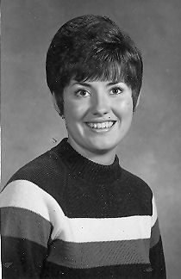Ellen at Ricks College
Yutanna graduated from BYU then she worked in Salt Lake for a while. Then she went down to Arizona with Ron Stephenson and worked in a department store. Now at present (1974) Yutanna is in California working as a secretary for Drexal and Burnham. Yutanna was engaged twice, first to Kent Hodges then Chad ________. Ron Stephenson is still in Los Angeles. They still do some show business.
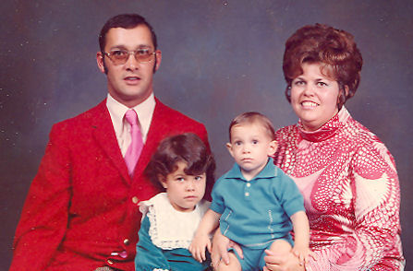Joanne's Family; Dennis, JoNelle, Denny, and Joanne
Joanne came home from her mission and met and fell in love with Dennis Hacking. They were married om May 1,1969 in the Idaho Falls Temple. Now we have two lovely grandchildren. JoNelle is 4½ years old. She is just a doll we lover her so much and so lovable, Then little Denny came. He had a real fight for his life. He had hyaline membrane disease. With good doctors and nurses and help of the Lord he lived and is a sweet little grandson. He is now 2½. We have a lot of fun with our grandchildren.
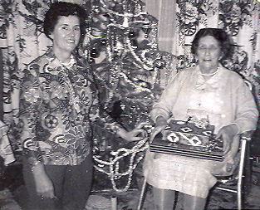Wanda and her Mother, Christmas 1969
Ellen was going with DeLyn Kruse. DeLyn was going to college in Hawaii. He wanted Ellen to come to Hawaii for Christmas. I think he sent half of the money and we let her go. I can't hardly believe I would do that. (She was 15 at the time.) But Ellen went, she had a good trip. But things did not workout for Ellen and Delyn. He had another girlfriend and Ellen was thinking about Joe Jones at home whom she liked real well. When she got back she fell madly in love with Joe Jones. Ellen went to Ricks College for one year. She did real well and got good grades. Ellen and Joe were married in the St. George Temple on June 8, 1971, it was very nice. We are hoping Ellen and Joe will soon have a family. We were married 7 years before we had children but we hope they don't wait that long.
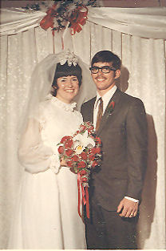Ellen and Joe
I worked about 15 years in the MIA. At present (1974) I teach night Relief Society social relations lessons. I have worked for about 12 years. I sold Avon for 2 or 3 years. Then I worked part time at the Idaho Department Store which turned out full time. The Idaho Department Store went out of business then I worked at JC Penny. Then I went to Gibson's, then a new Sprouse Reitz store went in besides Safeway, so I applied there. I worked there from April 1973 until December 1, 1973 when I decided to stay home and take care of my home and have fun with Bonnie.
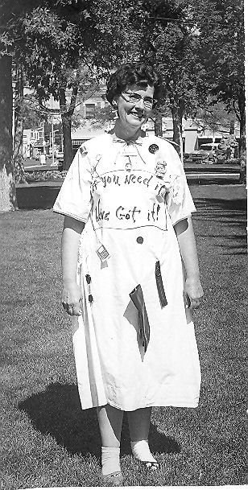Crazy Daze at Penny's - 1970
One day, when I was working at Sprouse Reitz I went to pay the phone bill. When I got out of the car I left the engine running. I thought I had it in neutral, it was in in reverse. While I was in paying the bill, the car backed itself across the street. When I came out, the car wasn't there. Wondering where it was, I saw it across the street sitting on a sheet of ice with the wheels spinning.
When Joanne decided to go an a mission, Emanuel thought he should work at Safeway to send Joanne the money she needed on her mission. He liked it so well he worked there permanently. He started in August of 1966. We never were in need since he worked we always paid our tithing the first thing. There has always been enough to go around. I saved some of the money I earned to help build our fireplace which we enjoy so much.
Later, Carl and Don's in Tremonton made Emanuel an offer to manage Carl and Don's in Rupert. Emanuel left Safeway after nine years. He likes it real well at Carl and Don's but it has had its problems. One time he came home after going to the bank. He had borrowed Dwayne's pickup and had $190.00 in a pouch that he put on the floor. He backed into the yard by the gas barrel and got out out, I guess he kicked out that pouch. Our neighbor's dog picked it up in his mouth and took it out on the road and dropped it. We searched but could not find it. Someone must have stopped and picked it up. So we had to pay it back to the store. The store can't do enough volume. I hope things work out.
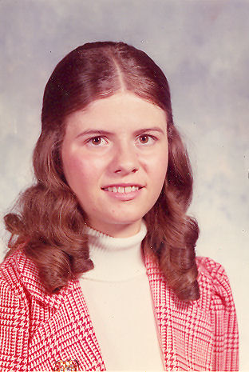Bonnie at 16
Bonnie is 16 now. She is a pretty young lady and is beginning to date. She has been going with Delain Horn. He is going to college in Twin Falls. Bonnie works part time at Sprouse Reitz. She is buying her a typewriter. She gets fair grades in school . We have a lot of fun together. I'll sure miss her when she is gone.
I have a testimony of the gospel. I know with all my heart that its true. The only true happiness comes by the things that are right. Emanuel and I have a good life together. We have helped each other. I love him very much he has been a good father. We hope to have many more good years to come. It will be fun staying home and being a good homemaker. I love my children, they have been good.
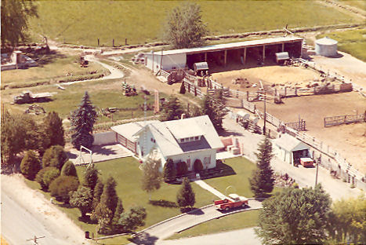The farm - 1973
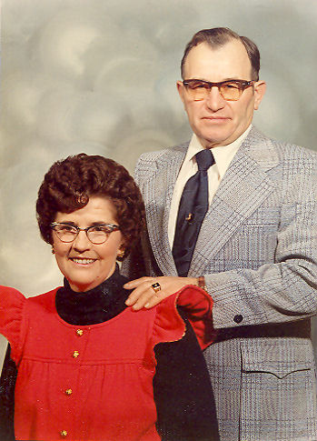Wanda and Emanuel in 1973
* * * * *
Part I was written by Wanda in 1974.(It has been edited slightly for clarity.) From November 1978 until April 1981 she kept a journal, with scattered entries there after. Part II is extracts from her journal.
In the meantime, two more grandchildren were born. In 1975 Joanne and Dennis' last child, Grant was born. He was born with a serious heart defect and almost didn't survive. Manuel went to work as an assistant manager at Nelson's Foods. Wanda and Manuel celebrated their 40th anniversary in 1977 with an open house hosted by the girls. Ellen and Joe's first child, Wes, was born in 1977. Bonnie graduated form High School in 1976. During her senior year, they hosted a foreign exchange student named Naoko Yuba from Nagoya, Japan. As a graduation present, Wanda and Manuel took Bonnie to Hawaii. Bonnie went to Ricks College and graduated in 1978. After graduating from Ricks, she came home for the summer and met and became engaged to Gordon Buttars, a returned missionary who was farming with his father south of Burley.

