Gordon Gover Buttars
Sailor ~ Farmer ~ Father

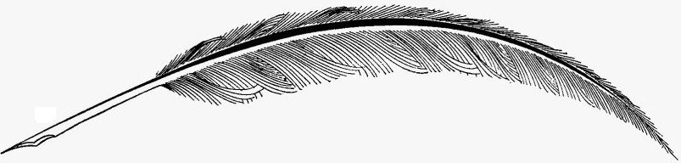
Gordon Buttars

Cover by Gordon Buttars

Copyright MMXXII, Gordon Buttars
All rights reserved. Independently published in the Unites States of America.
For information contact Gordon Buttars, 1256 N 4000 W, Rexburg, Idaho, 83440 or at gordon@buttars.me.

ISBN: 9798425834355
Imprint: Independently published

For his posterity

Foreword

This is taken from a series of recorded conversations we had in the early 1980s a few years before he died. Much of the language is how he told his stories without much polishing.
Gordon had lived a good but a hard life, with many challenges along the way. He was honest and hard working. The most important thing to him was his family. That is why he worked so hard. There were four events that most affected the course of his life in an adverse way. The first was the death of his mother. The second was moving away from Clarkston and the support of his extended family when he was eleven. The third event was a little blip in history called Wold War II. The final blow was when Celia left him. She was certainly the love of his life.
Gordon was not an easy person to live with. Much of the way he was was a result of external circumstances over which he had no control, especially at a young and tender age. Along the way, he picked up some habits that also took a toll on his life. He started smoking at a very young age and was never able to quit, even though his health depended on it. He smoked until the day he died. Although genetically prone to heart disease, it was considerably compounded by smoking.
The purpose of this story is to preserve an account of his life for his children and grandchildren and their children after them. His story is their heritage and a part of who they are. What they have is in part because of what he did during his life. There is something to be learned from every person's life. Every person deserves to be remembered, may his legacy live on.

Table of Contents

Chapter 1 | HERITAGE | Page 1
Chapter 2 | CLARKSTON | Page 6
Chapter 3 | BURLEY | Page 17
Chapter 4 | SEAMAN | Page 25
Chapter 5 | STOREKEEPER | Page 42
Chapter 6 | THE UNSETTLED YEARS | Page 60
Chapter 7 | CELIA | Page 66
Chapter 8 | BIRDENA | Page 80

Chapter 1

HERITAGE

Cache Valley is a broad arid valley in Northern Utah and Southern Idaho. It extends approximately 50 miles along the west side of the Bear River Mountains, the northernmost extension of the Wasatch Range, and along the east side of the Wellsville Mountains (in Utah) and the Bannock Range (in Idaho). It is drained by the Bear River and its tributaries, into the watershed of the Great Salt Lake.
Under the direction of Brigham Young in the fall of 1856, a group of Mormon pioneers settled in the south end of the valley where Wellsville now is. As the settlers began to prosper they began to create new settlements in other areas of the valley. One of their early settlements included Logan which was established in 1859 and became the prominent city. The eventual influx of people helped create the large number of towns that can now be found in Cache Valley.
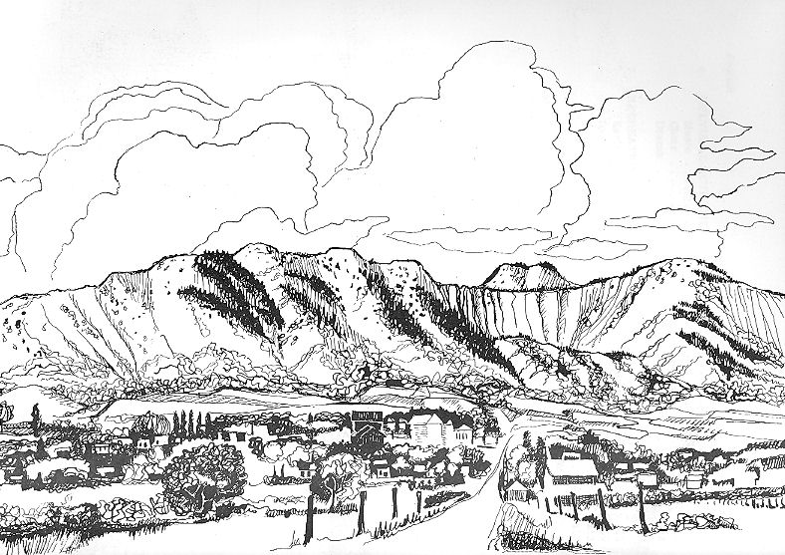
Clarkston was one of these towns. It is tucked away in a secluded corner of the valley thirteen miles north and thirteen miles east of Logan, and five miles south of the Idaho boarder. The prominent landmark is Gunsight peak directly west of town. Several creeks flow down from the mountains providing an abundant source of water. City Creek flows right through town.
In the fall of 1864 a group of twelve families under the direction of Israel Clark, for whom Clarkston was named, were the first to settle the area. The following spring brought more families, including John and Mary Pittaway Godfrey. John was the first to put a plow in the ground in Clarkston. By 1866 several families had established their homes in Clarkston to the dismay of the Shoshone Indians who claimed the land west of the Bear River. The Indians set up camp on City Creek, just outside of town, and demanded beef and flour from the settlers. Brigham Young determined that it was better to feed the Indians than fight them. But when their food supplies dwindled they were unable to meet the demands of the Indians. It was advised that they abandon their homes and relocate to Smithfield.
The following spring, the pioneer families returned to their farms and built a fort. They formed a militia consisting of a horse company and and an infantry company to keep the Indians in check. During the trouble, one Indian was killed. Once peaceful and friendly relations were established with the Indians, Clarkston once again continued to grow as more settlers arrived. By 1867 the Clarkston Ward was organized. In 1869 a co-operative store was formed and in 1870 a post office was established.
Among the new settlers were David Buttars in 1868, George Godfrey in 1870, Maurice Gover in 1871, and Peter S. Barson in 1876.
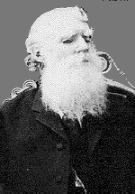
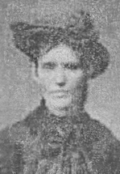
David Buttars was born December 2, 1822 in Rattray, Perthshire, Scotland. In 1848 he married Margaret Spaulding. They joined the LDS Church in 1851 and immigrated to Utah in 1854 with their three children. While crossing the Atlantic Ocean their three month old son, David, died and was buried at sea. They arrived in New Orleans and traveled up the Mississippi River and then crossed the plains by covered wagon. They settled in Lehi where David made his living as a shoemaker. Four more children were born in Lehi, including their son Daniel who was born on September 22, 1858. Margaret died in Lehi on August 10, 1863 Just five days after the birth of her last child. The baby died several days later.
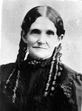
David later married Sarah Keep in 1866 in the Endowment House in Salt Lake. Sarah had a daughter from a previous marriage who David adopted as his own. One more child was born in Lehi before they moved to Clarkston in 1868 where seven more children were born. David farmed in Clarkston and became one of its prominent citizens.
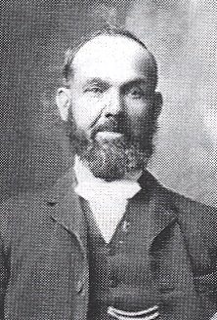
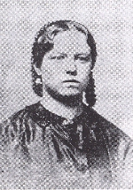
George Godfrey was born on January 24, 1845 in Worcester, Worcestershire, England. He was the oldest son and second child of John and Mary Pittaway Godfrey. They joined the Church of Jesus Christ of Latter-day Saints in 1848 and desired to eventually im-migrate to Utah. It was decided to send George ahead on his own to prepare the way for the rest of the family. At age sixteen he sailed to America. He joined up with a wagon company and walked from the Missouri River to Salt Lake City, arriving in September 1861. He bought a piece of property and built a log house and had it ready for the rest of the family when they arrived in 1862. George married Emily Gover in 1865 and moved to Clarkston in 1870. (His father, John Godfrey, had moved to Clarkston in 1865.) They were the parents of eight children. One of their sons was Joseph Maurice Godfrey who was born in Clarkston on June 3, 1874.
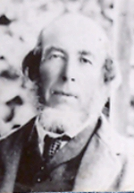
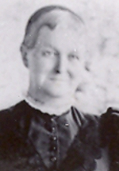
Emily Gover was the daughter of Maurice and Sarah Tucker Gover. Maurice was born on November 6, 1827 in Clutton, Somerset, England. He and Sarah were married in 1848. Maurice be-gan working in the coal mines at an early age. As the mines were work-ed out, they moved to Abersychan, South Wales to work in the coal mines there. It was in Abersychan where Emily was born on June 18, 1848. While there, Maurice and Sarah joined the LDS Church in 1849. In 1853 they immigrated to Utah. The night before they left England to sail to America, their son, Elijah who was only a month old, died and had to be left with friends for burial. Emily was four years old at the time. After arriving in New Orleans, they made their way up the Mississippi River to Keokuk, Iowa, and traveled to the Salt Lake Valley with a wagon train. They lived in Salt Lake until 1869 where six more children were born, including Emma, who was born on November 19, 1864. They moved to Newton, about six miles from Clarkston in 1869 and then to Clarkston in 1870.
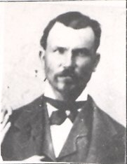
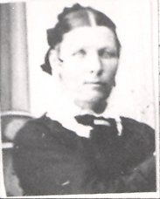
Peter S. Barson was born on February 12, 1849 in Wellingborough, Northampton, England. His parents, Samuel and Ellen Sheffield Barson joined the LDS Church in 1844 and set out for America in 1854. Peter's mother died from cholera while making their way up the Mississippi River. His younger brother and sister were left in St. Louis with Ellen's father who lived there. Peter and his father crossed the plains with a wagon company. When they arrived in the Salt Lake Valley they learned that the children had both died. His father later remarried but died when Peter was sixteen. His stepmother took her children and returned to England, leaving Peter to fend for himself.
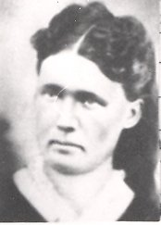
Peter married Mary Ellen Scott in the Endowment House in Salt Lake City on October 20, 1869. While living in the Mill Creek area of Salt Lake City, three children were born to them, including Mary Eliza who was born on January 10, 1873. Peter married his wife's sister, Eliza Ann Scott, on August 8, 1875.
In 1876 Peter and his two wives moved to Clarkston where Mary Ellen had two more children and Eliza Ann had three. The family arrangement worked very well. When Eliza Ann died in 1887, Mary Ellen raised her children as if they were her own.
As the next generation, including Daniel Buttars, Emma Gover, Joseph Godfrey, and Eliza Barson, began growing up in Clarkston the Indians became a menace again. In 1871 a bridge was built across the Bear River giving Clarkston better access to the rest of the valley. That summer the crickets devoured their crops three times. Three times the seagulls descended on the fields and devoured the crickets. Three times they replanted their crops and in the fall, David Buttars harvested a record crop of 1,300 bushels of wheat.
During the 1870s the hardships of pioneer life began to ease. New homes were built, accompanied by barns, graineries and gardens. A woolen mill was erected. And a rock meetinghouse was completed and in the 1880s a two room schoolhouse was built. Life was good in Clarkston.
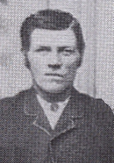
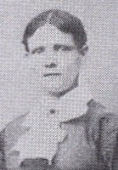
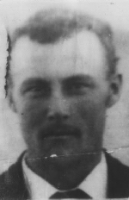
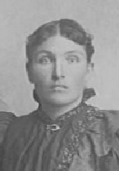
Daniel Buttars and Emma Gover were married in the Endowment house in Salt Lake City on December 27, 1883. Their sixth child, Gover was born on December 10, 1895 in Clarkston.
Joesph Godfrey and Eliza Barson were married on June 10, 1897 in the Logan Temple. Their first child, Mary Eliza was born on April 13, 1898 also in Clarkston.
Utah became a state in 1896 and by 1900 the Clarkston Ward had grown to 628. A water works system was installed in 1908 bringing water to town at the turn of a tap. A new school was completed in 1910 and a new meetinghouse was dedicated in 1913.
Gover married his childhood sweetheart, Mary Eliza Godfrey on November 23, 1915 in Preston, Idaho. Since Gover and her father were first cousins, it was against the law to marry, so they had to go out of state. Gover and Mary made their home in Clarkston where Gover.

Chapter 2

CLARKSTON

Gordon enters his own story at 2:10 a.m. on July 1, 1918, an early Monday morning. He was blessed by Thomas Godfrey on August 4, 1918.
At this time, Woodrow Wilson was the President of the United States which was involved in the “Great War” which later became known as World War I. The war ended on November 11, 1918 but before long the nation was faced with another crisis which affected Gordon and his family. As the soldiers came home from Europe, they brought with them a deadly influenza virus. That fall, the terrible Spanish Flu epidemic swept the country. Mary, Gover, Ervin, and Gordon were all flat in bed with terribly high fevers. Mary’s mother took care of the stricken family. Everyone wore gauze masks. Despite this precaution, Liza was soon as sick as the rest of them.
Church and school was canceled from October 1918 until January 5, 1919 due to the flu. Mary’s cousin, LaRee Barson, was asked to help take care of the very sick family. An uncle called on them each morning to see what supplies were needed. LaRee did her best tending the baby and taking temperatures but soon became sick herself. Very few people in town escaped the epidemic, some even died. The funerals were held out in the open. A few young men in town went from door to door doing the milking and other chores. Eventually Clarkston lived through the epidemic.
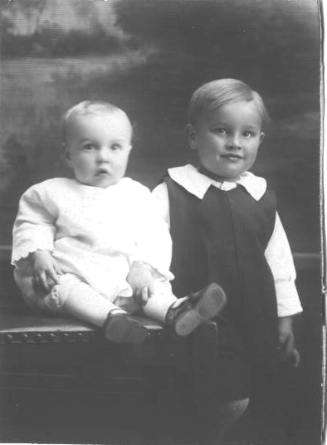Gordon and Ervin - 1919
This family was off to a happy start with their two little boys. Gover and Mary each had a rocking chair in which they would take a little boy and rock him to sleep every night. This lovely young mother stated that she wanted to have ten children. She was pleased to make the announcement that a third child would be added to their family in September.
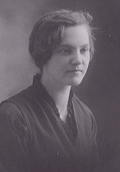 Mary Eliza Godfrey Buttars
On September 25, 1920 Milton Rudger was born. What should have been a blessed and happy event, became a dark and tragic day. Mary died in childbirth at the young age of twenty-two. Gordon never really knew his mother.
Gover was now alone with three small children without a mother to care for. Ervin was four, Gordon two, and Milton was just a baby. Not being able to care for his little boys and run the farm, he turned to his family for help and moved his motherless family in with his widowed mother.
She had a large house with plenty of room. Gover could still run the farm and have his sons cared for by his mother and sister, Archulious, who still lived at home. His brother, Wallace, also lived at home at that time.
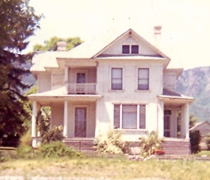Grandmother Buttars’ house built in 1906
Gordon was a little boy with white curly hair and brown eyes and was into more than his share of mischief. Once when he was about three or four he got into some black, sticky axle grease used to grease wagon wheels and farm machinery in his hair. Aunt Archulious had quite a time getting his hair clean again. His hair was hard enough to comb as it was because it was so thick and curly anyway. When she would comb out that snarled, matted, curly white hair he would bawl and carry on something fierce.
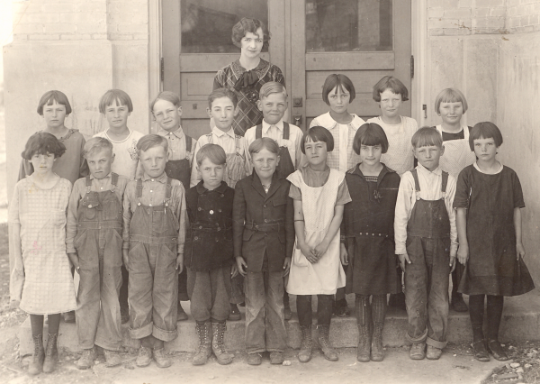Gordon's second grade class(Second from the left on the front row)
Gordon and Ervin picked up foul mouths at a early age. When Aunt Archulious' husband to be, David Archibald, came courting, those two little tykes would hide under a bed or behind the couch and try out their newly learned vocabulary of cuss words and giggle. Aunt Archulious didn't like swearing so Dave would chase them down, which was great sport for the little boys, until they got caught. When Dave caught them he held them over his knees face up and pulled their tongues out with his fingers as Aunt Archulious poured cayenne pepper on their tongues. When they turned the darling little brats loose, they ran off drooling, spitting and swearing.
After living with Grandmother Buttars for about two years, Gover remarried. His new bride was Mary Harriet Bowles from Lewiston, Utah. They were married June 28, 1922 in the Logan Temple. After they were married, Gover moved his new wife and two of his sons back into his own house. Milton lived with his grandmother until he was about eight. As the kids grew up they called their stepmother Aunt Mary.
In 1923 or 24 Gover bought his first car, a brand new Model T Ford. Aunt Mary had Gordon with her when she took the car to learn to drive. She nearly scared little Gordon to death. With a car, now it only took about an hour to drive the twenty miles to Logan. Gordon can remember making the trip in a white top buggy drawn by a team of horses. Then, the trip took over four hours.
To go to Logan was a treat for a little boy. Gordon loved to go to Logan with his father. One day Gover needed to go to Logan for something and naturally Gordon wanted to go. At dinner, Gover took a meat fork full of cooked cabbage and put it on little Gordon's plate. Gordon turned up his nose because he didn't like cabbage. Gover put salt and pepper and butter on it and fixed it up so it would taste good. "Now," he said, "If you eat this, you can go to Logan with me." Gordon ate his cabbage and got to go to Logan. At the same time he learned to like cabbage.
On one trip to Logan, Gordon and Ervin were attracted by a pall parrot perched on a sign in front of a shoe store. As people walked by, the parrot would squawk out "Hallow." They wanted to talk to the bird but didn't get much response so they commenced shaking the sign to see if they could get him to talk. The poor old parrot clung to the sign squawking, "Downt! Downt! Downt!” The storekeeper ran outside to see what all the commotion was about and down the sidewalk they dashed.
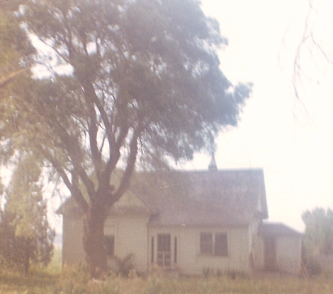The house down by the creek
In about 1924 the family moved to a new place out of town, down by the creek. That same year Gordon started school. The next few years had many adventures in store.
Gordon had a little dog named Sweed who became his faithful friend. Uncle Ervil (his mother's brother) made a little two-wheeled cart with a pair of shaves so Sweed could pull Gordon around in it. He had to sit just right to balance the cart. If he sat to far back, the cart would rare pulling up on Sweed and he would turn around and "chew all hell" out of him. If he sat too far ahead it would put all the weight on Sweed and he'd turn around again. As long as he kept balanced, Sweed could pull him all over the place. Sweed could pull him in a little sleigh too.
Sweed was a good dog to have around. You could stand in the yard and throw your arms showing him where the cows or horses where and he would bring them in on a dead run, almost knocking down the fences. One day he and Gordon went down to the creek to catch magpies. He heard that magpies could talk when their tongue were slit. They were not able to catch any to find out if it was true.
Gordon also had a pony named Old Cassey. Her tongue hung out the side of her mouth. When she got a drink of water she had to bury her nose in the water past her nostrils so she could drink.
At times Gordon would sneak away from Aunt Mary and ride Old Cassey up by the cemetery where the farm was to watch his dad work. The big thing to do was to ride side saddle. One day he was bringing in the cows perched on the saddle sideways thinking he was neat, until he fell off backwards practically landing on the back of his head. Old Cassey stopped for him as Gordon got up shaking his head. When he got to the yard, Gordon was sitting in the saddle like he should.
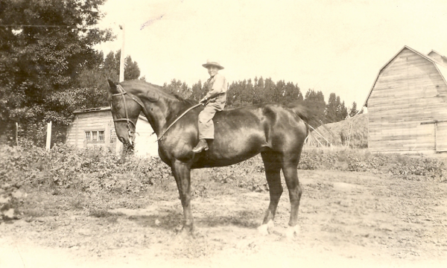Gordon on Topps, another of his dad’s horses
A neighbor by the name of Bois Jardine made Gordon a pair of wire spurs. He got on Cassey and jabbed her in the ribs expecting her to go. Instead, Old Cassey turned around and bit him on the leg. The spurs weren't such a good idea after all so he didn't use them anymore.
When Gordon was a little boy, his Great-grandfather Peter S. Barson was still alive. Grandpa Barson would gather all of his great-grandchildren and seat them on the floor and play an old fiddle and a wind up phonograph that had a little man that danced around the record as it played. He gave each of them a nickel to sit on the floor and listen to him play his fiddle and tell stories of fighting Indians or riding for the Pony Express. If one of the kids got up to leave, he took the nickel away from them. As a young man, Grandpa Barson fought Indians when Clarkston was first settled. When Gordon was born it had been less than thirty years since the last of the great Indian Wars so there were plenty of stories to be told.
These stories had Gordon scared of Indians. At times the Indians came off the reservations to go about begging for flour and food. When he saw them coming up to the house, he would immediately leave his playing and run in the house and hide under the table.
Being located on the slopes of the Wasatch Mountains, Clarkston got a lot of snow in the winter. Snow and kids could mean only one thing, sleigh riding. There was always a huge snowdrift against his grandmother's barn. All the kids in town brought their sleighs to the top of the drift and would ride them down. The more kids on a sleigh, the faster and farther they could go. One of Gordon’s cousins was bigger than the rest of the kids. He would lie down on his sleigh and pile four or five smaller children on top of himself and down the run they'd go. They got going so fast that sparks flew from the runners as they skimmed over the snow. They could go clear down to the creek, almost a mile and a half away.
When it wasn't sleigh riding in the winter, it was the swimming hole in the summer. This swimming hole was just down the creek from their house. According to legend, the swimming hole had no bottom because a runaway team of horses drown there. Even though the water was ice cold, there were always ten or twenty kids in there swimming. They'd dive in one side and come up the other into some wild rose bushes, but that didn't stop anyone.
Gordon had his chores too, so there wasn't always time to play. He was milking cows before he was big enough to go to school. He wasn't big enough to lift the buckets after he had filled them so his dad dumped them in the milk can. By the time he was eleven he could milk as fast as his dad.
At haying time, his job was to ride the team that worked the derrick. When the men went out after another wagon load he would ride the wagon. On one Fourth of July they were stacking hay and a bunch of kids were going down to the swimming hole and stopped to ask, "How come you're stacking hay on the 4th of July?” The hired man answered, "So we don't have to do it on the 5th."
After the chores were done they made their own fun. Gover used to raise purebred ewes. Once during lambing season it was stormy so he put them in the barn. Gordon and Ervin got the idea they would trip the ewes as they went through the door. Ervin had the handle end of a fork and Gordon had the tines. The sheep tripped over the fork handle, and somehow one of the tines got into Gordon's wrist but he didn't feel anything. His next move was up the ladder to the loft. As he reached up to the next rung with that arm to pull himself up, all of his weight caused the puncture to finish breaking open. The blood squirted, he squealed and fell off the ladder, and ran in the house to get bandaged. The wound healed without needing stitches but it left a definite scar on his wrist.
After getting bandaged, Gordon and Ervin went back to the barn to ride sheep. When Gover got a hold of them, the buttons were flying off their clothes to where it sounded like a hail storm in that old barn. Boy, did they get a walloping.
Another day they caught a Rambulet buck in the barn so they could ride him. Now, when a sheep jumps, it jumps stiff legged, so a little kid seven or eight years old would naturally fall off. When it was Ervin's turn to ride him, Gordon went to the other side of the barn and opened a door that was never used because there was a three foot drop. When a sheep sees an opening they most always go through it. When this old buck saw the light through the door, out he jumped with Ervin on his back. The buck landed just short of the creek and Ervin flew off and landed in the dirt. The ram got in with the ewes where he wasn't supposed to be. Gordon jumped out of the barn door and Ervin got up brushing the dirt off his clothes. Now they had to get the buck out of the ewes before anything happened.
In the days of work horses, there was a contest called a pulling match. The object was to see who had the strongest horse or team of horses. Ervin and Gordon would have their own pulling matches using their father's work horses. Those little boys would get the teams harnessed up themselves and hitched them back to back to get them to pull. A lot of the time this would balk a good team, or get them so they wouldn't pull anymore. They managed to ruin a team for their dad. This team was Vick and June. Soon after, Gover had Vick and June hitched to a load of gravel but they just wouldn't pull it.
It wasn’t hard to figure out what was wrong and naturally he got mad. He made Gordon and Ervin walk up to City Creek where Blanche and Bolley were pastured. Blanche and Bolley were Gover's best team. They caught them and put their collars and harnesses on and brought them back to Gover so he could hitch them to the wagon. When they started pulling, Blanche chocked down because they put too small of a collar on her and it cut off her wind. Gover got mad and worked their pants over once more. He was going to make the boys walk home and get the right collar, but instead of wasting anymore time, Gover tied Blanche back and had Bolley pull most of the load.
The little boys in Clarkston would put their dogs up against each other in dog fights. The boy whose dog lost would inevitably tear into the boy whose dog won. A lot of times there were gang fights too. Several smaller boys would tear into an older kid. Gordon and Ervin got in on their share of the action.
It was in Clarkston when Gordon started smoking. The thing to do was to peel the bark off of a cedar post and shred it up real fine in their hands. Then they'd “roll there own” and light up. Puffing on that burning cedar bark tasted nasty so they switched to tobacco .
In Clarkston, their family usually went to church. Gordon remembers going to Primary. Some of his teachers remember him too. One of them told a story about him. She asked him too say the prayer one day. Gordon stood up and bowed his head and folded his arms. Then there was a long pause. After a minute he said, "Oh, hell. I don't know how!” and sat down. Gordon was baptized on 4 July 1926 by George D. Loosle and confirmed by Joseph G. Christensen.
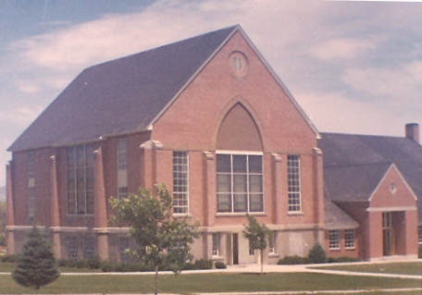The Clarkston Ward Meetinghouse that was dedicated in 1913
He had a cousin, Susie Buttars, who was in his class. When the teacher called the roll, he was clowning around. When she called Susie's name he hollered, "Present!" That got all the rest of the kids teasing Gordon and calling him "Susie."
Built in 1910, the School stood in the lot next to the Ward Building. It was a two story building of yellow brick. There were four big rooms, two downstairs and two upper rooms. Each room had about fifty desks. In each room were two grades. For example, in one room were the first and second grades, in another were the third and fourth, and so on. The school had a big bell that could be heard all over town. It rang at eight o'clock in the morning, giving the children one hour to get ready for school, which started at nine when the bell rang again.
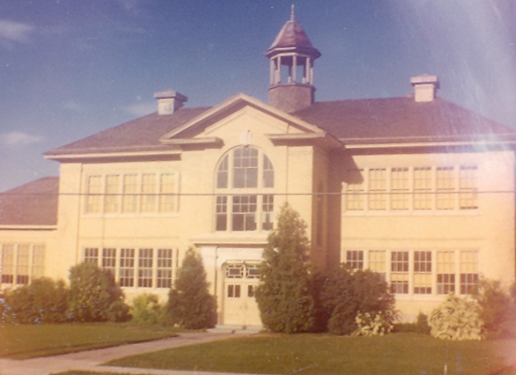The Clarkston School
Gordon started school in 1924 when he was six years old. His first grade teacher was Gretta Tippets. He thought she was very pretty. Gordon knew how to tell time before he went to school. He had a pocket watch that he carried with him and the other kids were always asking him for the time. He about wore it out by taking it out of his pocket. It was a West Clock pocket watch that cost ninety-eight cents.
One morning in about the first or second grade, one of the bigger kids lifted Gordon up and made him grab a hold of the bell rope and left him hanging. His weight was just enough to keep the bell going around and around and he was going up and down. It was too far to the floor so he was afraid to let go for fear of hurting himself. The bell kept going around and around and up he went again and then down he'd come. The bell rang at the top and on the bottom and a few times in between. As the bell came down it picked up enough speed to go on over again and up he would go again. Everyone in town heard the bell ringing and wondered what in the world was going on. Finally someone came and rescued him.
On April Fool's Day in the fourth grade a bunch of kids (Gordon included) got in the school house before any one else was there and took the door knob off the door in one of the upstairs rooms. In its place they put a bolt with a big washer on it. To the bolt they tied one end of a rope. With the other end of the rope they tied several desks together. With the use of another rope they climbed out the window to the ground. When the teacher went to her class room, she couldn't get in because there was no door knob. Nor could she pull it open because it was tied to all the desks. Finally, they had to get someone with a ladder to climb through the window to untie the rope.
Gordon liked school and got pretty good grades. He got into enough trouble for two kids too. They had an teacher by the name of Miss Sarah Heggie. One day in class Gordon was acting up so Miss Heggie bent a geography book over his head. If the class didn't study, or got caught goofing around, she would keep them after school and make them run around the room until they couldn't run anymore. Then when they got home from school they would get in trouble with their dads for being late and not having their chores done.
One day she had about twenty-five kids running around the room after school. Golden Buttars (Gover's cousin) burst into the room and told all those kids to get home to their chores. Then he proceeded to set Miss Heggie strait. Never again did she make anyone run around the class room after school.
Gordon's fourth grade teacher was Miss Smith. In the same class was his cousin, Ira Jardine. (With all these cousins, you have probably figured out that he was related to about half of Clarkston.) One day in class, Miss Smith did something to one of them, the other one got mad too, so they try to fight her.
His fifth grade teacher was quite a change from Miss Heggie or Hiss Smith. She was a middle-aged woman from Virginia. She was about his favorite teacher, but he can't remember her name. She couldn't sing but she had to teach music and singing. She taught them songs like, "Way Down Yonder in the Cotton Field", and her favorite, “Carry Me Back To Old Virginny." Since she couldn't sing at all, the kids would laugh at her. She had quite a chore teaching the kids how to sing.
In the late 1920's, Gover bought the family's first radio. Being so close to the mountains the reception was very poor. They had to huddle close around the radio to hear Amos and Andy, and other programs.
After being married for almost six years, Gover and Aunt Mary had their first child. On February 18, 1928, Gordon's half brother Nolan was born. Something went wrong in the delivery that caused him to be stillborn. Nolan never took a breath of this life. Then on January 30, 1929 William Ralph was born. Soon after Ralph was born, Gover moved his family to Burley, Idaho, where he had bought a sixty acre farm with a good sized house. Moving away from Clarkston was hard for Gordon. This move changed the course of the rest of his life.

Chapter 3

BURLEY

The winter of 1928 and 1929 dumped deep blankets of snow on the Intermountain West. There was so much snow that they had to bring most of their belongings up on the train and leave the car in Clarkston. At the time Ervin and Milton had the chicken pox so they stayed with Grandmother Buttars. Gover, Aunt Mary, Gordon, and Ralph, who was just a tiny baby, came up on the train with ten head of milk cows, their horses, and equipment. Gover's cousin, John Buttars, brought their household belongings up on his truck. Since Ervin and Milton stayed in Clarkston until spring, Gordon was the only one to help milk the cows and feed the horses and put them in the barn at night.
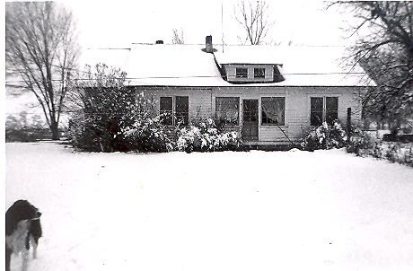The Buttars home in Burley
Burley was founded in 1905 when the town site was platted on the south bank of the Snake River as it bends around the north side of town. In 1904 work had begun on the Minidoka Dam. When completed in 1909, it provided irrigation water for more than a million acres of farm land in Cassia and Minidoka Counties. The hydro-electric power plant supplied the area with electricity. Burley was incorporated on July 19, 1909. It was named after David E. Burley, an Oregon Short Line Railroad Company passenger agent. In 1929 the population of Burley was about 3,900, not counting the outlying rural areas.
Gordon started school in Burley during the middle of the fifth grade at the old Miller School. He rode Old Topps to school in the morning after his chores were finished. When he got to school, he'd turn Old Topps loose and she would come home by herself. After school, Gover would usually pick him up, once in a while he would walk home. Gordon didn't like school in Burley. It was almost like another world compared to Clarkston. It seemed like there were more kids in his class than there were in all of Clarkston. He hated being around all those city kids, they were a lot different than him.
The change was so drastic, he soon became disinterested in school and in going to church. Several months after moving to Burley, Gordon was ordained a Deacon in the Aaronic Priesthood. Over the next three or four years the entire family, except for Aunt Mary, completely dropped out of activity in the Church.
He was homesick. All of his friends and cousins, his aunts uncles and his grandmothers were all back in Clarkston. Moving to Burley meant leaving all of his support structure behind. He felt all a lone. Not long after moving to Burley, he wrote a letter to his fifth grade class in Clarkston. He signed it, "Your lonesome school boy." The teacher read the letter to his former classmates in her tearful, southern accent.
Another thing that made things seem different, the absence of Ervin, Milton, and Swede. Gover told Gordon that they couldn't bring Swede with them. In spring when the snow was gone, Gover rode the train to Utah to get the car and Ervin and Milton. He was gone a few days longer than it should have taken because he was getting shots for Swede so he could come across the state line. He knew all along he was going to bring Swede to Burley. He was almost as attached to the dog as was Gordon. Not long after moving to Burley, one of the neighbors poisoned Swede for no apparent reason. He wasn't mean or didn't run the neighborhood. Whatever the reason, Swede was dead.
October 29, 1929 was a day that drastically affected every living American for most of the decade of the 30's. "Black Thursday," it was called. The day the stock market crashed, and the beginning of the Great Depression. Money was tight and times were tough. The Buttars ate as good as we do today. They raised a big garden and canned their harvest. They would kill a calf or a lamb and bottle the meat or cured it in salt brine. Money was tight for everyone, but farm families seemed to live through it better. Gordon wore old clothes with patches, but at least they ate from their own table, rather than from a soup kitchen. And the family had work, unlike so many. Gordon remembered getting a new pair of shoes at J. C. Penny's for $1.25.
On the 15th of January 1931, Orvin Allen was born. Three years later, Gover's seventh and last son, Dean, was born on April 19, 1934. Like his older brother Nolan, Dean never took a breath of this life. Nolan and Dean are both buried in Clarkston cemetery. Gordon was very close to Ervin and Milton, but Ralph and Orvin were so much younger than him, ten and a half and twelve and a half years respectively.
Life in Burley was a lot like Clarkston in one way. They still pulled their pranks, only now Milton was old enough to help. Gover had a hired man named Charlie Walker. Once Gover and Aunt Mary went to Utah, but before leaving, he told Charlie not to let the boys out of his sight. The first chance they got, they snuck off while Charlie was tending the water. Out in the barn they harnessed up a milk cow with the intention of riding her. By then, Charlie missed them and went looking for them. Just as he got up to the barn door, Milton opened it. With Gordon on her back, the cow ran out the door, over the top of Charlie, through the fence, around the yard, and taring up the flowers and garden. At some point, Gordon was thrown off. They eventually caught he cow and got her back in the barn.
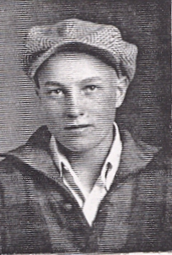Gordon
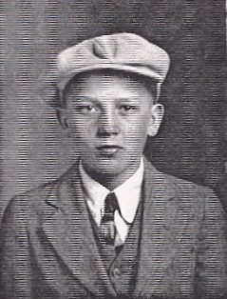Milton
Another time, Gordon and Milton got two cats and tied their tails together with a piece of string. Milton opened the stanchion and Gordon dropped the cats onto the cows back. Away the cow ran, trying to shake the cats off her back, tearing down the fences as she went. Poor old Charlie spent more time fixing fences than doing anything else. Gover made the boys help Charlie put things back in order. Gover watched them straighten things up with a twinkle in his eye, remembering doing the same things as a kid.
For Gordon, school had become a drudgery. In the fall of 1934 he started the tenth grade. He was so tired of school, he did not want to go. Back then school would let out in the early fall for what was called spud vacation, so the kids could help pick potatoes. In those days the potatoes were dug one row at a time. Rather than being loaded directly into a truck, they were dumped on the ground. That is where the kids came in, they followed behind the digger picking them up and putting them into a burlap sack. Once the sack was full, they left it for someone else to load it onto a wagon or truck. It was a very laborious job and no vacation! But to Gordon, it beat going to school.
On the first day of school after spud vacation, Gordon dreaded going back and his father knew it. As he was standing by the road waiting for the bus, Gover called him into the house and told him to change his clothes. Gover's plan to get him to go back to school was to work him so hard that he'd welcome going back and finishing school. He and Uncle Iraw (Gover's brother, who moved to Burley a few years earlier) had bought a band of sheep that fall. They gave Gordon a dog and put him to work herding sheep. The thing they didn't realize was that the dog had been trained by a Basque sheepherder.
Gordon wasn't very far from the house when he sent the dog out to round up the sheep and get them headed down the road. There was a big drain ditch full of water and the dog got the sheep heading right for it. Gordon couldn't call off the dog because he hadn't been trained to understand English. He threw rocks and everything at it, but the damage had been done. Over one hundred head of sheep had drowned.
Gordon went back to the house to tell his dad what had happened. Gover was about ready to slit the poor kid's throat. Uncle Iraw was ready to help him. As they looked over the damage, Iraw realized what had happened. He told Gover that it wasn't Gordon's fault. The dog couldn't understand him. After that, Iraw never let a Basquo train a sheepdog.
Gordon spent the rest of that fall herding sheep around the area on different farms. After he was through with the sheep, he still didn't want to go back to school. Gover had more work for him to do. That winter he had bought forty head of cows and put Gordon to work feeding them and hauling hay for the cows, and there were spuds to cull as well. He liked working better than going to school. Needless to say, he never went back.
By not going to school, Gordon didn't know much of what the rest of the kids his age were doing. Besides if he did, he was probably too busy to run around with them anyway. Every Saturday night there was a dance at the Y-Dell. Every once in a while, one of the Big Bands like Glenn Miller or Lawrence Welk would come to town. If not dancing, there was the Burley Theater and the movies. Other than that, there wasn't much entertainment for the young people so they had to make their own.
Gordon and Milton had a 1929 Chevrolet Model A they called Old Molly that they ran around in. The two of them were like best friends and ran around together. They even double dated together. Gordon felt bashful and backwards, so he did not go to very many of the dances. He did, however, take girls out. There used to be a lot of pretty girls over in Paul. He could only afford a date about once or twice a month. Fifty cents for gas at nineteen cents a gallon, fifty cents for the show or a dance ticket, and how much ever the beer cost.
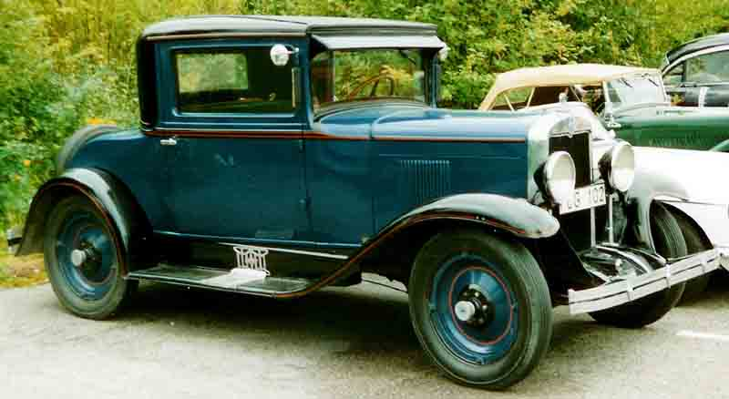A 1929 Chevrolet Model A similar to Old Molly
In the spring of 1935, just before turning seventeen, Gordon wasn't getting along with his stepmother. He wasn't very happy at all. He had dropped out of school and quit going to church, although he was ordained a Teacher on March 19, 1935 by James D. Hoggan. The same thought that goes through the minds of many unhappy teenagers went through his too. “Run away from home.” He didn't know where he was going, except running away. Not telling anyone what he was doing, he bought a bus ticket to Pocatello. He didn't like it there so he got back on the bus and went to Blackfoot. That wasn't the place either and he finally ended up in Idaho Falls. Gordon was standing around in a pool hall where a lot of bums hung out. A man by the name of Ben Moore came in asking if anyone wanted a job. Gordon spoke up. Ben asked him how old he was. "Seventeen," was the answer.
Mr. Moore replied, "You don't look it to me." He took Gordon home with him and put him to shoveling spuds. Finding out he knew something about potatoes, Mr. Moore put him to work sorting potatoes. During that first day, Ben found him to be a good worker and took a liking to him. He told his wife, "I'm not taking that kid back to town." Ben took the rest of the help back to town and left Gordon to help his wife milk the cows. They were so impressed with him because he was such a hard worker for a young man seventeen years old, that they hired him and let him stay in their home. He worked for them for about a month.
After that he went to work for Ben's brother–in–law for the rest of the summer. He worked with a man who was an epileptic. One night at supper this man had a seizure in the kitchen door. Gordon was alone with him at the time and it scared him to death. The only way out was through the door and over the top of the poor man. He ran and hid himself in the barn. By then the man came out of his seizure and staggered out of the house into the yard. Gordon, peeking through the cracks, saw him coming and ran out the back of the barn. He was afraid of him because he thought he was crazy, not understanding the man's condition. Gordon told the boss, "I'm not going to stay around someone like that. He's crazy! I'm going to quit." Rather than loose a good worker like Gordon, Mr. Sleppy (the boss) took the other man back to town.
Gordon wrote a letter to Ervin telling him where he was, and he came to see him. Later, his folks found out where he was and wanted him to come home. Gover was sick and they needed him. So Gordon reluctantly decided to go home.
That fall (1935) he met Lola Dayley. She was a couple of years younger than Gordon. He met Lola through her sister, who he had gone to school with. They went together for nearly two years. Milton dated Lola's friend and for about a year and a half the four of them ran around together. In the meantime Ervin married Illa Haden on May 28, 1936.
After going together for a couple years, Gordon and Lola decided to get married. Part of the reason for their decision was that they were both tired of living at home. On September 1, 1937 they were married in American Falls. He was nineteen and she was seventeen. They made their home in Burley and Gordon started farming.
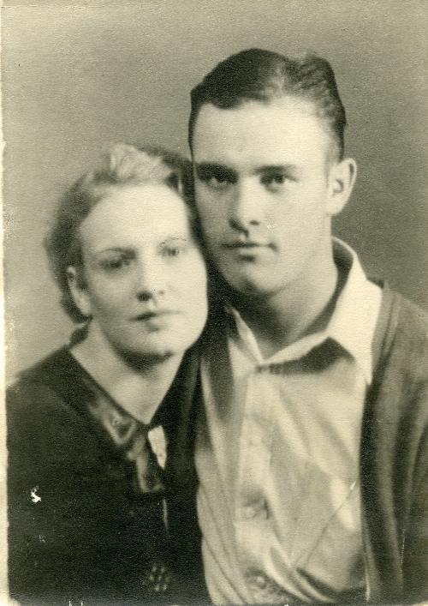Illa and Ervin
Shortly after their marriage, tragedy struck. One night Ervin and Milton went over to Paul to get Illa. At the time there were no street lights except right in town and North Overland was dark. Where the railroad crossed the highway, there were no signals. As Ervin approached the tracks he couldn't see anything until his head lights illuminated the passing railroad cars. By then it was too late. Rather than hitting the train broadside, he turned down the tracks. Regardless of his efforts to get out of the way, he still hit the train. Milton was thrown free, unhurt. But Ervin was caught in the wreckage. His legs were badly mangled, but he was still alive. Due to improper medical care, gangrene set in and two days later Ervin died on February 7, 1938, leaving a wife of less than two years and Lynn, their infant son. Had he lived, Ervin would have been crippled for the rest of his life. They had a funeral for him in Burley as well as in Clarkston where he was buried near his half brothers and his mother. Ervin's loss was felt hard by all the family.
In 1938 Gordon had rented eighty acres from Jack Simplot across the road and over the canal from his dad's place. Along with running his place, he helped his dad. However Gover wasn't much help to him in getting started. After he got his crops harvested, he wasn't able to keep going on his own.
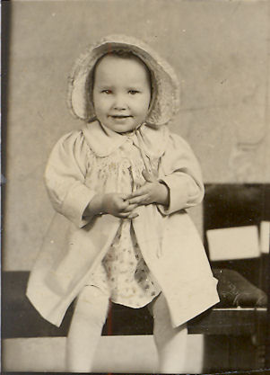Joyce
About that time Lola had a baby girl on September the 18, 1938. They named her Joyce Thelma. The happiness of the event was marred by the fact that he lost the farm. Having no other choice Gordon went to work for his father and different neighbors. He walked to and from work and earned a dollar a day.
To make natters worse, he and Lola weren't getting along. They were to young to start with, and their financial bind contributed to the conflict. After a while they were separated in 1940 and Gordon went back to Idaho Falls to find work. Not finding any, he came back to Burley. After being separated for about a year, Gordon and Lola were divorced in July of 1941. Lola soon remarried and left town. Gordon didn't see his daughter again until several years later.
Milton had gone back to Clarkston where he married Annabelle Loosle on January 21, 1941, Before they had been married a year, Annabelle died in childbirth. The baby died too.
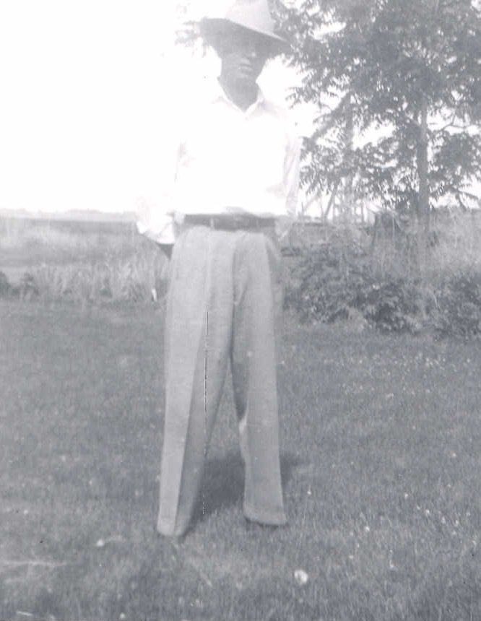Gordon in 1941
Gordon was tired of the troubles and problems, and finding work was hard. The draft had started due to the mounting world situation with the war in Europe and mounting tensions with Japan. He had heard army stories of World War I and knew that wasn't for him. Rather than being drafted, he enlisted in the United States Navy on September 18, 1941.

Chapter 4

SEAMAN

Upon enlisting in the Navy, Gover and Aunt Mary presented Gordon with a gold ring with GGB engraved on the front. Inside it had the inscription “1941”. They also gave him a Swiss watch that was also engraved with “1941”.
A few days later, he rode the train to San Diego for Basic Training. On the train he met a girl from Smithfield, Utah, who was on her way home to Los Angeles. She knew a lot of his cousins and people he knew. Smithfield is just a few miles from Clarkston. She told him if he ever got in Los Angeles to look her up and gave him her address. He never did anything about it.
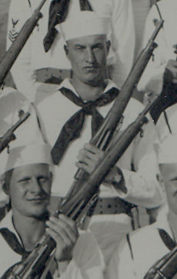Gordon in boot camp. Cropped from the picture of his company, below.
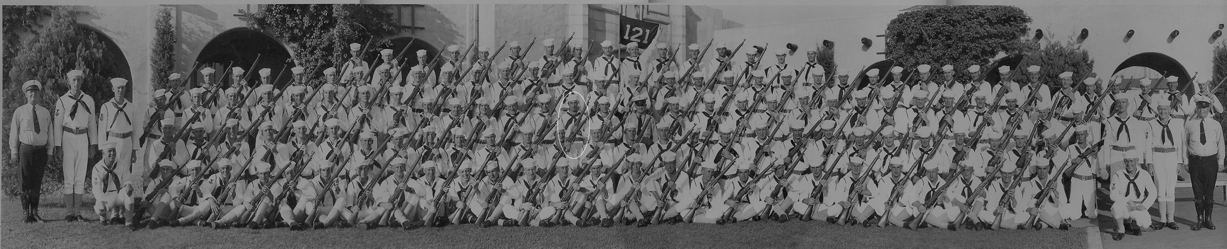
Boot camp was an ordeal that he hated. He had it in his mind to join the Navy and ride a ship so he wouldn't have to walk. In boot camp they marched everywhere. In October, Gordon got word that Milton's wife, Annabel, had died in childbirth. He asked the chief if it would be possible for him to take leave and go to her funeral. The Chief told him that it was possible but if he did, he would have to finish up in the next company. He didn't recommend it, so Gordon stayed.
One day long about October the company was goofing up and not doing things right. The Chief pulled them over into the shade and gave them a talk. He told them, "You think you're here just to have fun! Well, you're all going out in the Pacific and fight Japs." Boot Camp lasted six weeks and was not worth remembering.
After Boot Camp, he came home on a leave for nine days before going back to San Diego. His company was assigned to report aboard the three aircraft carriers in the Pacific Fleet. The three carriers were the Lexington, Saratoga, and Enterprise. There were sixty men, twenty for each ship. They each got to sign up for the ship they wanted. Gordon and his buddy, Martinez, sat on the running board of a car until everyone else was done and took what was left. They wanted to be on the same ship and didn't realize that one could end up on different ships. When they went to sign up, there were two places left for the USS Enterprise.
From North Island, he departed for Pearl Harbor in the Hawaiian Islands where he was to go aboard the Enterprise. When he wrote home to tell his family, he did not even know how to spell Enterprise, (he spelled with it an I) let alone know what an aircraft carrier was. It took nine days to go from San Diego to Pearl Harbor aboard an old troop ship, the USS Henderson. He got there on December 4th. In three days, his life and the whole world would never be the same again.
In Pearl Harbor, so many miles from home, Gordon ran into Louis Jones from Burley. He was stationed aboard the USS Oglala. They decided they would get together on Sunday when Louie was off duty and the two of them would spend the day together. Until the Enterprise returned from sea, Gordon stayed at the Receiving Ship, a barracks for peronnel in transit.
Sunday he had plans of seeing Honolulu and the rest of the island first hand. He left the Receiving Ship early enough to get a good start. As he left, Gordon paused a moment to salute the flag. The time was 7:55 am, Sunday December 7, 1941. The sky was filled with aircraft from the airfields around the island . . . NO! . . . They were Jap dive bombers and torpedo planes. In an instant, Pearl Harbor became a mass of confusion, explosions, fire, smoke and destruction.
Not knowing what else to do, Gordon ran down to 1010 dock where he was to meet Louie. He got there just as the Oglala rolled over. He found Louie on the dock with a 30 caliber machine gun mounted on a tripod next to a little building. Louie immediately put Gordon to work loading the machine gun as he fired at the unannounced enemy.
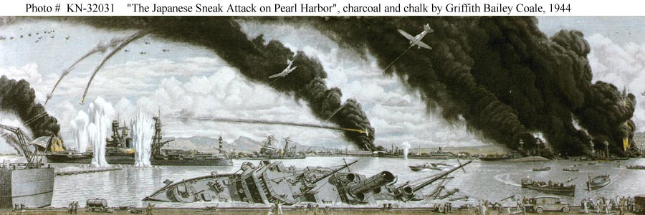This is a paining of the attack as seen from 1010 Dock. In the foreground is the Ogala rolling over with Battleship row in the background.
Eventually, someone came and got Louie because they needed him elsewhere. Gordon was left alone to load and fire the gun himself. There was a Zero (Jap fighter plane) circling overhead nearby. Gordon opened fire on it but about all he did was to annoy the enemy pilot. What a target, an unexperienced farm boy behind a 30 caliber machine gun, and down he came strafing all the way. When he was close enough to see the pilot's face, Gordon decided it was time to leave. Down the dock he ran with bullets ripping the concrete at his heels. The plane passed overhead and into the sky already crowded with planes and smoke.
With the Zero off his back, he kept running down the dock passed the USS Helena. A pickup full of marines picked him up. Where they were going didn't matter, there was no place to go. Another Zero dove out of the sky strafing the pickup. Gordon and the marines all scrambled at once to the bottom of the pickup for cover. Somewhere along the way, they let him off and he ended up out in the harbor on a tug boat fighting fires on the battleships.
At one point, he saw someone climbing a ladder on one of the huge oil storage takes. A nearby Marine raised his rifle and shot the man. Saboteurs had been a major concern prior to the attack. Whatever the reason he was climbing the tank, the Marine wasn't taking any chances.
From Sunday morning until Monday night became one day without any recollection of what he had done. He found himself in a chow line back at the Receiving Ship when someone from his group spotted him. The Enterprise had come in Monday night after dark. He just had time to get his gear and go aboard. He was still wearing his white uniform and was a real mess from the smoke and sweat. At this point, Gordon's story and the story of the Big E become one in the same.
He went aboard about ten o'clock that night. Gordon remembers walking up the gangway with his sea bag over his shoulder. Once aboard they put the twenty new "boots" in a safe place out of the way on the hanger deck while the ship took on fuel and provisions. The next morning while still dark, the Enterprise got under way. Gordon could feel the ship moving and walked over to the edge of the ship to watch what was going on. He could see the little tugboats pulling the ship away from the dock. "Oh my God. It must be helpless if it has to be pulled around by little boats."
As it got lighter, he looked around and got a worse impression. The size was more than he could imagine. The Enterprise was 824 feet long and 114 feet wide and weighed 20,000 tons. When he looked around and saw all that iron, he knew he was in trouble. Back home, if you through a piece of iron in the ditch, it would sink!
Meanwhile back in Burley, his folks heard the announcement of the attack on Pearl Harbor. Knowing their son was there, they anxiously awaited word from him telling them he was alright. Instead, they got a telegram from the Department of Naval Personnel stating that Gordon was missing in action. The loss of Ervin was still fresh in their memories, now the fate of Gordon was uncertain. Since he hadn't mustered in when he returned to the Receiving Ship before reporting aboard the Enterprise, no one knew where he was.
He had breakfast Sunday morning before the attack, and didn't eat again until Tuesday morning at sea. By then he wasn't even hungry. Upon reporting aboard he was assigned to the deck division. In charge was Chief Boatswain's Mate Holdebe. Before his records caught up with him, he wasn't getting paid, and didn't have any money. After a couple days at sea, Holdebe asked him, "Why don't you clean up'?"
Gordon's reply was, "I don't have anything to clean up with."
"Aren't you getting paid?" he was asked.
"No," he answered. "I guess my records aren't aboard yet." So, Holdebe gave him some money until he got paid.
Gordon was assigned a bunk in the crew quarters below decks. Having witnessed first hand what a torpedo can do to a ship, he didn't want to be down there on the waterline and have one hit the ship. He wanted to be where he could get off. So he found an army cot and some lockers up on the hanger deck (or the main deck) near his battle station and that was where he bunked.
It wasn't long before he found out how "all that iron" could maneuver. During the week that followed Pearl Harbor, the Enterprise patrolled the waters around Oahu searching for enemy submarines. There were plenty of sightings, and dive bombers from Enterprise sunk one on the 10th. The first Japanese ship to be sunk during the war.
There were plenty of false submarine sightings as well. Gordon's battle station was on the five inch antiaircraft guns. One of these false sightings was a whale that surfaced right close to the ship and to some scared sailors it looked like a submarine surfacing. They opened fire with the five inch guns, getting a direct hit on the unsuspecting whale. A destroyer could see what was going on and began signaling to call attention to the fact that it was only a whale. The ensign over the gun crew was going to put them on report for opening fire without orders. When Admiral Halsey heard about it, he dismissed the charge by stating, "We'll shoot first and ask questions and figure out what we did later."
Gordon learned how to preform all the duties pertaining to the operation of the five inch guns. It took a crew of several men for each gun. The five inchers were arranged around the ship in groups of two. They were located fore and aft on both sides. The ship had eight of these big antiaircraft guns along with sixteen 1.1 inch antiaircraft guns in four mounts, two forward and two aft of the island structure. There were also twenty-four .50 caliber machine guns arranged in batteries along both sides of the flight deck.
To operate the five inch guns, It took a man to turn the cranks that elevated and rotated the barrel. One to load the powder shell, one to set the fuse on the projectile, another to load it into the gun. Then the gun captain "rammed it home" and fired the gun. A man with asbestos gloves caught the empty powder can as it was ejected from the barrel after it was fired. There was also a man who was in communication with sky control in the island structure, who told the gun crew where to aim and fire. The five inchers had a range of thirteen miles.
The main battery on an aircraft carrier was its air group. The Enterprise carried between eighty and ninety planes. There was a fighter squadron consisting of two or three dozen fighters. They were the first line of defense in defending the ship and the task force against enemy air attack. There were always several in the air on combat air patrol. They also accompanied the bombers and torpedo planes on missions.
The Enterprise carried two squadrons of dive bombers, one was designated as a scouting squadron. These planes carried either a five hundred our a one thousand pound bomb under their belly. Behind the pilot sat the rear seat gunner with a thirty caliber machine gun. The remaining squadron consisted of between fifteen and eighteen torpedo bombers capable of carrying either a torpedo or two bombs.
With the war in the forefront of everyone's consciousness, everyone was uncertain of their futures and the prospects of facing battle. The twenty new boots had something the seasoned veterans did not have, battle experience. They were often asked what it was like. In the months to come, they would all find out.
The Enterprise returned to Pearl Harbor on the 17th. At that time Gordon's records caught up with him. Even though his records were brought aboard, it was about six weeks from the time he went aboard until he got paid twenty-one dollars a month for his wages. His family then got another telegram from the Navy, this one stating that Gordon was alive and well.
The ship was only in Pearl Harbor for a couple of days before heading back to sea to patrol the area west of Oahu and provide support to the failed attempt to relieve the Marines on Wake Island. By the time they returned to Pearl Harbor on the last day of the year, Gordon pretty much had his sea legs under him. Now that the Navy was operating under wartime conditions, the carriers didn't stay in port very long. Of the three carriers, only one was in port at a time in case the Japs returned for another attack. The Enterprise and her escorts departed again on the 3rd of January so the Lexington could come in. The Big E spent the next four days conducting training exercises north of Oahu.
While in port, the crew was granted shore leave. During these times Gordon finally got to look around Honolulu and parts of the island. Waikiki Beach had lost it's peacetime appeal as it had barbed wire strung along the otherwise beautiful sandy beach. The sun bathers had been joined by soldiers on patrol.
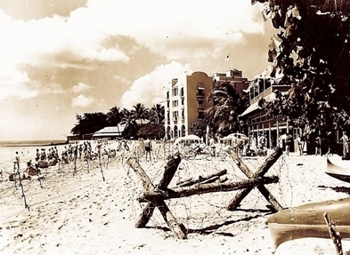The Royal Hawaiian Hotel and Waikiki Beach behind barbed wire
After another brief stay, the Enterprise put to sea on the 11th of January, surrounded by the screening vessels, and set course for the South Pacific to provide cover for the reinforcement of Samoa. That same day, the US carrier force was reduced by one as the Saratoga had been torpedoed off Oahu. She would be out of commission for the next six months while being repaired on the west coast.
Four days after leaving Pearl Harbor, the Enterprise and her task force crossed the equator. Traditionally when a ship crossed the equator, an elaborate celebration was held by the shell backs to initiate the polliwogs who had not yet crossed the line. Because the task force was on heightened alert, the ceremonies were canceled. On the 18th Gordon was promoted to Seaman 2nd Class. A few days later, the Enterprise rendezvoused with another carrier task force centered around the Yorktown, which had just came from the Atlantic. Together they patrolled the area around Samoa as the Marines went ashore.
With Samoa secured, the Enterprise and Yorktown were ordered to carry out the first strikes against the enemy in the Marshall and Gilbert Islands. As they sailed northwest, they recrossed the equator as well as the International Date Line. The two groups separated and took up their positions.
On February 1, 1942 the Enterprise air group attacked the Japanese held islands of Wotje, Roi, and Kwajalein in the Marshall Islands. The strategy was to go in and attack and retreat and attack another island and retreat again, thus keeping the Japs guessing as to the American's strength and position. During the raid the Enterprise was in range of attack by Jap land based bombers. Later in the day a formation of twin engine bombers attacked the Enterprise and her escorts.
Gordon was the first shellman on the gun crew, the one who loads the shell. The process was for the first shellman to touch the first powderman once the shell was loaded. He would in turn touch the gun captain and he would then fire the gun. Evidently, someone must have bumped the gun captain. The gun captain began to "ram it home" before Gordon had his arm out of the way. When Gordon felt the powder rammer bump his arm, he hurried and jerked it out of the way before his arm ended up in the barrel or even worse, out the other end. He could have been seriously hurt.
Gordon filled about every position in the gun crew. They rotated around so everyone knew everything about the gun mount. During one of these early engagements, the ensign who was the gun captain got scared and panicked. An experienced 2nd class bosun's mate took his head phones and told him to sit in the corner out of the way. As the firing continued he told the ensign to get up and help pass ammunition. Later the ensign thanked his much wiser subordinate.
Of the fifteen bombs dropped, all missed the ship, but one went off in the water only thirty feet away which started a small fire and caused minor damage. The last bomber in the formation had been hit and fell out of formation in an attempt to crash dive into the Enterprise. All guns in the task force fired on the plane as it kept coming. The captain ordered a sharp turn to avoid being hit but the desperate pilot maneuvered to keep the fast moving ship before him. At the last minute, one wing of the bomber sliced through a dive bomber parked on the flight deck as it continued on its way and crashed into the sea. Seconds later it sank as the ship passed the wreckage. With her mission completed, the Enterprise return to Pearl Harbor on February 6th.
After a week in port, the Enterprise set out once more on the 14th with orders to attack the enemy on Wake Island on the 24th. With that accomplished, Admiral Halsey received orders to take his ships deep into Jap waters to attack Marcus just a thousand miles east of Tokyo on the 4th of March. The raids on Wake and Marcus were carried out without counter attacks from the enemy. All the while, the ships were at full alert and Gordon was at his battle station almost continually. With the mission accomplished, they returned to Pearl Harbor on the10th.
On this stop over at Pearl Harbor, Charles "Tommy" Tomilson came aboard and was also assigned to the deck division. He and Gordon became close friends. While in port, the ship took on provisions for its next mission. At this time, the Enterprise got a fresh coat of dark sea blue paint. Being part of the deck division, Gordon no doubt got in on the paint job. The .50 caliber machine guns were replaced by thirty six of the more capable 20 millimeter anti-aircraft guns.
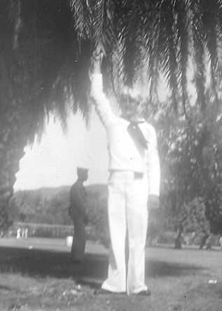Gordon on shore leave
Reprovisioned, repainted, rearmed, and well rested after four weeks in port, the Enterprise with two cruisers, four destroyers, and a tanker set sail on April 8th on a secret mission. For four days they steamed northeast into the stormy North Pacific. As the task force went north, it became very cold. It wasn't very comfortable sleeping in his improvised quarters so he moved back down below for the duration of the cruise. Hearing the water sloshing against the hull was unsettling. His fear of torpedoes didn't make it any better, but at least it was warm.
As the ship continued north, fog, clouds and rain shrouded the task force. It was so cold that the men dressed in foul weather clothing to stand watch. If there had have been anything out there they wouldn't have been able to see it for the fog. One day while standing watch, as he gazed out into the gray his thoughts turned to home. His daydreaming was interrupted when Ensign Crocker came along. He asked Gordon “What are you looking at, Buttars?”
Gordon figured a dumb question deserved a smart answer. So he replied, “Mermaids!”
On the morning of the 12th, another small task force was spotted coming over the horizon. Soon the Enterprise was joined by the Hornet, two more cruisers, four destroyers, and another tanker all of which had just came from the Atlantic. Gordon and his shipmates marveled at the sight of the sixteen twin engine Army B-25 bombers aboard the Hornet. They weren't capable of operating from an aircraft carrier. The scuttlebutt aboard the ship was that there mission must be to deliver the army planes somewhere in the Aleutians.
With the two task forces joined as one, they headed straight west. Day after day they came closer and closer to Japan. Watching their compasses and the speed of the ships, they decided that if they didn't change course soon, they would be unloading them in Tokyo Bay. How right they were! The skipper announced that they were to deliver Colonel James Doolittle and the sixteen B-25s to within five hundred miles from Japan for a raid on Tokyo. At the word, Gordon cheered along with the thousands of other sailors on the sixteen ships.
Three days from Tokyo, the tankers refueled the carriers and cruisers. The destroyers and the tanker fell behind and the task force plunged deeper and deeper into Jap water until the morning of April 18, 1942. The wind was blowing right out of Tokyo. As the two carriers headed into the wind, and Tokyo, the Enterprise launched her planes first to provide air cover over the task force. Air cover was always a necessity in the war zone. After the combat air patrol was established by the fighters and the dive bombers were on patrol, the Hornet began launching the B-25s, which were never designed for carrier operations.
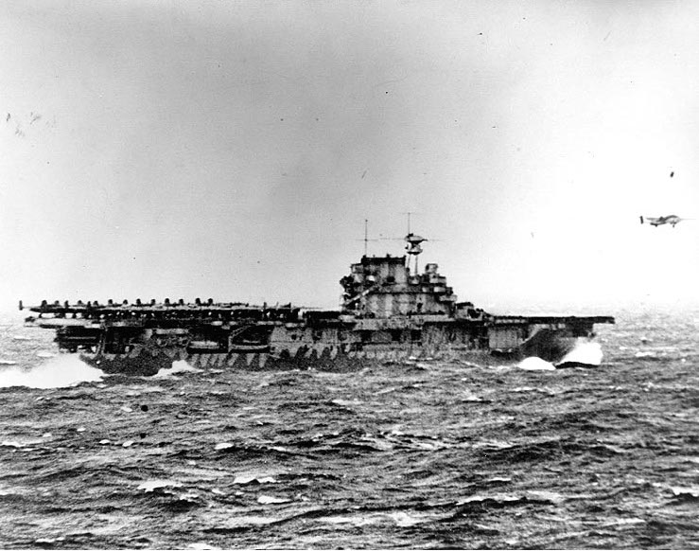B-25 Taking off from the Hornet
Gordon watched from the port forward five inch gun battery as one by one the B-25s lifted off the Hornet's flight deck. It seemed as though it took forever to get them all airborne. Every minute brought them closer to Tokyo, and certain death if they were discovered. As soon as the last bomber left the deck, the Hornet brought her air group up from the hanger deck and began launching her planes to add to the air cover. The small task force turned around and got out of there as fast as they went in. The term was “Haul out with Halsey.” A couple days later they rejoined the waiting destroyers on there way back to Pearl Harbor.
The Japanese homeland had been dealt it's first blow of the war. The damage was slight but the boost to American morale was tremendous. When the ships returned to Pearl Harbor on the 25th, they were not permitted to say were they had been as the mission was a well guarded secret. So much in fact, that when asked where the bombers took off from, President Roosevelt responded, “From our secret base in Shangri La,” the fictional place described in the 1933 novel Lost Horizon.
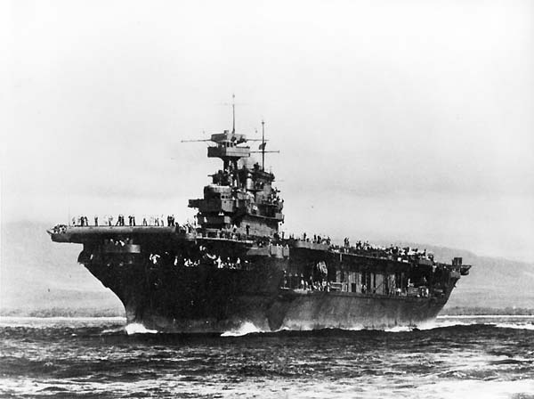The Enterprise - Spring 1942
During the first months of the war, Japan had rapidly expanded their holdings in the Pacific. The United States was strictly on the defensive. All there was between the Japanese and the west coast of the United States were a handful of unmercifully outnumbered ships. Japan was increasing their holdings in the Pacific and Asia. With their eye on cutting off the lifeline to Australia, they planned to mount an invasion of Port Moresby on the southern coast of New Guinea. The Yorktown and Lexington were in position to counter the Japanese moves. The Enterprise and Hornet quickly reprovisioned and on the 30th of April departed Pearl Harbor to join the anticipated battle.
As they rushed south, Gordon crossed equator again on May 5th . Again there was no time to celebrate. While en route, news of the Battle of Coral Sea was received aboard the Enterprise and the other ships of the task force, which were only a day away from the scene of battle. The Lexington had been sunk and the Yorktown was severely damaged. The Japanese had been turned back and were retreating. Coral Sea was the only battle that the Enterprise missed. The Enterprise and Hornet operated in the South Pacific until the 16th when they received orders to return to Pearl Harbor with all haste. After joining up with the Lexington's former escorts, they set course for Pearl Harbor. The return trip was Gordon's fourth crossing of the equator.
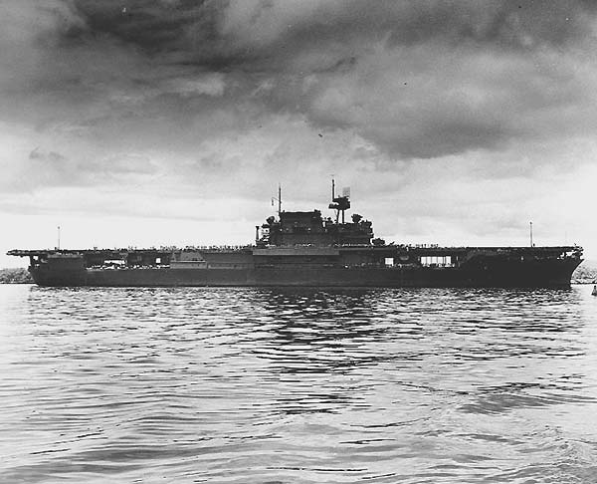The Big E entering Pearl Harbor on May 26, 1942
The quickly expanding Empire of Japan had plans that would bring the Americans to surrender. In June of 1942 they planned a massive strike at Midway Island, about one thousand miles from Pearl Harbor. There plan was to capture Midway and establish a base. From there, their plan was to destroy the remains of the American fleet and capture the Hawaiian Islands. From Pearl Harbor they would have access to the entire west coast of the United States. The only thing to stop them was the Enterprise, Hornet, and the quickly repaired Yorktown.
After returning to Pearl Harbor on the 26th of May, the Enterprise and Hornet went to sea again only two days later on the 28th. The Yorktown was quickly patched up and she sailed two days after that. And stop the Japs they did. On June 4, 1942, four of Japan's finest carriers were sunk in one day. That morning, the Japs launched their first wave against Midway. In the meantime, their carriers were found by US patrol planes, and an attack was launched immediately from the Enterprise, Yorktown, and Hornet. Shortly after the strike was launched, the Japs attacked the Yorktown, leaving her seriously damaged, claiming that it sank.
The torpedo squadrons were the first to attack the Jap carriers . . . or rather to be slaughtered. When the dive bombers attacked, the enemy's carrier decks were loaded with armed and fueled planes ready for an attack on the American carriers. They dove out of the sun on three of the unsuspecting carriers, blowing them out of the water.
Planes from the remaining Jap carrier followed the Yorktown's planes back to the ship. She had put out her fires and was under way again. Claiming that the Yorktown had been sunk, they thought they were attacking the Enterprise. Again, they heavily damaged her and left claiming the Enterprise as sunk. (They first claimed to have sunk the Enterprise at Pearl Harbor when they sunk the old Utah. The Enterprise was supposedly to have been sunk six times earning the title of "The Galloping Ghost.")
From one of the five inch guns on the "Big E" Gordon watched the smoke filled horizon as the Yorktown fought for survival. The Jap planes returned from the torture of the Yorktown and prepared for yet another strike. Again, American dive bombers appeared out of nowhere and set the deck load of fueled and armed planes ablaze and the fourth enemy carrier began sinking.
All there was to do for the vast Japanese armada was to withdraw, with the Enterprise and Hornet in pursuit. The Yorktown once again put out the fires and began to repair the damage while being towed back to Pearl Harbor. Unfortunately she was sunk by torpedoes from a Jap sub three days later. The Enterprise and Hornet never were attacked during the battle, however their air groups contributed greatly to the victory. On the 13th of June the victorious Enterprise sailed into Pearl Harbor. The tide of the war had been turned and the Americans would soon be on the offensive.
The picture at the left was taken of Gordon just after the Battle of Midway. While on liberty in Honolulu he saw a photography studio and decided to go in and have his picture taken. When he went back to sea he had forgotten all about the picture. Nearly a year later while in port again, one of his shipmates walked past the same studio and saw Gordon's portrait in the window. Recognizing his buddy, he went in and got the pictures and took them back to the ship. A copy hung in his Grandmother Buttars' home until her death in 1952. Another copy hung in Gordon's home next to a large photograph of "The Big E”
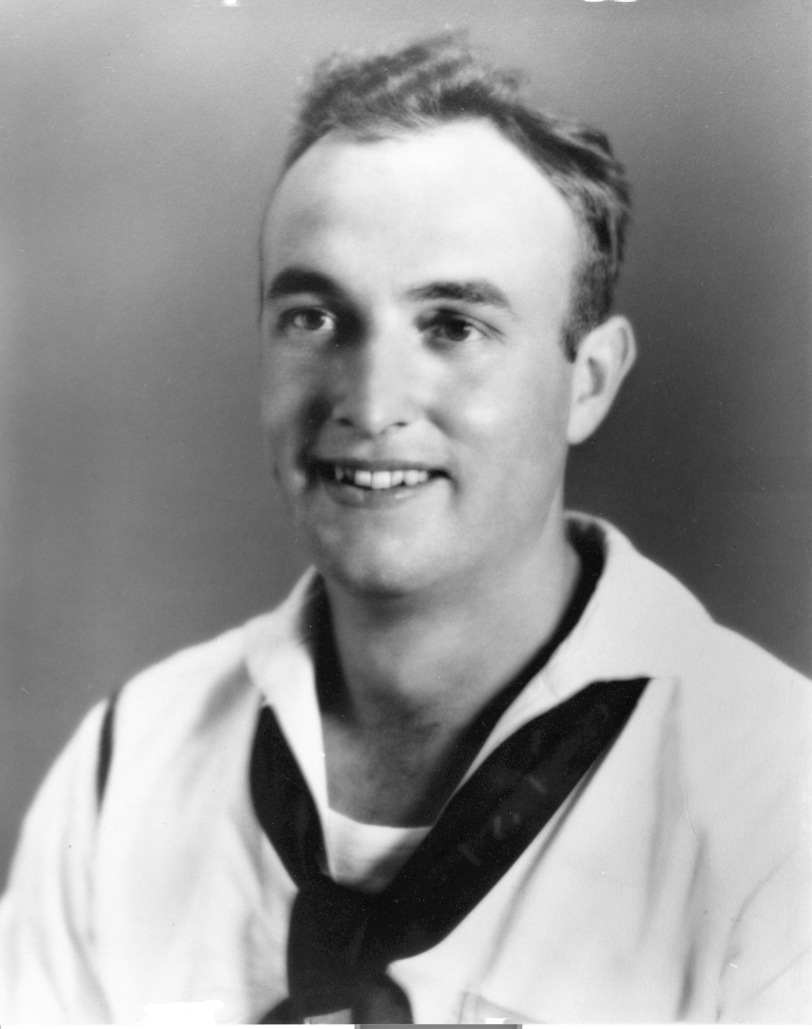Gordon - June 1942
About this time, while on liberty in Honolulu, Gordon got a tattoo on his right arm. It was a woman wearing a red bathing suit setting above the name of the ship. While on liberty, Gordon lived the fast life, which included drinking and women. He wanted to get as much as he could of both before going back to sea. After all he might not be coming back.
On the 15th of July, the Enterprise sailed out of Pearl Harbor. Just out of the channel, she was joined by two cruisers and a brand new battleship as well as the familiar destroyers of the task force. Once again they set course for the South Pacific. The thing that was different about this mission was that this time they were on the offensive. On the 19th Gordon crossed the equator for the fifth time. On the 24th of July the Enterprise dropped anchor at Nufualofa Roads, Tonga for a brief stay. The harbor was crowded with transports and cargo ships loaded with men and supplies for the invasion of Guadalcanal. Later the same day. The Enterprise and the invasion force departed Tonga and joined other elements of the fleet on the 26th. After consolidating forces, Enterprise became part of a larger task force that included the recently repaired Saratoga and the Wasp fresh from the Atlantic.
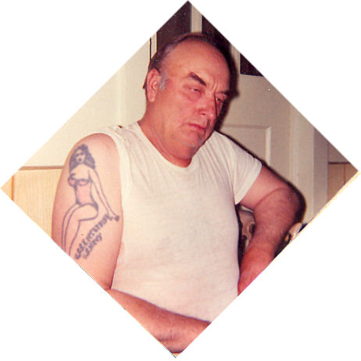 The tattoo. This picture was taken many years after the war.
The sleeping Japanese on Guadalcanal were awaken on August 7th by the shore bombardment from the cruisers and destroyers off shore while planes from the Big E, Wasp, and Saratoga provided air cover during the invasion of Guadalcanal. By then Gordon had been transferred from the five inch guns to the 20 millimeters. His new battle station was Battery Twelve, located along the island structure.
After being caught off guard, the Japs launched a counter strike against the American carriers on August 24, 1942. They found the Enterprise. At 5:14 p.m. Three minutes later the first bomb smashed through the aft elevator and exploded five decks below. The big carrier shuddered at the first blow and the crew was thrown off balance. For an instant the guns went silent while the gunners got back on their feet. Thirty seconds later, the second bomb hit only fifteen feet from the first. The five inch gun deck Gordon had just been transferred from three weeks before was demolished, killing forty-three men. Thick black smoke poured from the listing ship with only three-fourths of her guns still firing.
Two minutes after the first bomb hit, a third bomb blew a ten foot hole in the flight deck putting the Number Two elevator out of order. By 5:17 the attack was over but the battle continued as the crew fought the fires and brought them under control.
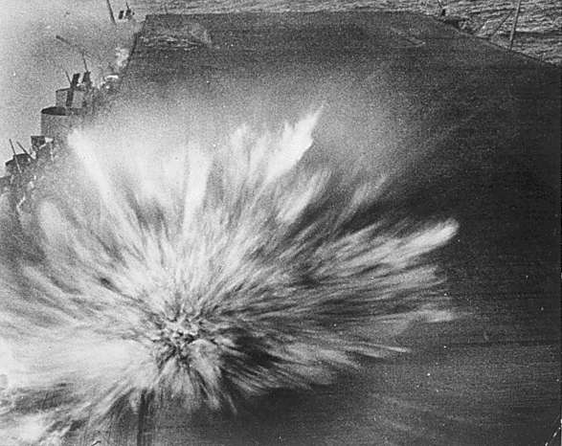Enterprise hit by the third bomb in two minutes, Near the aft end of the deck, smoke can be seen from the first bomb hit, which obliterated a starboard 5" gun mount and its crew.
When the fires were out, the gaping holes in the flight deck were patched up and an hour and a half after the first bomb, the air group began coming aboard. Twenty-five planes had landed before the ship lost steering control. The planes still in the air landed aboard the Saratoga while the steering was being repaired. Without steering control, the ship was a sitting duck as another wave of Jap planes appeared on radar. Fortunately they never found their target.
The battle goes on long after the last of the enemy planes leave. The fires had to be brought under control, the wounded tended to, and the damage patched up as good as can be. Then there the debris to clean up. One time Gordon found a piece of a cog among the debris that he recognized as part of an International mower. It even had “International” stamped into it. He kept it for a while and showed it off. The cod had been packed into the bomb casing to be hurled as shrapnel when the bomb detonated. He figured it must have been in some scrap metal that the Japs bought from the United States before the war.
The Enterprise was so badly damaged that she had to go back to Pearl Harbor for repairs. The Enterprise and Saratoga had stopped a major drive to recapture Guadalcanal. The Enterprise was detached from the area and stopped off in Tonga on August 30th and sailed again on September 3rd. She returned to Pearl Harbor on the 10th. The trip back was Gordon's sixth crossing of the equator.
Shortly after the battle, Gordon received the following citation:
From: The Commanding Officer
To: Buttars, Gordon G. Sea2c. U.S. Navy
Subject: Commendation
1) The commanding officer takes pleasure in commending you for your efficient and untiring performance of duty during and after the action against the enemy off the Solomon Islands on August 24, 1942. As a gunner and loader on 20 MM Battery No. 12, you preformed your duties in a particularly cool and efficient manner, thereby contributing materially to the excellent performance of your battery in shooting down enemy aircraft. This display of courage and zeal, and your exceptional performance of duty during this emergency, is considered to be worthy of special commendation.
2) A copy of this letter will be filed with your service record and suitable notation will be made there in.
A.C. Davis

Chapter 5

STOREKEEPER

During the battle, one of the bombs exploded in a storeroom killing several storekeepers and the ship was in need of replacements. Gordon and Tommy were tired of being in the deck division with all of the work details involved. One work party consisted of carrying a halve beef on their shoulders from the dock to the freezer compartments deep inside the ship. Gordon and Tommy noticed the storekeepers standing on the dock with a pencil and a paper keeping track of the beef that was being brought aboard. Right then they decided that was the kind of job to have.
When the positions came available, they put in their requests, Tommy was accepted for general ship supply and Gordon for aviation supply. In September, Commander Scirka (the supply officer) gave him the rate of Seaman 1st Class. His new assignment was working in the storeroom where the parts for the planes were kept.
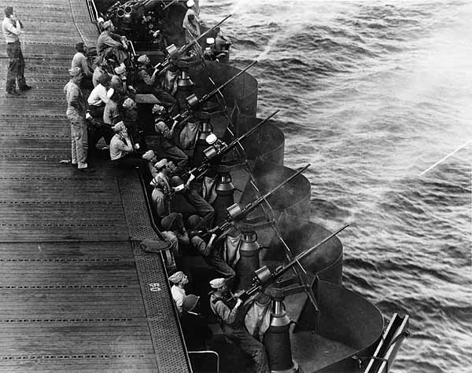The 20 Millimeter anti-aircraft battery Gordon was at during the Battle of Santa Cruz. This picture was taken a few months earlier.
One of the men he worked with in the storeroom was Edwin Stanislawski. Gordon and Ski soon became good friends. He moved his army cot into the storeroom and set it up among the carburetors. There were some lockers nearby and he finally had more suitable quarters. Ski and some of the other storekeepers had already set up house-keeping in that corner of the storeroom.
About the same time, his battle station was moved from Battery Twelve to the 20 millimeters just ahead of the island structure, between the 40 millimeter mounts (which had replaced the 1.1s during the repairs) and the five inchers.
After being overhauled and put back in order, on October 16th the Enterprise went back to sea, and back to Guadalcanal, and back to war. The voyage back to the South Pacific was Gordon's seventh crossing of the equator. In the meantime, the Wasp had been sunk in September and the Saratoga had been torpedoed again and was in the States for repairs for several more months. The only carriers left were the Enterprise and Hornet. On October 26, 1942 the American and Jap navies engaged in yet another sea battle for Guadalcanal. This one near Santa Cruz Island in the Solomon chain.
When General Quarters sounded in preparation for battle, Gordon was the last man out of the storeroom and dogged the hatch behind him. As he slammed it shut, somehow his ring got caught. As soft as gold is, it bent in two tearing it right off his finger. At the time he didn't know it happened.
As the Battle of Santa Cruz began, the Enterprise was hidden in a rain squall. The first wave of Japs unloaded their fury on the Hornet. When they were finished, the Enterprise was the only American aircraft carrier left in the Pacific. By the end of the day, it narrowly escaped not being there either. With the useless and abandoned Hornet adrift, the Japs returned for the Big E.
For the first four minutes, she successfully e-vaded any hits. Then the first bomb ripped through the forward overhang of the flight deck exploding deep in the bow area. In the same minute, a second bomb hit just behind the middle elevator and exploded on the hanger deck. The Jap dive bombers still poured out of the sky. There was one more direct hit that shook the ship and the battle appeared to be over. Five minutes later the Enterprise was attacked by several torpedo bombers from all directions. Due to the maneuverability of the ship, the marksmanship of her gunners, and the fighter pilots who flew from her deck, no hits were scored. Four torpedoes were dropped but the twisting carrier maneuvered to avoid them. Three of them passed on the port side, and one to starboard. Gordon was firing at a plane as it glided down to drop it's torpedo. He saw the torpedo drop into the water and streak toward the ship. Once again, captain ordered a hard turn and the big ship paralleled the track of the torpedo. Gordon watched it speed by just a few yards from the ship.
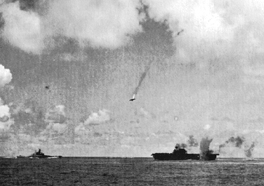Enterprise at the Battle of Santa Cruz
Another time, after dropping it's torpedo, a plane flew right along side of the ship. Gordon could see the rear seat gunner standing up in the open cockpit firing his machine gun at the men at their battle stations along the edge of the flight deck. It was so close that he got a good look at his face. It zipped by so close and so fast that they weren't able to train their guns on it. The torpedo was dropped so close to the ship that it didn't have time to arm, so it didn't go off when it hit just aft of the bow.
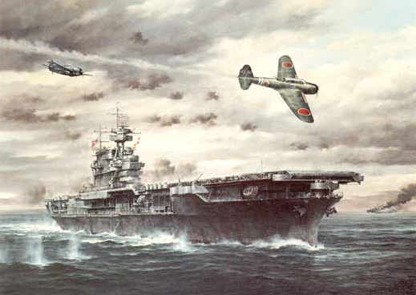A painting of the Enterprise at the Battle of Santa Cruz by Marii Chernev. The plane in the foreground is a Kate torpedo bomber.
It was a hot October day and the South Pacific sun was bright and everyone was sweating. Gordon's 20 millimeter was next to the five inch guns. As they spewed projectiles from their barrels, the hot powder cinders were falling onto his back. At the same time, they were being strafed by some Zeros. The powder cinders stung and the sweat running down his back felt like blood. He got weak and scared because he thought he had been hit.
Some were not so lucky. Once Gordon watched a man die. A sailor at one of the guns next to him got hit and fell to the deck. As he laid there in the catwalk, Gordon lost touch with the battle for an instant as he watched the life go out of the quivering body. The thought ran through Gordon's mind that he was glad that wasn't him. He worried about when his number would come up because the odds couldn't be in his favor forever. It wasn't so much the bomb or bullet that had his name on it that concerned him. He figured he could dodge that one. It was the ones that said “to whom it may concern” that worried him.
By now, the Big E's bow settled low in the water and smoke poured from the holes in the flight deck. Her aircraft, as well as those from the soon to sink Hornet were still in the air with no place to land. Soon the fires were put out and the returning aircraft began coming aboard, dodging the craters in the deck.
Only a few touched down before the wounded ship came under attack again. Several bombs exploded dangerously close in the water but not hitting the ship. One of these near misses went off in the water not far from the battery where Gordon was. The force of the explosion bent and twisted the gun deck and threw the gunners onto the flight deck. Gordon got up and ran back to Battery Twelve, where he used to be, and resumed the fight.
It had been a long, hard day. At one point during the battle, the Enterprise's survival was questionable. The gallant crew fought hard to save their ship. If it would have become necessary to abandon ship, Gordon was to stay aboard with the skeleton crew of seven hundred and fifty men to bring the ship in, if possible. He always wore a hunting knife on his belt in case he ever had to abandon ship. At least he would have something to use a weapon or a tool. With everything under control, the ship received her air group aboard as well as the Hornet's.
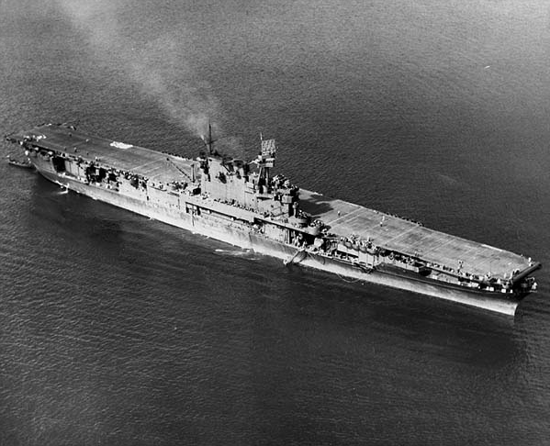The Enterprise at Noumea - November 1942
Coming back to the storeroom after the battle, Gordon and Ski weren't able to get into the storeroom at first because the hanger deck was covered with water and foam and had to be cleaned up before they open the hatch to the storeroom. There was a thousand pound bomb on a cart that had broken loose. As the ship rocked back and forth in heavy seas the bomb cart rolled back and forth across the deck. A sailor was trying to catch it so he could secure it. At first Gordon and Ski thought it was comical. Then it dawned on them that it really wasn't that funny and decided they had better get out of there. Finally when they were able to open the hatch and renter the storeroom, there was his ring lying on the deck. Then his finger started to hurt.
When Gordon was thrown to the flight deck, his legs were hurt. After the battle they were stiff. He was put in the sickbay to keep him off his legs for a few days. At the same time, they took an ingrown boil from under his arm. While he was in the sick bay, Admiral Kincaid came to visit the men. In talking to Gordon, he asked, "Did they hurt you, son?”
"No, sir. Admiral."
"Good, good." as the admiral shook his hand, he said. "But we sure raised hell with them if that does you any good."
When the battle over, Japan was the looser, despite the loss of the Hornet. They lost at least one hundred aircraft and two of their carriers were so badly damaged that they would not see action again for many months. The second attempt to recapture Guadalcanal was halted. Four days later on the 30th, the Enterprise dropped anchor in the harbor at Noumea, New Caledonia, to lick her wounds.
Less than three weeks after the Battle of Santa Cruz, the Enterprise had not yet fully recovered from her battle damage. Regardless, she sailed into battle again on 11th of November. Friday the 13th was a lucky day for the Enterprise. She helped stop the Japs final attempt to recapture Guadalcanal. The Enterprise escaped being attacked by hiding in a rain storm. She returned safely to Noumea on the 16th to finish repairs.
By December, the Saratoga was back in the area after being repaired. Christmas was different at a tropic island with no snow or pine trees. To make it worse, Bing Crosby's “White Christmas” had just been released and was played over the ships sound system. It caused the throats to swell and eyes to cloud for many crusty, battle weary sailors, Gordon included.
They would hang screen on the hanger deck to show the latest movies (as soon as they could reach the war zone). It was supposed to boost moral, but sometimes they induced homesickness. Once they showed a movie starring Esther Williams that took Gordon out of the war to be with her on a sandy beach, if only for a moment. Esther Williams was a competitive swimmer and actress who starred as a bathing beauty in several movies of the time.
The Enterprise put to sea again on December 4th, once more in top fighting condition. The Enterprise spent the next several months either anchored in the tropical ports of Noumea or Espiritu Santo, on patrols, or raiding Jap islands. On January 30, 1943 she participated in the Battle of Rennell Island by providing air cover for a force of cruisers and destroyers that had been attacked by land based bombers which resulted in the loss of one cruiser.
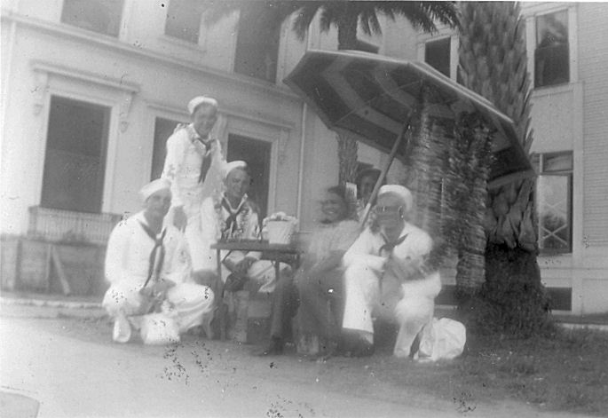Gordon (left) and some shipmates at the Royal Hawaiian in June or July 1943
During the next four months the Enterprise patrolled the South Pacific and conducting training exercises with the Saratoga and other elements of the fleet. She rotated back and forth between Noumea and Espiritu Santo in the New Hebrides Islands. Once while anchored at one or the other, Gordon and Ski went over to a supply ship that was also anchored in the same harbor to see what they could round up. Gordon recognized the ensign they were talking to and asked him, Aren't you Jack Roper from Burley, Idaho.”
Jack responded, “Yeah, and you are … Taylor? No. Gordon Buttars. What ship are you on.”
Gordon pointed across the harbor to the Enterprise and said, “That ship over there.” Not long after that the supply ship sailed for the west coast and Jack went home on leave. While there he went out to see Gover and Mary and told them about having seen Gordon.
On April 1, 1943 Gordon received an advancement, becoming a Petty Officer, rated as a Storekeeper Third Class.
The Enterprise sailed for Pearl Harbor on May 1, 1943. On the voyage, Gordon crossed the equator for the eighth time. On May 8th the Enterprise returned to Pearl Harbor for the first time in seven months. On May 27th, Admiral Chester Nimitz came aboard and presented the Enterprise and her crew with the Presidential Unit Citation which read:
For consistently outstanding performance and distinguished achievement during repeated action against enemy Japanese forces in the Pacific war area, December 7, 1941, to November 15, 1942. Participating in nearly every major carrier engagement in the first year of the war, the Enterprise and her air group, exclusive of far-flung destruction of hostile shore installations throughout the battle area, did sink or damage on her own a total of 35 Japanese vessels and shoot down a total of 185 Japanese aircraft. Her aggressive spirit and superb combat efficiency are fitting tribute to the officers and men who so gallantly established her as an ahead bulwark in the defense of the American nation.
The Big E spent the next two and a half months operating in the Hawaiian area conducting training exercises with the brand new Essex. On July 14, 1943 she sailed for Puget Sound for repairs, arriving at Bremerton, Washington on the 20th.
Gordon hadn't been in the United States for a year and a half and it was good to be home. His dad was anxious to see him. Gover, Ralph, and Orvin came to spend a week in Bremerton to visit with Gordon even though he wouldd be home in three weeks for an entire month. Gordon tried to tell his dad that he would be home in three weeks, but he insisted on coming because he was afraid that the ship would have to leave and he wouldn't be able to come home. Gover wanted to go aboard and see what the Enterprise looked like. Gordon got permission from the executive officer for him to come aboard and had the papers and everything. But Gordon was leery of letting him see the ship in the condition it was in. It was all torn up inside so the repair crews could rebuild it. If Gover saw it in the shape it was in, knowing his son had to go back to sea on it, it would probably have haunted him. So Gordon decided to tell him that he was unable to go aboard. Gover was content with seeing the Big E at a distance. He never did tell his father that he had it all arranged.
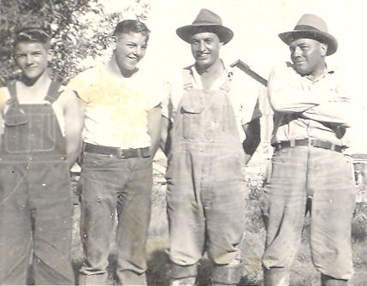Orvin, Ralph, Gordon, and Gover - August 1943
Gordon came home to Burley on a thirty day leave around the 20th of August. Jack Roper also happened to be home on leave at that time. Mr. Roper, Jack's father and the owner of Roper's Fine Clothing, invited Jack and Gordon to attend a Chamber of Commerce luncheon in the Old National Hotel. Mr. Roper introduced Gordon and asked him to say a few words. Gordon Stood up and said, “I haven't much to say, other than I am glad to be home.” And then he sat back down.
Then they asked Jack to say a few words. He stood up and said, “I really don't have much to say, either. You see, I am on a cargo ship and where I go the sea lanes are open, because Gordon opened them.” Then he proceeded to describe all that the Enterprise had done and been through. When he was finished, Gordon wished he was a little mouse and could go hide in a hole in the wall because he didn't like having the attention drawn to him.
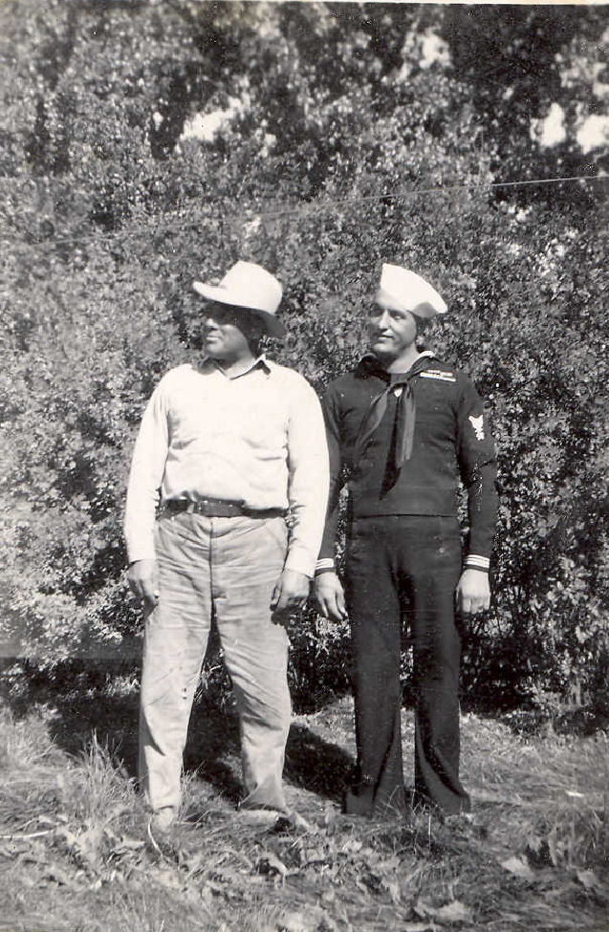Gover and Gordon - August or September 1943
While home on leave he got some well deserved rest and did a little work around the farm, leaving the war behind. . . Or did he? One day he went into Nelson's Cafe for coffee. He saw a Jap setting at the end of the counter having lunch. When the waitress asked Gordon what he wanted, he said, “That Jap!”
She told him that there was a whole bunch of them in the kitchen. He got up and made his way to the unsuspecting man who was on his lunch break. Being a sailor who had been trained to hate and kill Japs, his natural reaction was to attack. Gordon grabbed the Jap's plate and flung it down the counter. As it slid along, it knocked everything else off of the counter and it landed in the lap of a man wearing a suit at the end of the bar. Then he grabbed him by the throat and tried to choke him to death. Another waitress tried to stop him but Gordon back hand-ed her, knocking her to the floor. Finally, a soldier (also home on leave) pulled him off.
Gordon then ran into the kitchen and grabbed a meat cleaver and chased all the Japs out on the sidewalk. Once outside, the Police Chief tried to put him in his police car. At first Gordon resisted, but then he thought that if he could get in the car he get the Chief's gun. Then the Chief tried to keep him out of the police car. Finally, a couple of Gordon's friends came and got him and took him home. With the war in the Pacific so many thousands of miles from Burley, Idaho, Gordon had just fought the Battle of Nelson's Cafe.
After that, he stayed home for a few days. When he finally got the nerve to go into town, he left his uniform home and wore civilian clothes. He didn't dare go near Nelson's, so he went into the Oregon Trail Cafe to get something to eat. There was the fellow who got the Jap's plate in his lap. He came over to talk to Gordon and asked him if he was the sailor who was "raising hell" in Nelson's the other day.
Gordon told him, "No. I'm just a farmer out south of town, but I heard about it."
He responded, “You sure look like him.” Just then the man moved in his seat and his jacket folded open enough for Gordon to see that he had a gun in a shoulder holster. Then he got scared! Figuring he was an FBI agent or something, Gordon decided he had better level with him and told him his story. Nothing more was ever said or done. If he was an FBI agent, he was probably there to keep an eye on all of the Japanese-Americans who had been relocated from the west coast when the war began.
While home on leave, he took his ring to Scholer's Jeweler in Burley and got it fixed. He wore that ring for the rest of his life and you could still see where it had been bent.
After a month at home in Burley, Gordon went back to the ship. He ended up on a bus full of older women. He was tired and worn out and fell asleep. After a while, his own snoring woke him up. All of those ladies were looking at him and smiling. He figured they must have felt sorry for that poor little sailor.
The Enterprise back in tip top shape, as good as new. Actually better with the addition of numerous 40 millimeter mounts and a new radar set. Gordon's battle station was now on the 40 millimeters. On the 1st of November she left Bremerton and was back at her berth in Pearl Harbor on the evening of the 6th. Pearl Harbor was full of ships. There were brand new carriers, some of which bore the names of The Big E's former running mates. There were new battleships as well as those that had been resurrected from the waters of that very same harbor. Among the cruisers and destroyers were those familiar to the men of the Enterprise along with brand new ones. Pearl Harbor was also filled with transports and cargo ships loaded with men and material ready to begin the island hopping campaign across the Central Pacific.
The Enterprise departed Pearl Harbor on November 10, 1943 and sailed into action. For the men aboard the Big E it was a whole new ball game. They found themselves sailing in company of a large task force, one of five large carrier task forces. No longer was the Enterprise alone to suffer the wrath of Nippon's warlords. From November 19th through the 26th Enterprise participated in the occupation of Makin, and on December 4th carried out an attack on Kwajalien. Enterprise than returned to Pearl Harbor on the 9th of December. During that time, Gordon received a rate advancement to Storekeeper Second Class which took affect on December 1st.
In January of 1944, Gordon was transferred from the store room to the aviation issue room. The issue room was the office for the aviation supply room. There were some bunks and lockers located in the issue room. It was better than the makeshift quarters he had improvised in the storeroom. At the same time his battle station was changed from the 40 millimeters to the aviation issue room. He had been a gunner for so long that his effectiveness had worn off.
Gordon knew a lot of pilots better than he knew the crew. They would come back to the storeroom where there was always a fresh pot of coffee and sat around Gordon's desk to shoot the breeze. His desk was the main attraction because it was covered with pinups, overlaid with a sheet of glass. He and Ski also had a still hidden among the carburetors with which they made their own brew. Once during stormy weather, the ship was rocking with the rough seas and their still tipped over. Burning alcohol ran across the deck. Gordon and Ski quickly smothered the flame before it got away from them.
After a months stay in Pearl Harbor, Enterprise departed with the rest of the fleet in support of an ambitious island hopping campaign that pushed deeper into Japanese held territory. On the 22nd of January Gordon crossed the equator for about the ninth time. On this particular crossing, there was time to initiate the hundreds of polliwogs on board into the “Solemn Mysteries of the Ancient Order of the Deep”. By this time Gordon was a very crusty shellback. On the 29th planes from the Enterprise attacked the island of Taroa and from February 1st through the 4th participated in the occupation of Kwajalien, both in the Marshall Islands. On the 5th of February the Enterprise dropped anchor in Majuro Lagoon.
Majuro had been captured from the Japanese only a few days earlier. Majuro Lagoon was an ideal anchorage for the fleet. It was one hundred and fourteen square miles of shallow water enclosed by a ring of sixty four small atolls. It was within close range of the objectives the Navy and Marines were concentrating on during the campaign. It did not have the facilities and amenities offered by Pearl Harbor. For example, there was no opportunity for shore leave. All of the reprovisioning was provided for by store ships which were designed to provide the necessities for the fighting ships in advanced anchorages such as Majuro.
Over the next few months, Enterprise was in and out of Majuro on a regular basis. On one occasion Gordon and Ski learned that there was an aviation store ship in the lagoon and went over to check it out. On going aboard, they got excited and hurried back to the Enterprise to get the necessary paperwork and a barge with a work detail and went back to the supply ship. By the time they got back to the Big E, they had more than their supply rooms could hold. They had to keep engines on the hanger deck, wings were tied to the overhead beneath the flight deck, and they put things anyplace they found room. Because of Gordon and Ski, the Enterprise always had the best supply of parts of any carrier in the fleet. Once in a while, a plane from another carrier came aboard just to get fixed. Gordon new all of the part numbers, where they were, and how many there were in stock.
On the 12th of February the Enterprise departed Majuro to participate in two days of attacks, along with the rest of the fleet, on Truk, Japan's Pearl Harbor, in the Caroline Islands. After two days of attacks on the 16th and 17th, The Enterprise was then detached from the main fleet and carried out raids on Jaluit on the 20th. Jaluit was one of the atolls in the Marshalls that had been bypassed during the occupation of the island chain. The Enterprise dropped anchor again at Majuro on the 21st for a brief stay.
After two weeks, The Big E departed Majuro on March 7th and sailed to the familiar waters of the South Pacific. Rather than part of a large task force, she was accompanied by two cruisers and eight destroyers, just like earlier in the war. By now Gordon had lost track of the number of times that he had crossed the equator. On the 11th the Big E's anchor rested on the bottom at Espiritu Santo which had been home to the Enterprise a year earlier. She only remained there for four days and departed on the 15th to cover the unopposed occupation of Emirau on the 20th. Then on March 30th and April 1st her air group conducted raids on targets on Palau, deep in Japanese territory west of the Carolines. At the conclusion of the voyage, she rejoined the rest of the fleet at Majuro on the 7th of April.
Seven days later on the 14th April, the Enterprise departed Majuro with the fleet. On the 21st Gordon crossed the equator yet again as the carriers commenced air attacks in support of General Douglas McAurthur's invasion of New Guinea at Hollandia from the 21st to the 24th. Then carried out more attacks on Truk on the 29th and 30th before returning to Majuro on May 4th. All this time new carriers and escort ships continued to join the fleet.
For the next month, the Enterprise rested at anchor in Majuro Lagoon until getting underway with the fleet on June 6, 1944, the same day the allies stormed the beaches of Normandy half way around the world. The first order of business on this voyage was to attack Jap positions on Guam, which began on the 11th. On the 15th the Marines stormed ashore. That night after dark, a formation of twin engine bombers armed with torpedos attacked the task force. It was the first time since the Battle of Santa Cruz that The Big E had come under attack. All of the bombers were shot down, two of them by Enterprise gunners. On the 16th and 17th the air group continued to attack enemy positions on Guam in support of the advance ground troops.
Japan committed their entire fleet and naval air force in an attempt to destroy the U.S. fleet. On the 19th and 20th of June 1944 the fierce Battle of the Philippine Sea was fought. American air power so great that they swept the sky of Japs. One fighter pilot commented that shooting down enemy planes was like shooting turkeys back home. The battle came to be known as the Great Marianas Turkey Shoot. However, some got through to the task force that the Enterprise was part of and she came under attack. For Gordon, being below decks in the aviation issue room during battle was hard for him to take. He wasn't able to see what was going on, he could only listen to the booming of the guns and the roaring of the planes. The worst part of it was that he was not able to fight back.
The next day the Jap fleet was located and the carriers in the various task forces launched their attacks. The planes from the Enterprise were responsible for sinking one of the Jap carriers. When the battle was over, Japan had been utterly defeated, loosing over four hundred planes and three carriers. The US Fleet withdrew to refuel and regroup and then the Enterprise returned for one more attack on enemy positions on Guam on the 5th of July. After that, The Big E was detached from the fleet with orders to proceed to Pearl Harbor for upkeep and maintenance. During the last six months, the Enterprise had sunk nineteen ships and shot down three hundred enemy aircraft, plus untold damage to shore installations.
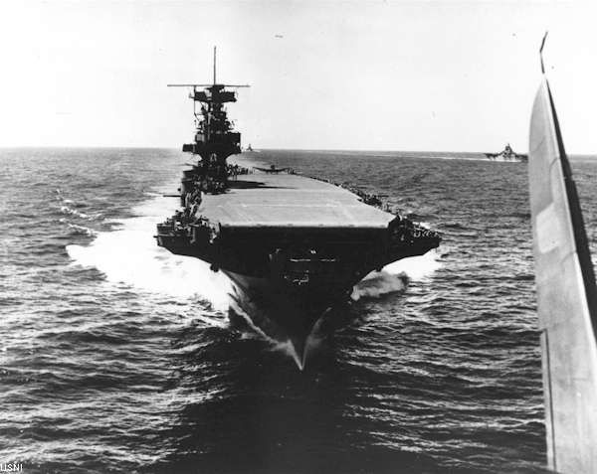Enterprise July 1944
On the 15th of July 1944 the Enterprise steamed into Pearl Harbor. For Gordon, it was the last time. On the 26th, Gordon was one of nine hundred and seventy-five men to leave the ship. He had served aboard her since December 8, 1941. At one time just before leaving the ship, his pay number was 513, meaning that many men out of three thousand that had been aboard longer than him. He and the USS Enterprise CV-6 had fought in seventeen battles together and he fought two by himself, Pearl Harbor and the Battle of Nelson's Cafe.
Gordon later reflected, "I often wonder what I ever did to be in Pearl Harbor like I was and then to end up on the Enterprise. I had to of had someone riding around in my back pocket because I walked off that ship without loosing a single drop of blood.”
The Enterprise went back to sea without Gordon. During the remainder of the war, she continued her outstanding performance until May of 1945 when a Kamikaze, or suicide plane, crashed into her forward elevator blowing it four hundred feet in the air. The Enterprise spent the rest of the war in Bremerton for repairs. During the War, the Enterprise won for herself a fame that has not been topped. The most famous warship in the history of any navy had sunk seventy-one ships and damaged one hundred and ninety-two others. Her guns and planes had downed nine hundred and eleven planes. She had been damaged nineteen times by direct hits and near misses, but was always back in the ring for the next round of action.
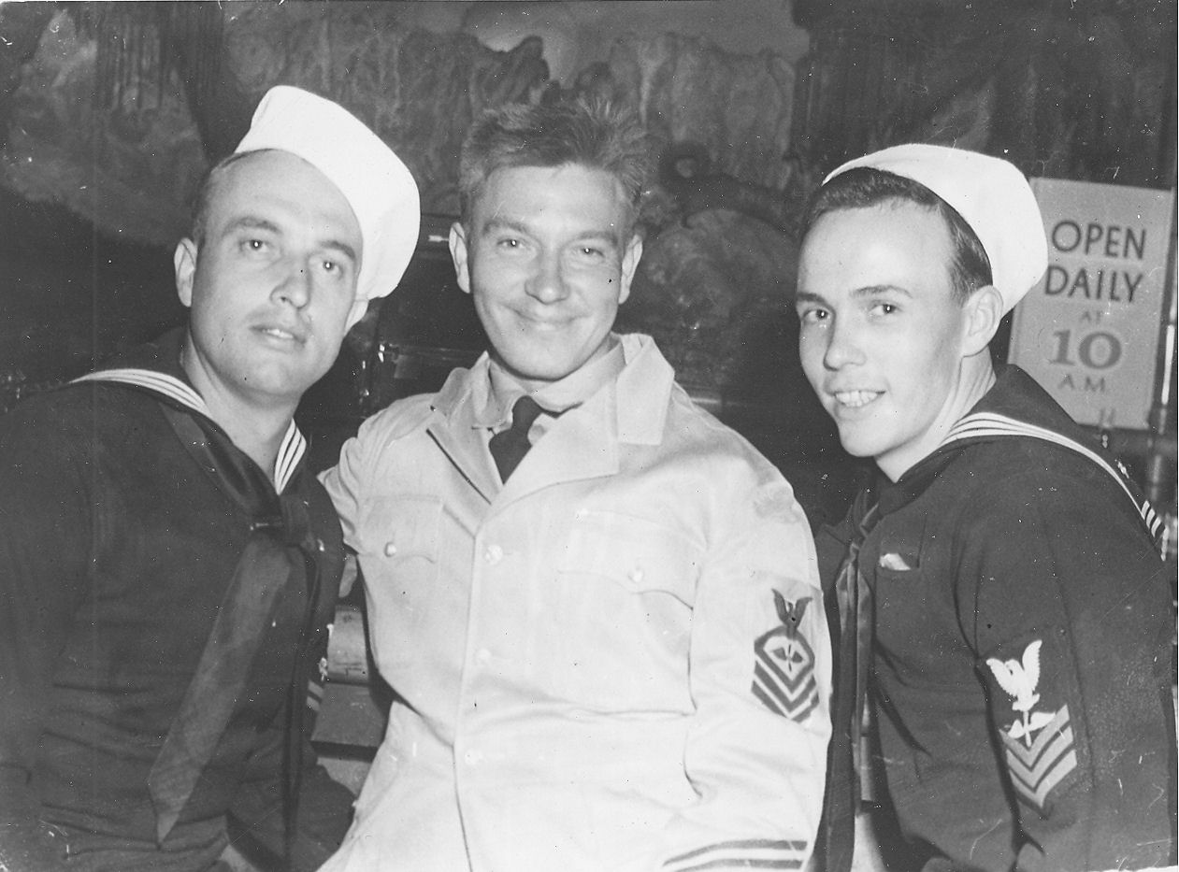Gordon (left) and some shipmates at the The Jade Hula Shack in Oakland, California - August 1944
After a few days at Pearl Harbor, Gordon rode a troopship, the SS Sea Cat, to Alameda, California, arriving on August 3rd. He stayed in Alameda for seventeen days before being assigned to CASU 7 (Carrier Aircraft Service Unit) at the Sand Point Naval Air Station in Arlington, Washington, near Seattle. He was granted a twenty three day leave before reporting to his new assignment. He rode the train home to Burley and spent two weeks at home. On his way to Seattle, he spent a few days in Portland.
Gordon reported for duty with CASU 7 on September 14th. At this facility, they serviced engines, airframes, propellers, instruments, and electronic equipment.
A seagoing sailor is different from a landlubber, especially after being at sea for almost three years, Gordon really didn't feel like he fit in. It seemed to him that the seagoing sailors always had sea duty and the shore based sailors were always ashore. He didn't last very long there and after a few months he was transferred to CASU 55 and reported for duty at Astoria, Oregon, on February 7, 1945.
When he reported in to the division officer, Gordon was afraid his next move would be back to sea. As he was reporting to Lt. Atwater, the window which had been propped up, fell with a bang. He threw his arms in the air and let out a war hoop. He had no sooner gathered himself up from that when a sailor took a picture behind him. As the flash went off he went through the commotion again. From being in battle for so long, he was "shell shocked" or suffered from war neurosis. That was the reason for being taken off the ship. Lieutenant Atwater understood the problem and took it easy on Gordon.
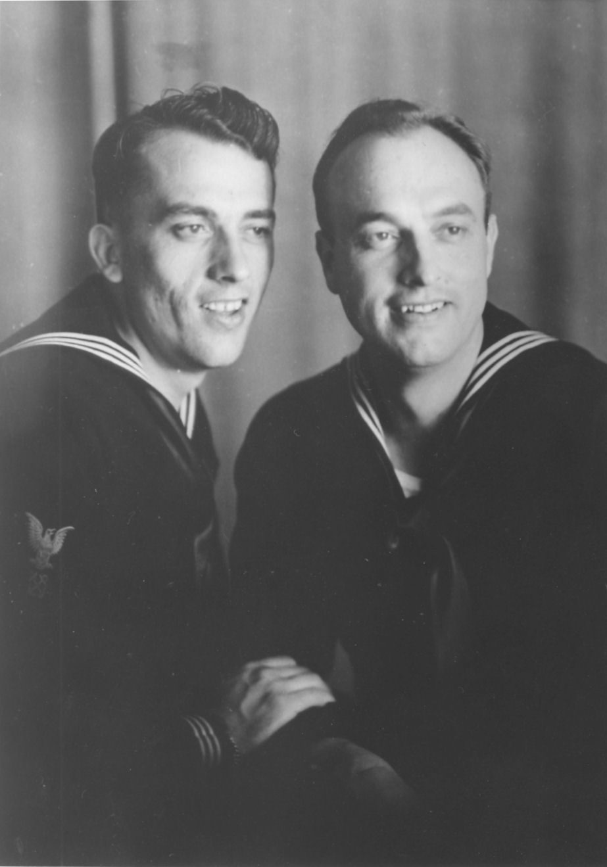Milton and Gordon - 1945
Milton was stationed not far away at Corvallis, Oregon. They went on liberty several times together. It was there that Milton married Mildred Pauline Lewis on February 28, 1945. While Gordon was in Astoria, Gover took a trip to Oregon and spent about a week there.
One day in July, Lieutenant Atwater called Gordon in and asked him if he wanted to go back to sea. There was a carrier needing an experienced aviation store keeper.
Gordon's reply was, "Please, Mr. Atwater. I'd really rather not. I know that my shore duty time is up but can't you send one of these kids. They have never been at sea and are dying to see some action."
“Don't you want to know what ship it is,” he was asked by the Lieutenant.
"Not really, sir. I don't even care to know."
"It is your old ship."
Gordon's face turned white. "Oh, please no, Mr. Atwater. I've had enough. Can't you send someone else?"
"Okay, Gordon. I just wanted to give you the first choice."
Just three weeks later the atomic bombs were dropped on Hiroshima and Nagasaki. On September 2, 1945 Japan surrendered. Had he known then that the war would soon end and the Enterprise would not sail into battle again, Gordon might have re-enlisted and gone back aboard. He could have sailed through the Panama Canal and into New York Harbor on Navy Day in October 1945. At New York, the hanger deck and other available compartments were lined with bunks before sailing to Liverpool, England, twice and once to France to bring the troops home from Europe.
The Enterprise was placed in reserve and later decommissioned and placed in mothballs until she was broken up for scrap metal in 1959. The USS Enterprise is truly the most famous warship in history. During the war years she was an important part of the victory as well as an important part of Gordon's life. But deep down, he knew that the Navy wasn't the place he wanted to spend the rest of his life.
Gordon was to have been discharged on the 26th of September, but he was in Portland on liberty and didn't get back in time. The next opportunity was the 6th of October. Needless to say, he didn't miss it this time. In order to be discharged he needed to have so many points. Points were awarded for being married and so many for each child. The first two didn't concern him. Where Gordon's points came from where each month at sea and each battle he had been in. He needed 165. He had 280.

Chapter 6

THE UNSETTLED YEARS

When Gordon came home from the Navy, he felt lost and didn't know what he wanted to do. He didn't want to farm after having been in the service. Farming was to much work. One of the first things he did when he got home was to buy a 1940 Buick Special Coupe.
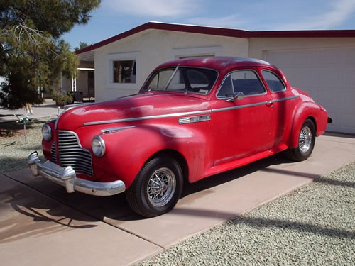A 1940 Buick Special Coupe, similar to the one Gordon had
Ralph wanted to wear his uniform to a Halloween party. His friend had borrowed his brother's uniform and the two of them wanted to go as sailors. When Ralph put it on, Gordon said, “Now, Ralph. You're going to get into trouble if you wear that.” He wore it anyway and sure enough they got into trouble. They had been drinking and ran Gover's car off the road, breaking out a headlight and dented the fender. Gordon happened along in his car and saw them off the side of the road. He stopped and helped them get it back on the road. Ralph was scared and afraid of what Gover would do to him. Gordon let them take his car. He would take the blame for wrecking his dad's car. Ralph ended up getting into more trouble for letting Gordon take his car “while he had been out drinking” than he would have if he would have been upfront and took the blame for wrecking it himself.
Not long after coming home, he went to a movie at the Burley Theater with his date, Myrtle Drake, and Milton and Mildred. The movie opened with a battleship sailing across the screen. All of a sudden it opened fire with it's big guns; right into the audience. Gordon let out a blood curdling scream and threw his hands in the air as he rared back in his seat, tearing the screws out of the floor. The entire row of seats and everyone on it went over backwards with him. It wasn't hard to figure out who did it. He was the one with a red face that glowed in the dark.
Gordon fought worse battles in his sleep after the war than he was ever in. One night soon after the war he dreamed that a plane flew up the flight deck and dropped it's bombs and blew him into the water. He lost an arm and a leg in the explosion and the salt water was burning the open wounds. As he laid in bed, he cried out with moanings and groanings. It sounded like someone in terrible pain to Gover, so he burst into Gordon's room to see if he was alright. Another time he dreamed some Jap flying boats flew over the farm many times searching for him as he hid in the well. The war was over but it took many years to get back to a normal life, although he never really did get over it.
Gordon stayed around Burley for a few months, living at home. The next spring he helped put up the first crop hay. Ralph had his appendix taken out earlier and still was slightly weak but was strong enough to work. Gordon pitched the hay from one side and Ralph from the other. Orvin rode the wagon tromping the hay. After the stack got so high, Gordon wouldn't let Ralph pitch any more and he worked from both sides of the wagon.
Orvin wasn't helping, so Gordon chewed him out. Orvin, who was about fifteen, stood up and said, “Now you listen here, you are not talking to a bunch of sailors any more!" That was the wrong thing to say. Gordon stuck his fork in the ground and started up the front of the wagon. Orvin squealed and jumped off the top, hitting the ground on a run for the house and told Gover that Gordon was after him. When Gordon got to the yard, his dad asked him, “What happened out there?”
He responded, "All I was trying to do was to get Orvin to help Ralph."
Soon after that, Gordon went to Idaho Falls to see if he could find work. He went to work in a Safeway store stocking shelves. After a month, his boss told him, "Now, I'm not going to fire you, but you're not much good to me. Why don't you get a job driving a big truck or a cat?" He gave Gordon a recommendation to use in getting other jobs stating that he was a loyal and hard worker. Gordon carried that recommendation around with him in his wallet for a longtime after that.
He decided he wanted to go to Denver, Colorado. He set out hitch-hiking and soon got a ride. Only the man who picked him up was going to Ontario, Oregon. Ontario sounded good enough to him, so he took the ride. In Ontario he got a job at a frozen food plant. The following spring he quit there and returned to Burley.
Gordon married Carolyn Bowers on April 27, 1947 in Elko, Nevada. At the time, he was living alone and getting married and settling down seemed like the thing to do. Shortly after getting married, they went back to Ontario and he got a job in a grain mill.
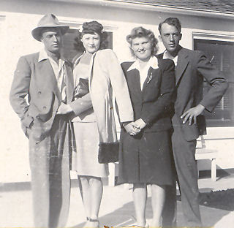Gordon and Carrie with Mildred and Milton
That November he had a heart attack at twenty nine years old, only he didn't know what hit him. He called in sick and said he wasn't feeling well. A few days later he went back to work. He did go to see a doctor, but there was a long waiting line and he didn't want to wait so he left. In March 1948 he had a second one, still not knowing what was happening.
After he was feeling better, Gover came to see him and talked him into quitting his job and coming home to work the farm. So he and Carrie moved back to Burley. In June he went to the VA Hospital in Boise to find out what had happened to him. That is when he learned that he had had a heart attack. He was there quite some time. While he was in the hospital, Gover took care of the farm.
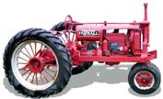A Farmall F-12 similar to the one Gordon had
In 1949 Gordon decided to start farming for himself. He rented a farm in Declo on the east side of the highway next to the river. That spring Gordon bought an old Farmall F-12 tractor at a farm sale. The morning of the sale, Frank Coffee, the auctioneer, had bought some hay from him and knew that Gordon had $300 (the price of the hay.) As the bidding got going, Gordon bid $300. Mr. Coffee stopped the bidding and said, "Sold to Gordon Buttars for three hundred dollars.” The tractor came with a hang on plow. The F-12 had a crank that had to be turned in order to start the engine. It was rated at about twelve horsepower on the draw bar.
He had some milk cows before moving to Declo. All he had for machinery was that old tractor and plow. Years later he made the statement, "When I started farming, all I started out with was a sack of bullduram and a mad wife." Being married to Carrie was agony. They were more like drinking buddies than anything else. When they weren't drinking they were fighting.
He only farmed in Declo one year. During 1950 and 1951 he farmed at 450 South 50 East. Then in 1952 he moved to the George Kelly place about a mile away.
He and Carrie were divorced on March 12, 1952 . They had no children as she was unable to have any. He thought about having a family of his own, but had to be content with being an uncle. When Milton and Mildred got married, he became Uncle Gordon to her four daughters. A year later, Reed was born. Ralph married Arlene Stevenson on August 25, 1946. They gave Gordon another niece and two more nephews. Ralph and Arlene were later divorced.
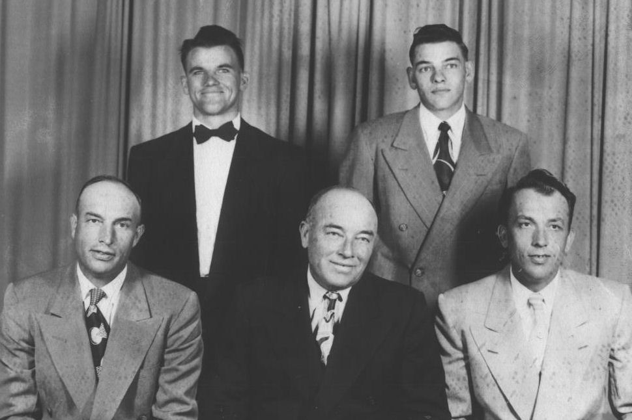Gordon, Orvin, Gover, Ralph, and Milton in 1953
Gordon remained on the Kelly place and ran the farm that year and 1953. In 1953 Lola brought Joyce to meet him and told her that he was her father. All that time she was under the impression that her step-dad was her father. It was many, many years before he had any further contact with Joyce.
The eight years following the war was an unsettled time for Gordon. He had tried many things and moved several times. He would move onto a farm and spend a year or two getting it in condition to begin producing. Then the landlord's son or the landlord himself decided they wanted it. All he could do was find another place to rent and move on. He was able to build a good herd of dairy cows and acquire a more complete line of farm equipment. He also traded his Buick in for a 1948 Studebaker Land Cruiser
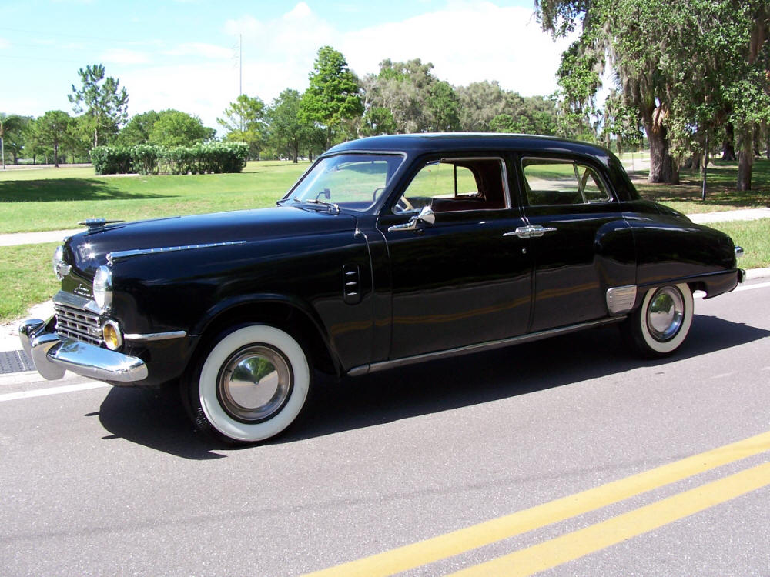A 1948 Studebaker Land Cruiser similar to the one Gordon had
The only family he had other than his folks was Nick, his dog that he raise from a pup. When Gordon fixed breakfast for himself, he'd always fix a couple eggs for Nick. Nick was about the only friend he had. What Gordon needed was a wife and family.
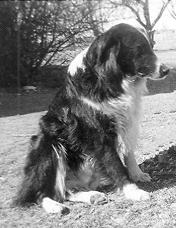Old Nick
In the spring of 1954 he moved to the Asel Gee place at 500 south 150 east of Burley. About this time Aunt Mary introduced him to Celia Frost. She was actually a second cousin to his first wife. At the time she worked at Miller Drug. Celia, who was twenty seven years old at the time, was recently divorced with two children, Melody and Tim Dudley.
The first time Gordon took Celia out, his friend, Gene Riddle, took Celia's cousin, Lois Dayley. They went to a night club in Twin Falls for an evening of dining and dancing. On the way home, he had to stop suddenly. All the beer bottles came rolling out from under the seat of his car.
He found Celia to be a decent woman and they began courting. He would take her to a movie and out for a hamburger. Celia lived with her parents and her mother made him have her home by midnight. Celia and her mother worried about his drinking. Her father told them not to worry, "He's a man, he'll quit. You won't get him to stop smoking but he is man enough to quit drinking.” And he did.

Chapter 7

CELIA

Gordon and Celia were married at the home of her parents by Bishop Morris Baker on September 22, 1954. For their honeymoon, Gordon's folks took them to see the Ice Follies in Salt Lake City. While they were gone some neighbors had most of his beans thrashed. There was twelve acres of beans that did not ripen until very late. While they were laying in the windrow, a windstorm came up one afternoon. All Gordon and his new bride could do was stand on the back porch and watch them blow away. Celia made the comment, "If this is farming, I don't know if I want much to do with it."
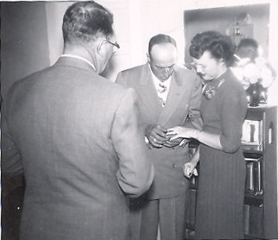Gordon and Celia
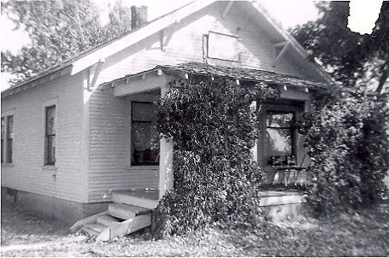The house on the Gee place
The next spring Gordon went to work for Newel Baker as well as run his own farm. Mr. Baker put him in charge of the farm as foreman over 960 acres and five hired men. On Father's Day, Sunday, June 19, 1955, he had two big streams of water turned together. There was over 500 inches all together. \That day he left a hired man with the water because he had something more important to do. He had to take Celia to the hospital to have their first child. When Doctor Sutton came out of the delivery room he asked Gordon, "Well, what do you want?"
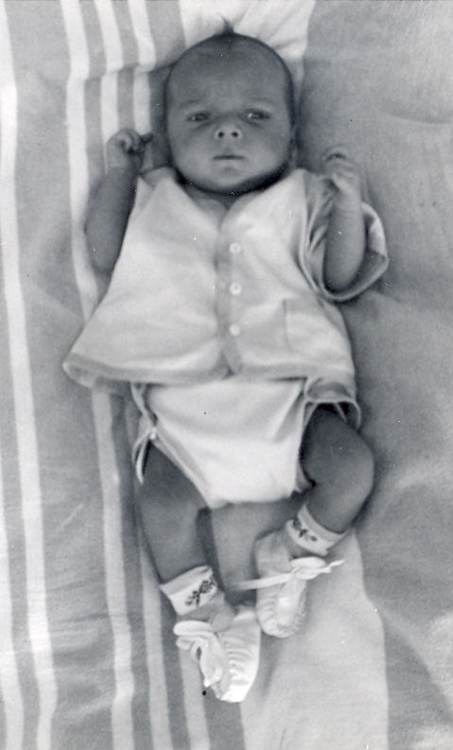Little Gordon
He replied, "By God, it had better be a boy." He wasn't disappointed. That day Gordon Gene was born.
The rest of that year he ran the Gee place, milked his cows and worked for Newel Baker until September. The next year Gover was going to sell Gordon the home place. They moved into the house and during 1956 Gordon farmed it and rented the Van Engelen farm down by the river. The next year, Gover decided he wanted the farm back.
Gordon had nowhere else to go for land and was left with no other choice than to have a farm sale. By then he had a good line of machinery. He had a B John Deere, and a Super M Farmall, a tumble bug plow, a set of discs, some harrows, and a beet topper, along with other odds and ends. He sold his dairy heard too. It was about this time that he traded his Studebaker in on a 1953 Buick.
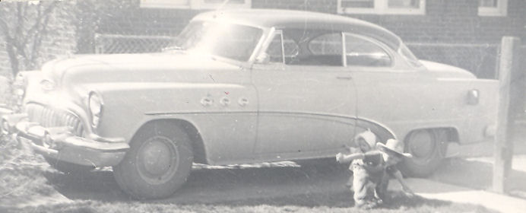Gordon's 1953 Buick
Gordon learned that Phillip's Petroleum was looking for service station managers. Not knowing what else to do except wanting to work for himself, he thought he would give it a try. So Gordon, Celia, little Gordon, along with Melody and Tim moved to Salt Lake City. Not long afterwards, Gover sold the farm to someone else.
Gordon moved his family to Salt Lake (except for his dog Nick for whom he had to find another home) where they lived at 1350 S. 7th East. Gordon was paid $285 a month while he attended the Phillip's Petroleum School. Along with the schooling, came on the job experience. This was working the midnight to eight shift at a service station. That got old fast. He told the instructor that he was not going to work that shift any longer. He told them he didn't mind working from four in morning until real late at night like he had on the farm. Besides, his wife was expecting another baby and he wanted to be free. He added that if they did not change his work schedule he was going to quit. They didn't want him to quit because they knew that he had enough money of his own to get started in a station. Usually Phillip's had to loan out the money. Because of this they changed his schedule to something more suitable.
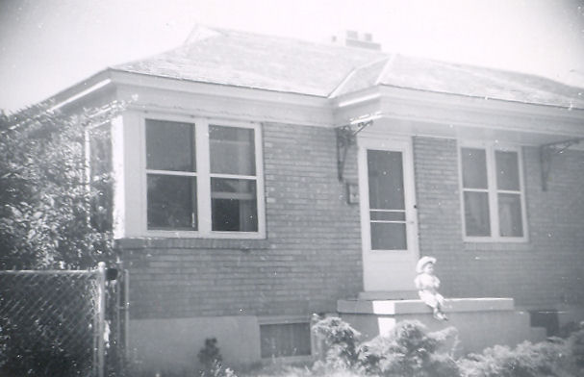1350 S. 7th East Salt Lake City
On June 2, 1957 Cindee was born in Salt Lake City. Celia had trouble with the pregnancy and went into premature labor on more than one occasion. When the baby was coming for real, they just barely made it to the hospital in time. Soon after Cindee was born, she began loosing weight because she was not getting enough nourishment. She was thin when she was born as it was.
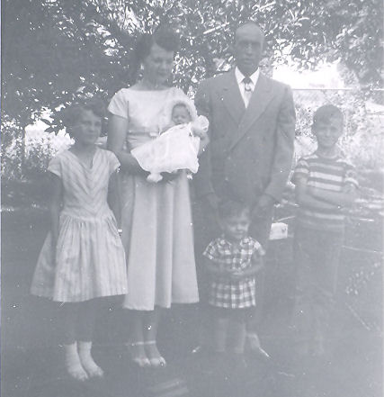1957 family picture: Melody, Celia holding Cindee, Gordon with little Gordon in front of him, and Tim
About a month later they came to Burley for a vacation. While there, they took her to Doctor Sutton. What Cindee needed was a stronger formula. The main purpose for the vacation was a trip to Yellowstone Park with the Cecil Toner family, some former neighbors in Burley. Cindee was too small to take on such a trip and was left with her Grandmother Frost.
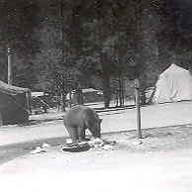The bear that wandered into camp looking for food
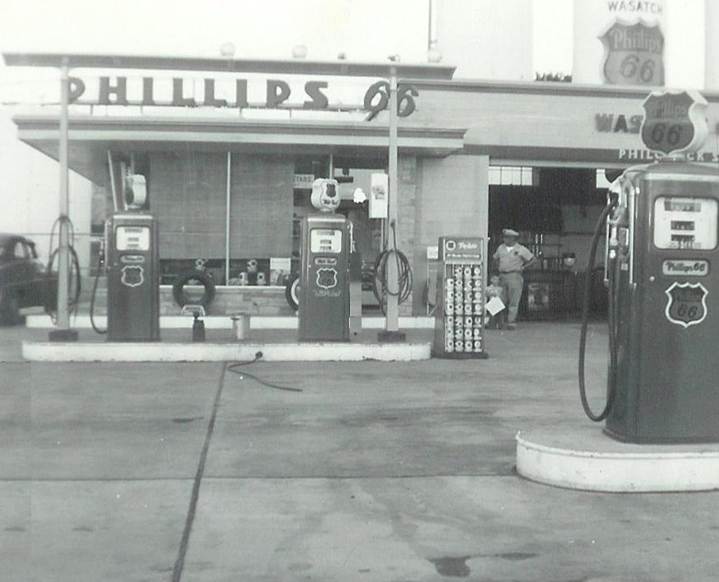Gordon and Little Gordon standing in the open bay door
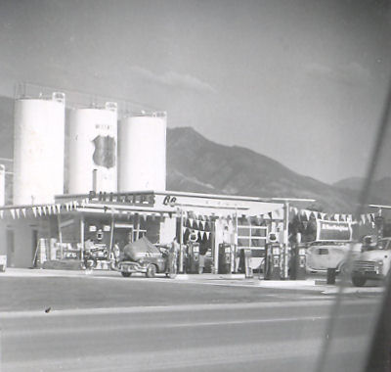Buttars' 66
The two families camped out in tents. Gordon never was much for camping and roughing it. One Morning a bear strolled into camp just in time for breakfast. The first thing Gordon did was put little Gordon in the car where he would be safe. Cecil was cooking breakfast that morning and was armed with a pan cake turner. The bear came sniffing around to see what he could find to eat and appeared harmless. When he got close enough Cecil spatted him on the nose. The bear turned and ran across the river and up the hillside.
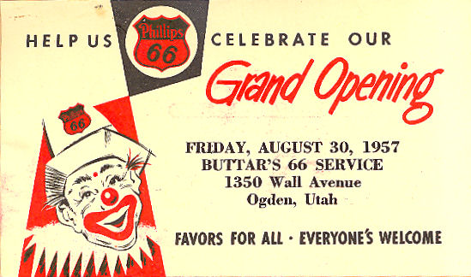
In the Summer of 1957 Gordon graduated from the Phillip's Training School and moved to Ogden, Utah. They lived at 555 South 5th Street. On the corner of 13th and Wall. He opened a brand new service station. He had $3600 of his own money from the farm sale. To go with it he borrowed $2000 from the Bank of Ben Lomand. After buying his equipment and tools, and getting his tanks filled, Buttars' 66 was ready for its grand opening on August 30.
After the first winter, Gordon got homesick for the farm and wanted to go back. Getting started was rough. Business was slow and he wasn't making much money. Rather than having him go under, the jobber let him go rent free on the station for three months so Gordon could get better established. The rent was $150 a month. He even let him charge fuel when everyone else had to pay before the delivery truck left the station. He had good credit.
Business started to pick up and he soon began seeing where he might get his feet under him. He soon had several steady customers. His station also became a popular place for bull sessions. As a prank, one of his regular customers signed his check, “Youare Stuck.” Naturally, the bank refused it and sent it back to the station. It didn't take long to figure out that it was written as a prank by a truck driver for a company that did business with him.
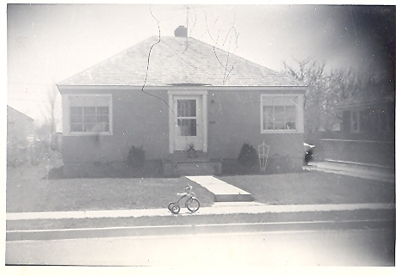555 South 5th St. Ogden
Gordon and the salesman from that company hatched a plot to turn the joke around on him. The salesman casually mentioned to the truck driver that someone had written a bogus check to Buttars' 66 and that he had turned it over to the FBI. (He really didn't, he kept it in a drawer.) They toyed around with him for two or three weeks. In the process, he got scared and confessed that it was him and pleaded for Gordon to get it back and tell the FBI that it was all a harmless joke.
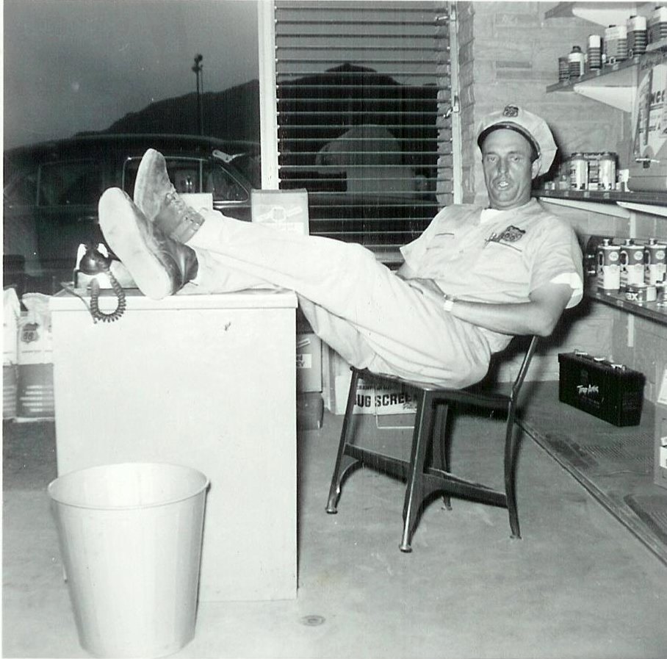Taking a breather...
Gordon told him that he would see what he could do. After about another week of making the pour guy think he was going to prison, Gordon finally told him that he was able to convince the FBI to not pursue the case and gave him the check back. He promptly wrotea properly signed check and went on his way. The prankster never knew that he had been pranked.
Even though business was picking up it became clear that he was in the wrong business. He had too much farm blood throbbing through his veins. On a visit to Burley Gordon learned of some ground for rent out on the desert. The very thought made that old farm blood pump even harder, and he liked the station even less. But Celia liked the city and did not want to move back to Burley and the farm.
One day he came to the end of the line. He had already rented the desert ground. When Gordon told Spence Bagnell (the jobber) he wanted to quit, Spence tried to convince him to stay. When he threatened to throw a match to the whole place, he finally believed him and found someone to buy him out.
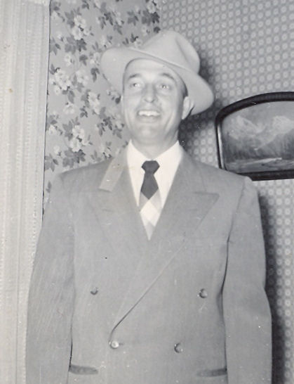Gordon in 1958
Gordon went right down to the John Deere dealer in Ogden and bought two tractors, a John Deere A and a G. He also bought a side rake, a set of discs, and a tumble bug plow along with four sections of harrows plus a few odds and ends.
Gordon wrote out a check for $4600. The salesman asked, "Now, where do you want to have this delivered?"
He asked so Gordon told him. "Six miles south and four miles west . . . of Burley, Idaho."
The salesman pounded the desk and shouted, "Hell no!" Gordon reached for the check and said, "Alright then." The salesman gave in and delivered the two truck loads of machinery at no cost.
There was 250 acres but no house so they rented one from Spencer Bingham at 400 South 100 West, five miles from the farm. He planted most of it to beans and the rest to barley. That fall the rain caught his beans out in the field. It was November before they were thrashed but they still yielded twenty-one sacks to the acre. It was rocky ground and not very good farm land. Gordon only farmed there the one year.
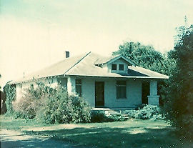The house on the Hitt place 100 W 500 S Burley
In the fall of 1959 he found a place to buy. It was 50 acres just down the road a mile to the south of where they were living. He moved his family into the house and got the fall plowing done. The deal was all settled. Gordon was to receive $2,700 in April for his previous years bean crop. He would then give Mr. Hitt $2,500 down and then pay him $1000 a year at five percent interest until it was paid. Everything was agreed upon until someone offered Mr. Hitt $5,000 down in cash. Mr. Hitt took it, leaving Gordon out of the deal. He even had the 50 acres across the fence rented from Clark Judd.
Now he had to find another place for the next year. He rented an eighty acre farm a couple of miles away belonging to Edna Story. For the second time that fall and winter Gordon moved his family to another home. In the spring of 1960 he planted the first of many crops on that farm. To go with it he had some other ground rented a couple miles away and let the Judd place go. The next year, Jake Kerchisnik, a neighbor across the road, came to Gordon and wanted him to rent his his 80 acres.
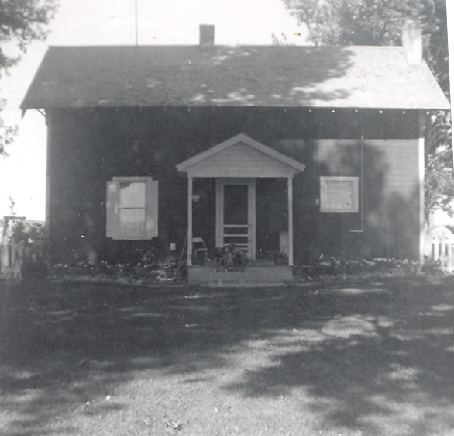The house on the Story place 550 S 150 E Burley
In the fall of 1961, he got into the Sheep business. Each fall he would buy ewes from Garnet Kidd that were being culled from his heard. During the winter Gordon would lamb them. In the spring he sold the lambs and the ewes. This way he didn't have land tied up in pasture. His time and land were available for raising other cash crops. Then the next fall he bought another band of ewes, usually between 200 and 300 head.
It was also in the fall of 1961 when his family became complete. Connie was born September 29th at the new Cassia Memorial Hospital. Celia had a hard time carrying Connie as well. She came close to losing the baby several times and was sick a lot of the time and had to be down in bed. Sometime during the next year however, his household was reduced from five children to only three. Melody and Tim went to live with their father in California.
Gordon was able to pickup some more ground and needed help. During 1962 he hired Les Turner. Les was still in high school and only worked during the summer. After he graduated, Les worked full time (except for the winter months) for the next nine years. With Les, Gordon could run even more ground.
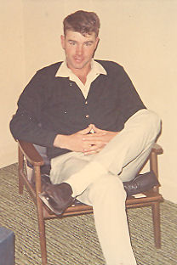Les Turner
In 1963 Gordon traded the old '53 buick for a 1960 Buick Le Sabre. He bought most of his cars in Kemmerer, Wyoming from Vernal Peterson. The old car never ran better than on the way to Kemerer. Then in 1965 Gordon traded once again. This time for a red 1963 Buick Le Sabre.
In the spring of 1966 Gordon finally had the opportunity of buying a farm of his own. It was the old Judd place (the one he had rented but never farmed.) There was 53 acres with a house and a barn, an old pig pen, a grainery, and a spud cellar. The cellar was torn down and some corrals were built. The lambing shed was brought over from Story's and was set up between the barn and the road.
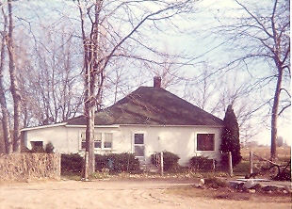510 S 50 W Burley
The soil at the new place was extremely rich and fertile. It was called goose creek because hundreds of years ago a flood occurred on Goose Creek bringingt with it rich, black, volcanic soil down from the mountains covering the existing terrain leaving a blanket several feet deep. This band of soil was two to three miles wide and stretched form the mountains south of Oakley all the way to the Snake River. The soil was so heavy that it had to be handled differently, but the crops yielded better.
With everthing ready Gordon, Les, young Gordon, and whoever else he could roundup drove the sheep the two miles to the new place. Now he owned his own ground, Gordon planted ten acres of pasture and began to keep some ewes over during the summer, adding younger ones in the fall.
With this 53 acres, he rented 50 acres to the south. He also kept Story's and Jake's across the road from Story's. Besides this he had the Van Engelen place on the river again and some desert ground across the canal. That year he had two other men besides Les. Altogether he had 400 acres. As he put it, "I've got ground scattered from the river to the desert." It was too much to try to operate efficiently. After that, he cut back to what he could handle. He kept the Story place.
As a family, they took a few trips together. The best time for a vacation was during the second week of August when the watering was caught up and just before the harvest. While going to the Phillips School, Gordon got acquainted with Neil Hart, who went on to open a service station in Rexburg, Idaho. Neil and his wife, Shirley, also had three children and the two families were close friends. On several occasions the Buttars went up to Rexburg to see the Harts. While there they took the opportunity to go to Yellowstone Park. On another occasion they went up into Montana from Rexburg. There were some trips to Nevada to see Milton. One summer they took a trip through Central Idaho to Salmon and Stanley. If there were things that needed done while he was gone, Les could handle it.
The Cassia County Fair and Rodeo occurred during this time as well. Most years they went to the fair topped off by an evening at the rodeo. Celia's family always had a family reunion about the first or second Saturday in August. He always referred to it as the rendezvous. Sometimes he would go long enough to have something to eat, but he didn't feel very welcome around them.
As a family, they went to the drive in movie at the Alfresco Theater on occasion. They would dress the kids in their pajamas so they could fall asleep in the back seat during the movie. Went they got home, they packed the kids into the house and put them in their beds. Other times they would go out as a family and have hamburgers at the A&W.
Gordon had nick names for each of the kids. For some reason Gordon was Piddles. Cindee was Jimm, and Connie was Jomm. Another name he had for Cindee was Puge. He and his brothers all had nicknames that they called each other. Gordon was John. Milton was Rudger, which actually was his middle name. Ralph was Peter and Orvin was Andro.
He had a lot of silly words that he used. Some had meanings. For example; chawtet was water. Some of the words had no meaning and could be used for any thing. Words like; demifriss, geekersoker, fiddlymocker, agoonyaqualila, heskalemilyho, or phrases like; a beestisho and a waistishum.
In addition to these silly words, his vocabulary included a repertoire of other words that are not appropriate to be used here. He included one or two of these words in about every sentence. He wasn't hesitant to use them. Not everyone spoke his language, but everybody understood it.
Gordon took his work seriously and took care of his family. Sometimes he felt he was too busy to take much time out for his family. The farm and the sheep were very demanding on his time and every move counted, but he felt it was better than having hungry kids. At least he was close to home and in and out of the house during the day.
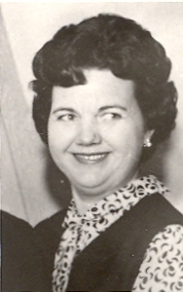Celia in 1965
Gordon's day usually began at four o'clock in the morning and made a pot of coffee. The he would sit at the kitchen table and work the numbers a few cups of coffee and about as many cigarettes. He would run figures on costs and prices and yields. He would have everything figured out and what he needed to do before he went out the door. Then the next morning he would figure it out again and come up with something completely different. Sometimes it lead to indecisiveness on his part. Farming was always a gamble. There was so much over which there was no control. Sometimes he hit the market just right. Other times he sold his crops to soon and the prices went up. Other times he waited to long and missed the peak price. When it got light outside, it was time to go out and take care of the chores or set the water. Breakfast had to wait until the chores were done or the water had been set. Most mornings breakfast consisted of bacon and eggs. Often lamb chops were served in place of bacon.
He always took a break at noon for dinner. That was the big meal of the day. It most likely included a roast (usually lamb) with mashed potatoes and gravy. After dinner he always took what he called a snooze, a fifteen or twenty minute nap, before going back out to work. Then at 4:00 sharp he took a thirty minute coffee break. Many of his friends knew they could stop by at that time for some freshly brewed coffee. When they got to shooting the breeze, much more than a half an hour went by before he got back to work.
Even though Gordon didn't go to church, Sunday was always a day of rest, except for the usual daily chores involved with the sheep or changing the water. Celia and the kids usually went to church.
Gordon had a suit and always dressed up when he had somewhere to go. He never wore a colored shirt with his suit, because you weren't dressed up without a white shirt and tie. Nor was his attire complete without a dress hat.
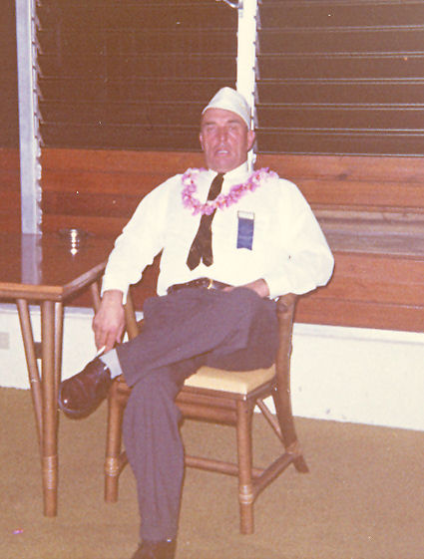Gordon in Hawaii in 1966. The hat he has on is his Pearl Harbor Survivors hat.
In the fall of 1966 Celia went to work at the U&I beet dump weighing beet trucks. This was the first time worked since they were married. They were planning a trip to Hawaii in December and the money would be used for the trip. December 7, 1966 was the twenty-fifth anniversary of the attack on Pearl Harbor and the Pearl Harbor Survivors Association was holding a reunion.
Gordon, Cindee, and Connie were distributed among Celia's sisters. Gordon and Celia drove to Reno, Nevada, and left the car at Milton's. From there they rode the train to San Francisco and flew to Honolulu on a Boeing 707 jetliner. At Pearl Harbor Gordon revisited his old stomping grounds. They even stayed at the Royal Hawaiian where he had stayed many times while in port. They spent ten days touring the island before returning home.
They got home just in time. Gordon's father had been ailing with emphysema for quite some time and was in the hospital. Gover died on December 24, 1966, just two weeks after his 71st birthday. Gover is buried in Clarkston next to his first wife, Mary. When they dug his grave they got too close and scraped her casket. Gordon was one of the pallbearers.
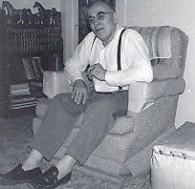Gover, a few months before he died.
Gordon felt the loss of his father. During Gover's later years they spent a lot of time together. He would take little Gordon and the two of them went to his folks for breakfast once in a while. Other times he would take his dad to the water with him or to town after parts or on business. If Gover and Aunt Mary needed to go to Salt Lake or someplace, Gordon was there to take them. A tradition was to go to Clarkston on Memorial Day together every year. After Gover died the tradition continued.
During the fall of 1967 Celia went back to work at the beet dump. Then one day, everything changed. Celia confessed to having made a terrible mistake in which she became trapped.
His family was the only decent thing he had in life, and later in life at that. He wanted life to go on as it had for the last thirteen years. It was of no use, living with the heartache was next to impossible.
That fall, Gordon had to have a hernia operation as soon as the crops were out. He got out of the hospital in time for Thanksgiving. He didn't feel that he had much to be thankful for.
In February Celia left. After only a few days, he asked her to come back on account of the kids. He hoped to hang on at least until school was out. One morning in late spring Gordon and Gordon were waiting for a stream of water, when the Deputy Sheriff found him and served divorce papers. That day she moved out, taking Cindee and Connie with her. At the time, young Gordon was twelve, Cindee was ten, and Connie was six.
A bitter and costly court battle followed. Gordon had to mortgage his farm for more than it was worth in order to pay the attorney fees and court costs and all of the expense that goes with a divorce. On May 11, 1968 it was allover, as far as the legalities went. He ended up with Gordon, the farm, a lot of debt, and a broken heart.
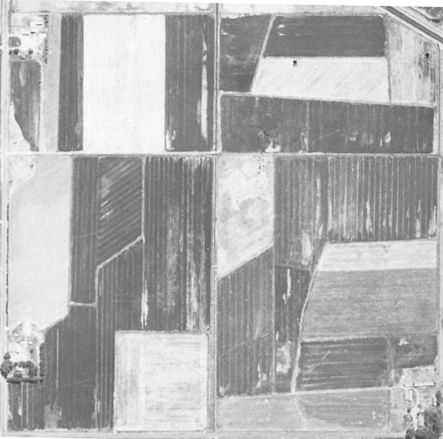The farm Gordon bought is the lower third portion of this picture. The Hitt place that became the West 50 is in the lower right third. The top third is another piece of ground that Gordon rented at one time. The layout of all of these pieces of ground were changed after this picture was taken.
While all this was happening, a second opportunity to buy the Hitt place across the fence came along. Like in 1959, the opportunity fled from his grasp.
All he could do was to pick up the pieces and try to start over. The first thing to do was to get a refrigerator and stove, and buy some groceries. Kind hearted neighbors brought in a meal once in a while. The only way he could get his mind off things was to work and work hard. Young Gordon was with him twenty-four hours a day. They even slept together because they only had one bed. At noon he would let "Sis" off to pop a couple TV dinners or meat pies in the oven while Gordon went to another stream of water. When he got back to the house, dinner was ready. He always told Gordon that someday he would make someone a good wife. During the next several months they became inseparably close.

Chapter 8

BIRDENA

Ralph's wife, Betty, worked in Roper's. One day she and her girlfriends made up a list of eligible women for Gordon. At the top of the list was Birdena Bell. (Her Maiden name was Burnham.) She too had recently gone through a divorce. One night in November, Gordon got up the nerve to call her and introduce himself and arranged for them to meet. Early one Sunday morning, Gordon and Gordon got in the old 58 Chevy pickup and went to meet Birdena and her son. She had three sons, Ron, Wes, and Kevin. Ron was in the Arny, Wes was off somewhere, and Kevin was the only one home.
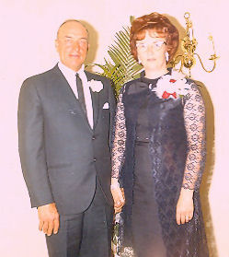Gordon and Birdena
The four of them crowded in the pickup and went off to spend the day together. Gordon and Birdena let the two boys off at the bowling ally and rode around to get acquainted. After a while they picked up Gordon and Kevin and took them to the roller rink while they rode around some more. In the evening they took the boys to a movie while they went to dinner.
By the time the day was over they were pretty well acquainted and began seeing each other on a regular basis. Birdena worked at Thriftway Drug—so did Celia. They had gone together for a few weeks before Celia learned what was going on right under her nose. The very day she did, she quit and went across the street and got another job.
After going together during the winter they began to talk of marriage. The date was set for June 2nd. They decided not to wait and moved the date up. By then Gordon had bought a 1965 Buick Le Sabre. With the wedding plans set, they drove to Reno, Nevada where they got married on April 11, 1969 in the presence of Gordon and Kevin. For their honeymoon they drove to San Fransisco where Ron was stationed. Being in the Army he got them into the base where he was stationed as well as a couple of Navy bases. After coming home, things settled down and there was a family again.
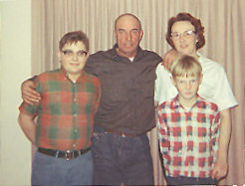Young Gordon, Gordon,Birdena, and Kevin
Gordon soon began to get his feet back on the ground but there was a long way to go. Les still worked for him. He had enough land and raised good crops and he still had his sheep. Birdena kept her job in the drug store.
During the course of Gordon's life, the world made many advancements. Before his dad had a car, he rode in a horse drawn buggy. He remembers the first airplane that flew over Clarkston as well as Lindberg crossing the Atlantic. When Alan Shepard became the first American to go into space in 1961, Gordon had an eerie, haunting feeling that someone could actually leave the earth. Then on July 20, 1969 he watched on television as the first men walked on the moon.
Not long after Gordon and Birdena were married, they took young Gordon and Kevin on a trip to Northern Idaho to visit Birdena's family. She was born in Culdesac and lived in Lewiston before her mother came to Burley when she was a young girl. Her father and brother and several relatives still lived there. Her brother, Dick, and his family lived in Moscow. There were several trips to see them.
In February of 1970, they took Gordon and Kevin out of school for a few days and took a trip to Arizona to see Birdena's step father, Albert Burnham. Gordon was fascinated to see crops being raised year around. As they took a drive through the country, they passed a field where they were digging beets. Right behind the beet topper, they were disking up the ground and planting another crop. The thought ran through Gordon's mind to move is farming operation down there. But it was only a fleeting thought.
When the third time the opportunity to buy the Hitt Place across the fence came along, Gordon still was not in a financial condition to buy it but Birdena was. Gordon rented it from her for a couple of years until he was able to buy it from her. It came to be known as the West 50.
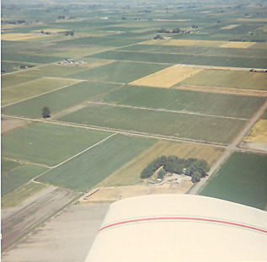A view of the house and yard from the air
The way the ground on the home place was laid out wasn't very efficient. Gordon had someone come in with a carryall and move some dirt around making three larger fields. They were now laid out with the right slope so the water ran through much better. He also had a lot of gravel brought in to build roads along the ditch banks.
A lot of times Gordon worked with other neighbors, particularly during the harvest. He didn't have a combine of his own, but his cousin Cleo Buttars did. Gordon would take his trucks and help Cleo get his grain cut. Then Cleo brought his combine over and cut Gordon's grain. He had a similar deal with Blaine Robins when it came to topping beets. Gordon had a beat topper and Blaine drove the trucks. In 1971 Gordon quit raising sugar beets and concentrated on beans and wheat.
Also in 1971 Gordon rented the Pasket farm which was ninety acres located three miles north. He now had a hundred acres at home, eighty on Story's, ninety at Pasket's, and a forty next to Pasket's, which he rented for a couple of years. That made just over 300 acres.
This is about when Les quit. Once in a while when things got in a bind, he would help out. By now young Gordon was old enough to run the tractors and do a good share of the work. He had been helping with the irrigating for a long time. That same spring Gordon sold all of his sheep, getting out of that phase of his operation.
Grain planting was interrupted that spring when Aunt Mary died on April 16, 1971 and her funeral was a couple days later. She is also buried in the Clarkston cemetery on Gover's other side. When the estate was settled Gordon received $500. At Gover's death, the estate went to Aunt Mary. In her will, Ralph received most all of the estate. That caused such a rift in the family that Gordon, Milton, and Orvin didn't speak to Ralph for several years.
With his $500, Gordon bought a large shed. The old garage was torn down and gravel was hauled in where the new shed was to go. It made an excellent garage with enough space for four cars or some of the machinery. There was also a double deck storage room in the center. Moving it over from Heyburn cost $750, more than the building cost.
December 7, 1971 was the thirtieth anniversary of the attack on Pearl Harbor. Once again the Pearl Harbor Survivors held a reunion in Hawaii. Gordon and Birdena drove to Salt Lake and flew to Los Angeles where they changed planes and flew to Honolulu on a brand new Boeing 747 Jumbo Jet. They stayed for two weeks before returning home.
In August 1972, the beans had been watered for the last time. It was the perfect time for a vacation. Some neighbors had a son aboard the New Enterprise. They told Gordon that the ship was having a dependents day cruise in which the families of the crew could go to sea for a day. Gordon got on the phone and began making calls. Finally he reached the public relations officer aboard the ship. He learned that crew members of the Old Enterprise were honorary members of the New Enterprise. Gordon and his family were extended a special invitation to go on the cruise as guests of the ship.
Gordon, Birdena, and young Gordon made a trip of it. They drove to Portland, Oregon, the first day. The next day to Seattle, Washington, where they got into the ship yard at Bremerton. It was not hard for Gordon to get into bases or Navy shipyards when he showed the guard his Pearl Harbor Survivors Association and Enterprise Association cards. At Bremerton they went aboard the USS Missouri and visited the exact spot where the war officially ended. While in Seattle, Gordon revisited the summer and fall of 1943.
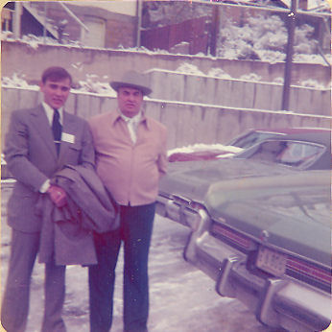Young Gordon leaving on his mission
From Seattle they drove down the coast to the Bay Area where they stayed with Gordon's old shipmate, Edwin Stanisloski. Gordon and Ski (as he was called) were together in aviation supply. The drive down the coast was not as enjoyable as it may have been because it was foggy all the way.
The big day was August 7, 1972 (exactly thirty years after Gordon and the Old Enterprise were participating in landing the Marines on Guadalcanal.) The ship pulled away from the pier at eight o'clock in the morning. Gordon did not think they could take their cameras aboard because it was a Navy ship. On going aboard everyone else had their cameras but it was too far back to the car to get them in time.
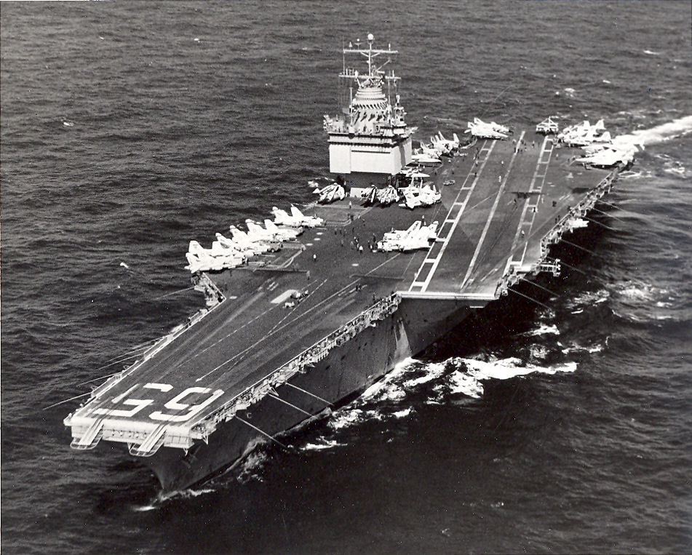The New Enterprise about 1972
The nuclear powered Enterprise was much larger than the Old Enterprise. The New Big E was 1,123 feet long, 250 feet wide and weighed 90,000 tons. When they went under the Golden Gate Bridge the mast barely cleared the bridge. Because of the fog, the ship had to go out about one hundred miles before it was clear enough for the air show. After several planes were launched, the giant carrier stopped dead in the water so the guests could watch the air show from the flight deck. They ate lunch in the mess hall along with the crew. Most of the ship was opened for display. To Gordon, so many things were the same and many things were different. The carrier returned to port just twelve hours after departing. This was truly a memorable day for Gordon.
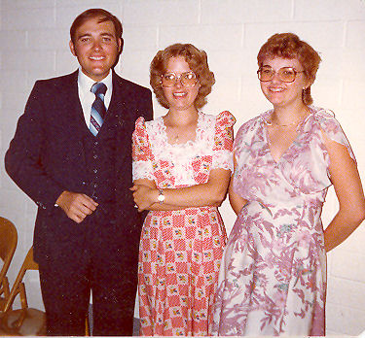 Gordon, Cindee, and Connie July1979
As Connie got a little older she was tired of living in town. Over the course of time when she came out to spend her weekends she would purposely forget to take her clothes home with her. Eventually she had all of her stuff at the farm and one day she simply didn't go home.
Cindee was affected in an adverse way. She began to run with the wrong crowd and got into trouble with the juvenal authorities. Sometime later she was placed in Gordon's custody and she unwillingly moved back out to the farm.
By 1973, he had his three children with him again. At that time Celia moved to California. Thanks to Birdena, Gordon, Cindee, and Connie had an excellent mother. She would not let them call her Mom, rather she preferred to be called Birdena. For a short time there were four children at home. But there was a lot of friction with Kevin. He didn't want to get along and make things work. All he wanted was to go live with his father. Finally he got his wish.
Gordon's family was growing up fast. In May of 1973 young Gordon graduated from high school. The next year Cindee was still not over her problems and quit school.
Gordon still had the same amount of ground, less the forty next to Pasket's. Instead, he had another fifty acres nearby. During 1973 and 1974 Gordon made some good money and was able to buy a bigger tractor and machinery as well as a brand new Buick Electra 225.
Over the years Gordon traded in his tractors for newer ones. First he traded in the G for a Farmall Super M. He then bought a Farmall 460 outright. Later he traded the Super M for a turbo charged Farmall 560. All the while he kept the old A. In 1973 he was considering trading the 460 in for a Farmall 806. While looking into it, he discovered he could get a much more powerful 1206 for not much more money. Gordon was always a generation behind with his tractors but he always did the best he could with what he had.
During the 1973-74 school year young Gordon attended Ricks College in Rexburg. He came home every weekend during the fall and spring to work on the farm.
Cindee married Russel Jamison in Elko, Nevada, on April 26, 1974. About 6 months later Russ joined the Army.
In November of 1973 Gordon and Birdena took a trip to Virginia to see another of Gordon's old shipmates, Charles "Tommy" Tomlison. They drove all the way in their new 1973 GMC pick up. (Actually it was only nine months old when he bought it.) While back east they visited Washington, DC, as well as places of interest long the way.
In December 1974 young Gordon left on a mission for the church in Colorado. With his right hand man gone, Gordon let Pasket's and the other fifty acres close to it go because he wasn't able to handle it by himself. It was hard enough for Gordon to run the home place, West 50, and Story's. During the summer Connie was a big help with the irrigating. She referred to herself as "Daddy's little wet back."
In October of 1976 Gordon finally made contact with his daughter, Joyce. He called one of her aunts to see if he could locate her. Joyce found out about it and called him first. She was married to Joe Taylor and living in Wenatchee, Washington. They had one son, Little Joe. Joyce had two other children, James and Janet Robbins, by a former marriage. The following spring Gordon, Birdena, and Connie drove to Washington to see them. Now they were reunited, they saw each other many times after that.
Cindee and Russel were stationed at Fort Carson near Colorado Springs, Colorado and Gordon was serving in the Littleton area. For Thanksgiving 1975 Gordon, Birdena, and Connie went to spend the holiday with Cindee and Russel. On the way They stopped off to see Gordon. It wasn't long after that Russ was transferred to Germany. Young Gordon came home from his mission in December 1976 and Gordon meet him at the airport at Salt Lake and they drove home together.
With young Gordon now home, once again they worked together. Six months after returning from his mission, he got into an ill fated marriage that ended in divorce the following February. In March he bought a mobile home and set it up in front of the barn where the old lambing shed used to be.
In January of 1978 Russell and Cindee returned from two years in Germany and moved to Alameda, California, were he was stationed. Cindee went to night school at a high school across the street from were they lived and received her high school diploma in 1980.
In September 1978 Gordon had another heart attack, thirty years after his first one. While he was in intensive care at the VA hospital in Boise his beans were getting rained and snowed on. This only made matters worse.
Gordon spent the remainder of the fall taking it easy while young Gordon got the beans harvested and the fall work done. On December 1, 1978 he married Bonnie Jean Kerbs in the Idaho Falls Temple.
Gordon had yet another heart attack on January 29, 1979. This time he spent a few days in intensive care in the Cassia Memorial Hospital in Burley. After that Gordon wasn't able to work on the farm and had to rely on his son to take care of the farm. In 1979 young Gordon started farming for himself. He rented the Story place and a forty across the road from home. Besides doing his own work, he worked for Gordon for the use of the machinery.
Connie graduated from high school in May 1979. She finished a semester ahead of her class and was attending the Overland Beauty College in Burley at the time of her graduation. Gordon did not graduate from school but was proud that his children all did. A year later she finished beauty school and received her operator's license.
On October 30, 1979 another Gordon came into this story. Gordon and Bonnie had their first child, a baby boy who they named Gordon Glen. Gordon was one proud grandpa! Having a grandson living that close gave him something to do also. Nearly every day or two he wandered across the driveway to check in on that little boy. When Gordy got big enough to crawl, he crawled on his hands and knees across the driveway and up to the front door.
In November of 1979 Joyce was left a widow when her husband died of a heart attack. At the time of his death, Joe was running for Sheriff and was attending a rally. Gordon and Birdena made a trip to Washington to attend his funeral.
For thirty years Gordon had worked hard. Now that he couldn't work any longer, he had to find something else to do with his time. He bought a travel trailer and became a fisherman. During the summer Gordon and Birdena would park their trailer at Magic Reservoir. Whenever she had time off from work they would go fishing for a day or two or longer. It wasn't so much the fishing that he enjoyed so much, rather he liked to visit with the other people there; most of them were retired farmers too. They liked Magic because it is close to home, exactly one hundred miles away.
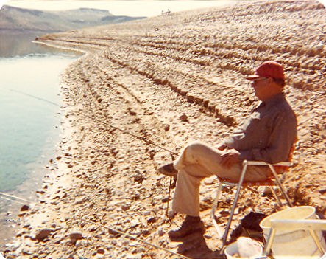Gordon fishing at Magic Reservoir
Connie was now grown up and ready to settle down. She married Samuel Gochnour on February 14, 1980 in the First Christian Church in Burley. They moved into a home at 300 South and 125 East of Burley, only about 4 miles from home. Sam farmed with his family in the Kasota area west of Paul and Connie worked in a beauty shop in Rupert. They both had a ways to go to get to work. Later they moved into a little house only a half a mile away, around the corner from Gordon.
At the age of sixty-two Gordon was old enough to retire and draw Social Security. He had mixed emotions about quitting but knew he had to. He rented his farm to young Gordon and tried to help once in a while. He found out that he couldn't even do a little work.
On the first Saturday in August 1980, a Gordon Go-ver Buttars Family Reunion was held in his own front yard. All of his children were there except Cindee who was in California. Connie and Sam, Gordon and Bonnie and Little Gordy, and Milton and Mildred came over. Ron and Mona came from Boise. And Joyce came all the way from Washington. It was a joy for Gordon to have his family together. Cindee spent a lot of time at home that fall and part of the winter.
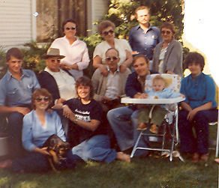The reunion. Seated: Connie and Joyce. Middle row:Sam, Gordon, Milton, Young Gordon, Gordy, and Bonnie. Standing: Birdena, Mildred, Ron, and Mona.
On January 26, 1981 Gordon sold part of the farm to his son. With the money he got for the West 50 Gordon was able to payoff what he still owed on the rest of the farm and the rest of his debts. It made him feel good to know that what he worked hard for all of his life was staying in his family.
During the summer of 1982 Gordon wasn't feeling well and had been to the VA hospital in Boise several times. On July 13th his granddaughter, Kellie Jo Gouchnor, was born. Earlier in the spring, Cindee and Russell were divorced.
In September it was discovered that he had an aneurysm on the aorta leading from his heart. It was like a bubble that could rupture at any time, causing him to bleed to death. Surgery was the only way to correct the problem but first the doctors had to determine if his heart was in good enough condition to go through with such an operation.
After a few more trips to Boise, his doctor decided to send him to the VA Hospital in Salt Lake. The doctors in Salt Lake decided that before the aneurysm could be repaired, he needed to have double bypass surgery.
While waiting to have the operation, another granddaughter, Olivia Buttars, was born on November 13, 1982. For Thanksgiving, the whole family got together. But the occasion was overshadowed by worry and concern over the pending operation. The operation was scheduled for just before Christmas. He went to Salt Lake only to have it postponed until January 13th. So Gordon came home for Christmas and waited for his next appointment.
At the same time, he was concerned for young Gordon. There had been a frost the year before that devastated his bean crop and he was not able to repay his operating costs for the year. In 1982 he had a pretty good crop but it wasn't enough to make up for the previous year. The overall farm economy was not very good at the time. The Farm Home Administration was demanding payment before extending any credit for the next year. Gordon and Gordon talked a lot during December and early January as what he should do. It was obvious the farm was in trouble.
Gordon and Birdena went to the hospital in Salt Lake only to have the operation postponed for another week, so they came home to wait a few more days. Finally the day arrived. The morning he went into the hospital, Orvin and Nadine, and young Gordon were there with Gordon and Birdena. Orvin and Nadine had to leave but Birdena and young Gordon waited with him until he was wheeled off to the operating room. As he was being taken away he said, “Off I go into the wild blue yonder.”
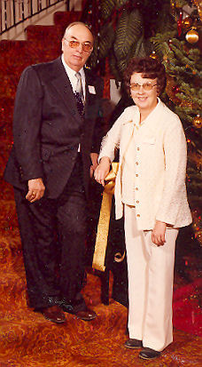Gordon and Birdena
Throughout the operation a nurse kept Birdena and Gordon posted and assured them that everything was going fine. When the operation was over, Dr. William DeVries (the doctor who only weeks before had performed the worlds first artificial heart transplant) came out to tell them that everything had gone perfectly. Gordon was in the recovery room and he told them that they would be able to talk to him in a couple of hours.
While in the recovery room, before he came out of the anesthesia, Gordon had a massive heart attack. The doctors did everything in their power to revive him, with no success. Gordon Gover Buttars died on January 19, 1983 at the University of Utah Medical Center in Salt Lake City, Utah, at the age of 64 years, 6 months, and 2½ weeks. Funeral services where held at 11:00 a.m. at the Pella LDS. Chapel and he was buried in the Pleasant View Cemetery in Burley.

~ ~ ~ ~ ~ ~ ~ ~

In February, Gordon moved his little Family to Salt Lake were he attended a vocational school and received training as a computer programmer. Gordon and Bonnie moved to Rexburg, Idaho in October 1983. Two more children were born to them there. Vance Allen Buttars was born on November 22, 1985 and died the next day. Loren Vance was born on June 28th 1987.
Cindee married Steven Werich on November 6, 1983 and they made their home in the Burley/Rupert.
Connie and Sam moved to Grandview, Idaho near Mountain Home where Sam worked on a Dairy. Their second child, Kyle Austin was born on November 6, 1984. They had bought a doublewide mobile home and were in the process of setting it up when Sam was killed on February 22, 1985 as the eight foot deep trench he was working caved in on him. He is buried next to Gordon. Connie moved back to Heyburn and raised her children alone. She married Frank Uriguen on June 16, 2004.
Joyce disappeared and the family lost contact with her and her family. She died on September 29, 2005 in Las Vegas, Nevada.
Birdena bought a trailer house in a mobile home park in Burley. She continued working as a dietitian at Cassia Memorial Hospital until she retired. After fifteen years, she remarried on December 18, 1997 and moved to St. Anthony Idaho to be with her new husband, Edland Clark. She died suddenly in her sleep of a heart attack on April 6, 2000.
Of his surviving brothers, Milton died on September 22, 1984, Ralph died on July 24, 2010, and Orvin died on September 20, 2019.

