PART III
Farmer

Chapter 5
THE UNSETTLED YEARS

When Gordon came home from the Navy, he felt lost and didn't know what he wanted to do. He didn't want to farm after after having been in the service. Farming was to much work. One of the first things he did when he got home was to buy a 1940 Buick Special Coupe.
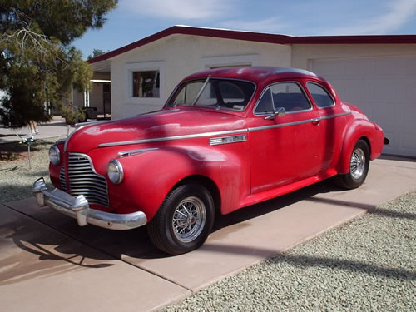A 1940 Buick Special Coupe, similar to the one Gordon had
Right after coming home, Ralph wanted to wear his uniform to a Halloween party. His friend had borrowed his brother's uniform and the two of them wanted to go as sailors. When Ralph put it on, Gordon said, “Now, Ralph. You're going to get into trouble if you wear that.” He wore it anyway and sure enough they got into trouble. They had been drinking and ran Gover's car off the road, breaking out a headlight and dented the fender. Gordon happened along in his car and saw them off the side of the road. He stopped and helped them get it back on the road. Ralph was scared and afraid of what Gover would do to him. Gordon let them take his car. He would take the blame for wrecking his dad's car. Ralph ended up getting into more trouble for letting Gordon take his car “while he had been out drinking” than he would have if he would have been upfront and took the blame for wrecking it himself.
Not long after coming home, he went to a movie at the Burley Theater with his date, Myrtle Drake, and Milton and Mildred. The movie opened with a battleship sailing across the screen. All of a sudden it opened fire with it's big guns; right into the audience. Gordon let out a blood curdling scream and threw his hands in the air as he rared back in his seat, tearing the screws out of the floor. The entire row of seats and everyone on it went over backwards with him. It wasn't hard to figure out who did it. He was the one with a red face that glowed in the dark.
Gordon fought worse battles in his sleep than he was ever in. One night soon after the war when he was asleep in his own bed, he dreamed that a plane flew up the flight deck and dropped it's bombs and blew him into the water. He lost an arm and a leg in the explosion and the salt water was burning the open wounds. As he laid in bed, he cried out with moanings and groanings. It sounded like someone in terrible pain to Gover, so he burst into Gordon's room, to see if he was alright. Another time he dreamed some Jap flying boats flew over the farm many times searching for him as he hid in the well. The war was over but it took many years to get back to a normal life, although he never really did get over it.
Gordon stayed around Burley for a few months, living at home. The next spring he helped put up the first crop hay. Ralph had his appendix taken out earlier and still was slightly weak but was strong enough to work. Gordon pitched the hay from one side and Ralph from the other. Orvin rode the wagon tromping the hay. After the stack got so high, Gordon wouldn't let Ralph pitch any more and he worked from both sides of the wagon.
Orvin wasn't helping, so Gordon chewed him out. Orvin, who was about fifteen, stood up and said, “Now you listen here, you are not talking to a bunch of sailors any more!" That was the wrong thing to say. Gordon stuck his fork in the ground and started up the front of the wagon. Orvin let out a squeal and jumped off the top, hitting the ground on a run for the house and told Gover that Gordon was after him. When Gordon got to the yard, his dad asked him, “What happened out there?”
He responded, "All I was trying to do was to get Orvin to help Ralph."
Soon after that, Gordon went to Idaho Falls to see if he could find work. He went to work in a Safeway store stocking shelves for a while. After a month, his boss told him, "Now, I'm not going to fire you, but you're not much good to me. Why don't you get a job driving a big truck or a cat?" He gave Gordon a recommendation to use in getting other jobs stating that he was a loyal and hard worker. Gordon carried that recommendation around with him in his wallet for a longtime after that.
He decided he wanted to go to Denver, Colorado. He set out hitch-hiking and soon got a ride. Only the man who picked him up was going to Ontario, Oregon. Ontario sounded good enough to him, so he took the ride. In Ontario he got a job at a frozen food plant. The following spring he quit there and returned to Burley for a while.
Gordon married Carolyn Bowers on April 27, 1947 in Elko, Nevada. At the time, he was living alone and getting married and settling down seemed like the thing to do. Shortly after getting married, they went back to Ontario and he got a job in a grain mill. That November he had a heart attack at twenty nine years old, only he didn't know what hit him. He called in sick and said he wasn't feeling well. A few days later he went back to work. He did go to see a doctor, but there was a long waiting line and he didn't want to wait so he left. In March 1948 he had a second one, still not knowing what was happening.
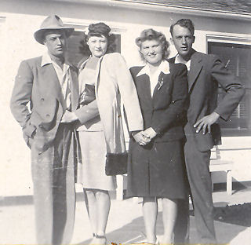Gordon and Carrie with Mildred and Milton
After he was feeling better, Gover came to see him and talked him into quiting his job and coming home to work the farm. So he and Carrie moved back to Burley. In June he went to the V.A. Hospital in Boise to find out what had happened to him. That is when he learned that he had had a heart attack. He was there quite some time. While he was in the hospital, Gover took care of the farm.
In 1949 Gordon decided to start farming for himself. He rented a farm out in Declo. It was on the east side of the highway next to the river. That spring Gordon bought an old Farmall F-12 tractor at a farm sale. The morning of the sale, Frank Coffee, who just happened to be the auctioneer, had bought some hay from him and knew that Gordon had $300 (the price of the hay.) As the bidding got going, Gordon bid $300. Mr. Coffee stopped the bidding and said, "Sold to Gordon Buttars for three hundred dollars.” The tractor came with a hang on plow. The F-12 had a crank that had to be tuned in order to start the engine. It was rated at about twelve horsepower on the draw bar.
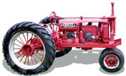A Farmall F-12 similar to the one Gordon had
He had some milk cows before moving out to Declo. All he had for machinery was that old tractor and plow. Years later he made the statement, "When I started farming, all I started out with was a sack of bullduram and mad wife." Being married to Carrie was agony. They were more like drinking buddies than anything else. When they weren't drinking they were fighting.
He only farmed out to Declo one year. During 1950 and 1951 he farmed at 450 South 50 East. Then in 1952 he moved to the George Kelly place about a mile away. On March 12, 1952 he and Carrie were divorced. They had no children as she was unable to have any. He thought about having a family of his own, but had to be content with being an uncle. When Milton and Mildred got married, he became Uncle Gordon to her four daughters. A year later, Reed was born. Ralph married Arlene Stevenson on August 25, 1946. The gave Gordon another niece and two more nephews. Ralph and Arlene were later divorced.
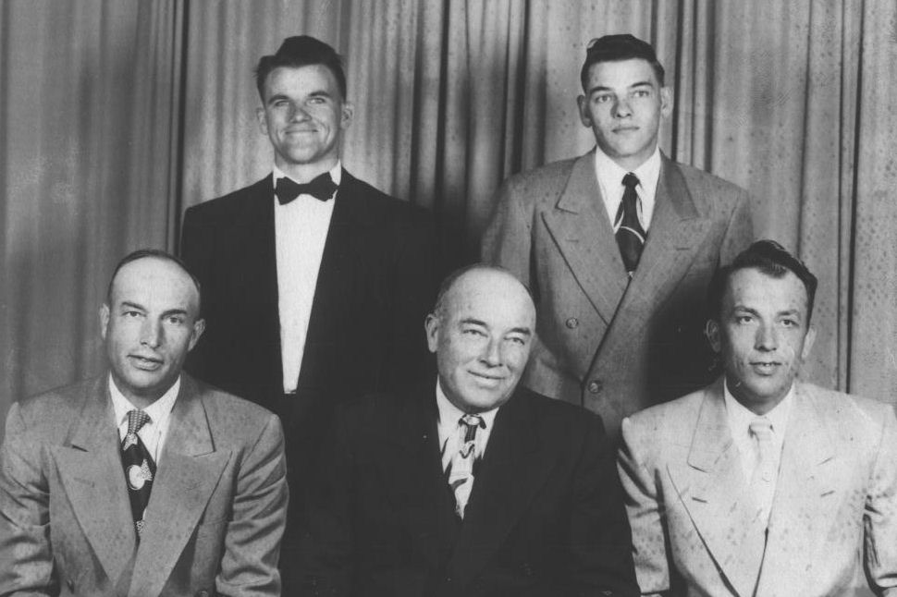Gordon, Orvin, Gover, Ralph, and Milton in 1953
Gordon remained on the Kelly place and ran the farm that year and 1953. In 1953 Lola brought Joyce to meet him and told her that he was her father. All that time she was under the impression that her step-dad was her father. It was many, many years before he had any further contact with Joyce.
The eight years that followed the war was an unsettled time for Gordon. He had tried many things and moved several times. He would move onto a farm and spend a year or two getting it in condition to begin producing. Then the landlord's son or the landlord himself decided they wanted it. All he could do was find another place to rent and move on. He was able to build a good herd of dairy cows and acquire a more complete line of farm equipment. He also traded his Buick in for a 1948 Studebaker Land Cruiser
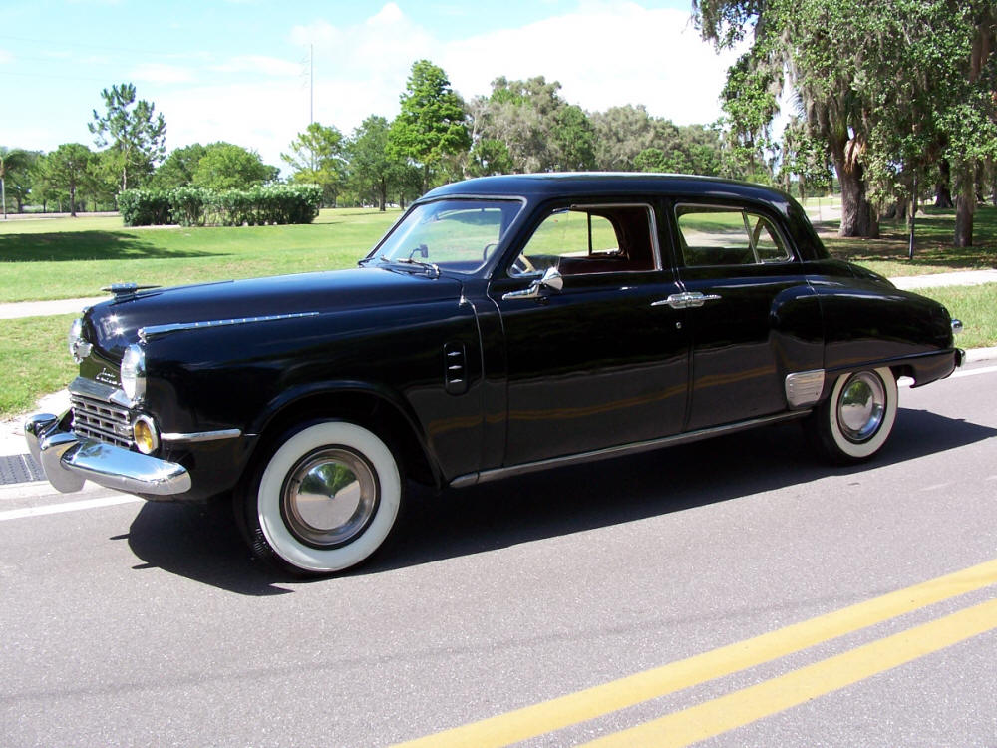A 1948 Studebaker Land Cruiser similar to the one Gordon had
The only family he had other than his folks was Nick, his dog that he raise from a pup. When Gordon fixed some breakfast for himself, he'd always fix a couple eggs for Nick. Nick was about the only friend he had. What Gordon needed was a wife and family.
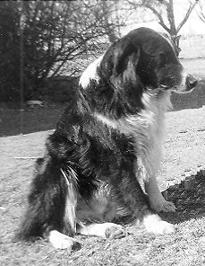Old Nick
In the spring of 1954 he moved to the Asel Gee place located at 500 south 150 east of Burley. About this time Aunt Mary introduced him to Celia Gean Frost. At the time she worked at Miller Drug. Celia, who was twenty seven years old at the time, was recently divorced with two children, Melody and Tim Dudley.
The first time Gordon took Celia out, his friend, Gene Riddle, took Celia's cousin, Lois Dayley. They went to a night club in Twin Falls for an evening of dining and dancing. On the way home, he had to stop suddenly. All the beer bottles came rolling out from under the seat of his car. Celia was actually a second cousin to his first wife, Lola.
He found Celia to be a decent woman and they began courting. He would take her to a movie and out for a hamburger. Celia was living with her parents and her mother made him have her home by midnight. Celia and her mother worried about his drinking. Her father told them not to worry, "He's a man, he'll quit. You won't get him to stop smoking but he is man enough to quit drinking.” And he did.

