Chapter 7
BIRDENA

Ralph's wife, Betty, worked in Roper's. One day she and her girl friends made up a list of eligible women for Gordon. At the top of the list was Birdena Bell. (Her Maiden name was Burnham.) She too had recently gone through a divorce. One night in November, Gordon got up the nerve to call her and introduce himself to her and arranged for them to meet. Early one Sunday morning, Gordon and Gordon got in the old 59 Chevy pickup and went to meet Birdena and her son. She had three sons, Ron, Hes, and Kevin. Ron was in the Arny, Wes was off somewhere, and Kevin was the only one home.
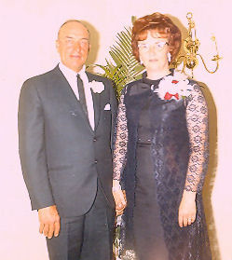Gordon and Birdena at their wedding
The four of them crowded in the pickup and went off to spend the day together. Gordon and Birdena let the two boys off at the bowling ally and rode around to get more acquainted. After a while they picked up Gordon and Kevin and took them to the roller rink while they rode around some more. In the evening they took the boys to a movie while they went to dinner.
By the time the day was over they were pretty well acquainted and began seeing each other on a regular basis. Birdena worked at Thriftway Drug… so did Celia. They had gone together for a few weeks before Celia learned what was going on right under her nose. The very day she did, she quit and went across the street and got another job.
After going together during the winter they began to talk of marriage. The date was set for June 2nd. They decided not to wait and moved the date up. By then Gordon had bought a car, a 1965 Buick Le Sabre. With the wedding plans set, they drove to Reno, Nevada where they got married on April 11, 1969 in the presence of Gordon and Kevin. For their honeymoon they drove to San Fransisco where Ron was stationed. Being in the Army he got them into the base where he was stationed as well as a couple Navy bases. After coming home, things settled down and there was a family again.
Gordon soon began to get his feet back on the ground but there was a long way to go. Les still worked for him. He had enough land and raised good crops. He still had his sheep. Birdena kept her job in the drug store.
During the course of Gordon's life, the world made many advancements. Before his dad had a car, he rode in a horse drawn buggy. He remembers the first airplane that flew over Clarkston as well as Lindberg crossing the Atlantic. When Alan Shepard became the first American to go into space in 1961, Gordon had an eerie, haunting feeling that someone could actually leave the earth. Then on July 20, 1969 he watched on television as the first men walked on the moon.
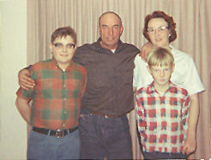Young Gordon, Gordon,Birdena, and Kevin
Not long after Gordon and Birdena were married, they took young Gordon and Kevin on a trip to Northern Idaho to visit Birdena's family. She was born in Culdesac and lived in Lewiston before her mother came to Burley when she was a young girl. Her father and brother and several relatives still lived there. Her brother, Dick, and his family lived in Moscow. There were several trips to see them.
In February of 1970, they took Gordon and Kevin out of school for a few days and took a trip to Arizona to see Birdena's step father, Albert Burnham. Gordon was fascinated to see the crops being raised year around. As they took a drive through the country, they passed a field where they were digging beets. Right behind the beet topper, they were disking up the the ground and planting another crop. The thought ran through Gordon's mind to move is farming operation down there. But it was only a fleeting thought.
For the third time the opportunity to buy the Hitt Place across the fence came along. Gordon still was not in a financial condition to buy it but Birdena was, with some money that she had. Gordon rented it from her for a couple of years until he was able to buy it from her. It came to be known as the West 50.
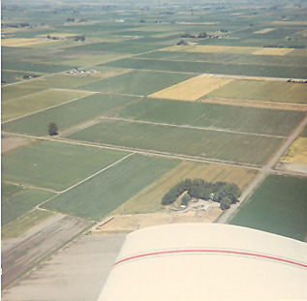A view of the house and yard from the air
The way the ground on the home place was laid out wasn't very efficient. Gordon had someone come in with a carryall and move some dirt around three larger fields. They were now laid out with the right slope so the water ran through much better. He also had a lot of gravel brought in to make some roads built along the ditch banks.
A lot of times Gordon worked with other neighbors, particularly during the harvest. He didn't have a combine of his own, but his cousin Cleo Buttars did. Gordon would take his trucks and help Cleo get his grain cut. Then Cleo brought his combine over and cut Gordon's grain. He had a similar deal with Blaine Robins when it came to topping beets. Gordon had a beat topper and Blaine drove the trucks. In 1971 Gordon quite raising sugar beets and concentrated on beans and wheat.
Also in 1971 Gordon rented the Pasket farm which was ninety acres located three miles north. He now had a hundred acres at home, eighty on Story's, ninety at Pasket's, and a forty next to Pasket's, which he rented for a couple years. That made just over 300 acres.
This is about when Les quit. Once in a while when things got in a bind, he would help out. By now young Gordon was old enough to run the tractors and do a good share of the work. He had been helping with the irrigating for a long time. That same spring Gordon sold all of his sheep, getting out of that phase of his operation.
Grain planting was interrupted that spring. Aunt Mary died on April 16, 1971 and her funeral was a couple days later. She is also buried in the Clarkston cemetery on Gover's other side. When the estate was settled Gordon received $500. At Gover's death, the estate went to Aunt Mary. In her will, Ralph received most all of the estate. That caused such a rift in the family that Gordon, Milton, and Orvin didn't speak to Ralph for several years.
With his $500, Gordon bought a large shed. The old garage was torn down and gravel was hauled in where the new shed was to go. It made an excellent garage with enough space for four cars or some of the machinery. There was also a double deck storage room in the center. Moving it over from Heyburn cost $750, more than the building cost.
December 7, 1971 was the thirtieth anniversary of the attack on Pearl Harbor. Once again the Pearl Harbor Survivors held a reunion in Hawaii. Gordon and Birdena drove to Salt Lake and flew to Los Angeles where they changed planes and flew to Honolulu on a brand new Boeing 747 Jumbo Jet. They stayed for two weeks before returning home.
In August 1972, the beans had been watered for the last time. It was the perfect time for a vacation. Some neighbors had a son aboard the New Enterprise. They told Gordon that the ship was having a dependents day cruise in which the families of the crew could go to sea for a day. Gordon got on the phone and began making phone calls. Finally he reached the public relations officer aboard the ship. He learned that crew members of the Old Enterprise where honorary members of the New Enterprise. Gordon and his family where extended a special invitation to go on the cruise as guests of the ship.
Gordon, Birdena, and young Gordon made a trip of it. They drove to Portland, Oregon the first day. The next day to Seattle, Washington where they got into ship yard at Bremerton. It was not hard for Gordon to get into bases or Navy shipyards when he showed the guard his Pearl Harbor Survivors Association and Enterprise Association cards. At Bremerton they went aboard the U.S.S. Missouri and visited the exact spot where the war officially ended. While in Seattle, Gordon revisited the summer and fall of 1943.
From Seattle they drove down the coast to the Bay Area where they stayed with Gordon's old shipmate, Edwin Stanisloski. Gordon and Ski (as he was called) were together in aviation supply. The drive down the coast was not as enjoyable as it may have been because it was foggy all the way.
The big day was August 7, 1972 (exactly thirty years after Gordon and the Old Enterprise were participating in landing the Marines on Guadalcanal.) The ship pulled away from the pier at eight o'clock in the morning. Gordon did not think they could take their cameras aboard because it was a Navy ship. On going aboard everyone else had their cameras but it was too far back to the car to get them in time.
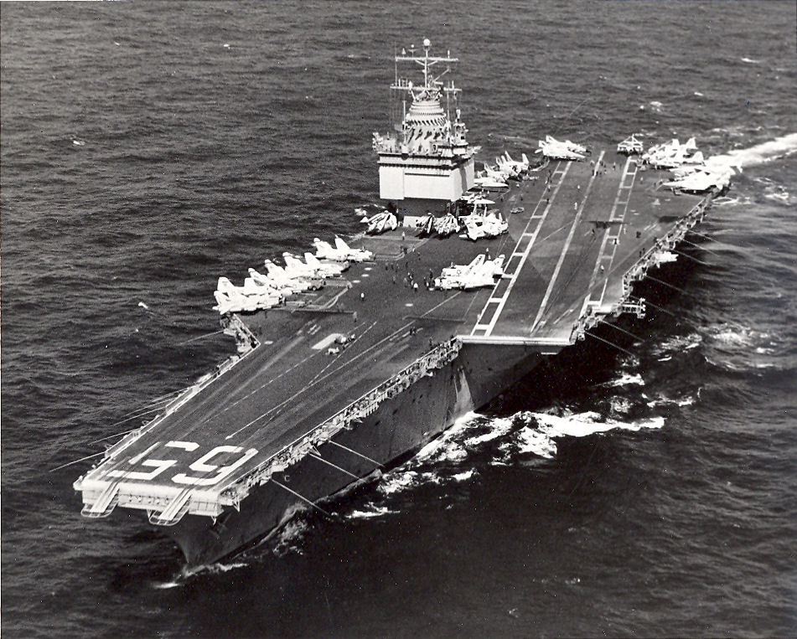The New Enterprise about 1972
The nuclear powered Enterprise was much larger than the old Enterprise. The New Big E was 1,123 feet long, 250 feet wide and weighed 90,000 tons. When they went under the Golden Gate Bridge the mast barley cleared the bridge. Because of the fog, the ship had to go out about one hundred miles before it was clear enough for the air show. After several planes were launched, the giant carrier stopped dead in the water so the guests could watch the air show from the flight deck. They ate lunch in the mess hall along with the crew. Most of the ship was opened for display to the visitors. To Gordon, so many things were the same and many things were different as well. The carrier returned to port just twelve hours after departing. This was truly a memorable day for Gordon.
As Connie got a little older she was tired of living in town. Over the course of time when she came out to spend her weekends she would purposely forget to take her clothes home with her. Eventually she had all of her stuff at the farm and one day she simply didn't go home. Cindee was affected in an adverse way. She began to run with the wrong crowd and got into trouble with the juvenal authorities. Sometime later she was placed in Gordon's custody and she unwillingly moved back out to the farm.
By 1973, he had his three children with him again. At that time Celia moved to California. Thanks to Birdena, Gordon, Cindee, and Connie had an excellent mother. She would not let them call her Mom, rather she preferred to be called Birdena. For a short time there were four children at home. But there was a lot of friction with Kevin. He didn't want go along and make things work. All he wanted was to go live with his father. Finally he got his wish.
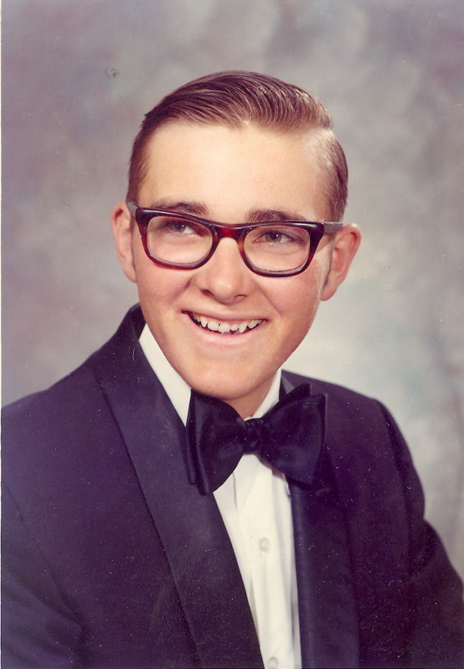Young Gordon 1973
Gordon's family was growing up fast. In May of 1973 young Gordon graduated from high school. The next year Cindee was still not over her problems and quit school.
Gordon still had the same amount of ground, except for the forty next to Pasket's. Instead, he had another fifty acres nearby. During 1973 and 1974 Gordon made some good money and was able to buy a bigger tractor and machinery as well as a brand new Buick Electra 225.
Over the years Gordon traded in his tractors for newer ones. First he traded in the G for a Farmall Super M. He then bought a Farmall 460 outright. Later he traded the Super M for a turbo charged Farmall 560. All the while he kept the old A. In 1973 he was considering trading the 460 in for a Farmall 806. While looking into it, he discovered he could get a much more powerful 1206 for not much more money. Gordon was always a generation behind with his tractors but he always did the best he could with what he had.
During the 1973-74 school year young Gordon was attending Ricks College in Rexburg. He came home every weekend during the fall and spring to work on the farm. Cindee married Russel Jamison in Elko on April 26, 1974, Nevada. About 6 months later Russ joined the Army.
In November of 1973 Gordon and Birdena took another big trip. They went to Virginia to see another of Gordon's old shipmates, Charles A. "Tommy" Tomlison. They drove all the way in their new 1973 GMC pick up. (Actually it was only nine months old when he bought it.) While back east they visited Washington D.C. as well as places of interest long the way.
In December 1974 young Gordon left on a mission for the church in Colorado. With his right hand man gone, Gordon had to let Pasket's and the other fifty acres close to it go because he wasn't able to handle it by himself. It was hard enough for Gordon to run the home place, West 50, and Story's. During the summer Connie was a big help with the irrigating. She refereed to herself as "Daddy's little wet back."
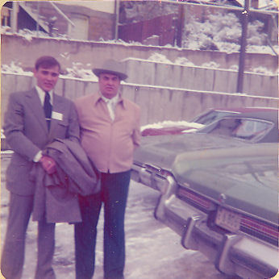Young Gordon leaving on his mission
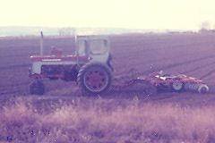The 560
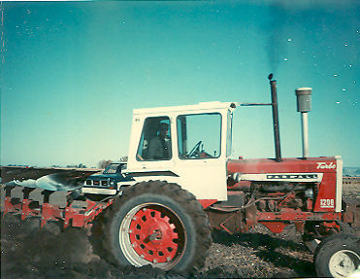Gordon plowing with the 1206
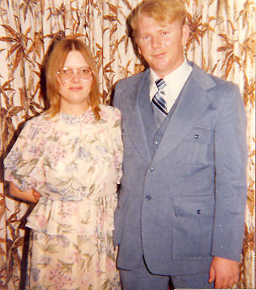Cindee and Russell (taken in 1978)
In October of 1976 Gordon finally made contact with his daughter, Joyce, after so many years. He called one of her aunts to see if he could locate her. Joyce found out about it and called him first. She was married to Joe Taylor and living in Wenatchee, Washington. They had one son, Little Joe. Joyce had two other children, James and Janet Robbins, by a former marriage. The following spring Gordon, Birdena, and Connie drove up to Washington to see them. Now they were reunited, they seen each other many times after that.
Cindee and Russel were stationed at Fort Carson near Colorado Springs, Colorado and Gordon was serving in the Littleton area. For Thanksgiving 1975 Gordon, Birdena, and Connie went to spend the holiday with Cindee and Russel. On the way They stopped off to see Gordon. It wasn't long after that Russ was transfered to Germany. Gordon came from his mission in December 1976. Gordon meet his son at the airport at Salt Lake and the two drove home together.
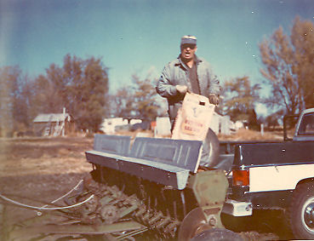Gordon Planting grain 1975 or 76
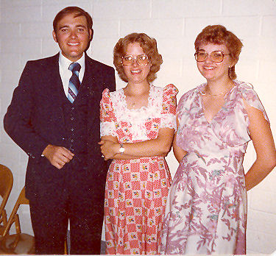 Gordon, Cindee, and Connie July1979
With young Gordon now home, once again they worked together. Six months after returning from his mission, he got into an ill fated marriage that ended in divorce the following February. In March he bought a mobile home and set it up in front of the barn where the old lambing shed used to be.
In January of 1978 Russell and Cindee returned from two years in Germany and moved to Alameda, California were he was stationed. Cindee went to night school at a high school across the street from were they lived and received her high school diploma in 1980.
In September 1978 Gordon had another heart attack, thirty years after his first one. While he was in intensive care at the V.A. hospital in Boise his beans were getting rained and snowed on. This only made matters worse for him.
Gordon spent the remainder of the fall taking it easy while young Gordon got the beans harvested and the fall work done. On December 1, 1978 he married Bonnie Jean Kerbs in the Idaho Falls Temple.
Gordon had yet another heart attack on January 29, 1979. This time he spent a few days in intensive care in the Cassia Memorial Hospital in Burley. After that Gordon wasn't able to do any work on the farm and had to rely on his son to do take care of the farm. In 1979 young Gordon started farming for himself. He rented the Story place and a forty across the road from home. Besides doing his own work, he worked for Gordon for the use of the machinery.
Connie graduated from high school in May 1979. She finished a semester ahead of her class and was attending the Overland Beauty College in Burley at the time of her graduation. Gordon did not graduate from school but was proud that his children all did. A year later she finished beauty school and received her operator's license.
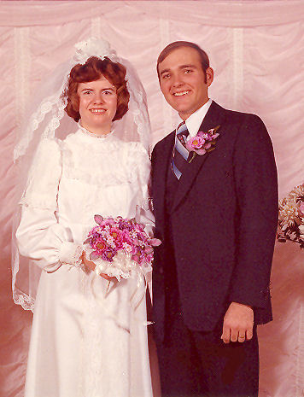Bonnie and Gordon
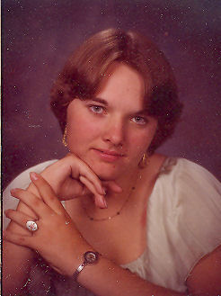Connie i n 1979
On October 30, 1979 another Gordon came into this story. Gordon and Bonnie had their first child, a baby boy. They named him Gordon Glen. Gordon was one proud grandpa! Having a grandson living that close gave Gordon something to do also. Nearly every day or two he wandered across the driveway to check in on that little boy and play with him. When Gordy got big enough to crawl, he crawled on his hands and knees across the driveway and up to the front door.
In November of 1979 Joyce was left a widow when her husband died of a heart attack. At the time of his death, Joe was running for Sheriff and was attending a rally. Gordon and Birdena made a trip to Washington to attend his funeral.
For thirty years Gordon had worked hard. Now that he couldn't work any longer, he had to find something else to do with his time. He bought a travel trailer and became a fisherman. During the summer Gordon and Birdena would park their trailer at Magic Reservoir. Whenever she had time off from work they would go fishing for a day or two or longer. It wasn't so much the fishing that he enjoyed so much, rather he liked to visit with the other people there; most of them were retired farmers too. They liked Magic was because it is close to home, exactly one hundred miles away.
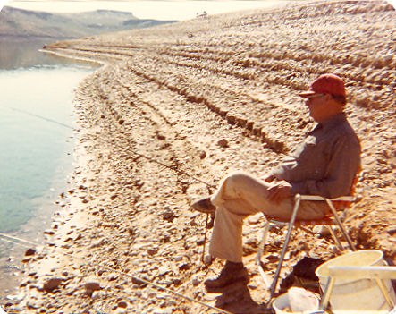Gordon fishing at Magic Reservoir
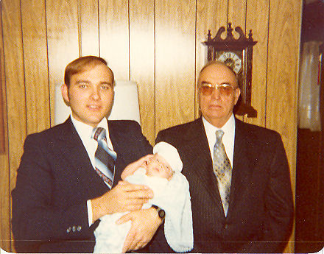The three Gordons
Connie was now grown up and ready to settle down. She married Samuel Gochnour on February 14, 1980 in the First Christian Church in Burley. They moved into a home at 300 South and 125 East of Burley, only about 4 miles from home. Sam farmed with his family out in the Kasota area west of Paul and Connie worked in a beauty shop in Rupert. They both had a ways to go to get to work. Later they moved into a little house only a half a mile away, around the corner from Gordon.
At the age of sixty-two Gordon was old enough to retire and draw Social Security. He had mixed emotions about quiting but knew he had to. He rented his farm to young Gordon and tried to help once in a while. He found out that he couldn't even do a little work.
On the first Saturday in August 1980, the first ever Gordon Gover Buttars Family Reunion was held in his own front yard. All of his children were there except Cindee who was in California. Connie and Sam, Gordon and Bonnie and Little Gordy, and Milton and Mildred came over. Ron and Mona came down from Boise. And Joyce came all the way from Washington. It was a real joy for Gordon to have his family together. Cindee spent a lot of time at home that fall and part of the winter.
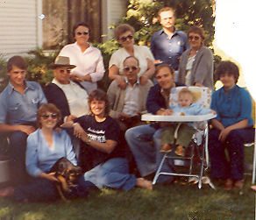The reunion. Seated: Connie and Joyce. Middle row:Sam, Gordon, Milton, Young Gordon, Gordy, and Bonnie. Standing: Birdena, Mildred, Ron, and Mona.
On January 26, 1981 Gordon sold part of the farm to his son. With the money he got for the West 50 Gordon was able to payoff what he still owed on the rest of the farm and payoff the rest of his debts. It made him feel good to know that what he worked hard for all of his life was staying in his family.
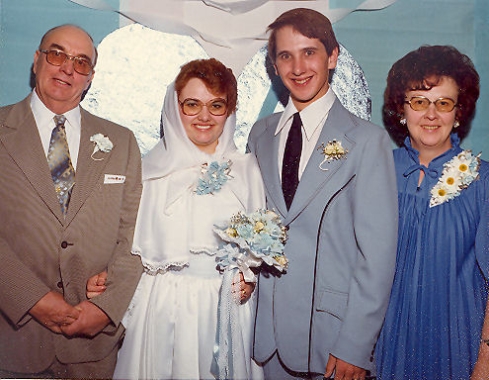Connie and Sam's wedding
During the summer of 1982 Gordon wasn't feeling well and had been to the VA hospital in Boise several times to see the doctor. On July 13th his granddaughter, Kellie Jo Gouchnor, was born and there was another grandchild was on the way. Earlier in the spring, Cindee and Russell were divorced.
In September it was discovered that he had an aneurysm on the aorta leading from his heart. It was like a bubble that could rupture at any time, causing him to bleed to death. Surgery was the only way to correct the problem but first the doctors had to determine if his heart was in good enough condition to go through with such an operation.
After a few more trips to Boise, his doctor decided to send him to the VA Hospital in Salt Lake. The doctors in Salt Lake decided that before the aneurysm could be repaired, he needed to have double bypass surgery.
While waiting to have the operation, another granddaughter, Olivia Buttars, was born on November 13, 1982. For Thanksgiving, the whole family got together. But the occasion was overshadowed by worry and concern over the pending operation. The operation was scheduled for just before Christmas. He went to Salt Lake only to have it postponed until January 13th. So Gordon came home for Christmas and waited for his next appointment.
At the same time, he was concerned for young Gordon. There had been a frost the year before that devastated his bean crop and he was not able to repay his operating costs for the year. In 1982 he had a pretty good crop but it wasn't enough to make up for the previous year. The overall farm economy was not very good at the time. The Farm Home Administration was demanding payment before extending any credit for the next year. Gordon and Gordon talked a lot during December and early January as what he should do. It was obvious the farm was in trouble.
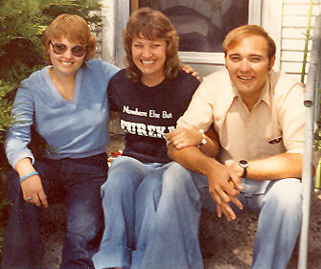Connie, Joyce, and young Gordon
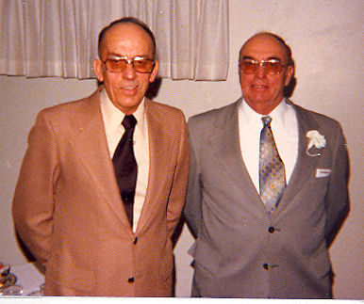Milton and Gordon - February 1980
Gordon and Birdena went down to the hospital in Salt Lake only to have the operation postponed for another week, so they came home to wait a few more days. Finally the day arrived. The morning he went into the hospital, Orvin and Nadine, and Gordon were there with Gordon and Birdena. Orvin and Nadine had to leave but Birdena and young Gordon waited with him until he was wheeled off to the operating room. As he was being taken away he said, “Off I go into the wild blue yonder.”
Throughout the operation a nurse kept Birdena and Gordon posted and assured them that everything was going fine. When the operation was over, Dr. William DeVries (the doctor who only weeks before had performed the worlds first artificial heart transplant) came out to tell then that everything had gone perfectly. Gordon was in the recovery room and he told them that they would be able to talk to him in a couple of hours.
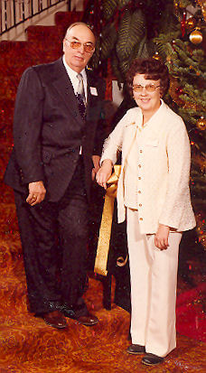Gordon and Birdena
While in the recovery room, before he came out of the anesthesia, Gordon had a massive heart attack. The doctors did everything in their power to revive him, with no success. Gordon Gover Buttars died on January 19, 1983 at the University of Utah Medical Center in Salt Lake City, Utah at the age of 64 years, 6 months, and 2½ weeks. Funeral services where held at 11:00 a.m. at the Pella L.D.S. Chapel and he was buried in the Pleasant View Cemetery in Burley.
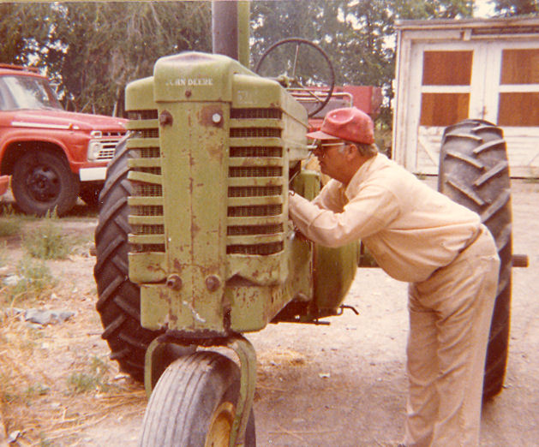Tinkering with the old A


