Esther Davis 24 April 1839 – 26 December1910
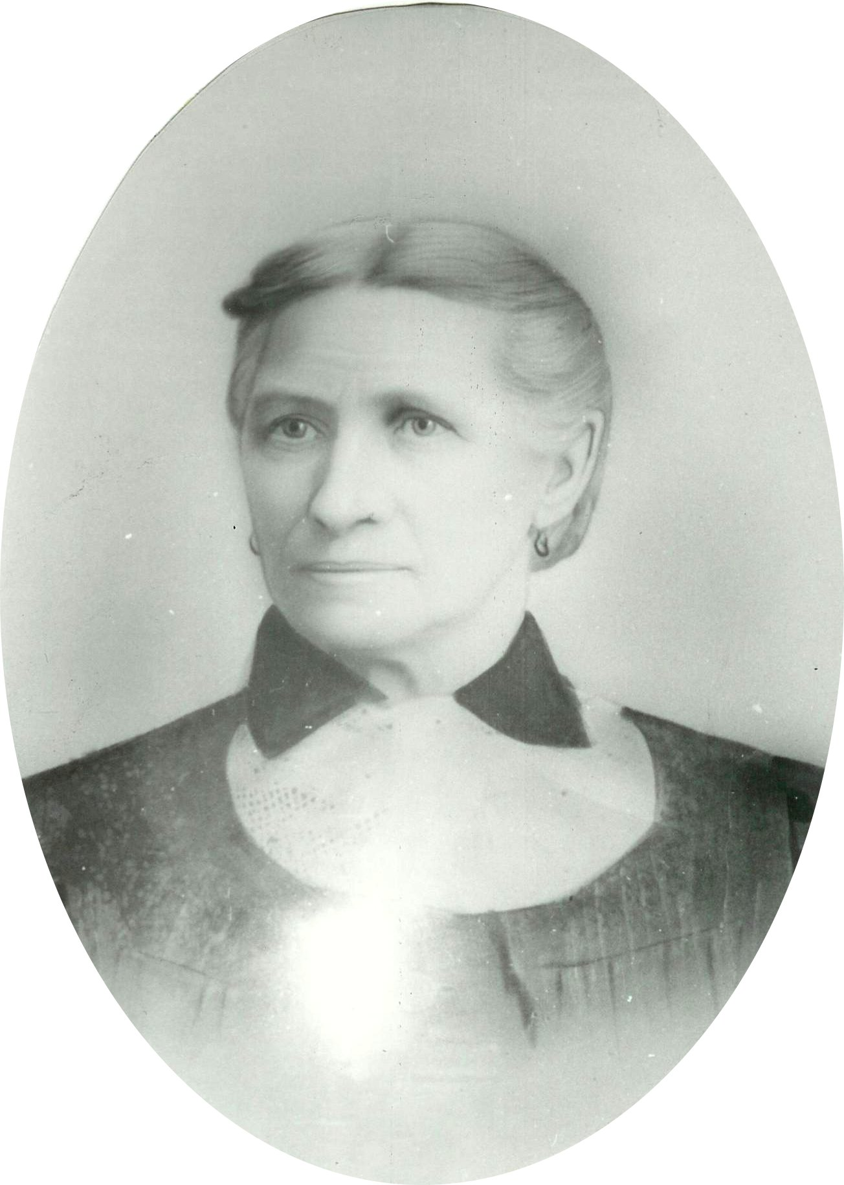
Courage, also known as bravery, fortitude, will, and intrepidity, is the ability to confront fear, pain, risk, danger, uncertainty, or intimidation. It can be broken down further as physical courage and moral courage. "Physical courage" is courage in the face of physical pain, hardship, death, or threat of death, while "moral courage" is the ability to do the right thing for the right reasons in the face of popular opposition, shame, scandal, or discouragement.
Courage, in its various forms, is a character trait that serves a person well in all ages. Certainly, the pioneers required a great amount of courage to do what they had to do. It is no different in more modern times, only the things that we have to be courageous in the face of have changed. In some ways, they are even more challenging than those of ages past. Regardless of circumstances, we can learn from the their examples of courage.
To posses courage, one does not have to be big and strong. Courage can even come in small packages. For example, consider Ester Davis, a small, slender young woman with medium brown hair and gray eyes. The courage she displayed as a young woman was exemplified throughout her life.
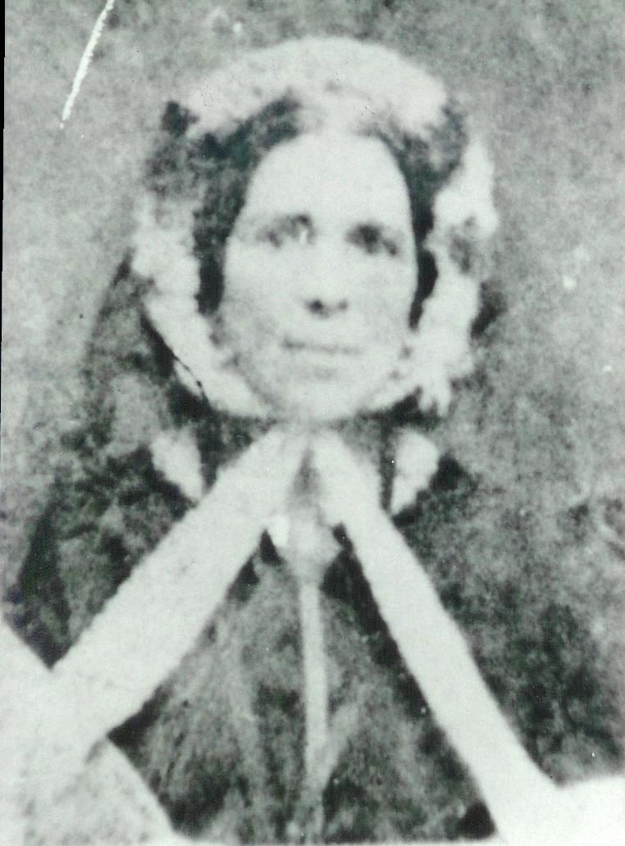Keziah Geers
Esther Davis was the daughter of William Davis and Keziah Geers born April 24, 1839 in Pauntley, Gloucester, England. She was named after her paternal grandmother, Ester Stone. When she was just a baby, her family was converted to The Church of Jesus Christ of Latter Day Saints, having been baptized on October 4, 1840. At the time they had three little girls, Amy (10 Oct 1835), Maria (14 Oct 1836), and Esther. Maria died on March 31, 1841 at the age of five years old. Three more children were born to William and Keziah: William (7 Oct 1841), Alice (3 Aug 1845), and Henry Albert (25 May 1850). William died on April 30, 1845, and Henry died on July 2, 1850 and Alice died two weeks later on July 15, 1850. Of their six children, only Amy and Esther lived beyond childhood. Her father also died on November 11, 1856.
As she grew older, Esther too was baptized on February 3, 1850 at the age of eleven. She had a longing to come to America, and to go to Zion In Utah. She worked and saved enough money to pay for her passage on a sailing ship to the new land she had dreamed about. When she was eighteen years of age, her dream came true as she courageously set out on her adventure all on her own.
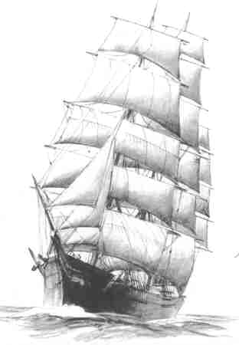
On March 28, 1857 at about 5 a.m. the George Washington, a 1534 ton square-rigged sailing ship, weighed anchor with the assistance of a tug. She stood out of Liverpool, passed down the River Mersey, and into the Irish Channel. The songs of Zion issuing forth from the passengers collected in groups on deck.
The George Washington was one of many ships chartered by the Church to bring emigrant converts to America. With three decks, she carried 817 passengers on this trip. Each passenger had 10 cubic feet allotted them for their luggage and a berth. Adult passengers had to pay £4.5 for their passage; £3.5 for those under eight, and one shilling for infants. The cost of passage included provisions for the voyage.
As the voyage began, the weather was stormy and unsettled and many of the passengers came down with seasickness. Some truly had a tough time, being confined to their berths, too unwell to wait on themselves. Esther helped the sisters care for those who were ill, until she became very ill herself. She could hear the people talking but couldn't move or speak. They thought she was dead too. Her spirit left her body and went back to her mother in England. Her mother told Esther that the Lord had a mission for her in Zion to do and that she must return to the ship. That was when one of the sisters noticed one of Esther's eye lids flutter, and knew she was alive. They started working with her and praying. Finally she could open her eyes and speak. They took such loving care of her and eventually she could leave her bed. As soon as her strength returned she again helped wherever she was needed.
They had better sailing on the mid portion of the voyage, but had to endure another storm during the last week. Early in the morning on May 20th, the George Washington anchored in Boston Harbor after twenty two days at sea. For two days the ship rode out gale force winds at anchor in the harbor. Finally on the 22nd the ship was assisted to the wharf and the passengers prepared to disembark. Despite the number of people who were sick, only three died and had to be buried at sea. There was also one baby born on the voyage.
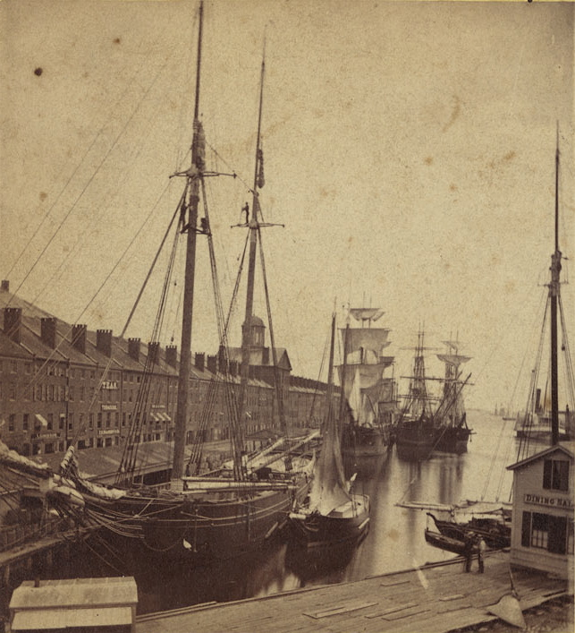Boston Harbor's Central Wharf
As the ships company left the ship, most boarded trains to continue west. Several passengers, including Esther didn't have enough money to continue on. She was a highly skilled seamstress and looked for employment as soon as she could after disembarking from the ship. Esther had learned to spin and weave beautifully. She made her own clothing and took in sewing for others and made silk dresses, wagon covers, horse blankets, and anything else there was to sew.
She soon found employment in the beautiful home of the poet Henry Wadsworth Longfellow. Because of her sewing skills, she was assigned to care for the lovely lace curtains throughout the house. All of her sewing was done by hand with thread and needle. For her, it was a labor of love. She would dream and plan as she sewed. When Esther set a goal for herself she never gave up or looked back until it was completed. Another dream was soon to come true. She also helped the other workers to keep the home neat and tidy.
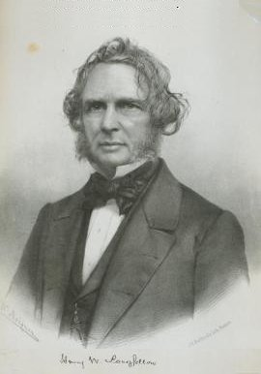Henry Wadsworth Longfellow ~ 1858 ~
On her days off she would visit the dress shops where the lovely dresses were made for those who could afford to buy them. She would get the nice scraps of the silk, satin, and velvet or even remnants and made what she called, 'crazy patch work quilts'. The pieces were sewn together around each block. She put a backing on the larger quilts, and because they were very stylish in those days, she had a ready sale for her quilts as soon as they were finished. These quilts and her clothes were all made by hand, when she had spare time or at night by candle light. She even won a first prize with one of her quilts at a fair in New York.
The Longfellow home had been used as the Revolutionary War headquarters for George Washington during the winter of 1775-76. When Esther was living with the Longfellow's, her room was on the third floor directly above the entrance. The half-circle window on the third floor was the window to her room. She only had a candle for light at night when she lived there.
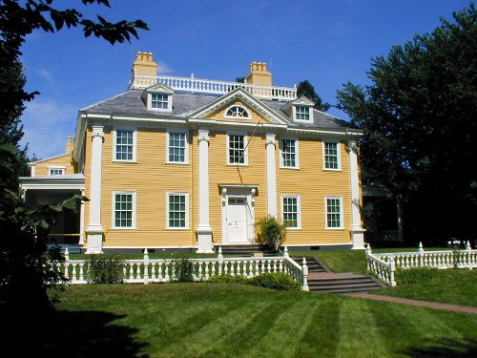The Longfellow Home
Not far from the home was an old blacksmith's shop, with a beautiful spreading chestnut tree. When Longfellow saw the shop and tree after he had bought the home, he wrote a poem about the shop and called it, The Village Blacksmith which was first first published in 1841.
It took Esther four years to save enough money to come to Utah. By then her sister Amy and her husband, Thomas Fairbrass, had come to Boston from England leaving their mother in England all alone.
Welcome news reached the Saints comprising the flourishing branches of the Church in Boston and other parts of the Eastern States in 1861. Amid concern over the commencement of the Civil War on April 12, 1861 between the North and the South, it was announced that the Church in Utah would send to the frontier two hundred teams suitably equipped to aid in transporting across the Plains those not otherwise provided with means for the journey.
The company of Saints from the Boston Branch numbering fifty to sixty members commenced their journey Monday June 10, 1861, traveling to New York City via Stonington, arriving at New York early the next morning by steamer, landing near Castle Gardens, thence by steam-tug to Jersey City; here they were crowded into a small waiting room in close proximity to a regiment of New York State Volunteers waiting for transportation to the battlefront.
At 7 p.m. the New York Saints arrived in large numbers, and by 10 p.m., with the Boston Saints forming one company, were en-route to Dunkirk, via the N. Y. & Erie Railroad; and the following evening on their arrival at Elmira, Pennsylvainia, the company was there joined by a large number of the Saints of the Philadelphia Branch, forming a company so large that many had to ride in freight or cattle cars fitted up with a single bench placed around the sides.
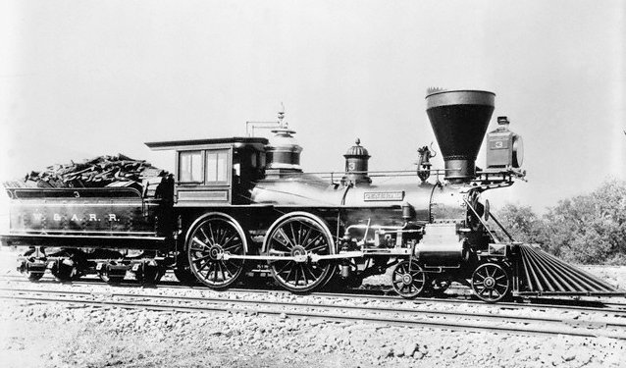A Civil War era steam locomotive
At 10:15 a. m. Thursday, June 13th, they arrived at Dunkirk on the shores of Lake Erie, and were “dumped off”, with their baggage, into the streets. The call of the government for means for transporting the troops had left but a few spare cars. These could take only part of the company, the remainder having to wait some 22 hours, exposed to the jeers and taunts of drunks and others. After this wait, however, special accommodations were obtained, and a six hour run brought them to Cleveland, Ohio. Only fifteen minutes was given them to change cars, and shortly after coming up with the main body arriving in Toledo. Three hours were spent in getting their train ready which now consisted of two engines, eight freight and twenty passenger cars.
The feverish condition of the nation upon the outbreak out of the war was indicated to the Saints the next day, when they saw a gallows furnished with a noose and an inscription which read "Death to Traitors."
They reached Chicago, Illinois on Saturday afternoon, and there was another tedious wait in a large warehouse for nearly six hours. While waiting, they were subject to the profanity and abuse of a number of drunken men, so that it was a welcome relief to be on their way again, bound for Quincy, Illinois.
Sunday afternoon found the company pleasantly engaged in a large wooded area, making tea and chatting merrily with one another and having a general good time. The opportunity was occasioned by the breakdown of one of the engines, causing a six-hour stop-over. Arriving at Quincy the next morning the company was transferred to the steamer "Black Hawk". It steamed down the Mississippi River to Hannibal, Missouri, where they unloaded their baggage into a large shed by the river's edge. At this place a glimpse of the realities of the war was experienced. The "Home Guards" (loyal to the Union) were at their quarters guarding a cannon captured from the secessionists and one of the rebel officers was confined in a room of the depot. Excitement filled the air and reports of the actions of large numbers of rebel troops in the interior of the state; burning bridges, firing into railroad trains, etc.
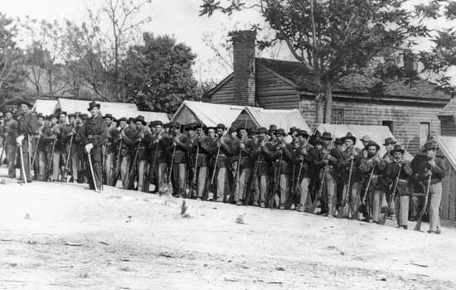Union Troops - June 1861
The wait at Hannibal continued until the following morning, Tuesday, June 18th, and enabled the Saints to replenish their provision baskets by the purchase of eggs fresh, hard and soft-boiled, bread, garden stuff, milk and meats.
The run of some two hundred miles from Hannibal to St. Joseph, across the State of Missouri, was an exciting one, as most of the towns through which they passed were under guard by Union troops, as also were the railroad bridges. Nearing Chilicothe, now under martial law and presenting the appearance of a captured city, all business being suspended, armed soldiers patrolled streets. The train was stopped and army officers and guards inspected the train, and then stationed sentinels at each door before allowing the train to proceed. A train a few hours previously had been fired upon, and they saw some of the bullet-riddled cars.
The road-bed was in such a horrible condition that passengers and boxes were thrown around and shaken as if on a ship in stormy seas. During the night they arrived at St. Joesph, and in the heat of a sultry morning they removed thier baggage from the cars to a large building by the river's edge, where lay the steamer "Omaha", which was to convey them up the Missouri to Florence, Nebraska.
The day was spent in loading the freight, which with nearly all the passengers was destined for Salt Lake City. St. Joesph, as well as other places in Missouri, was a divided community, a Confederate flag having been hoisted just previous to thier arrival, by its supporters, and after much excitement was pulled down by the Unionists. Suspicion and antagonism prevailed; citizens were armed and no man's life seemed secure.
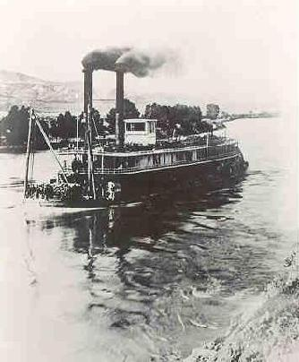A steamboat on the Missouri River
At 6:35 p.m. Wednesday, June 19th, all being ready, they cast off and steamed slowly up the large, deep, dirty and swift-running Missouri River. The boat was densely crowded, every available spot being occupied by men, women, children, freight, cord wood, etc. The tedium and intolerable heat of the next day was relieved by the excellent musical abilities of several of the Saints in discoursing sweet music, vocal and instrumental. The sight of some Indians on the banks of the river was a first for many in the company. A heavy thunderstorm in the evening necessitated tying up the boat for a while.
The next day, June 20, 1861, they arrived safely at Florence, and the "Church teams" were soon busy hauling the passengers and their belongings to the many deserted and unfurnished houses in that vicinity; houses which proved very acceptable places of shelter and were free to all.
The following Sunday the Saints gathered beneath a bowery and were addressed by Elders Joseph W. Young, Jacob Gates, and others relative to the next stage of the journey, and the arrangements therefor and regulations to be observed.
The next week was spent by the emigrants, teamsters, and presiding officers in arranging the details of the company organization, purchasing supplies, oxen, wagons, manufacturing tents, breaking in cattle, collecting such cash from the emigrants that they could advance to purchase needed groceries, bacon, etc.
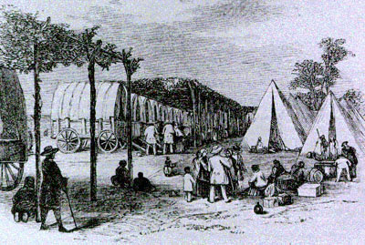Trail staging camp
The furious thunderstorms with lightning, wind, and rain of this locality caused some inconveniences to the new-comers. Other companies of Church teams also arrived from the Valley, so that by Sunday, June 30th, the meeting in the bowery was filled to overflowing, remarks being made by President Joseph W. Young, Jacob Gates, and several of the brethren from the Salt Lake Valley.
The next day the loading up of Captain Joseph Horne's Company commenced. The passengers assigned to his company had their baggage taken to the bowery, weighed, and properly loaded into the wagon. They were only allowed to take about 70 or 75 pounds of luggage. The company drove out some three miles to the place of rendezvous, there taking their first lesson in camp life, such as getting water, fuel and cooking with the camp fires. The organization and fitting out of Captain Horne's Company continued the remainder of the week.
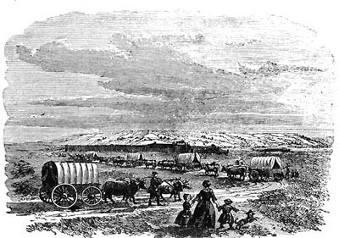
A large drum called the people of the camp to prayers, and on Sunday Apostle Erastus Snow, Elders Jacob Gates and Joseph W. Young held a meeting instructing them further in relation to their journey, touching on things temporal and things spiritual. The almost daily hurricane blew over several of the tents. On Tuesday, July 9th, all things being ready, the company rolled out and traveled 10 miles to Reed's Ranch and camped, making the Elkhorn River the next day. Here, in this Campers' Paradise, they remained until Saturday morning, gathering wild grapes, shooting wild ducks, bathing in the river, washing clothes, having an abundance of wood, water, grass and shade, and being visited by a number of friendly Pawnee Indians.
Breaking camp at 6:50 a.m. they followed in the wake of Captain Murdock and Captain Eldredge's trains. After the noon break, they started out ahead of the Murdock Comapany and passed through to the corral formed by the wagons of the Eldredeg company.
During the following nine days they came to the Platte River, experiencing the heavy dews of this locality, crossed Loup Fork with its sand bars, passed by a ranch where hostile Indians had run off all of their cattle. They also met U. S. troops from Fort Kearney en-route to the east on their way to war.
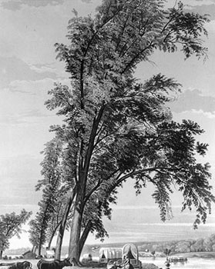Platte River Crossing
On Tuesday, July 23rd, Apostles Orson Pratt, Erastus Snow, and Elder Joseph W. Young came into camp bringing letters for some of the company. On Pioneer Day (July 24th) Elders Pratt, Snow, and Young held a meeting with the company, and after a day's journey of 18 miles, Elders Gates and Spencer joined. After suitable remarks from them, a ball in honor of the day was held, the teamsters carrying off the honors. The next two weeks the journey was along the Platte River, over sand hills with its citizens of lizards, ground squirrels and rattlesnakes.
Grateful to partake of the grateful water of the Pawnee Springs, they gathered wild cherries, fought mosquitoes, and viewed distant prairie fires. Moving on, they finally came in sight of Chimney Rock. That evening they camped near Chimney Rock. Some were allured by its seeming nearness and waded across the river and toiled on and on until wearily and faint they reached its base. After carving their names on the rock, they gave three cheers for President Brigham Young and the Pioneers. After experiencing other adventures, they returned to camp.
A few days later they could again obtain wood in lieu of "buffalo chips" for making campfires. Esther was assigned to take charge of the children old enough to watch for fuel along the way. The children picked up sticks when in tree country; or when in buffalo country, they picked up buffalo chips. Laramie Peak, like a distant cloud, came into sight, and after Fort Laramie they encountered rough roads, scarcity of feed for the animals, and crossed and re-crossed the river.
The Overland Coach with its mail and passengers went dashing past in a cloud of dust. Workmen were setting the poles for the Overland Telegraph. Indians visited the camp to "swap" their pelts, buckskins, etc., for sugar, flour and trinkets. At Deer Creek they replenished their stock of flour at a log store-house from flour that had been deposited by the wagon trains when coming to the frontier from Utah. On Aug. 21st they left the headwaters of the Platte.
While traveling along a rocky road a fatal accident occurred to a faithful old lady - Sister Mary Ann Foreman, from the Dover, Kent, Branch. She slipped from the wagon and was run over. She only lived about an hour after that. That same evening, without change of clothes, or a coffin or a box, she was laid to rest in a shallow grave. After a few words of consolation and a short prayer, a buffalo skull with a penciled epitaph to mark for a brief time her resting place. By the starlight the wagon train again rolled out while the moon rose over a distant hill.
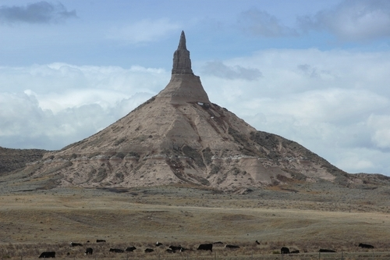Chimney Rock
The frosty air gave brilliancy to the camp-fires of the large body of U. S. troops of Johnston's Army, traveling from Camp Floyd, Utah, to the war. They finally made camp at 1:30 a.m. During the next three weeks they crossed and re-crossed the Sweetwater River and passed those well known landmarks, Independence Rock and the Devil's Gate around the Saleratus Lakes, occasionally shooting a deer and rabbits, being visited by Elders Orson Pratt and Erastus Snow. Bacon was getting scarce, so an ox was killed and distributed.
With the snow-capped Wind River Mountains in sight they looked with interest upon the waters of Pacific Springs wending their way westward and finally emptying into the Pacific Ocean.
After crossing the Green River they made their first camp in the Utah Territory. From there they wended their way by Ham's Fork, past Fort Bridger, across Bear River, through Echo Canyon and East Canyon to the summit of the Big Mountain. With varying emotions, the emigrants obtained their first sight of their long sought for promised land, the Salt Lake Valley.
On Friday morning, September 13, 1861, Captain Joseph Horne's Company broke camp for the last time and rolled into Salt Lake City. The trek ended as all emigrant trains did, in the 8th Ward Square, where the City and County Building now stands.
Esther had walked most of the way so that her sister, who was not well and had two children, could have her turn riding in the wagon. After arriving in Utah she came down with Mountain Fever and was terribly ill for a long time. Because of this illness, her hair turned completely white at twenty-three years of age.
Soon after arriving in the Salt Lake Valley, she met a man by the name of Henry Woollacott. He and his wife, Martha had emigrated from England to Utah in 1854. He asked Esther to be his second wife. She talked to the church authorities and was ecouraged to marry him. They were married in Salt Lake City on February 22, 1862. At the time Esther was 22 and he was 35.
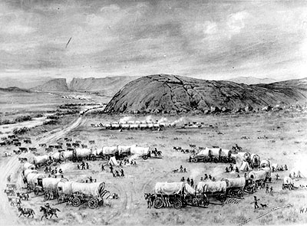Camped at Independence Rock
Esther lived in the same home with his first wife, their children, and his mother but they were not kind to her. She had a little boy, Albert James, on January 13, 1863. Unhappy and mistreated, Esther left with her baby and was granted a divorce.
On her own and needing to support herself and her baby, she found employment as a housekeeper in the home of a blacksmith by the name of Samuel Buchanan Frost. We was a widower who had buried his wife a few years earlier. His older children were married and in homes of their own, but he still had three children living at home; Hettie, Sam Jr, and James. His children loved Esther and her little boy Albert. Sadly little Albert died on March 5, 1864. Samuel asked Esther to marry him, which took place on April 17, 1864 in Draper. He was 54 and she was 25.
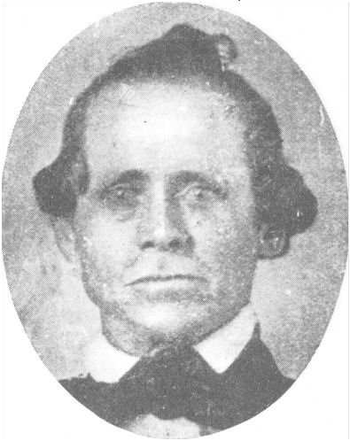Samuel Buchanan Frost
Soon after their marriage Samuel and Esther moved to Spring City, in Sanpete County, Utah. There he farmed extensively and they owned a fine home for the times. During the Black Hawk Indian War in Southern Utah between 1866 and 1868 he was a Captain in the Territorial Militia.
During that time, Esther and Samuel had their first three children: Stephen (1 Apr 1865), Chauncy ( 8 Oct 1866), and Rebecca Penninia (26 Sep 1868). Samuel's daughter, Hettie, got married in February of 1867 and his son, James, died in September 1868 at the age of 16.
The Black Hawk War was a dreadful time for the pioneers. The Indians stole livestock, burned crops, destroyed fences, and even killed families. Militiamen stood guard wherever they could be spared. Most of the people had to guard their own property or move to a more protected settlement. The Indians were angry because they were loosing their hunting grounds to the settlers. Many sad things happened to both sides during the war. Following the war, there were some small groups of Indians that continued to carry out raids.
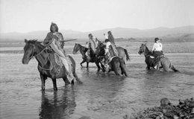Ute Indians of Central Utah
Now the Pioneers had the U.S. Government to contend with besides the Indians. But the people won as God had sent them to the West so they could worship in peace. They were raising fine crops and fruit of all kinds. Factories were built so they could make the clothing, machinery or most anything they needed. So life was much better for the people now. With the completion of the transcontinental railroad in 1869, people could come to Utah from the east by train.
Two more years had passed by. Samuel and Esther were sealed in the Endowment House in Salt Lake City on May 23, 1870. Another baby boy, Adolph Lesseau (15 Aug 1870), blessed their home.
Another little girl, Margaret Elzira (30 Sep 1872), and two more boys, Ivan Danzoff (9 Jan 1875) and Marion (12 May 1878), were born, and that made a family of seven children. The older children were a great help when their father had to be away. No matter what Samuel had to do or where he had to go, Esther never complained as she was still left alone quite often, with the children. Her husband had been hired by the government to work with the Indians to try to keep peace among the pioneers and Indians and among the different tribes. He spoke the Indian language very fluently. He loved the Indians and respected them. The Indians loved him and treated him as one of them.
They had a wonderful dog that hated the Indians. If Samuel was gone, Esther was always watching for those few Indians that from time to time would ride to people's homes and just walk in, helping themselves to what ever they wanted; usually food.
Samuel had dug a nice cellar under the floor of the large combined kitchen and living room, where their vegetables could be stored. He put a trap door to cover the cellar. Esther made a large braided rug that covered the trap door, then put her little rocking chair on the rug. When she saw more than two or three people on horseback coming toward their home she knew it had to be Indians. She would quickly get the children into the cellar, replace the rug, get the dog in the house, sit down in the rocker and hold the dog's collar so she wouldn't take after the Indians.
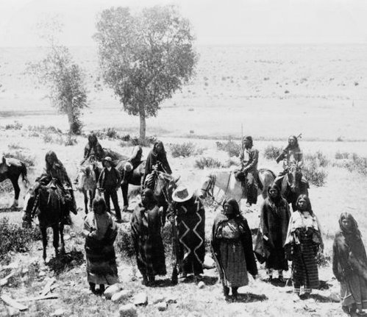A band of Ute Indians
There was a gang led by an old squaw that everyone called 'Old Sally'. They never took anything except food, then they would leave. They were called 'renegades' because they were somewhat wild. One time the renegades went to the little store. People would take small buckets to the store and buy syrup by the pound from a larger bucket. One of the store clerks had waited on a customer and left the lid off of the large bucket, and a mouse got into the syrup and died night before. The lady working in the store, didn't know what to do. The group of Indians, let by Sally, came in and wanted food. Sally spied the syrup bucket. She wanted that, but the clerk said it wasn't good as a mouse fell into the bucket of syrup and it would have to be thrown out. Sally fished the mouse out, licked the syrup off the mouse, threw it outside, put the lid on the bucket and was tickled that she had a real prize. No doubt the Indians were hungry as game was now either shared with the settlers or had left that part of the country.
The Indian braves saw the pretty shirts that Esther made for Samuel. They wanted shirts like his, with ruffles down the front and around the cuffs. So Esther made them some after they got the material for her. With all those little ones, she stayed up after they were in bed sewing shirts.
One morning the family was sitting around the fireplace getting dressed and a knock came at the door. Esther went to the door to see who was there. It was a stranger who asked her for a needle and thread, he wanted white thread. She got it for him and he pulled his robe back and pinned it to the inside of his lapel. Esther said the skin under his robe was as white as the driven snow. He gave the boys a lot of good instructions. He told them not to do things they shouldn't. After he left, he'd only been gone a moment, they thought he would have been off the doorstep at least. They went outside to look for him. The house was on a hill so they could see in every direction, but they couldn't see him anywhere. He just disappeared!
Having sold their farm in 1888, Samuel and Esther took the younger children and moved to Coyote, in Garfield County, where they purchased another small farm. Early in the spring he fell from a haystack and broke several ribs, which never healed and made him ill most of the time. Nevertheless, they moved to Coyote on the 12th of May. He lived little more than a month and died on June 27, 1888.
Again Ester was left alone. By then both Stephen and Rebecca were married and Chauncy and Adolph were pretty much on their own. That left Margaret (15), Ivan (12), and Marion (10) at home. But she carried on with the help of her children and friends. Ester kept busy. She helped bring new babies into the world. She helped when there was illness in homes, or whenever help was needed. She worked in the Church, whenever she was called.
On May 3, 1890, Esther and her son Chancy traveled by wagon to the Manti Temple and did the endowment work for Henry Wadsworth Longfellow. Then on January 7, 1893, they returned for the sealing. Chancy acted as proxy for Mr. Longfellow and Esther was proxy for his wife. Seeing that this important work was done for the Longfellow's was typical for Esther. She would be mindful of those people who helped her as she journeyed from England to bring her dream of life in America true.
Many people were beginning to move to Idaho. Some of her older married children went to Idaho to start new homes on dry farms near Oakley. Esther came with her son Adolph in 1904 when they moved to Idaho. Adolph was a blacksmith and had his shop close to their house in Marion, Idaho. He put up a wire fence around a small plot in the front yard so Ester could plant some flowers. She sent for some flower seed from England. The garden was very well kept and no one went into it unless Esther went with them. Stephen and Chauncy didn't move to Idaho until 1908.
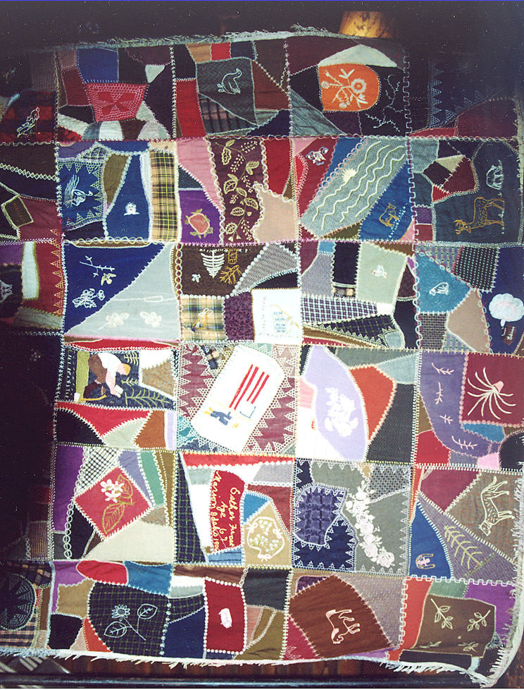One of Esther's "crazy quilts" made in 1906
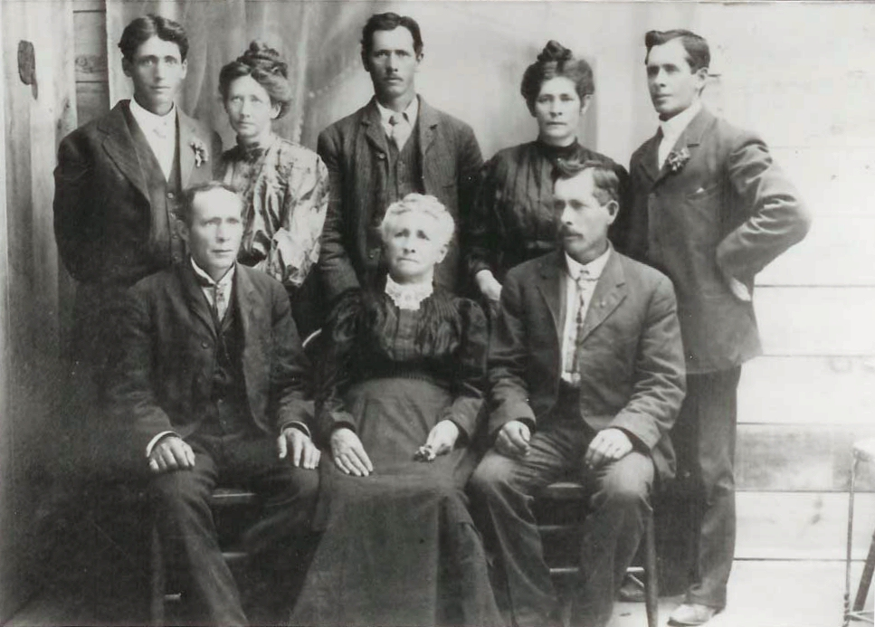Esther and her children, after Samuel died: Back: Marion, Margaret, Adolph, Rebecca, and Ivan Front: Chancy, Esther, and Stephen
Esther had the knowledge of how to make and use the most healing salve. It seemed to cure most anything. Then all the families would get a jar or can of it. Her daughters never learned how it was made. No one knew how it was made, as she took that knowledge with her to her grave.
In her later years she was such a sweet patient little lady. Always so neat, and her hair was always combed so neatly.
In December of 1910, a few days before Christmas, Esther became very ill and the family was summoned to come as quickly as they could. She was very ill but she prayed that she would not die on Christmas Day because she did not want to spoil it for the grandchildren. Her prayers were answered and she lived until the day after. Esther died at Marion, Cassia County, Idaho on December 26, 1910.
Margaret's husband, Wallace Warner, and Adolph made the casket, and Rebecca and Margaret lined it neatly and put a pillow in it and covered it with pretty white cloth, The ladies sat up all night after bathing and getting her ready for burial. They didn't have mortuaries in those days, so to keep her flesh from going dark, they used cloths rung out in a solution of formaldehyde and placed on the exposed hands and face The funeral was a day or two later. It being winter, there were no flowers. She was buried in the Marion Cemetery.
The world is a much better place for having had a courageous lady, like Esther Davis Frost, here for 71 years, 8 months, and 2 days.
* * * * * * * *

This story comes from two life stories of Ester Davis Frost. One by her granddaughter, Viola Warner McKendrick, and the other by her grandson, Ira L. Frost.
The definition of courage is from Wikipedia
The voyage of the George Washington is from the diary of Amos Milton Musser posted at http://www.lib.byu.edu/mormonmigration/voyage.php?id=152&q=George%20Washington Esther's name doesn't appear on any of the ship registers of the time. However, the George Washington was the only Mormon emigrant ship that went to Boston that particular year. The account of the voyage closely matches her experience.
The journey from Boston to the Salt Lake Valley is from the Journal History of The Church of Jesus Christ of Latter-day Saints, 13 Sept. 1861 posted at http://www.lds.org/churchhistory/library/source/1,18016,4976-9229,00.html The two life stories differ as to when Esther crossed the plains. Viola's said she came with the George Rowley handcart company in 1859. Ira's said it was the Joseph Horne wagon company in 1861. Her name is listed in the church archives as being with the Horne company. http://www.lds.org/churchhistory/library/pioneerdetails/1,15791,4018-1-41385,00.html

