CHAPTER 3
1920 – 1935
We were married December 4, 1920 at the courthouse in Burley by Frank B. Datson. Faye and Bill had been married an hour or so earlier and they stood with us as did Grandma Frost. It was a bitter cold day. We went to Cora Drussell's for supper, a crowd were trying to find us. They hunted all over Burley and Oakley, we were right there in the Cook Rooms. We gave them the slip. The next day, Sunday, we spent with my folks in Starr's Ferry.
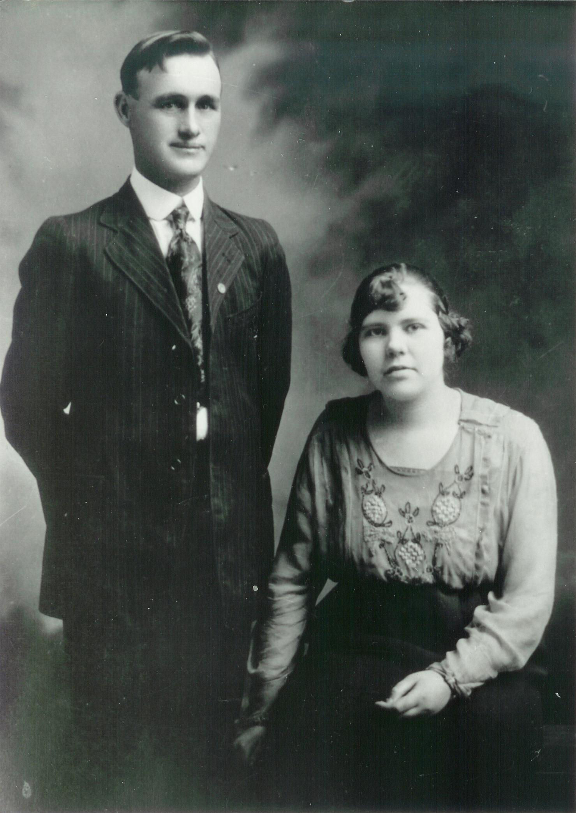Ira and Vyla on their wedding day
On Monday we were at his folks and wrote some letters to relatives and announced our marriage. that evening the folks had a small reception for us at Cora's.
Tuesday December 7th Ira left by train for Pullman Washington to enter vocational training under the G. I. Bill. He immediately transferred to Moscow, Latah, Idaho. I joined him two weeks later.
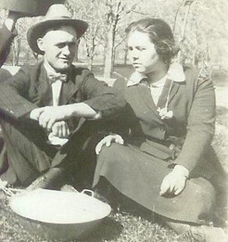Ira and Vyla at a church picnic in Moscow
We helped organize a branch of the church. A branch in the North Western States Mission. We mingled with Elders and Lady missionaries. On many occasion they ate with us. During the summer months when the Elders were laboring in the country they would come on week-ends and stay in our home. It was a wonderful fifteen months, we called it our honeymoon. I was the first secretary of the Sunday School in the branch I also was a visiting teacher.
It was there on February 7, 1922 that our first darling little daughter came to make her home with us. She was born about three o'clock in the afternoon with Dr. Clark and Mrs. Savage, a nurse, in attendance. We gave her the name of Eunice after a very lovely girl we knew, She was blessed March the 5th by a dear friend, Joseph Sudweeks. He was also one of the professors at the ag collage where Ira was studying.
By this time, the three semesters of training were over and we were ready for a farm, so we headed back to Burley and our families. We came by train, all three sharing a berth in a pullman. We arrived in a blizzard March 9th. We stayed with my folks a few days then rented a farm.
We rented from the North American Mortgage Company. The farm was on a sand hill on the bank of the river north of Declo. We were in the Declo Ward. We had a good garden and I canned some, we even had some melons. We planted ten acres of spuds, they were good spuds but for ten cents a bushel they were to cheap to dig, we tried to give them to the Mortgage Company but they didn't want them either, so they stayed in the ground.
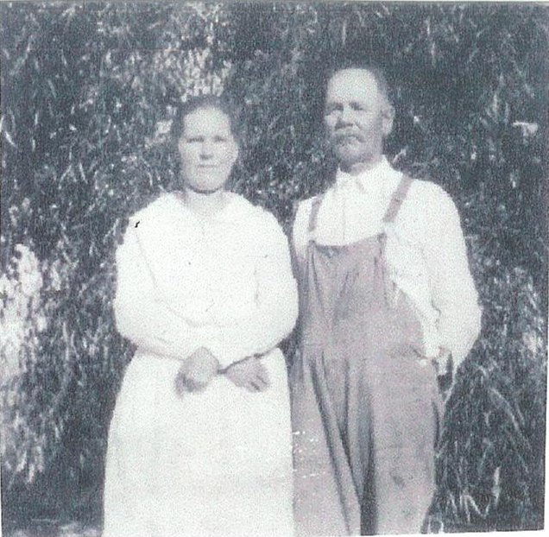Carrie and Charles Dayley
That fall we moved to the George Schults house in the Starr's Ferry area where we spent the winter. It was a nice place and we again had electricity. That was Eunice's first Christmas and we had a wonderful party. All the folks on both sides were there except Nettie's family. We had a Christmas tree. They stayed the night, there were beds all over the place but not much sleeping was done. We had a big dinner, it was fun but I was so tired I was glad to see all of them leave and I suppose all of them were glad to get home too.
In February 1923 we rented a farm in Twin Falls (the same company) about a mile and half south of South Five Points. That summer we raised purebred duroc pigs, onions, beans, potatoes, and chickens. There was an orchard where we had the pigs. An old sow had some little ones, we had to go through the orchard to the garden or something I don't just remember now. Anyway I was going through, she was up in the other end, she saw me and here she came as hard as she could with her mouth wide open ready to grab me. I sure got out of there. It scared me half to death.
There was so much noise in the house all the time, it sounded like someone going up and down the stairs. People around there said it was haunted. No matter how we tried, we could not keep the door upstairs closed. This is where our second darling daughter, Thelma June, was born early in the morning June 29, 1923. Both our mothers were there to welcome her into the world. Grandma Frost said she saw a woman one night and thought it was my mother but it was not.
I had the measles along with Eunice and Thelma and the girls had whooping cough. Thelma only about three months old. We got them both while visiting teaching. Boy, I was never so sick in my life as when I had the measles.
It was while we were living there that we went to the Logan Temple to be sealed for time and eternity and have our two little girls sealed to us. We went by train and was met by a Moscow friend, Les Bolton. We stayed the night with them and he took us to the temple. While we were gone, Faye and daughter Cora took care of things for us. We didn't know what Grandma Frost saw till after we moved away. Several years later we went back to take a picture and the house had been torn down.
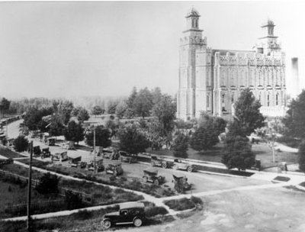The Logan Temple about 1923
By March of 1924 the G. I. training was finished and we moved to a farm west and a little south of Burley and quarter of a mile down the canal bank (Starr's Ferry area). The house here only had two rooms. Still with the same company. We stayed there three years and were in the Burley First Ward. In the winter when the snow drifted it was very hard to get out. Myron, our precious son, came to us January 5, 1925. Also another sweet little girl, Celia Gean, was born August 19, 1926.
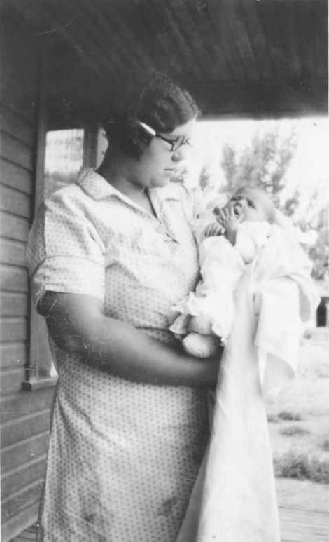Vyla holding Celia
The early summer of 1926, I decided that I wanted to go with the new hair style, which was a short loose bob. I had always worn my hair long and in a bun. It was hard to care for and hot in the summer. I picked out a cute style in a magazine and asked Ira's opinion. His answer was he would not like to see me with short hair. He asked me how I would like to see him with real short hair. (Now by this time he did not have a large amount of hair on top anyway). He contended that women were supposed to have long hair. That's the way the Lord intended it to be. Well, I had made up my mind. With that weeks egg money, I was going to get my hair cut off short and curly. Ira told me that if I did, he would get his shaved off. To make a long story short. I DID!!!- and – HE DID!!!
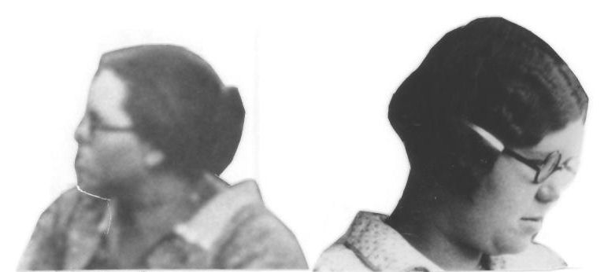Before and after
We had a pretty good potato crop that year so we bought our first automobile, a model T Ford and we were ever so proud. We thought we had the world by the tail. Until then we would put our darlings in a bed in the bottom of the wagon and away we would go. When our families were small, our brothers and sisters and we had our New Years Eve watch parties first at one place then the other. Those were the days! Sometimes we would get home in the wee hours, but it was fun.
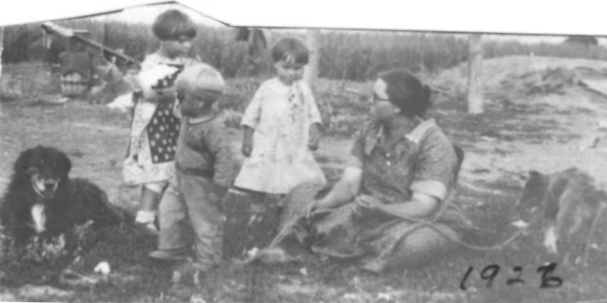Vyla with Eunice, Thelma, and Myron along with two dogs
New Years Day was always my father's day, they always had us home for dinner. We had a lot of good times together as families. One night we were at Net and Hen's having a good time. Someone opened the door and in popped the old billy goat. I went on a chair as fast as I could. Oh!! What fun. I would like to have some of those times over again but they are gone forever.
In January 1927 we rented a farm (same company) one and one half mile South of the present (1958) Springdale Store. We were there three years. This is where our dear little Lorna first saw the light of day on the 6th of May 1929 at about nine o'clock in the evening. Sister Nellie Dayley and Dr. Dean were there.
I was secretary of the genealogical committee and a visiting teacher. Ira was assistant Sunday School Superintendent of the Springdale Ward, ward teacher, and an assistant in the Aaronic Priesthood committee. Not all at same time however.
In January 1930 we rented and moved to a farm in the Unity vicinity which we later purchased. The house was very cold, lined with building paper which was loose and there were cracks all over the place. When there was a west wind we had to live in the east part and when there was east wind we lived in the west part. There were three small rooms and no electricity, we had to hand pump water for everything. But we were used to not having electricity. Along towards spring the well would almost go dry. We had the rest of our family while living there.
Our little blond Marian came to make her home with us September 12, 1930, one day after her daddy's birthday. She was born in Burley at the home of my mother on Schodde Avenue. Pearl helped Ira with the other children while I was gone, in those days we had to stay in bed ten or twelve days and then would be so weak we couldn't do anything for a few days.
On March 3, 1932 dear little Irma arrived. She was born about half hour before the doctor got there, we had some neighbor ladies (Mrs. Silcock and Mrs, Peterson) there and they said its a boy . When the doctor got there he said, "who said this is a boy? Do you want me to put it back"? We didn't, we were happy with her.
Finally, after four lovely girls we got a precious son, Gerald Ira. He came December 10, 1933. We were very happy with him and especially for Myron to have a brother, we named him Gerald Ira and he is very precious to me and was to his father and loved his father very much.
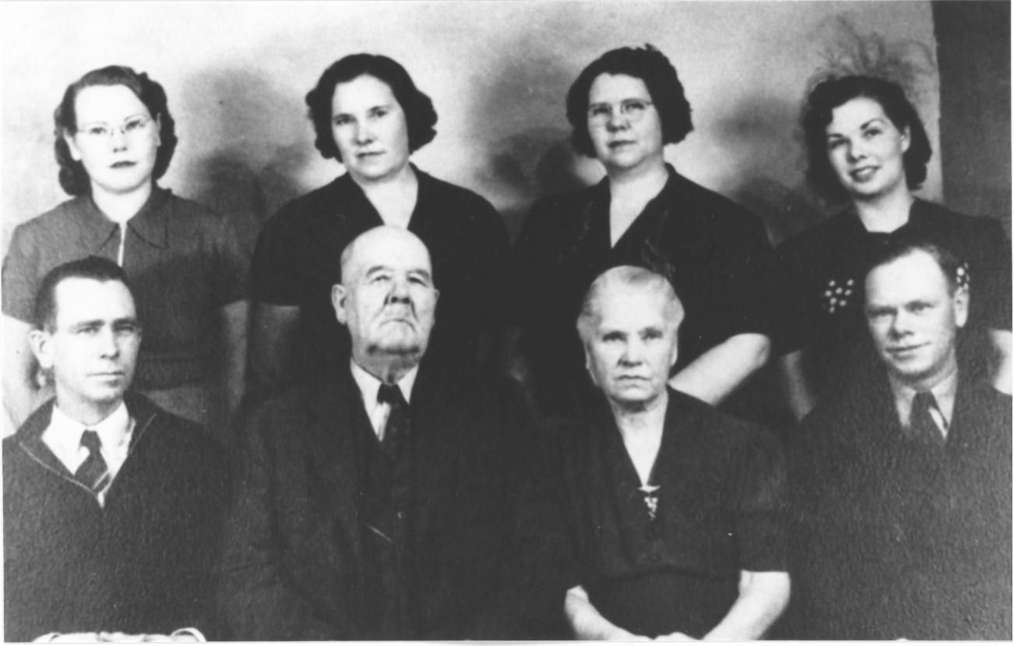The Dayley Family: Standing: Daisy, Janette, Vyla, and Nina. Seated: Slim, Charles, Carrie, and Myrl.
Last but not least, on May 30, 1935 our lovely, dainty baby girl brought joy to our home. We had a house full but none to spare, we loved them all the same. We named her Kathryn.
* * * * * * * * *

