Chapter 1
My Beginning

The heavens opened a tiny bit as a tiny spirit bade her Heavenly Parents and the multitude of brothers and sisters good-bye. She was so excited because her TURN ON EARTH had finally arrived, this was her day! With much excitement and joy, there was still sadness in leaving behind all her loved ones. Knowing that it would only be for a short time, she caught a rainbow and slid to the planet earth into the home and hearts of the Ira Frost family. The Frost family lived on a farm in the Starrs Ferry district in a two room house one and a quarter mile west of Burley, Idaho, right under the first lift canal. The canal bank was the road to their house.
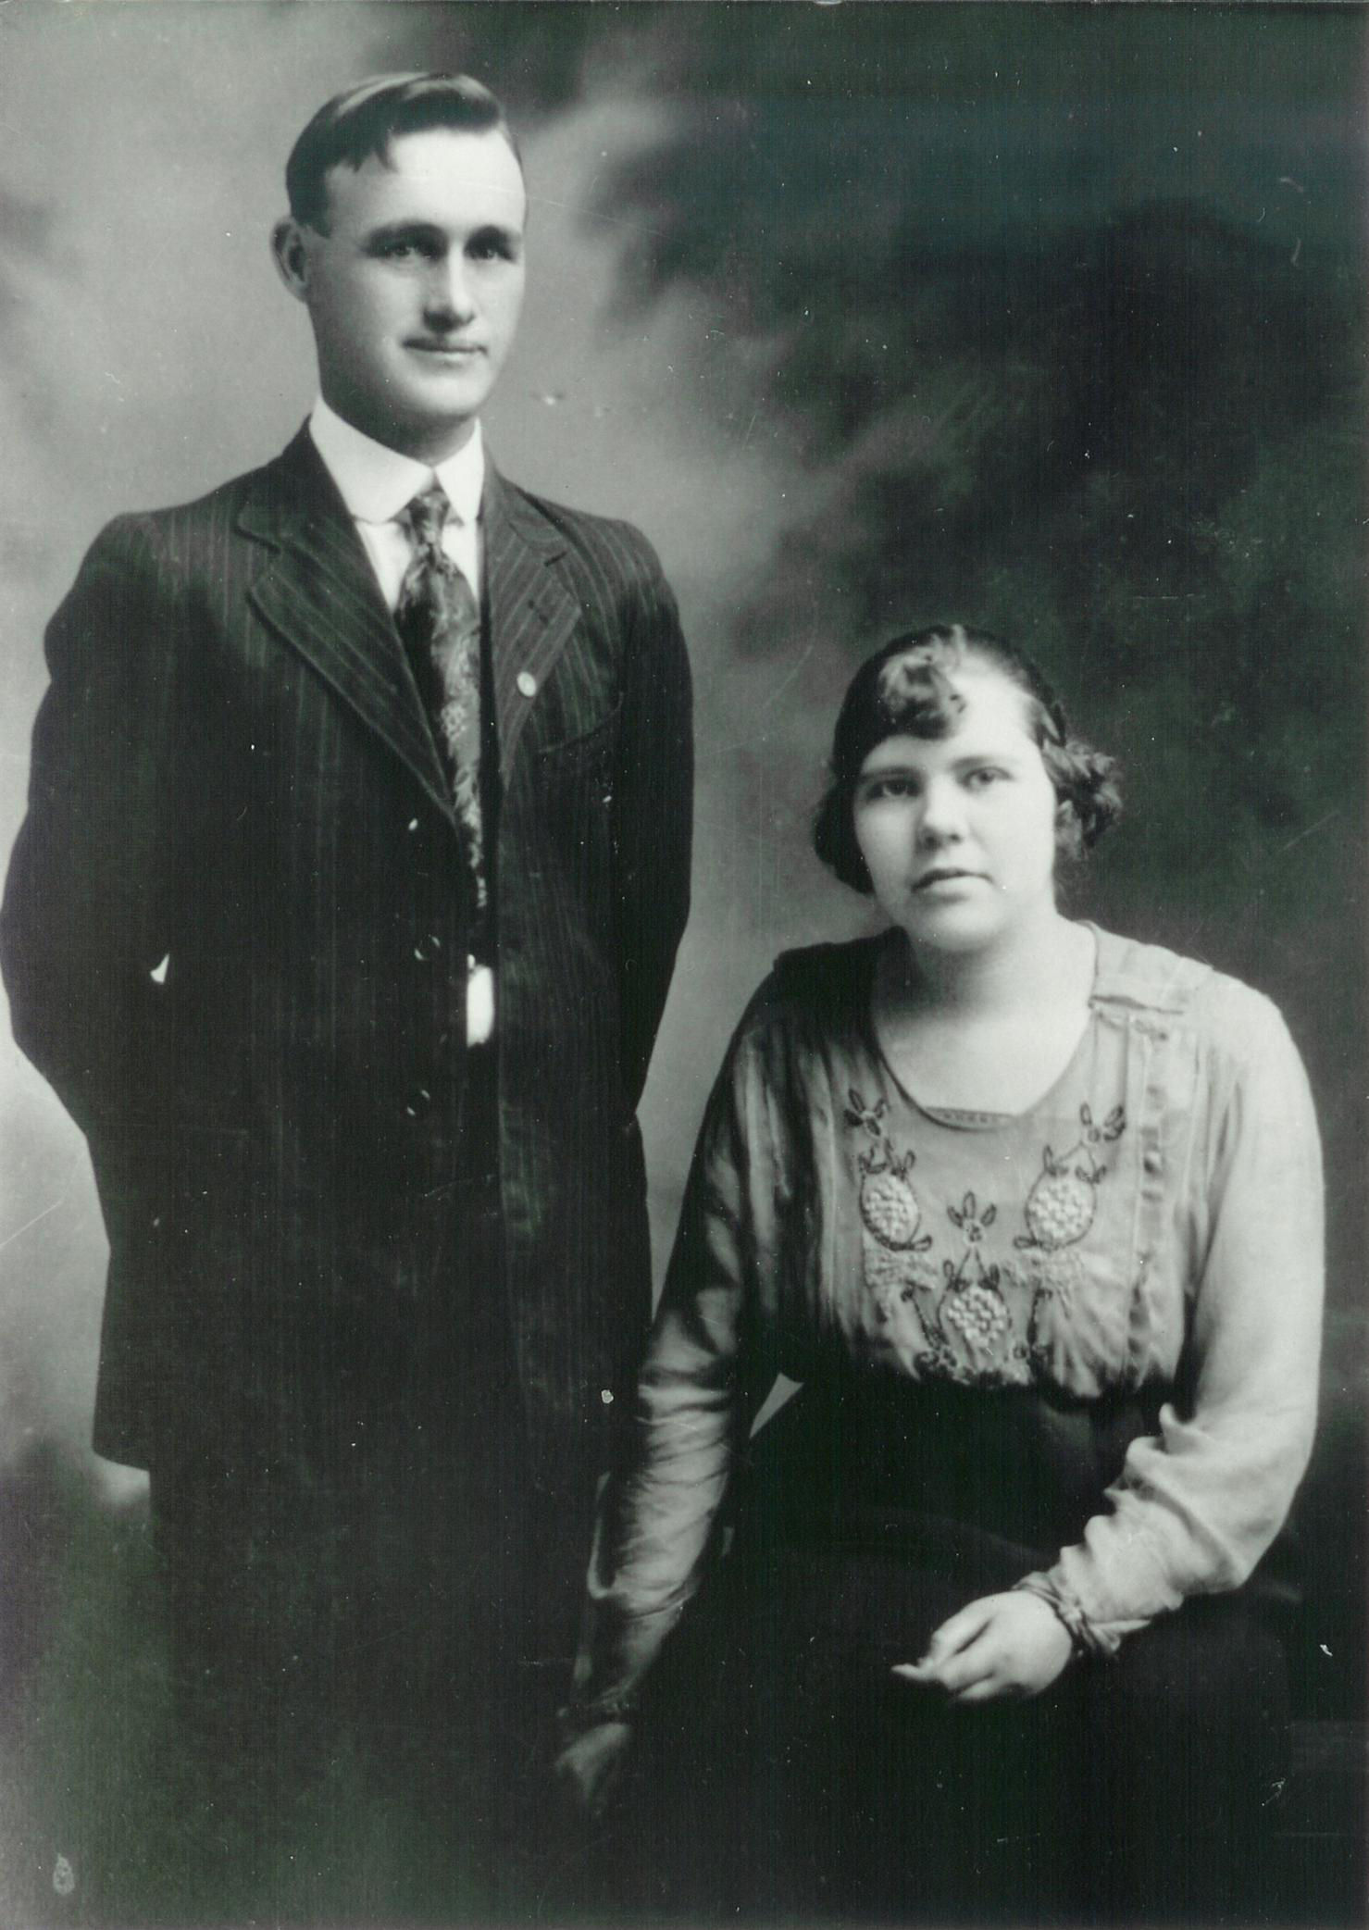My parents, Ira and Vyla Frost on their wedding day, December 4, 1920.
This tiny round faced bundle was delivered at home, at 5:00 a.m. on Thursday, August 19, 1926 with the help of Doctor N. A. Olsen, and probably one of the grandmothers. Wow, after waiting eons for my Turn on Earth, now that I have my body, what now? I wanted to keep my memory of my Heavenly Home as long as permitted. Now I have a whole new world to explore and things to learn and much knowledge to gain, and to love and to be loved. “Thursday’s Child has far to go”!
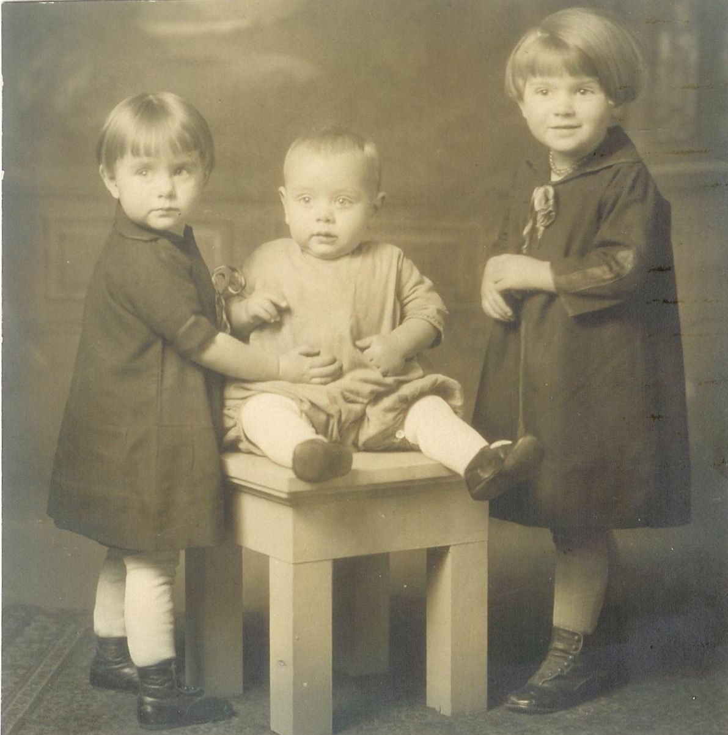Thelma, Myron, and Eunice
I was happy to find that I had arrived in the Frost family. There was my father, Ira Lewis Frost age 35 and a farmer, my mother Vyla June Dayley Frost age 25 a mother, and two sisters, Eunice age 4½, Thelma June age 3, and one brother, Myron Delbert (Buddy) 1½.
My grandparents were Chauncey and Loneva Warner Frost, and Charles and Carrie Sanford Dayley. There were many aunts and uncles and a lot of cousins. I felt like I was no stranger, that I already knew my new family from the beyond. I had a very humble beginning that has followed me all my life.
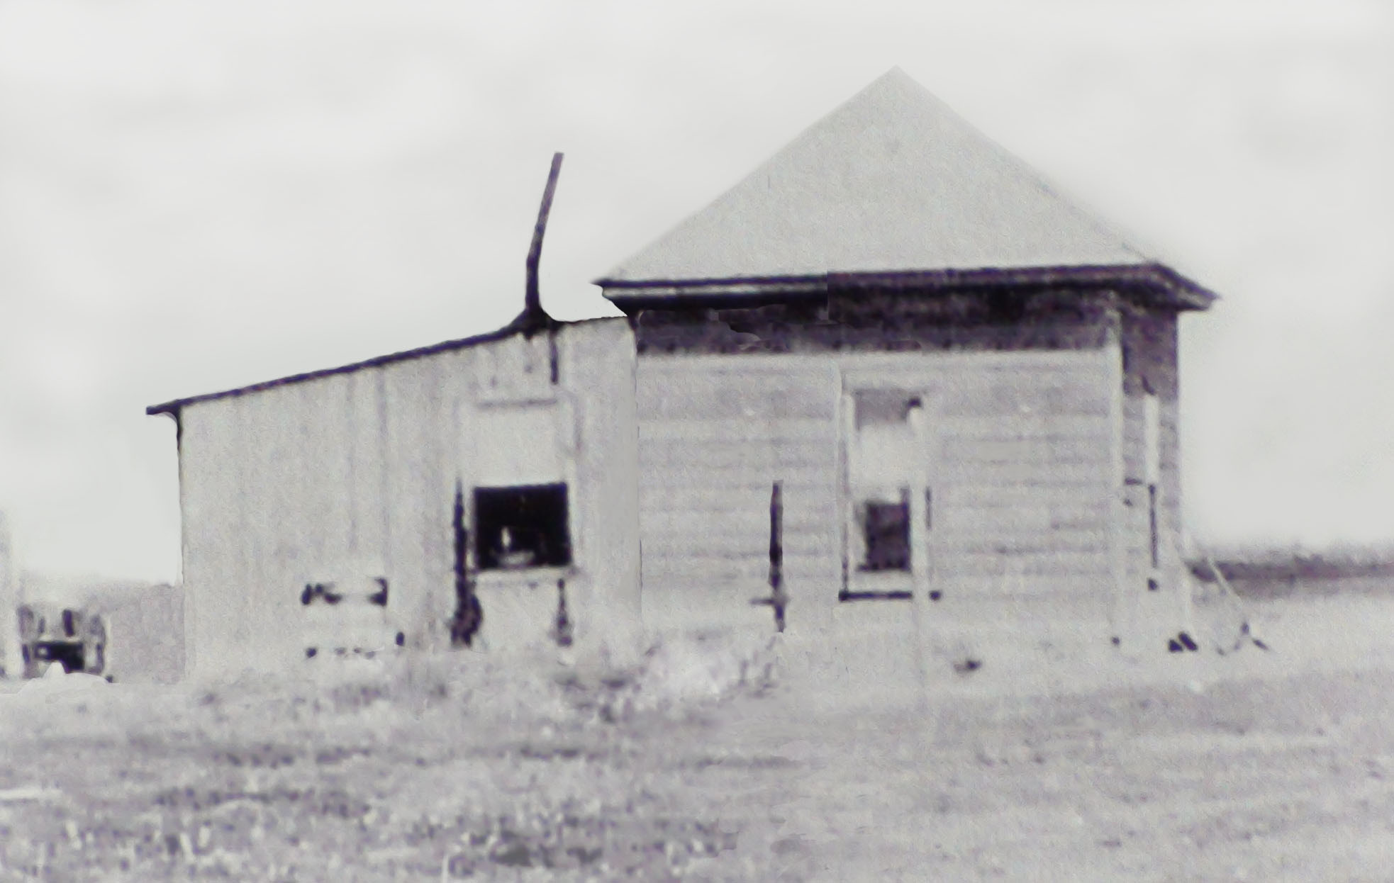Our home in Starrs Ferry where I was born.
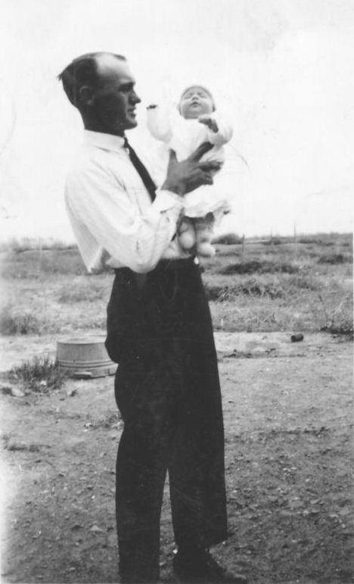Daddy holding me on the day I was blessed.
My mother choose my name “CELIA” from a book she had been reading. I was blessed Celia Gean Frost into the Church of Jesus Christ of Latter-day Saints on September 2, 1926 by President David R. Langlois in the Burley First Ward. I do not remember to much of my younger years. My father kept a diary through most of his life so I was able to gather information from his and Mothers diaries. I remained the baby of the family for three years. My sister, Thelma, told me me that I was cute and very spoiled. I didn't think I was ever cute or spoiled but, maybe a wee bit those first three years.
Those early days, with their small family, and struggling for a start in life were rewarding times for my parents. To go places, they hitched the team of horses to the wagon, placed us children in the bottom of the wagon bed and headed for town, church, or family gatherings. In the winter, a few blankets wrapped around us little ones kept us warm and cozy. The year I was born, Mother was busy with the growing family and Daddy with the farming. Their potato crop that year was bounteous and the market value such that they felt they could reward themselves by buying their first automobile. What a thrill it was for Daddy to load his family into their new Model T Ford and drive to town.
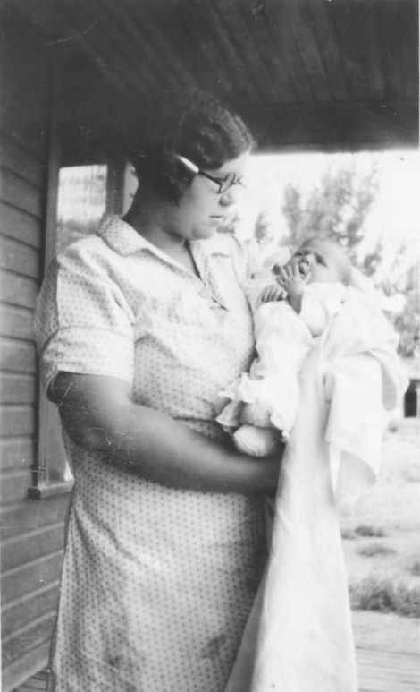Me in my mother's arms, the day I was blessed.
In January of 1927 we moved to a farm in the Springdale area, southeast of Burley.
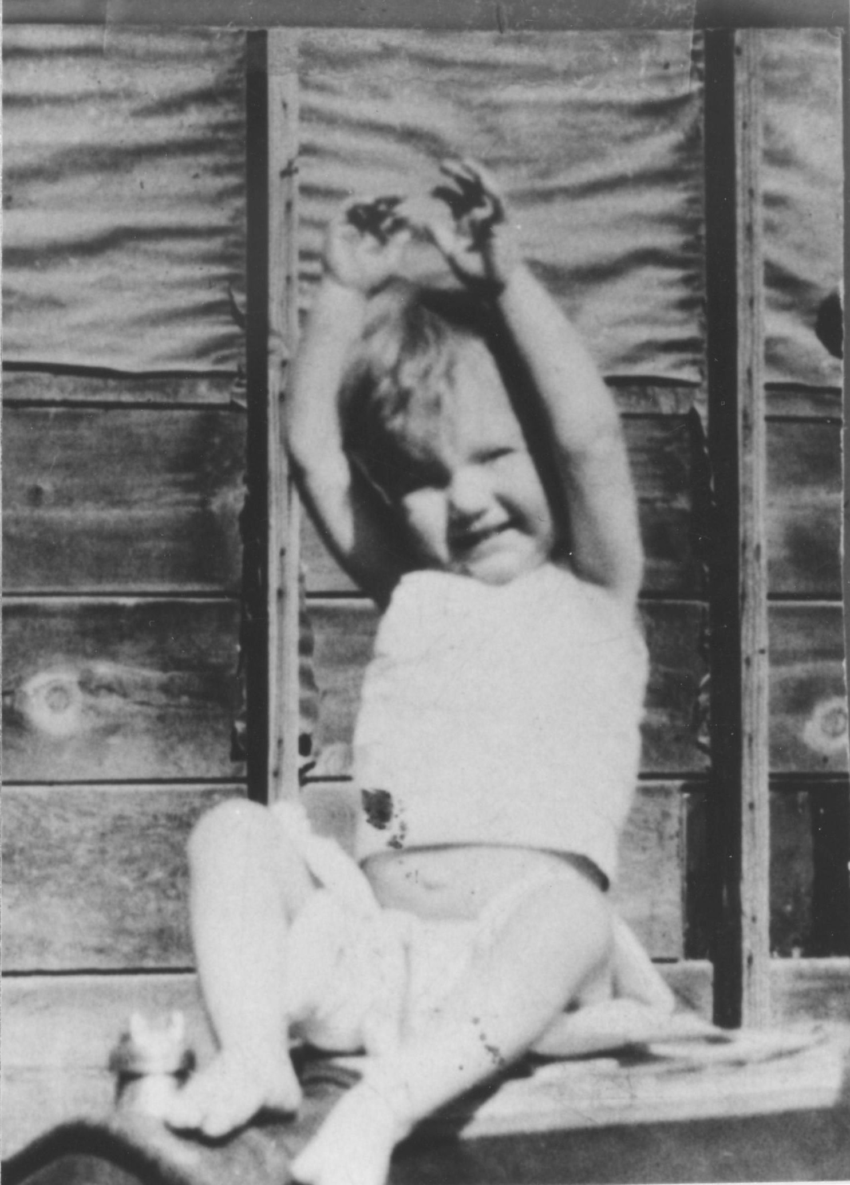Sitting on the hood of the Model T
On December 21, 1928 when I was two, Mamma noticed that my face was swelling. I developed a very large gathering (an inflamed swelling) on my right jaw. Doctor Dean had Mamma keep it packed with a poultice of tobacco and apples. (A poultice is soft moist mass of bread, meal, clay, or other adhesive substance, usually heated, spread on cloth, and applied to warm, moisten, or stimulate an aching or inflamed part of the body.) I kept the family awake for three nights and Eunice and Thelma were upset with me because they were sure that I would scare Santa Clause away. On December 29th, a very rainy, snowy, slushy day, they took me back to Doctor Dean. The gathering had to be lanced before it could heal. I kept the family awake until 4:00 in the morning. On the 31st they took me back to the doctor. He took the packing out and redressed the open sore on my face. On January 2nd they took me back to the Doctor to have it dressed again. On the 5th they took me back to the doctor again, this time he was able to leave the bandages off. All of this left me with a scar that looked like a misplaced dimple for many years.
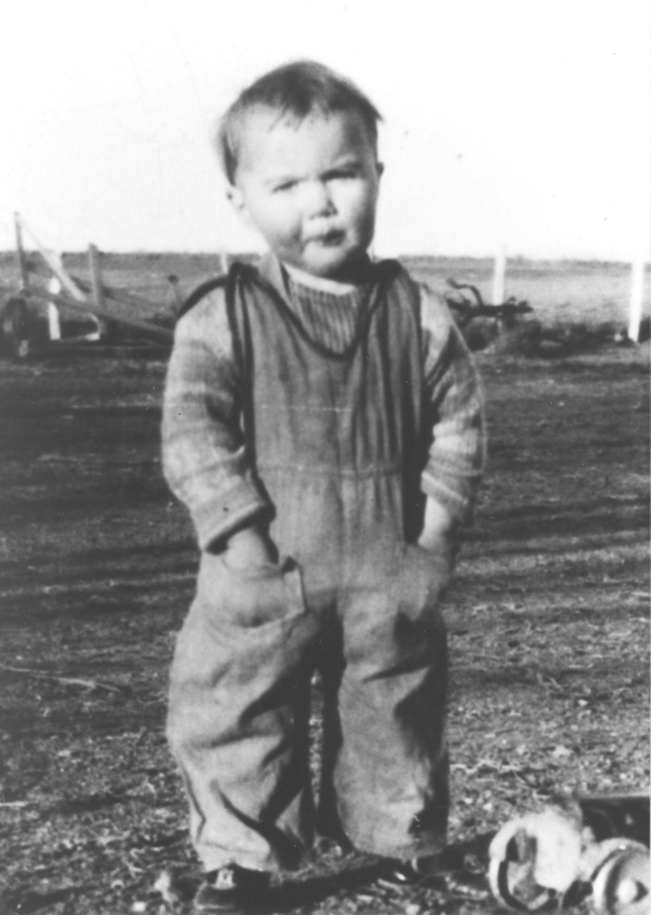Me at about 2 years old
My parents had very close relationships with both of their families, it was a tradition to always spend New Years Day at Grandma and Grandpa Dayley's. All the aunts, uncles and cousins were there, we always had a big dinner and played with all the cousins.
As a tot, I loved to play outdoors, even on cold days, when my older sibling would not go out to play with me, Mamma had to bundle me up and I would go out and play by myself. The dog kept me company until I would get cold or tired and Mamma would have to unwrap me.
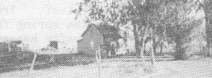Our home in Springdale
It seems that I was sick much of the time, causing many trips to town to Doctor Dean's office. Daddy took advantage of my doctor trips by having hog feed ground, or selling hogs, or doing other errands. On one such trip he sold eight hogs for 8¢ a pound. I had the croup most of my first two years.
My parents loved to dance and socialize with their families, or go to movies. We “kiddies” as Daddy fondly called us were babysat quite frequently by Aunt Nina Dayley or Aunt Ruby Frost, Mamma and Daddy's teenage sisters.
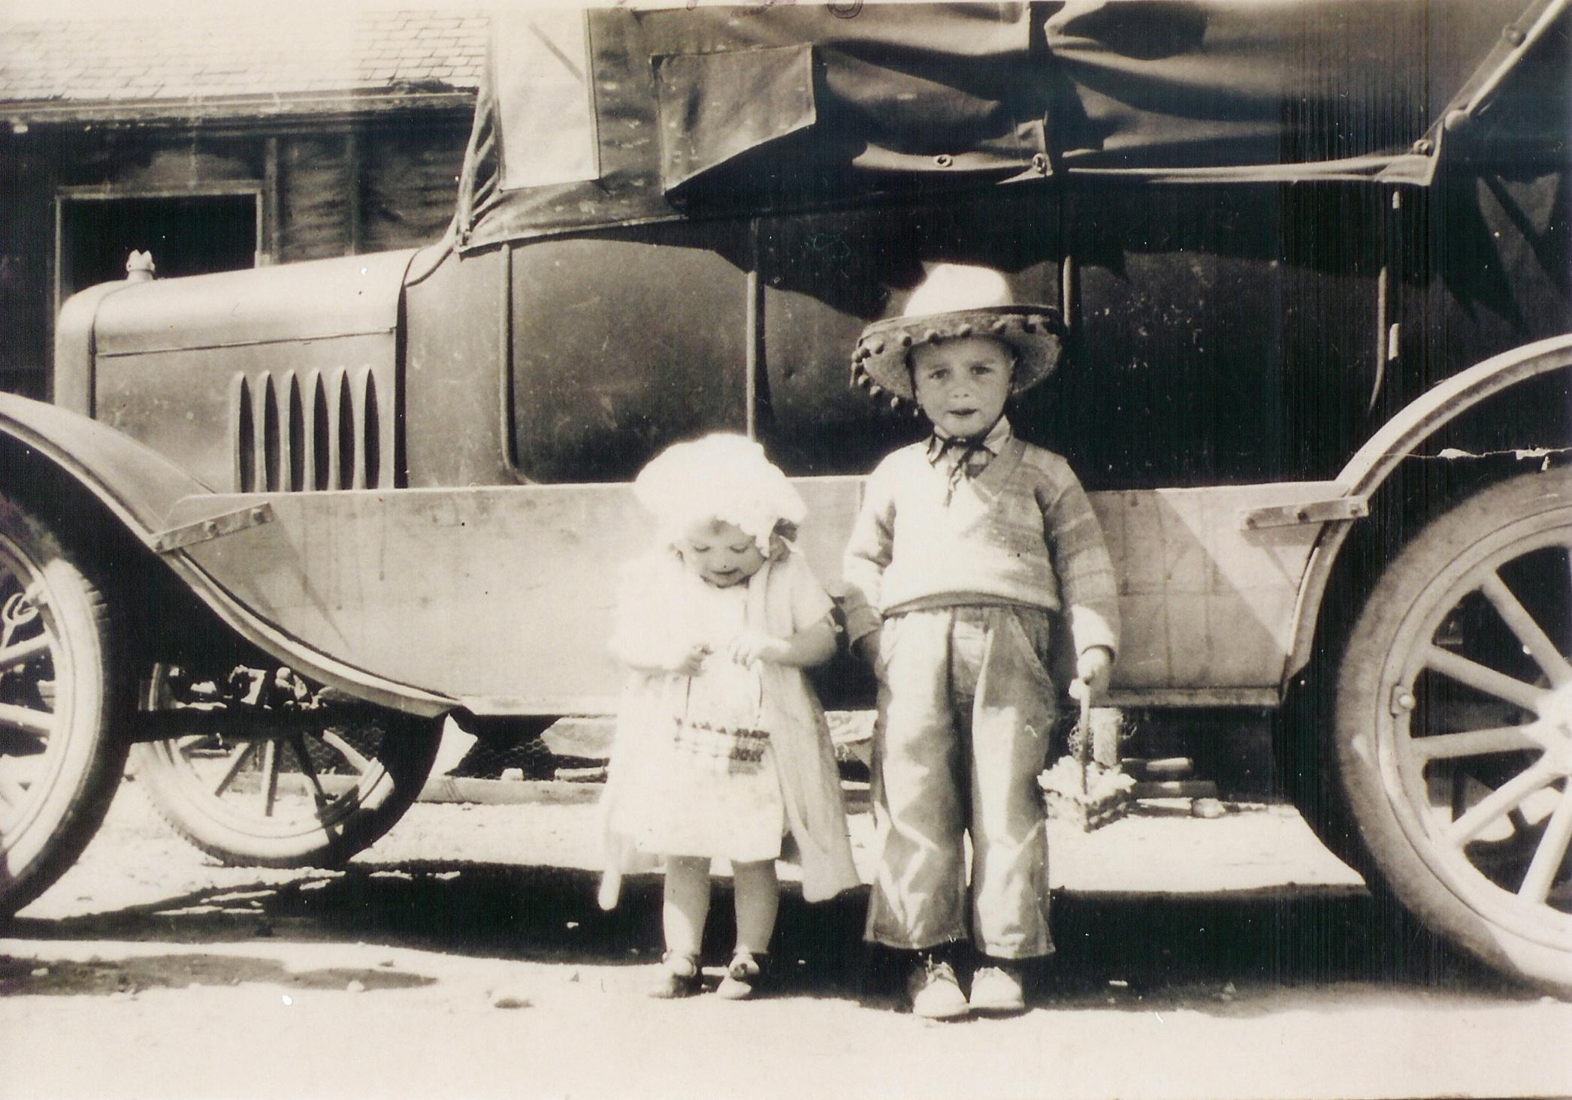Me and Myron standing in front of the old Model T on Easter morning
It was while living in Springdale that on May 6, 1929 a tiny 7½ pound baby girl was sent from heaven to our family. She had a lot of black hair and dark eyes. She was given the name of Lorna. What a shock! I was no longer the baby!
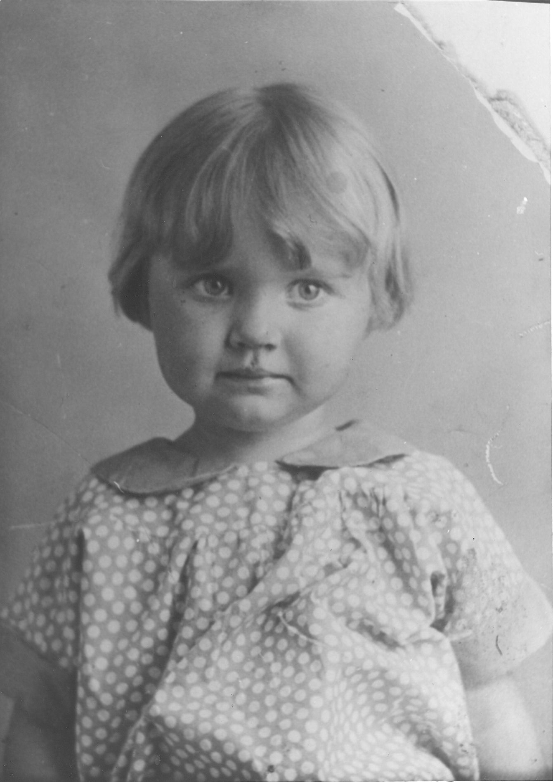Me as child
On my fourth Birthday, August 19, 1929, Mamma made a new dress for me, but the day was spent canning apricots and mowing hay. A birthday cake was not mentioned so I probably did not have one. I never ever had the privilege of having a birthday party until I was an old lady. Well sort of old. I was invited to Donna Bowen's birthday party, the only one I went to when I was a child. I don't think birthdays were a big deal in our family in those years.
In December of 1929 our family made our last move to a three room house in Unity. The farm consisted of forty acres of farm land and sixty acres of pastureland next to the Snake River. Our neighbors were the Vern Peterson family. There were two children Elaine and Ray. Elaine was my age so I had a little playmate other than my siblings. Mrs. Peterson was not a very nice lady, she took advantage of Mother, because Mother was so kind. She even tried to flirt with my dad. The folks were glad when they moved away. For Christmas that year I received two dolls, a little set of dishes with a teakettle and a hanky. On New Years Eve, I got to sleep with my Aunt Ruby.
The Stock Market Crash hit us hard. The Depression was on! By growing a garden and our milk cows, Daddy was able to keep food on the table but our family experienced many hardships. On February 30th we had the first of many hobos come to our door, living close to the railroad tracks made it convenient for them. Mother would usually give them some sandwiches and a cup of milk and they would be on their way. As a little girl I remember being frightened by them.
On May 13, 1930, my Grandfather Frost passed away. I can still vaguely remember my Grandpa sitting in a chair just inside the kitchen door. He loved to tease us as we came into the kitchen. At the time of his death, we children had the chicken pox. I also had pneumonia. I was four, I can still remember, probably my earliest memories. While I was sick, I would lick the calcimine off the wall by my bed. I must have been lacking something in my diet, I am sure it was not for the taste. Maybe the awful taste is why I remember it. (Calcimine is a white or tinted liquid containing zinc oxide, water, glue, and coloring matter, used as a wash for walls and ceilings)
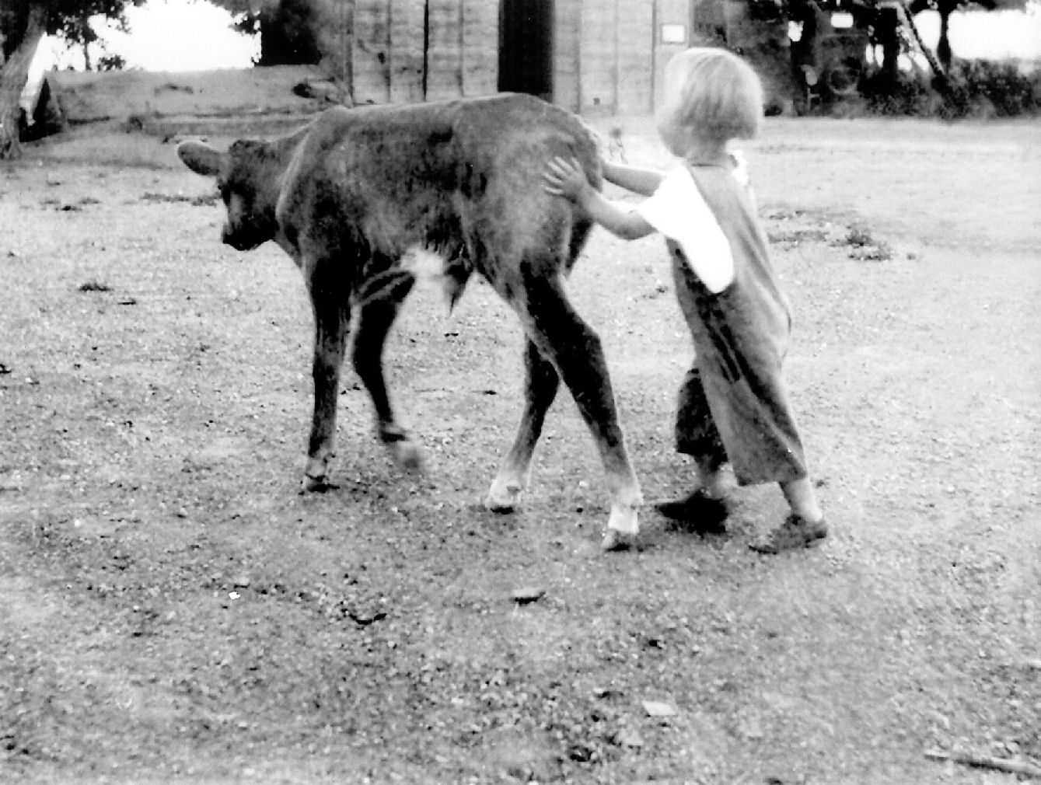Helping Daddy herding cows
On September 12, 1930 the stork found our new farm and delivered a darling little blond baby girl. She was a special birthday gift to Daddy, being born one day after his birthday. She was not well and they were afraid of losing her. Daddy hurried up and blessed her and give her the name Marian after his very special uncle, Marion Frost. We older children were delighted to have a new baby sister.
Every Sunday morning Daddy would take us kiddies to Sunday School. We were in the Unity Ward. By now there were five of us. Our parents taught us at a very young age to be reverent in church, both at Sunday School and again at Sacrament Meeting in the evenings. They taught us to pray and to pay tithing with what pennies we had been given. About as soon as we could talk, we took turns saying the blessing on the food at every meal and even the family prayers night and morning I am sure the Lord understood us.
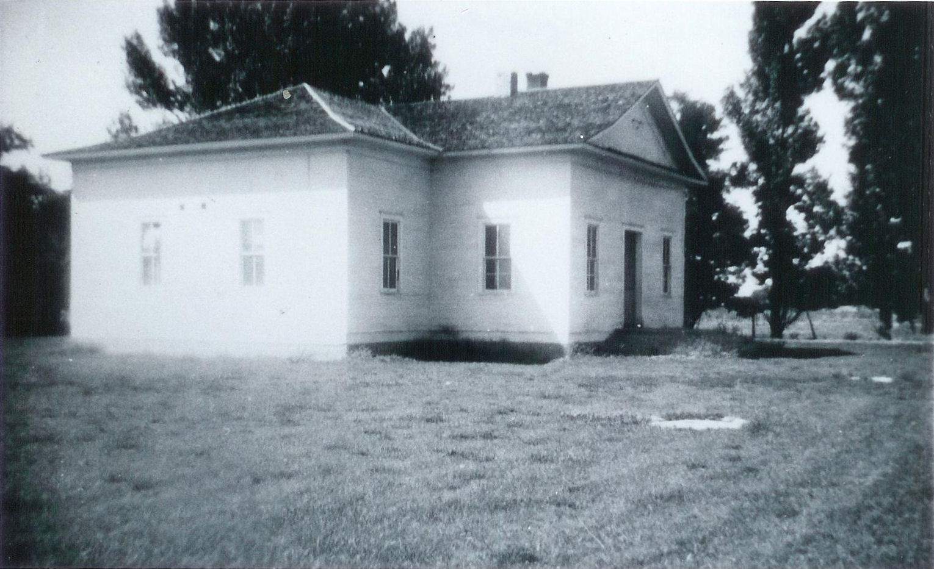The old Unity Church
On Sunday December 30, 1934 I gave a 2½ minute talk in Sunday School. I did fine, so Daddy said, but I couldn't talk plain. I was 8 years old and still couldn't talk plain? What was wrong with me? One other time I had to give the little “gem”, a four line saying that the congregation repeated. No one repeated it because I had said it so fast that no one could understand me. That was the very last time I would give a talk or participate in anything. My real problem was that I just talked too darn fast.
Most Sundays between Sunday School and Sacrament Meeting we would go into town to spend time with our two sets of grandparents. The Dayleys and Frosts lived on the same block on Schodde Ave., just north of the railroad tracks. That was exciting because most of our uncles and aunts lived close by. It was wonderful to know and play with all of our cousins from both sides of the family. There were cement sidewalks in their neighborhood, all we had was dirt! So we had fun roller skating. Its pretty hard to roller skate on dirt.
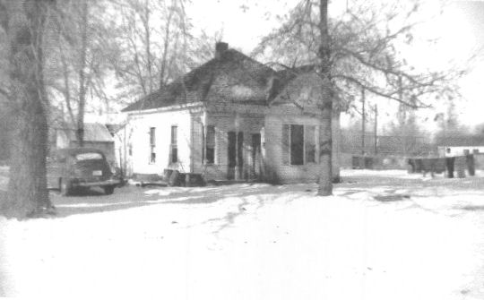Grandpa and Grandma Dayley's home on Schodde Avenue.
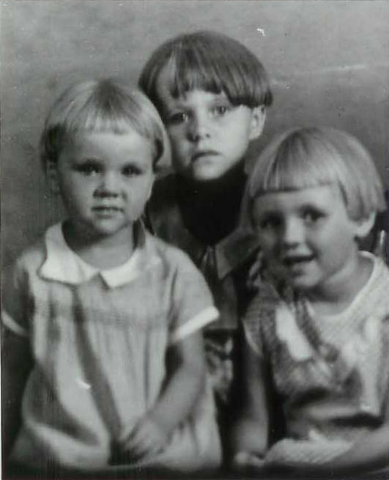Irma, Lorna, and Marion
We older kids always knew when a new baby was about to arrive. When a phone was installed in the house, we knew a baby was on the way. Sure enough, as soon as the baby was born the phone phone was taken out. On March 3, 1932 pixy faced Irma joined our growing family now of seven children.
On December 10, 1933 To Daddy and Myron's delight we finally got a baby brother, Gerald. Then on May 30, 1935 Kathryn made nine. She was a darling black haired and brown eyed baby girl. We all spoiled both Gerald and Kathryn. That completed the Frost family of nine children plus our mom and dad.
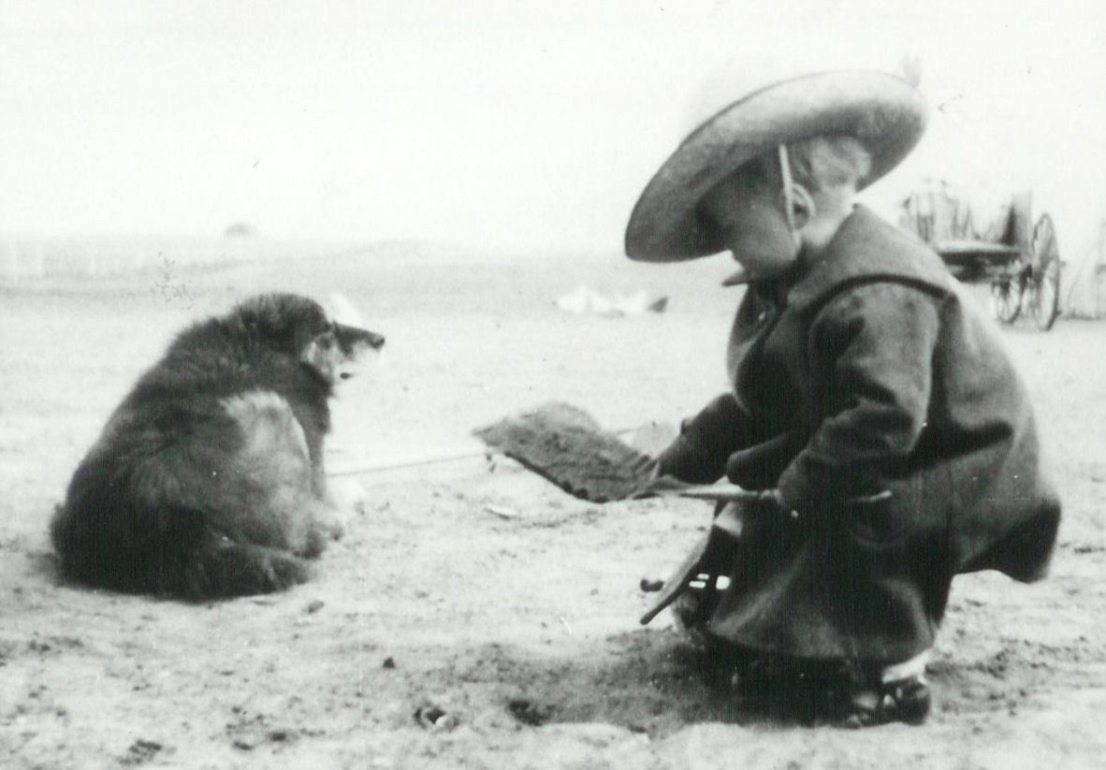All bundled up, playing outside
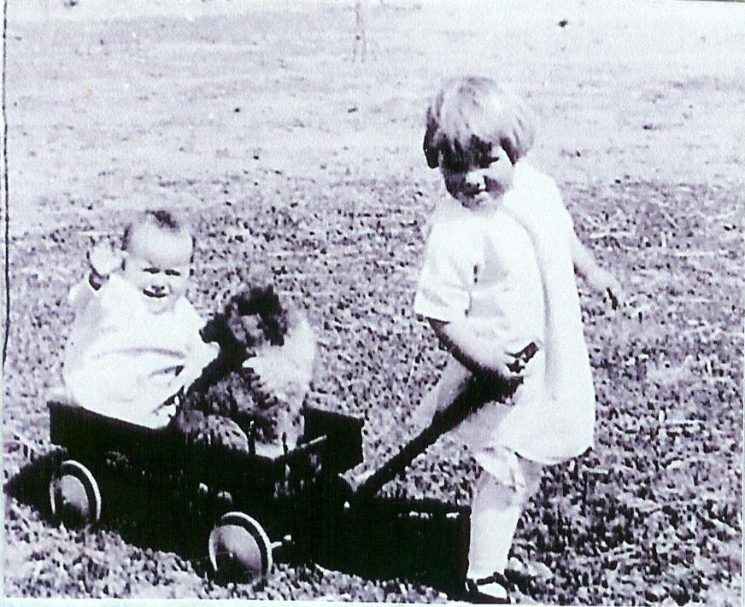Thelma pulling me and a puppy in a little red wagon
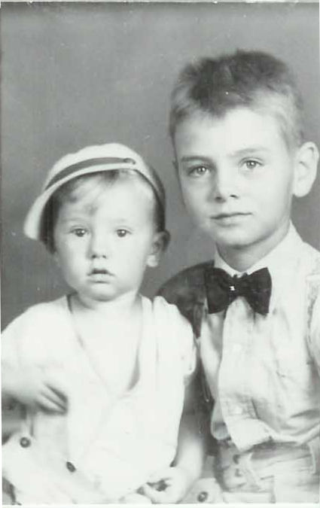Myron and Gerald
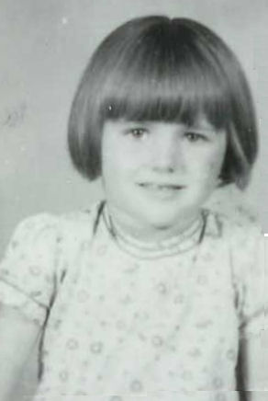Kathryn

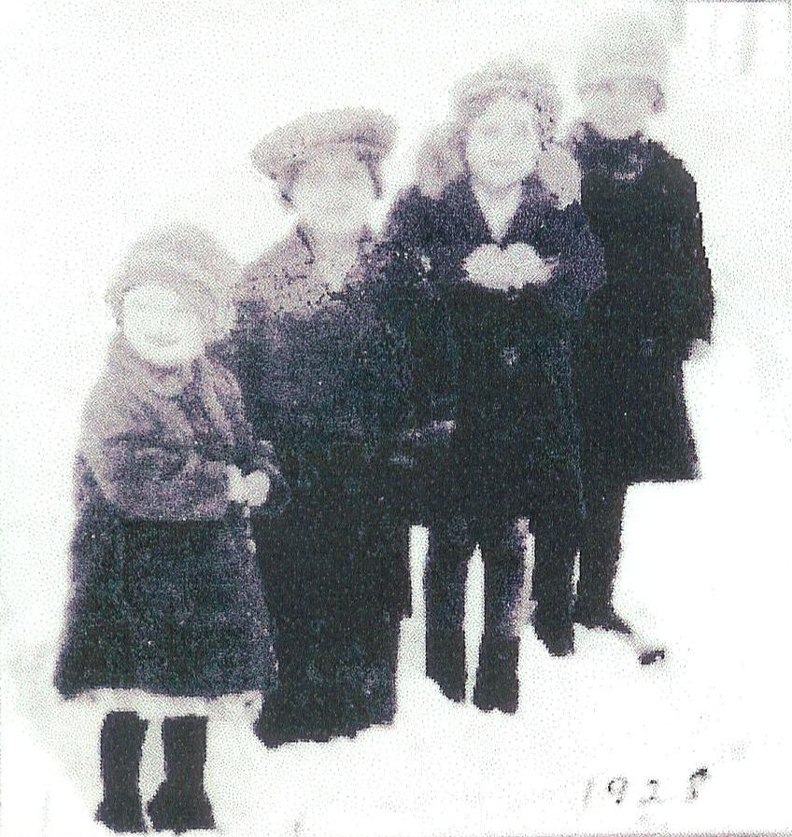Me, Myron, Thelma, and Eunice in the winter of 1928

