Chapter 12
A Marriage and a Divorce

I meet Ray Dudley in October of 1945 at the skating rink while he was home on leave from the Navy. I thought he was pretty neat in his sailor uniform. He told me he had been a good friend of Myron's and knew all about him. (It was funny, if he was a friend of Myron's I hadn't met him or heard Myron talk about him.) When he went back to his ship we corresponded. He wrote beautiful letters and sent me lovely pencil sketches that he had drawn. I fell in love with his letters and drawings. On December 1st Ray was coming home on a 25 day leave. He was about three and a half months younger than me, being born on December 8, 1926 in Burley.
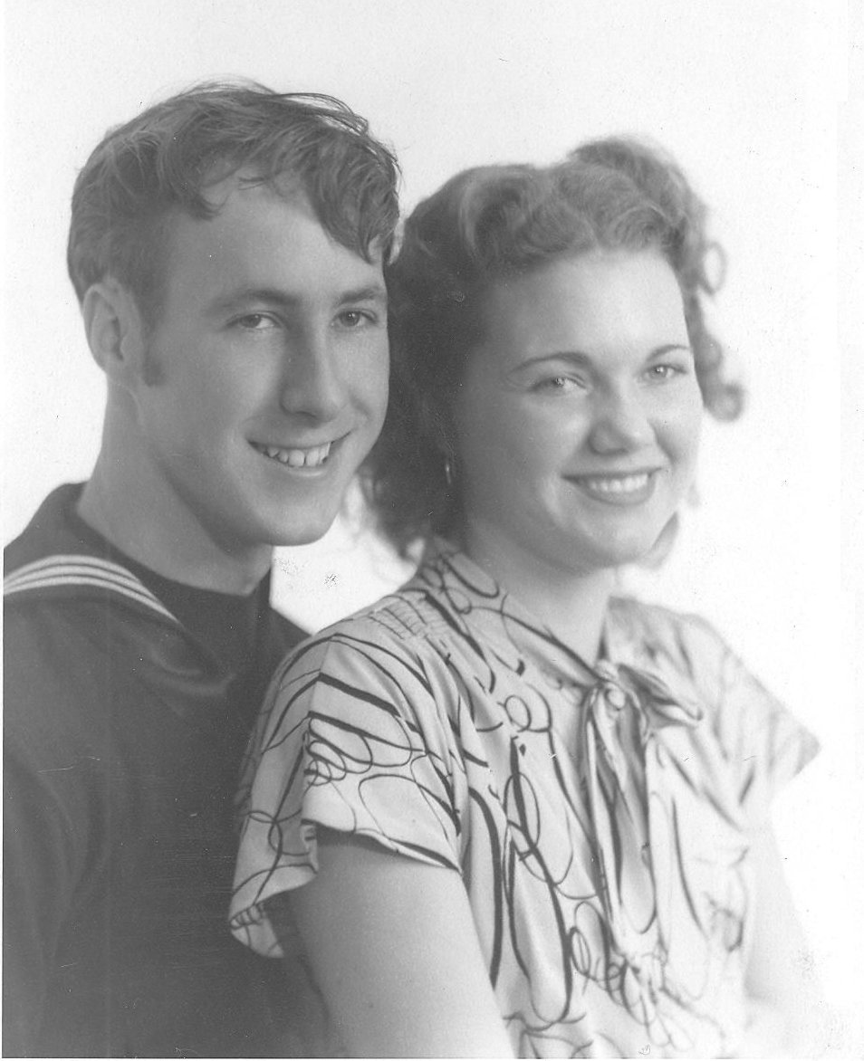Our wedding picture
I went to Boise with his parents, Jack and Mamie Dudley to meet Ray. We decided to get married on Mother and Daddy's twenty fifth wedding anniversary, December 4, 1945. What a dirty trick to play on our parents just before Christmas. We were married at my parents home by Bishop Larson of the Burley Third Ward. I was 19 and in love with the idea of being in love. The only ones attending were our two families, Theo and Donna Gooch. and Mrs. Beaver, my landlady. We spent our honeymoon in a cheap motel. A few days later we were honored at a wedding reception at the Third Ward Chapel and received many nice gifts. We spent our first Christmas with the Dudley's. Ray had to leave that day to go back to his ship.
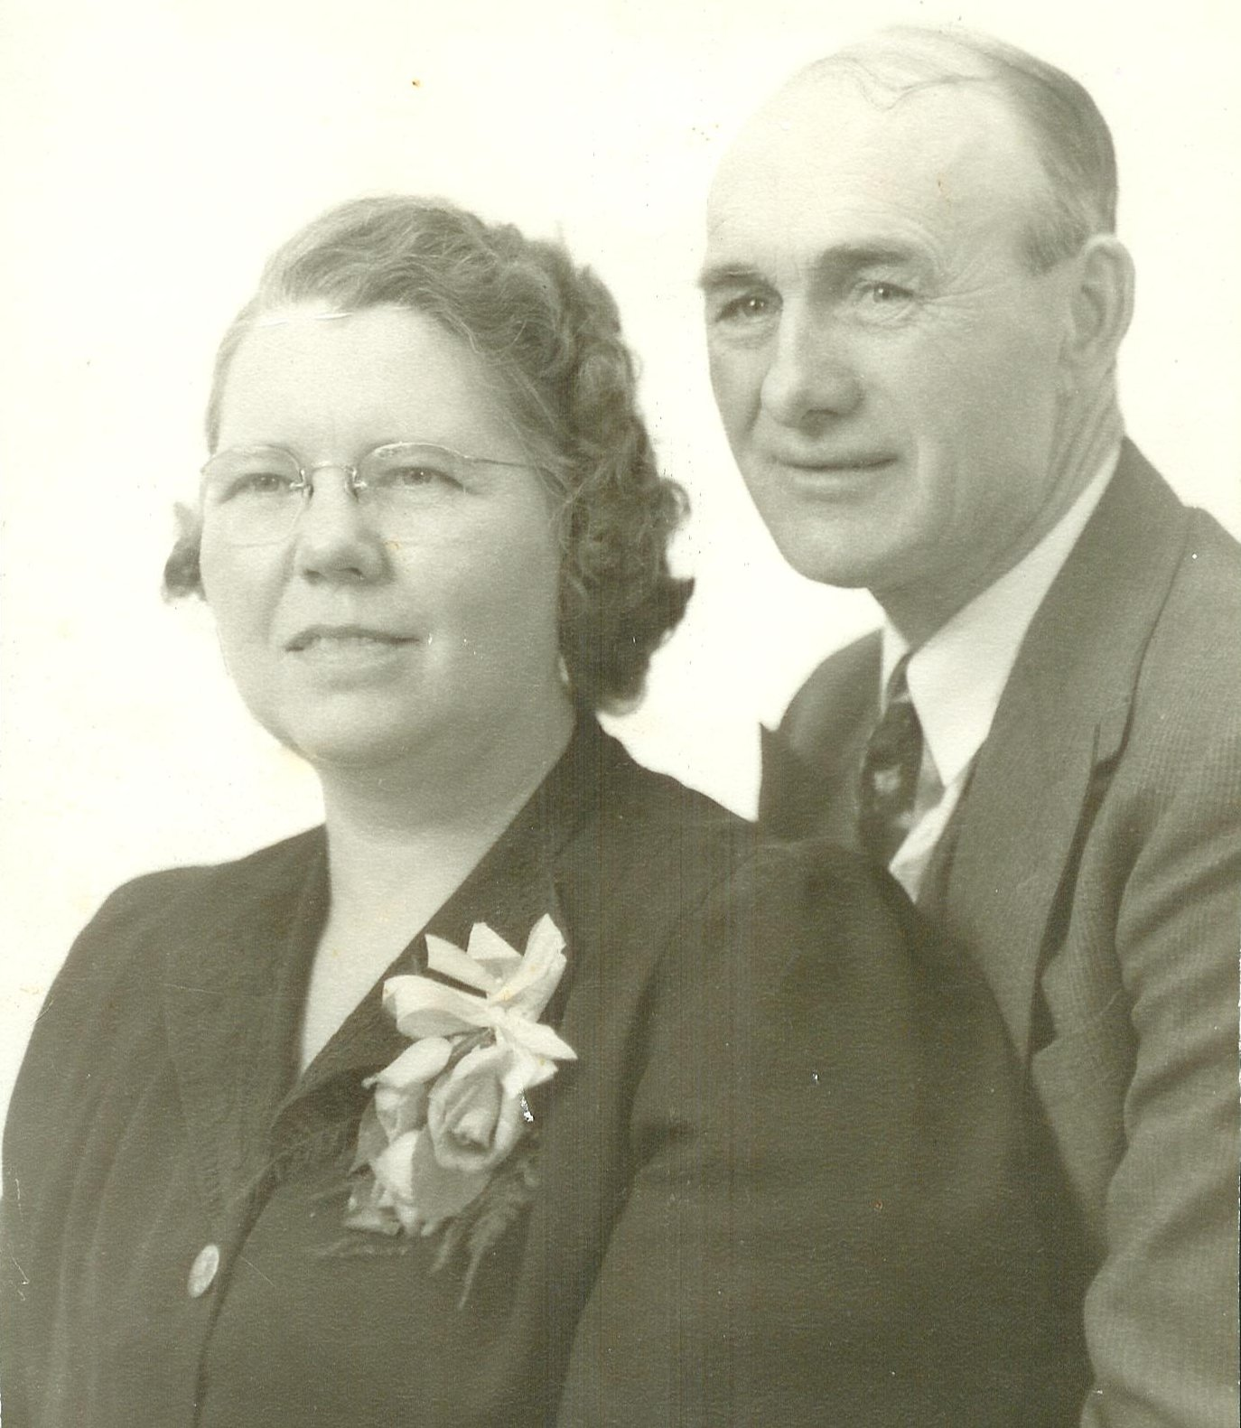Mother and Daddy on their 25th anniversary
On January 13, 1946, I left on the bus for Bremerton, Washington to be with Ray. We shared a navy apartment with another couple, a shipmate from Pennsylvania and his wife. We got a long good by keeping out of each others way. Ray was discharged and we arrived back in Burley on March 19th. We moved into Stout's basement house up the road from the folks. Without a car it was difficult to get around so we bought a tiny one room homemade trailer house from his Grandfather Saterely and lived in it on their property.
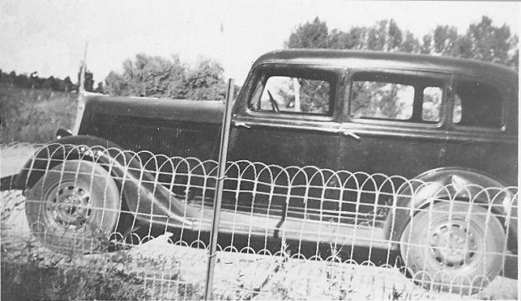Our first car
He worked for Farmer's Equity, a hardware, lumber, and feed store. He was transferred by Farmer's Equity to work at a small saw mill on the Boise River. We moved our home on wheels to Boise on the bank of the Boise River where the Julia Davis Park and the Boise Zoo are now located. Later, we sold the trailer and rented an old house. We had no furniture and slept on the floor.
I was pregnant and very ignorant about pregnancy. I had not been going to a doctor, and I should not have been sleeping on a bare wood floor. One morning in August, I woke up not feeling good, so we headed for Burley in our old rattletrap car that had no windows and only 35¢ in our pockets. Out by the Paul Labor Camp, 15 or 20 miles west of Burley, the car quit. We hailed down a milk truck that took us into Emerson to the Dudley's home were we found only little Gloria at home. She was sent to a neighbors to call Dad Dudley. He picked up Ray's mother and hurried home. They took one look at me and rushed me into Mrs King's Maternity Home. Mother was called along with Doctor Dean. He looked at me and declared I was not due yet and left.
Precious, tiny Melody was born without the aid of a doctor or anesthesia. Ray named her Melody. When the doctor did come, Mother asked him if she was premature, and he said yes. She was barley 5 pounds and 17 inches long. She was so tiny I was afraid that I might break her. She was blessed into the Church of Jesus Christ of Latter-day Saints at the Unity Ward by her grandfather, Ira Frost, on September 1, 1946.
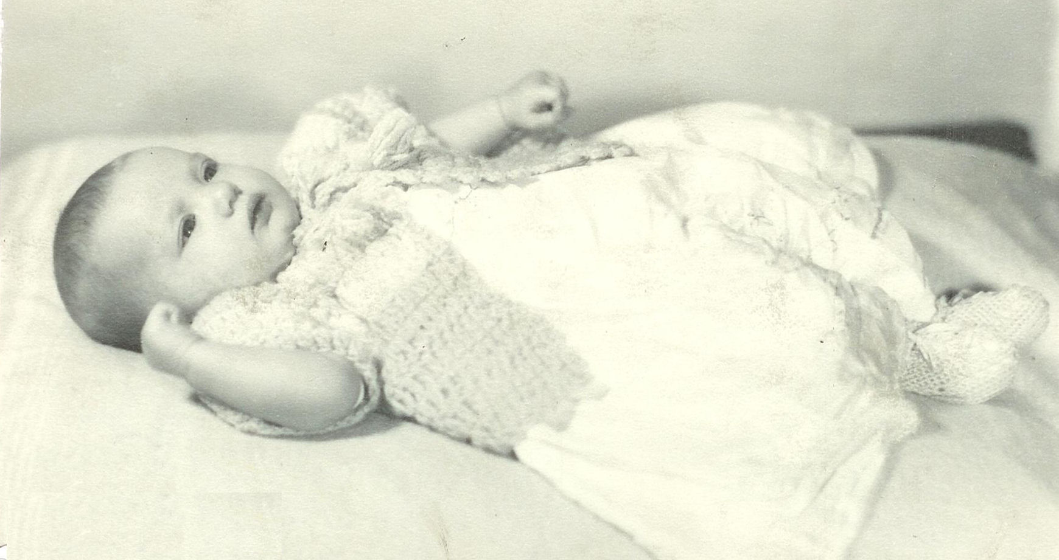Melody as a baby
We never went back to Boise and I don't know what happened to the old car. We lived with the Dudley's along with Ray's sister, Coral and her husband Bob, and their children Gloria and Linda for a short time. Later we moved to the Hugh Allen place on on Almo Avenue in southeast Burley on Goose Creek. It was a small, beat up, old three room house furnished with cast off furniture from relatives. At least I didn't have to sleep on the floor anymore. I did the best I could to make it a home. We had no car, it as just like growing up poor, again.
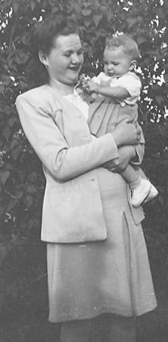Me and Melody - Summer of 47
I certainly enjoyed my firstborn beautiful little daughter Melody, as I was learning to be a mother. I enjoyed caring for her, feeding her, loving her, sewing cute little dresses, and doing all the things that mothers do for their children. Her name fit her so well as she was a little song and a real joy. She started walking at 10 months, what a tiny toddler. She would pass out for no reason and frighten me to death. I would run out in the fresh air with her, and she would come out of it.
My little sister, Lorna, graduated from High School in 1947 and married Kenneth Turner on October 16, 1947 In the Logan Temple.
On January 12, 1948, I lay in a hospital bed experiencing a very difficult birth. Strange doctors that I didn't know with long somber faces were coming in and out of my room to examine me. I was unaware of what the problem was. When Ray came in with tears in his eyes, I knew something was dreadfully wrong. I silently prayed, “Father in Heaven, I don't know what is wrong, but something is dreadfully wrong. I need your help now! In the name of Jesus Christ, amen”. Immediately things become normal. The doctors could not believe what had happened. They did not know that they had just witnessed a miracle through prayer. They were getting me ready for a cesarean section and a blood transfusion. Both the baby's life and mine were in danger. The problem was called placenta previa. The placenta was between the baby and the opening. If it had not been moved we both could have bleed to death in a matter of minutes.
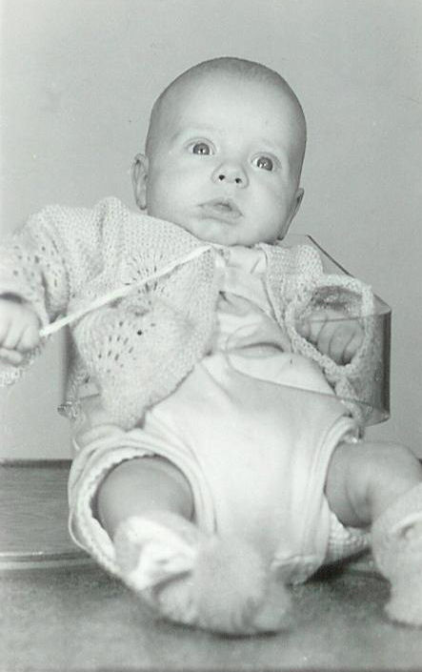Tim
Delivered by Dr. B.T. Wilson, I gave birth to a healthy, wiggly, bald headed baby boy on January 12, 1948 at 2:20 p.m. at the Cottage Hospital in Burley. He was born smiling and has never stopped. Ray named him Tim, I didn't really like it so I added Galen as his middle name. Tim was blessed at the Unity Ward into the Church of Jesus Christ of Latter-day Saints by his Grandfather Frost on March 7, 1948. After two granddaughters, Tim was the first grandson. He was also the Dudley's first grandson.
With two small babies, I more or less grew up with them. I was immature and not ready for marriage or motherhood. I had a lot to learn about being a wife and homemaker. I did not know the essentials of time or money management. I had been taught how to cook, but this was a whole different ball game.
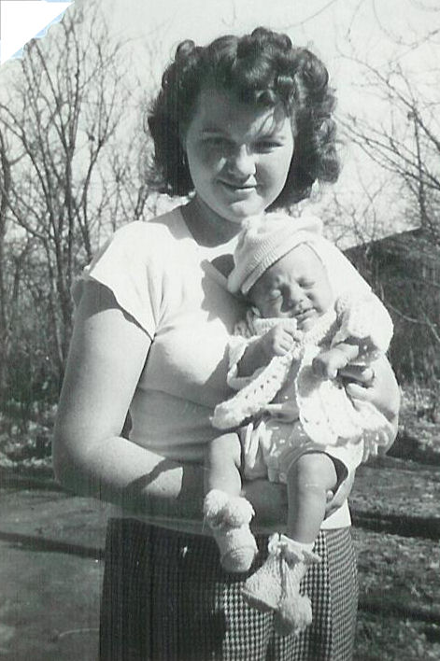Me and Tim
We moved into another one bedroom house in Burley on Elba Ave. During those years our vacations were all trips to the mountains, camping and fishing. I did not like camping or fishing!
In May of 1948 my Grandma Frost died, she had been living with her daughter, Nettie Martindale in Oakley. She was never well after the tragic shooting death of Aunt Cora. I missed her and once in a while I dreamed of going to her house on Schodde Ave.
The first time I voted was in the 1948 presidential election. President Harry S. Truman was running against Thomas E. Dewey, the republican, and Strom Thurmond, who was running as a Dixiecrat. Jack and Mamie took us to the polling place and instructed us that we were to vote for Truman. I didn't like being told how to vote, besides my parents always leaned Republican, so I voted for Dewey. The Chicago Tribune was so sure of Dewey's victory it printed “DEWEY DEFEATS TRUMAN” on election night as its headline for the following day. In the end Truman was re-elected. I have always tended to vote Republican.
in 1950 Irma graduated from High School and she married Don Lindsay on June 9, 1950 in the Salt Lake Temple. Marian and Doug were married November 28, 1950 in the Idaho Falls Temple.
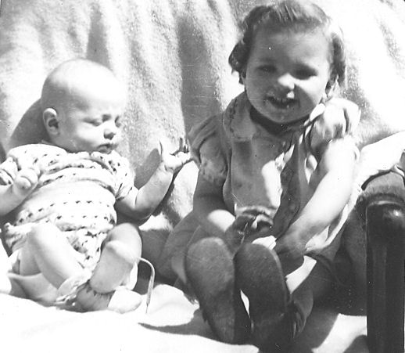Tim and Melody
In 1952 we bought a home in Heyburn. It was a cute little house on the corner of 18th and S Street. I repainted the kitchen cupboards white with blue and pink morning glory blossoms across the top. That fall Melody began the first grade. I was asked to teach Primary in the Heyburn Ward. Ray was not active in the church and was not too pleased with that.
One summer day I was out mowing the lawn with Dudley's new power lawnmower. It was equipped with three mowing machine blades. I was mowing under the clothesline between the garage and fence when I stepped into a hole, causing the power mower to roll back over my foot cutting through my shoe, making three separate cuts through the top of my left foot and one cut on my right leg. I ran to the house with blood spurting with every step. My foot was numb and I was sure that I had cut it completely off. Melody and Tim were both screaming. I called Mom Dudley and she rushed me to the emergency room at the hospital. I spent the next hour or so getting my foot sewed back together. My first thoughts were, “I'll never be able to dance again.” Even though I hadn't danced a step since we were married. (Ray did not like to dance). After about six weeks, I was able to put my shoe on. The Insurance company asked the doctor how many stitches it took. His answer was, “ Have you ever tried to sew up a piece of hamburger?”
In 1952 Gerald graduated from high school and Kathryn graduated a year later. June 4,1953 was a very joyous day for my family, especially my baby sister Kathryn and little brother Gerald as they were about to be married for all time and eternity in the Idaho Falls Temple, just as the rest of my sisters had done before them. I know I felt very much alone as I watched my whole family walk through those doors. I tried to console myself by tending the nieces and nephews on the Temple grounds and making them happy even though my heart was heavy. If only I had married right, I could have been there with them. That day was Mother's birthday.
Ray loved his kids dearly and was good to me, but neither one of us were mature enough for marriage. We did not know each other long enough to really know what we wanted out of our marriage. I was not in love and very unhappy. Our marriage was going no place and in May I filed for divorce. I and the children moved back in with my parents. The divorce was final on June 28, 1954. Breaking up a family also breaks many hearts. But being blessed with those two sweet children was meant to be.
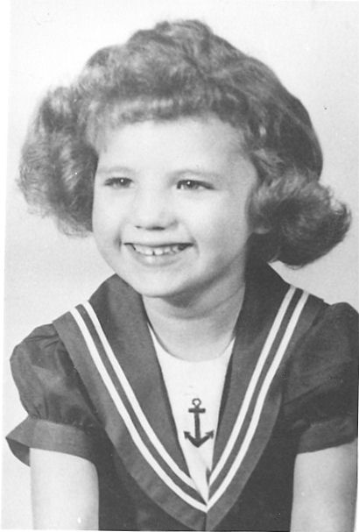Melody - age 5 (1951)
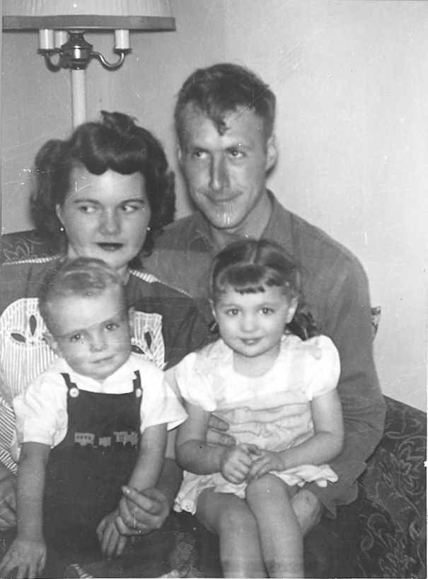Me and Ray; Tim and Melody - 1949
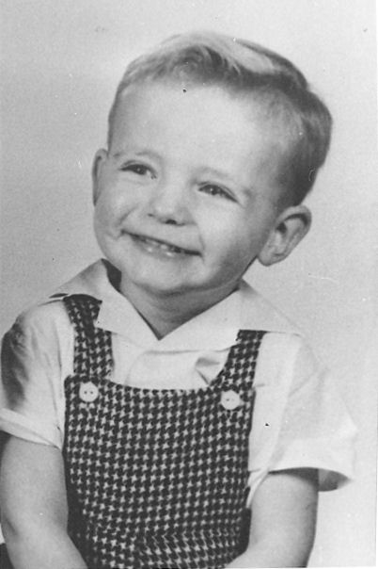Tim - age 3 (1951)
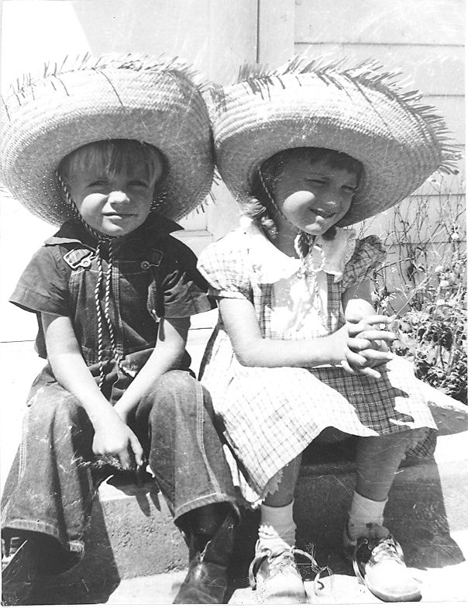Tim and Melody - 1952

