Chapter 13
Another Marriage

Melody, Tim, and I moved back with my parents which put a hardship on them. I got a job at Miller Drug Store on the corner of Overland and 13th Street, right across the street from JC Penny's. Melody was eight years old and Tim was six. Daddy baptized and confirmed Melody into the Church at the Unity Ward on August 27, 1954.
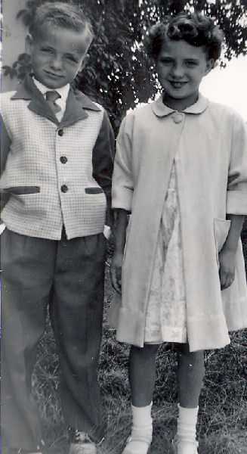Tim and Melody in 1954
One day as I was working, Mary Buttars came into the store. I had known her previously from teaching primary. She asked me all kinds of questions about myself. The next thing I knew, her single stepson came in the store to look me over. I guess he liked what he saw because later her asked me out. Most of our dates consisted of spending time at his parents home, watching boxing matches. His name was Gordon Buttars.
In 1954 Gerald was called to serve a mission in the Central Atlantic States Mission. Verlynn was born while he was on his mission. Verlee and Verlynn had to move in with the folks and I had to move out! I had only been single since the end of June. On Sunday, September 19th Gordon asked my Dad for my hand in marriage. We were married September 22, 1954 at 8:00 p.m. in my parent's front room by Bishop Morris Baker. His father, Gover Buttars, and my mother were our witnesses. Our wedding guests consisted of our parents, Verlee, Melody, and Tim, I don't remember any one else being there. Gordon said that he either had to buy a set of rings or a dishwasher and he thought he could get more use out of the set of rings! We went to Salt Lake City for our Honeymoon to see the Ice-Capades, Gover and Mary went with us.
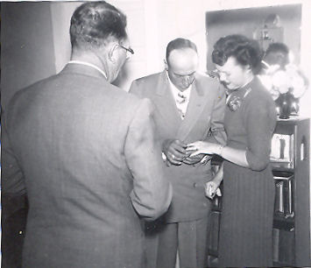Gordon placing the ring on my finger
Gordon Gover Buttars was born on July 1, 1918 in Clarkston, Utah. His mother died when he was only two years old. His father remarried after a couple of years and in 1929 they moved to Burley. Just prior to the outbreak of World War II he enlisted in the Navy and was at Pearl Harbor on that fateful day. During the war he served aboard the USS Enterprise which participated in every major battle in the Pacific. When the war was over he was a nervous wreck. He had been married twice before, once before the war and once after.
Mother and Daddy helped me move into Gordon's home in Unity where he was renting the Gee farm. On Thanksgiving day we fixed dinner for both sets of parents. He was a very good farmer and could make anything grow. Newel Baker hired him to run his farm up the road a couple of miles away, along with farming the Gee place.
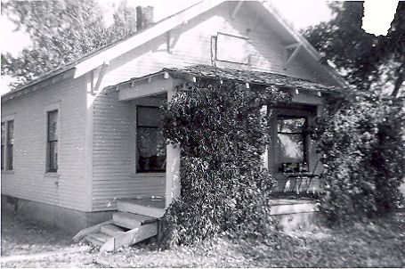Our home on the Gee place (510 S 150 E)
Daddy was stricken by his first stroke in April of 1955 while in the barn milking the cows. Melody was out there at the time and walked in the barn and found him stricken. He was rushed to the hospital where he remained for several weeks. He was devastated because he wasn't able to do the things that he was used to doing. He worked very hard to get the use of his hand back. Kenneth and Don ran the place the rest of that year. The next year Irma and Don moved to Idaho Falls. A year or two later, Mother and Daddy had a new home built on the hill above the pasture on the river bottoms.
While living in Unity, little Gordon Gene was born. A very special Father's Day gift for Gordon. We called him Little G.G. or sometimes Gordy. Mary and Gover were there the day that he decided to come forth. He was born on Sunday June 19. 1955 at 3:45 p.m. in the afternoon at the Cottage Hospital. He was delivered by Dr. Sutton and weighed 7 pounds 1 ounce and was 19½ inches long. He was his Daddy's boy right from the start. Melody and Tim loved having a new little brother and living on a farm with farm animals and a big black dog named Nick to play with.
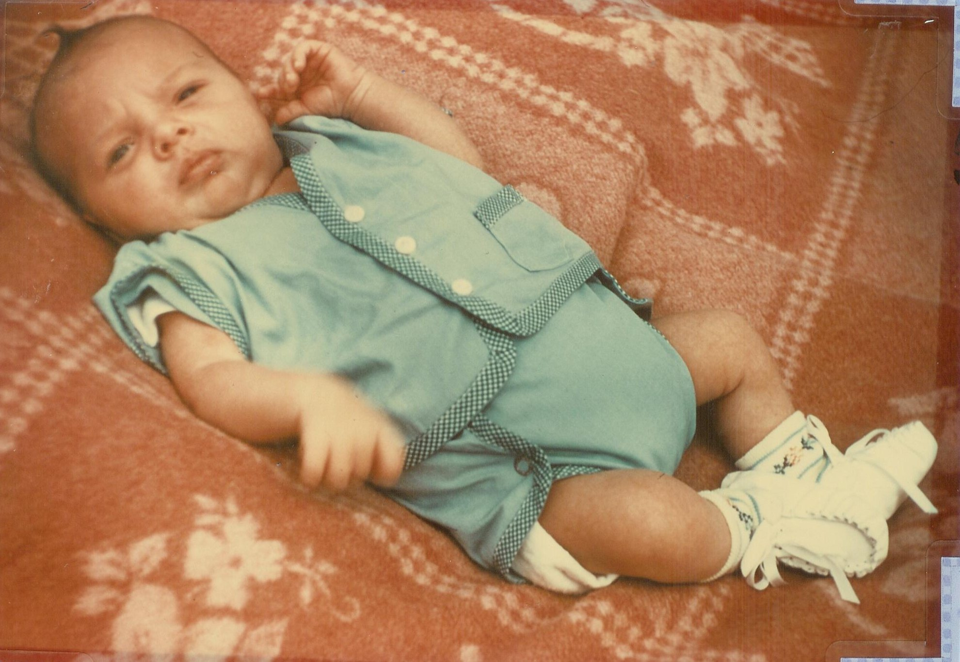Gordy at 2½ weeks old
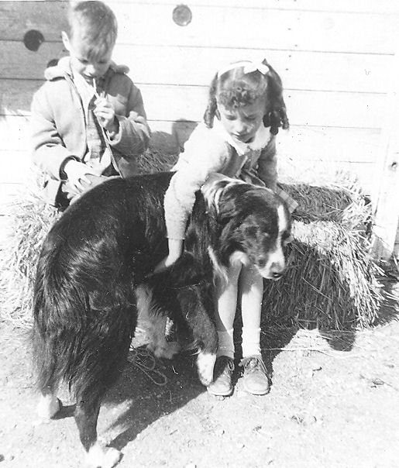Tim and Melody with Old Nick
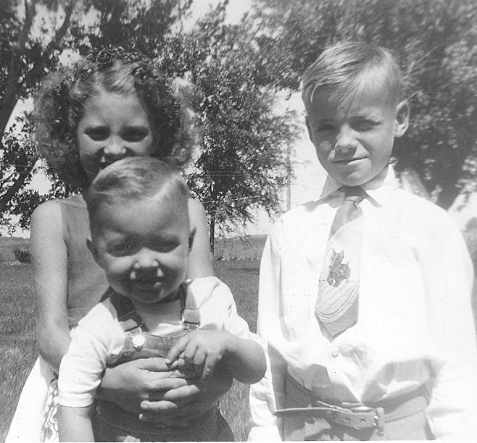Melody, Gordy, and Tim - 1956

Gover and Mary had bought a house in town and decided to sell their farm to us. So we moved into their place 1 mile South a half a mile east of Burley in 1956. I really liked it there. It was here that I caught little G.G. just as he placed a very large black stink bug in his mouth and crunched down. I was only able to retrieve a portion of it. It didn't seem to make him sick, but it sure did me.
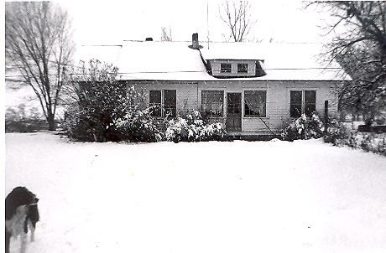The Buttars place (50 E 100 S)
We lived there one year and in the spring he had the ground ready to farm. Mary and Gover decided they didn't like living in town and wanted the place back. We had a farm sale and sold all the farm equipment. We packed up and moved to South Salt Lake City to the Sugar House District. Our address there was 1350 E. 27th S. We lived in a very nice brick duplex with a fenced in backyard for the children. Gordon enrolled in the Philips Petroleum Co. School to learn the service station business.
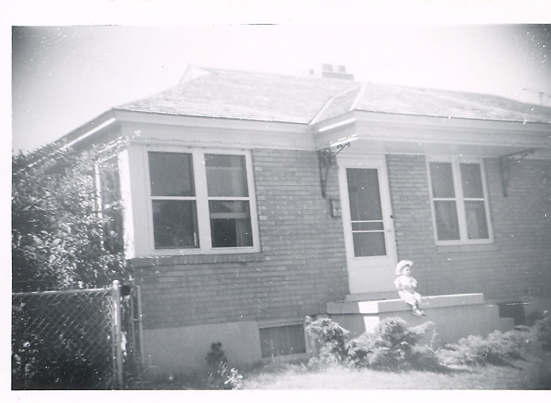Our home in Salt Lake
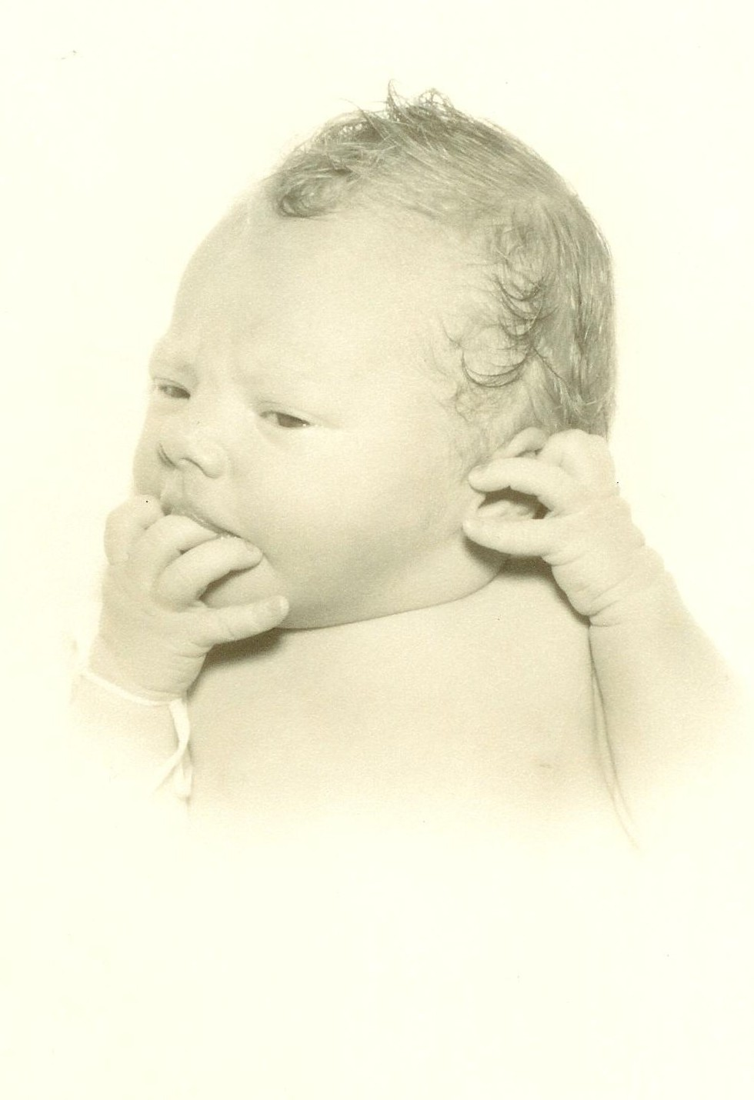Cindee 1 day old
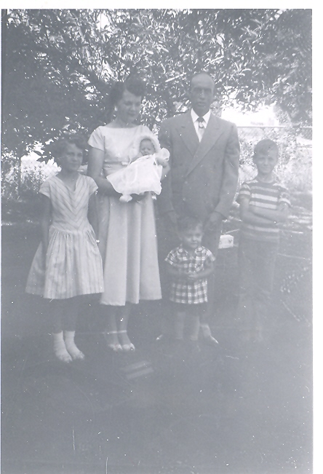Our Family – July 1957: Melody, me holding Cindee, Gordon and Gordy, and Tim
I was expecting at the time and was having problems with this pregnancy also. This little child kept wanting to be born before her time. I went to the Hospital three times before it was her time to arrive. When she finally decided to come, she was almost born in the car. We got in the hospital just as she came screaming into this world. She was born at the L.D.S. Hospital June 2, 1957, at 12:02 a.m. She was 7 pounds 2½ ounces and 21 inches long. She was delivered by Dr. Hall. I named her Cindee. Cindee was born with red hair that turned blond. Her little nose was pushed to one side but it soon straightened out. She was a beautiful baby. At the time, Gordon was 39 years old and I was 31. She was blessed by Earl Read, her uncle, on July 8th into the Church of Jesus Christ of Latter-day Saints at the Imperial-West Ward, Wilford Stake Salt Lake City, Utah. Cindee was the only one of my children was not born in Burley, Idaho.
Just after Cindee was born we went to Yellowstone Park with Cecil and Claris Toner and their kids, we even camped out that time. We were cooking breakfast over some kind of grill, Cecil was cooking bacon and hot cakes or something that smelled really good. Good enough to attract a big old bear. As he came toward us, I grabbed my kids and put them in the car. That old bear came right up to our table, Cecil hit him on the nose with the pancake turner he was using, and the bear shook his big old head and turned around and went back down the hill with a very disappointed look on his face. Gee, maybe it was a Mrs. bear, but whatever it gave us some excitement for a while.
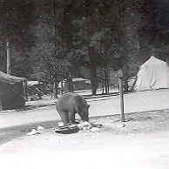The bear that came to breakfast
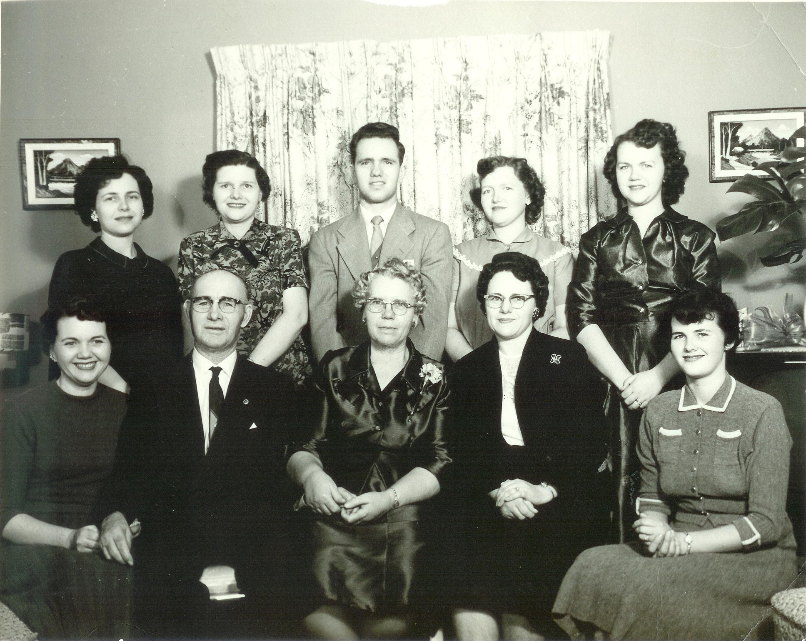The Frost Family - 1957. Standing: Lorna, Eunice, Gerald, Marian, and Irma. Seated: Me, Daddy, Mother, Thelma, and Kathryn
I had many good times living in Salt Lake, Thelma and Jay and their little family lived there. Eunice and Earl were living in Provo. Thelma and I spent a lot of time together. Our little children played together, Gayle being just 3 months older than Melody and Jaylynn was 4 months older than Gordy.
While Gordon was in training he met Neil Hart from Rexburg, Idaho who was also going through the program. We became good friends to Neil and and his wife, Shirley. In August of 1957 Gordon finished his Philips 66 training and was ready for his own station. We moved to the north end of Ogden, Utah. Our address there was 555 5th St. We lived on a good street with good neighbors and lots of children to play with ours. There too we also had a nice fenced in backyard. Neil got a station in Burley, Idaho of all places and later in Rexburg.
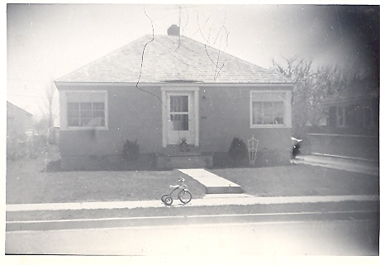Our home in Ogden
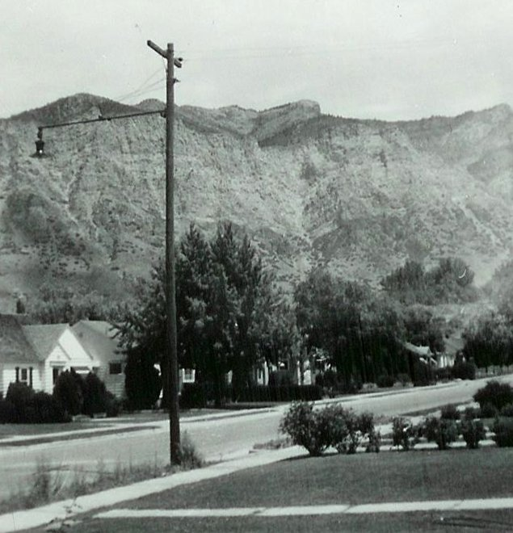The view from our home in Ogden
On August 30, 1957 we had our big grand opening of our Philips 66 gas station on Washington Blvd. It was a brand new station and on a very busy street which brought in a fair amount of business. He hired a young man and later another older fellow.
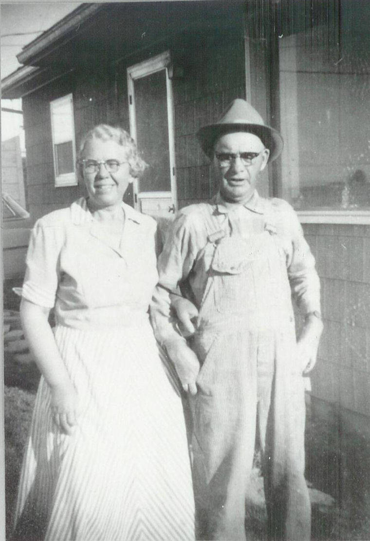Mother and Daddy - 1957
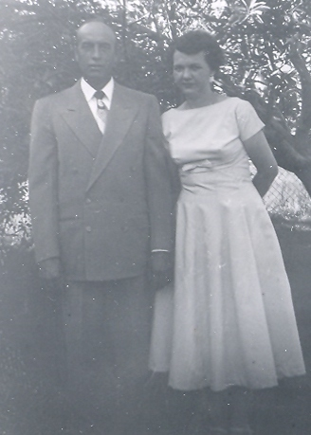Gordon and me - 1957
In the Spring of 1958 Gordon was not happy being away from the farm so he sold the station and we moved back to Burley into a little shack of a house that we rented from Bingham's just about a half mile from the Pella Church. It was not a good place!!! did what I could to make it a home. We lived there only one year. I was so thankful when we were able to move from there. Gordon was renting a farm from Trummals a few miles south of there. We had to buy all new farm machinery as everything had been sold in the farm sale.
Melody was in the 7th grade at Burley Jr High. The Utah schools were ahead of Idaho's and she couldn't keep up, so she went back to the 6th grade at the Miller School. When we moved back to Burley, Little G.G. said, “We left G.G. in Ogden, I am Gordy”. He would never answer to G.G. after that.

My kids in 1958
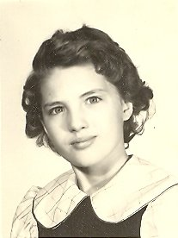Melody - age 12 ½
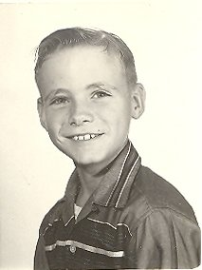Tim - age 11
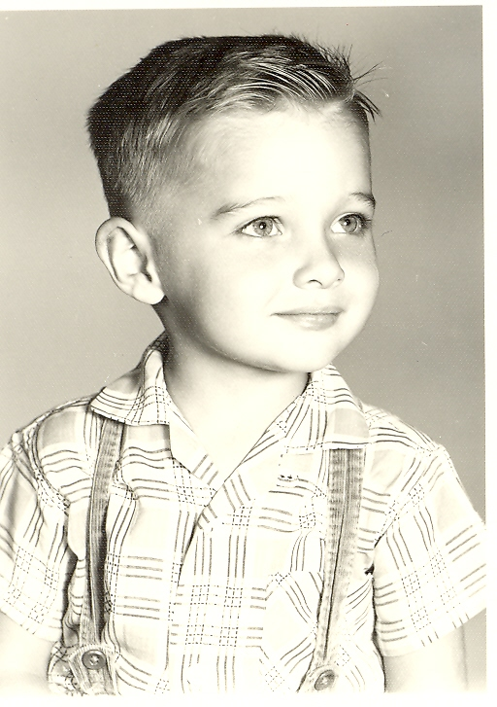Gordy - age 3
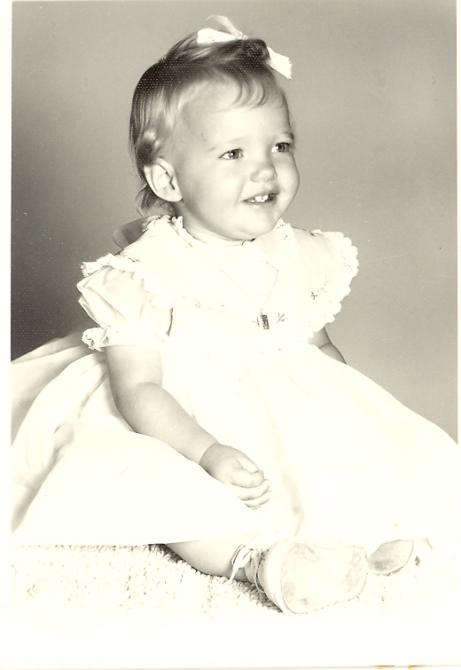Cindee - age 1

In the fall of 1958 we bought the Hitt Farm just a mile south of where we were living. We moved into the house and Gordon got the fall work done and was all ready for spring. During the winter the deal fell through. So we had to move again. This time to the Story farm, still in Pella on the same road as the Gee place. It was a tall two story house the kids always called the “Gick House”. Rented farms didn't come with very nice houses. We lived there for 6 years, and had good times and bad times. I tried again to make the best of a not so great home.
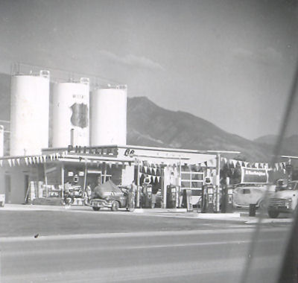Buttars 66
There was an old chimney on the north side of the house. It wasn't used for anything except a beehive. One day I had sprayed the house for flies and we all went out on the lawn while the fumes cleared. The kitchen window next to the chimney was open a crack. The spray made the bees sick and a we were attacked by a swarm of mad bees. Everyone was stung but Gordy.
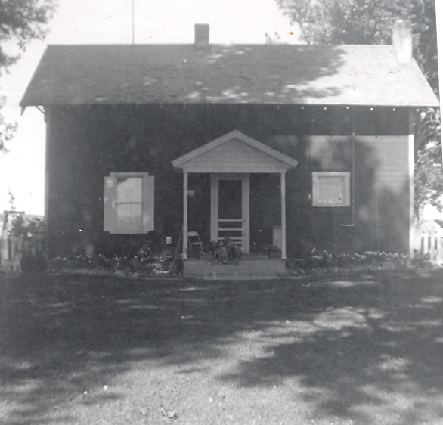The Story place (550 S 150 E)
There was a big 7.5 earthquake that took place August 17, 1959 at about 11:37 p.m. Just before midnight we got a rude awaking as the whole house shook. The quake's center was in Montana just above the Idaho Montana border and close to Yellowstone Park. The quake caused a mountain landslide that buried a whole campsite taking the lives of 27 people and dammed off the Madison River forming Quake Lake. It was felt as far away a Salt Lake City and even Boise Idaho. We certainly felt it in Burley It shows just how powerful Mother Nature can be.
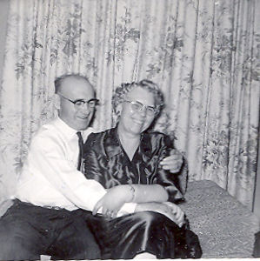Daddy and Mother, after Daddy had another stroke
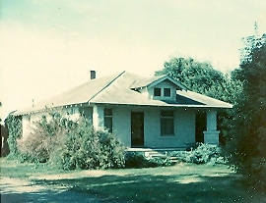The Hitt place (100 W 500 S)
An event that was part of the times were the atomic bomb tests in the Nevada desert. I remember on at least one occasion that as a family we went outside in the per-dawn darkness and saw the southwestern sky aglow from one of the detonations.
In October of 1957 we would go out at night and sit on the hood of the car and watch the Russian satellite, Sputnik as it circled the earth every 90 or so minutes. It was really spooky to think that man could actually invade outer space. To me that is God's space. It was only a few years later as we watched the launch of Freedom 7 which took Alan Shepard, the first American to go into space, on a fifteen minute sub-orbital space flight on May 5, 1961. Prior to that launch there had been several unmanned test flights.
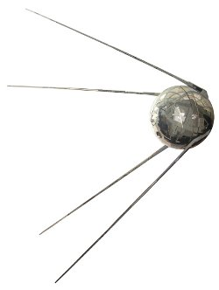Sputnik
Television was just coming of age. For better or worse, it was the world's most powerful, influential and immediate medium of mass communication. Television enabled people across the globe to witness events as they happened. We are able to watch all these amazing history making events take place right from our living room. In 1962 we watched John Glenn circle the earth three times. It was so awesome to see these space flights take off into outer space and to land again.
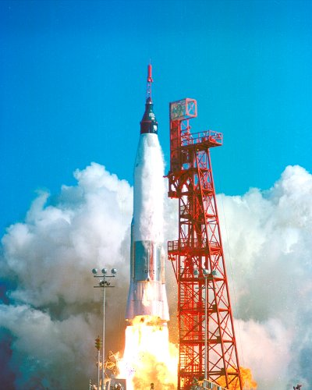The launch of Friendship 7 and John Glenn
Gordy started first grade at the brand new Dworshak Elementary School in the fall fall of 1961.
We were expecting our third child in 1961 and once again I was having a difficult pregnancy. This child just like Melody, and Cindee wanted to be born before her time. I could not even sweep the floor without going into labor. Dear Shirley Hart was the only one that came to help me. With rest and a very expensive pill I was able to keep her until her time. Then she didn't want to come. I think she thought if you wouldn't let me come when I wanted to, you can just wait until I get darn good and ready to come. So it took another expensive pill to get her here.
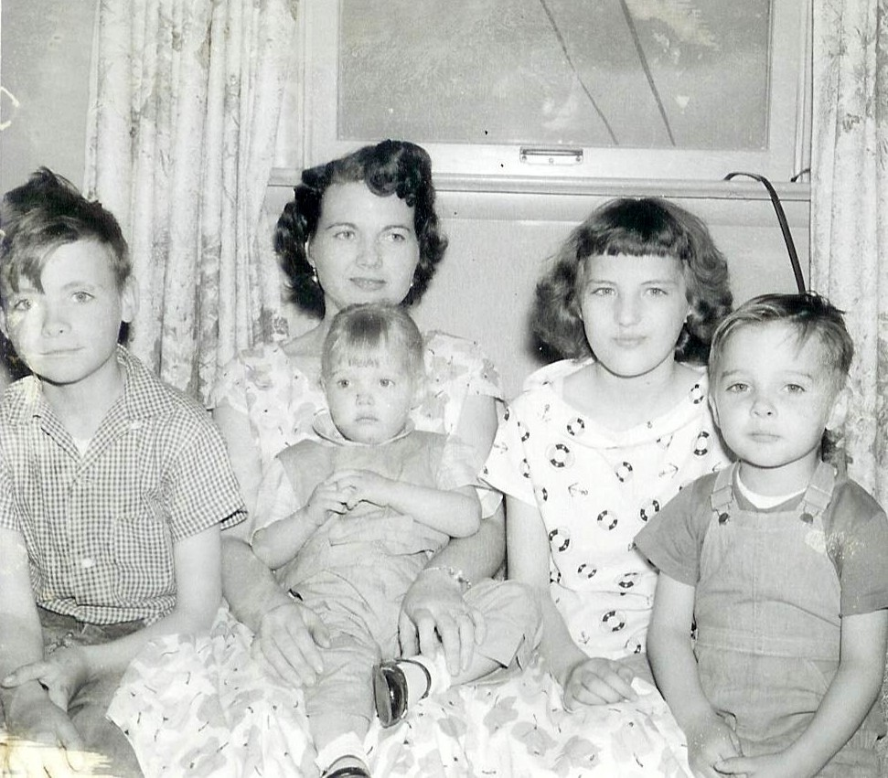Me and my kids - about 1959.
On Friday, September 29, 1961 Connie was born at 5:22 p.m. at the Cassia Memorial Hospital. She weighed 6 pounds and 15 ounces and was 19 inches long. Connie was so precious, right from her heavenly home into ours! When I got home from the hospital I was very, very depressed!!! The house was a mess, I had to get dinner for the family, no one came to help me. Melody and Tim helped what they could. Poor little Melody was 14 and she felt very picked on because she had to do so much of the work and most of the dishes. (No dishwasher then.) I felt so very bad for her but none of my sisters or no one from the ward offered us any help. Connie was blessed into the Church of Jesus Christ of Latter-day Saints by her Grandfather Frost on November 5, 1961. Gordon was my only normal birth.
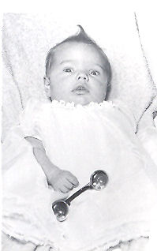Connie at 5 weeks old
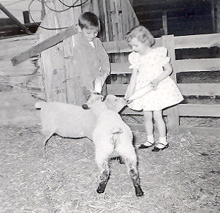Gordy and Cindee feeding some bum lambs
In the fall of 1962 Gordon went into the sheep business as well. Eventually, he built up to a very large herd. When the little lambs came in the springtime, it delighted the kids. They loved bottle feeding the bum lambs and making pets out of them.

