Chapter 18
The Third Time is a Charm

After knowing each other for a year and a half, I don't know what happened but out of the blue Jack said, “How would you like to get married?” I thought, “Its about time you big lug!” My answer was, “As cheap as possible”. He took it for a “yes”. And that is what we did, first we went looking for someone to marry us. Then we set the date for November 25, 1978.
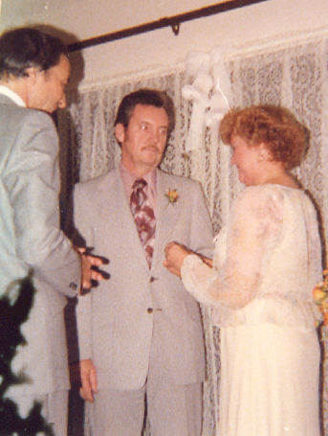The Third Time is a Charm
We then went over to Palo Alto to get our marriage license. What a ordeal I had to put up with there. They were going to make me, a fifty two year old, get a rubella shot. I couldn't get it through her noggin that I would not be getting pregnant and would not be getting the German Measles. She kept arguing that it was the law and we could not get the license without the shot. Finally I won out and we did get the license.
Next we informed everyone and ordered the cake and flowers. I didn't even buy a new dress. Remember, I said cheap! I had a pretty light colored apricot dress that Jack had bought me for a birthday gift. And he already had a suit. See how fast I was getting this thing moving. No longer was Jack dragging his big feet!
The wedding was going to be at our apartment, so we limited our guest list to a few friends. Cindee and Russell were the only family we invited since they lived close by. So you can imagine the great astonishment and joy when Cindee showed up on my doorstep with my mother, Connie, and Gordy and his fiance, Bonnie. She had picked them up at the airport and brought them over. Gordon had bought the tickets for Mother and Connie, and Gordon and Bonnie used the money they had set aside for their honeymoon to come to our wedding.
Since we only had a one bedroom apartment, we put Mother on the couch, Connie on the loveseat, and Gordon and Bonnie on the floor in sleeping bags. The next day was Thanksgiving. Cindee and Russell came over and we all had Thanksgiving dinner together.
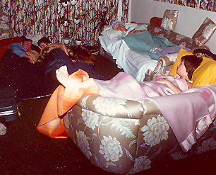All sacked out for the night
Mother enjoyed all the beautiful flowers and green trees for November. Jack was very nice to her, helped her in and out of the car and up and down the stairs. She was very impressed.
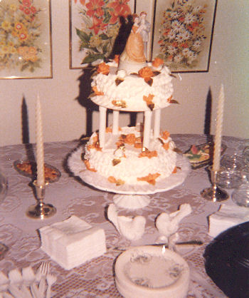Our Halloween wedding cake
The big day, November 25, 1978, finally arrived, we were all busy getting the house ready, cleaning, putting up streamers and bells etc. The door bell rang and it was a young man delivering the wedding cake. He looked around and asked “Where is the bride”? I said, “I am”. He had the most astonished look on his face. I am sure he was expecting a beautiful young lady and there was me! He was not expecting two fifty year old’s. He was not the only one astonished. The cake was ordered to be done in a light apricot icing and it was orange like Halloween. The second disappointment was that the ceremony was to be taped and we flubbed up and got nothing.
The Reverend Asa Collins of the Presbyterian Church preformed the ceremony. He put on quite a show! Lou Rizzo was Jack's best man, Yoshiko was my maid of honor, and my son, Gordon, gave me away.
Our wedding guests were my family, Mother, Connie, Cindee and Russell, Gordon and Bonnie. Also in attendance were Ray Coccocan, Yoshiko's friend, Mildred and Charlie Glaser, long time friends of Jack, Leonard and Mary Cancilla and Bonita Boren, friends from the YMCA. Last but not least were two of Jack's work buddies and their wives, Cecil and Bonnie Harrell, and Danny and Kathy Bishop. These two ignorant bums sat and smoked cigars all through the ceremony. My Mother about choked on all that smoke. I thought it a very rude act at a wedding.
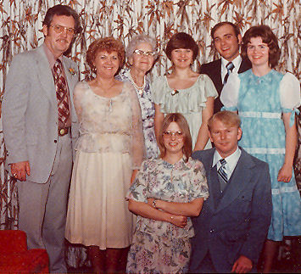Standing: Jack, Me, Mother, Connie, Gordon, and Bonnie. Kneeling: Cindee and Russell
After a weekend of adventures in Sunny California, the family left on Monday morning. And as for Jack and I, it was back to work. A honeymoon was not part of the deal. The girls back at work were betting that our marriage wouldn't last a year. After I had retired, I would drop in and see my Syntex friends and the first thing they would do was grab my hand to see if I was still wearing my ring. Boy, did we fool them.
That wasn't fun enough so we held an open house on December 3rd for other friends that were not at the wedding such as people from I worked with, some old friends of Jack's, along with some from the YMCA and even some that we had dated. Twenty four guests in all. It was our first of many parties to follow.
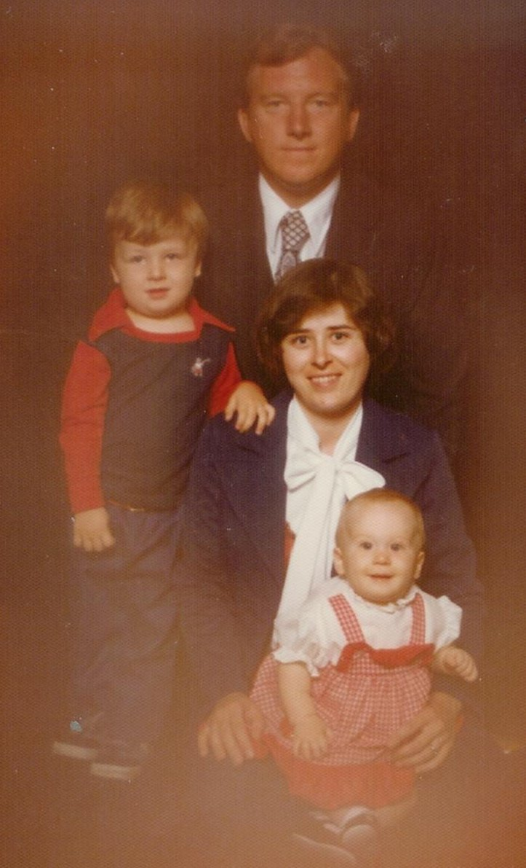George and Becky's family 1977
Now my family had increased to include Jack's oldest son George and his wife, Becky, and their two children Jason (March 13, 1975) and Stephanie (February 21, 1977), and Jack's youngest son, Jack Jr. who was in the Navy. Jack's family increased many times over. He has always bragged that when he married me he married most of Idaho and half of Utah.
December 9th found us at a wedding reception in Burley, Idaho for Gordon and Bonnie Buttars. They were married in the Idaho Falls Temple on the 1st. They had a lovely reception and I know that their wedding ceremony was much different from ours. Yes, Bonnie thought ours very unusual! Are you ready for another embarrassing moment? Well you are going to get it anyway! Jack and I were standing in the reception line. Birdena was next to Gordy, then Gordon, me, and Jack. Then, here came Ray and Jan Dudley, who were in Bonnie's ward. Have you ever been in a situation where you are surrounded by your brand new husband and two former husbands? Everyone thought it was funny, except for me. Jack has never let me live that one down.
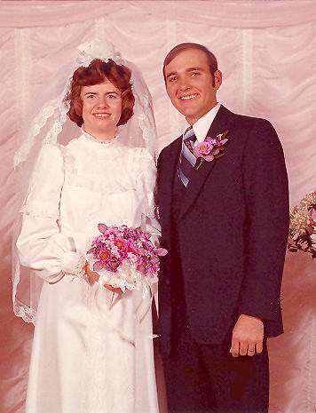Bonnie and Gordon
On December 31st we attended the wedding of Cecil and Bonnie Harrell over in the LDS Church in Watsonville, California. Jack and I stood as their witnesses. Jack and Cecil worked together. Her mother was the only guest with Bishop Jon Salden performing the ceremony, his first since he was just put in as Bishop. They didn't even tell their kids they were getting married. We went out to a nice restaurant for their wedding dinner, and like us they had not planned a honeymoon.
When we got married neither one of us had no more than our weekly pay checks to count on. We have come a long way and we did it together. Now that we were married, we could not let work get in our way. We could no longer go dancing at the YWCA so we had to find another respectable place to dance. Our friends, Mary and Leonard Cancilla, from the YMCA, as they had the same problem when they got married. They introduced us to a group of very nice couples of older people of different backgrounds and religions, most of them were retired, they lived all over the valley. Seems like most were Italians and Catholics, and of all ages, but none of that mattered. They took us right in, religion was never brought up.
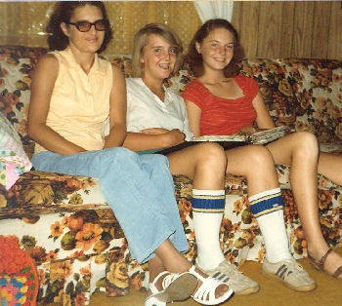Melody, Emily, and Adlema - 1980
This group met at the Moose Lodge in San Jose every Saturday night to dance the night away to live band music. After the music stopped we usually went someplace for breakfast before departing. They also met for everyone's birthdays and anniversaries. It was with them that I had my very first birthday party! (No. I recall Mother and the kids held a little party for me once when home on vacation, sorry about that.) I waited 50 some odd years and then I had to share it with Pat Mardson and Gordon Harrison as we all shared the same birthday. That was okay, my name was on the cake. As we were now part of the group, we would meet at each others homes and talk about food! Those Italian gals could cook! We even had them in our small home on occasions. There were twelve couples and sometimes more, but always the faithful friends that were always there. They were very nice, decent people with the exception of one guy that thought he was funny, but all he was, was crude! We ladies just ignored him.
Well, there I was again with another big circle of friends. I think most of them have passed away. The dearest, sweetest of them all were Anne and Robert (Bob) Rogers of Hayward, California. We are still very much in touch with them. This year (2010) they are both ninety six years old and still living in their own home. Anne still drives only to places nearby as Bob is blind. They get their Catholic Services through TV now that it is hard for them to go to Mass. I do love those two!
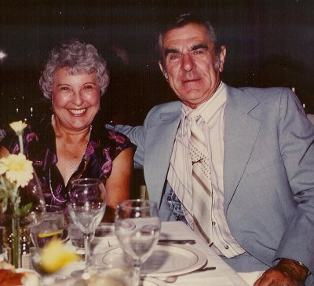Anne and Bob Rogers
Working at Syntex I had a good wage plus benefits. I was able to put money into the company credit union that we used for our vacations each year. Most of our vacations started out in Burley for the family reunion and then on to our planned destination. In 1979 our trip took us through Yosemite National Park over the Tioga Pass through the most beautiful country I had ever seen. We went over into Utah to Zion's National Park. We stayed in Kanab and went out each day to the different parks. Every site we went to was just awesome. I just couldn't believe God's works of wonder. Anyone seeing God's work at its best and not believe in God is a mystery to me. Each place we went was more spectacular in beauty than I could imagine. We went over to Pipe Springs, Arizona which was an old Mormon fort. It was a very interesting stop as it was just like in the old days. The people were dressed in period costumes and demonstrated the old ways of doing things.
We went from there over to Bryce Canyon. Which too was mind boggling with the beauty of all the formations. We took walks through the canyons to see everything that we could see. On the other hand, the Grand Canyon was a total disappointment. We got there early in the morning and had breakfast in the lodge. We came out in total fog. We were not able to see anything of the Grand Canyon.
Our next stop was at Lake Powell. The landscape there was entirely different. It was dry and barren. We took a boat tour from Wahwep to Rainbow Bridge. It was very pretty and we had a fun day on the water, although it was chilly.
From there we went to Monument Valley Tribal Park on the Navajo Reservation in Utah and Arizona. We were plagued with foreigners everyplace we went on this trip, as that year the money exchange was so that they could afford to vacation in the US. Some of them were rude on the trails and in the restaurants.
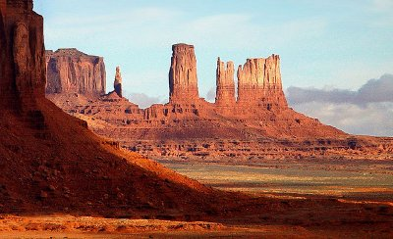Monument Valley
When we got to Kayenta, there was not a single motel, hotel, or bed and breakfast to be found that had a vacancy within one hundred miles. We drove to the entrance of Monument Valley where we bedded down in our Chrysler Cordoba, which was not that roomy. We had a lot of company on the knoll. It rained pretty hard during the night and we did not get much sleep, but what a wonderful gift from God we woke up to. The sun was just pecking between some of the monuments below in the valley. The earth was red and we could see forever. As we drove down through the valley, the beauty was unbelievable. Our white and blue car was red from the soil we drove though. We could see a Navajo hogan and a couple of people were throwing dirt on it.
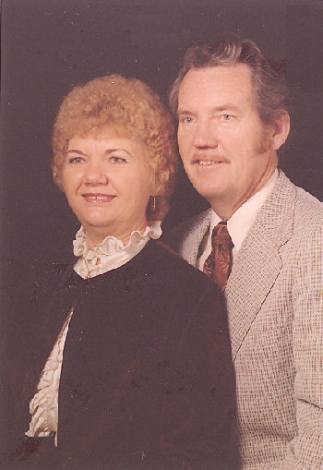Our first anniversary - 1979
We drove on over to the Arches National Park for more of God's handiwork. Anyone who has been there will know what I am talking about. I can't begin to explain the beauty of it all. You can see lovely pictures of these places but you have to see them with your own eyes to see the true beauty. We ended up in Salt Lake for a visit with Thelma and Jay before going on up to Burley for the family reunion. On our way home we went to Crater Lake in Oregon and down through the Red Woods and back to Sunnyvale. We were gone all of two weeks. Then it was back to the work world to save for next years fun.
Our first wedding anniversary was on November 25, 1979 and we held an anniversary party with fifteen guests. Charley and Millie Glaeser with three of their uninvited family members were the first ones there and they gobbled up most of our refreshments before the others even arrived.
Earlier that year, Connie had graduated from Burley High School with the Senior Class of 1979. Then two more grandchildren and a new son-in-law came along. On October 30, 1979 Gordon Glen Buttars, a bouncing baby boy weighed in at 6 pounds 1½ ounces. He was born at the Cassia Memorial Hospital in Burley, Idaho to Gordon and Bonnie. Mark Lee Dudley was born less than three months later on January 17, 1980.
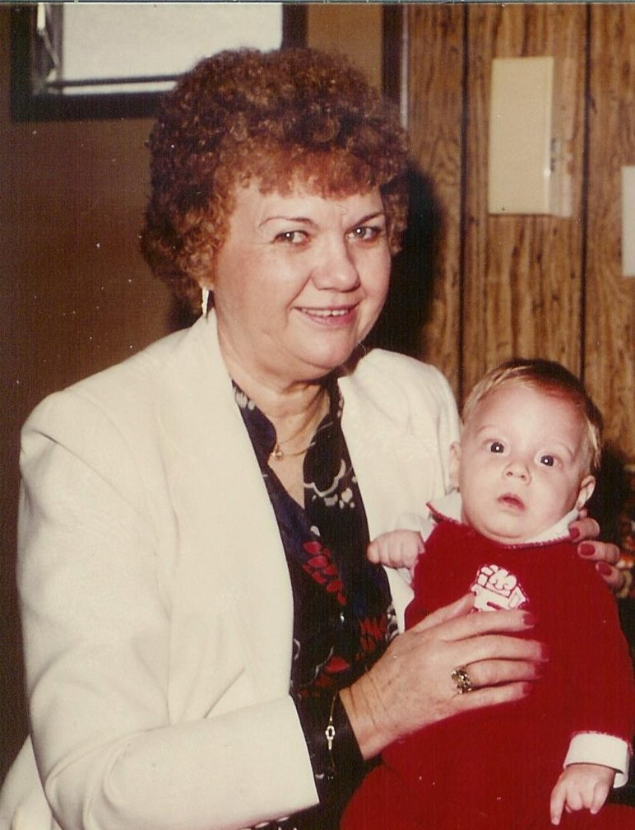Grandma and Gordy
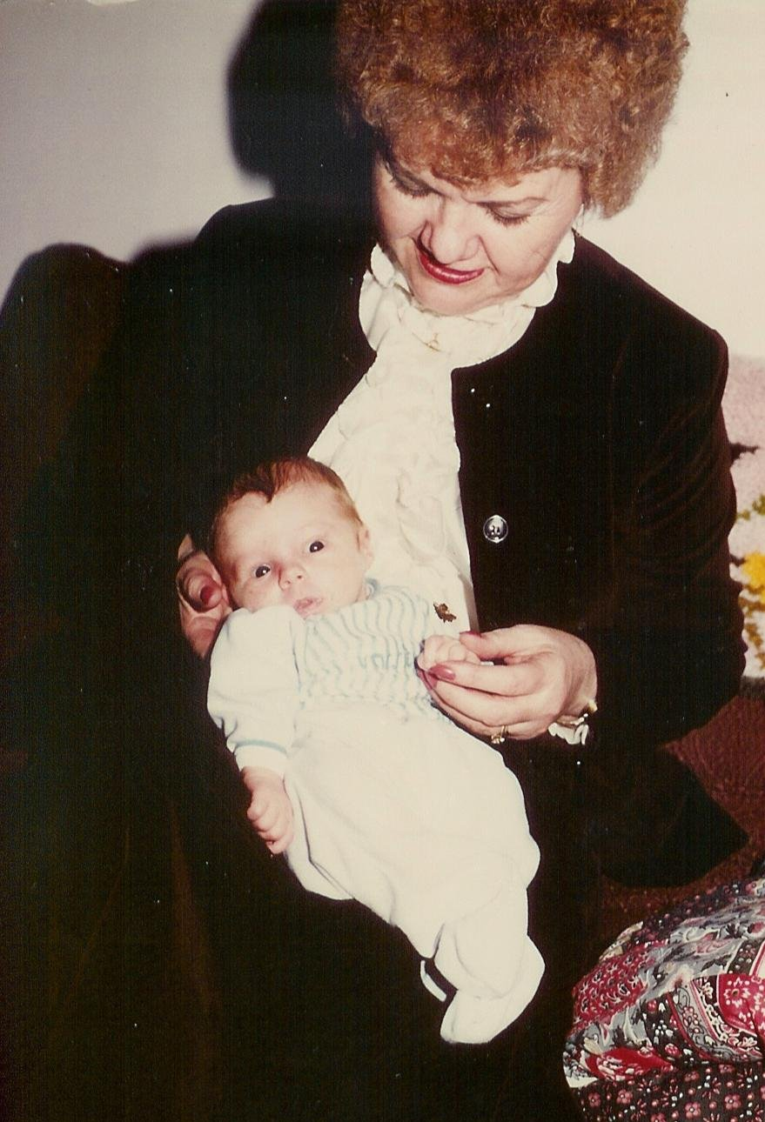Grandma and Mark
We flew into Twin Falls for Connie and Sam's wedding on Valentines Day, February 14, 1980. She looked so young and pretty. I couldn't believe that my baby girl had grown up. My regret was that I was not there to help her with her dress and other plans. I think things would have been different. They were married in the First Christian Church of Burley. I was left out and everyone thought Birdena was her mother. We did get to help decorate the church. It was a nice little wedding and the cake was lovely and we had a new son-in-law! At the time Connie was attending the Magic Valley Beauty Collage. She graduated as a cosmetologist on the sixteenth day of June 1980. That was also the first time I got to see Gordy and Mark.
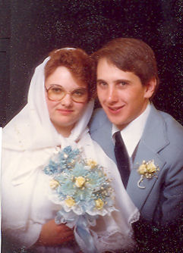Connie and Sam Gochnour
Our flight home was very interesting. We flew from Twin Falls to Boise, where we had a layover. Then up to Portland, Oregon where we changed planes and on to San Fransisco. As we approached the San Fransisco Bay area, the plane started bouncing – and I mean badly. The sky was dark with storm clouds. Everyone on board was very tense. A Catholic Priest sitting across the isle from us was counting his prayer beads. We had to come in over the ocean on a different approach. After a bumpy landing, everyone clapped. The Airport was closed for a while right after we landed.
The first stop on our 1980 vacation was Burley for the Frost Family Reunion on August 9th. As usual, the reunion was great. Being with my family for those few days was just wonderful and renewed all of the love. I have always been so grateful that my brother and sisters have always been so close.
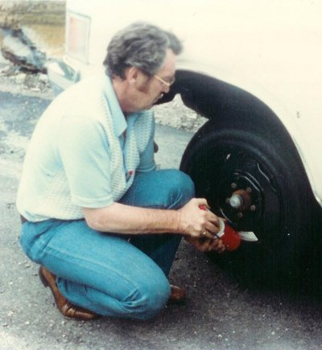
We left Burley and headed north into Montana. Our first night's stop was at Hungry Horse, Montana – the “Friendliest Dam Town in the West”! (Dam is spelled right, there is a dam there.) Heading for Glacier National Park, we passed beautiful Flathead Lake and Lake McDonald. We enjoyed all the waterfalls and mountains as we drove over Going to The Sun Road. We did have a flat tire near the summit that had to be fixed. We thoroughly enjoyed the park, in spite of stormy weather at times.
We crossed over into Canada where we stopped at Fort Macleod, Alberta which is the official Northwest Mounted Police Museum of Canada. There was a lot to see there. We went on up to Calgary and on over to Banff, how beautiful. We took the Banff Gondola lift up to the top of Sulphur Mountain where we could see all over the Canadian Rockies. We saw lots of mountain goats and other critters. That night was spent in Banff in the very worst motel. The worst of the worst. It was that or sleep in the car.
Our destination for the day was Lake Louise. We were not disappointed. We took a walking path as far around the lake as it went, ending up at a quaint little teahouse. I remembered a movie I saw years ago that was filmed around Lake Louise, about the Canadian Mounted Police with Jeannette MacDonald and Nelson Eddy singing “Indian Love Call” and my all time favorite, “Rose-Marie”!
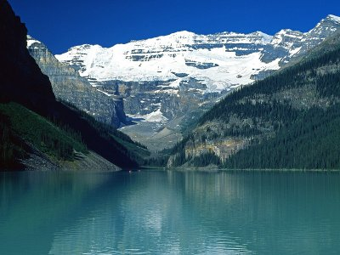Lake Louise
Leaving Lake Louise, we went on over to Jasper National Park and took a boat tour on beautiful Maligne Lake. Val and Warren were the boat pilots. They made the trip really fun. Our next adventure was riding a huge Snow Cat to the Icefield Centre and up to the Athabasca Glacier. Bill was our guide.
After seeing Angel Glacier and Edith Cavell Gacier, we headed for British Columbia and Prince George were Jack's grandparents had homesteaded. He asked around but didn't find out much. We went on down to Vancouver, B.C. where we weret stopped by a highway patrolman for making a U turn. We got lost looking for the hotel where we had a reservation for the night. He didn't ticket us but told us how to get there. It was a small, ivy covered, English style hotel set back behind a mall. It had lovely grounds.
Before we had the worst of worst in Banff. This was the very best of the best. As we went down to the dinningroom for a wonderful dinner, the power went off. It was off all over the northwest, even as far as Seattle due to a bad storm that had passed through. There was no way to cook anything but we lucked out as one dish had already been prepared, so we dinned alone in the dark to a really delicious meal. I am not sure if the power was restored by the time we left in the morning.
We stopped over in Victoria (one of my favorite places that we had visited previously). We went down through the San Juan Islands and into Seattle. There we stayed a couple of days with Jack's sister, Pat. Jack went out to the car to bring in our clothes when he discovered we had left our big bag hanging in the hotel in Vancouver. With some phone calls, we had it shipped home which took about a month. Bidding Pat goodbye we headed back down through Oregon and home. What a time we had in just two wonderful weeks! I had been two wonderful years!!

