Chapter 19
Born Again or Re-entrance?

Many times the Missionaries knocked on our door. I had always taken their phone number telling them, “I will call them when we have an evening that we could both be at home”. I never made the call.
It was the first Saturday in October 1980. Jack had been working the graveyard shift at P.G.&E. And I had an early appointment with my hairdresser so was already gone when he arrived home. As he walked down the walk to our place, two young men were knocking on the door across from our apartment. Jack told them there was no one at home there; he then recognized them as Mormon missionaries. They asked him if he knew anything about the L.D.S. Church. He told them, “A little, my wife had been raised a Mormon”.
Seeing the lights go on in their eyes, he told them that I was not home at the time, that they could call back later and gave them our phone number. I had been home a short time when the phone rang. It was Elder Sweat. Jack and I exchanged a few thoughts and invited them to call on us Monday night. I was excited about their visit and Jack was willing to listen to their message.
On Monday night, Elders Kraig Sweat and Kent Davis, both from Heber City, Utah rang our doorbell promptly at 7:30 p.m. After a word of prayer, we sat down to our first missionary lesson that was not new to me. Our home was filled with an overwhelming spirit. The Spirit made it known to me that without a doubt this was my time. I wanted Jack to believe, but if he didn't, it wasn't his time yet, It was mine and I knew that I better act upon it now.
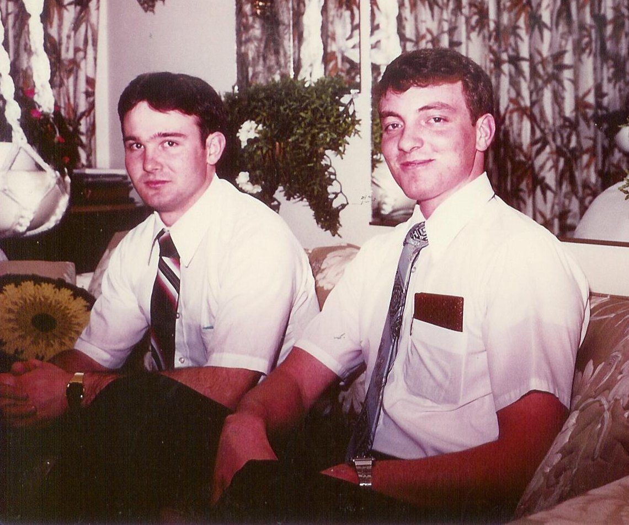Elder Sweat and Elder Davis
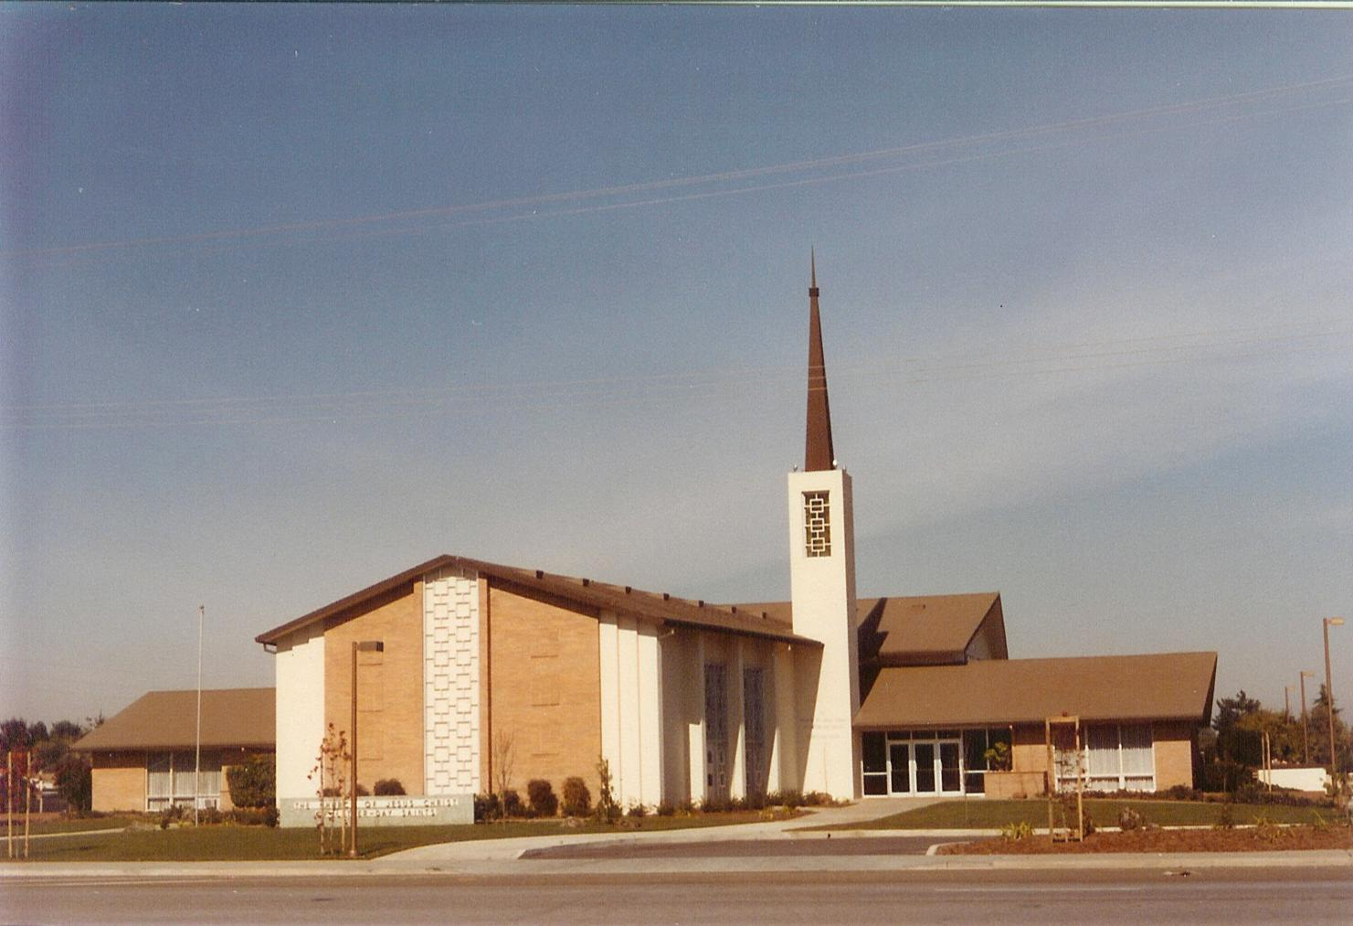The Sunnyvale Chapel
We invited the Elders to come back the following week for the next lesson, promising them we would meet them in church on Sunday. From our first lesson the Spirit affected me in a way that I felt my chest might burst. It was difficult for me to speak about the church. I would choke up and tears flowed from my eyes. Even singing the beautiful hymns would cause me to choke up. (Jack would ask me if I was having hot flashes!) We did go to church the following Sunday at the Sunnyvale 1st Ward, just two miles from where we lived. The ward members made us feel very welcome as they met us at the door. (We did not find this at other denominations we attended.) Sister Helen Starley took charge of us until the Elders found us. We started in the investigators class with Jim Thorne as the leader.
I had to swallow my pride, something I didn't think I would ever, ever be able to do, and admit my sins. I read the book “Miracle of Forgiveness” by President Kimball and acted upon it. I prayed and fasted that I could fully repent, and that God would acccept my repentance, and that I could ask forgiveness of all I may have hurt. I had sins between God and myself that I asked forgiveness of. I wrote fifteen letters of forgiveness, plus letters to the Bishopric in Burley, Idaho. Happily I was granted forgiveness from all but one.
Together, Jack and I enjoyed attending church each Sunday. We went to the investigators class and continued with the missionary lessons and watched the film strips they brought. Still, I did not know how Jack was feeling about the gospel. I wanted so badly for him to enjoy the fullness of the gospel and it's blessings with me. I could not talk to him about his feelings for choking up. I fasted and prayed, knowing my family were also praying that Jack would accept it and be baptized.
As time was drawing near for my baptism, Jack had not declared his wishes to be baptized. One night I left him a note asking if he would please be baptized, and if he would give it some thought. When he asked me what he had to do to be baptized I was overjoyed, yet apprehensive. I wanted him to be baptized because he believed and wanted to do it for himself, not because it was what I wanted. The Elders stopped by that evening and were delighted to set up an interview appointment for Jack with the Ward Mission Leader, Jim Thorn, at the same time I had my final interview with Bishop Murri.
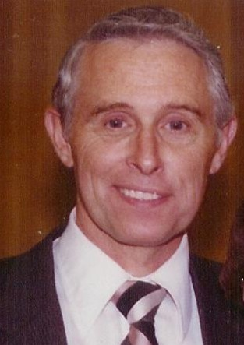Bishop William Murri
We were overjoyed with the news that certain members of my family were coming to be with me for this special occasion. We were happy to welcome Mother Frost, Dick and Kathryn Goodfellow, Thelma and Jay Jackson and Lorna Turner and were very surprised and happy to see Gordon and Bonnie, who we were not expecting. Cindee also came from Alameda. They were overjoyed to hear it was to be a double baptism.
Gordon being a returned missionary got on the phone and made arrangements with the Elders, for him to do the baptisms. I am sure they must have been disappointed, but happy for Gordon to baptize his loved ones.
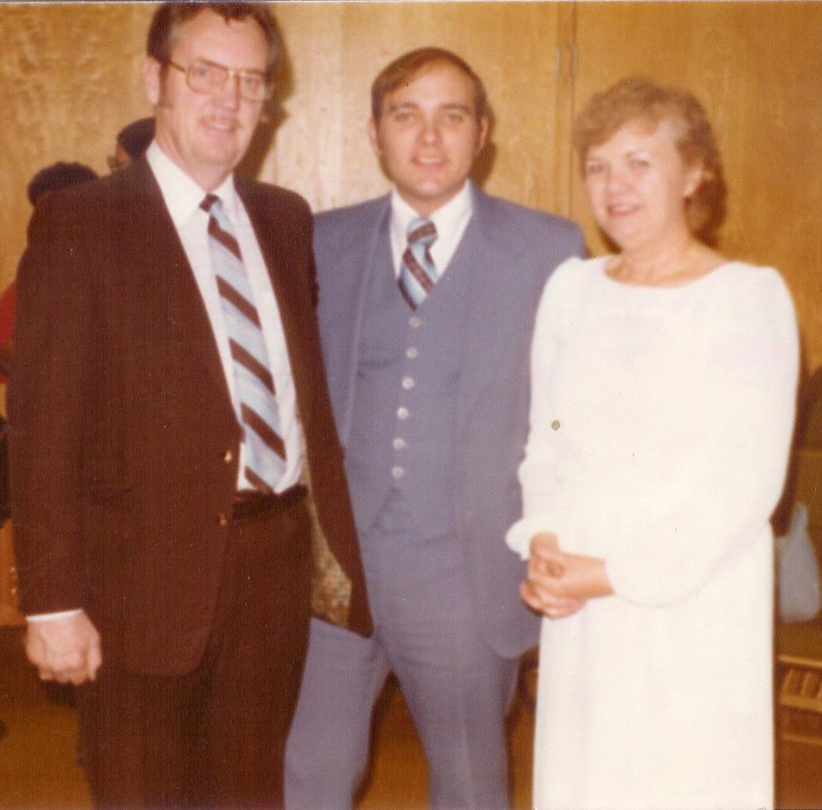Jack, Gordon, and me at our baptism
We were to be at the church at seven to be ready for the baptismal services at 7:30 p.m on January 9, 1981. It was a very beautiful spiritual evening. A lot of ward members came to share the event with us. The Elders had arranged a lovely program. Primary children sang “I Am A Child of God”. The Relief Society sisters had prepared refreshments for after the service.
After a hymn, prayer, and talks Gordon helped me down into the font. He raised his arm to the square and repeated the words of the prayer and laid me under the water. As I came up out of the water he gave me a hug and kiss. I left the font and Jack stepped into the water. One of the witnesses realized that Gordon had raised his left hand to the square and not his right. Since Jack was standing there, he baptized him and then I went back into the font. This time, he did it right.
After we had all changed our clothes and rejoined the rest, I took the seat at the front. Gordon stood behind me and placed his hands on my head and with the assistance of Dick, Jay, and the two missionaries confirmed me a member of the Church and conferred upon me the gift of the Holy Ghost, which I had lost so long ago. Then I then switched places with Jack and one of the elders confirmed him. This was the rebirth of Celia and Jack Gilmour, the first day of the rest of our lives and eventually all eternity!
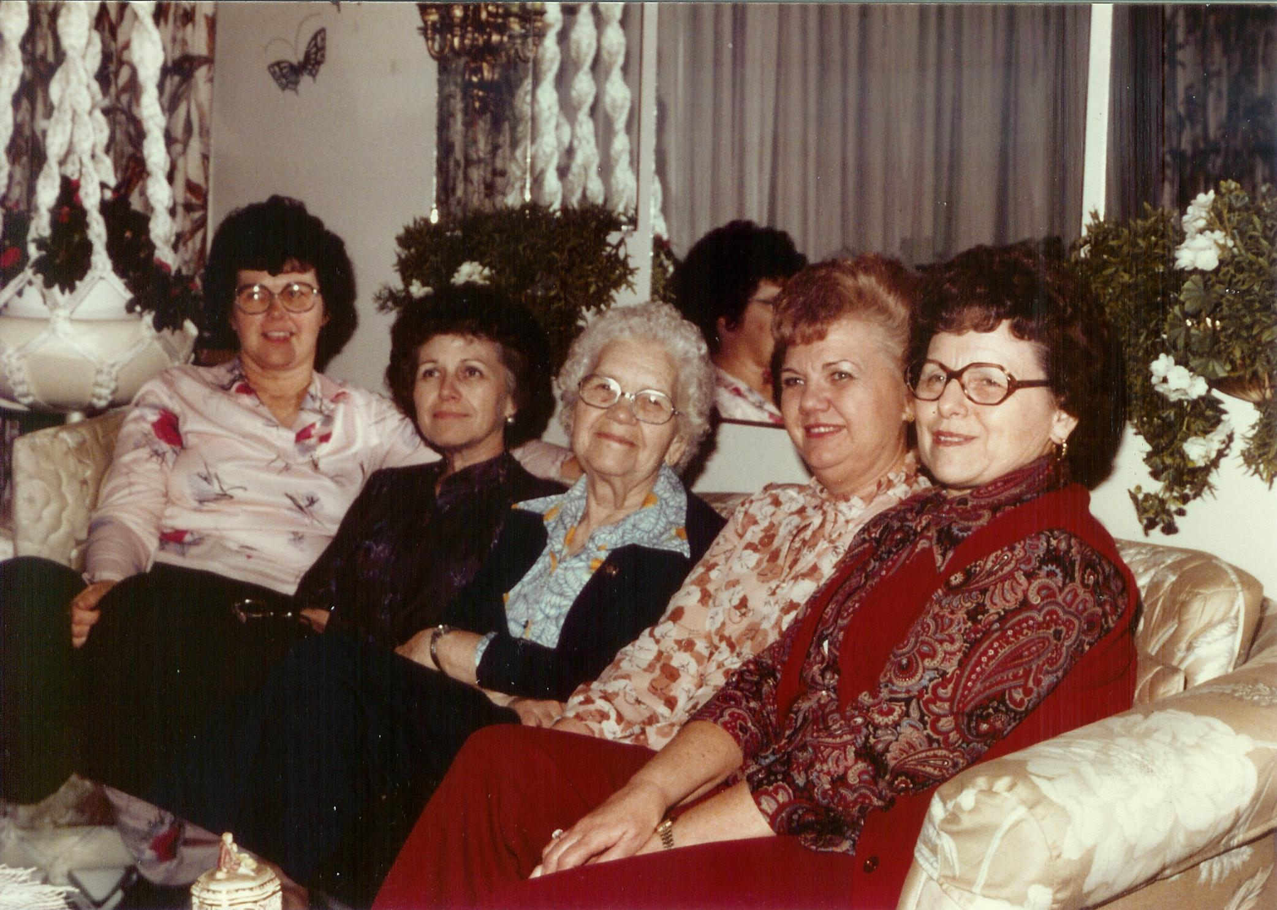Kathryn, Lorna, Mother, me, and Thelma at our home in Sunnyvale - January 1981
Jack had prepared a spaghetti dinner for the family and friends to enjoy at our home later in the evening – it was a most delightful evening. The next morning after our baptism, Mother greeted Jack with a “Good morning you old Mormon!”
Mother told me to expect all of our friends to drop us after our baptism. Not so, it didn't make one bit of difference to any of them, they went right on treating us with the respect they always had.
As I think of this saying “born again” is a miss-statement for me. Even though I was inactive for a time, I never once doubted the truthfulness of the Church or the Church Authorities, I still had my testimony. A better word is probably “re-entrance.” 1981 got off to such a wonderful start for us with a very spiritual new out look on life.
During the previous fall, Cindee had gone to Burley at Russell's encouragement to spend some time. One night he called her and told her not to bother coming home. He sent her belongings to her and told her to file for a divorce. She got an apartment found a job, and proceeded with a divorce, which final early in 1981. As it turned out, Russell had been seeing someone else all along.
My dear mother, Vyla Frost, was honored Saturday June 6, 1981 for her 80th Birthday hosted by her children at the home of Irma and Don Lindsay. Each family made posters depicting our individual families on display. She had a beautiful birthday cake, and was honored by all family members both her's and Daddy's that were still around, plus each of us kids and our kids. Friends and neighbors also honored her. She had a wonderful day, everyone was making a fuss over her and taking pictures of her with their families. She was plenty tired when it was over. At this time she had 48 grandchildren and 54 great grandchildren. I came up by myself as Jack was unable to get off of work. I don't remember if I drove or flew. I more than likely drove as I drove back and fourth more than I flew.
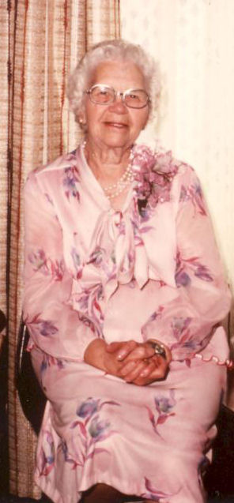Mother at her 80th birthday celebration
We decided to start our vacation that year with a visit to Tucson, Arizona to see Melody and Emil. We drove down as far as Bakersfield and stopped for the night. I couldn't believe the prostitutes up and down every street. We stayed in another bad motel, this time it was cockroaches! They were coming out of the sink and were everywhere. I had only seen cockroaches one other time in my life, and they were little ones. These guys were huge. I tried to sleep with my head under the sheets to keep them off me.
Heading out the next morning, we drove past the Salton Sea and through a lot of desert. Nothing impressed me enough to remember much about the drive. We ended up that evening in EL Centro, which is not far from the Mexican boarder, were we spent the night. The next day we drove over to Yuma, Arizona for breakfast and drove on through the Sonora Desert. We enjoyed seeing the Sonora Cactus and other cacti in bloom. We arrived in Tucson and found the Wilkinson's. They were very good hosts and took us to some great places.
Emil had to work, so Melody took us around. We really enjoyed Old Tucson and the afternoon shootout at the famous O.K. Corral. We also went to the Arizona-Sonora Museum. We went out to the historic Catholic mission of San Xavier del Bac near the copper mines where Emil worked. We had fun taking fun pictures of us in the museums.
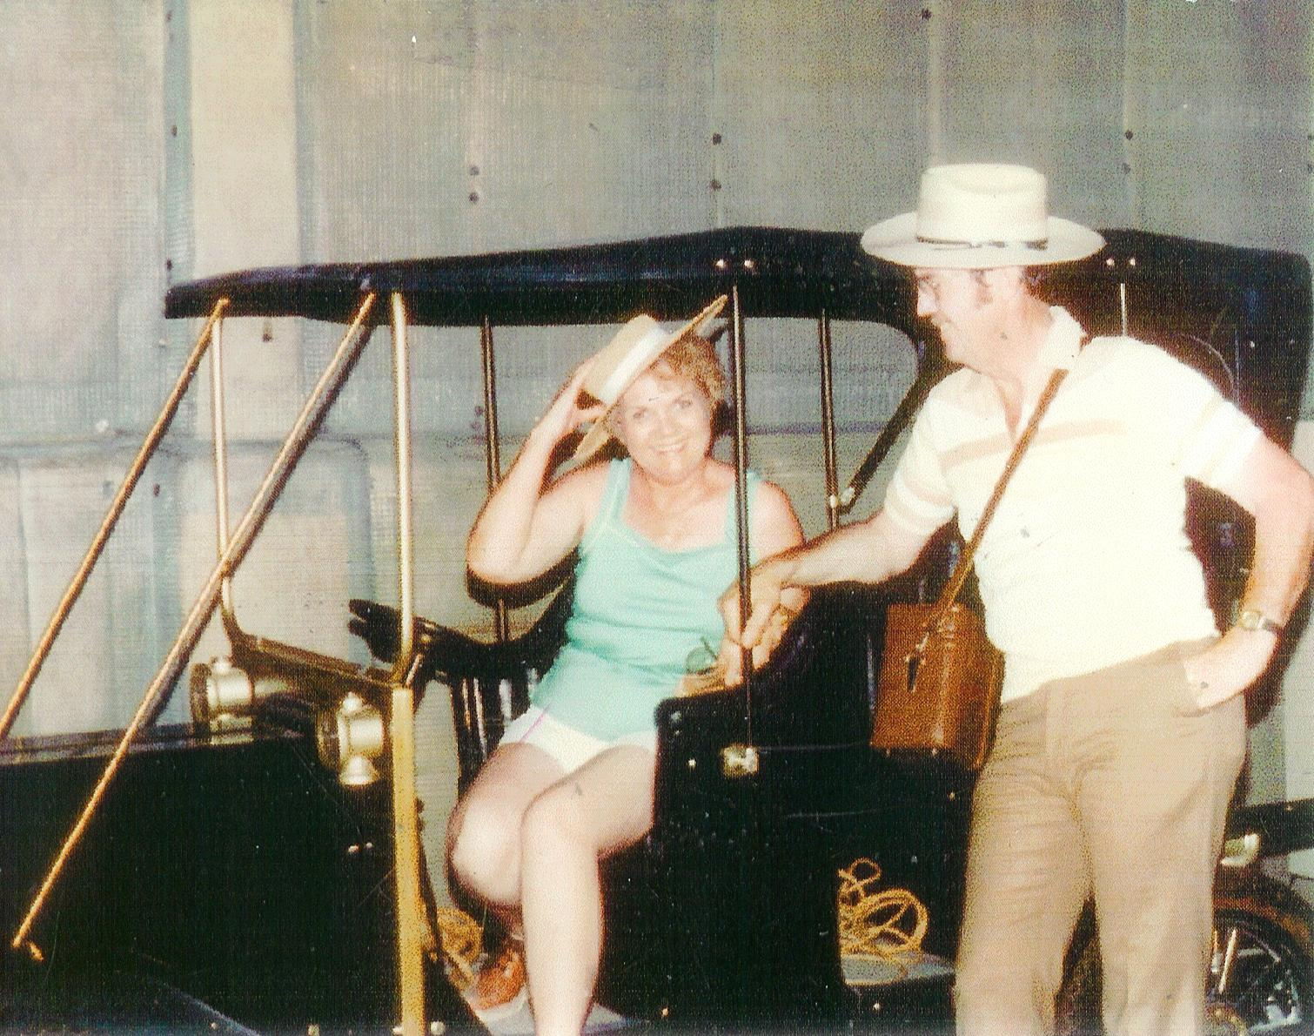Yes, Lady it does have A/C
After a very good time in Tucson, we bade the Wilkinson's goodbye and headed out for New Mexico. We drove over to Las Cruces and stayed overnight there. From that point we went down to El Paso. Leaving our car there, we walked across the bridge over the Rio Grande River into Ciudad Juarez in Mexico. I did not like what I saw. There were little children and elderly people everywhere begging and selling cigarettes or whatever. The place was littered and dirty. It just felt evil all around me. We walked around a little bit and I told Jack I had had enough and wanted to get back into the U.S. As we walked back across the bridge some teenage girls we met started laughing at my hat. It kept the sun off my head and I didn't think it looked that funny. I know that is what they were laughing at because one of them pointed at it. I sure felt better then we was back in the good old U.SA.
From there we went over to the Carlsbad Caverns, another awesome handiwork from God. Oh my gosh! Uncounted years of slow growth resulted in the meeting of the stalactite and stalagmite. Room after room each with different formations and fancy names like “Eternal Kiss, Queens' Chamber”, “King's High Way” etc. There were giant domes in different places. I am so grateful that I had the opportunity to be there and see what God dose to beautify this world for us.
We also went to the glistening dunes of gypsum at “White Sands.” We had fun romping around in the sand and taking pictures. We also went to the Pueblo Indian ruins. We got there first thing in the morning and were the only ones there. It gave me a humble feeling, like we were walking on scared grounds. All those people that had lived there so many years ago just vanished. We climbed up into the dwellings and spent quite a bit of time there. All the time I had that humble feeling.
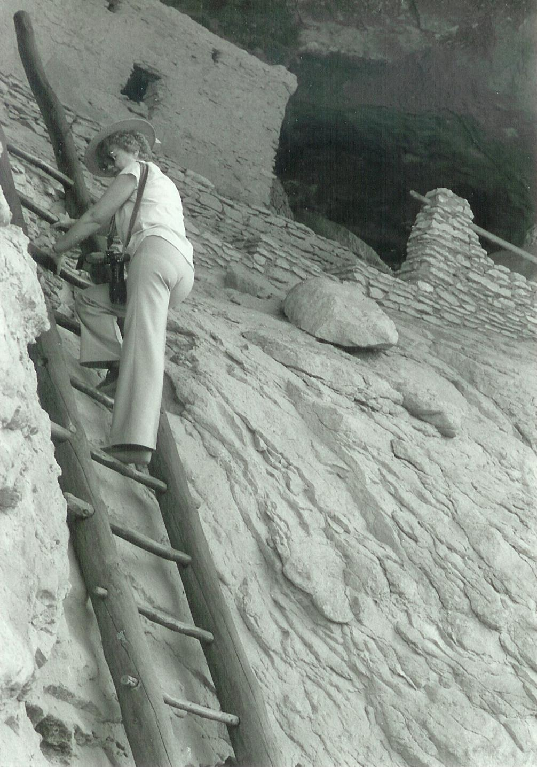Checking out our new apartment. (Cliff Dwellings in New Mexico just north of Silver City.)
Albuquerque was our next stop. I loved the old part of town. We walked around and saw what we could that evening. The street markets were already closed. There was a beautiful old cathedral that we wanted to get pictures of, but there were too many cars and people around, so in the morning we went out early and got our pictures. We did some shopping and ate some good food.
We went through Santa Fe and ended up at Val Verde where Kit Carson is memorialized. At Taos we went to the Pueblo de Taos, some thousand year old ruins. We drove in and parked and walked around. It wasn't until we left that we saw the sign with the entry fee. We had a good time taking pictures of people and places and we should have paid for. We came across a squaw sitting in the shade of a tree with an electric frying pan and a bowl full of dough making Indian fry cakes or scones. Man, it made my mouth water. I looked around, there were dogs everywhere and dirty little kids. I have to admit that I am a fussy eater, but those fry cakes won out. She put on plenty of butter and when she handed them to us they were dripping with honey. Honey, I never tasted anything so good.
From there we ended up in Colorado Springs, Colorado and drove though The Garden of the Gods. We didn't spend any time in Denver as our time was limited because we were headed for Thelma and Jay's in Salt Lake. We drove up to Cheyenne, Wyoming where we stayed overnight. Jack's heart started to act up as we were eating breakfast. He had run out of his medication. We called Thelma from our room and drove to Salt Lake and stayed a night or two before heading home to Sunnyvale.
We hadn't been home long when we got word of Stephanie's death and had to make the trip to Anaheim. On September 18, 1981, Stephanie Anne Gilmour was just four and a half years old on the day that her family decided to visit friends in Anaheim California. Stephanie was excited to see her little friend and jumped out of the car after her father and ran in front of a car and was killed instantly. What a horrible thing for the poor parents to watch happen and not be able to do a thing. We made arrangements to get off work and drove to their home in Anaheim for the funeral. It was the first time that I met George and Becky. Not a good time. All of Becky's family were there from Minnesota, making it necessary for us to stay in a motel. The funeral was held in a Baptist Church on the 22nd of September. She was buried in Anaheim. Not being used to a Baptist service all of the Amen's after a few statements seemed strange. It was a sad drive back home.
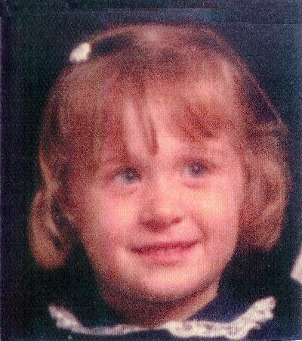Stephanie Anne Gilmour
1981 ended with a nice quite Christmas. I am not sure if we went to my company party or not, but Christmas Eve and Christmas Day were spent at home enjoying the Spirit of Christmas with music, exchanging our gifts, and cooking a special Christmas dinner. We never ever had a white Christmas in California.
The year 1982 was a very special year for us with a wonderful start. On January 15th 1982 just one year after our baptism, we were on our way to Salt Lake City to meet with my family as we were going to be sealed for time and all eternity in the Salt Lake Temple. I was so excited. Even with the temple preparedness lessons, I still was not totally aware of what to expect. We drove from Sunnyvale to Wendover, Nevada where we stayed the night, waking up to a very cold morning. It was so cold we could not get the heater in the car to register and the windows were frosted over most of the way into Salt Lake. But oh what a winter wonderland, when we could see out the windows. My dear sister, Thelma, helped me pick out my temple clothes. I wanted to have my own for my first time through the temple. We picked the Salt Lake Temple as our own, as that is what we promised the family who had driven all the way to California to attend our baptism. That way more of our family members could attend.
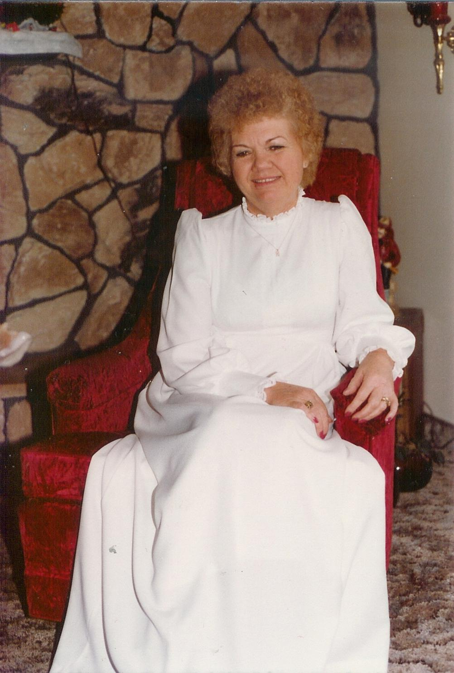My temple dress
On January 16th we went through the Salt Lake Temple and received our endowments and were sealed for time and eternity. With us were my son Gordon and his wife Bonnie, my mother, all of my sisters and brother-in-laws, Gerald and Verlee, Elders Kent Davis and Greg Sweat and his new wife. A lot of my nieces and nephews that lived in the area and my friends LaPreal and Herald Hull were also there with us. Gordon and Bonnie almost missed our sealing because of miss information and went to the Jordan River Temple. They just barley made it to the Salt Lake Temple in time.
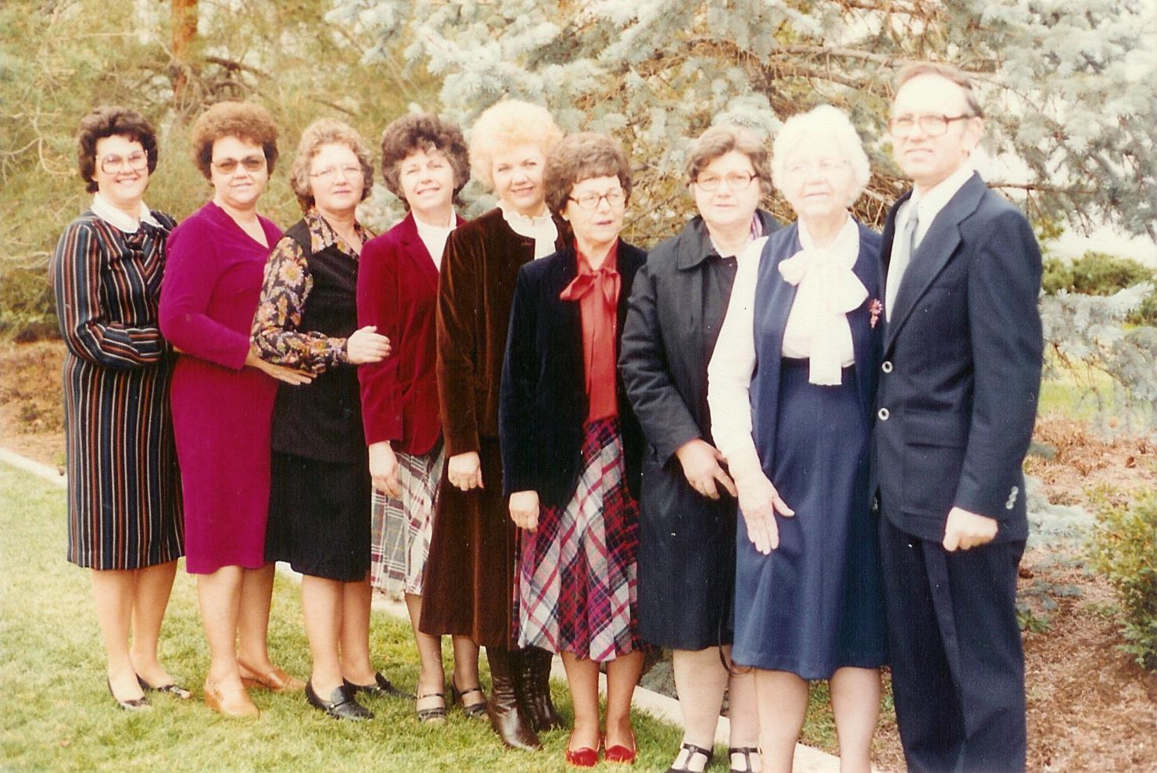The Frost Family - 1982: Kathryn, Irma, Marion, Lorna, me, Thelma, Eunice, Mother, and Gerald Taken on the Salt Lake Temple grounds
I was so grateful to have my mother as my escort as she had been for all of my sisters. Jay Jackson accompanied Jack. Mother had prayed for years to have all of her family in the temple at one time. I made it happen. I know that in the temple with us that day were my deceased Father and dear brother Myron. One of them embraced me, if not both. What a spiritual experience, I still get goose bumps when I think of it. (Goose bumps are spirit sparks, because they call attention to an immediate recognition of spirit awareness). Some day in the beyond I will ask them about it.
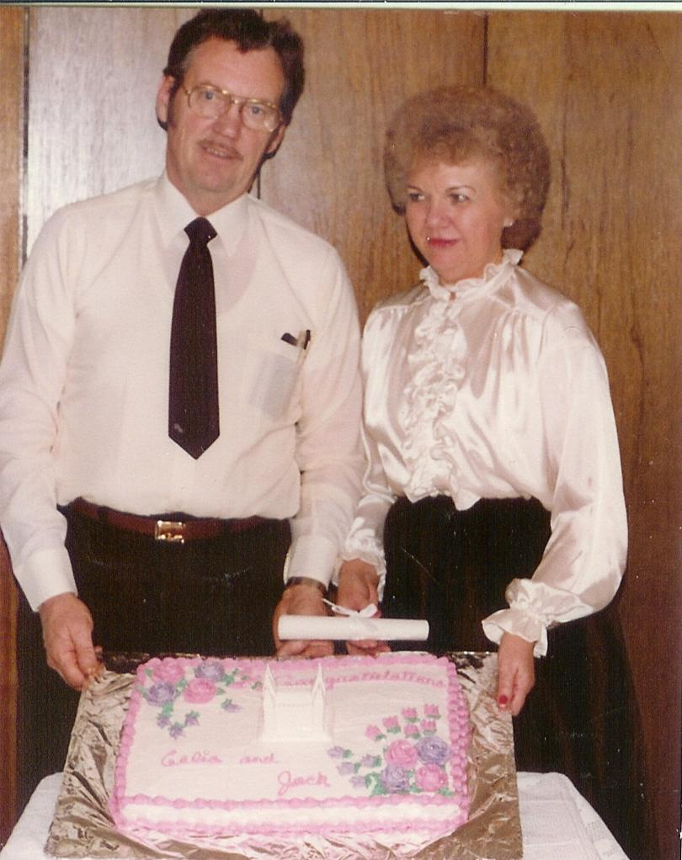Our wedding cake
Everything was so new to me and I could not comprehend all that I was experiencing. I was so happy to have my eternal husband, Jack, by my side. I knew that I would understand more each time I entered the temple. After the temple ceremony we took a lot of pictures on the grounds and then gathered at Thelma and Jay's lovely home for a delicious dinner. Thelma and Gayle surprised us with a beautiful wedding cake.
Before going back to Sunnyvale we went to Burley for a couple of days. My mother hosted a dinner for us and all of my children and their companions.
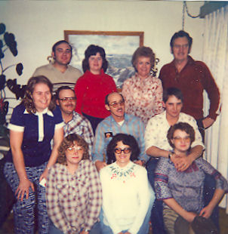My family – 1982 Back: Gordon and Bonnie, me and Jack. Middle: Deelyn and Tim, Emil, and Sam. Front: Cindee, Melody, and Connie
The Atonement of my Savior, Jesus Christ was the greatest gift to me in my life. Without it all would be lost for me; my family and everything. Through my humility and repentance, I was able to receive the blessing of forgiveness.
All of those years that I was lost and wandering, I'm sure Heavenly Father smiled down on me because he knew that I would come back and bring Jack with me.

