Chapter 2
School Days
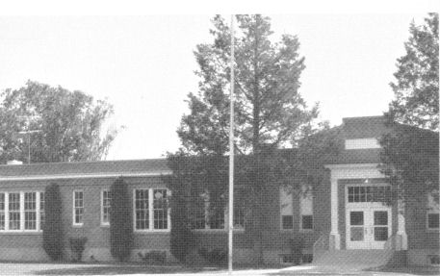Southwest Elementary School
My first day of school was on September 6, 1932. I was so excited. Finally getting to ride that big black school bus that stopped at our house twice a day for all the big kids. I felt pretty important, carrying my lunch wrapped in newspaper, sitting next to my big sister Eunice. We went to the Southwest School. Miss Gee was my first grade teacher. I loved my Dick and Jane Book. (I have two that I bought at an antique store, that is how much I loved that book).
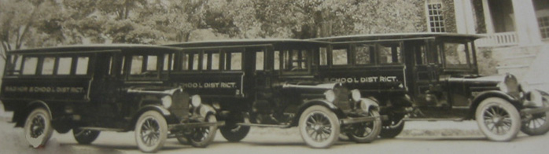
Mr. Woods, a cranky looking man, was our bus driver for many years. One day he sneezed so bad, causing him to bump his head on the steering wheel. What a good laugh we all got out of that but to Mr. Woods, it was not funny, no sense of humor, I guess that proved that he was a cranky old man. Other long term bus drivers we had during our school years were Mr. Budge and Mr. Bunn, who happened to be our mother's cousin. I do not recall any other school bus drivers. It was a very exciting day when big brand new yellow school buses pulled up at school to take us home.
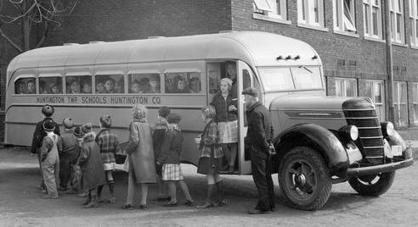These buses are similar to the ones we rode.
On December 12, 1932, Lorna came down with Scarlet Fever, giving it to all of us but Thelma and Eunice. They were sent into town to stay with one of the grandmas so they wouldn't have to miss school. Of course we were quarantined until January 2, 1933. Scarlet fever is a disease caused by an infection with by same bacteria that causes strep throat. The illness typically begins with a fever and sore throat. A rash appears on the neck and chest, then spreads over the body. The rash is described as "sandpapery" in feel and can last for more than a week.
When we were allowed to go back to school, the roads were drifted in with snow. Being snowed in happened quite frequently while we were growing up. School went right on without us. The children who lived in town, or close by were able to attend. The highway was cleared as soon as possible. On days that we could, we would walk the fourth of a mile to the highway to catch the bus, if it even got through. Daddy would carry me to catch the bus some mornings. Some days he would meet the afternoon bus with the horses pulling the “slip”, to take us home. The slip was a large sheet of metal about 6x8 or 9 feet with a double tree hitched to the horses. It was used in the winter like a sled for hauling milk cans, feed, hay, and best of all sleigh rides in the open fields. That year we missed school for most of January.
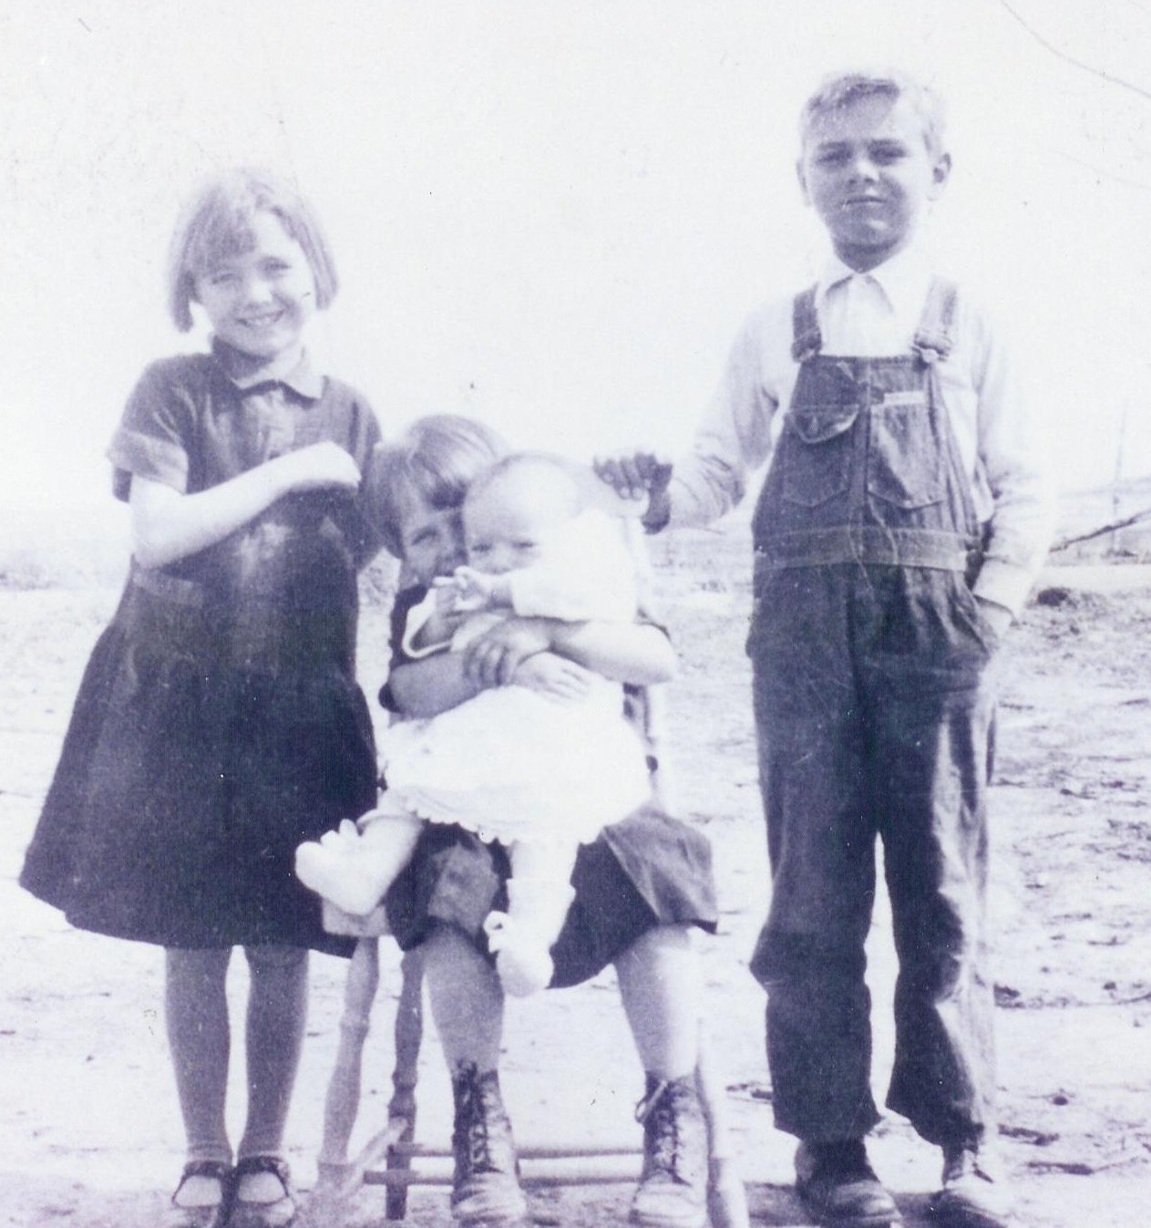Me, Lorna holding Irma, and Myron; Summer of 1932 when I was about six.
Southwest was a great school. It is just one story with a basement for the lunchroom, nurse's office, etc. All the outside stairs had wide cement banisters that were great fun for sliding down, which was against the rules but they had a difficult time keeping us from that extra fun. Also it was very hard on the seat of your pants, even tough flour sack bloomers.
In May we kids got the measles, again. Up went the quarantine sign. On May 29th I became very ill! I begged for the doctor. The doctor could not be reached so Brother Christensen and Brother Rasmussen were called to administer to me. The next morning I was somewhat improved.
On Monday August 27, 1933 Dr Dean took out my tonsils. I think that was my Birthday gift that year. My throat was so sore that ice-cream was the only thing that felt good going down, but Mother also fed me hot soup. With all that ice-cream I had a speedy recovery.
When school stared in the fall of 1933, I had to take the first grade over. I was a very shy and thin. (No, a down right skinny, sickly child). All during my grade school days I was given a big spoon full of cod liver oil and a dried prune chaser each day by the school nurse. From the diaries I gather I could not talk plain, plus I talked very fast (I got that from Aunt Ruby). All of those negative conditions in my young life did not build my self-esteem. I thought myself as a snot-nosed, ugly duckling.
At 8:05 a.m. on March 12, 1934 while at school we had a fairly severe earthquake that measured 6.6 on the Richter Scale centered about 80 miles southeast of Burley at the north end of the Great Salt Lake. We were all very frightened and they sent us home from school. There was 6.0 aftershock later that morning at 11:20. I was so afraid, like Chicken Little, I thought for sure the sky was going to fall in on us. I do remember that day very well. There were three or four large after shocks over the next six weeks. There were other earthquakes from time to time but that one at school frightened me the most.
April 24, 1934, I became very ill. Daddy stayed up with me most of the night reading to me trying to make me comfortable. A couple of days later I was take to the doctor and he found that I had an acute inflammation of the gal bladder and yellow jaundice. Two day later they took me back to Doctor again and he said it was clearing up. Daddy said I was sure “Yella!”
Every winter we would all get whooping-cough and give it to each other, you can say we had whooping good times. We also exchanged pink-eye frequently. We were taught to share with each other at a very young age, so we did.
When school started on September 1, 1934, Myron and I were transferred to the Miller School. Daddy did all he could to keep us all in the same school. The school felt that we needed a special teacher. Mrs Cora Garner was that teacher. We both liked her but hated changing schools. Mother and Daddy had little time to help me with my studies. I felt that I was dumb and I think I just gave up. Life had to go on. A new School. New friends.
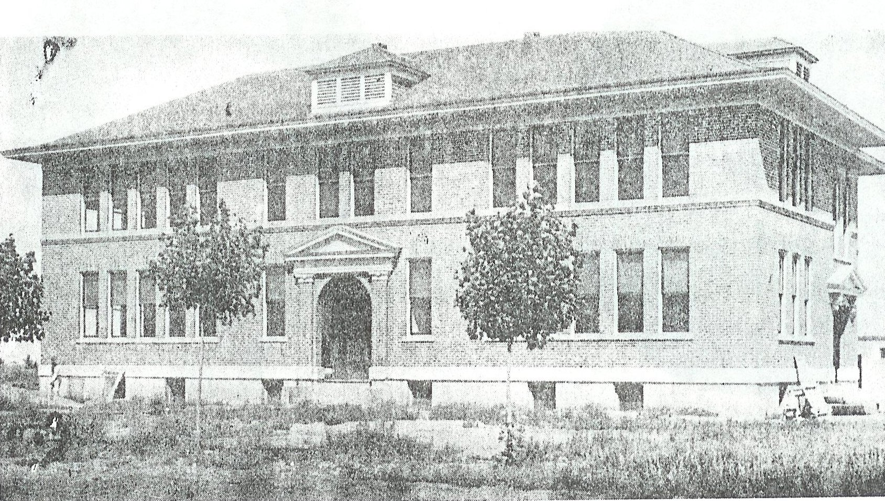The Miller School
On Sunday September 17th I had climbed up on the wagon that was loaded with sacks of potatoes to get a potato to eat. (I liked them raw with salt.) I slipped. Falling, I caught a very large splinter that went all the way through my right index finger. The doctor could not remove it. So he had Mamma bandage it each morning with a strip of raw bacon. I went to school with a huge bandage. One day while playing hide-and-seek in the girls restroom (which was also against the rules), one of my friends jumped out of one of the stalls at me, grabbed my hand pulling off the bandage. My poor teacher just about fainted when she saw that big old splinter clear through my skinny finger, but she managed to get it wrapped back up trying to keep from gagging. She probably went to the Teacher's Lounge and threw up! Every morning, Mamma would try to pull it out with the tweezers, after more than a week of raw bacon bandages, one morning it slipped out with the help of Mamma's tweezers.
During the depression Daddy did all he could to save a dime to make ends meet. He would work on relief for W.P.A. when his name would come up. His pay was 50¢ an hour. As long as he was on W.P.A., we kids were eligible for free hot lunches during the cold winter months. Otherwise Daddy would take sacks of potatoes and carrots to the schools in exchange for our hot lunches. W.P.A., or the Works Progress Administration was created by President Franklin D. Roosevelt in 1935 which employing millions of people across the county to carry out public works projects, such as the construction of public buildings and roads.
In the fourth grade, my teacher was Mr. Day. I thought it was really cool to have a man teacher. He had curly, red hair and I thought he was oh so handsome. At Christmas when we drew names for our gift exchange Mr. Day got Everett ------'s name and he got him a rubber doll. He invited another male teacher in to watch when Everett opened it. Everett was from one of the poorest families in town. When he opened his gift to find that stupid doll he began to cry and those two jerks stood there and laughed. I think I cried with Everett, I felt so bad for him and I never liked Mr. Day after that. Well, come the end of the school year he held me back.....Recycled Again! I was not only humiliated. I was painfully embarrassed, totally ashamed. My world crashed again, what was left of my self-esteem went down the tubes. I did not ever want to go to school ever again.
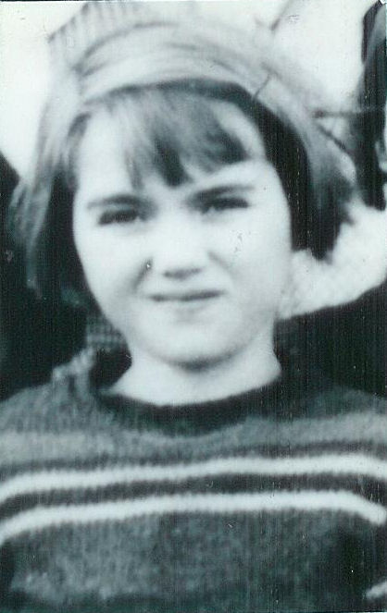Me in the 4th grade
When school began in the fall all my pain returned. I was so shy and self conscious by now. I would not participate in class and would rather take an F (Failure) before I would give an oral report. If the teacher called on me my face would go red. To make matters worse, the kids would laugh. Which made me go even redder. It took me years, and I mean years, to get over that. I really hated school. Can you blame ME? However I did like art, geography, and history.
I was very good at art. Miss Warner (Daddy's cousin) was my art teacher at the Miller School. I also took art in Jr. and Sr. High. Rose Jaskowaki taught Sr. High art. She had to be good with that kind of name. I was never in any of the school plays or programs, but I got to help paint all the scenery for them. My Miller School friends were Marjorie Bunn (my second cousin), Helen Wixom, Norma Jo Price, and LaPreal Boyce, plus others. I have kept in contact with these special friends all my life.
Every spring in grade school we would celebrate May Day. For weeks we would learn happy springtime songs and dances. We would make flowers out of brightly colored crape and art paper to decorate the May Pole, our hair, and the school grounds in general. The classes would take turns winding the May Pole. In the sixth grade all the girls were Greek Goddesses. Our costumes were long flowing gowns. Mine was made from an old sheet that I decorated in art class. I painted it with an Egyptian graphic border down the front and around the bottom and sleeves. It was really pretty, I thought. May Day, art and recess was the only part of school I even liked, and then of course later, BOYS. Girls wore dresses and boys wore pants and shirts. None of this stuff the kids wear to school now days (2010). Myron and I both had a bad start in school due to illness and being kept out a great deal due to being snowed in during the winter.
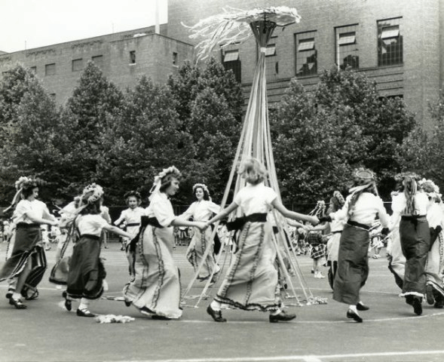School children dancing around a Maypole
Luckily, I grew out of all those childhood illness by my Jr. High School years. Luckily no more cod liver oil. I found out years later that I have scoliosis of the spine probably from birth or early childhood. It got very bad as I aged.

