Chapter 21
Many Life Changes

As August approached, we prepared for the trip to Burley for the reunion and on to a much needed vacation. Jack bought my birthday gift and packed it to give to me on my birthday, which was 8 days away. It was a very fragile Irish Beleek Plate. I don't remember where we were on the 19th, maybe in Wyoming. The Jackson family sponsored the reunion held at Minidoka Dam. We had great food and a good time with the 83 family members that showed up.
We went on to Salt Lake, up across Wyoming and through Yellowstone Park. We stopped at Buffalo Bill's Museum in Cody, and on through South Dakota going through the Bad Lands. We stopped at Mount Rushmore and visited with those great presidents. We Traveled along the border of Iowa and saw hundreds of miles of wheat and tall corn fields. We stopped in Mitchell, South Dakota and saw the Corn Palace with the buildings outer walls decorated in corn.
We went on over to Minnesota. We visited with Jack's only aunt, Rhoda, and cousin also named Rhoda in St Paul. She was 87 years old at that time. She took us through the capital building and other interesting places in both St. Paul and Minneapolis. It was all Jack and I could do to keep up with that young lady. From there we went across Lake Michigan and took a boat ride out to Mackinac Island where no cars are allowed. It was a wonderful place. We took a wagon ride around the island and had to get back to the boat before it left without us.
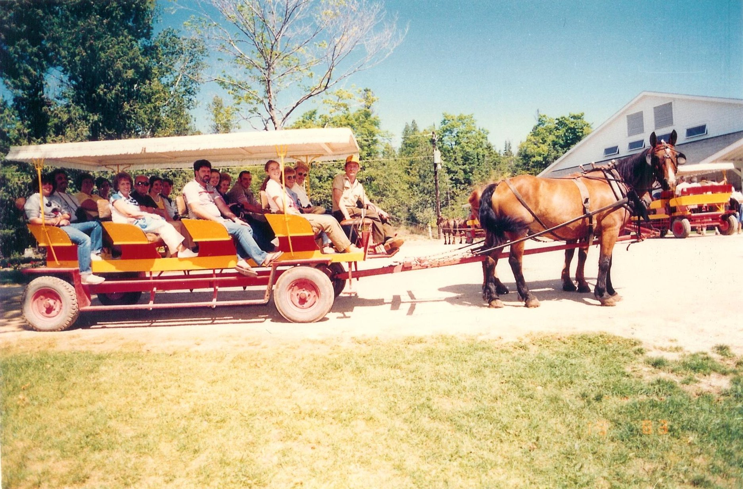Jack and I (wearing sunglasses) are seated behind the driver.
We went up into Clinton and Wingham, Ontario, Canada and down to Niagara Falls where we took a little more time, as that was our main destination. We even took time to ride over the falls in a barrel, here is a photo to prove it! The falls were one more of God's great gifts for our eyes. All I can say is, “Awesome!”
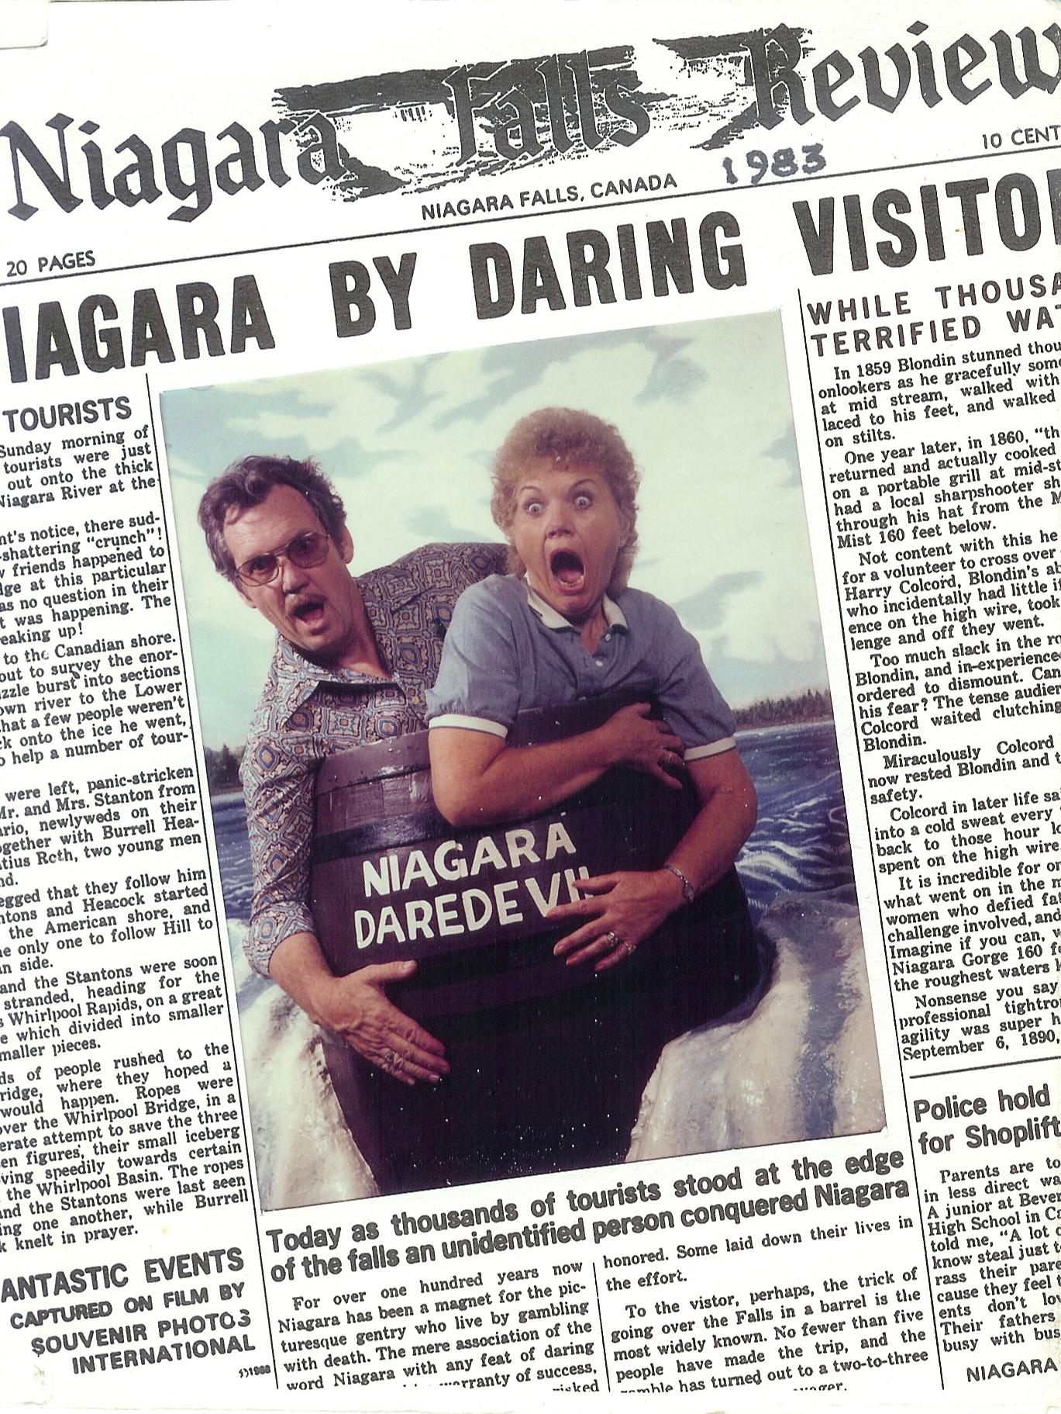c
We went back through Buffalo, New York but didn't even get close to New York City. Then down to Cleveland, Ohio. We stopped in Kirkland where we toured the Kirkland Temple, which no longer belongs to the church. It was really wonderful to see part of our church history, but as for me, I did not feel any spiritual feelings. Then we went over to Nauvoo, Illinois, another highlight of the trip. There I knew I was walking on sacred ground. There was not a lot that remained of the old town, like it is today. We walked the streets that Joseph walked. We walked down Parley Street where the saints along with so many of my own ancestors, walked as they exited their beautiful city as they watched it burn!
Another very spiritual place were we stopped was at Adam-ondi-Aham. We were there at sunrise and the only ones there to enjoy the calmness, looking out over the valley and feeling the spirit.
Back on the road towards home, we passed through Iowa City, Omaha, Cheyenne, Salt lake City, Reno and home to Sunnyvale. WOW! What a whirlwind trip. 7,800 miles in just three weeks in our little 1982 GMC S-15 pickup truck. We did not go into any of the big cities other than Minneapolis. We spent our time only in the special “to see” places. It was good to be home even if it meant back to the grind.
Later that year in the fall of 1983, Gordon got job with Diet Center in a Rexburg, Idaho and they moved up there. Also that year Tim changed careers and went into law enforcement. Cindee married Steve Weirich on November 6, 1983. Jack and I attended their wedding in the First Christian Church in Burley.
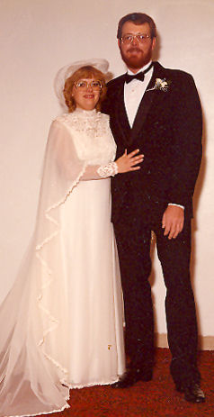Cindee and Steve
The Holidays were upon us for another year, Thanksgiving and our fifth wedding anniversary. We celebrated our anniversary with our dancing friends. Christmastime had the usual Syntex, friends, and church parties. We were blessed in so many ways that year, we had our good health, good jobs, friends and family. We were living in Sunny Sunnyvale California. What more could we want out of one year?
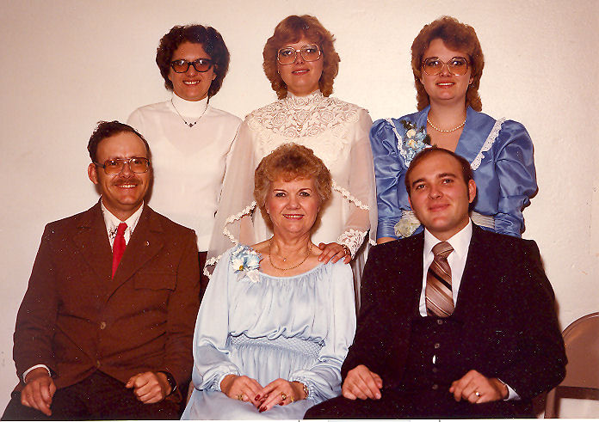Me and my kids - November 1983. Front: Tim, me, and Gordon. Standing: Melody, Cindee, and Connie
Both feet had been bothering me for a long time. Cortisone shots only worked for a short time. When I walked, it felt like a needle sticking in the ball of my feet. When it began interfering with my dancing it was time for surgery. On April 6, 1984 my doctor put me in a small hospital that only did feet. Tiny tumors had grown on the nerves between the toes and built up and became very painful. It was an overnight stay and I was ordered to stay off my feet for two months. Most people have one foot done at a time giving healing time. I wanted it over with! I was given three months sick leave from work to recuperate.
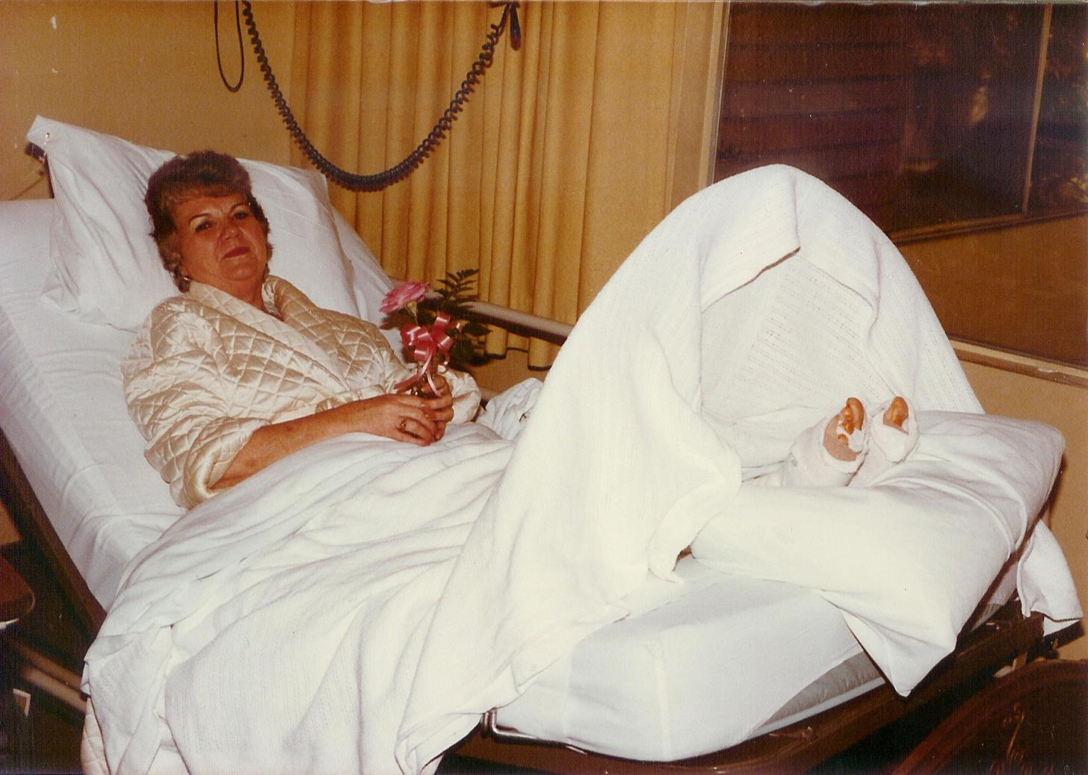Foot surgery
On a very hot windy Memorial Day in 1984 Jack was asleep as he had a long graveyard shift the night before. I hobbled out on our patio and I noticed black smoke coming from the duplex behind us. I woke Jack up and then hobbled back to Yoshiko's apartment to alert her, I knew she was home, but she too was napping. I pounded and pounded screaming for her to get out.
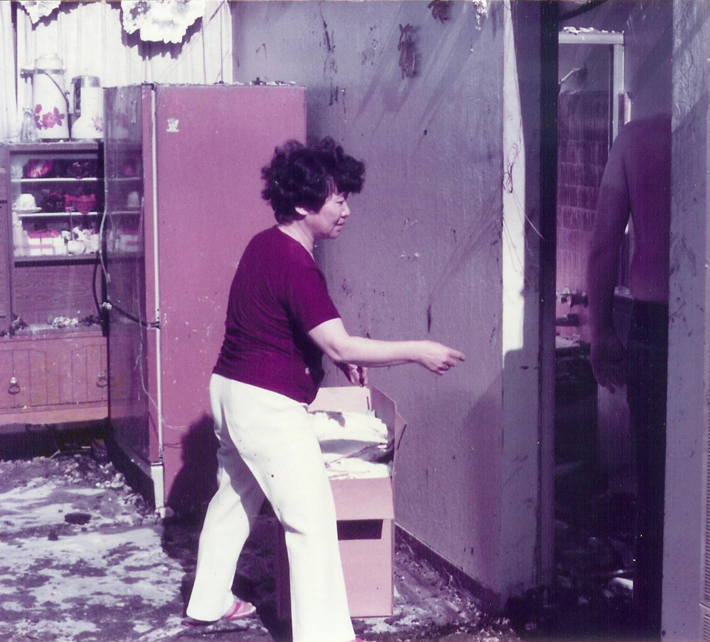Yoshiko's apartment
The fire department had just arrived and firemen were able to get Yoshiko and her dog out, plus some of her choice Japanese dolls. Her place and the adjoining duplex went up in flames. There was not very much saved from either place. The firefighters fought to save our place as the winds were strong and the temperature was above 90 degrees. When the firemen arrived they envisioned the whole block going up in flames.
Our fence and the laundry building did get charred but were put right out. Poor Yoshiko had to go stay with a Japanese friend and we took in her dog until she was able to place him in a kennel. All this time the firemen would not let me go back in our place. There I stood out there leaning against whatever I could, both of my feet in bandages and wooden medical shoes hurting like h....l !
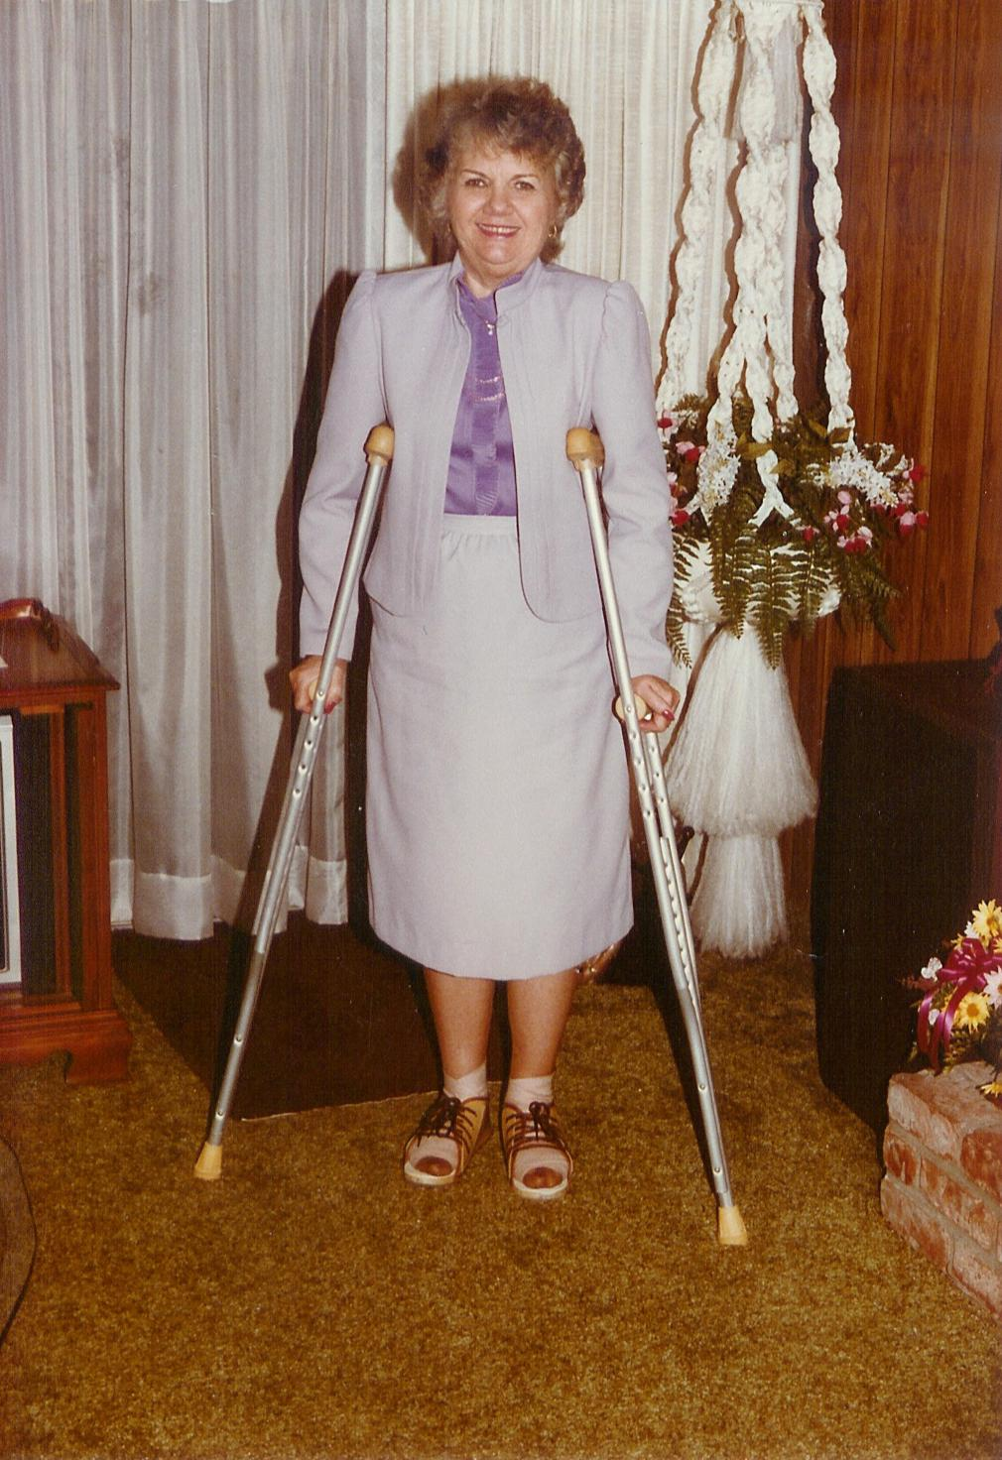Recovering from foot surgery
It was two or three months before the burnt-out duplex behind was rebuilt. And of course it took time to rebuild. The contractor had a lot of different crews working on the rebuilding. It was nice to come home from work each night and see the progress.
Yoshiko never did move back into the newly built apartment. She got her dog back, but he died shortly after. The family that lived in the other duplex did not move back, much to our delight. Sorry to say but they were nothing but trouble makers and the kid was a thief. We were glad to see them gone. They stole our lounge chairs and were sitting in them in the carport. When they left them, we took them back. They had the nerve to call the police and reported them as stolen.
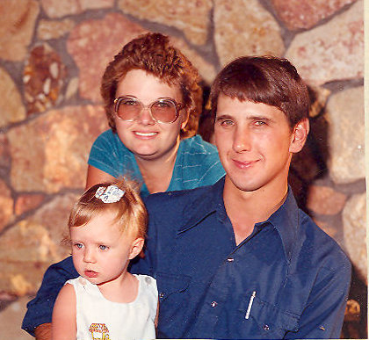Connie, Sam, and Kellie Jo
In June I flew to Burley to be with my family as I concluded my recuperation. Bonnie and the kids were in Rupert visiting her mother. On the 13th I went back to Rexburg with them. It was the first time I had been to their home there. They took me swimming at a place called Heise Hot Springs, and a production of Cinderella at Ricks College. We had a barbecue for Gordon's birthday.
My sick leave was over and I had to go back to work. It was just enough time to convince me that staying home can be very gratifying.
In August we went back to Burley for the Frost Family Reunion on the 10th and 11th. It was a camp out held at Minidoka Damn Recreation Area with the Turner family was in charge. There were always so many fun things to do, with a pancake breakfast to start Saturday off. That evening we all went into Burley to the Racquetball Club. What fun that was for all the swimmers and racquetball players. I had to be a bystander with my sore feet. After the reunion we went to Salt Lake. We didn't see enough of our Utah families at the reunion. Thelma and I did a lot of shopping. We always have a wonderful time when spent with family before having to go back to Sunnyvale.
With all of this going on in our lives, the kids continued to have changes going on in theirs as well. Melody and Emil moved from Tuscon to Gooding, Idaho. Emil had decided that they needed to start going to church. They made themselves ready and on October 13, 1984 we witnessed their sealing in the Boise Temple. It was a very special day for them as well as the rest of the family. We were so happy that they finally got their lives in order. Besides us, also attending were Gordon and Bonnie, my mother, some of my sisters, Melody's half sister Lorie and her husband, plus their Bishop and friends from their ward. After the ceremony we gathered at North's Restaurant for a wedding dinner. Jack was able to get a very nice wedding cake for them. That topped a beautiful day.
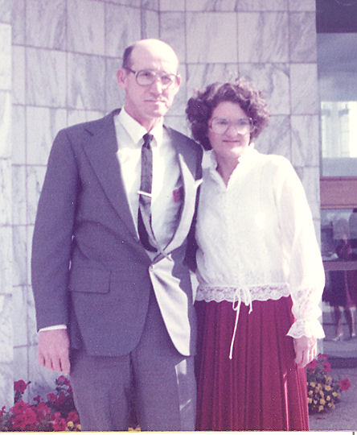Melody and Emil at the Boise Temple
In the meantime, Connie and Sam moved to Grandview, Idaho about twenty five miles southwest of Mountain Home. Sam was working on a dairy there. Then here came Kyle Austin Gochnour who was born on Tuesday November, 6, 1984. Kellie had a little brother. What a sweet little spirit. He too was born at the Cassia Memorial Hospital, in Burley.
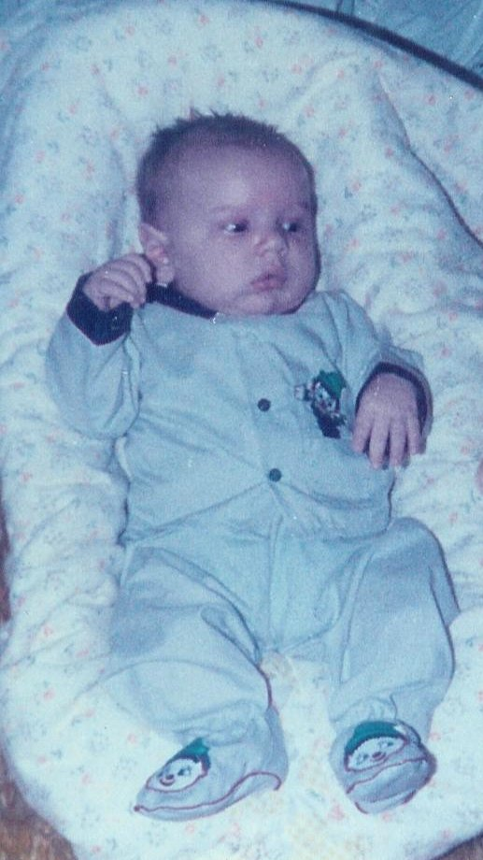Kyle Gochnour
Jack was working graveyard shift and got home about 9:30 a.m. one morning in November of 1984. He fixed himself some breakfast and left the apartment to do some shopping and returned home around 1:00 pm. As soon as he walked into the house he saw that things were amiss. It took only seconds for him to realize the horror! We had been burglarized! He called me at work and I was allowed to go home. What I saw was devastating. They didn't only take everything they wanted, but they trashed the place. The police were called, and it didn't take long to discover who the thieves were. They left white footprints over the fence, across the patio, forcing the sliding glass door open and entering. A chair was placed by the fence for a look out position. It was determined that there were two of them, and they had been putting up sheet rock in the burnt out apartments. (White foot prints.) They had been watching our activity, and when they saw Jack leave, they made their move. The contractor was no help. He denied knowing who all the guys were as they were hired by other contractors.
They took all of my jewelry, the VCR, all our electronics, cameras, and camera equipment. They did miss our best camera, and dropped Jack's gold chain on the floor. The sad thing is they took keepsakes that could not be replaced. They were professional burglars who knew what was worth taking and what was not. They took my gold jewelery and left the costume. They were never apprehended. Thank the Lord we did have insurance coverage on everything but the jewelry.
We felt very bad over the loss but we didn't let it destroy our lives. It left a mark on me that lasts to this day. I felt so violated. Eventually most everything was replaced by the insurance. Most of it newer than what we had. My diamond necklace was the only piece of jewelery replaced. Jewelery is a costly item to insure.
We went to the Syntex Christmas dinner and party for the last time, also our ward Christmas dinner and party.
I had been with Syntex twelve and half years so it was time for me to retire. I was goofing up a lot the last year. I guess I was day dreaming and not paying attention to my machine, causing problems for the mechanics. I am sure they were relieved when I left, but no more than I was. The girls at Syntex gave me a little farewell party during our lunch break and had a very nice gift for me. My last day of work there was Friday December 28, 1984. A lot of good years passed while I was employed there. A lot of good friends and good memories. When I left Syntex I was earning $8.39 an hour, $335.83 a week and $1,409.52 a month. After retiring I got $183.81 a month. What a let down. Oh well, it was my allowance and pays for my little needs. Jack gave me a beautiful opel and diamond ring for all those years of labor.
And thus ended 1984 – Another year gone forever. 1985 was a year for visitors, tragedy, a move and a fabulous vacation.
I was retired! I enjoyed ever minute of it. No more punching time clocks, apologizing to the mechanics, or begging for time off to go to Idaho. I was free!
After I retired Carolyn and Glen talked me into working in their pharmacy just to help out. Ya right! Hey, guys, I am retired! I do not want to work any more. I did for a short time at their persuasion, but it turned out that I was working full time.
In February of 1985 we took a trip over to Santa Rosa to the main State Farm Insurance Office to take care of the insurance from the burglary, so we planned a couple of days of pleasure. All work and no play is just not good for the soul. It was a beautiful drive over there.
After we got our business taken care of, we drove over to Calistoga, an old mining town but not a ghost town. It is full of very interesting old historical buildings etc. We did all kinds of fun things including I took a wonderful mud bath in a real old fashioned tub. Boy was I dirty! Then came the massage that was close to heaven. I realized I don't baby myself enough. You just can't go through life without a mud bath and a massage. I guess I had better go find a mud hole, only that was clean mud. I think we stayed over night in Calistoga. We also drove over to Sutters Mill, the site of the first gold strike in California. We had a good meal and headed for home.
When we arrived home there were notes attached to our front door from Helen Starley, telling us of an emergency, to call Irma in Burley immediately. There were two such notes. Irma had called Helen being the only one she knew that might know our whereabouts. Mr. Starley had been the president of the Idaho Bank and Trust in Burley and were living in our ward.
We called Irma as soon as we got in the house to find out that Sam had been killed when the trench caved in as he was preparing to move their mobile home onto their property. He died February 20th. He was only twenty four years old, leaving Connie a young widow and three year old Kellie Jo and three month old Kyle fatherless. What sad, sad news.
We left for Burley as soon as we could make arrangements. His funeral was held the 25th at the Burley First Christian Church. Connie was beyond grief, the first thing she said to me was “Mom, I am too young to be a widow”, and rightfully she was. I stayed there in Burley to give Connie all the support and to help her with the children I don't recall just how long I stayed maybe a month. When I did leave I brought the little family back to California with me. I'd had enough of the cold Burley weather. We tried to show them a good time to ease the hurt. They stayed with us until Connie felt that she could get along okay on her own, so we took them home. Oh, how I missed them after being with them for so long.
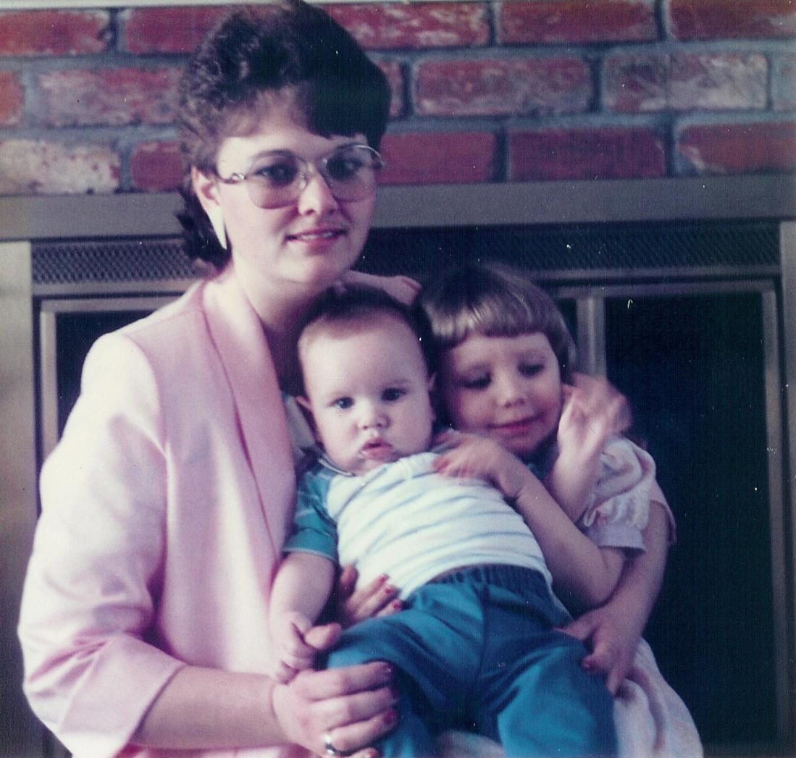Connie, Kyle, and Kellie Jo
Our cute Chrysler Cordoba was hit by a drunk driver while parked at the Moose Lodge in San Jose while we were dancing the night away. Later we traded it in and got a pretty blue Chrysler Fifth Avenue in May.
During the first two weeks in June Gordon, Bonnie, Gordy, and Olivia came. It was the first time the kids got to come to Grandma's house. Jack was working the grave yard shift so I got to take them to all to the fun places. I turned the driving over to Gordon. We went to Yosemite National Park for a day, Golden Gate Park, Marine World, Great America, the beaches, Monterrey, Caramel by the Sea, and a ride to Daily City on Bart (Bay Area Rapid Transit). (A Bart ride was a must for all of our guests).
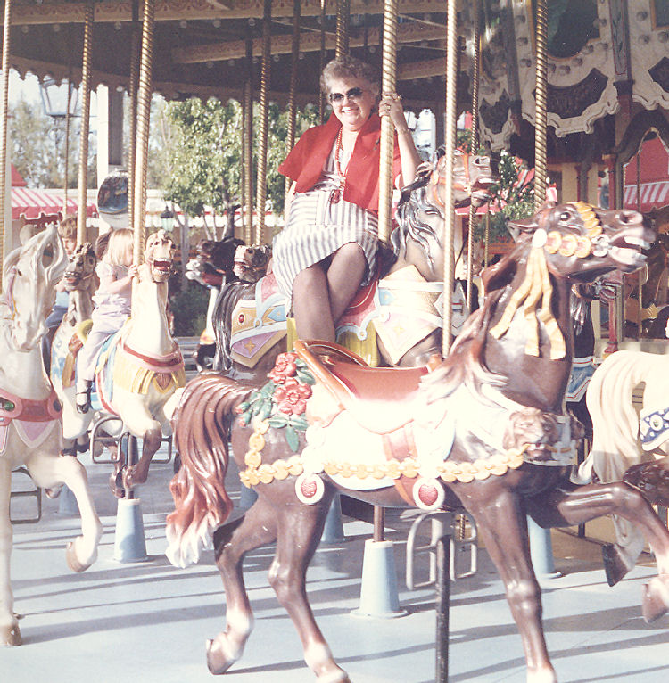Riding the Merry-go-round with Gordy and Olivia
Gerald and Verlee and all 12 of their family came for two days on the tenth of June in two cars. The Buttars were still there, so that made eighteen of us. Our living room floor was filled with bodies, what a sight and sound. They followed us on some of the tours. Jack cooked a spaghetti dinner for everyone the last night that the Frosts were there. Jack finally got off that crazy shift on Friday the day that Gordon and Bonnie left. I hope everyone had a good time because I sure did.
We took off on a two day trip to the Sequoia National Park and some old mining towns in The Mother Lode. If I had still been working we would not have been able to do all those enjoyable fun trips.

