Chapter 25
Island Princess

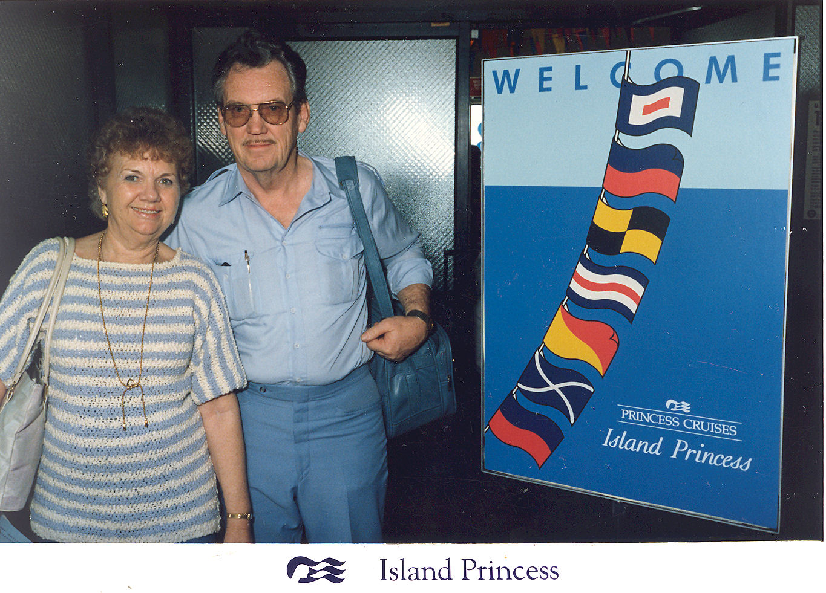
Sunday January 1, 1989 another bright New Year bringing us new hopes and expectations, after staying up to watch 1988 die and 1989 born, I didn't want to get up and go to church, but I could not start the new year out that way. January 8th was our Fast and Testimony meeting because of New Years. Jack and I bore our testimony’s . It was hard to get up and walk up there to let the Lord know just how grateful I was for all my blessings. I was weak with fright but what a wonderful feeling. It is a good thing that Jack and I are best friends because we don't have any family a round to enjoy holidays with.
Jack finished our “table” bookshelves and we got the books put into their new home, very nice work. He takes pride in his work and it shows. On January 5th I lost my playmate, Jack had to return to work after his three month recuperation period.
I had a good scare, I had received both of my checks that was spending money for my vacation. $445.00 in all. I put them away until time to go. I could not remember where I put them, I looked two or three times in all my little secret hiding places. They were not there. We searched the house up and down, even the trash cans. I knew they had to be in the house someplace. I started to panic as time was running out. I went into the bedroom and sent up a prayer for help. I went back into the office and opened up a drawer and there they were. I know that we had looked there before. Talk about a happy me. I went back in the bedroom and sent up another prayer of thanks.
My lifetime dream vacation was about to come true. We, along with Jacksons, Turners, Harpers, and Goodfellows had planned a Caribbean Cruise for January . We left Aptos and was on the freeway at 1:00 p.m. on our way to Salt Lake. We drove as far as Elko, Nevada. It was a beautiful moonlit night with brilliant stars all the way. We bedded down at the Red Lion Motel, getting up at 5:30 to a bitter cold, frosty wonderland. We seldom got to see the beauty of winter. It was a cold drive as the car didn't warm up for hours. We arrived at the Jacksons around noon. One by one, everyone arrived. At 10:00 p.m. Scott and his daughters came with a van and station wagon to haul all eight of us and our luggage to the airport where we meet up with Goodfellows and other fellow passengers, plus Pixie, our tour guide.
I still could not believe that it was true. Our poor mother worried about half of her family all on one plane.
We and the Harpers were the only ones without boarding passes. We were assured that we would get on, but watching the plane fill up and we were still standing there, the only ones left. We did get in “First Class.” Not bad for all the worrying we did. We flew Delta 727, flight # 326.
Saturday 21st 12:30 am …......Take Off!!! I was so excited, I love to fly. Very soon we were above the fog and it become clear. As we passed over the cities, towns, and farms below. We could see their lights twinkling like zillions of jewels in their white blanket of snow. The whole scene below all the way to Atlanta was awesome. The snow disappeared as we approached the South and it was replaced with greenery. Having perfect seats, we could view with ease. I couldn't sleep, I was afraid I might miss something.
We landed in Miami at 7:30 a.m. When we went to claim our luggage we found that some had been mistakenly sent to Fort Lauderdale. You guessed it. Our big bag along with Harpers', and Goodfellows' were missing. We waited around the baggage room until the buses came to take us to the Continental Hotel where we were to wait until time to go to the ship. At the hotel, we were given buffet snacks as the wait was lengthy. We could see our Island Princess across a bay along with a replica of the old sailing ship, the Bounty.
Again we boarded buses that took us around to the dock where the Princess was docked. We boarded at 12:00 noon and went directly to the Coral Dining Room where we were served our first ship's meal. The staterooms were not ready, so more waiting and our luggage had not yet caught up to us, and the ship was about ready to sail. I was really starting to worry! It would be bad if we had to wear the same clothes the whole trip! At 2:00 p.m. we were taken to our staterooms. Our stateroom was starboard, Deck 4, Fiesta Deck # 103. It was an outside room so we had portholes. We were close enough forward that we could hear the waves slapping against the ship's hull. We also had more motion, which was good for rocking me to sleep. Harpers were in the next stateroom over, the others were farther down and Jacksons were on the other side.
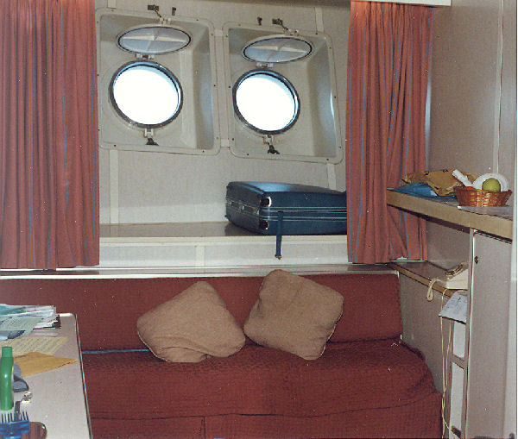Our stateroom
Our luggage did make it on board just before we weighed anchor. The ship's horn blew its blasts at 4:00 p.m. as we left Miami. Music was playing and everyone was out on deck while hundreds of red white and blue balloons were set adrift. We were off! It was truly exciting, I felt like the princess that I am.
We had first seating for our meals and were assigned to tables 44 and 46. Everyday we went to breakfast at 8:00a.m., lunch at 12:00 noon, and dinner at 6:00 p.m. sitting at tables 44 and 46. If you missed a meal, you would have to have snacks on the Sun Deck. There would be open seating once in a while. The Captain and most of the crew were Scottish. Most of the waiters, chefs, maitre d's, and busboys were Italian. Our waiters throughout the cruise were Danny and Dino, our busboys were Max and Rafael (Mexican). They were all neat guys and got to know us real well. We were pretty dumb about ordering. About the third meal we wised up, with all those fancy names we had to ask before ordering. We did not have one bad meal the whole time.
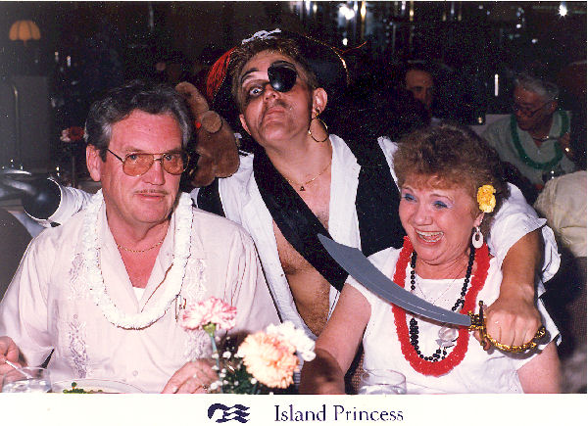Captain Hook stopped by our table on Island Night
The first night, Jack and I were really tired so we went to our stateroom and conked out. We missed out on the first night activities, such as meeting the crew and a tour of the ship, lots of fun, entertainment, and excitement. Lorna and Kenneth went, and bragged about it.
When we woke up Sunday morning, we were out to sea. I had a hard time standing up in the shower and walking down the long corridors. There were a lot of things going on, us gals did go to a “Grandmothers Get Together”. We did not go to the “Captains Welcome Aboard Cocktail Party” so we did not get to meet the Captain and get our picture taken with him. That night was formal dress, we dressed for dinner and what a wonderful dinner it was. We went to the Carousel Lounge to see the “Princess on Parade”. Every night the same group of performers put on wonderful, wonderful productions. You could not see anything better in Los Vegas or New York City. Every night at mid-night, they put out a big all you can eat mid-night buffet with a different theme each night. They also had a buffet set up on the Sun Deck at all times. So there is no need to go hungry
One night was “London Pub Night” with passenger participation. We hurried to get front row seats. First thing we knew Nick Charles, the cruise director was standing in front of Jack...saying, “I heard today that you always wanted to lead a band...now is your chance.” leading Jack to the bandstand. All the way Jack was saying, “You have the wrong guy”. Well he took the baton and starts to lead and you never heard such a racket in your whole life. So he returned him back to his seat and I am rolling out of my seat with laughter. Nick asked me, “He hasn't much rhythm has he?' I answered “No”. He says “I don't know what you are laughing for, it's your turn now.” He took me up there and said “Now tap this baton three times and say Go.” and the whole band got up and left. “Now look what you did!” Nick said, he talked them into coming back. I started over and they played beautifully. Nick stood beside me and all the time he was bumping me so I bumped him back. All this time he was holding his hand behind me and it looked like he was holding my butt. He didn't really touch me, but everyone was cracking up. He finally let me go back to my seat but the band played on. I had to stop them. It was really fun. They gave me a nice Island Princess pen and Jack a key chain. You should have seen what they did to Kenneth. Anyway there were fun things and dancing going on in all the lounges all the time. You could pick what you wanted to do or see.
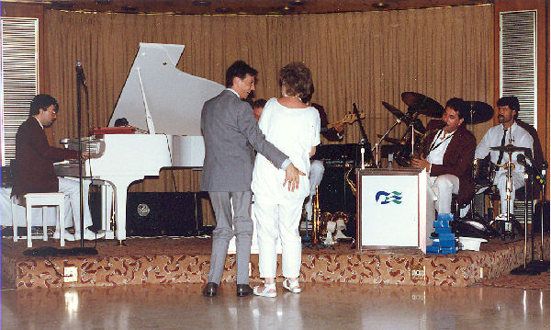Leading the band
After two fun filled days at sea, we sighted land. Our first stop was St. Maarten, The Princess dropped anchor at 7:45 a.m.. We had breakfast on the Sun Deck because it was quicker. We were taken ashore by a tender and walked into town. It was 70 degrees. The island is only 37 square miles There is a lot of interesting history there . We went in to few of the shops as we didn't have a lot of time to tour. In one of the shops, I held a cute baby girl, Michelle. (French.) We all walked back to the dock and waited for the tender. I bought a pretty black and mother of pearl necklace on dock for $20.00. The tender took us back to the ship at 1:30. Ship pulled up anchor at 2:00 and resumed course for Mayreau in the Grenadines.
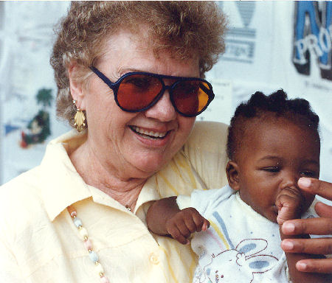Me and Michelle
We went to the show in the Carousel Lounge to see a “Happy Days” production. It was a great show. Nick sang to Kathryn, Lorna, and Thelma; kissing their hands. But he sat on my lap and kissed me on the cheek. Jack was tired and went to the stateroom. I stayed and got in on the Teddy Bear Dance. Two gals and one guy. It was lots of fun. I went to the mid-night buffet just to look, Ya right? It was a French Theme. It was an Eiffel Tower made out of food. I went down to my stateroom to be rocked to sleep.
Wednesday the 25th was an all day island day. The weather was perfect; 79 degrees. Us gals went to a flower making class in the morning while the guys did their thing. The ship dropped anchor at 12:00 noon in Saline Bay off Mayreau Island. We went ashore by tender. Mayreau is a small private island with less than 100 inhabitants. It is one and half miles from tip to tip. The Princess Lines leased the beach for all their Beach Day parties. The ship's crew set up and served a great beach barbecue. We ate and most of us went swimming. The water was great but fierce. I got caught by a wave that dashed me and my floater into the hard sand, hurting my bottom. I floated farther from shore than I liked and when I was knocked off my floater and couldn't touch bottom, I panicked.
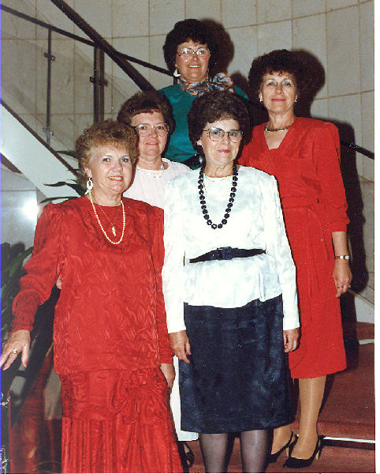Us gals: Me, Marion, Kathryn, Thelma, and Lorna
Kathryn, Marian, Doug, and myself walked up a very steep winding road to the top of the island. On the very top was a church and a school with no glass in the windows. The smaller children were in school and we could hear them reciting. We watched them and their teacher come out the windows to go to another building. We talked to a seven year old boy that wanted Kathryn to write to him. His name was Kenry. There were pigs and cows tied up to trees and stakes, and goats and chickens all over.
Down on the beach, the islanders had their crafts set up for sale and a calypso band played music all afternoon on their steel drums. At 3:00 p.m. all of us took a tour on a glass bottom boat that took us out to the reefs of Mayreau where we viewed Mayreau's own underwater spectacle of colorful tropical fish and exquisite coral structures. The harbor was beautiful and had a lot of very large sail boats from around the world. We even watched nude sunbathers on a French ship. We got back at 5:30 just in time to catch the last tender back to the ship. The ship remained in harbor for an Island atmosphere for our Island Night. The dinner was out of this world. The waiters were dressed in floral shirts. We were all given leis and the “fairer sex” were given carnations for our hair. Some of the ship's officers performed Scottish country dances. Jack and I watched all of this from the Sun Deck above.
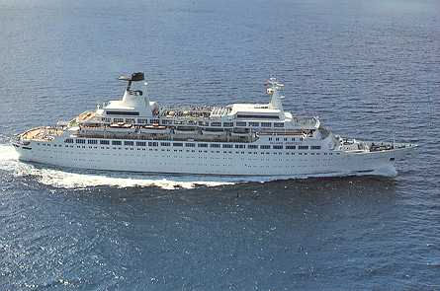The Island Princess underway at sea
The ship pulled up anchor just before mid-night . What a wonderful full day, it was just great! Mayreau is what paradise is all about!!! Off to bed and on to the next port ...Martinique. On Thursday 26th the Island Princess entered Fort de France the main port of Martinique and was along side the berth by 8:00 am. We didn't need tenders, we just walked off onto the dock. There was a lot of history here. Martinique is French with a population of 310,000. Their language is French with a smattering of English. Napoleon’s empress, Josephine was born there.
We took a bus tour that took us along the circuitous coast through fishing villages. We went shopping at St, Piere and visited a museum that commemorates the total destruction of the city by a volcanic explosion in May 1902. What had been a town of 40,000 was wiped out that morning leaving only one survivor. A prisoner in an underground cell. I am giving you a history lesson as we go along here.
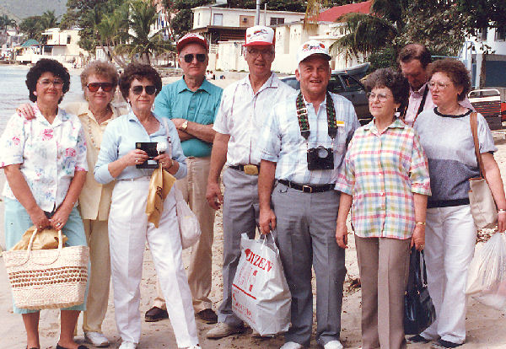Our gang: Kathryn, me, Lorna, Kenneth, Dick, Jay, Thelma, Doug, and Marion
From St. Piere the tour took us along a twisting road into the mountains past banana, pineapple and sugarcane plantations. I don't know when I had ever seem such unique tropical flowers and trees.
We had them drop us off downtown at 1:00 pm. They failed to tell us all the shops and businesses close every day between 1:00 and 3:00. We also failed to order our sack lunches from the ship the night before, so we ate bananas and strolled the open air shops where we enjoyed a huge squabble between shopkeepers. One probably cut prices. It would have been fun if we could have understood French.
We walked around a very beautiful park there. I thought Martinique had the most beautiful flowers and trees, the park also had a lot of statues. It was one and half miles back to the ship, we debated over walking or getting a taxi. The decision was to walk. I was really tired by the time we got back. The ship pulled away from the dock at 4:30 pm. I was watching as we left port from my porthole. I even saw some flying fish.
We did not go to the “Captains Farewell Party”. We never did even meet the Captain.
The “Captain's Gala Dinner” was one of the best. It ended with a parade of flaming baked alaska, carried by all the waiters. It was amazing. I never saw anything like it. Our table was given complimentary bottles of non alcoholic wine. In the Carousel Lounge we saw the Princess Cruises' latest production. The 1940's spectacular “In the Mood”. They did some very funny, crazy acts Jack and I went to a show in the Carib Lounge but didn't think it was funny so we went to bed.
Friday the 27th was a very sad day for me, our last day on the ship. After breakfast Jack and I went to our stateroom to start packing our bags. We missed out on the San Juan disembarkation talk and the Caribbean shopping hints because we didn't read our newsletter. The others went.
The Island Princess berthed at St. Thomas at 10:15 am. St Thomas is second largest of approximately fifty islands of the Virgin Islands. The Virgin Islands were discovered by Columbus on his second voyage. He named them in honor of the 11,000 virgins who were martyred in the early days of the Christian Church. The town that we visited was the legendary Charlotte Amatie which is converted warehouses that once stored pirate booty.
That morning, we were the last to leave the ship because we were waiting for the Jacksons. Lorna went back to look for them. We decided that they must of gone ahead. The eight of us took a taxi downtown, what a jungle, but I loved it. Narrow streets and shops shops and more shops. I did buy. We didn't see any of our group until about 11:00 am when we first ran into the Turners. The four of us taxied back to the ship for lunch. Jay, Jack, and Kenneth had a snorkel tour scheduled for 1:00pm. We ladies along with Doug and Dick had an Island tour scheduled. Back on board the ship we went to the Sun Deck for lunch and found the Jacksons. Instead of meeting at the appointed place they waited for us in their stateroom and got left behind. Marian and Doug went ahead on the tour, Thelma, Lorna and I decided not to take the tour because it would take the whole afternoon so we found the cab driver we had had before and hired him to take us on a private tour for $10.00 each.
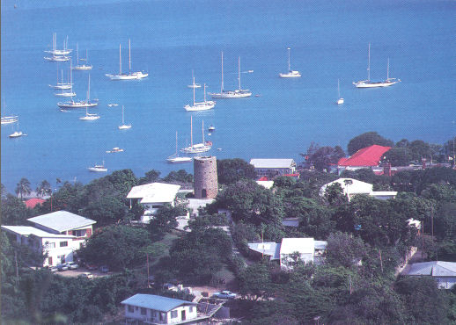Black Beard's Castle on St. Thomas
He took us to some of the most important points of interest, such as Blue Beard's Castle, and on top of the mountain. We could see Black Beard's Castle and he pointed out many things from the mountain top. He took us back downtown to finish our shopping. We soon lost Lorna so Thelma and I window shopped until we got tired so we hailed a taxi back to the ship.
We all made it back to the ship and met up for our last dinner aboard. I was really sad. It was as usual, a lovely informal dinner. We went to the Carousel Lounge to see the Farewell Showtime “Dancing Down Broadway” starring Joy and Nick. Their performance also included “Evita” “Cats” and “For Me and My Gal”. Jack and I did not go to any of the other entrainment. Our bags were packed and gone. We were tired and went to bed to let that wonderful ship rock us to sleep for the last time. We were on the way to dreamland and San Juan, Puerto Rico .
Saturday January 28th ….As our wonderful trip drew to a close, I felt all sorts of emotions. I had loved ever minute of that delightful cruise. We had to be at breakfast at 6:30 am and say our goodbyes to our waiters, Danny and Deno, Max and Rafeal and to Erik our cabin boy that kept our room clean, and our beds made, with fresh fruit in our room and was our mail carrier, etc. He was a tall English lad, I really liked him. This was the time to tip all these people that looked after us all week. Pixie, our cute little Hawaiian tour guide from the very beginning was always there when we needed her. Jennifer Nud, the Social Director from Sacramento, California, was a good friend to us gals, she was also LDS. This was our goodbyes to people that made our trip what it was.
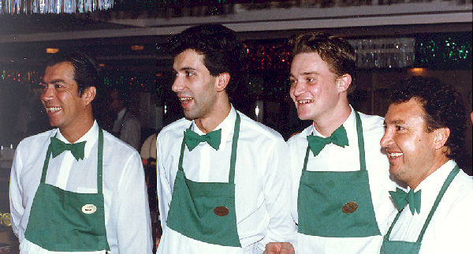Rafael Danny Max and Dino
We had to wait for disembarkation, all non US Citizens were first, next to leave were passengers that had early flights. So at last, us with orange tags got to go as we said our goodbyes to the crew and handed in our ship's ID cards. That was not the end of our waiting. Next we had to go down to the dock where all the luggage had been unloaded and find our own and tag it. Then we had to listen to more instructions about lunch and when to be at the airport. When everybody was ready, we boarded buses that took us to downtown San Juan (it was called a free tour) to Hotel La Concha. The Hotel was on a very beautiful beach with shops near by. We had a pretty good buffet lunch there. Pixie arranged for a private tour in a taxi bus. He took us to two old marvelous forts. I won't go into the history of Puerto Rico, as interesting as it was. He drove us down a narrow cobblestone street that was lined with shops.
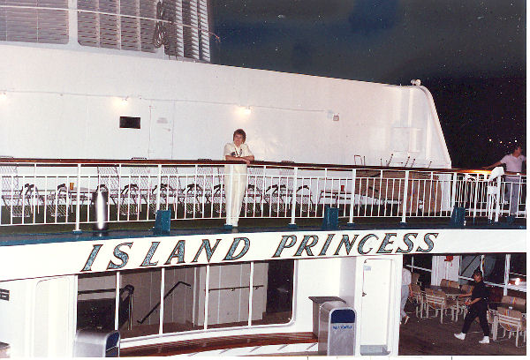Saying goodbye to the Princess
We stopped at a jewelry shop where they had a non alcoholic piña coladas waiting for us. It was hot and they tasted so good. That was winter time for the Caribbean, the average temperature was 77 degrees and above. He took us through the modern San Juan and to the airport.
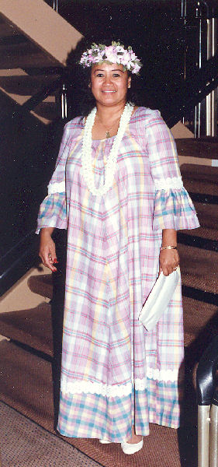Pixie, our tour guide
We spent a lot of time sitting around airports, hotel lobbies, and ship lounges just waiting to go some place. There again, we had a two hour wait for our flight. Our flight to Atlanta left at 6:40 pm where we had an other hour layover. Another three and half hours in the air. We landed in Salt Lake at 11:45 pm. Scott and Judy came to chauffeur us back to the Jacksons. Everyone went right to bed and went to sleep. We arose around 7 or 8, Sunday morning .(Who was keeping time at this point?) We ate a bit of breakfast, visited a few minutes, and headed for Aptos. With a couple of stops along the way, we got home at 12:30 am, unloaded the car and went to bed.
Our mother was very happy that we all arrived safely, and we ten came back with much more love and appreciation for one another.

