Chapter 26
The Big Shaker

We settled back in to our lifestyle, Jack's work and me, I'm happiest when I am creating things beautiful and useful. We were still doing things for Theresa, and Clyde is a permanent Sunday dinner guest. Jack had a little scare with his heart, but that too settled down.
Cindee and Steve came from Pocatello for a few days in February. We just did the usual things. In April we drove to Los Angeles to go to the temple. I guess the Oakland Temple was closed. We did some sightseeing while there.
Jack put on a spaghetti dinner for a High Priest Social down in the park's Club House on July 14th. We were expecting Thelma and Jay as they were on their way to Los Angeles to serve a mission in the Los Angeles Temple Visitors Center. We left a note on our door telling them to come to the club house. They got here right in the middle of the dinner, so they got in on the fun also.
We went to a flea market and out to the Old Mission Jan Juan Bautista and around Santa Cruz. Saturday evening we all went to the newly remodeled Stake Center dedication and out to dinner someplace on the water in Santa Cruz. It was a clear night and we could see all the beautiful twinkling lights of Monterey across the Monterey Bay. We sure enjoyed them, and missed them when they left on Sunday.
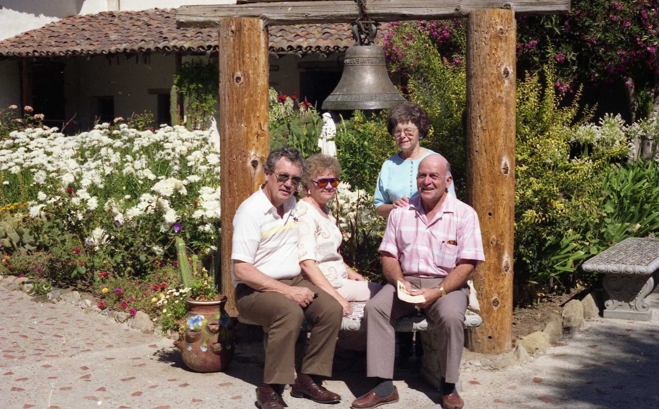
With Thelma and Jay

On July 24th we fixed dinner for three Elders and Clyde. A couple of days later we were headed for Seattle. Jacks vacation started July 26th and we had a lot of places to go. The Gilmour Clan had decided to hold their first ever Family Reunion, so that was our first destination. It was held in Bothell, Washington, outside of Seattle. His nephew Dave and his wife, Bev, were the hosts. They had a large lot with the cutest 100 year old house. It was the first house that I had seen with two toilets in the bathroom. I have only seen one other since. The whole house was so quaint, but really cute. The yard was something else. He did rock work and had built a huge waterfall that was an ideal place to take photos and for kids to climb on.
The reunion went very well. The gals did a wonderful job on the food. Everyone was there except for three families that live out of state. It was nothing like our reunions, but was good. Carolyn Gilman, a cousin from Minnesota was also present.
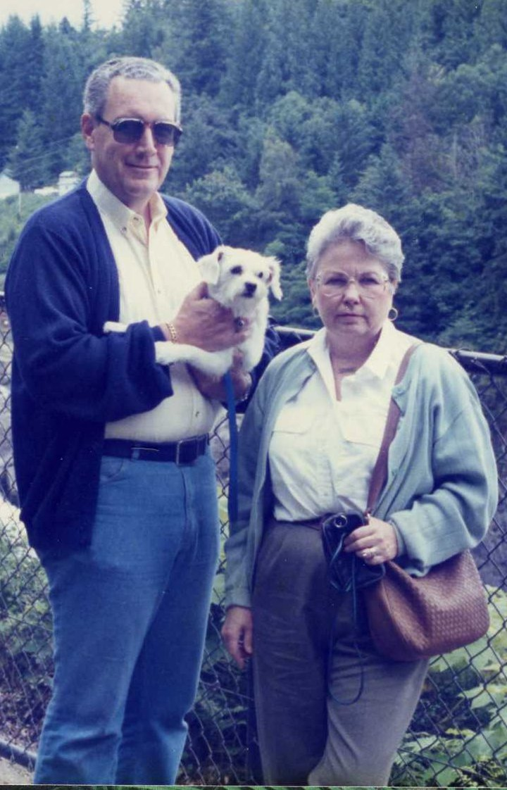Al and Marge
After the reunion, we went over to Federal Way and stayed a night with his brother, Al and Marj. They took us to some neat places with waterfalls. We left there and were going to go to the brand new Portland temple. It took us forever to find it and when we did, it was closed for cleaning after the open house. It was foggy that morning and the temple looked to me like it was veiled with a sacred shroud. So we just took pictures of it and went on our way.
Our next stop was Selah, Washington near Yakima, where we found LaPreal and Harold there in their 100 year old house. It was a two story stone house with a beautiful yard. It was magnificent. LaPreal took me to some antique shops and around Yakima. After one night, we were off to Burley.
This was also time for the Frost Family Reunion in August as usual. We just can't miss that! It was on the 4th and 5th up at the Oakley Stake Ranch. Goodfellows were in charge and Guy won the quilt. The evening was spent around campfires eating roasted wieners, marshmallows. and s'mores The day had its planned events including a pot luck dinner and the raffle. After a great time with family (we sure missed Thelma and Jay who were serving a mission in Los Angeles) Jack had to be back to work on the 8th. We did a lot of traveling and saw a lot of family in those two weeks with two family reunions.
Gordon was working for Diet Center in Rexburg and had to go to a conference in Anaheim, California down south near Disneyland in September. Bonnie and the kids came with him on this trip. They drove down and they left Gordy, Olivia, and Loren with us for the week. What a mean trick Bonnie pulled on me. She had nursed Loren, who was nearly weaned all the way from Rexburg and left him high and dry with me. Not knowing why Loren was screaming his little head off all the time, I didn't know what to do for him After the second or third day he settled down somewhat. He was two. We had a lot of fun with them. They were real good kids and minded us better than they did their mom and dad. What I hated was Loren's dirty diapers. He wanted to be held and rocked every night. He was such a joy, woke up cheerful and was good all day.
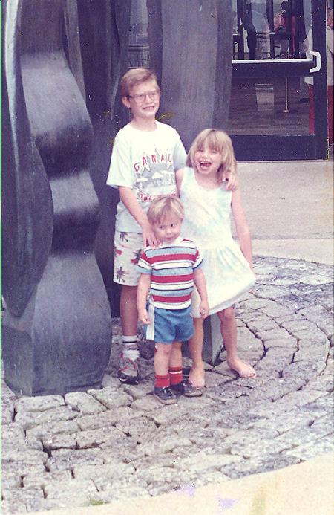Gordy, Loren, and Olivia
On Monday I took them to the beach all afternoon. They had so much fun. Wednesday was a day that I worried about getting through, but it went very well. I had to help serve lunch at Relief Society and decorate the tables and clean up afterwards. That afternoon Jack and I both had dentist appointments in Sunnyvale. So we took them along with us. They were real good with both of us in the chairs. Afterwards we did a little shopping, they stayed right with us and didn't ask for a thing.
The next day I took them to Monterey to the Aquarium. Even little Loren loved it. It poured down rain all the way home from Monterey. They had a lot of fun just at home. The week had really gone fast, and boy was I tired. God knew what he was doing when he made young parents. Gordon and Bonnie got back, the kids were happy to see them. Gordon had taken an extra week off so they could stay with us. One day we went to the beach and another time we took them to San Francisco. When they left, I missed them for a few days.
On August the 31th we were on the road again for Salt Lake, This time it was to take Clyde to the Temple. He had been baptized a year earlier and was anxious to get his temple work done. We met his two sons there that he hadn't seen in 35 years. Ed and Betty from Montana and David and Joyce from Los Angeles. Clyde did his endowment and was sealed to both of his wives. We all went to Muldoons in Trolley Square as guests of Ed and Betty for a great dinner with all the shrimp we could eat. We stayed at the Best Western right downtown, and left for home the next morning.
If you are tired of hearing about our earthquakes, here is one more that you must read about.
On Tuesday October 17th Jack had worked a long shift of 24 hours, returning home at 9:30 am. He went to bed and slept until 1:15pm. After a bite to eat we left together to take care of some business. The last stop was at Micheal's Jewelry, on 41st Street in Capitola. We were getting new watch bands.
While there, at 5:04 pm we experienced 15 seconds of horror that lasted an eternity. What seemed like a gigantic explosion and instant power outage. It did not “rock n roll,” it jumped up and down. We looked at each other and said “This is a biggie!”
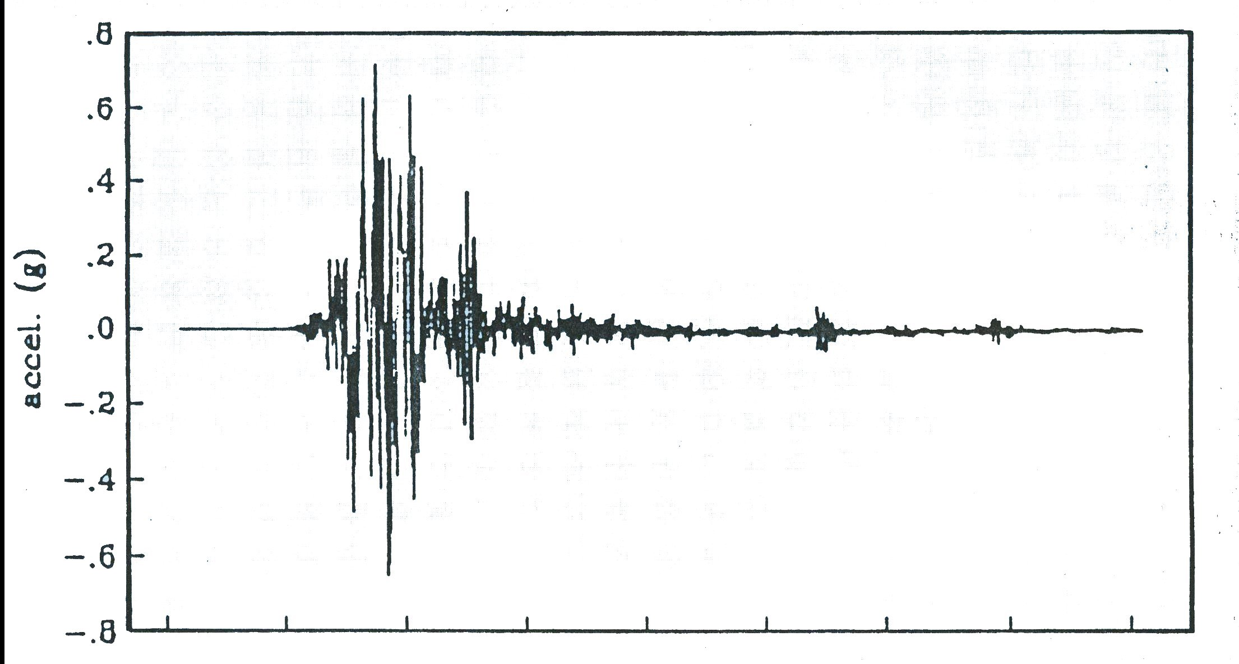The Richter Scale chart
I thought the building was going to come down and swallow us up. The cars out in the parking lot were jumping as in a dance. All the lovely jewelry was doing flip flops like popping pop corn in the show cases. The whole building was jumping up and down and swaying back and forth. As it subsided, we got our half made out receipt and headed for the car. Two major aftershocks followed us out the door. We and the lady owner were the only ones in the store and we bonded that day. We got in the car and headed home by way of Capitola Village and Park Avenue to avoid the freeway. All the signal lights were out, but all drivers were extremely courteous.
As we neared our park entrance, I was fearful of what we would find at home. My heart sank as we saw the damage done to different homes, as we drove up our street. Our first stop was to see if Theresa was okay. Many of the homes were off their foundation. Everyone was out in the streets in a daze. What was really strange was the homes on the other side of the street from us had very little damage, inside or out. Ronny was cleaned up in about an hour, Theresa only had a few bricks knocked off the front of her place. I don't know of the damage on the other streets below us, but our side sure got it Shannon's house next door was off its foundation and she couldn't even get in. She slept in her car rather than accepting our invitation to stay in our guest room..
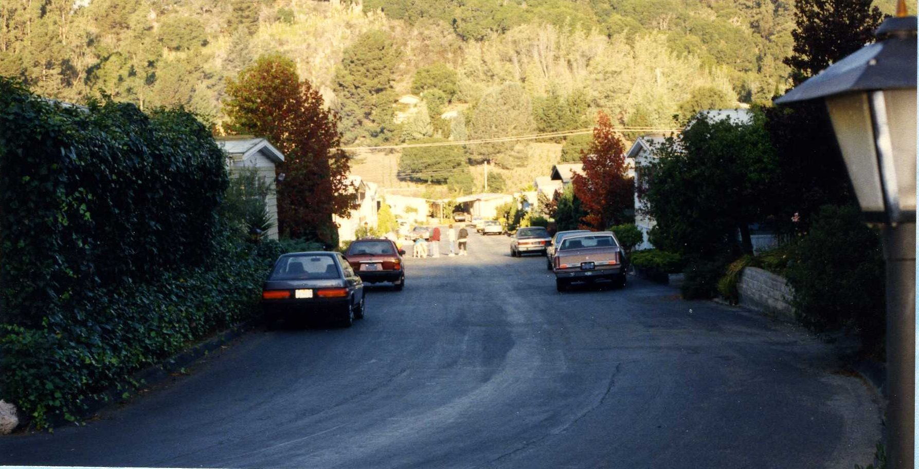The view from our street
As we neared our home we could see that we were extremely blessed. We were still on our foundation and no apparent damage. We both uttered our thanks As we unlocked the back door, we met an awful sight that we did not want to see. The back entrance was filled with things from the cupboards above the washer and dryer plus the things that flew out of the small bathroom. The contents of the medicine chest had unloaded in the sink. We stepped over and through that mess to be an even bigger mess. Our Grandfather Clock was laying across the love seat. The antique cabinet was leaning across what was a glass coffee table, its contents broken on the floor. The fish tank and contents were splashed across the the end of the room, and into the bedroom. Lamps were down and broken. What pictures that remained on the walls, and everything that wasn't on the floor was topsy-turvy. It was the same story in both bedrooms and bathrooms, it was a disaster. We could not open any of the closet doors, everything from the shelves had unloaded against them. The den/office/whatever room was buried in paper, books etc. The computer was completely buried. The glass shade on the chandelier over the dining room table was hanging by one of the light candles. Most of the heavy furniture was six to eight inches from the walls (except for the water bed) a few things didn't appear to have moved at all. All power, water, gas, and telephones were out
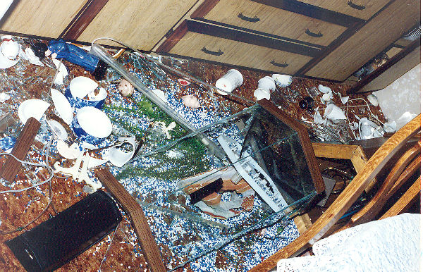The 30 gallon aquarium

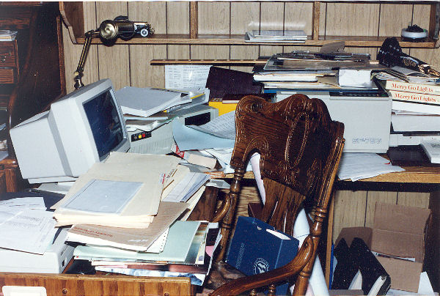The office

We spent the evening wandering around in pure shock, mingling with our shock stricken neighbors, comparing damage, and feelings, supporting one another. Late evening found us in candle light, eating a cold chicken dinner, and listening to disaster reports on a battery operated radio. There were conflicting reports as to the magnitude and epicenter. We knew it was close and at least a 6.9 or better.
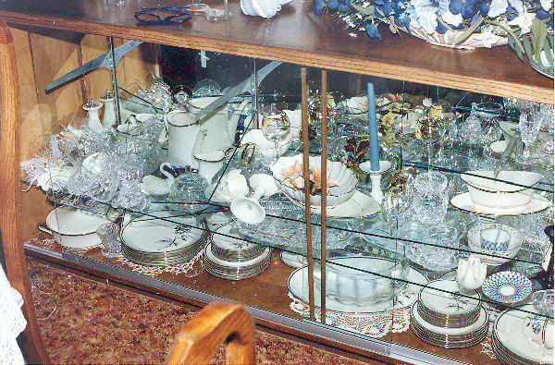The china cabinet
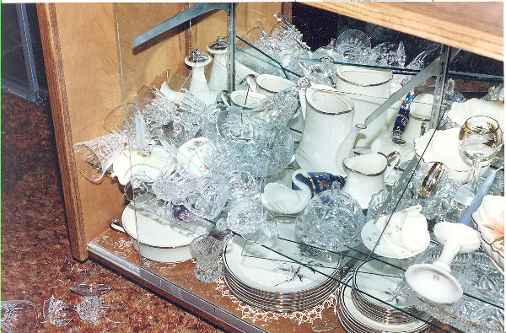None of the china was broken
It all happened at once in those 15 seconds. Think of the noise it must have created in our house, we are also thankful too that we were not there during the upheaval . We probably would have been injured.
The continuous severe aftershocks and the shrieking sirens did not help our fears as to what yet might come. We spent the first night on a giant bowl of Jello-O. Being right over the fault, we felt every small trembler along with the large aftershocks. We got no sleep that night. So many families had nowhere to sleep.
We did not shed tears over our losses. We were blessed. We had our lives and each other, nothing else seemed to matter at that point. It was a blessing for us to experience this disaster together. So many families did not know where, or how, or if they would ever see other family members again. We were spared that agony. We thanked the Lord for those blessings and asked Him to bless us through what else might come.
October 18th 1989, the dawn of a new day and it warmed up to be a very hot day for October. “Shake and Bake” as our bishop put it. We checked on Theresa and Shannon next door, with our ears on the unfolding reports and fearful with each ongoing aftershock, we got into the clean up mode. We discovered a lot of very strange things.
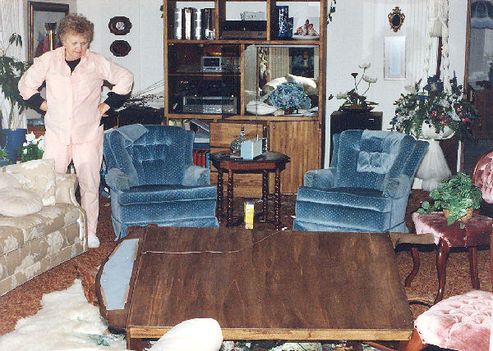The living room
We got power back, much to the surprise of the whole area, by that evening but no water or gas. Each big aftershock would scare the crap out of you and no water to flush the toilet! We had cold meals of chicken and peanut butter sandwiches. Jack was called back to work and I did not want to spend any part of the night alone. The seismic action had no pity. I laid in fear with the radio on and a flashlight in my hand. Jack would call me after each new shock, knowing I would not be asleep. There were four big ones within 45 minutes. I will not go into our clean up details, that took months. Because of the fish tank water and all the shattered glass we had to put boards down to walk on to get from room to room and not shoeless.
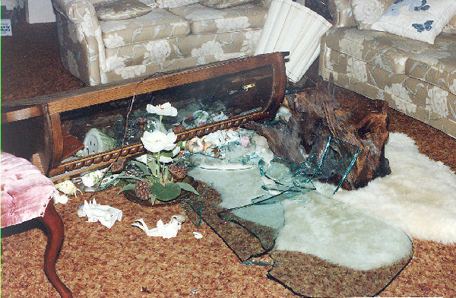One big heap
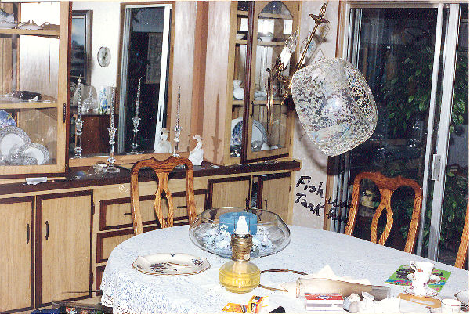Chandelier over the dining room table
I thought I was strong, but that was really traumatic. The earth was still shaking under me, it was hard to tell a real tremor. Even now, I would rather go through another big earth quake than a fire, flood, hurricane, or tornado. I just pray that I won't have to go through any of them again. I did not cry over the loss of my treasures, they were only things. We were blessed, I knew the Lord loves us and He did protect us. We were grateful for all that were concerned about us. We had calls and letters from friends that I hadn't heard from in years. It is so nice at times of distress to know that I was loved.
To make matters worse I had received in the mail a summons for jury duty for two weeks beginning October 30th, just what I needed. I called in, as directed and to my surprise I did not have to report.
For once we lucked out, we did have earthquake insurance. State Farm was unable to get to us until four or five weeks after the quake, as we were that far down on the priority list. Most of the loss and damage was paid for by State Farm.
A Couple of Facts about the Quake: from the Santa Cruz Sentinel. The 7.1 magnitude quake broke loose on San Andres fault at 5.04 pm October 17th 1989. The quakes center was 11-1/3 miles underground, four miles north and a mile east of Aptos village near China Ridge in the Nisene Marks Park.
The quake spawned 79 aftershocks magnitude 3.0 or greater, including 20 quakes 4.0 or greater, 2 aftershocks 5.0 or more. By 9:00 am there were recorded 4,000 aftershocks, many to small to feel. Aftershocks were still occurring at the rate of 5 to 7 an hour on Friday. The quake killed 63 people throughout northern California, injured 3,757 and left some 3,000-12,000 people homeless.
We did celebrate our 11th wedding anniversary with a delicious dinner out on Saturday November 25th and I am sure we did the usual Thanksgiving. Jack had his 63th birthday on the 19th of December.
We probably spent the rest of the year cleaning up and repairing damage and preparing the house for new carpet. On a Friday evening we went to our ward Christmas dinner at church. Jack asked some of the elders if they would come by and help move some heavy furniture out in preparation for laying the new carpet the next day. Which they did. About two hours later, the Bishop came by and without knocking walked in the back door and gave me my most embarrassing moment of my life. It was so embarrassing I can't say what it was!
We did the Christmas things that we do every year. We did take a few days off to go to Burley for our family Christmas dinner. We could not miss that! Sure can't remember who opened their home to us. But I know we had a good time.

