Chapter 29 Passages
I never really saw my life as a series of passages. We move through our lives, first, newborn to teenager to young woman to mother and so on. Just like the days, months and years. I hoped that each of these stages in my journey would bring new growth and joy to my life. We just passed into a new year, 1992 which brought many more passages into my life.
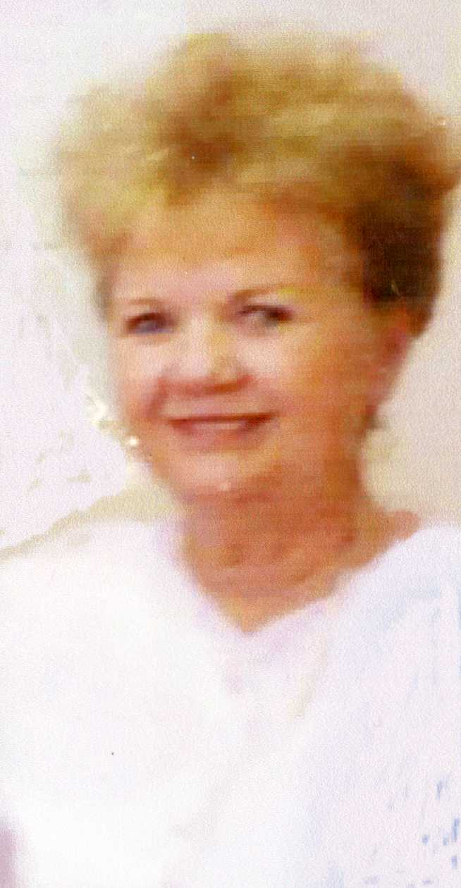Me at 66
As we anticipated our hopeful move. Our first guest of that year was one of my Syntex friends, Norma Jantzen. We had a lot to catch up on as we hadn’t seen each other for a while. She came January 12th.
Thelma and Jay came for their last visit to Aptos the last weekend in January. We did so much more this trip because they stayed longer. Jack had to work the first weekend that they were there. We went to Santa Cruz, and spent time along the ocean. We went to the Natural Bridges States Park where we saw zillions of monarch butterflies feeding on the eucalyptus trees. There were millions of butterfly clusters hanging from the branches. The trees and air above us was filled with color on wings. You have to see it to believe it.
We went to San Francisco and to Fisherman’s Wharf. Jack took us on board the old Submarine the USS Pampanito SS-383 that was berthed at Fisherman’s Wharf. Thelma and I could not get out of there fast enough! We went to Carmel one day and Thelma and I went back the next because the guys were in too big of a hurry. We girls wore our better halves out. Jay spent one day cleaning up the pine needles from the yard. Big help. We sure had a wonderful time, they stayed for ten days and the time went so fast. We spent one day in Oakland before they said their goodbye’s and left for Salt Lake. I sure hated to see them go.
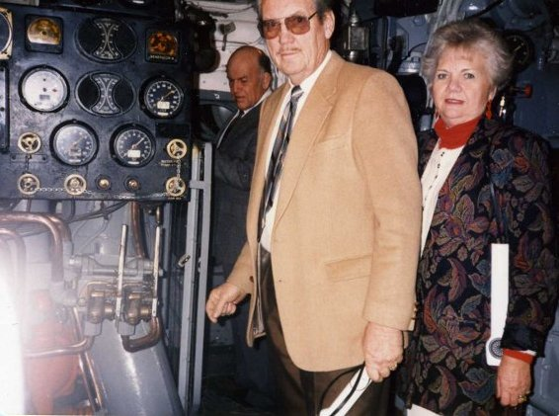Jack showing us around the Pampanito
Cindee and Steve also made a last visit to lovely Aptos the 25th of February. I went back on the Diet Center diet and three months later was back to me. Raydon Dudley graduated from Minco High School on June 2nd in Rupert. A passage from high school to soon to be married. I was able to be there for her graduation. Deelyn graduated from ISU on May 16th. Passage from Collage to a new career. I was so proud of them both.
We had another unexpected visitor. A little turtle about six or seven inches across moved into our back yard. He was really cute for a turtle with yellow spots on his legs and head. He belonged to the kids below us. Shannan and another neighbor said not to give it back to them because they did not take care of him and mistreated him. So I put out water and lettuce not knowing how to take care of the little critter. I didn’t know if he ever ate any of it. He went under the shed at night to get away from the raccoons. I finally asked a lady in the ward if Johnny would like him, she said “Oh Yes”. Johnny gave him a good home, so that ended our turtle story.
But it was not the end of ongoing animals that visited us. Besides the opossums and the skunks, those cute bandit eyed raccoons, tiny green lizards, and Zipper, the neighbor’s cat that would eat the tiny green lizards and then throw them up, were frequent visitors. One morning I saw deer tracks in the back yard. This is the very end of our Aptos animal stories!
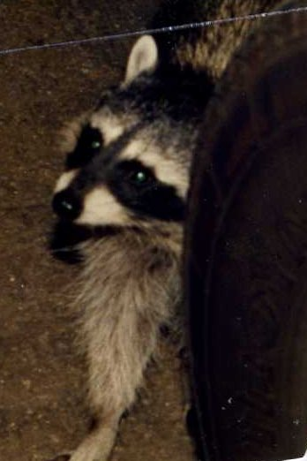 Bandit
I used to take a walk every day up the hill to the high school campus; it was quite a distance and a very steep climb. One day just as I started back down the hill, I must have stepped on a rock turning my ankle and I almost went down, as I was trying to right myself, then I started running down that hill. I could not stop, I could see myself with a broken leg or arm and all bruised up. After a distance, I finally was able to stop. I looked around to see if any one saw me; it had to have looked funny. Oh my, how my ankle did hurt and I had to walk all the way back home, it was so swollen and bruised, I put it in hot water when it should have been iced. I wasn’t able to take my walk for over a week.
Finally in March 1992 the deal on the Boise home closed. Our Aptos home went on the market on February 5th. We did it! The home in Boise was now ours; the bank still owns a part of it. We were in no hurry to move in, and Barbara was in no hurry to move out. She rented it back from us until July when she moved out. We prepared to move in on the 1st of August. Clyde had decided to move along with us as he had no one or no property to sell in California. On our many business trips to Boise he had located an apartment over in Meridian. Each trip to Boise Jack brought as many belongings as he could load in the truck and stored them in rented storage.
Another passage, we had bought a new 1992 Lincoln Town Car on one of our trips to Boise as the Chrysler was starting to give us problems. The last thing I needed was to be alone here in Boise with car trouble. It was a beautiful red, large comfortable automobile. The grandkids loved it, they called it our boat.
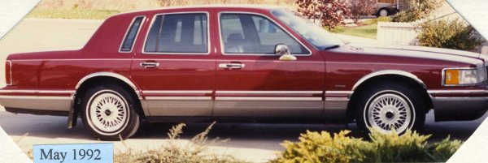Big Red
Our last guests before our move were my niece Ronda Read Cunningham, Walt and the two boys. That was June 24th and the very next day Kathryn and Richard came.
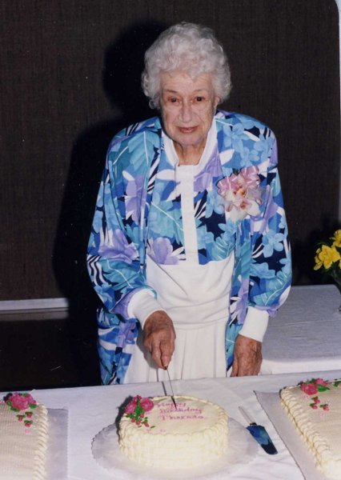Theresa's 90th birthday
June 14th our dear Theresa Sims turned 90 years old. Talk about passage! Rita and Ray Sims had asked me if I would make all the arrangements to have an open house, birthday party for her at the church. I asked her grandchildren to do the program. They furnished everything; all I had to do was help. Anyway, everything was set up beautifully in the cultural hall. Theresa didn’t think anyone would come; 60 of the ward members did come to congratulate her and show that she was well loved. Ray and Rita took us out to a nice Italian dinner in Santa Cruz after all was over and done.
We were both released from our ward callings. I was so glad to be free from my Relief Society calling in July! I had to move out of the country to get out of that miserable calling. The Sunday before our move we both had to give talks in Sacrament Meeting. After the meeting, they had refreshments ready and a farewell party in the recreation hall so we could say our good bye to our ward family. That was sad!
I went to my last oil painting class at Joan’s, and to my last “Out to Lunch Bunch”, lunch at Cez Renee. As a going away gift the ladies gave me a lovely silver-plated serving tray. All of these goodbye’s were very hard; many tears were shed. Theresa was so sad to see me leave. She said, “Now I know just how my mother felt when I moved to California”. I was sad to leave her too, but now I was going back to my own mother. Nancy Kloepfer promised me that she would take care of Theresa, and make sure she always looked nice when going to church.
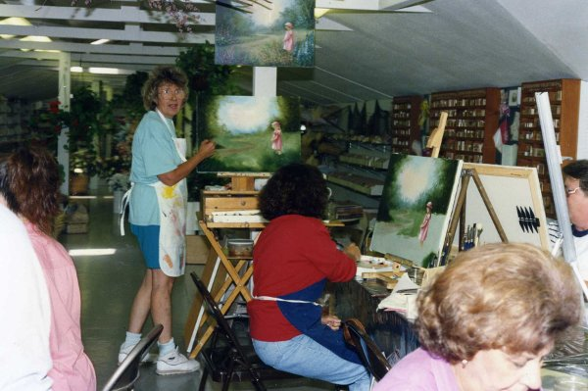My last painting class
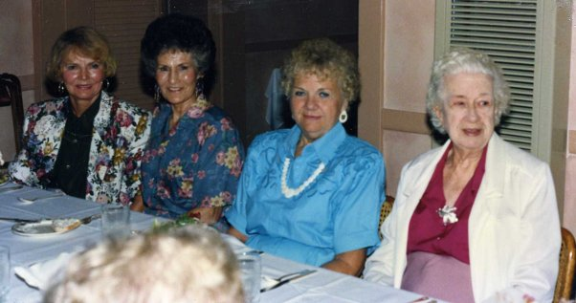The last lunch bunch get together
I did not paint after we came to Boise. I have paintings on my walls and in the closet plus the ceramics what I have left from the quake. I think my family was over gifted!
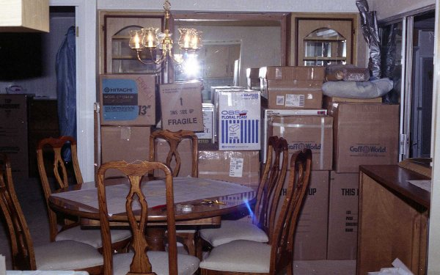All boxed up
So ends the old and the beginning of a new and exciting passage in my life! The day came for the move. We had everything packed in boxes and marked for each room where they were to belong. The moving van arrived in the middle of the week and it didn’t take long to load our belongings. They then loaded up Clyde’s. Clyde and I both left the next morning. I followed him.
The minute I got in the car, the tears started to flow! It was so hard to leave my lovely castle in beautiful Aptos by the Sea and my handsome prince, and all my friends that I was leaving behind. The tears flowed for it seemed like hundreds of miles. I didn’t understand the tears; I was going to another beautiful home. I think it was because of all the loving labor that we had put into our home there.
Clyde and I both stayed at LaPreal’s on Friday night, getting there late afternoon. Saturday morning after driving all night, Jack and the moving van drove up to 10097 W Silverking Ct. about the same time. They had already unloaded Clyde’s things in Meridian.
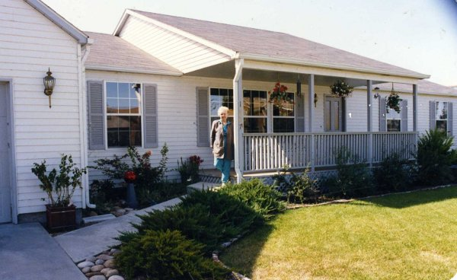10097 W Silverking Ct.
We got busy putting things in order so as to have a place to sleep that night. LaPreal helped me a lot; in fact she more or less took over. When the Relief Society President came by to help she had to ask which one of was moving in. That was a fairly easy move as we had everything marked and knew where each piece of furniture was to be placed. The grandfather clock was the only thing that had to be moved.
On a previous trip to Boise we found and went to the ward that we would belong to. On Sunday a few ward members stopped in to welcome us as they were expecting us. I think that this is where the Lord wanted us as everything fell in place; all the financing and everything that goes along with buying a new home in a far-away-land.
Well here we are at one more passage, a new state, a new town, a new home and new friends to make. A nice clean ready to move in house, all new Maytag appliances already installed, best of all we were closer to family. What more could we ask for? I always felt bad because my mother was never able to come see our new home. We are in a very nice quiet neighborhood, with great neighbors. Bob and Doris Asia lived across the street from us and near our ages, we become very close friends. Jack and Bob hit it off good as both were ex-submariners.
Our very first visitors to pass through our doors beside LaPreal and the Relief Society President were Cindee and Steve the very first day. They all loved our new home.
Businesses were close enough that we seldom had to go downtown with the post office, our State Farm Insurance Co., Albertson’s, restaurants, fast food places, a department store, beauty shop and even a liquor store (a joke). Our church is only two and one half miles away. Best of all, the Boise Temple is just two miles down the street. We could see it from our front windows, also the beautiful mountains with the lights from Bogus Basin Ski Lodge; until they developed the land between here and there. Now all we see is houses and tall buildings. In California we had to drive about fifty miles up to the Oakland Temple, it took close to two hours to drive there and two or so back, more because of the traffic than the distance. We went as often as we could. Now with a Temple so close we neglect going!
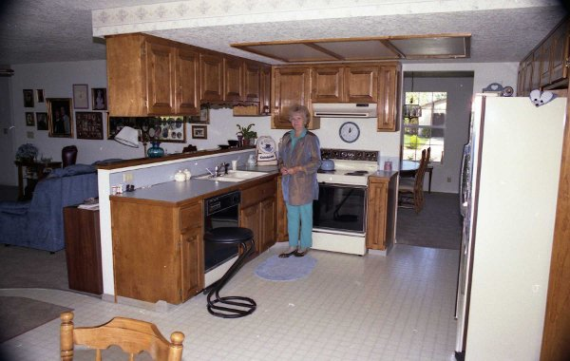My new kitchen
Now in 2010 we are in the city limits, with all kinds of businesses, stores of every kind almost in our back yard. The farm land behind us is now all homes, the cows and their flies are gone and replaced with kids and barking dogs. But that is across the creek and a whole different neighborhood. The dear neighbors across the street that we loved, were replaced by a single guy named Steve. Bob and Doris could not stand to tell us they were moving until the last minute. It was hard losing them, but we did still visit back and forth, but it was just not the same. We have new neighbors from California in the house next to us and the sweet little family next door on the west moved and we have another single guy, another Steve. We love our neighbors and neighborhoods.
Our Frost family reunion this year was much easier to get to, it was August 8th and 9th at Unity. The theme was “When We Were Kids.” We took Clyde, LaPreal and Harold, they had such a good time they wanted to be adopted into the Frost family, but that was not an option! Our family is so tight and loving they would not fit in. Turners were in charge and we had an old fashion style show that was fun and funny. We spent part of the time at our ol' swimming hole up above Turners. The kids had a blast floating down stream in the canal on tubes. Just like when we were kids! We moms had a good time chatting as we watched the kids running up and down the canal; we all had a great time. We with our guests drove back to Boise after the big event, “the raffle” and all the planned events were over. Collette won the quilt.
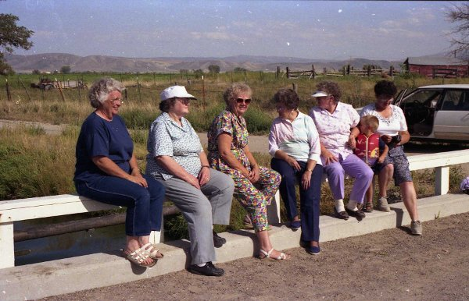Verlee, Eunice, me, Thelma, Marion, and Kathryn on the canal bridge
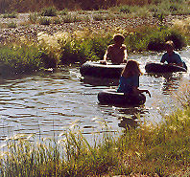Gordy, Olivia, and Loren floating the canal
After the reunion Gordon and Bonnie and children came August the 10th for a couple of days. We did a little shopping and one evening we went swimming. Gordon and I attended a session in the Boise Temple one morning. We were asked to be the witness couple. After the temple, I treated him to breakfast at Marie Calendars. In the afternoon we all up to the State Capital Building. My niece, Darla was working as a secretary for the Senate Republican Leadership at the time. She was at work, but the legislature was not in session so she gave us a tour of the Senate Chambers. In the afternoon we went to the Boise Zoo and Idaho Historical Museum. It was a very hot that day as the temperature reached one hundred and five degrees.
A couple of weeks after the reunion, August 19th, I passed from the age of 65 to 66, no big deal, no big bands or balloons, just another day of my journey, another year added on. I think I will pick an age that I like, and from now on stick to it!
Jack was only able to stay here a short time after we had gotten settled in and had got acquainted in the Boise 28th Ward. Our home in Aptos had not sold, about that time California was in bad trouble and the market went down to a standstill, and Jack had not retired. He had to go back to Aptos and live by himself and me here to live by myself. We did not enjoy that arrangement of living apart, and I did not enjoy going to church alone in a new ward, but I eventually made friends.
Jack came home on weekends when work permitted, there were a few times that I made trips back to California. I was here by myself trying to keep things going, with the help of a boy in the ward that kept the lawn mowed. He was a big help. I had trouble with the water system and had to make numerous phone calls to Jack for help. But I got along okay and had my own way in all things!
Bob and Anne Rogers drove their little ‘Blue Bird” all the way from Hayward, California to Boise to see me, as poor Jack was still in Aptos working. They came on the 28th of September and were here about one week. I took them to Idaho City where we spent a whole fun filled day. Most of the time was spent just loafing around here. They didn’t want to run all over, they loved our place and just enjoyed being here. Come Sunday I took them to “The Cathedral of the Rockies” in downtown Boise. After attending another Catholic service sure made me appreciate the Gospel that we know for the truthfulness we enjoy so much more.
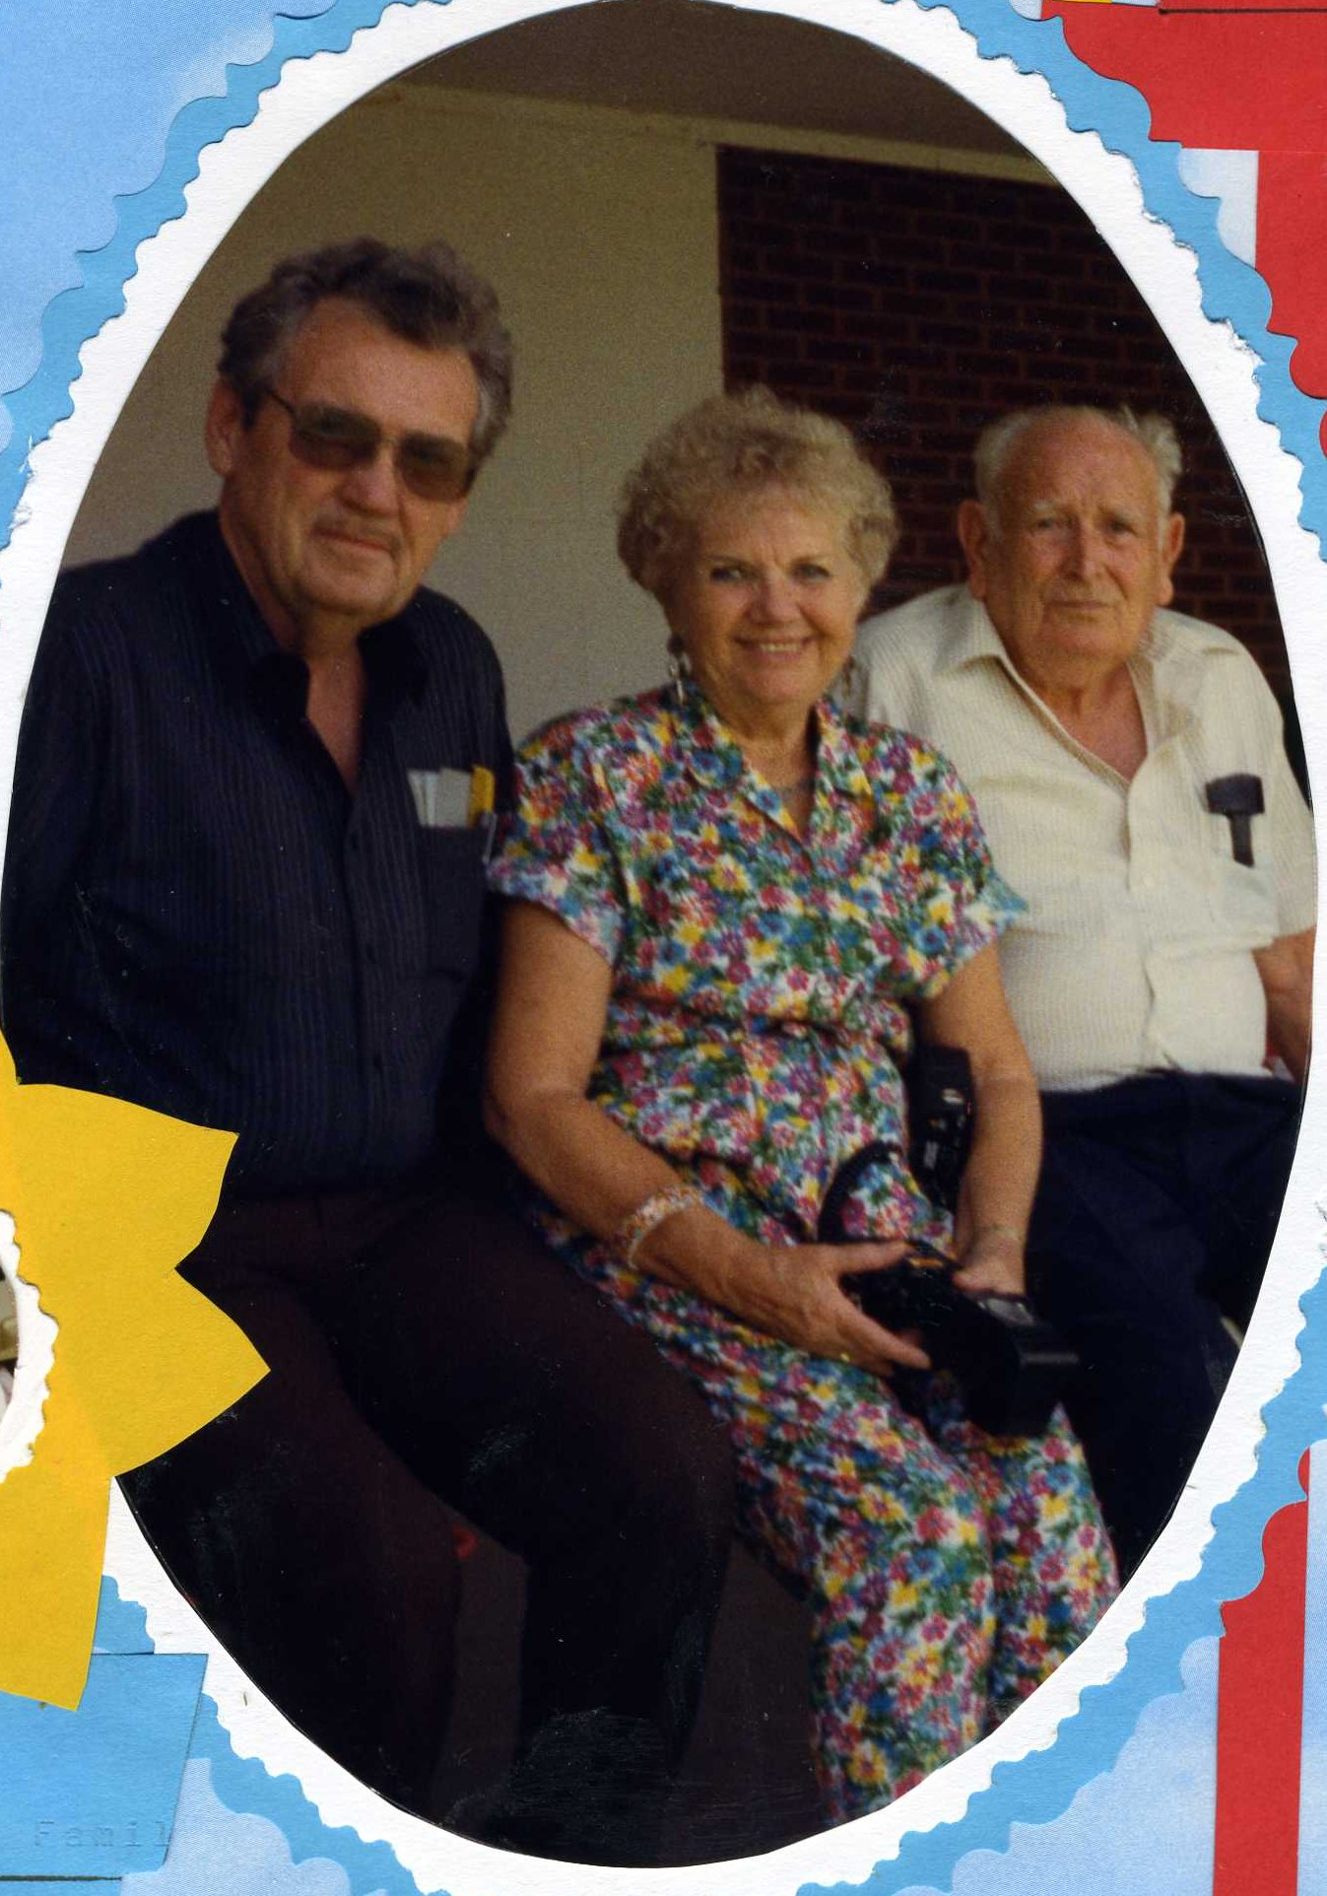Jack, me, and Clyde
The families were able to come now that there was just two and one half hours drive instead of the twelve to fourteen hours. I drove alone many times to Burley from California but now this was nothing to get in the car and go to Burley and spend time with my mother, grandchildren and other family members that I missed so much.
Our welcome mat was out and in September they came; eleven visitors throughout the month, and I really enjoyed every one that came, by the day or hour however long they stayed. Connie, Kellie and Kyle came from Heyburn, Cindee came twice from Rupert, Kathryn Goodfellow from Burley, Lorna Turner and daughter, Darla Jensen from Boise, LeAnn and Angie Turner daughter-in-laws all came on the 26th. And on the 30th Norma Jantzen from Sunnyvale California, one of my Syntex buddies, and spent the day with me. Our October guests were Irma and Don Lindsay, Gerald, Marian and Doug and the Goodfellows. My November guests, besides my children for Thanksgiving, were Thelma and Jay, Melody, Emil and his mother, Irene.
On November the 6th, election day, we finally got the first offer on our home in Aptos and at the end of December the deal closed. Jack was not yet retired and homeless! Theresa invited him to stay in one of her spare bedrooms; all that was required was to buy the groceries. So that worked out until his retirement. After living there seven years and making all kinds of improvements inside and out, we sold it for $105,000, after coming down from $128,000. What a relief after paying two house payments all those months. The greatest passage of the year.
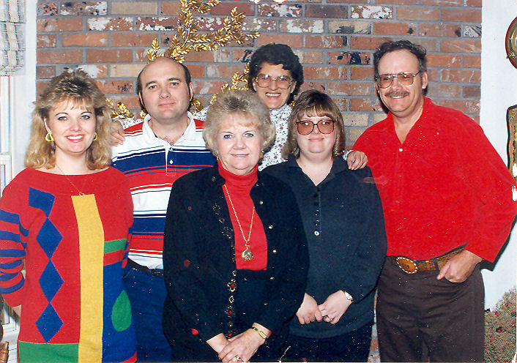Thanksgiving 1992: Connie, Gordon, me, Melody, Cindee, and Tim
Jack was able to fly home for our 14th wedding anniversary on November 25th. On Thanksgiving Day, November 26th, was the first time my children had all been together for Thanksgiving in a very long time. Clyde also joined us. Everyone was there but Michael who was away in the service of our great country. There were 20 of us for dinner, 11 adults and 9 children. The day was warm and was spent eating, visiting, and having fun. It was warm enough for the kids to play outside and get acquainted with one another. We took a lot of photos to prove that we are a family. Gordon and his family stayed for two more days. Jack left for Salt Lake the next day to fly back to Aptos and work. On the weekends that Jack was in Boise, we continued to have Clyde over for Sunday dinners.
One day when I had Relief Society visitors, one asked where Jack was living: I told her “Oh with a widow lady”. You should have seen their mouths fly open. I just let it go until they were ready to leave then I told them that she was 89 years old and blind. It was then that they were able to close their mouths. I have to have some fun once in a while.
The first snow of the year came during the last few days of November. I loved it! I was going to make a great snowman. Ya, right; the snow was nothing but powder and would not pack! Jack got his first taste of shoveling snow.
On December 4th Jack had his second back surgery, so I drove down to be with him. It must have been a scary drive for me as I hated driving in winter. He was in the hospital for two days and was released with a three weeks sick leave. We both stayed at Theresa’s until the doctors released him. After another doctors visit he gave his okay for him to travel as long as I did the driving. So after getting a late start we headed for Idaho, stopping outside of Sacramento for dinner and a short rest. The drive was okay until we encountered snow. Jack took over the driving as we were approaching the Donner Pass. We soon had to stop and have chains put on. He drove on over to Reno where we stopped for the night. The next morning, after a good nights rest which he needed, and after an even better breakfast, he had to crawl under the car to take the chains off. Not a good thing! Sure glad his doctor didn’t see that! We started back on our journey, trading off on the driving. I was so glad for us both to be home.
Jack was able to spend his 66th birthday at home. I don’t remember what gift I got him, but I did take him out to dinner.
Our Frost Christmas Party was in Burley, Gerald and Verlee hosted. It was great not having to travel so far as the previous years. We all brought assigned food and we all pitched in getting it on the table. You can be assured that we all pitched in and ate it. We have never had a bad or even a not so bad Christmas dinner. All have been better than you could get at any restaurant. We had our usual home crafted gift exchange that we worked on all year. There were a lot of photos taken and so much fun. When the Frost kids get together the house is full of love!
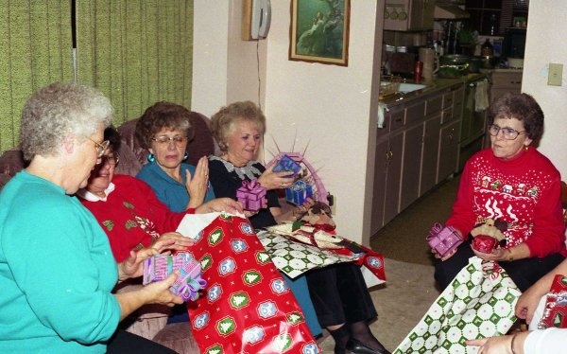1992 Christmas Party: Verlee, Kathryn, Lorna, me, and Thelma
As I sit here looking through my photo album and see all those cute faces of these grandchildren I wonder, they were just babies, then starting school, others graduating. I wonder where all those years have passed gone. This was a wonderful, happy year for us as we made our new home into our new “castle”. This place is where we hope to stay until we make the final passage into the Great White Castle in the heavens.

