Chapter 30 Our New Life
Yup, another new year has slipped in, after enjoying a great holiday season; it is time to get on with a new year and new beginnings. This is the first day of the rest of our lives. Every new day that we have, is a gift from God. We have to make each day count.
I thanked the Lord every day that we got our house in Aptos sold. I really loved it; I hoped that the new owners would love it as much. I love our new home even more.
It was great having Jack around. He healed up just fine, even though he did a lot of things that he should not have done, but you just cannot keep a good man down for very long. It hit us hard when the retirement plan his company was working on didn’t affect him. That meant longer before his retirement. So back to California and to work he went.
Clyde and I drove to McCall to see the famous ice sculptures for a day during the first part of February. We left early and were there most of the day. I could not believe what I saw, my goodness they were huge and so life like, there were hundreds of them spread all over town and out on the lake as the lake was frozen over. It was cold but we kept going, we wanted to see them all. We got a bite of food to warm us up for the journey home. I really enjoyed the day but his driving about scared me to death a few times.
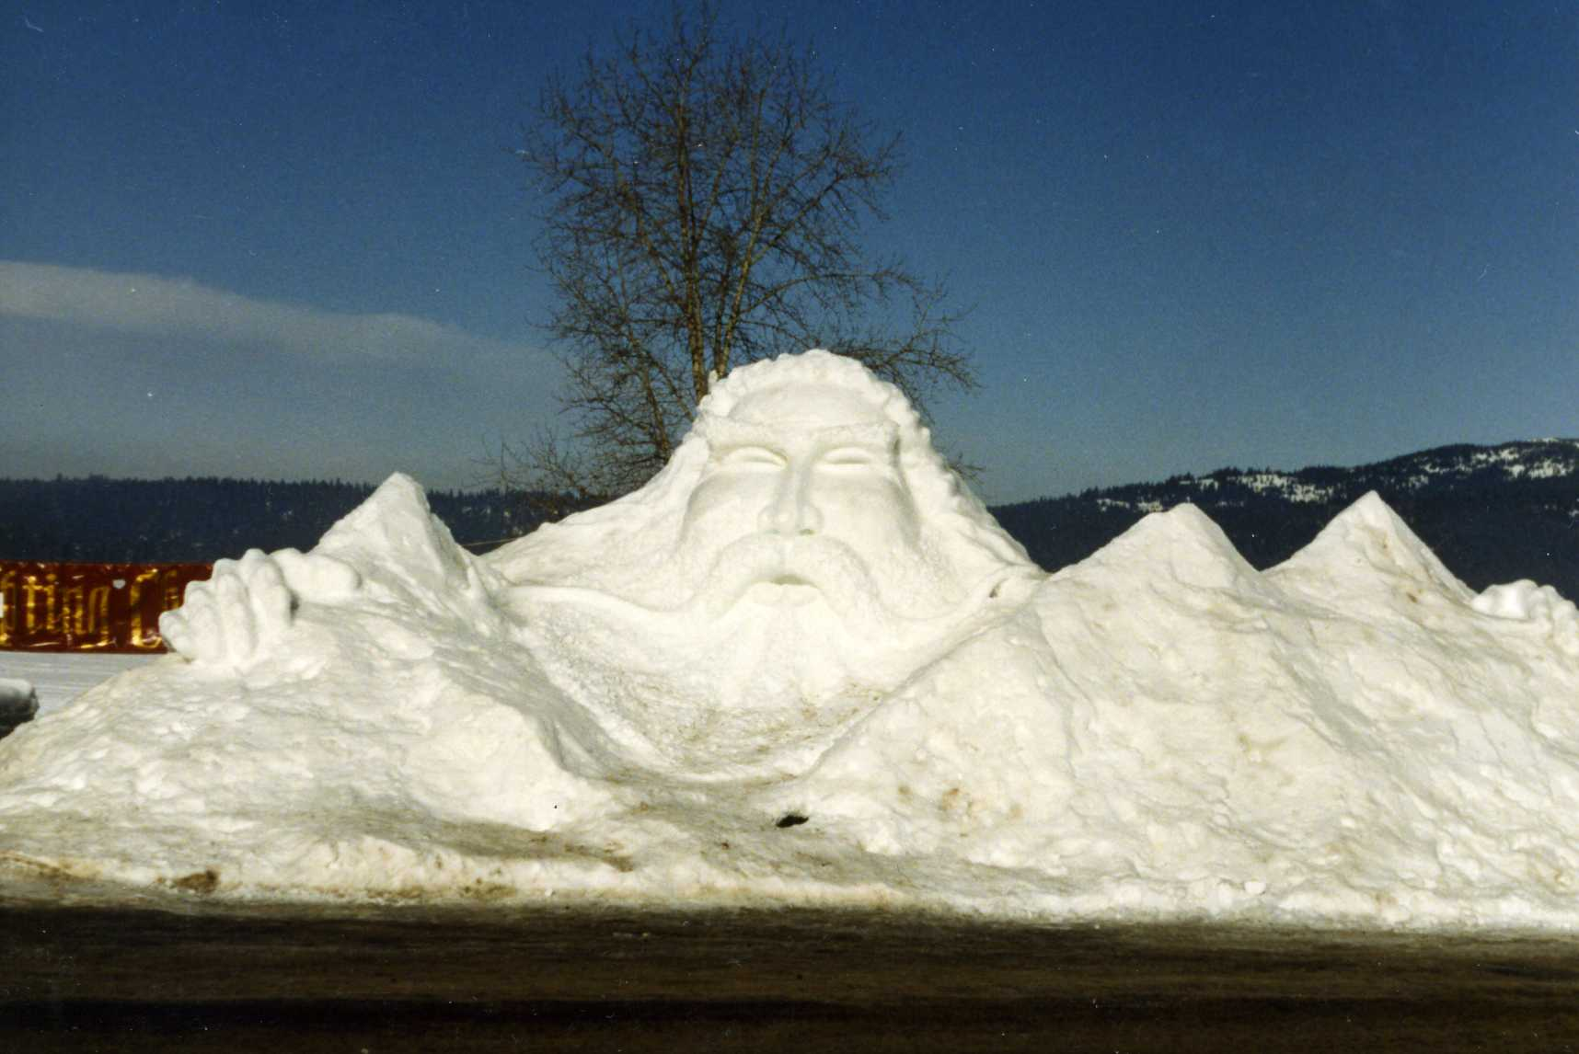One of McCall's great ice sculptures
Irma and Don were going to Arizona so I bummed a ride as far as Monroe, Utah to visit Thelma, getting there on the 11th of February. On Friday the 12th we drove down to Cedar City. Thelma surprised me by taking me to a Michael Ballam’s Valentine concert. He sang all love songs, what a wonderful voice God gave him to share. We stopped in to see Collette, as she was living there and working in the hospital. We had dinner at the Sizzler and got to the concert early, as we were walking to the entrance, we passed him and his young son as they were going to the back entrance, not realizing who they were, we just walked on by. Dumb us; we could have gotten his autograph. After the concert we drove back to Monroe, Thelma made me do all the driving, I do not care to drive someone else’s car, but being it was a Chrysler, I was okay with it. Back in Monroe we did a lot of fun things, we had our hair done; drove over to Maryville to an antique/craft store; and had lunch in a neat little place in Monroe. Thelma and I really knew how to have fun and loved each other so very much! Throw Lorna in and it is three times the fun!
We spent the weekend shopping in Richfield. There were one or two stores that I just loved. I always found something I couldn’t live without. On Sunday we all went to church. On Monday we were on the road again, on our way to St. George to meet Lorna. As we were staying three days we were able to get a room in the club house, which was very nice and convenient. Lorna took us sightseeing around the St. George area and on Tuesday we attended a session at the St George temple. We gals shopped in the afternoon. The next day Kenneth showed us some huge mansions and drove over to Leeds and Silver Reef. Later in the day, Thelma and I drove back to Monroe.
On Friday we went to the Manti temple and did a session there. We ate lunch in the temple and got lost on the way home and had to back track. On Sunday we went to church and Jay got sick. He was taken to the hospital by ambulance and was kept overnight. He had had two mini strokes, but was okay. After twelve fun filled days Lindsay’s got back about 11:45 a.m.. Don took us all to lunch in Monroe and at about 1: 00 p.m. we got in Salt Lake just in time to go to Ronda’s baby, Matthew's 1st birthday party. I stayed overnight with Eunice. Lindsay’s came after me about 9: 00 a.m. and we got in Burley about 3:00 p.m. We had very bad weather getting over the mountains. Even though I was anxious to get to Boise, I stayed over one more night so that Cindee could go back with me.
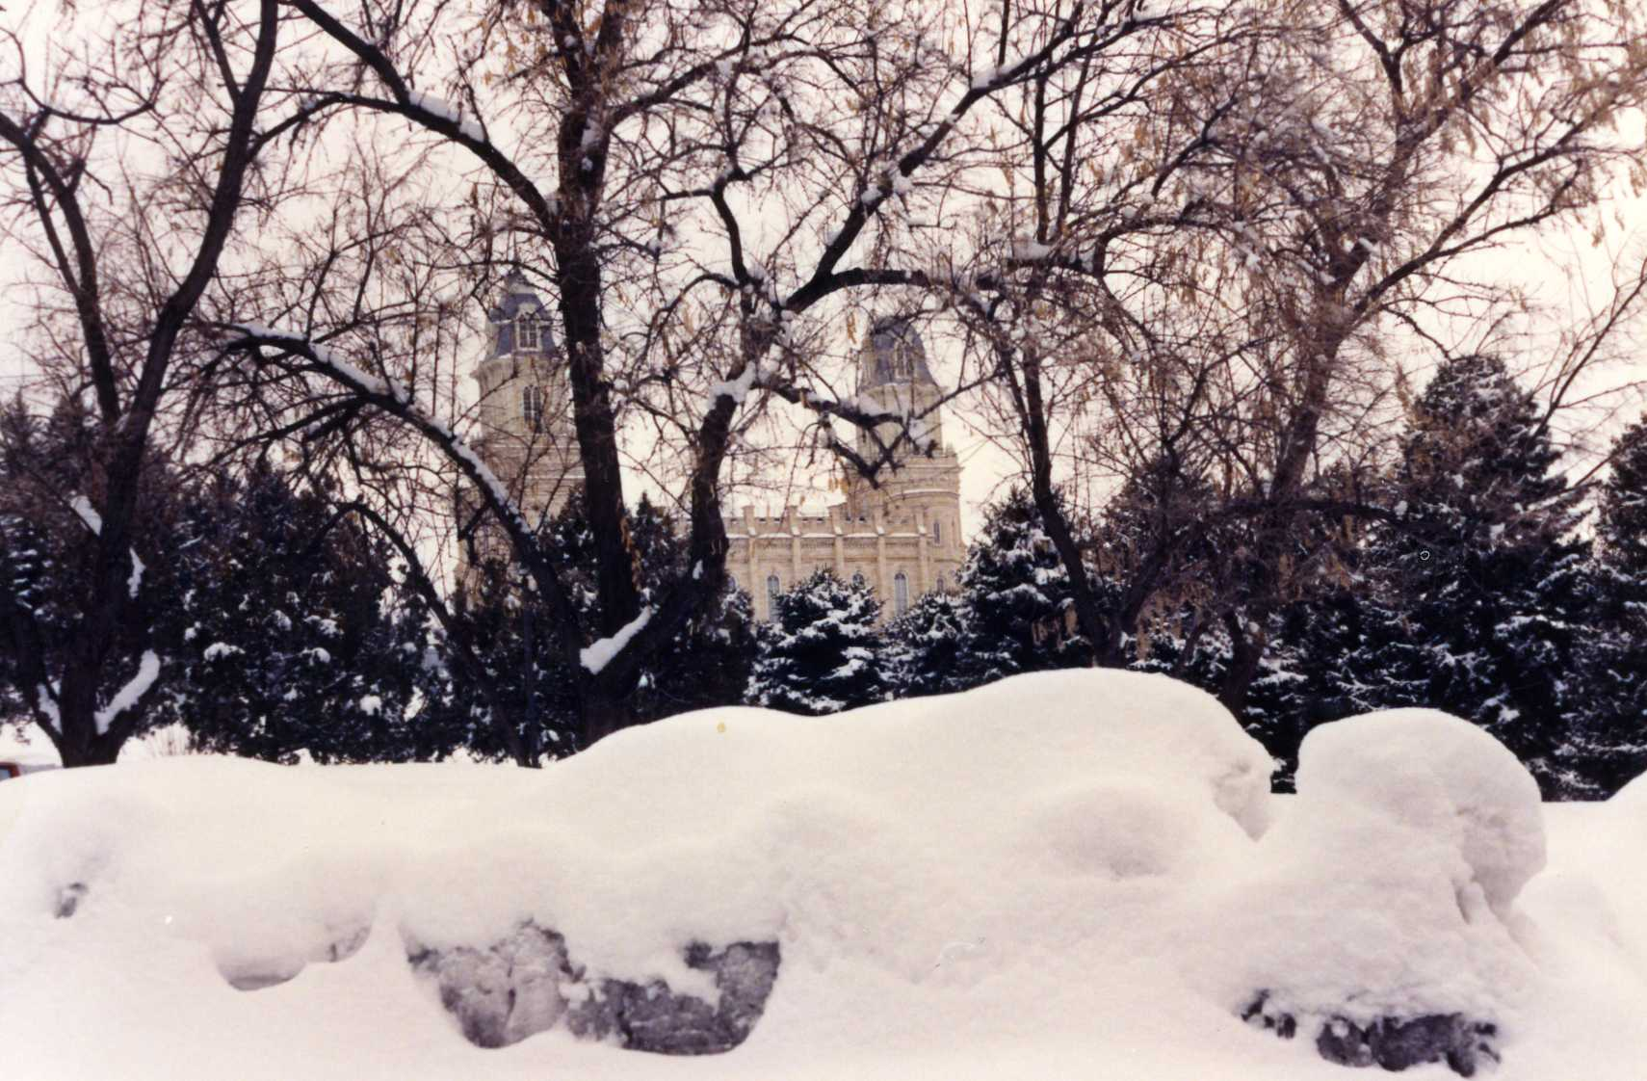The Manti Temple in February snow
A round the middle of March I went to Burley to do some dry pack canning for our food storage. I stayed over until Saturday so I could bring Kellie and Kyle back with me as they were out of school for spring vacation. We returned just two hours before Jack got home. For good this time! Not so fast, he is just back to see what PG&E is going to do with the retirement or whatever. We had a great greeting party.
The kids had fun doing crafts and playing games. We took them back on Friday. The whole idea was to give Connie a much needed rest from them and them from her. She got the flu and was in bed the whole time they were gone. Some vacation. We went to see Mother, she had been having memory problems at times; she knew Jack the minute he walked in the door. She seemed to be in a pretty good spirits. We had her really laughing. I hadn’t seen her laugh like that in a long time.
In April, I bought 7 tickets for the “Ice Capades”. Connie, Kellie and Kyle plus Cindee all came to Boise and we went together. We all really enjoyed the beautiful ice skating, the costumes were so colorful and there was a lot of comic skating, even Jack enjoyed the show.
Jack did go back to work, we were disappointed that things at PG&E did not go to our advantage, but we have to do what we have to do.
On June 3rd I arrived at Gayle’s in Salt Lake at 9:30 a.m.. I must of left Burley very early, or drove like a bat out of hell. Thelma took me to see the Cathedral of the Madelin that I wanted to see. We hurried over to the Jordan River temple where Raydon was to receive her endowment as she was going through for her marriage. We picked Jack up at the airport, went to the hospital to see Jaylynn, then we got something to eat on the way. Thelma and Jay went to Gayle’s to sleep and I and Jack went to a motel.
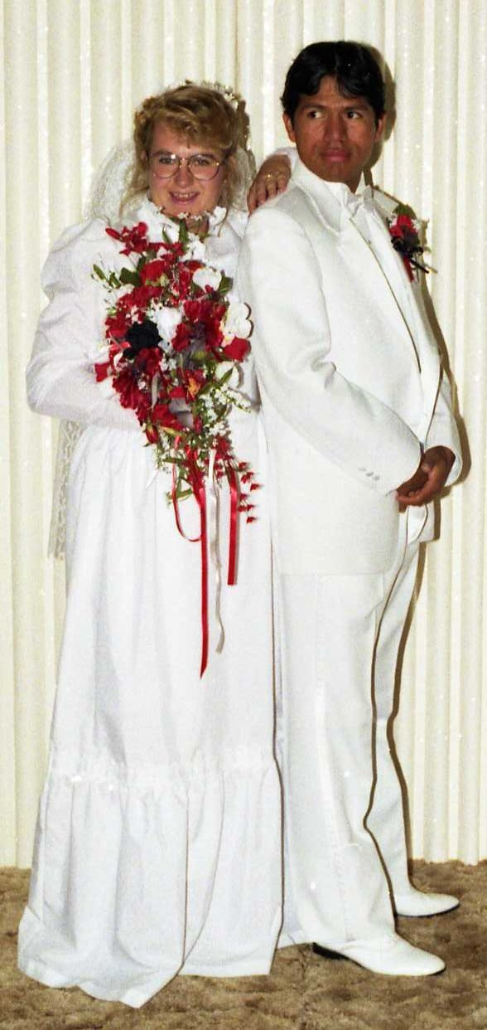Raydon and Coby
Friday, June 4th, was a special day in Raydon’s life as she was marring her sweetheart Coby Cardenas for time and eternity (they thought). Although they were very young and right out of high school; she was the first of our grandchildren to take the step. They had a nice wedding in the Salt Lake Temple. We took lots of pictures of the lovely bride and groom and families.
Later in the evening, they had a reception held at the Heritage Ward at 71115 S 3200 W in West Jordon. After the reception, about 9:00 p.m. we followed Thelma, Jay and Jaylynn back to Monroe. (Raydon and Coby made their home in Salt Lake). On Saturday, Jay and Jack worked on Jay’s riding lawn mower. Jack mowed the lawn while Jay fixed other things. Thelma and I just goofed off enjoying each other. On Sunday we all went to church and later drove around Richfield looking for a place to get some ice cream cones. We ended up buying stuff to make banana Splits at home. That was better anyway. Renee came over and we all had a great time eating yummy banana splits, visiting and laughing, what a good way to end the sabbath day before we left for home the next day.
Retirement finally came June 30, 1993. Jack was going to come home after living apart for ten months, things would be normal again. My sweet neighbor Doris told me, “You have had your way, way too long. You have to change”. Boy was she right! I had to start cooking again. When you live alone you do what you want when you want. One morning at 9:30 the door bell rang and I wasn’t going to answer it because I was still in my robe but finally did. There was Bob from across the street with one on Doris’s hot off the grill big waffles. Boy was I glad I didn’t leave him standing there. I was hungry and it was so yummy!
I flew to California the last week in June. I landed at 8:33 a.m. in San Jose and was in the dentist chair by 9:15 in Sunnyvale. Jack did not go to work until the afternoon, and the morning of his last two days at PG&E, which was on the 30th. We got our teeth all taken care by our long time dentist, Dr. Call. I had two caps and Jack had one cap and a filling. It cost us $2099.00. We made it in time for Jack’s work insurance to cover all but 20 percent. We also had physicals prior to his retirement so as to be covered.
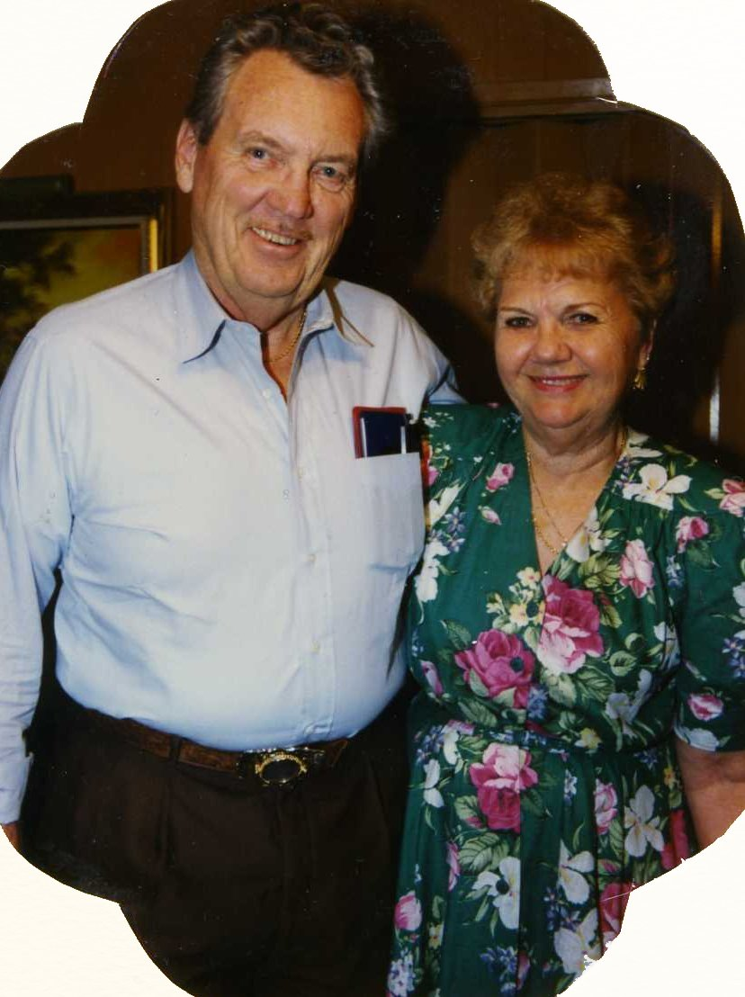Me and Jack at the Brown's home
I had a real good time while I was in Aptos, (we stayed at Theresa’s). We got in on a High Priest dinner and program. We visited with and had dinner with Anne and Bob in Hayward, and Jackie and John in San Jose. We spent an evening as guests of our friends Norma and Myron Brown. I went to swim aerobics with the gals from the park and got my hair done by Val. We went to church in both wards there that we had attended, so we got to see everyone that we hoped to see, except for Amy.
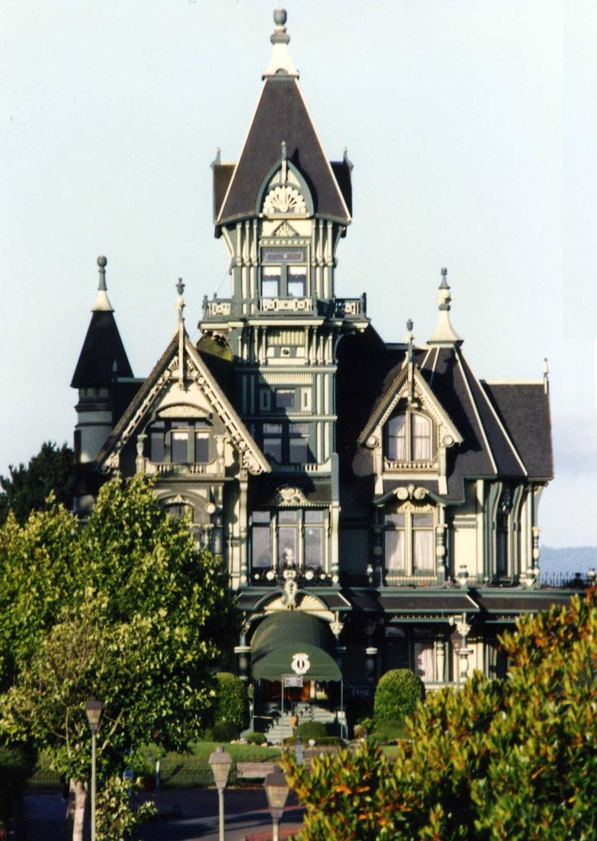Victorian home in Eureka, Ca.
On the morning of July 1st we left Aptos and Theresa, and headed north up through the Redwoods, staying in Eureka that night. After dinner we went on a photography tour of the wonderful old Victorian houses. The next morning we drove over to Willow Creek to see Jean and Elic Matson for their 50th Wedding Anniversary, later they took us out for a Mexican dinner. That night we ended up in a motel in Grants Pass, Oregon.
On the morning of the 3rd we were headed for Crater Lake. After a little time and taking some lovely photos, we headed on across Oregon on the upper route which proved to be a beautiful trip through the mountains instead of across the dessert and farm lands. We arrived home at 12:20 a.m. on the 4th.
We had the best 4th of July in many many years. Connie and the kids came and we cooked out and after dark and they shot off the fireworks that they brought. We were just like kids again; we did the same thing on Monday night.
Jack was so darn glad to be home that he didn’t want to go anyplace for a long time. We were so happy to be together again. We balance each other so well in our interests and our abilities. We both enjoy the same hobbies; photography has been a big part of our lives along with travel and dancing. We are both artistic and the scary part is we think alike; so many times we come up with the same idea at the very same time. Wouldn’t you call that scary?
A few words about my man, Jack. He can do anything and everything. With his great big hands he can fix a ten ton whatever and also fix the smallest piece of jewelry. Everything he builds or fixes has to be perfect and always is. He is in great demand in every neighborhood that we have lived in to fix broken furniture or anything else. He comes up with easy ways to do most jobs. He has cut out hundreds and hundreds of wooden projects that the Relief Society comes up with for their homemaking crafts. What would you say about my man?
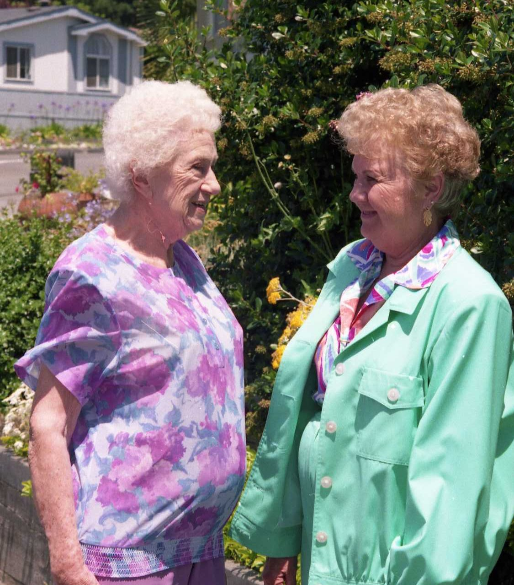Visiting with Theresa
After retirement, our income was cut to a minimum. We were not able to travel as we had hoped. And we didn’t get to dance any more. But what the heck! At our ages, it is about all we can do to get out of bed in the mornings. Actuality we both have been blessed with very good health and had no problem getting out of bed and getting the house and yard beautified.
We did not socialize with any of the ward members, except for at church; not like we did in all the California wards that we attended. I was asked to be Secretary of the Sunday School. That sounded like an ideal calling for me, it gave me the chance to find out who was who and to fit families together. I had monthly meetings with the Sunday School Presidency. Noel Janko, a converted Jew, was the President. He had a wonderful testimony. They soon caught up to Jack and gave him the 12 year olds in Sunday School. He loved teaching them and they loved him. He held that calling for many years.
My 2nd cousins, Glen and Ada Owens found us; and took us in. We did a lot of things together. Mostly going to musicals. Boise has a lot of entertainment going on all the time. They would get 4 tickets, invite us and we did the driving. We also ate out often. We soon were invited to all their family dinners and Christmas parties. We had to tell them “hey, we are not Owens.”
It was our turn to host the family reunion. We rented a patio at Salmon Park by the swimming pool in Burley. We had a stuffed pet show, with prizes. There was a short program and a Grandma Frost look-a-like Contest. Irma won. Of course there was swimming most of the afternoon. The high light is always the raffle, everyone hoping for their treasure. The wiener roast, boating and water skiing at Turners in the evening for the entire water enthusiast. The great sleepover with beds and tents everywhere. It all turned out very well.
We had a lot of family members come through the year. Our favorite places to take them was The Discovery Center for the children. They were able to interact with all the different displays and always had a great time there. It was fun to take the adults to the Anniversary Inn where each room was designed in a different theme. Idaho City was a great place for a day trip. The Capital Building was always interesting. A stroll through Kathryn Albertson Park was a must. Visiting the Old Prison was always exciting. And our patio and backyard was a great place to play, relax and BBQ. The welcome mat was always out.
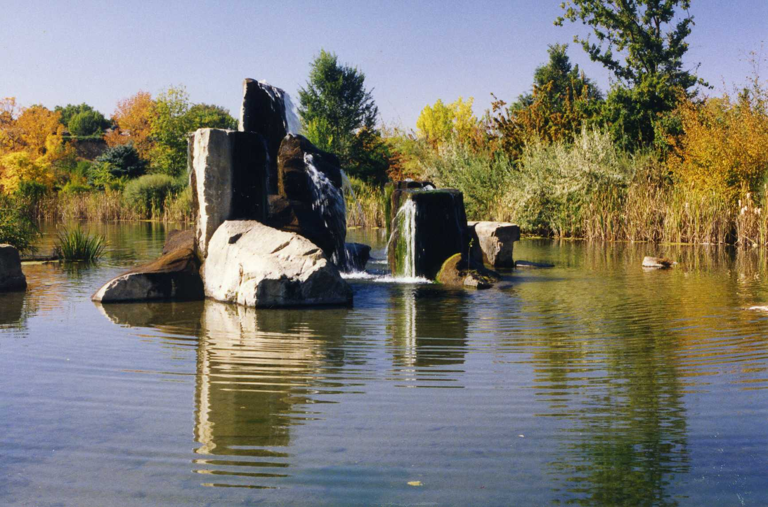Beautiful Kathryn Albertson Park
Gordon and Bonnie and the kids came over for conference weekend. They arrived Friday evening. After watching the morning session of conference, I took them to Kathryn Albertson Park. In the evening Jack, Gordon, and Gordy went to the Priesthood Session. On Sunday we watched conference again and in the evening we went over to Glen and Ada's. Glen had all kinds of things that kept the kids entertained. On Monday most of the places I wanted to take them had closed for the season. We ended up looking around the Temple grounds, going to the State Capitol, and Fish and Game nature Park.
Then at the end of October we made a trip to Rexburg for Gordy's 14th Birthday on the 30th. That year Halloween was so Saturday was the when all of the trick-or-treaters were out. Halloween there was much different than we experienced in Aptos. It was fun seeing how the children dressed up and the strange little creatures that came to their door. I think Halloween was their favorite day. Then on Sunday, Gordy was ordained a Teacher in the Aaronic Priesthood.
As fall passed into winter, I really enjoyed the beautiful fall colors and winter wonderland that followed.
We were the host for our Frost Christmas dinner and party. Everyone came except for Mother. I don’t know how we did it but we got everyone in the dining room and around the table. We fixed swiss stakes and the trimmings. Our gift exchange was exciting by the looks on Lorna’s face in one of the photos. As usual, we had such a good time; we Frost kids filled our house with love! Some of them left right away; while as many as we were able to provide beds for stayed, Goodfellows got a motel. We fixed breakfast for all that stayed and had a fun time shopping, and we acted like a bunch of silly kids. I had both Christmas trees up and dressed along with the rest of the house, it is funny we had room for the guests.
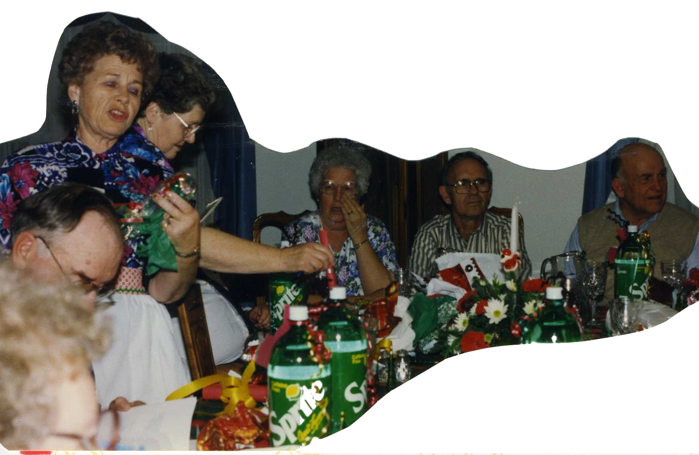Frost Christmas Party at our home
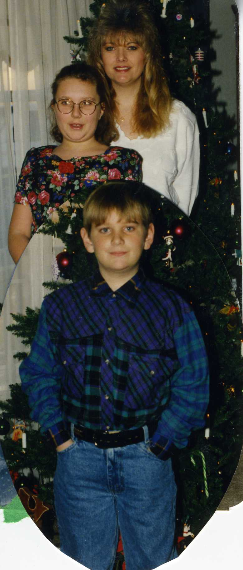Connie, Kellie & Kyle
Connie, Kellie and Kyle spent Christmas with us. It was the first time I was able to have a real Christmas since I left Burley. It was so fun having Santa Clause actually come to our house; and to see the excitement of the children on Christmas morning. The true Spirit of Christmas filled our house.
On December the 29th, we drove over to Gooding to spend time with Melody and Emil. We got to meet Little Melody and her dad, plus little Thomas, Emily’s children for the first time.
So my story comes to a close for 1993. I think it was a very good year with many new experiences in our Idaho life. RNULIFE was our license plate number indicating our life changes.

