Chapter 32 Once Upon a Time
I thought those were wonderful words as I continue my journey though life. “Once upon a time” promises a story of adventure and romance; an ongoing story of a princess and a knight. It may include tales of courage, hope and everlasting love. But perhaps most of all, I hope when you turn to the final line and your eyes see the enchanting words “And they lived happily ever after”.
We had a nice New Years dinner that included Clyde to start out a bright hopeful New Year, 1995. On the 17th we had a late Birthday dinner for Tim.
Losing my dear mother so recently, I reflect on how grateful I am that God choose to give me to her. I reflect on her love for each one of her children. She always put us first, no matter what. I remember the teachings she taught us, that we are daughters of the Living God. She taught me honesty, to cook and sew, to work and to play. I think of her every day of my life.
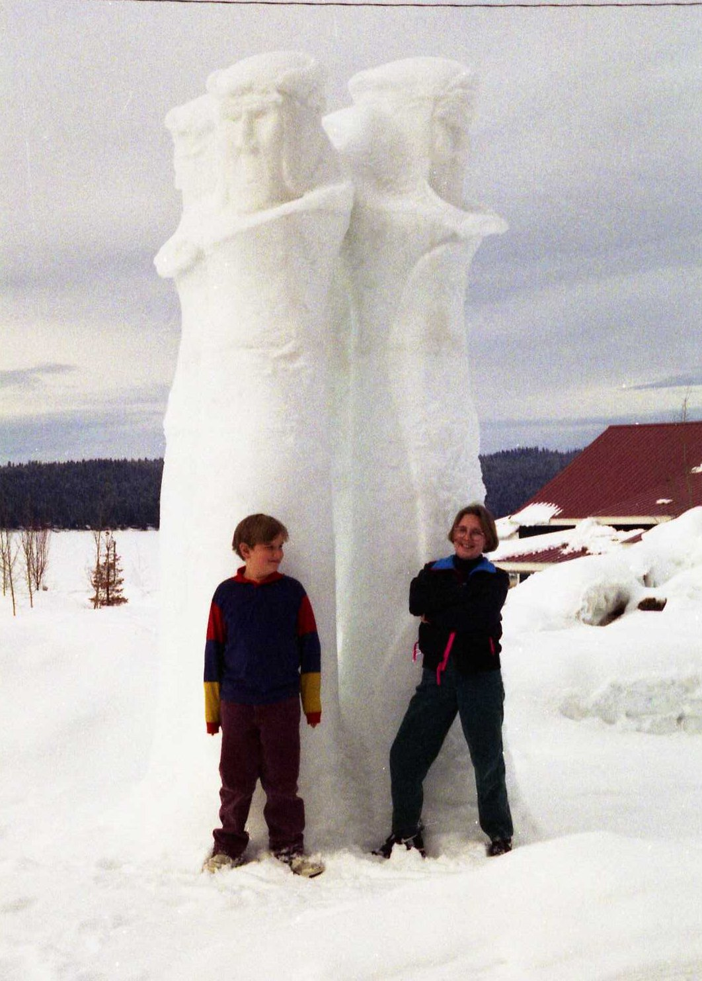Kyle and Kellie with one of the ice sculptures
Connie, Kellie & Kyle I went to the McCall Ice Sculptures. This was my third year. Each year is like going for the first time. It is “enchanting” to see all those beautiful snow white giants looming in the sunshine. We certainly did enjoy our day there. That was the last time that I went.
While we were in the Bishops office for tithing settlement at the end of the last year, the bishop asked if we would consider going on a mission. That was the farthest thing from my mind. The thought of knocking on doors and all that goes along with missionary work frightened me to death. We were not in a financial situation to support a mission. The only thing I could come up with was, “Well maybe one where we could live at home”. I was thinking of a service mission. Bishop Holderness wasted no time! On January 22, 1995 we were both set apart as Stake Missionaries. Not the service mission I had in mind. This took great courage for me!
We have had numerous callings in all the wards that we have lived in. My first calling in the 28th Ward was Sunday School Secretary shortly after moving here. I really enjoyed that position as it gave me the opportunity to learn the member’s names and put families together. I hated giving that calling up to become a stake missionary, but we do what we have to do.
There wasn’t too much knocking on doors, but a sprinkle of it. But it did include a lot of meetings. A stake meeting every Sunday afternoon was the one we were expected to attend! When Clyde heard that, he was not one bit happy. There went his free Sunday dinners. At our first meeting we met all the other stake missionaries from the various wards and the stake mission presidency that we would be working under. It took a lot of faith and prayer for me to get through the next two years.
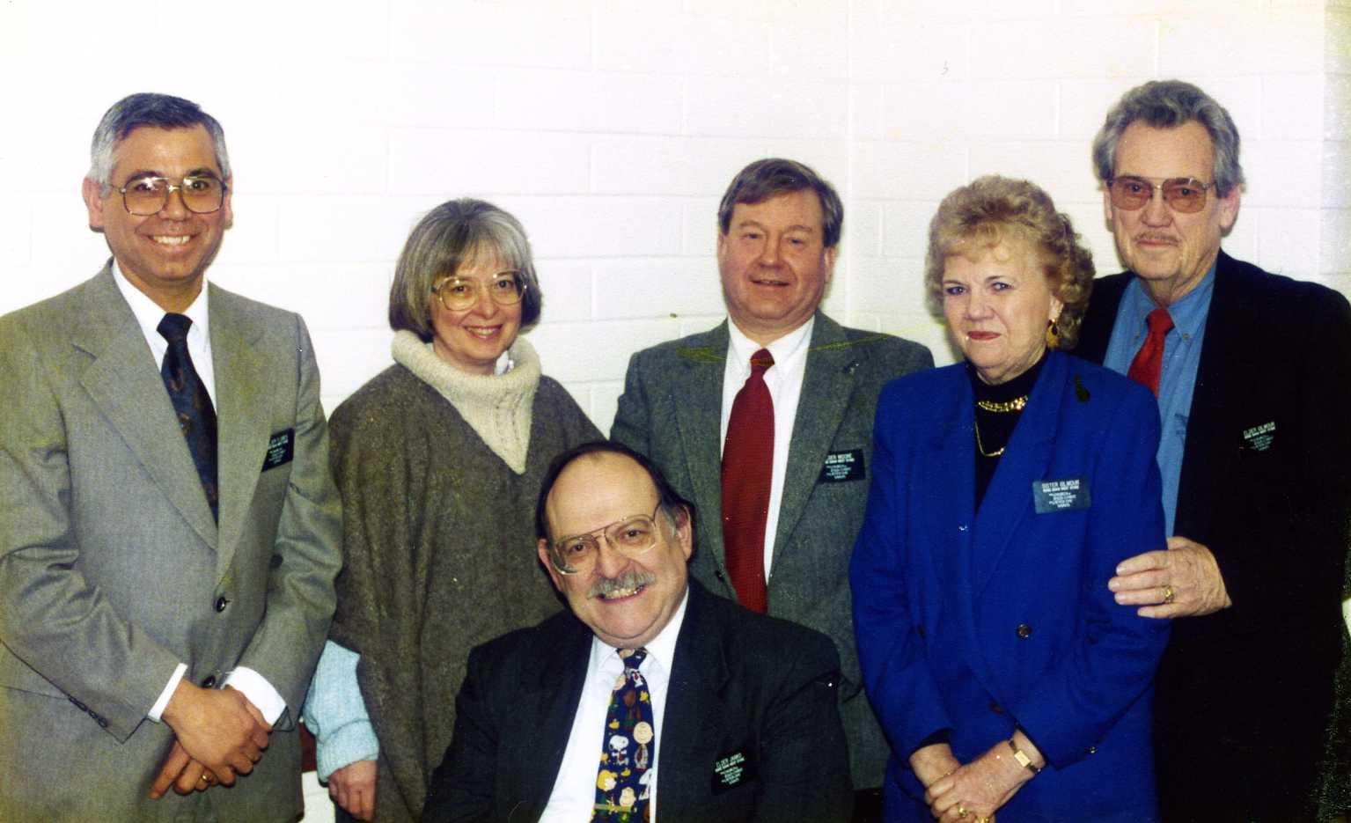Andy Flores, the Moores, us, and seated Noel Janko
We worked with some wonderful people, especially co-missionaries, the Moore’s, Clark and Diann and Andy and Peggy Flores, and Grace and Noel Janko from our ward. I mentioned Noel in another chapter as the Jewish convert.
We loved working with the young elders; we feed them a lot of dinners which included Clyde. They were so young, spiritually enthusiastic and fun to be with. Jack took them to most of their meetings and appointments. We helped them out with followup investigators. It was such a thrill when we had baptisms. We held a lot of missionary meetings in our home plus some dinners and parties. At Christmas time both years I made giant Christmas stockings for each of the Elders and had the Relief Society sisters help fill them. On Christmas Day we had them over for dinner and gave them their stockings. That was so much fun; they acted just like little kids on Christmas morning. We loved all of our Elders and as they filled their missions and returned home and married, we got invitations to their weddings. It was a great time in my life, I did grow spiritually and my testimony was strengthened, but I feel that I could have done more.
Our grandson, Mark Dudley at the age of 15 came down with a very rare condition called “Guillian Bairre Syndrome”. It came on him all of a sudden one Sunday evening around the first of April. His legs were paralyzed and he could not stand. As he lay on the floor his dad thought he was acting up, but soon found it was very serious and gave him a priesthood blessing. He was taken to the emergency room and from there rushed to the hospital in Twin Falls. This Syndrome paralyzes the whole body very quickly and mostly the lungs. If not put on a respirator very soon it will kill the patient. Mark was very blessed, as the first Doctor he saw had seen it once before and recognized it. He acted upon it very quickly that saved Mark's life. I drove to Twin Falls to see him one day. It took him a very long time to recover.
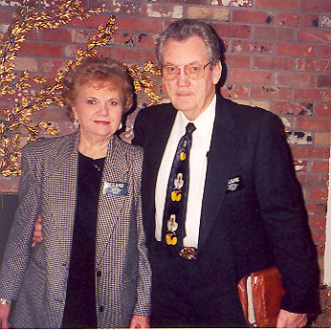Jack and I as stake Missionaries
Kellie and Kyle came and stayed during Spring Break, Cindee also came about that time. Even though we were missionaries we made time for family and friends. And we did have a lot of company. My guest book is full, a big share is related to our missionary work, feeding the young Elders and holding meetings here. We also had a lot of family members come during that time period. It seemed to be our missionary work was slow but did move forward. The fulltime missionaries had just started teaching a new family. We only had two full time missionaries for the Stake that covered six wards but with all the new housing that was being built in our area we got new members and even converts.
In August we met Connie and the kids at a junction just before Hailey and followed them to the Uriguen’s summer home in Ketchum. Connie was dating Frank Uriguen at time. Since his mother’s death, and Frank and Connie’s subsequent marriage, they own the house but as of 2011 we have never been invited back. We stayed there for three days and three nights. The home was so lovely. What a great vacation that turned out to be; just loafing and sightseeing and having fun with Connie and the children, running around Ketchum, Sun Valley and Hailey with all the wealthy people was exciting.
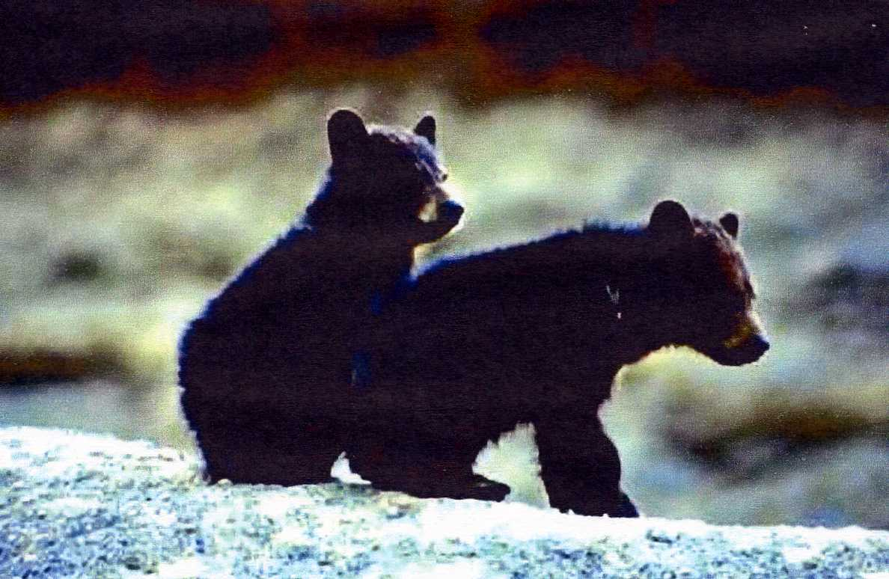
We were surprised to see Roger, LeeAnn, Brad and Raquel Turner peeking in a store window at us. They knew we were there but we didn’t know they were. What fun. All good things seem to never last long enough, it was so beautiful there. We took the mountain route going home, it too was very beautiful and our bonus was seeing a cub bear in the middle of the road. In all of our mountain travels through the years, it was the first time we saw a bear in the wild outside of Yellowstone Park.
It seemed like we didn’t stay home long enough to get very much missionary work done. Our Mission Leader was beside himself. He worked so hard to motivate us. We were to have a training meeting in our home the night we returned but found out there was a Stake training meeting so that got us off the hook.
One Sunday a young lady came to church by mistake. Boy did we jump on her! A young man friend of hers told her she should visit the Mormon Church, but she got the wrong building. She was really friendshipped and in the Gospel Principles class she asked all kinds of questions. Luckily the Elders were in our ward that day and they took over. “Golden?” Yes! Julie was a delightful young lady and stayed in our ward until after her baptism. We taught her the last new member discussion. We missed her after she started going to her own ward. She married the young man in the temple and she has kept in touch with us for many years.
Lynette was another delightful young lady, divorced with a small daughter, that we were able to teach the discussions too. She was baptized and later we were able to go to the temple with her and see her sealed to a young divorced man and see their two young daughters sealed to them. What a sweet experience seeing those two adorable little girls become sisters.
Well there we went again, this time to Rexburg for Loren’s baptism on July 1st. We stayed a few days and enjoyed touring the Ricks College Campus and the beautiful campus gardens. Melynda was going to school there worked in the greenhouse and planted a lot of the flowers. The way I love flowers, it was so fun seeing all the different blooms that I didn’t have. We stayed through the Fourth of July and went to the parade with them. Later we had a picnic in the park and that evening watched the fireworks at the fairgrounds.
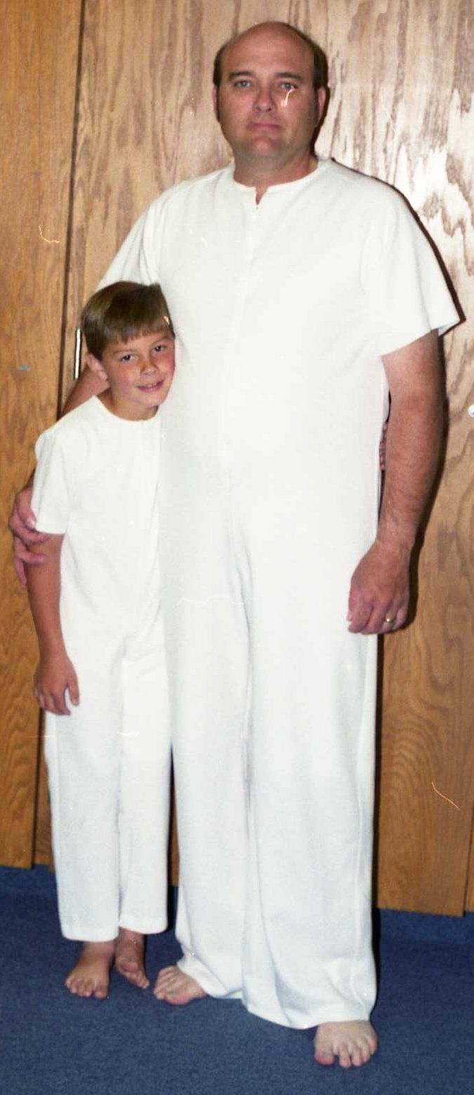Loren's baptism
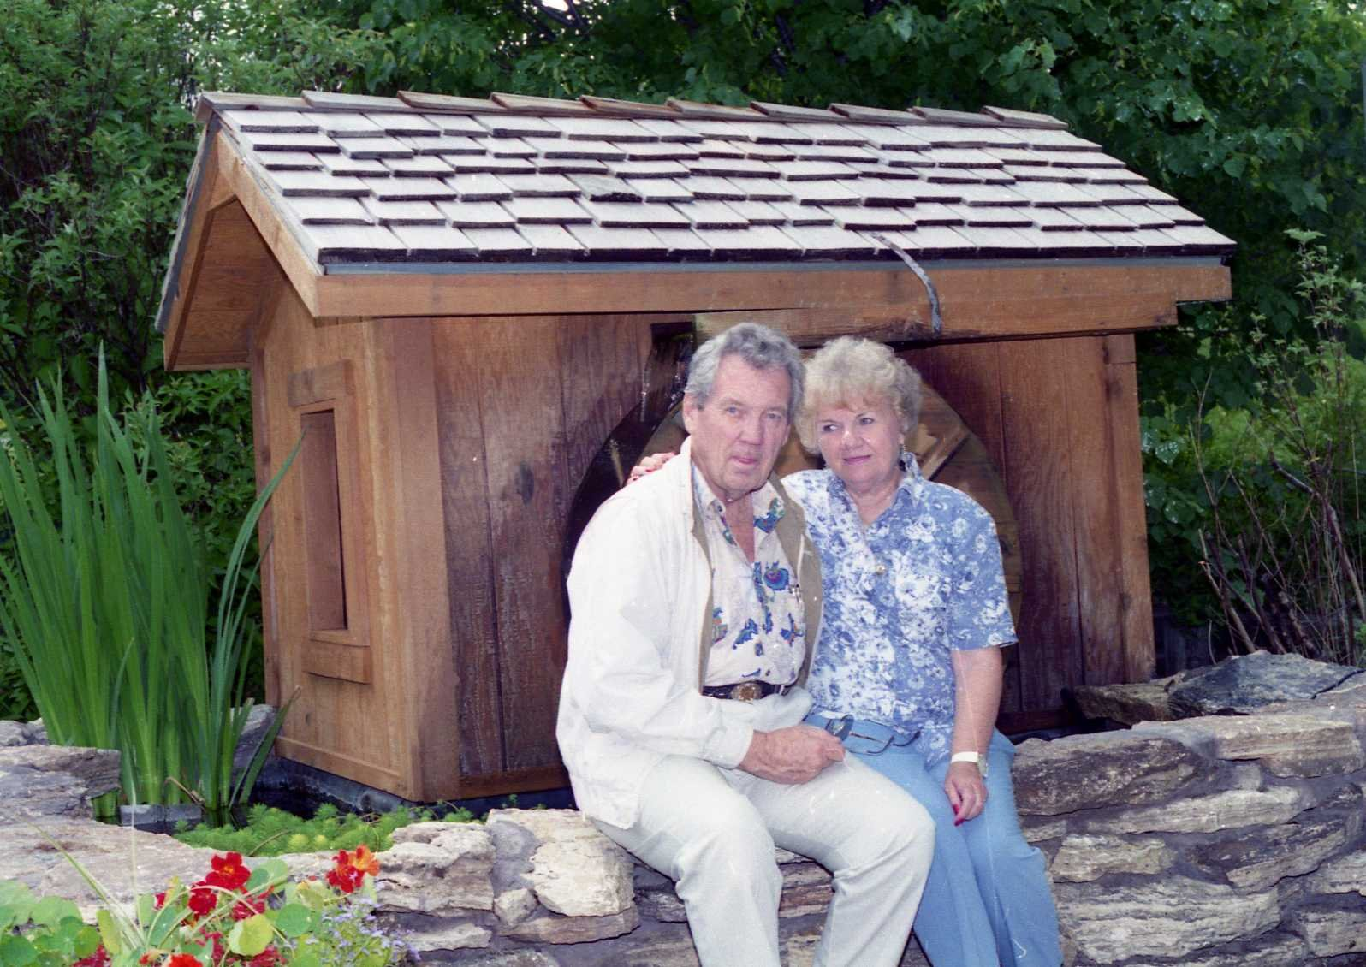Ricks College Gardens
I went to Salt Lake with Connie and the children. Connie had a lot of fun things planned. Lagoon, The zoo, the Heber Creeper, Sun Dance Resort in Provo Canyon, etc, We stayed in a motel, which was fun for the kids. Another three fun filled days and then back to Burley for the Frost Family Reunion that was held August the 5th. Turners were in charge, I don’t have any other information or newsletters from that year. But knowing the Turner’s it had to be a good one. Of course we had to stay and take in the Cassia County Fair and Rodeo before returning home. I was told that on a Stake Mission you have too many distractions. How True!
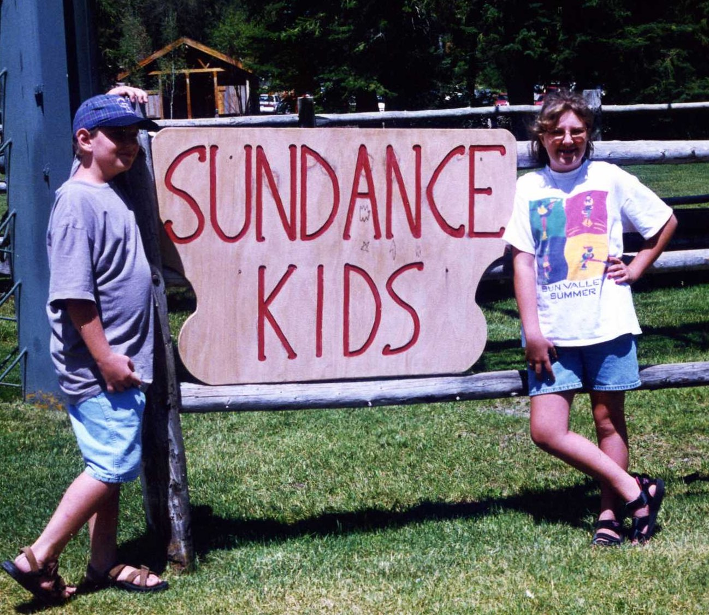Kyle and Kellie: Sundance Kids
We were very happy when Michael got out of the service the end of the month. He had served in Kuwait during Desert Storm in the Prussian Gulf War .
Oh my Gosh! I almost forgot to tell you that we are going to be great-grandparents. Raydon and Colby were expecting after two years of marriage. I thought they were too young, too immature and too selfish to be parents and I was right.
Emil’s daughters did not treat Melody and Emil like parents. Adelma had three or four children, and Emily had Thomas and Melody, Melody was killed in an automobile accident along with one of her children. We never got to know any of them, except for Thomas. So it was hard to claim them as grandchildren but we claim Thomas.
Okay, so our missionary work got a little slow, no co-operation from the ward. So we started working on our neighbors across the street, the Asins, (only they didn’t know about it). We took them to a Relief Society dinner at church and they were really made to feel welcome. We had the Elders over for a barbecue and asked Doris and Bob over, telling them the Elders would be there. The Elders gave them a copy of The Book of Mormon. We got tickets for a stage musical at the Boise State University Special Events Center put on by the Boise LDS Institute. If I remember right, the performance was “Joshua”, any way we all enjoyed it very much. We have had them over for dinners and barbecues, and they like wise have had us over.
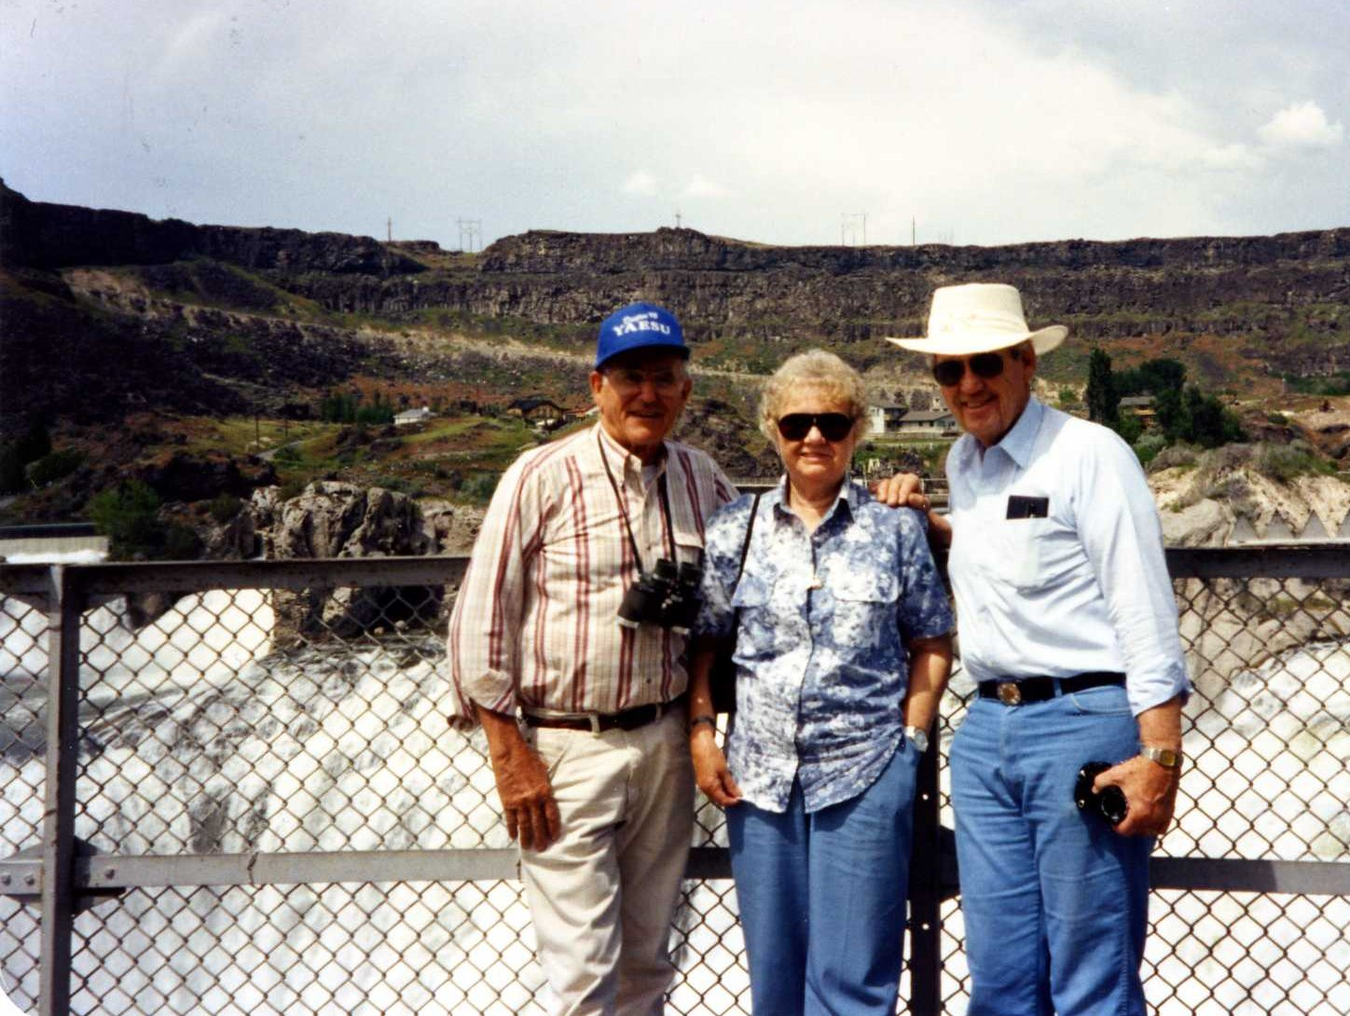With Bob Asin at Shoshone Falls
We also took them to see Shoshone Falls. Since they were from California, they had never been there. At that time the water was running full bore and was absolutely breathtaking. We also stopped and viewed the Malad River Gorge and Falls.
Jack was just elated to find a second cousin living in Lafayette, Louisiana. While getting some names on his mother’s side ready for their temple work, he found that a lot of the work had been done in 1982. With further checking, he obtained the submitter's name and wrote her a letter. Four days later he received a phone call from Muriel Roberts of Lafayette finding out that their grandmothers were sisters, which made them second cousins. They each thought that they were they only Mormons on that side of the family. She had traced their ancestors all the way back to the Mayflower and back to England.
In October we went to Spokane, Washington to meet Muriel Roberts. She had a son living there and she was visiting his family that weekend. She and Jack had a wonderful reunion, even though as for as they knew, they had never meet, except for the possibility of when children in Seattle. They exchanged a lot of family information and photos. John and Heather welcomed us into their home. Jack and Muriel hit it off just like cousins should.
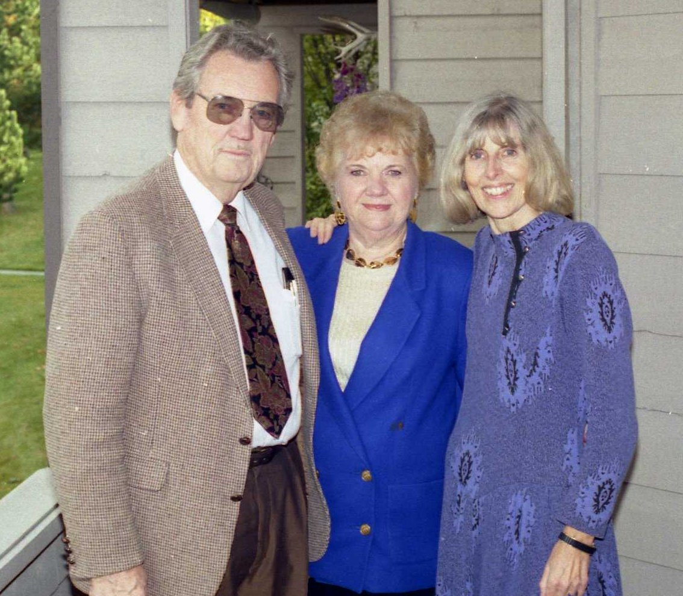With Jack's cousin, Muriel
We went to Malta where Jack photographed the wedding of our niece Corinne Harper to Burke Udy . It was a beautiful back yard wedding and Corinne looked just beautiful. The fun thing was that we got to be the first to see the wedding pictures and they all turned out beautiful!
During the summer we had a lot of guests come and go. Kellie and Kyle were here a lot. We did so many fun things; spent time at Kathryn Albertson Park, blew giant soap bubbles, made ghosts and painted pumpkins. We took a train ride tour of Boise, rode paddle boats on the lake in the park, explored the Discover Center had the most fun right here in our back yard.
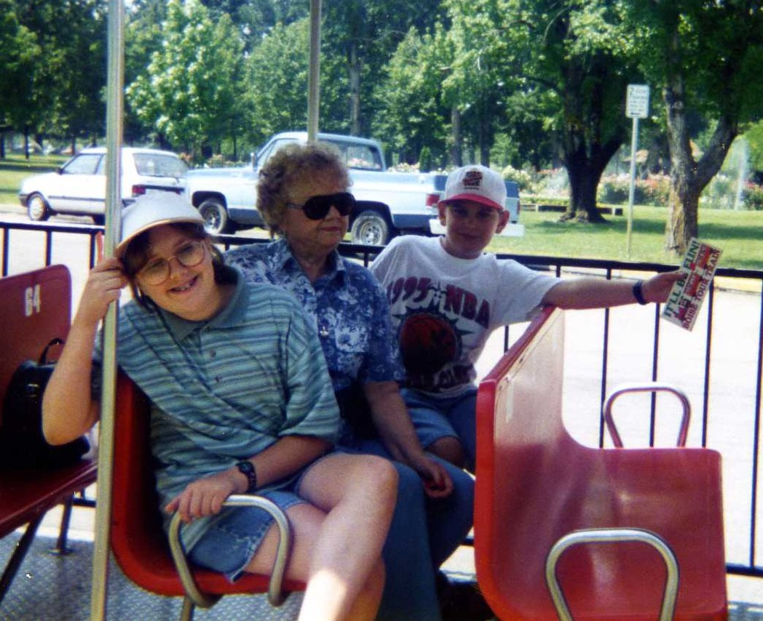With Kellie and Kyle on our tour of Boise
Kellie and Jeremy both had their 13th birthdays. Sometime during the busy summer I even had my 69th insignificant birthday. Gordy, who started going by Glen, had his 16th Halloween birthday. Halloween came and went and we had lots of little trick or treaters. We even drove up to McCall to see the scarecrows placed all over town. After Halloween, Livi also had her 13th birthday.
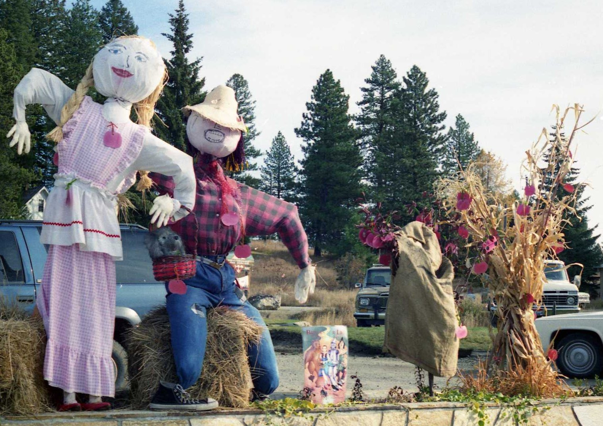Scarecrows in McCall
For Thanksgiving our special guests was Gordon and Bonnie and their family from Rexburg. What made it so special, they seldom get here, and Clyde. We had the traditional Thanksgiving dinner they stayed over for a few days so we had time for fun.
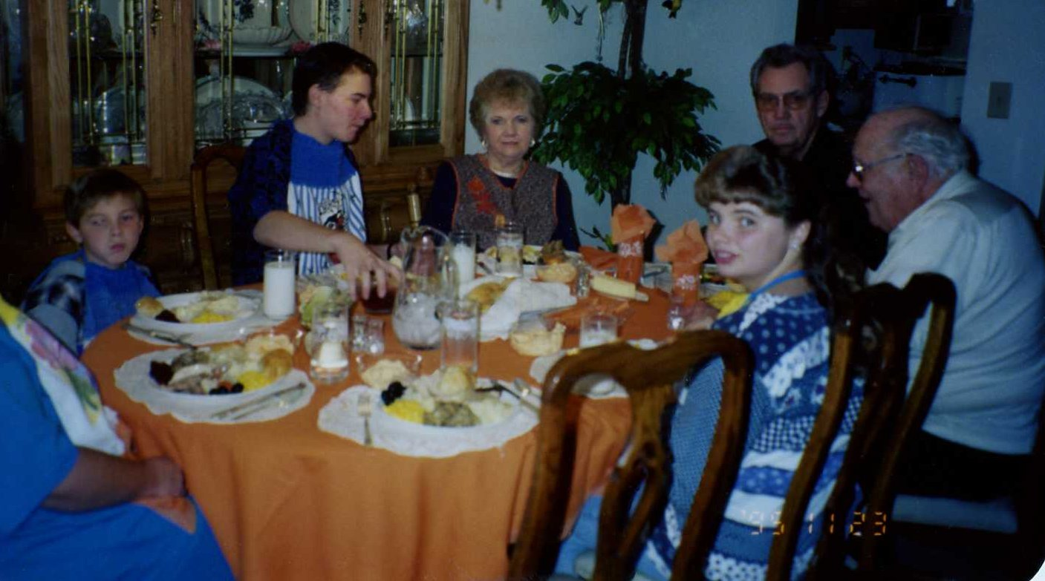Thanksgiving 1995
We celebrated our 17rd Once Upon a Time wedding anniversary by reaching out for each other’s hands and our life together is our happily ever after. We always buy something nice for our home. That has been a traditional throughout our married years. As usual, we dressed in our finest clothes to go to a very fine restaurant, The Chart House, for a very fine dinner, also a Once Upon a Time tradition.
For our Frost Family Christmas dinner we got to go to Monroe, Utah on December 6th . All of us Frost kids and our mates were there except Don and Irma. We got up and left before 9:00 a.m. to go to the Manti Temple. What a thrill it was to all be in the Lord’s House together and do a session together. All 14 of us except for Eunice and Earl were in the Prayer Circle. The temple president noticed us and as we was having lunch he offered to take us on a tour, and up the beautiful spiral staircase, all 151 steps, into the beautiful sealing room in the tower, explaining historical facts pertaining to the temple to us. People are not permitted up there but he took us because he was impressed by us all being there as a family. What a spiritual time for me. It really set the Christmas Spirit for me.
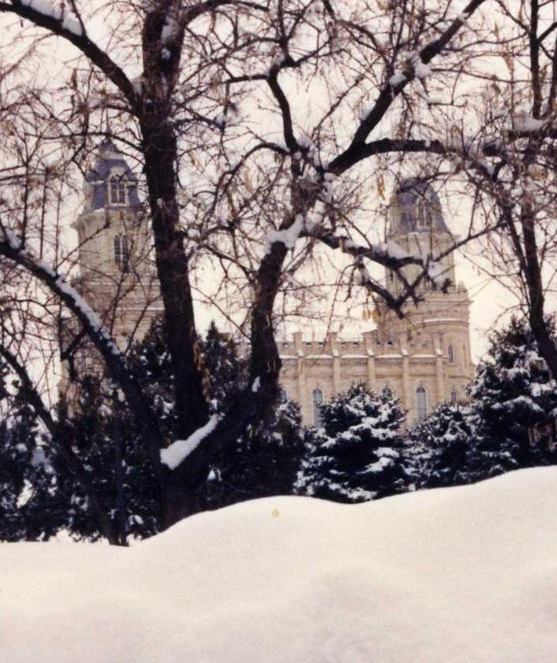The Manti Temple
We had a wonderful dinner at the lovely Jackson home. Renee’s young boys were our waiters. They were so cute with the towels over their arms just like any fancy restaurant; they were so cute. Then came the fun part of opening our gifts to each other. I am not sure where everyone else slept but we were there first and had our territory marked! It was a wonderful prelude for the Christmas Holiday to follow.
We both had our 69th Birthdays that year. We go to the restaurant of our choice for our Birthday dinner.
Christmas Day we had dinner for the Missionaries, I am not sure how many, and of course Clyde. Jack went and got them early and I gave them their giant Christmas stockings full of packages. Like I said earlier, they acted like little kids on Christmas morning. To think about it they were! It was a great day and Jack returned them to their apartment later in the day. We don’t see our own families for Christmas anymore because they all have their own family Christmases.
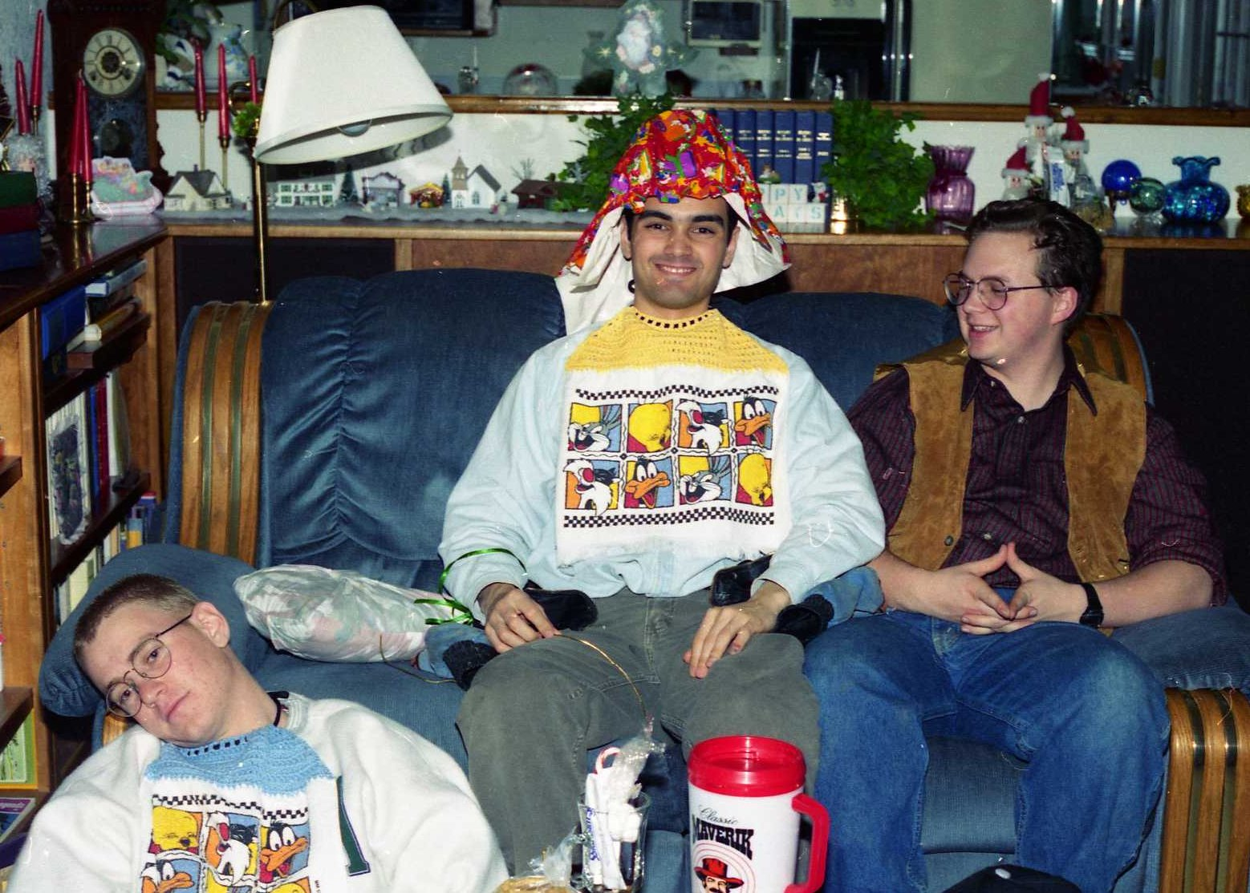The missionaries at Christmas
Thus ended another very wonderful, happy year in my journey through this worldly life! I am so thankful for each of my family members and my lifelong friends. I am so grateful for my noble knight and for the love and caring that we share for each other. I am so grateful for my knowledge of the Plan of Salvation; that we are God’s children and that we do belong to God’s Church on earth! We are living happily ever after each day of our lives.

