Chapter 34
One More Year

I was grateful that we were both still on this planet. We saw the old year out by spending the evening with Glen and Ada at a restaurant somewhere in Boise, I don't remember which one. Then the remainder of the evening was spent at their home where we played dominoes until the New Year kid arrived. Of course our first guest of the new year was Clyde who came for dinner. Doris Asin dropped in to see me too. Cindee was next.
Not wasting any time, we took our first trip to Salt Lake City to see Muriel and Phillip Roberts who were just finishing up their mission in Salt Lake and wanted to see us before leaving for Louisiana. We stayed at Eunice’s and also saw Raydon and that sweet little papoose, Lacoya.
Our dear little granddaughter Melynda got her mission call the 29th. She was the first of our grandchildren to go on a mission. She was able to come to Boise and spend time before leaving for the Mission Training Center. It was so fun to help her shop for clothes, and to enjoy her sweet spirit. The three of us did a session in the Temple. The whole Dudley Family came and we had a big Birthday dinner for Tim’s 49th Melynida’s 21st and Mark’s 17th. It was a wonderful send off for Melynda.
I got a bad case of the flu. Usually Jack gets it first and gives it to me but I got even with him this time. I did not want to suffer alone so I gave it to him, but I kept a big part of it for myself. Most of the time when he gets it, I manage to let him suffer alone.
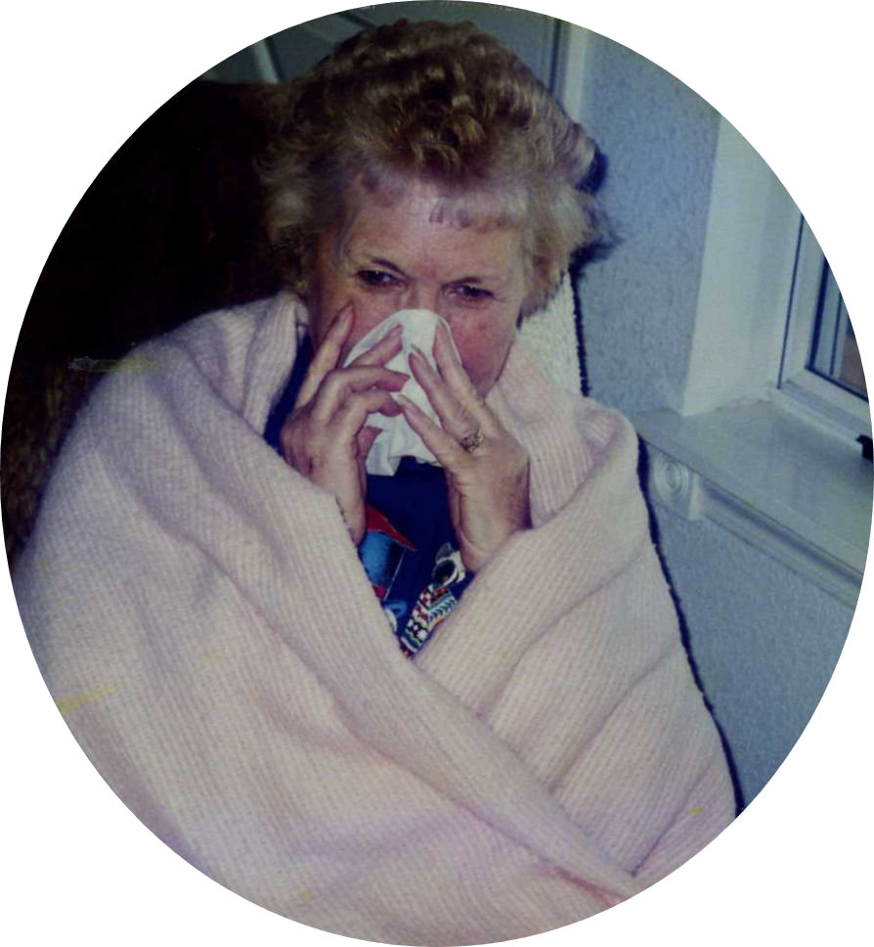Are there any more Kleenexes?
We finally got released from our stake mission on February 2nd after 25 months. We were very happy about that! Soon Jack was called to the Family History Center. He put in four hour shifts twice a week making it 8 hours, it was considered a family history mission. I did not get my beloved Sunday School Secretary job back but I was called to be Ward Bulletin Coordinator. As a matter of fact I had the outgoing coordinator put a bug in the Bishop’s ear. I got it! I would get all the ward information put together and Jack would do the computer work. I loved doing that because I was about the first one in the ward to know what was going on each week. Jack still kept busy hauling the Elders around, and they still liked to stop in.
With no more missionary work, I could not let the rest of the winter go to waste. I did accomplish several things I had on my “Winter To Do List”. I read 8 or 9 books including The Work and the Glory, Volume 7, Go Forward With Faith by President Hinckley, along with six or seven smaller books. I redid two years of photo albums, and started a quilt until my sewing machine quit on me. My biggest project was painting Amish children on my video cabinet. With that accomplished, I had hoped to start on my personal history but made a couple of bears instead. Unaccomplished that too! (I didn’t get to my history until 2010. Finally!!!) I had to discontinue my daily walks because we had very cold winds all of February. Jack was busy building a deacons bench for the kitchen. It is so cute and it fit right in. He also had a lot of training classes for the Family History Center.
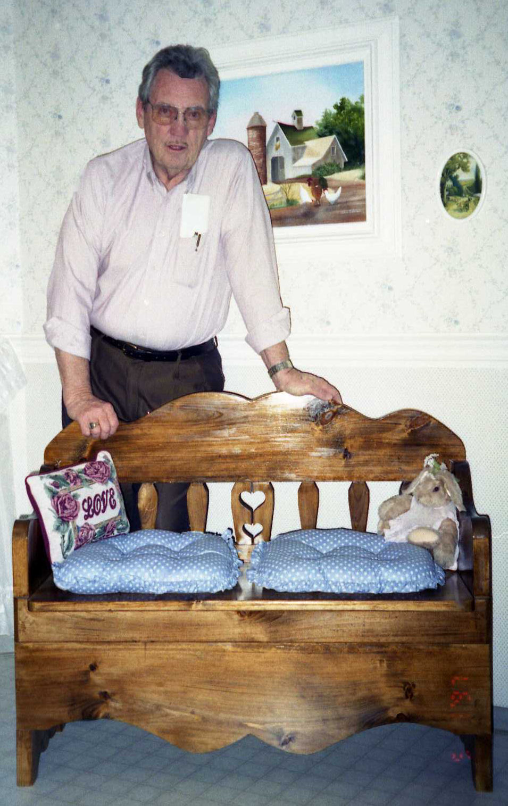The deacons bench that Jack made.
Connie had to Fly to Iowa for four days of schooling for her new job. We took her to the airport and picked her up again on Valentine’s Day. We love it when family members have to fly someplace. They come here, stay overnight, we take them to the airport and when they return we pick them up and sometimes they get to spend another night with us.
Gordon made an unexpected trip to Boise in April. One morning his boss had asked him if he could go to a class in Boise. The catch was that he had to leave that day. He hurried and put everything together and had Bonnie pack his bags and meet him at work to take him to the airport. When he went to get his suitcase out of the trunk, Bonnie had left in such a hurry that she left it home. He had to come in just what he had on. Fortunately Jack had some clothes that fit him. That evening after his class, Jack picked him up and we took him out to Red Lobster for dinner. The next morning we took him back to the airport for his flight back to Idaho Falls.
There was a big going away party for Kathryn and Richard held out to Turners April 8th as they were about to embark on their “Faith in Every Foot Step Odyssey”. They had joined the 1997 commemorative wagon train of the Mormon Pioneer Trail. Their journey was to take place soon. Richard got a head start, as he already had a good white beard. I think he was born 100 years too soon, as he loved that kind of life.
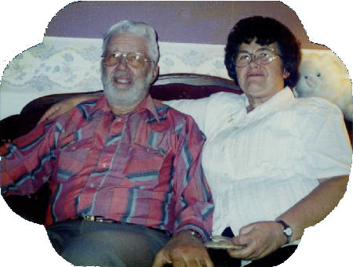Richard and Kathryn
Thelma and Jay came arriving at 5:00 p.m. on Friday the 11th of April, we were so happy to see them. They were tired from the long drive so after dinner and visiting a while, we all went to bed. After a good night’s rest and a wholesome breakfast, Thelma and I were ready for our day of shopping. I don’t know what they did all day, but I know what Thelma and I did. Shop! We went to the Mongolian BBQ for a great dinner, it was so good. It had better be because we dished it up ourselves and then watched them cook it. It was fun watching it being cooked, but was more fun to eat it. Back home Jack showed them some things that they didn’t know about the computer. In the evening we took them over to see Glen and Ada Owens, Thelma’s less than favorite cousin.
On Sunday we all went to Church, I was glad to show my pretty sister off to our ward. After staying for all three meetings, we had dinner and just laid around the rest of the day gabbing and watching TV. I sure don’t know what all we shopped for, but Monday morning we were back at it. This time we shopped at Costco and the Mall. Tuesday morning we bid them good bye as they left at 9:45 a.m. I sure hated to see them go! Our great granddaughter, little Papoose Lacoya had her first birthday and we didn’t get to go to the party.
Connie, Kellie and Kyle were here again this year for Easter. It is so much fun for me when any of them come. There is still enough kid in me that I love dying eggs, Easter egg hunts and of course eating them. If no one comes I just don’t bother to do anything but make a few deviled eggs for us, but it isn’t that much fun.
At that time Tim was still with the Minidoka Sherriff’s Department. He has had a lot of scary experiences that we have to hear about from the family in Burley. Michael was with the Filer City Police Department. We went to see him a couple of times. Melynda, our Missionary was in Monroe, Washington and she just loved her area and the work. They have already had two baptisms. She wrote to us every week. Gordon just feels like they are getting ahead when something drastic happens. His fairly new computer got completely destroyed and no one knows how it happened. (The kids all plead the 5th amendment.) Glen was driving and had so many fender benders that their insurance went way up. He was working toward his GED. Cindee was really doing poorly with her rheumatoid arthritis. Her left hand had deteriorated so badly that she had to wear wrist braces and she was only 39. Connie was slowly working into her new career, she came to realize that it takes time to build up her clientele, but she had the spunk and she made it. Deelyn was back teaching at Head Start.
As spring and summer finally come on, I was able to enjoy it after I got my bunches of weeds pulled. For some reason every year my flowers seem so slow. Everyone's roses and flowers are in full bloom while mine are still in the bud stage. The weather was just wonderful. I enjoyed sitting out on the patio until 10:00 at night watching the birds and the sunsets and all the wonderful sights and sounds that God sends my way.
We were able to enjoy a once in a life time experience watching the Hale-Bopp Comet as it passed its perihelion (the point nearest the sun in the orbit of a planet or other body) on April 1, 1997. The comet was dubbed the Great Comet of 1997. It was perhaps the most widely observed comet of the 20th century, and of the brightest seen for many decades it was visible to the naked eye for a record 18 months Hale-Bopp was discovered by Allen Hale and Thomas Bopp.
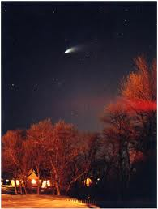Hale-Bopp Comet by Nancy Mueller
Hale had spent hundreds of hours searching for comets without success, and was tracking known comets from his driveway in New Mexico when he chanced upon Hale-Bopp just after midnight. Bopp did not own a telescope. He was out with friends near Stanfield, Arizona observing star clusters and galaxies when he chanced across the comet while looking through the eyepiece of his friend’s telescope. He realized he might have spotted something new. Allen Hale had e-mailed the Central Bureau for Astronomical Telegrams. The following morning, it was confirmed that it was a new comet and was given the name Hale-Bopp as it was discovered by two amateurs. Hale-Bopp will not appear again until the year 4385, and I doubt very much that we will be around to see it a second time.
We also witnessed Hailey’s Comet as it last appeared in the inner Solar System in 1989 and will next appear in mid-2061. It is the best known of short-period comets, and is visible from earth every 75 to 76 years. Halley’s Comet was more than 100 times fainter at the same distance from the sun than Hale-Bopp and Hale-Bopp was approximately six times the size of Halley. I hope you find this intersting. I am grateful to have seen both of those great comets in my lifetime. Thank you God.
In May, I made a trip to Rexburg for Glen's graduation on the 21st when he received his GED certificate from the Eastern Idaho Technical college. He actually achieved it a year sooner than if he would have stayed in school.
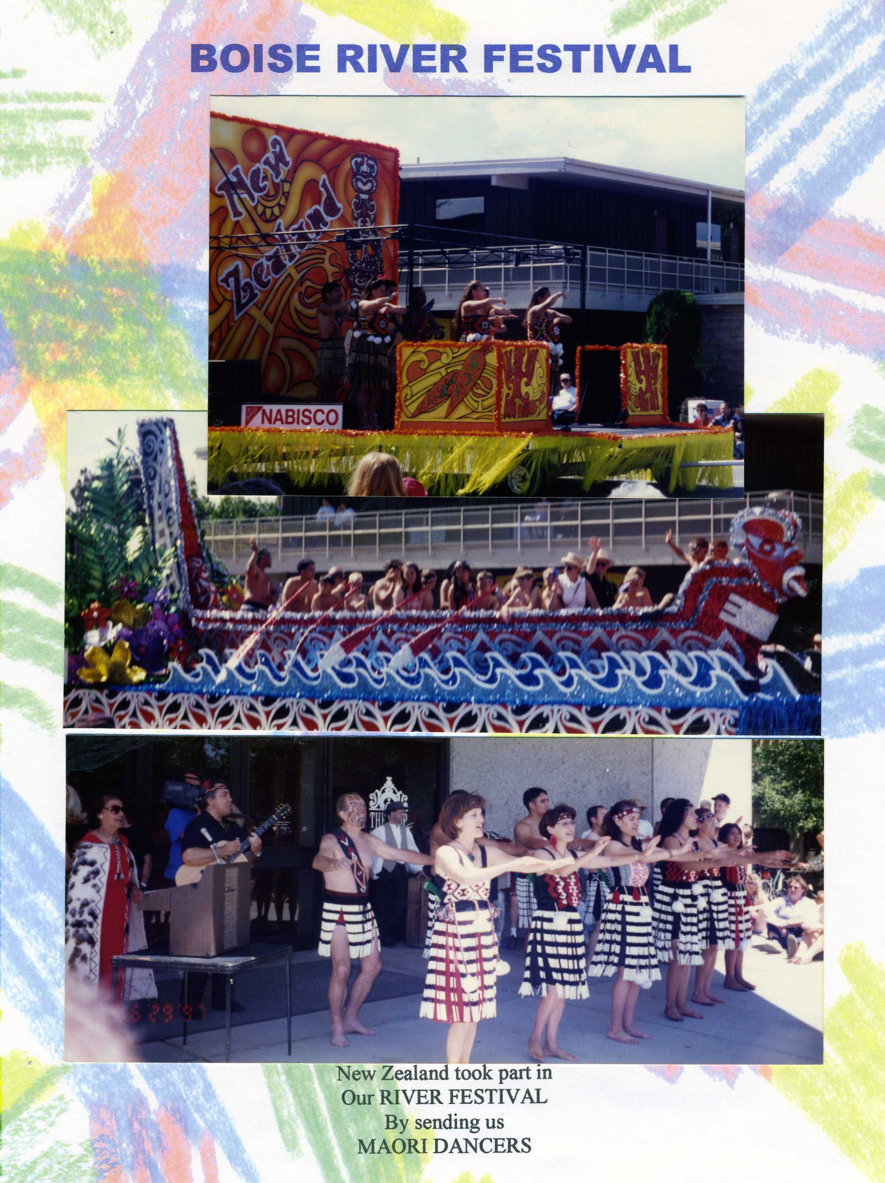
Cindee came for her 40th Birthday and as she does every year, bakes her own birthday cake, I try to make her day fun for her. She also was here for the 4th of July. We had a great dinner BBQ on the patio with Clyde, but no fireworks that year. We, Connie, Kellie, Kyle and Cindee helped Boise celebrate the River Festival in July. It was bigger and better than ever. We hung around all day and into the evening to see the lighted floats. It was well worth the fatigue we all felt.
I gave two classes in a craft store on “Fun with Photography”. I only had a half an hour for each class, and one in Relief Society. It was kind of scary because I only knew one person besides the owner. I thought it was dumb of me trying to do something like that. But I did really well and had my displays laid out just right. Everyone seemed to enjoy it, but best of all learn from it. It was fun.
We had our 2nd Gilmour, Dudley & Buttars Family Reunion up at Rexburg that turned out very well. We were all there except for Connie and her kids. Part One: Swimming at Green Canyon. Gordon and Bonnie and all the kids went swimming, the rest of us sat around watching. That little Lacoya had more fun than all the rest put together. It was a good thing the pool was an inside pool because it poured down rain all day long. I would not get in the water after seeing a couple of people blow their noses in the pool and with the pool so full of people and little kids that day. I wondered how much more snot and piddle was in the water. I stood my ground and stayed dry! After they had had enough swimming we went back to Buttars for part two: a picnic. It was raining so hard that Gordon set up some tables he borrowed from the church in their unfinished downstairs. Since it was too stormy to cook out on the grill, he went and got some chicken from the delicatessen at the grocery store. The rain didn’t dampen our spirits, the food was great and so was everyone that was there. Gordon and Bonnie did a nice job with the planning etc. Everyone else went home but we stayed the night and went home the next day.
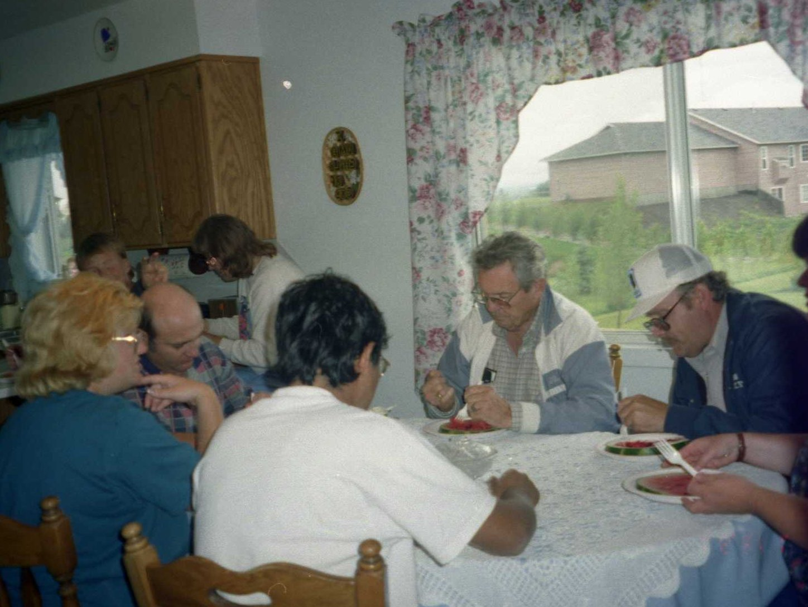Gathered around in Gordon's kitchen
On July 21st was the second to the last day of the 1,100 mile re-creation Mormon Pioneer Trail Trek. Fewer than a dozen wagons had come down off the steep incline from where they had camped for two days when a runaway wagon tore through the brush, bounced hard and tore apart. The team of mules broke away from the wagon which continued a wild run down the hill before . One of the six passengers in the wagon was my little sister Kathryn Goodfellow, then 62 and Tori her eleven year old granddaughter. They were all taken by ambulance to the Mckay-Dee Hospital in Ogden. Kathryn was in fair condition and treated for neck pain. She was badly bruised, some where she would not show anyone. The scene was broadcast around the world the same day it happened. My little sister was famous.
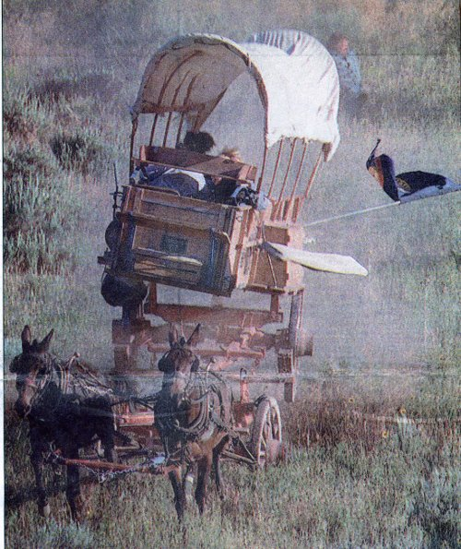Runaway wagon
Bob and Anne Rogers came out July 22nd from Hayward California, in their little “Blue Dove” instead of flying. We just had such a good time, they are such sweet people. I took them to the Catholic Church again this trip. We also spent a fun filled day in Idaho City. They stayed five days and drove home.
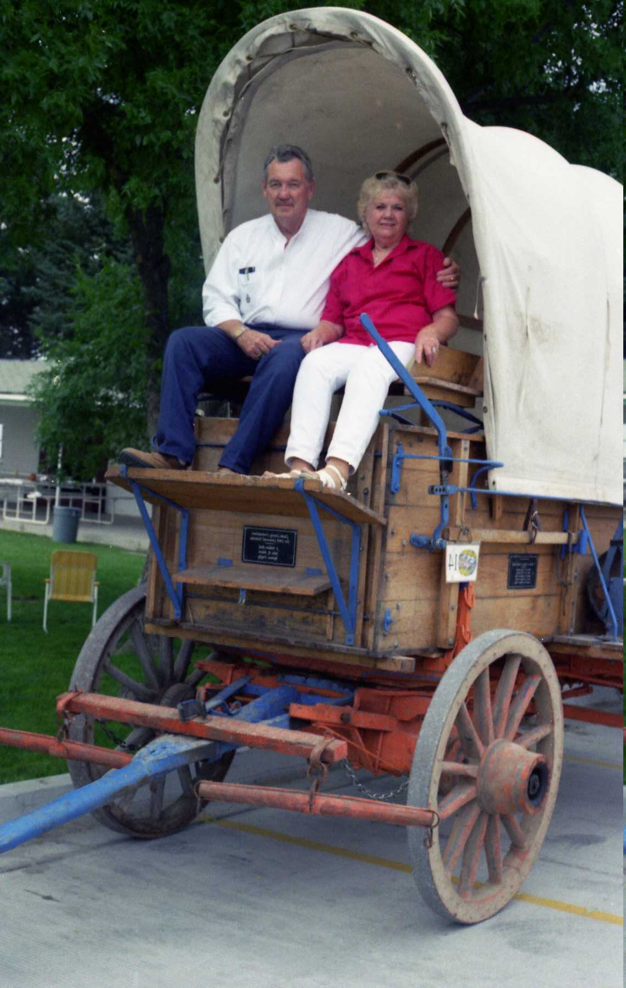Pioneers?
The Family Reunion came along August 9th at the Pella Ward Recreation Area put on by the Goodfellows. They showed a video of their trek. There was a merry-go-round for the kids, a dunking tank, volleyball, softball, and other games not to mention dinner, the raffle and visiting. They had the covered wagon there that Richard had help build, and of course everyone of us had to have our picture taken in it. Without fail, soon after the family reunion it was my birthday again. This was my 71st. Jack took me down town to “Noodles” for my birthday dinner.
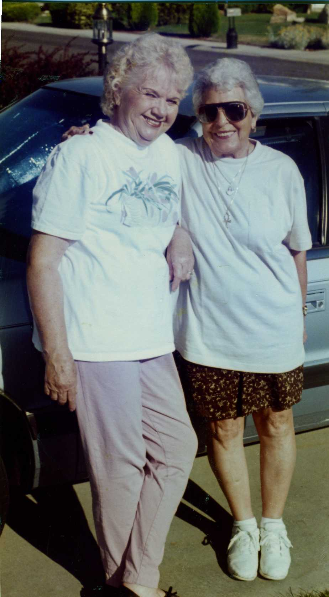Me and Anne
I started training to walk in the Women’s Fitness Walk, coming up. Remember last year I won a medal for admitting my age, well I thought I would try for another one. This year Connie and Kellie came to walk with me. Kellie wasn’t too enthused but went along anyway. We were in the Purple Wave and my number was 11235. Yup I got another medal. It was a lot of fun. As I mentioned last time, it is the largest women’s run or walk in the nation and growing every year. (The estimated attendance that year was 15,000). But that was my last try, I hated missing the fun. Connie, Kellie and some of their friends have done the run several time since but won no medals.
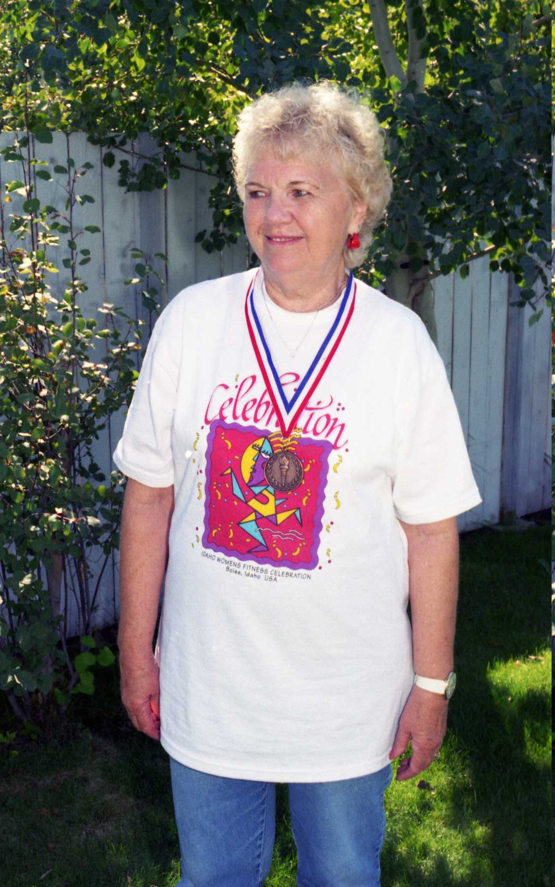Number 11235
Jack and I took a trip to Idaho City with Cindee; she hadn’t been there before and really wanted to go. We had been there before on other trips with Connie and kids, with the Buttars family and Bob and Anne. We all had a great day and this time with Jack driving we drove around to the outlying back roads and visited the old cemetery, seeing some of Idaho City for the first time. And of course we had to take pictures of the wooden people that live there on the streets and had some famous Idaho City Ice Cream.
The ending of an aggravation! Jacks shop was beginning to go up. He had done all his wood work in the garage all those years. Naturally he kept all those tools in the garage of course! First he had to dig out for the foundation so the cement flooring could be poured. When the builders got going, it didn’t take too long before he had a wonderful shop, that he has put to use ever since. His only regret was that he didn’t have it built bigger. It also was built over most of the gravel driveway that went from the street clear to the back fence. Bonus! We got cement clear out to the street and no more aggravation for me keeping the weeds down. He had to build a lovely breeze-way from the house to the shop with a boardwalk, or pay the city or county $500.00 to $600.00. The breezeway cost much more than that.
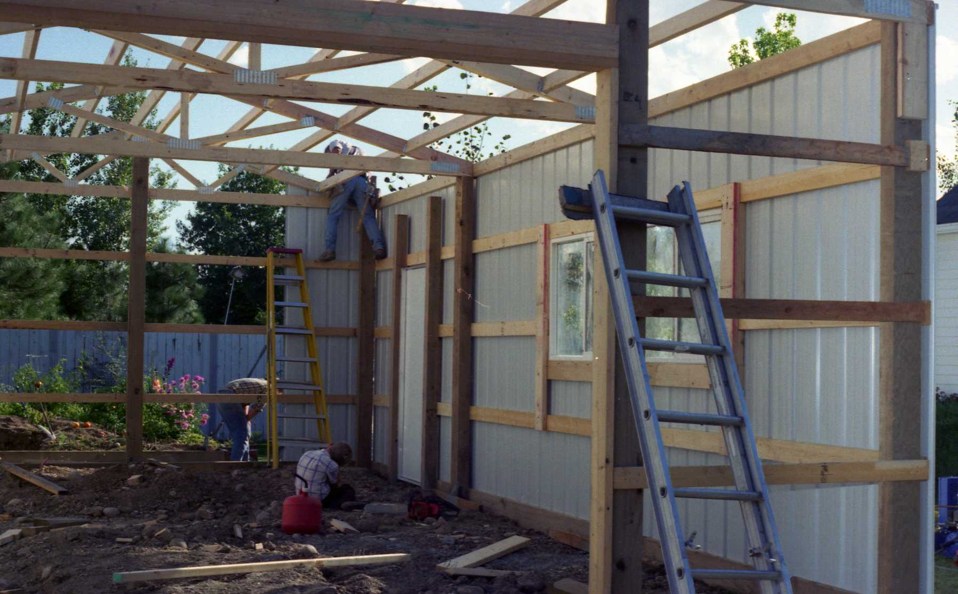Jack's shop
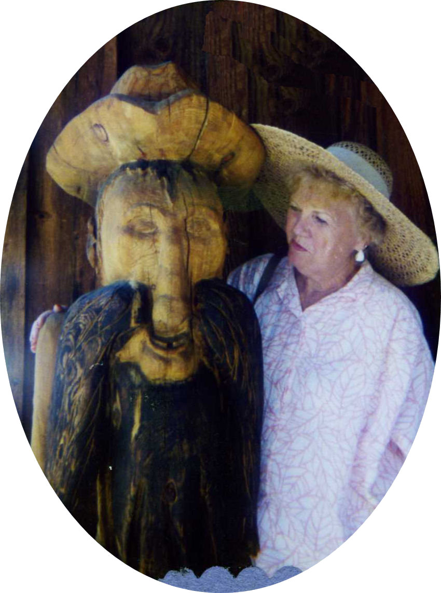Jack? and me in Idaho City

I baked a Birthday cake for Clyde for his 86th Birthday and treated him to a Birthday dinner September 5th. Gordon and Bonnie and their family came on the first weekend in October. We did a little shopping and watched general conference. Just a few days later, Gordon was back for a seminar for work. He spent the night and the next morning Jack took him to the convention center downtown. Jack picked him up at noon and brought him home for lunch before taking him back to the airport.
In honor of Lorna and Kenneth's 50th wedding anniversary, their children honored them with an open house on October 25th at the Unity Ward Building. It was well attended by both of their families and it seemed most of Burley, as they were both so well known and loved. Everything was done up so lovely. Darla appointed Jack to take pictures of everyone and everything which he did until his camera broke. It was so nice for me to see so many old time friends that I hadn’t seen for many years.
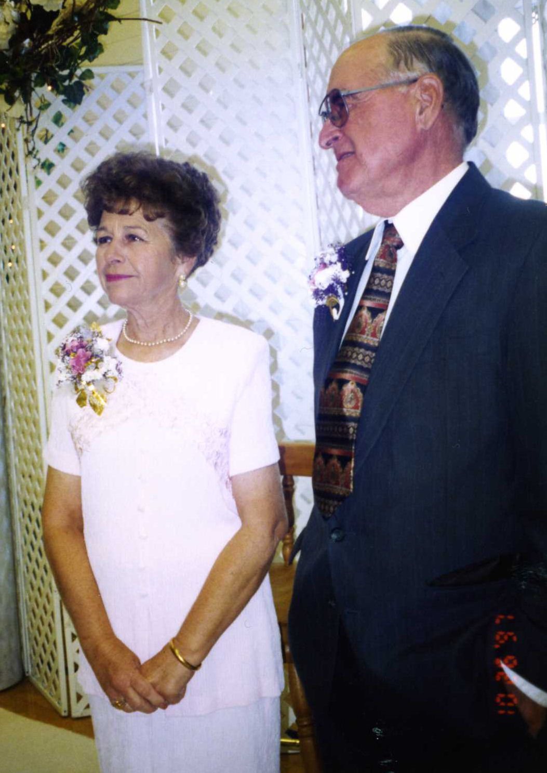Lorna and Kenneth
With autumn approaching, Halloween was on Kellie and Kyles minds. They came to Boise for a few days and they made jack-o-lanterns of all sizes and weird faces. We took in the five acre corn maze, wandering all through it, all the time wondering if we would make a wrong turn and get lost, but we didn't and we all made it out about the same time. We also drove over to Meridian to play among all the scare-crows the city had put out around town. Sometimes it was hard to tell who the real scare-crow was! We made a cool scare-crow of our own using Jack’s old worn out clothes. Cindee has always hated Halloween, but she came to get in on some of the fun and had her picture taken with uncle Jed, as we dubbed him. We put him out every year until the squirrels found his clothes to be good nesting material. Glen celebrated his 17th Birthday the day after. Halloween has always been his favorite day. Olivia also celebrated her 15th Birthday November the 13th. The autumn leaves were so beautiful and enjoyed until we had to rake them up!
For our 19th wedding anniversary we celebrated it along with our friends Helen and Russell Ivie. Their daughter had planned a quiet 50th celebration for them with only the best friends of each of them. Helen considered me hers so we were invited. They did not know it was also our anniversary. So we had a lovely anniversary dinner at the Chart House in Boise on their daughter.
Five Minico High School students were taken to Minidoka Memorial Hospital with varied injuries November 19th after a two car collision near the school. Kellie was one of the girls. Luckily she wasn’t driving. She had a massive cut along her forehead and hairline. She healed up. Glen bought himself a used 1982 Buick Skylark. His first car and it wasn’t long until it had ouches.
We cooked the turkey again this year for Connie, Kellie, Kyle, Melody and Emil, Cindee and Steve and of course Clyde. Our table was beautiful and the food was oh so good. Everyone one had a good time filling their tummies and gabbing and later snoozing it off.
Us Frost kids were at it again for our Frost Christmas Dinner and Party. That year Irma and Don hosted it in their lovely home on December the 10th. You just have to sneak a look in my photo albums to tell just how much fun us kids have and how much love is shared. The gift giving from the heart is so special.
Once upon a December day, Jack came into this world 71 years ago on December 19, 1926 as wonderfully unique as a snowflake, and as special as the season itself. How grateful I am that God lead me to him. Six days later we spent our 20th Christmas together in the peace and quiet of our lovely decorated home. With the New Year rapidly approaching, it has been a great enjoyable year for us.
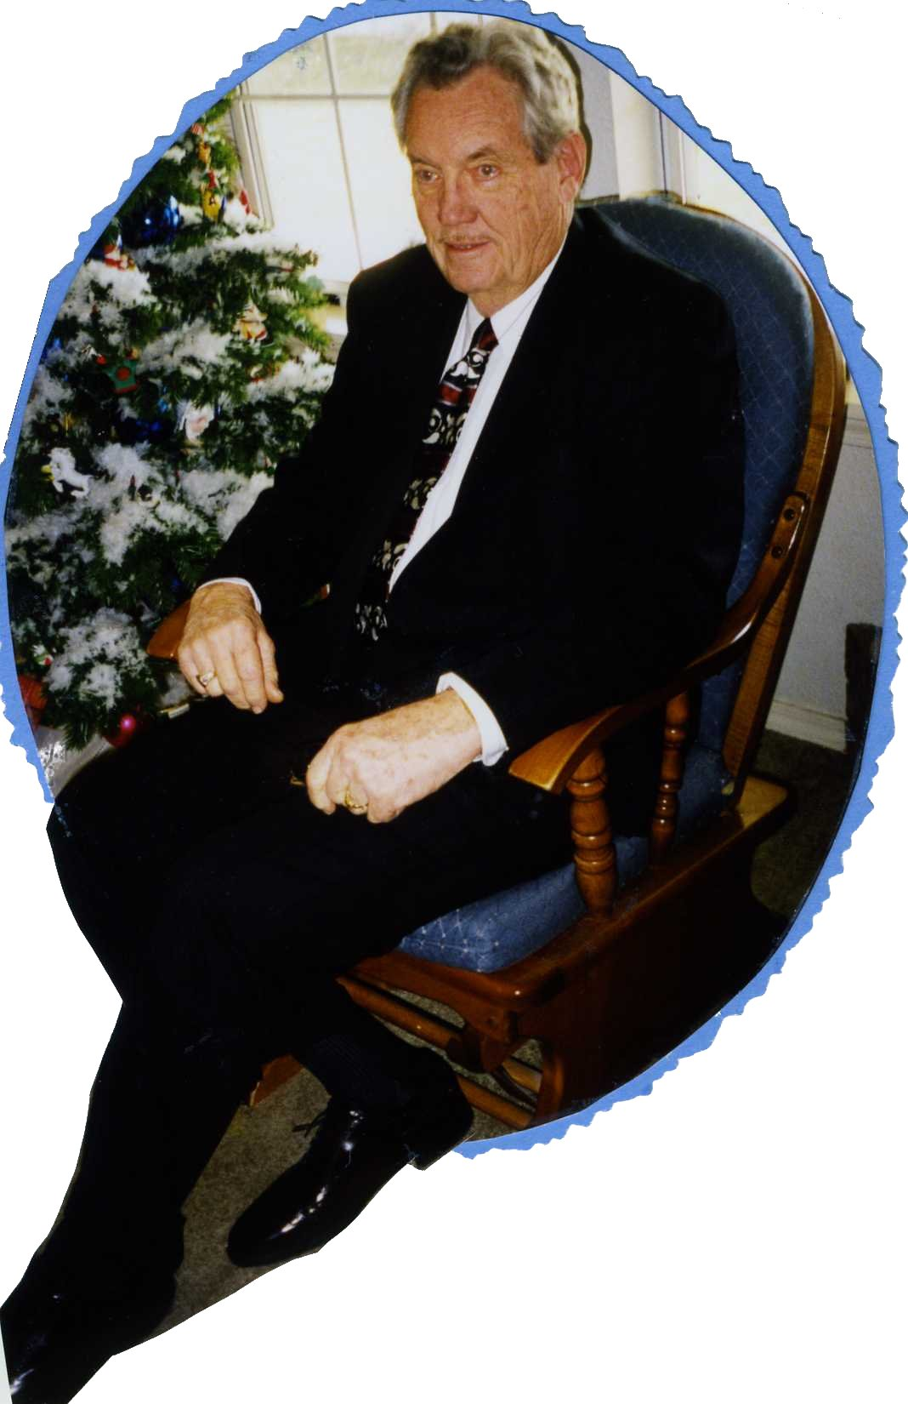Jack at 71
We did have snow that year. It was so nice to sit in our cozy house and look out the window and see the sun glistening on that white outdoor carpet. Another busy year had gone its way, never to be duplicated!
I have tried not to make my chapters too long. I want it to be a story, not a diary. In the event that some of my children and grandchildren ever take time to read this, it is for you. I want you to know me for how I lived my life and for what I stood for.

