Chapter 36
Prayer For a New Year

Lord, with you all things are possible:
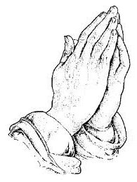
Without you, all things are impossible.
Make this year of new beginnings,
A year of favor from you, O Lord:
A year of amazement and gladness,
Not a year of anxiety and sadness;
A year of giving and forgiving,
Not a year of grudges and resenting;
A year of opening up and reaching out;
Not a year of closing down and shutting out.
Lord, with you all this is possible;
Without you, all is impossible.
By Andrew Castella.

As 1998 fell asleep forever, 1999 slipped in to take its place. I was still going to therapy for my vertigo, but doing a lot better. I did finally recover completely and was able to get on with my life. We were still getting snow into February. Our granddaughter, Melynda was working as a tutor at Minico High School until going back to the University of Utah in June. She was Relief Society President in her singles ward. She came and spent spring break with us; she is so sweet and pleasant to be around.
On February 1st, I got word that my beloved sister Thelma was diagnosed with breast cancer. What a horrible way to start out the new year. I was so frightened for her, all I could do was comfort her with phone calls. With potent radiation treatments, powerful priesthood blessings, and prayers from the family, she had her last treatment on April 1st. What a blessing and testimony that God does answer our prayers.

Mark got his mission call to the North Carolina Raleigh Mission. We spent a night in Malta with Marian and Doug and they went with us to the Logan Temple on January, Saturday 23rd where Mark received his endowment. We attended the Rupert 5th Ward on February 14th for his farewell Sacrament meeting talk followed by a dinner party at the Dudley home. He entered the Mission Training Center on the February 17th. Mark was a wonderful young man, the Light of Christ definitely shone though him, he will make a great missionary. Part of his mission was right on the coast of the Atlantic Ocean. We will have no more missionaries out until Loren is old enough.
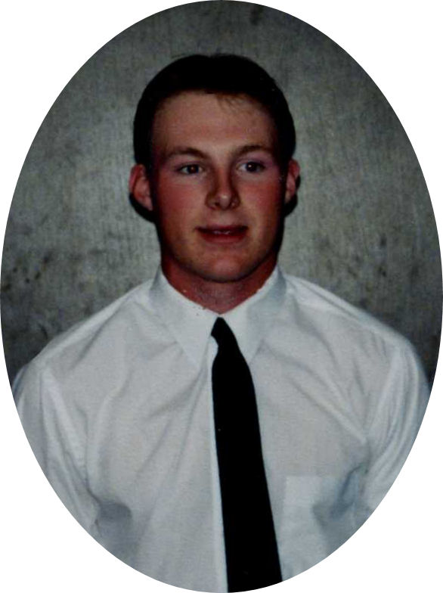Elder Mark Dudley
Glen was discharged from the Navy on February 10th after only one year. He spent some time in Italy. After returning to the States, the Navy put him on a bus and sent him to Boise. He arrived here at 8:00 am the next morning. We met him at the station. Gordon got here the next day at 1:30. After spending the night and a great visit, they left the next day.
Jack and I participated in a cancer detection program put on by the University of Utah for people age 55 to 75. There were two groups; # 1 group was just asked to answer questions two or three times a year. The #2 group actually got tests. This ran for six years. Well Jack made the # 2 group and got in on a lot of thorough testing every year. I got a mammogram and physical and participated in the mail in questioner.
We were delighted to have our children and grandchildren dropping in now and then through the year. Also nieces and nephews, my brother and sisters, and friends and cousins. My guest book for 1999 was blank. I really goofed. So I hope that will include everyone that crossed our threshold that year. I loved you all.
The spring was eventful with a temple session with Lorna and Kenneth at the Boise temple. Afterwards we had dinner at a Chinese restaurant with all the Turner kids for Stan’s Birthday. It is always more pleasant when we can enjoy time at the temple with family. I love going to the Lord's House to escape the cares of the world for those few hours. My regret is that we do not go as often as we should.
On March the 10th, 1999, a bright new star joined our family right from his Heavenly Father's arms. Tiny Jon Galen Cardenas was born to Raydon and Colby in Salt Lake City, Utah. He was smaller than his sister Lacoya, and not quite as much black hair but he had plenty, and black eyes. He was a real cutie. He was named after both his grandfathers. On April the 2nd I drove to Burley and Rupert all by myself to see Raydon and her family as they were in Rupert to show off their new little star. I had to see that new baby. Jack felt bad because he didn’t get in on Jon’s blessing, as he was blessed in their ward in Salt Lake. Raydon can’t have any more children, so Jon is the last great grandchild for us until some of the younger grandchildren get married.
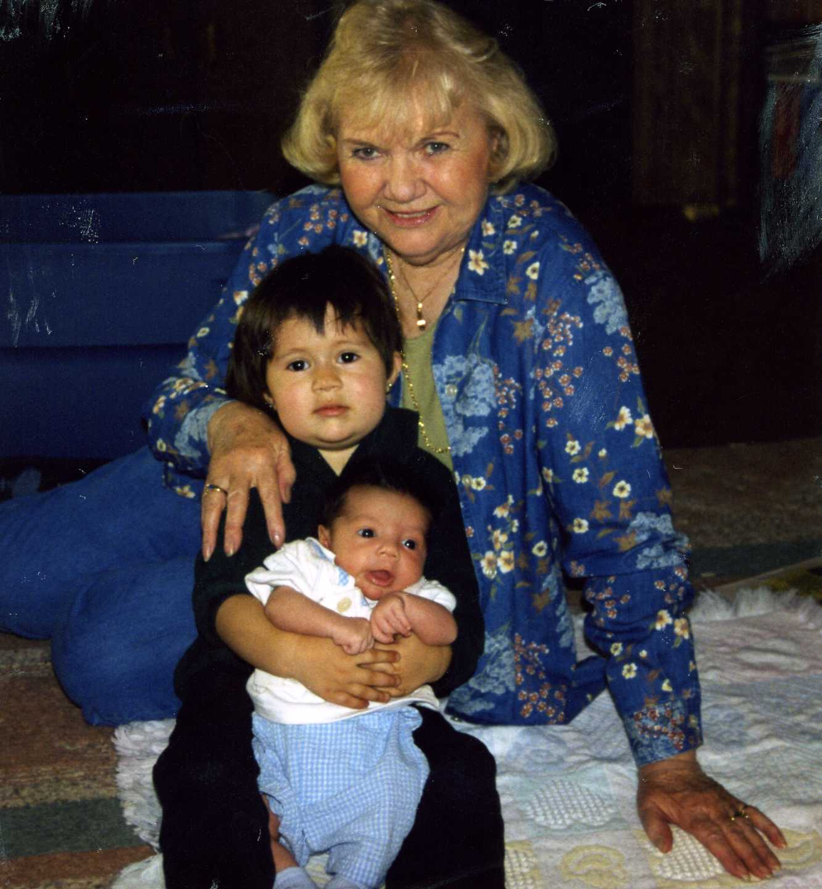My great grandchildren
On May 7th and 8th Cindee came as she and I had signed up for two days of classes at The Northwest Scrapbook and Stamp Convention in downtown Boise. What fun we had. We both signed up for six classes each day. She took the classes she was interested in and I took the ones that met my interests. Both days we had three morning classes, met for lunch and attended the remaining classes. We learned and did so much more than we did in the classes we took the year before. Cindee also came and spent Mother’s Day with me. While here we celebrated her 42nd birthday, which wasn't until June 2nd. She always likes to bake her own German chocolate birthday cake.
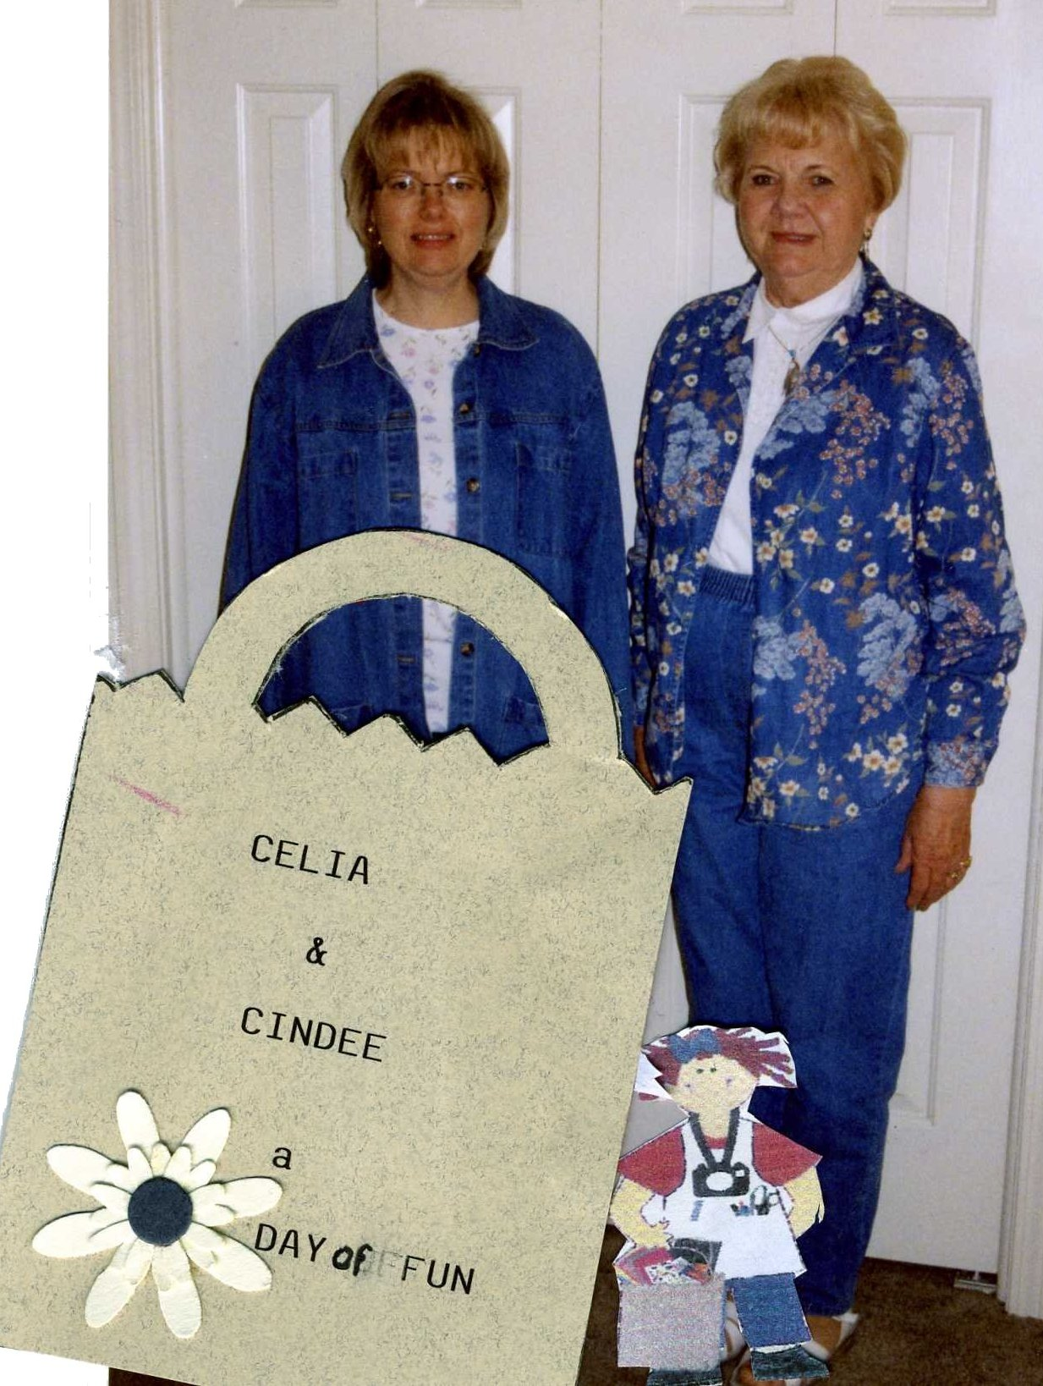Scrap-bookers
Our lovely friend, Theresa Sims celebrated her 97th birthday on the 14th of June. I don’t recall if we drove to Salt Lake to help her celebrate or not, but I do have photos taken that day so we must of gone. June was one busy month that year. In the latter part of the month, my California friends came for a couple of days.
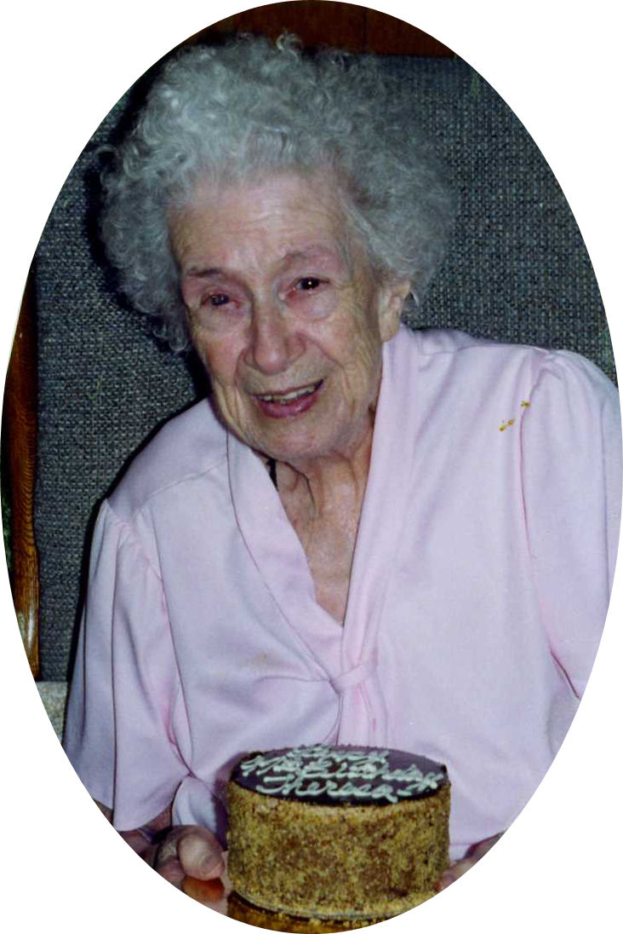Theresa Sims
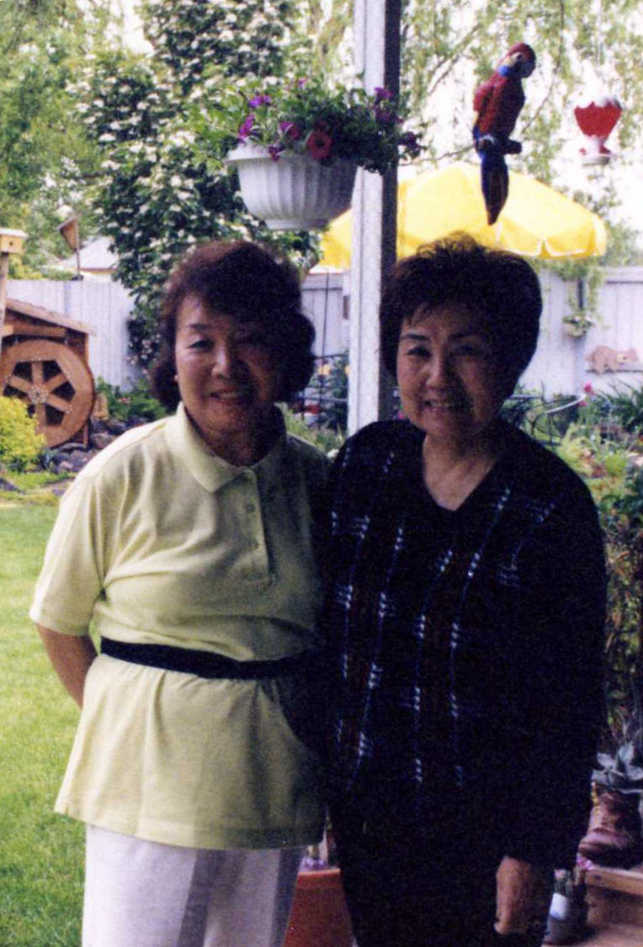Yoshiko and Sachiko
My little Japanese friends, Yoshiko Bowman and Sachiko Jones, along with Vivian Hatt were also going to come and stay but at the last minute their plans had changed. They stayed at a nearby hotel but spent the days here. How I cherished their visit. Sachiko passed away later in the year. Also Jack’s sister Pat and his nephew Steve from Seattle paid us a weekend visit. It was very nice to have them.
We went to Rexburg, on Friday July the 2nd. Independence Day was celebrated on Saturday the 3rd that year because the 4th fell on Sunday. Our main reason for going was for our grandson Loren who had just celebrated his 12th birthday on the 28th of June. It was a very special birthday because he was now eligible to be ordained to the office of a Deacon in the Aaronic Priesthood and pass the sacrament. What a sweet special spirit he has. After his ordination, he told his dad that he felt a special warming come over him, a great experience for such a young boy.
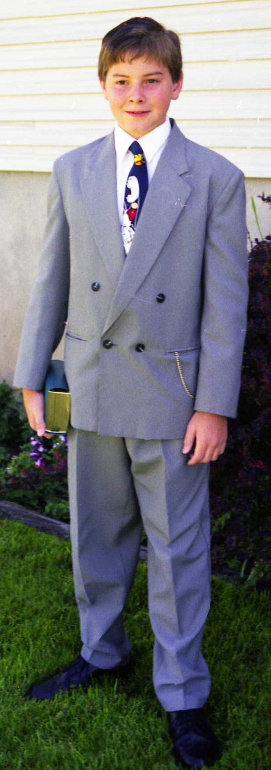Loren
Back to the 3rd, we all enjoyed the parade, but the best part was a float with a model of the Spirit of St. Louis to represent the 1920’s and to represent their ward in the parade. Gordon and another man built it and Loren was Charles Lindbergh. In the evening we watched the fireworks. We left the on the 5th to come home after a wonderful weekend.
Three of our grandchildren had their 17th birthdays that year. First Jeremy, June 29th, Kelly July 13th, and later Olivia November 13th. They are special and beautiful young ladies, and Jeremy is a handsome young man. Both of our youngest grandchildren, Loren and Chad turned 12 that year.
The grandchildren came as often as they could. Kellie and Kyle came the most. So many times we drove to Bliss, the half way point, to meet Connie and bring the children here. On one of Kyle’s work visits that summer, he helped his grandpa build an arbor at the end of the shop, then a board walkway beneath it, between the shop and the raised garden. It turned out very nice. Jack is a perfectionist and everything he builds is good! Kyle stayed with us for three weeks at one time. Jack also finished working on the waterwheel and pond in the far corner of the yard. I spent all the money that I could get my hands on to buy plants for the pond and yard. I bought good sized coy fish after the smaller fish disappeared. Kyle bought some cute little frogs, but they didn’t last long either. Well, the snakes got the fish and I got five snakes!!! I caught them red mouthed!!! Kyle saw me kill the first two. He said I had warrior eyes. No more fish and no more snakes.
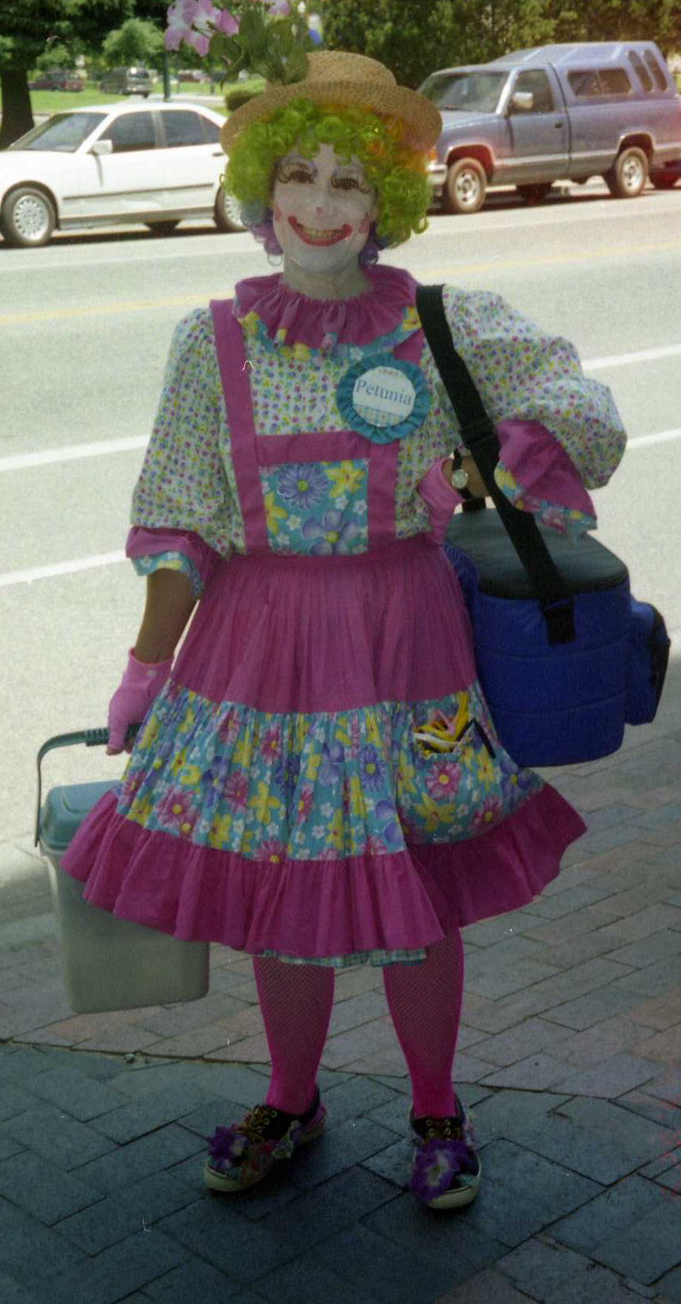An adorable scarecrow
That summer Connie took a new job in a law office in Twin Falls for training. That just ruined all the fun activities that we had enjoyed together in past years. Now she could only come to weekend events. In June we did go to an ice skating event and the Boise River Festival, This adorable scare crow was my favorite part of the whole festival, she really brightened my day.
Also that summer we went to a Shakespeare Festival. When Cindee came, we went shopping. Like her Aunt Thelma, we could go to the mall when it opens and shop until 5 pm. Shopped until we dropped, as the saying goes. Cindee also got in on some of the fun things we did during the summer.
I enjoyed my flower gardens and birds. How I love the gold finches and the house finches as their beautiful colors streaked across the sky. I welcomed any other birds that happens to fly to our feeders. The squirrels kept us laughing as they chased each other and did their antics. You may not believe this but one day I saw two of them actually patty caking. It was so cute, they were just like a couple of kids. We put a shield on the feeder pole to keep them out of the feeders. That didn’t stop them from trying and was so funny to watch them.
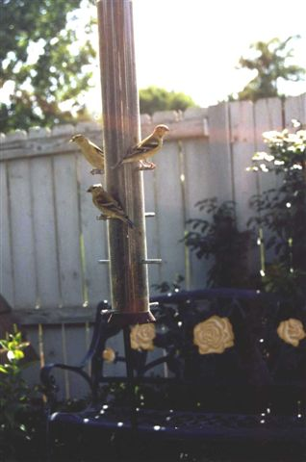Backyard visitors
We had plans to drive to South Dakota to meet up with George and Becky, as it was half way between Idaho and Minnesota. We hadn’t seen each other for a very long time, and we were really looking forward to it. But as fate had its ways, George had just changed jobs and wasn’t able to get the time off. So that burst that bubble and ended our plans.
We were both asked to go out to the prison to help the inmates with family history research. I was not into this research thing like Jack was. We did attend an all day orientation about hostage survival, security concerns and the games that convicts play, along with many other frightful details. It all sounded pretty darn scary to me. I didn’t want any part of it. For one thing, women could not go there looking decent or smelling nice because it might rile up the prisoners. Jack would have had to give up one of his days at the Family History Center and he didn’t want to do that. They kept bugging us to go out to the prison to see what it is all about. They have a huge Family History Library there. But NO! That was the last place I wanted to go! Yes Jack was still putting in eight hours a week at the History Center and loving every minute of it.
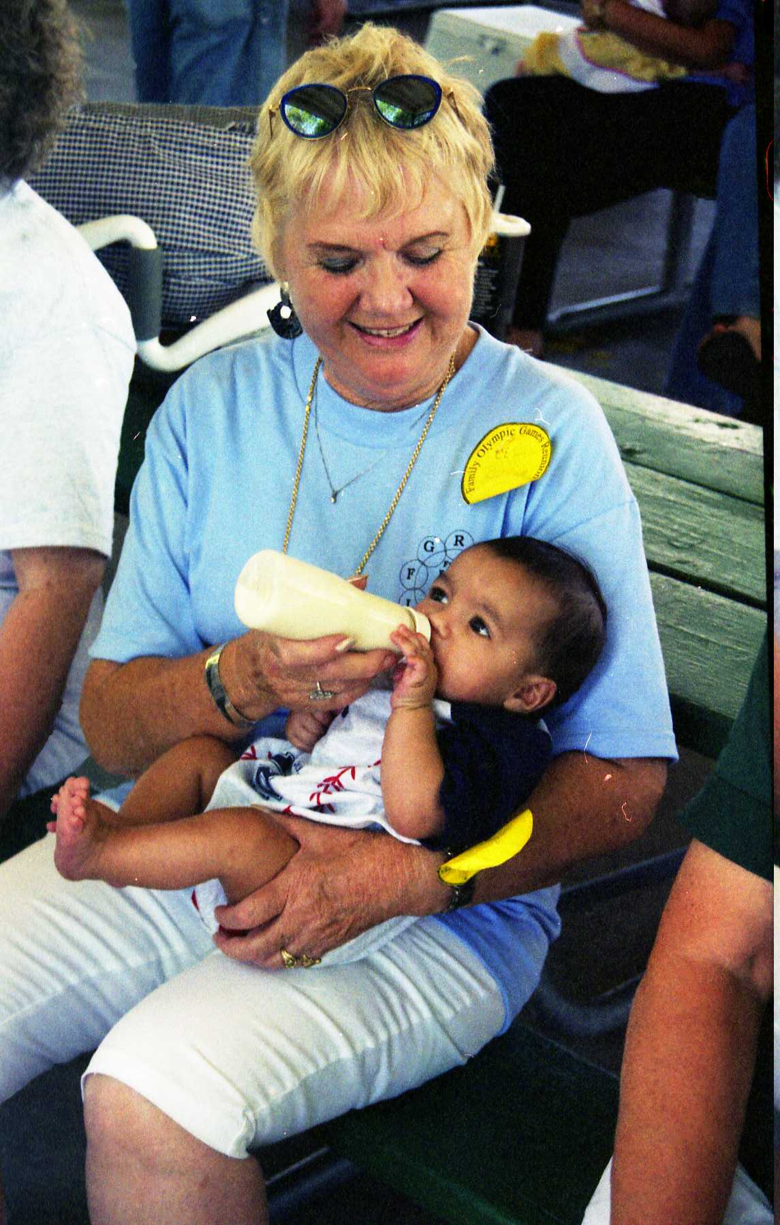Enjoying Jon
Melody planned our “Fun in the Sun” Family Reunion on July 17th at Niagara Springs-Pugmire Park, eleven miles south of Wendell. We had a barbecue and a lot of games planned. Actually the biggest part of the day for me was spent visiting and me playing with little great grandchildren Lacoya and Baby Jon. All of us were there but the Buttars family. The park was beautiful with the beautiful Niagara Spring cascading nearby.
A “Family Reunion Olympic Games” reunion was planned by the Jackson Family, for August 14th at the South Taylorsville Park in Salt Lake. They planned a lot of different things from our other reunions. Each family wore a different color T-shirt to represent that family. Our family had pretty blue T-shirts. Also each family brought their own food. They had 14 different Olympic Games planned. I was a party-pooper and just visited and watched the others have fun. “Kids, kids, kids.” as Gerald put it. The colored shirts sure helped know which kids belonged to what family. They also had a Cousin Party the night before. We stayed at Gayle’s that night and drove over to Monroe Sunday morning and stayed with Thelma and Jay for three days.
Thelma and I just messed around, fixing things up in her house, doing a little bit of shopping. There aren’t too many places in Monroe to shop, but I did buy an old rocking horse to fix up, at “Grandma’s House”. We drove over to Richfield and had lunch at JP’s. We just had so much fun together. We left for home on the 18th. Thelma baked birthday cake for me before we left. Oh, yes, I guess I should mention here that my 73rd birthday was on August 19th. Did you notice I didn’t say that I celebrated it? But I did hear from my kids, sisters and a ton of friends that didn’t let me down on that dreadful day.
I was sad to see summer coming to an end. The beginning of a new school year always signals what is ahead. Our families are all back in school, including Connie. Cindee was taking additional classes as was Raydon. Bonnie is back working in the school lunch program. Glen is also back in school. Michael joined the long haul truckers, he was very proud of his truck.
Michael's big rig!
Jack had a bumper crop of tomatoes. That is all we could grow anymore. I canned a lot and gave a lot away. I even made some salsa and chili sauce. By the way, I did not plant any of those tomatoes, but I had to can, freeze, and do whatever with them. Jack even made some pickled green tomatoes. They weren't too bad.
The year 1999 had the United States as well as the world in a panic as the end of the year was nearing. Governments were sure that with the new century, that all the computers all around the world would crash, as the world ran on computers. Big companies were hiring experts in the field of electronics to figure out ways to save their companies. It was quite chaotic. It was as if they thought the world would end.
Even Gordon was involved in a project at the Idaho National Engineering Laboratory where he worked to identify the potential problems. The problem was that for years everyone stored only the last two numbers of the year in the computers. Now all of a sudden it was going to go from 99 to 00 and the sequenced order of things would be all messed up since 99 is greater than 0. All it took to fix the problem was to change the years in the computers to include all four numbers so it would be 1999. Then when it rolled over to 2000 the sequential progression of things would be uninterrupted.
Anyway, people were panicking and buying all kinds of survivable goods practically clearing out the stores. Dumb me, I out thought all those big brains out there. For some reason it just didn’t alarm me. I just couldn’t see why it would make a difference. It was just going to be another year. I knew that God was in charge and it just wasn’t time for the world to end.
That year we had some serious illness among my siblings and their husbands. Earl Read broke his hip and then was hospitalized for various health problems. Eunice and Earl were both in different hospitals for six days the week before Christmas. Thelma had bladder surgery in January but had to go back for more surgery July 19th. If I remember right, Gerald was also having some health problems. Our Frost family had been so blessed through all these years with no serious illnesses or deaths since our dear parents.
Clyde turned 88 years old on September 11th and his health had failed considerably. He depended on Jack as his care taker more so than ever. Jack spent much time taking him to his appointments and just spending time with him. I also spent time with him, he was always like an older brother to us. He wasn’t able to come here for his Sunday dinners as in the past. It was a sad day when he had to give up his car.
Little bees
All the autumn and winter holidays laid a head of us. For Halloween, Lacoya and Jon were little bees. Thanksgiving, and our twenty first wedding anniversary both fell on November 25th that year. We had some good news and some sad news about that time. The good news was my little brother and his wife Verlee got their mission calls to far, far away Ghana, Africa. The sad news was that we had to attend the funeral in Twin Falls for my niece, Bonnie’s 7 year old son, Jordan Hennington who was killed in an automobile accident on November 2nd.
But the biggest event yet to come was Jack’s 73rd birthday on Sunday, December the 19th. We don’t make it a habit to go to restaurants on Sunday, but that year we did. By 11:00 a.m. we had two inches of snow but it didn’t last long. It turned to rain! On Friday night we had Glen and Ada over after their shift at the temple for birthday cake and hot chocolate. Then we all drove around to look at the Christmas lights, in our neighborhood. The next night we had Norma and Wendell Bryce over for cake and hot chocolate. What a birthday, we later finished up with sparkling cider in pretty glasses.
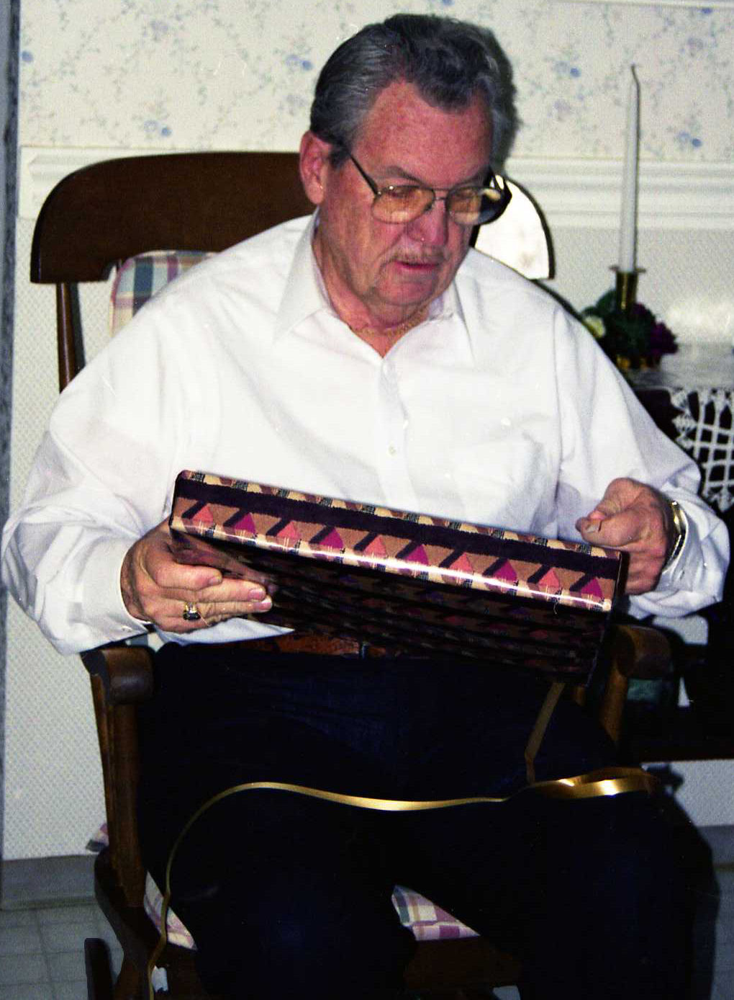Jack's 73rd birthday
We were to have the Christmas dinner and party at our place that year but because of Gerald and Verlee’s mission call and preparations we thought it best to postpone our Christmas dinner until the 8th of January. We promised to have it the next year. Anyway, as with all of our Christmases we enjoyed it by ourselves, going to all the invitation and ward parties. Each year I made tons of goodies. Both cookies and candy and packaged them up to treat all of the neighbors, of course we eat our share. But the best part, we remember that Christmas is all about our Savior’s humble birth and that is where our thoughts are during the Christmas holidays. I love the beautiful Christmas music, movies, and lights and hate to see it come so quickly to an end. But in just one week we turn our thoughts, dreams, hope and faith to a bright new year. In this case a new decade and new century.
Christmas 1999
This old world had seen so much since the year 1900. We have had good leaders and poor leaders. During that time there was the assassinations of President McKinley in 1901, President Kennedy in 1961, and an unsuccessful attempt on Ronald Reagan in 1981, along with the assassinations of other national and world leaders. There was two world wars and other wars that took the lives of millions of people; so much bloodshed in the name of greed. People rioted in protests, destroying cities and communities. Worldwide disasters in the form of hurricanes, tornadoes, and earthquakes caused untold damage, suffering, and loss of life.
With all the darkness, there was also much sunshine. Many great inventions have come forth for the benefit of mankind. The automobile, the computer, and the first human heart transplant. There has been so very, very much history in the last 100 years. The first flight by the Wright brothers, breaking of the sound barrier, space exploration, and men walking on the moon. The coronation of Queen Elizabeth II. Great medical advancements. Movies, wonderful music and books have been written for our knowledge and for our enjoyment and to lift us. The fall of the communism in Russia and Eastern Europe.
The Church of Jesus Christ of Latter-day Saints has blossomed worldwide. The Tabernacle Choir become world known and participated in several presidential inaugurations. The First Presidency announced the revelation that all worthy men would be eligible to receive the priesthood. Many Latter-day Saint men have held high government offices. Our church had nine presidents/prophets in the 100 year time frame. 63 temples had been built since 1900 and it had been announced that the historic Nauvoo Temple would be rebuilt. The new Conference Center was nearing completion. Over 100 million copies of the Book of Mormon have been printed since 1830. At the end of 1999 there were 10,752,984 members of the church worldwide, with more members outside of the United States than inside. In 1999 33,915 missionaries were called. Missionaries were even going into former communist countries.
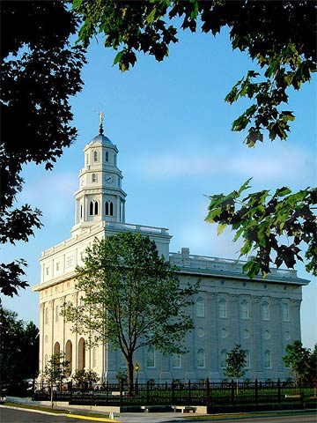The Nauvoo Temple
God is not dead, neither is Jesus Christ. They direct their church here on earth, just as their church in Heaven and the ancient church. I am so grateful for my knowledge of the Plan of Salvation, and that I am a daughter of God, and I know that He knows and loves me!

