Chapter 38
The Best of Times, The Worst of Times

I stayed up to watch the New Year come in, but I fell asleep and had the most wonderful dream. I dreamed there were beautiful flowers all around me, with butterflies flitting overhead and bees buzzing. Birds of all colors serenading me with their lovely songs; rainbows and waterfalls, weddings, parties and travel. I was the princess in Fantasyland. Then I woke up to a very dark cold snowy 2001 and I didn’t even see it come in. So I just went to bed like I should have done in the first place. Oh, but that dream was worth it!
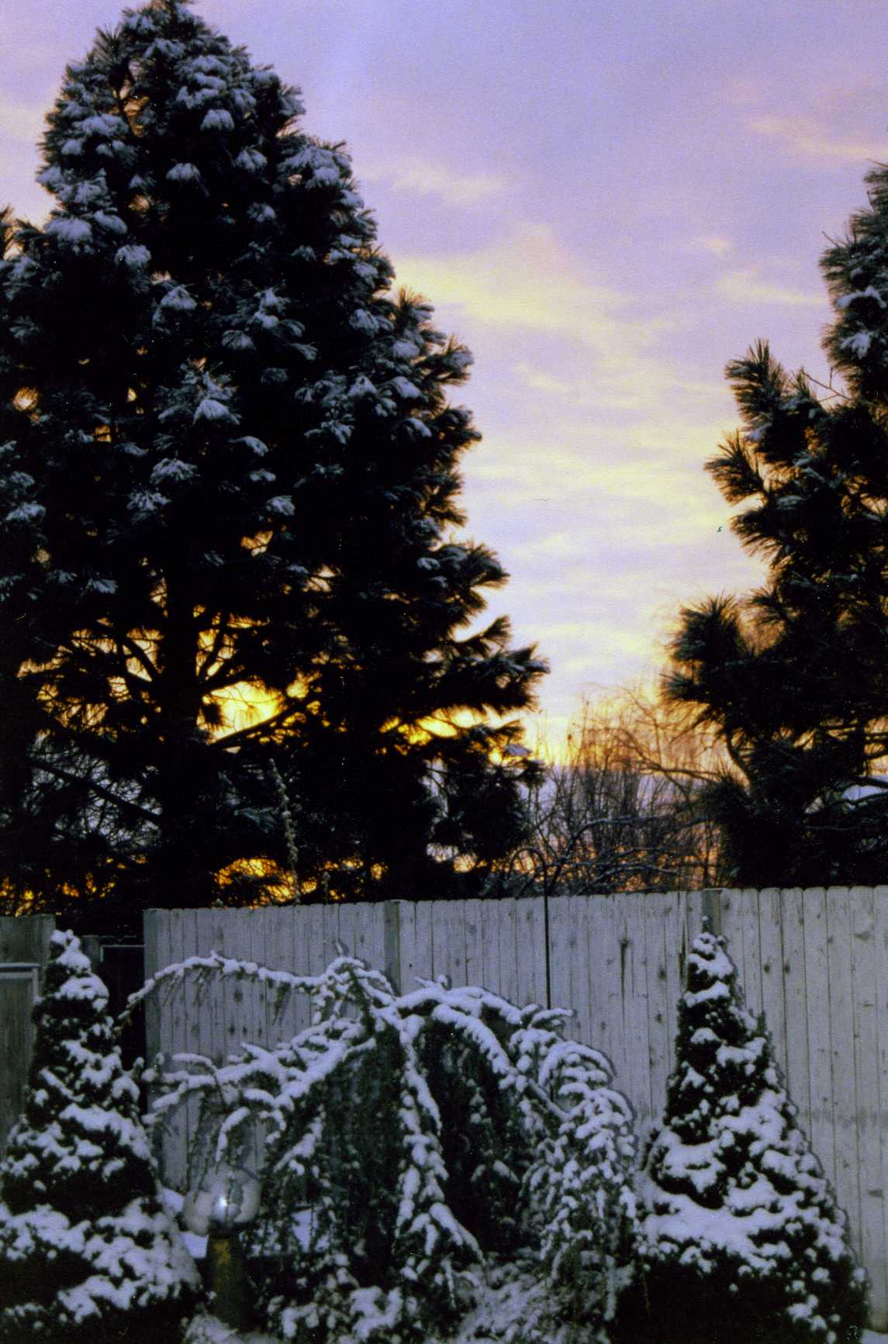The dawning of 2001
We had lived here in Boise for 10 years, in fact the longest we have lived in one place since we were married in 1978. This was our little piece of heaven on earth. I pray always that the good Lord will permit us to live here until our journey's end.
I spent the first month of the New Year reading! On January 3rd my friend Deanna Torfin brought over Volume One and Two of “Children of the Promise” for me to read. She had been after me for a long time to read them; she told me “now is the time” and January 3rd was the day. By the end of the month I had read all five volumes, each book containing 500 pages. It was a cold January so what better was there for me to do but curl up in front of the fire place with a good book.
Jack started out the year with bronchitis. I lost a tooth and looked like an old hag, not a princess. I ended up having to have a root canal; not a fun thing for a new year. Later in the year, I also had a bout with H-Pylori, an unwanted stomach bacteria that took some high-powered antibiotics to get rid of. I was thankful for two things that year; no family reunion or the Christmas dinner for us to host.
Emil had been doing poorly and Melody had her hands full caring for him. Emily, Emil’s daughter and Melody’s stepdaughter, passed away June 24, 2001 just five days before of her 35th birthday. She was found in her home by a friend. The last I heard, the cause of death was unknown.
My families are all doing well at that time. Connie, Kellie, Kyle and Cindee were our only visitors for the first few months, besides our Home Teachers and Relief Society Visiting Teachers each month.
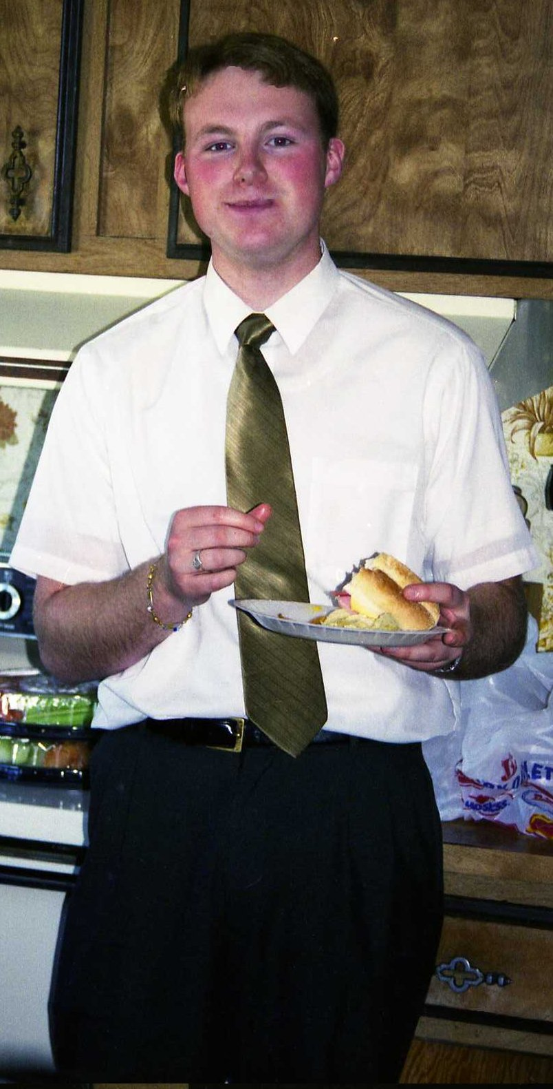Welcome home Elder Dudley
Mother and Daddy would have been proud of our army of missionaries; those out or those getting ready to go. Elder Mark Dudley finished his mission to the North Carolina Raleigh Mission of the Church of Jesus Christ of Latter-Day-Saints on February 22nd. He reported his mission in the Rupert 5th Ward on Sunday the 25th. The Spirit truly shone through him as he spoke. Melynda, Tim and Deelyn also spoke and Jack gave the benediction. They had a dinner party at the Dudley’s after the meeting. Besides our grandchildren there were nephews and nieces out, as well as the Jacksons, Turners, Goodfellows and Gerald and Verlee that served couple missions.
We were sure glad we were out of California, what a mess, all three power plants were in bad trouble. It all boiled down to the environmentalists. Anyway the stock prices went down the tubes and our dividends were cut off. All we could do was to salvage what we could and put into something else with hopes of getting it built back up but that didn’t happen. We survived but there was no more traveling and fun things that we had hoped for our retirement.
We did go to Logan, Utah for Melynda’s graduation from the Utah State University where she received a Bachelor of Science degree in accounting on May 4th. She was immediately employed by the government with a very high paying job with the Department of Energy. Melynda was always very quick, especially in math, and her education truly paid off.
Dreams truly do come true, if we just dream long enough. We had been to Nauvoo on a short stay and I always dreamed of going back. Doug Harper also had dreamed of going to Nauvoo. So he got the idea to get as many of our family members together that were interested and go. Now remember that Kathryn and Richard were serving a mission there at the time. Of course most of us wanted to go; so we along with Marian and Doug, Thelma and Jay, Lorna and Kenneth made plans to go. The four of us sisters and our good looking husbands all left Salt Lake City on Amtrak at 4:30 a.m. on May 12th and headed for Nauvoo to visit Elder and Sister Goodfellow. We disembarked at the Burlington, Iowa Train Depot at 12:00 noon on Mother’s Day, May 13th. What a good time we all had on that train.
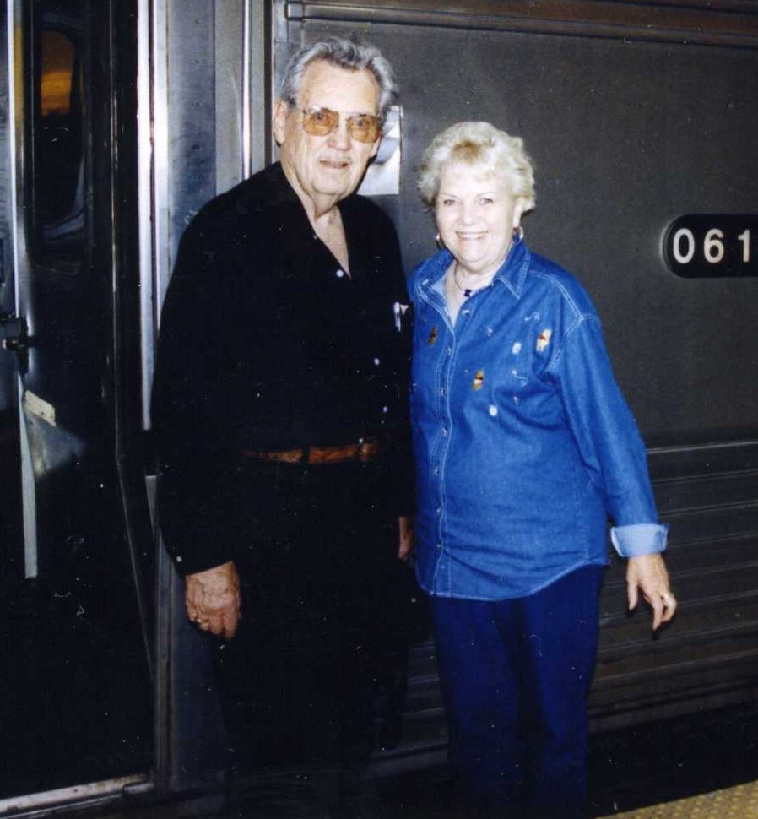Boarding the train
Kathryn and Richard were there to take us to Nauvoo. I will make this brief because there is no way I can tell all the wonderful things we saw and did. The wonderful spirit that we felt was thrilling as we walked the streets that the Prophet Joseph and Emma Smith and all the other great saints and many of our very own ancestors walked. To me, Nauvoo is a sacred city, I felt it.
OPPS! The Goodfellows lent us their van, and we had accommodations at the Nauvoo Family Motel; each with our own little family style room. Kathryn and Richard came over a couple of mornings and cooked breakfast for us. At that time the Nauvoo Temple was under construction and well on its way. We saw everything that we could see. We tried our hands at candle making, spinning, and rope making. We watched all the other things like bread baking in the old ovens, making soap, bricks, and even horse shoes.
Richard took us on a tour in his horse drawn bus. He worked with the horses. We visited most of the old homes that were so beautiful, Kathryn hosted the Heber C. Kimball Home. We drove over to the Cartage Jail where our Prophet along with his brother Hyrum were shot and killed.
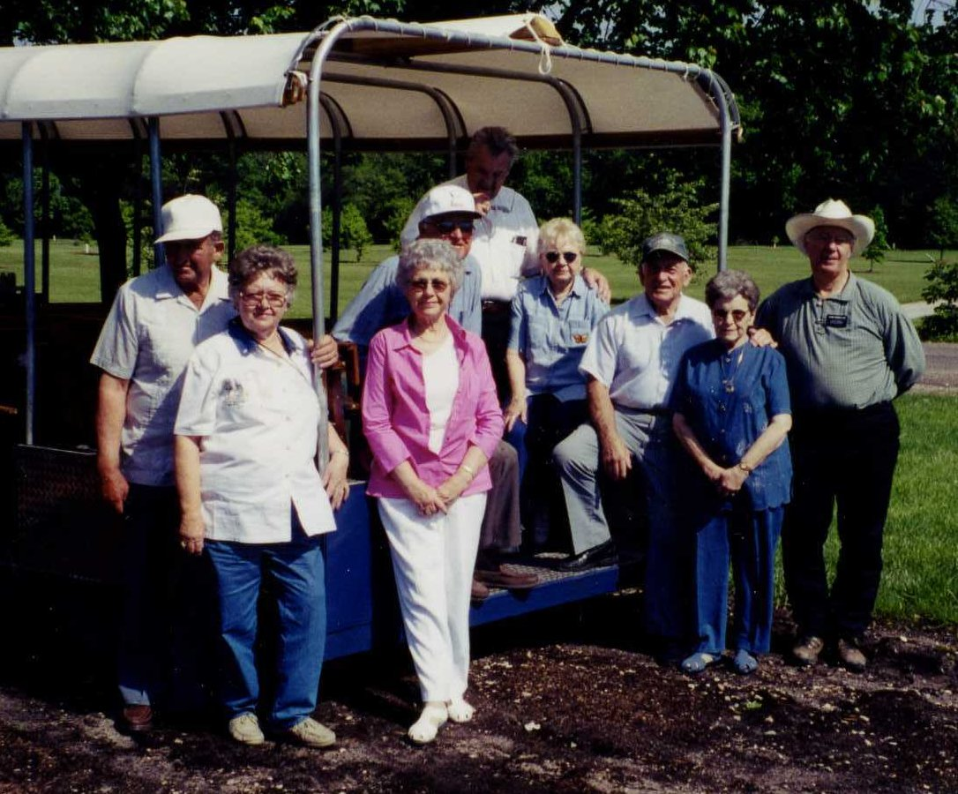Tour wagon in Nauvoo
We took a day trip over to Hannibal Missouri and saw the home of Samuel Clemens; also known as Mark Twain. On the way we were turned back by the flooded Des Moines River in Iowa. The Mississippi River was so wide and beautiful as it overflowed its banks. They took us to places most people don’t know about. Kathryn took us girls to a park one evening and I was so excited. It was beginning to get dark and the place became a glow with thousands of tiny fireflies. I had never in all my life seen fireflies; I thought I was in Fairyland again. I did seen glowworms in a cave in New Zealand.
May 17th was our last evening in Nauvoo. The missionaries always put on great performance on the weekends. We were able to see the Goodfellows in the play “Rendezvous” held in the Cultural Hall. After their last performance, they came over to our motel to spend more time with us. On Friday morning we all climbed back into the van and said our goodbyes to Beautiful Nauvoo with much sadness. The Goodfellows took us back over to Burlington to catch our train. We had a little time so Richard took us sightseeing before we said our last goodbyes to them at 7:00 p.m. on May 18th.
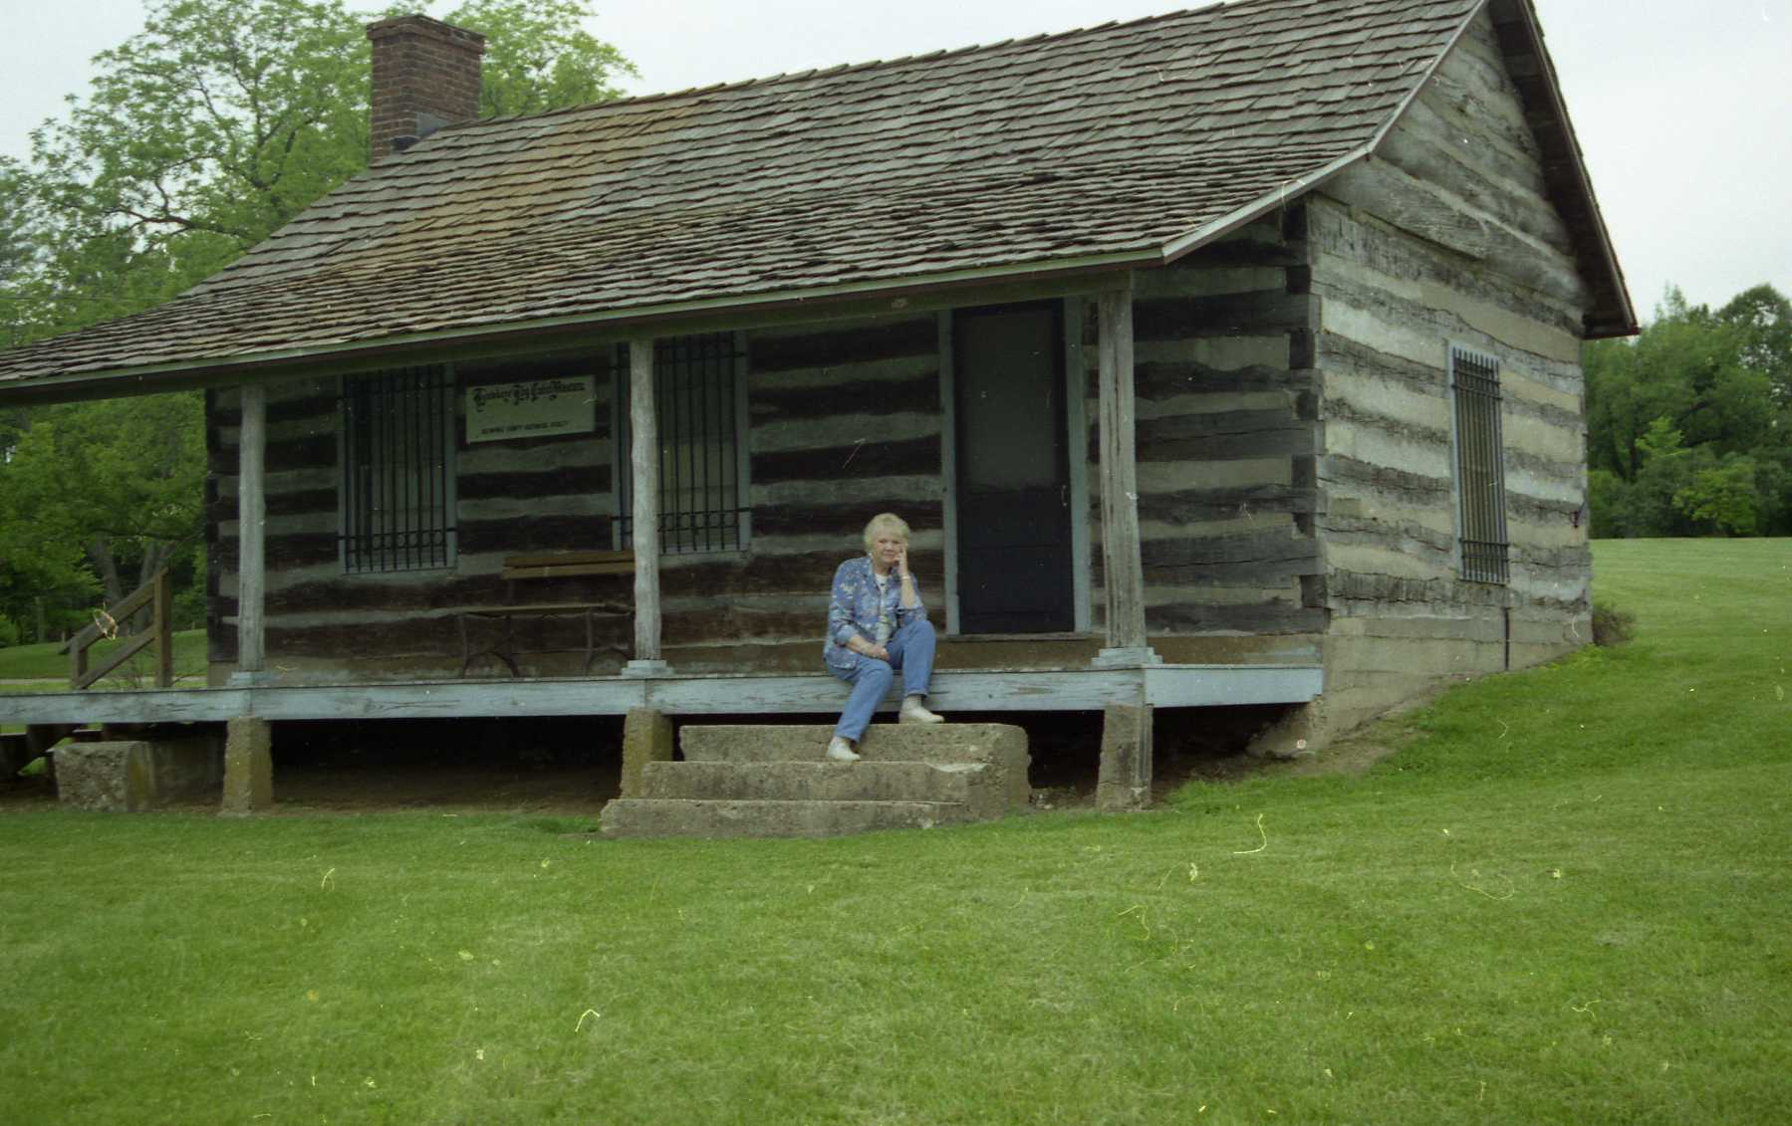Someone's dream home once upon a time.
I enjoyed the Amtrak ride. It would have been better if we had beds. Most of the country we passed through was nice but especially Colorado. We had a good trip back to Salt Lake City, arriving at 3:00 a.m. on Sunday morning. Scott and Judy were there to pick us up. We all crashed. After a little rest we headed back to Boise, it was nice being back home even if I did have a hard time leaving. What a wonderful dream fulfilled.
Good news: Cindee started a new job May 26th in the coding department at the Minidoka Memorial Hospital, where she had been working. She still had to take a lot of schooling, but she was a lot happier. We found ourselves back on the road, this time to Rexburg for Olivia’s graduation from Madison High School on May 24th. She was so happy and looked lovely in her cap and gown. Gordon and Bonnie had a family party for her at their home. Being that I had never worn a cap and gown, I put on Olivia’s and said that I had graduated from the “School of Hard Knocks”. Olivia was to start collage far away from home in Grand Junction, Colorado in the fall. A new school, a new home and new friends. She did great for never being away from home before.
Olivia's graduation
I was so grateful that we both had the health and strength to do the things that had to be done around here. We spent our time at home working in the yard, growing beautiful flowers, keeping the birds happy and doing projects that happened to pop up. Jack built a corner linen cabinet in the dining room. He also built cabinets in my utility/craft room.
Connie, Kellie, Kyle and Cindee came though out the spring and summer. Clyde was very demanding; he called and to ask Jack to go get him hamburgers at any given time of day. Jack even had to go over to help him go to the bathroom one day. So he is kept busy with Clyde.
We went to Music Week productions and other entertainment with Glen and Ada. I enjoyed going to lunch each month with the Ward Lunch Bunch and other ward activities. We still maintained our church callings. Our next door neighbor, Bonnie was killed in a car accident; she had a stoke while driving. We went to her funeral at the Jehovah Witness Church which was very different.
My little brother Gerald and Verlee returned from their mission in Ghana, West Africa. We went to their mission report on Sunday July 8th at the Burley 10th Ward. Besides Gerald and Verlee, their daughter Teresa also spoke. All three really know how to deliver a sermon; they all gave very spiritual talks. Irma and her daughter Shirley sang “How Great Thou Art”. That song always gives me goose bumps. It was so good to have them home, but oh what a special wonderful mission they had. They really loved those people and brought home some neat African art, and memories. They brought me a sweet little carved elephant that I treasure.
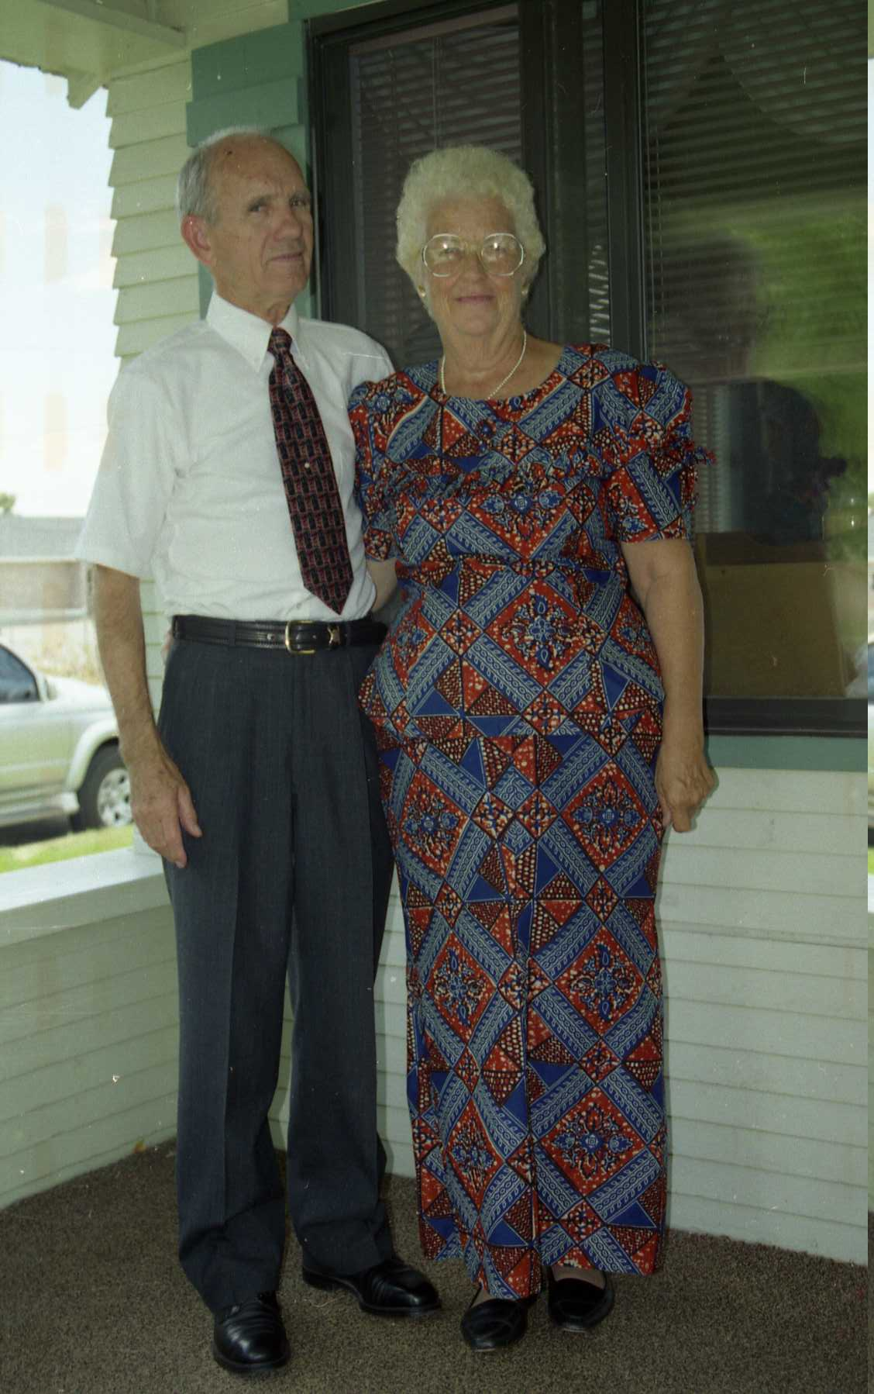Gerald and Verlee
Summer, means the Frost family reunion time, which was held on August 4, 2001 at the Unity Church park with the Harpers as hosts. The theme was “Let’s go to a Hawaiian Luau!” When the Harpers do something, it is big! What fun we had with some of the guys performing in grass shirts. I think Gordon was one of the funniest.
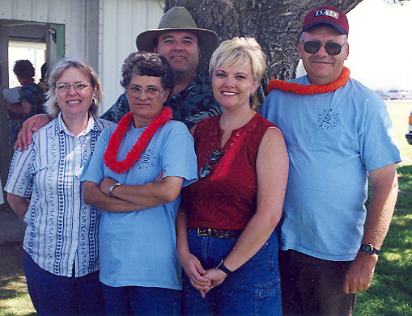Reunion 2001: Cindee, Melody, Gordon, Connie, and Tim
Did I say summer was reunion time, I guess so. On August 17, 2001 was also my 55th high school class reunion at Price’s Café for dinner, dancing, and pictures. Sunday the 18th we went out to the Grant Wyatt Ranch, where we had more food and a whole lot of chit chatting. It was always good to get back with old schoolmates.
The Minnesota Gilmour’s, George, Becky and Chad came to visit us on my 75th birthday on August 19, 2001, except they didn’t know it when they made their plans. That birthday I did not mind. We had a fun time, and cake. One more reunion but that was not all. The Frost cousins got together on Saturday, August 25th at the Burley Rotary Park boat landing at the golf course. My cousin Jack and Clara Olson planned and put it all together. I was surprised at so many of my cousins from all over showed up. Aunt Pearl and most of her family attended. All of us Frosts were there. It was really what you can call a reunion. We hadn’t seen each other in years. Everyone was excited to see each other and share family histories.
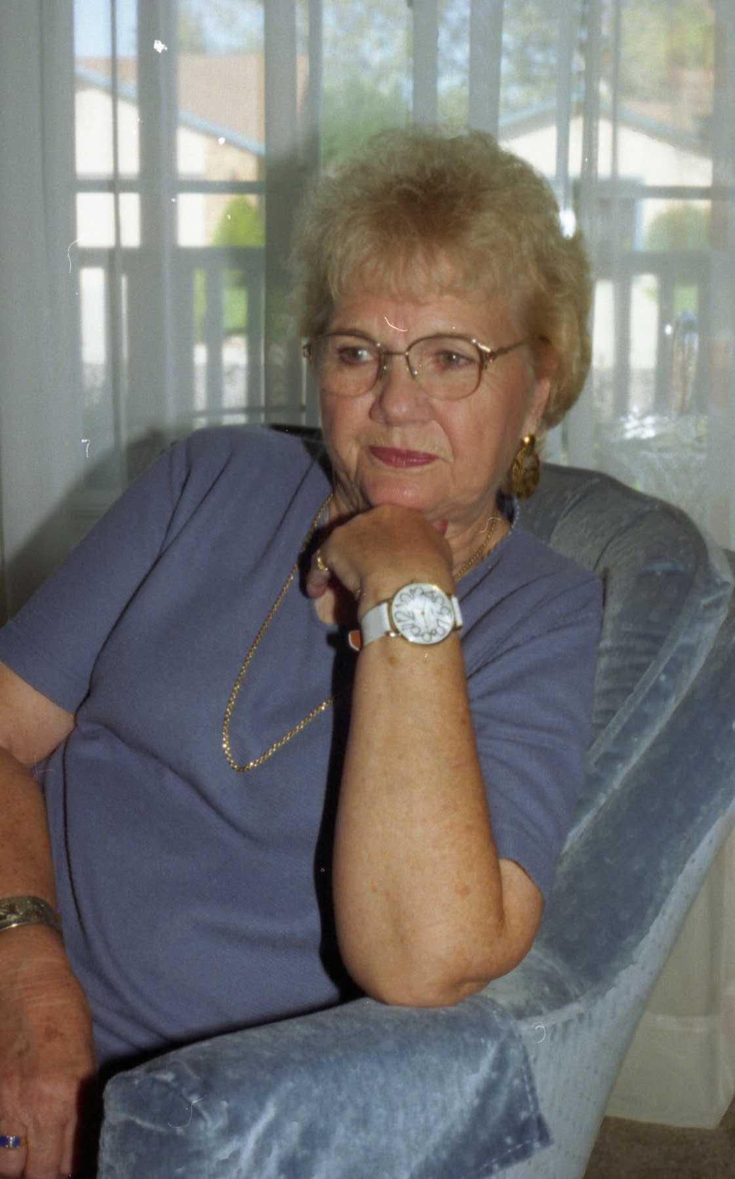75 years young
That very day we left for Seattle for a second mini Gilmour Reunion held at Lars' place. It too was nice getting together with his family again. During this trip we also meet a new found second cousin of Jack’s; Mary Jane Dumpster and her husband John. I think she was just as eager to meet Jack as he was her. She said, “It is sure neat to have a real cousin.” The Gilmour family, unlike the Frosts have very few relatives. How very, very, sad.
Actually, the first reunion we went to was in July when we went to Las Vegas for a submarine reunion for the crew of the Submarine Carp that Jack served on. About seventy shipmates showed up after fifty two years. They had an enjoyable time. Myself, I was bored; I did not know anyone and did not like Las Vegas at all, although we had very nice accommodations and food. We did not go downtown at all but we did drive out to see the Las Vegas Temple. It is very beautiful like all of our temples, but since it was Sunday it was closed. Can you believe that we attended five reunions that summer?
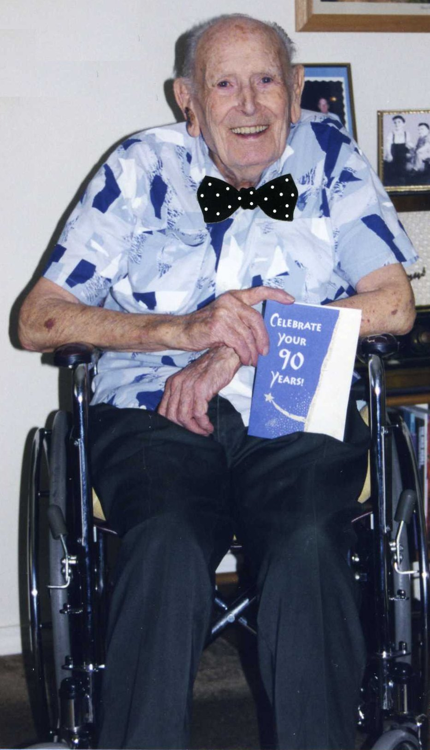Clyde at 90
Our dear, old Clyde turned ninety years old September 5th. I baked him a birthday cake and we got him a gift and took them over to his apartment in Meridian. He looked good and was one happy old dude. And yet, a greater birthday took place in Hailey, Idaho for my favorite aunt, Faye Dunlap, On September 23rd she turned one hundred years old. She was nearly blind, but she recognized me. Her family gave her a wonderful party at the nursing home that was her home. All of her family, Aunt Pearl her only living sister, and many of her children, and a whole bunch of us nieces and nephews helped her celebrate, and she was one happy lady.
Terror and Tears! On Tuesday, September 11, 2001 our great nation experienced the worse disaster in our nation’s history. A day America will never forget. Terrorists struck across the East Coast that morning. At about 8:45 am EDT (6:45am MDT) the first hijacked jetliner crashed into the north tower of the one hundred ten story World Trade Center in New York City, starting fires as the horrified nation watched on television. Eighteen minutes later, a second jetliner appeared low in the sky over New York City and slammed into the south tower, erupting in fire and smoke. Subsequent explosions caused both towers to collapse. A third hijacked jetliner hit and severely damaged the Pentagon across the Potomac River from Washington D.C. A hijacked United Airlines jet crashed outside of Pittsburgh. The passengers in all four planes were killed in an unprecedented, coordinated terrorist assault.
The World Trade Center
As I watched this on television, it reminded me of the fear and horror that I felt when Japan launched the sneak attack on the U.S. Naval base at Pearl Harbor, Hawaii, 60 years before. The White House, Congress and all federal government buildings were evacuated. The Federal Aviation Administrations ordered every flight in the United States grounded. The bombers were linked to Afghanistan-based Saudi dissident Osama bin Laden. There were 50,000 people who worked in the two buildings. People were trapped and many jumped to their death from the top stories. The official count of victims including New York, Washington, Pennsylvania, passengers and crew on the hijacked planes, and so many brave firefighter and police officers gave their lives to save others totaled 4,132.
It was such a horrible sight I hope to never witness again in my life. You cannot even imagine the horror that we saw during those next few days. This act lead us into a war against the Taliban in Afghanistan and the hunt for Osama Bin Laden was on. Which lead to wars through out the Middle East. That attack was the first war of the 21st century and is still going on as I am writing this in 2012. So many of our brave young men and women have lost their lives fighting a no win war. Those people hate Americans and want to kill as many of us as they possibly can.
Okay, we can dry our eyes now for some happy news. My little family increased on Saturday, fifteenth day of September 2001. On that day Michael Layne Dudley married Tatum Marie Miles at 2:00 o’clock at the Golden Heritage Center in Burley by the Mayor It was a really a cute wedding as the bride and groom choose to wear white T-shirts with BRIDE on hers and GROOM on his. Who would have thought of that? It was a nice afternoon wedding with family members in attendance. We not only added a new daughter-in-law to our family but her two children, Micah and Bradley Blacker, ages 9 and 7.
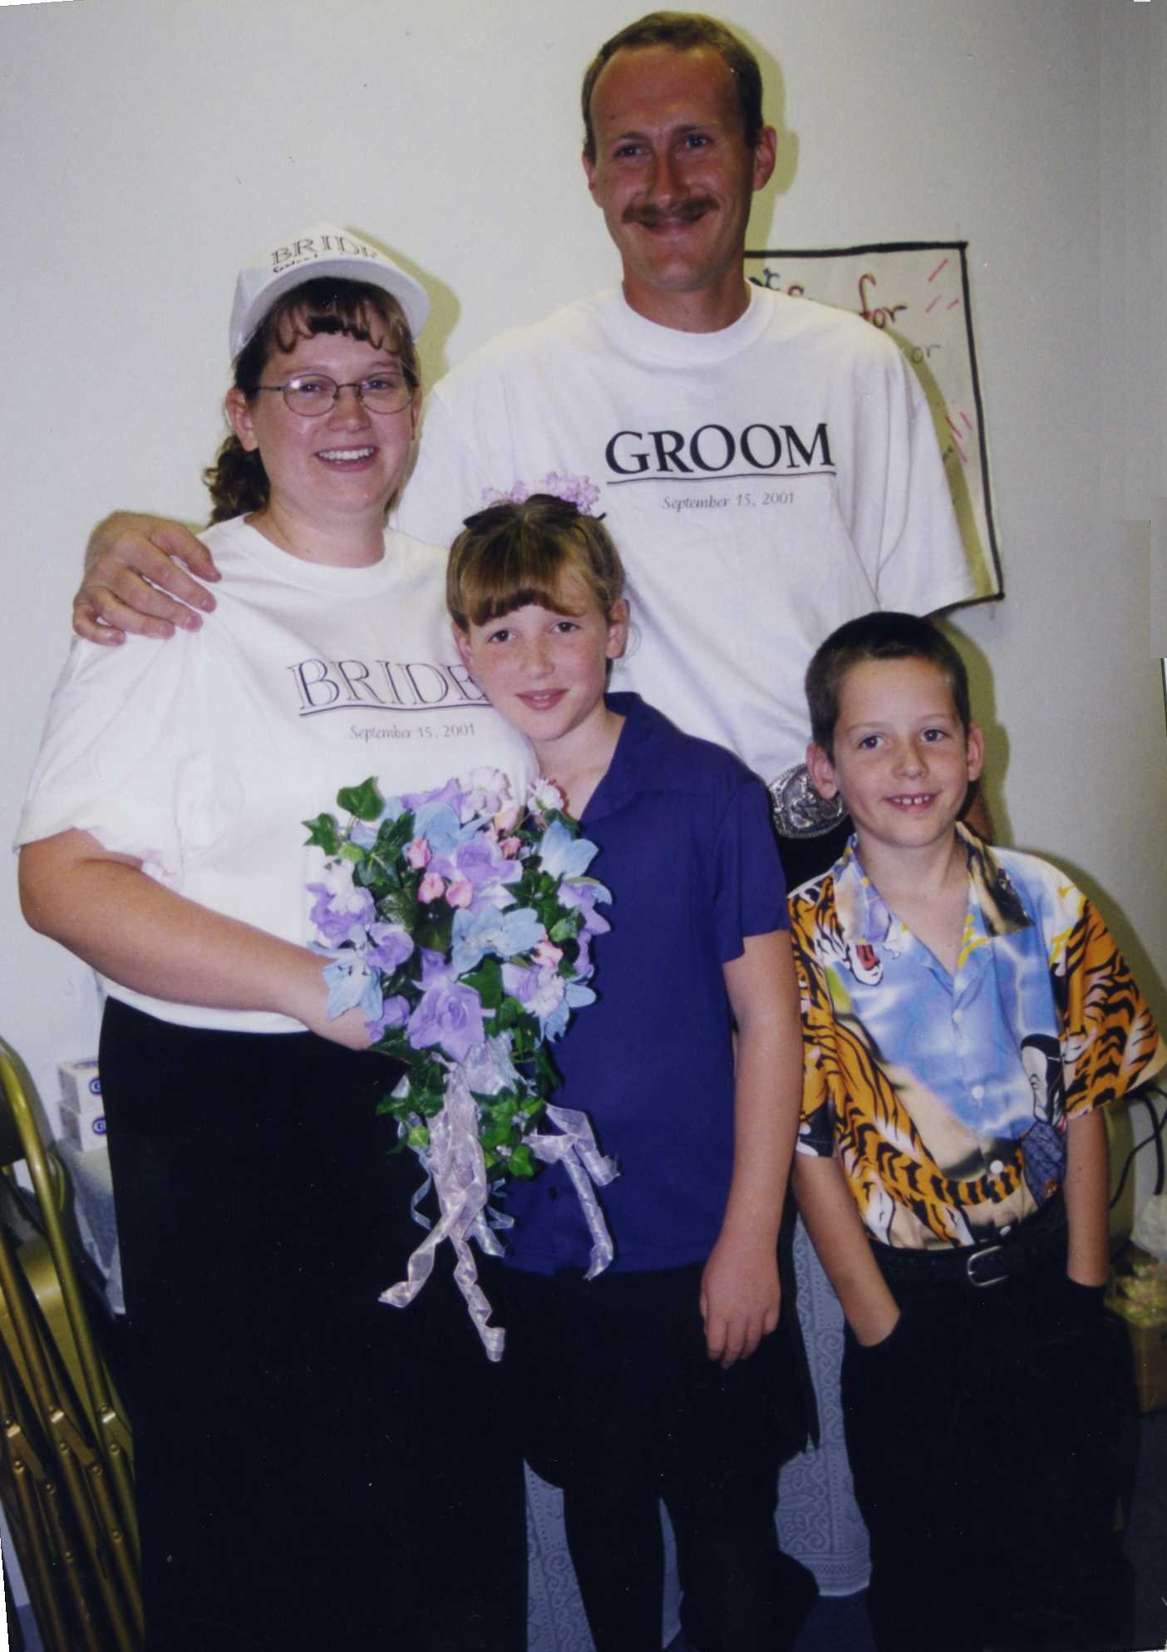Michael's new family
Before the summer ended we wanted to take one more little trip. We had heard so much about the town of Joseph, Oregon; we certainly were not disappointed. The welcome sign as we entered town read, “This little town Is HEAVEN to us. Please don’t drive like HELL through it”. The only disappointment we had was that most establishments were closed on Monday and that is the very day we arrived. We had to drive to the next town to get something to eat. It had a lot of history of Chief Joseph whom the town was named for. Also it was known for its bronze statues; there were statues of every description all over town. I think I took photos of most of them. I took pictures of two beautiful very unique churches. One was the United Methodist Church of Joseph. The other an L.D.S. church in La Grande that had the most beautiful stained glass window I have ever seen. We drove up to Wallowa Lake Village where deer roamed all over. Along our journey we encountered two amazing out houses, only they were not out back but in the front yards. We also took pictures of six old barns along our way down to Baker. There we took a side trip up to the ghost town of Sumpter. It was a very enjoyable three days.
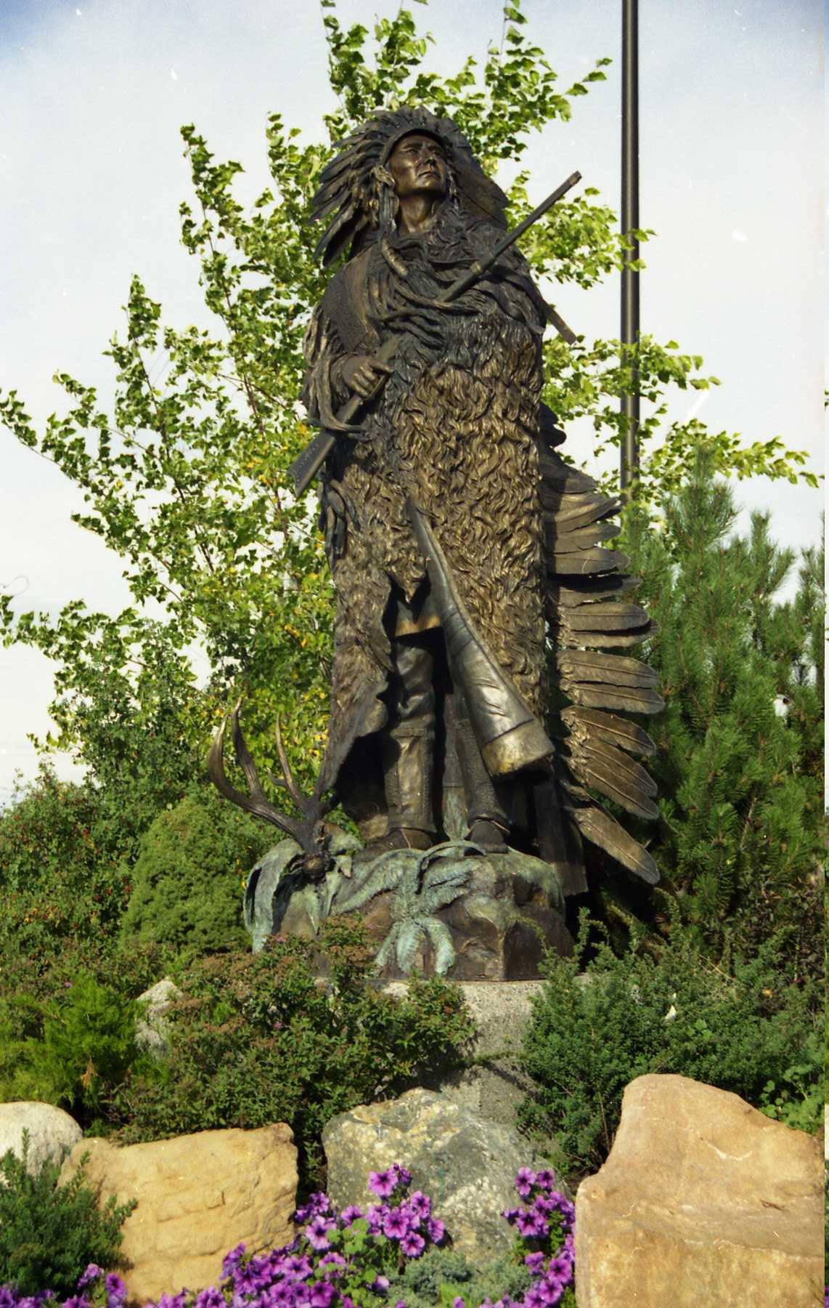Chief Joseph
Kathryn and Richard’s mission in Nauvoo came to an end and they returned to Burley hating to leave beautiful Nauvoo and their mission friends. We went to their mission report on the 14th of October 2001 at the Pella 2nd Ward where they both gave spiritual reports. Their son Rick flew in from Hawaii that morning bringing them lovely fresh flower leis. Their kids put out a luncheon for friends and family in the afternoon at their home.
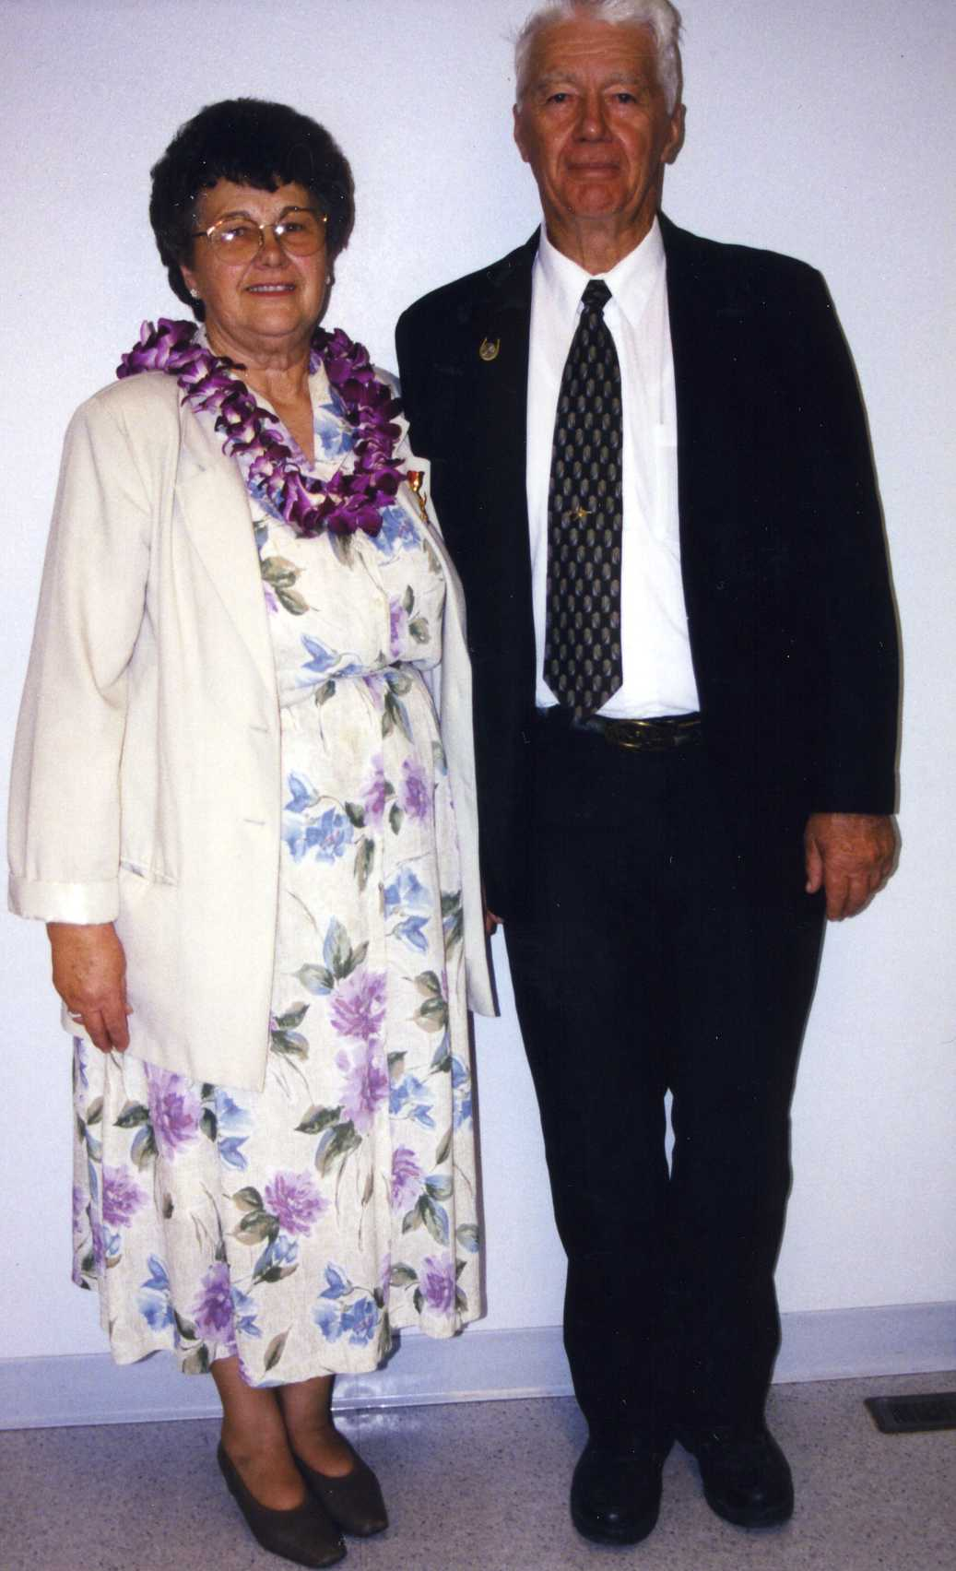Kathryn and Dick
Glen and Olivia both had birthdays as autumn rolled around along. With it was more bad news. In November, Gordon was laid off from his job at the Idaho National Engineering Laboratory where he had worked for eleven years. With nearly twenty years of experience as a computer programmer on his resume, he set out looking for a new job. He even had two or three interviews here in Boise, but nothing ever came of them.
Later in November was our 23rd wedding anniversary, followed by Thanksgiving. “We thank you Lord for all the blessing of 2001, for family and friends and turkey dressing”. Cindee and Steve were here for Thanksgiving dinner. We fixed the traditional Thanksgiving dinner with all the trimming and leftovers.
We had our Frost Christmas dinner and party out to Malta at the Marian and Doug Harper home the first week in December. What more can I say? We just have the best of everything; all of us being together as a wonderful loving family. We missed Eunice, she could not make it and her illness was serious enough to put her in the hospital. We had a wonderful dinner, lots of chit-chats and most of all the darling handmade gifts that we exchanged. We drove to Burley and stayed with Lorna and Kenneth that night and drove back to Boise the next day.
My niece Romona (Read) and Wayne Merrill were here the following Friday and stayed overnight as they were on their way to Kennewick Washington. They clued us in on how Eunice was doing. We celebrated Jack’s 75th Birthday in the usual way; dinner out. The rest of the month we spent doing our Christmas things. Decorating the house and yard, baking goodies to give away, and sending out Christmas greetings. We went to all the ward parties and dinners and just spent Christmas Eve and day playing Santa Clause to each other. Between Christmas and New Years we had a big snow storm that dumped a great amount of snow. Jack’s work was cut out for him shoveling the walks and driveway. Well, So Be It! 2001 with its sadness and joys left us for new beginnings.
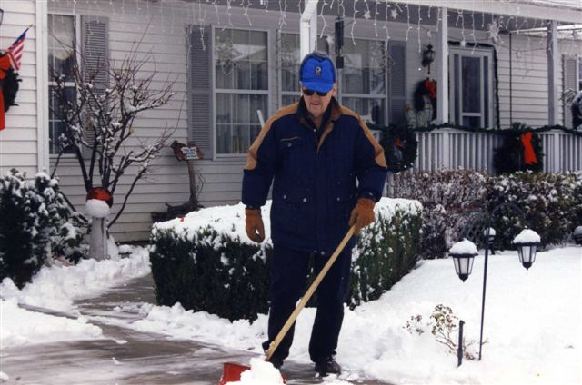Holiday snowstorm

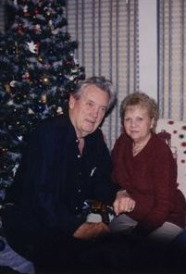Christmas 2001

