Chapter 10 1955 – 1978 The Declining Years
But there came a day in April of 1955 when the life style of Ira took a drastic change. As Vyla went into the barn she was shocked to see her hard working husband stricken and down on the floor of the barn unable to get up. With the help of Wayne Call and Bernell Stout, (neighbors) they took him to the hospital where it was confirmed that he had suffered a bad stroke. His recovery was to be slow and the beginning of his declining years. He was to find that he would have to be content to slow down. His life itself was in critical condition for several days.
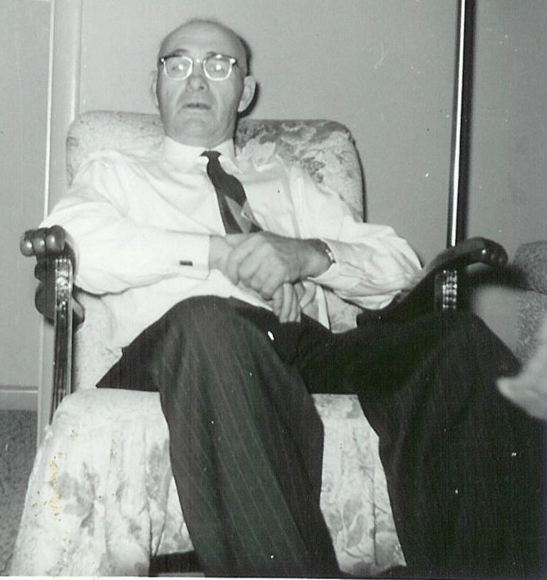Ira in 1958 at age 67
After coming home from the hospital, he was unable to get out of bed for quite some time. Kenneth and Don took over the farming and dairy work for the rest of the year, and Kenneth and Lorna moved out with them. The nice things that happened that year included five more grandchildren; Dennis Lindsay, Jaylynn Jackson, Dianne Harper, Gordon Buttars, and Rick Goodfellow.
In November of 1955 Ira wrote a letter to Gerald, who was still in the mission field, and read as follows:
Dear Son, I am going to try to write you a line or two tonight as ma has been trying to get me to write you. It feels like I am trying to write left handed. It is just like drawing I have to go so slow. I am afraid this will be an awful short letter. We got a letter from Eunice tonight telling us of Pres. Frisbys death. She and Thelma sent a bunch of flowers and put Elder and Mrs. Gerald Frost's name on them. Well, Don and Irma is milking one of the heifers this winter. Can you imagine me not able even to drive the car? I have sure let the place go to rack, I think well I'll do this or that, I can't even drive a nail. I have a black thumb nail now because I thought I could. . . Well, if it takes you as long to read this as it has for me to write it it will be equal to a long letter by the time you get it figured out. This is the first time I've written since I came home. I go without my cane now. Can you imagine me on a cane? Dad...
With Ira unable to do much, it was with a great deal of happiness that he welcomed Gerald home from his mission and he took over the farming for that year (1956). The grandchildren kept coming and this year it was Ramona Read, Clyde Lindsay, Charlotte Frost, and Patty Harper. For many years, Ira had talked of building a house on the hill overlooking the Snake River. The children had heard many times, “. . .when we build our house over on the hill. . ." The time had now come for this dream to become a reality, and after weeks of planning, the final arrangements were complete and a small home to their liking was built. It was a special day in Ira and Vyla's life to finally be able to move into their new home "over on the hill". Then began the work of planting the lawns and landscaping to make it the place they had dreamed of. Ira was able to do a lot even though he wasn't able to work as hard as he used to.
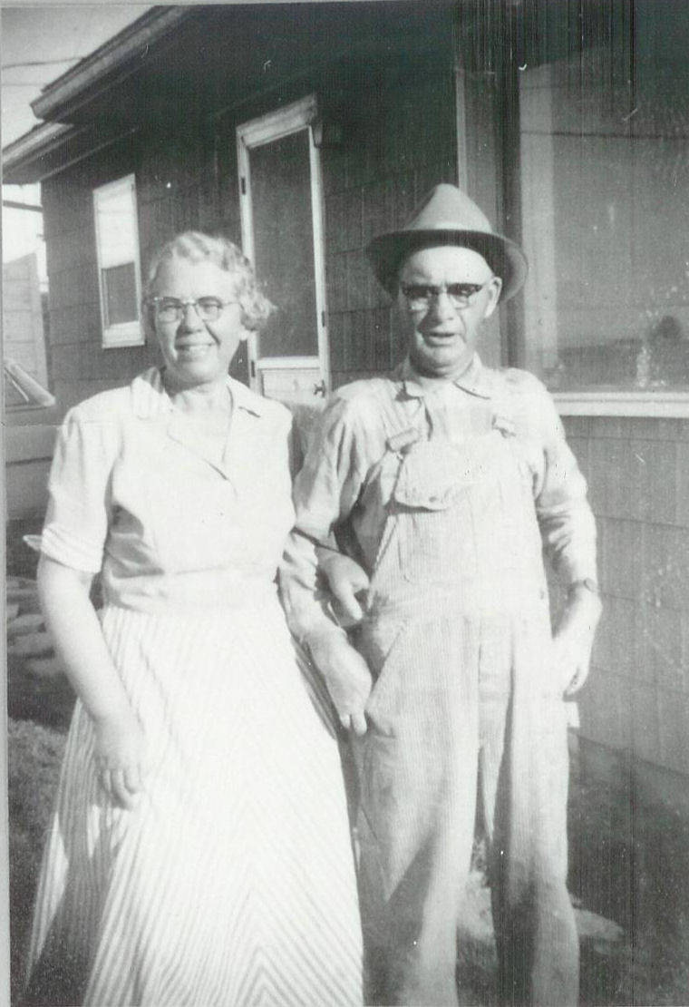Vyla and Ira - 1957
He loved his little grandchildren and played with them and was getting so many he could no longer hold them all on his lap. They did bring great contentment to him, so when 1957 saw Cindee Buttars and Guy Goodfellow make their appearance to join the others, he was real pleased. Don farmed the place that summer and in the fall, Ira and Vyla Made final plans to sell the farm to Kenneth and Lorna. Ira had always hoped that Gerald would take it over, but he had other interests and had moved to Salt Lake.
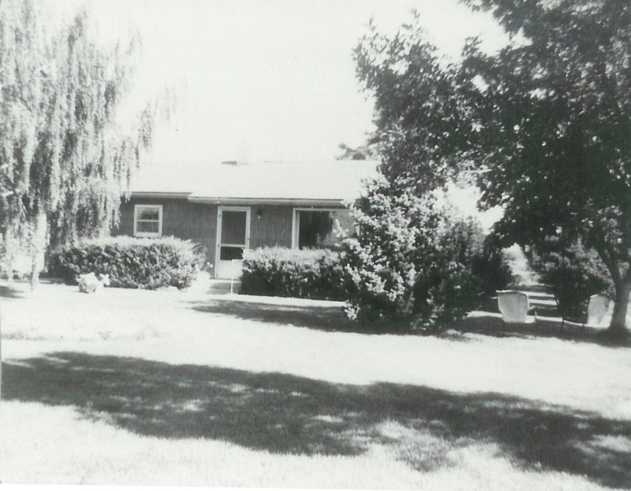The house on the hill
Mother Dayley had moved over by their new home and lived there until her death in December, 1957. In his retirement, now that the farm was sold, Ira had a chance to enjoy fishing, studying the scriptures, reading and being around his posterity. In 1958 four grandsons were born; Roger Turner, Ron Harper, David Read, and Kirk Lindsay. The children began to scatter. Eunice, Thelma, and Gerald and their families were living in Salt Lake and Irma and Don had moved to Idaho Falls. The rest all lived close by in the Burley area.
Ira was ordained a High Priest in on November 22, 1959 by Wallace L. Baker. With Irma and Don living in Idaho Falls, Ira and Vyla took advantage of their living close to the temple, by attending many sessions while staying with them. This gave him a chance to feel that he was doing something worthwhile. He truly had the spirit of temple work, loving all the time he spent there. There were also trips to Salt Lake to see the families there, and going to the temple. One special trip was with Wilson and Eva Warner, in which they went to Salt Lake to the genealogical library and to the temple. Then they went to Manti where they visited some relatives and went to the temple. They saw lots of beautiful scenery and reminisced of old times they had spent not far from there. They stopped in Salt Lake on the way back and on to Logan before returning.
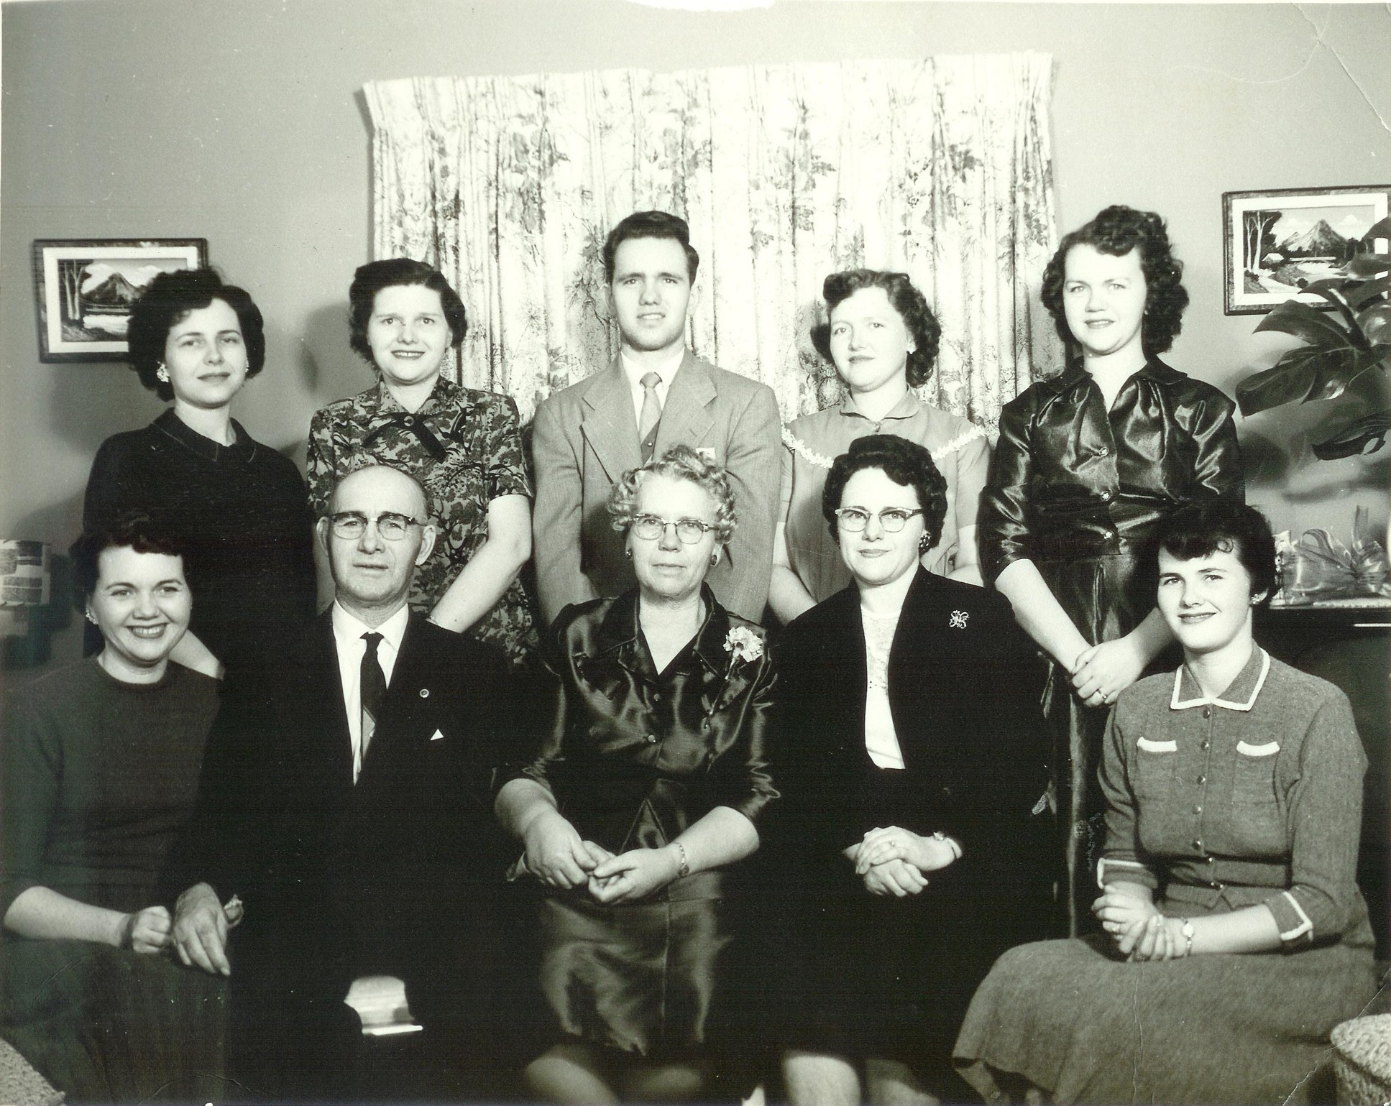The Frost Family - 1957. Standing: Lorna, Eunice, Gerald, Marian, and Irma. Seated: Celia, Ira, Vyla, Thelma, and Kathryn
The family had frequent gatherings and just good times, as they went to see the folks, sometimes showing off new babies; it was Debbie Lindsay in 1960 . . . Connie Buttars and Shelly Goodfellow in 1961 . . . Stan Turner and Teresa Frost in 1962 . . . Darlene Harper, Gwen Goodfellow, and Kevin Lindsay in 1963 . . . and Brad Turner in 1964. When Gerald and Verlee moved back to the area and built a lovely home next to theirs, Ira and Vyla were content. Kenneth and Lorna had also built close by, and it soon became a friendly and convenient neighborhood for helping each other and for the rest of the family to gather for good old visits. Gerald and Verlee were so excited in 1965 to show off their little newly adopted two year old son, whom they named Myron, and also two other new grandsons were born that year, Craig Lindsay and Shane Goodfellow.
Ira suffered another stroke which weakened his condition even more and he spent most of his time sitting in the yard. He was given a walker to help him get around. A railing was fixed by the front door to enable him to help himself down the steps. He would frighten everybody at times by going too fast a pace with his walker and just drag it behind his feet, nearly stumbling and falling. It was hard to see himself becoming an invalid, but he made the best of the situation and still was able to go on short fishing trips to Sublett and Lake Cleveland. Bela Rigby was one of his best fishing buddies. Vyla often went along also. In 1967 Kristin Harper was born . . . 1968 Wes Lindsay, and Stacy Frost were the newest arrivals; in 1969 R.J. Lindsay came along with Kelly Frost the next year and Corrinne Harper in 1971. This made a total of forty-eight grandchildren for Ira and Vyla; and now there were great-grandchildren coming into their lives, also.
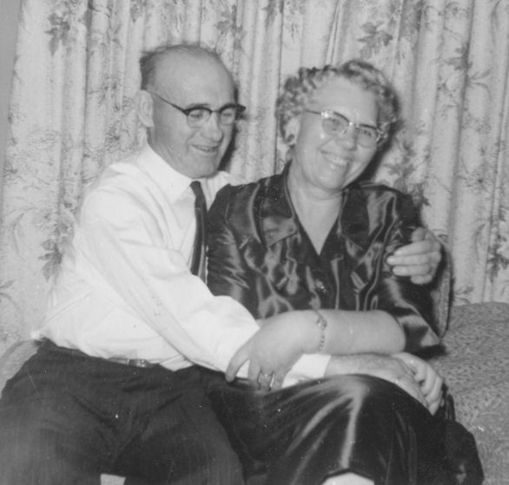Ira and Vyla after another stroke
A Golden Wedding Anniversary celebration was held for Ira and Vyla by the family on December 4, 1970 at the home of Kenneth and Lorna Turner. Many friends, neighbors and relatives came to the open house to wish them well. Though he was not able to communicate as much as he'd like with those who came to see them, he was happy with all the love and attention to he and his bride of fifty years and it was a pleasant day for him.
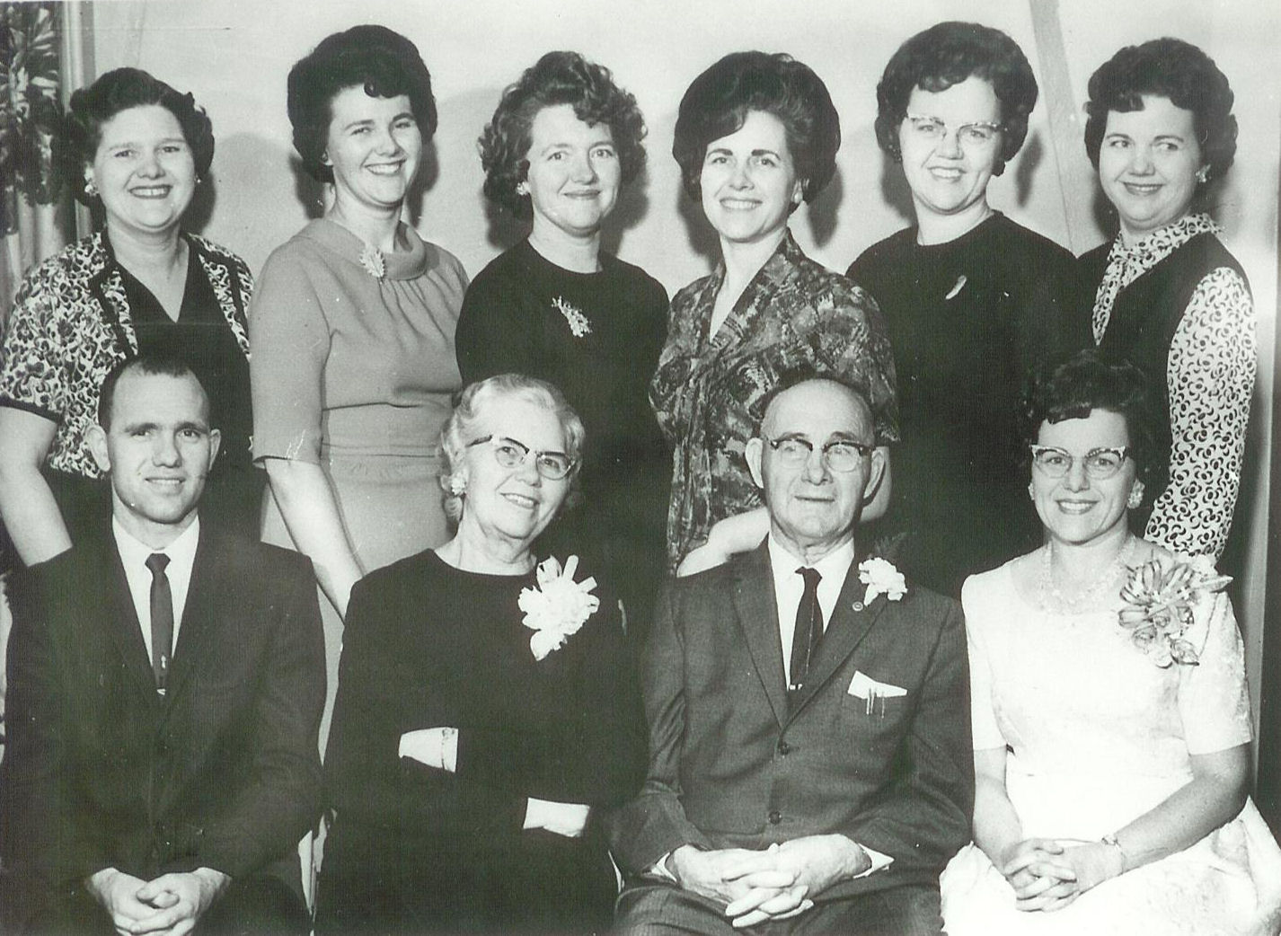The Frost Family - 1965 Standing: Eunice, Kathryn, Marion, Lorna, Irma, and Celia. Seated: Gerald, Vyla, Ira, and Thelma.
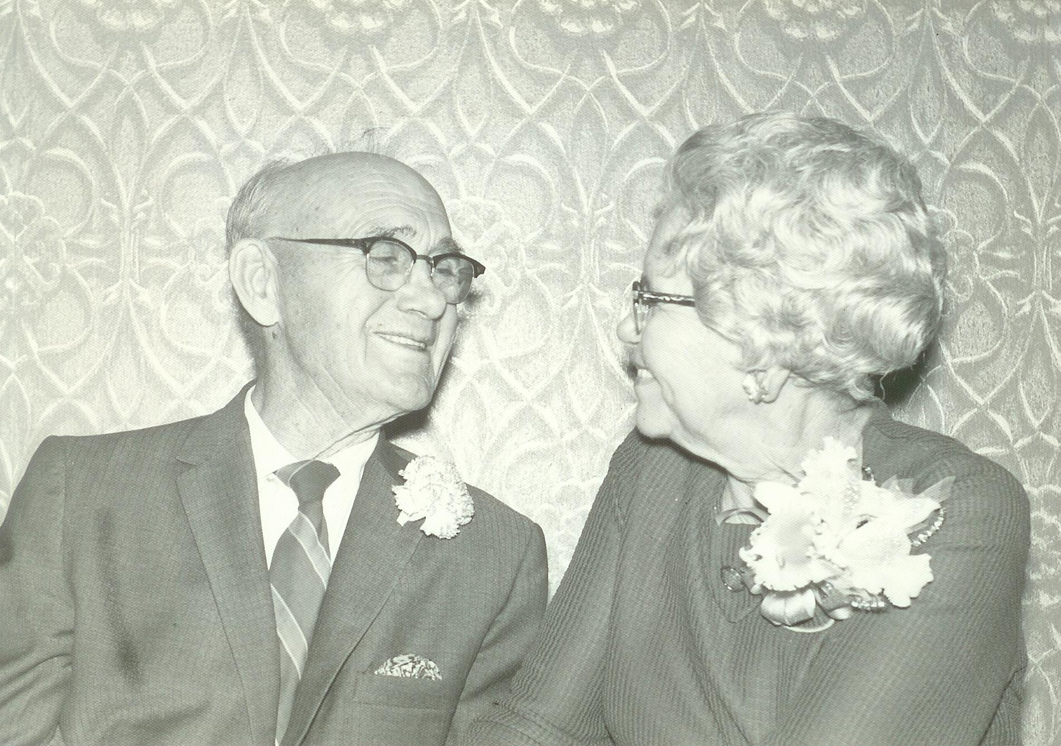Ira and Vyla on their 50th Anniversary
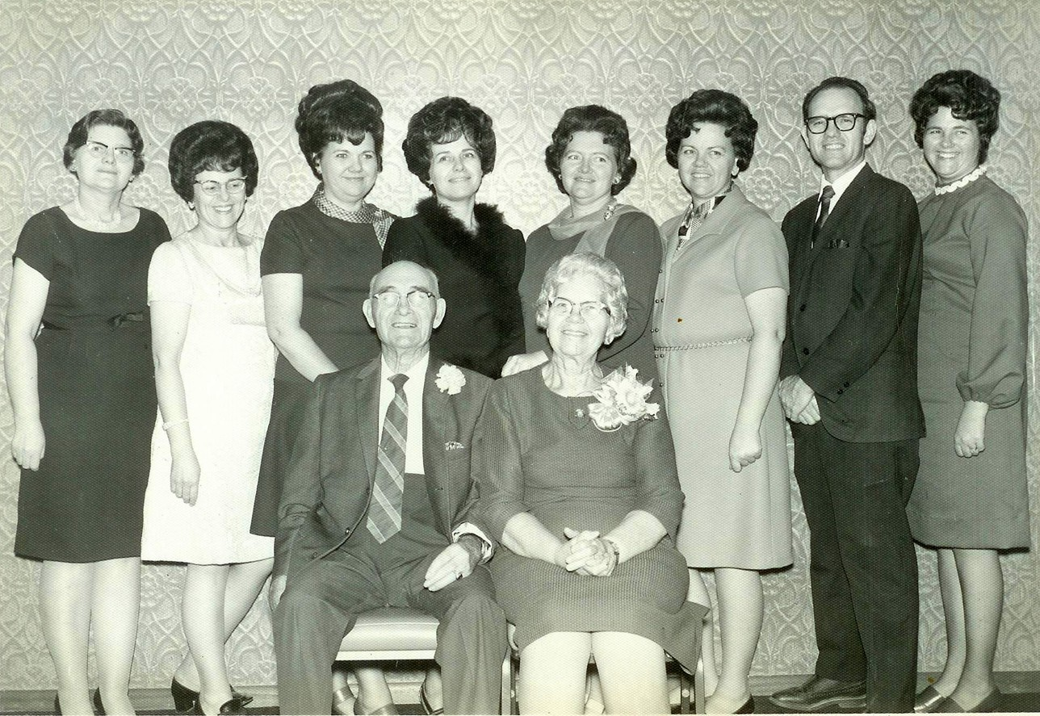The Frost Family - 1970 Standing: Eunice, Thelma, Celia, Lorna, Marian, Irma, Gerald, and Kathryn. Seated: Ira and Vyla
After another stroke and with Gerald having sold his home and moved into Burley, Vyla was finding it more difficult to help Ira into and out of his wheelchair and bed. Ira was becoming less responsive to things about him. It was Vyla's decision to move into Burley near Gerald and the Lindsay family (who had moved back to Burley) so they could assist her. They moved into a house next door to Lindsays and only a short distance from Gerald's. At the time Celia and her girls also lived just down the street.
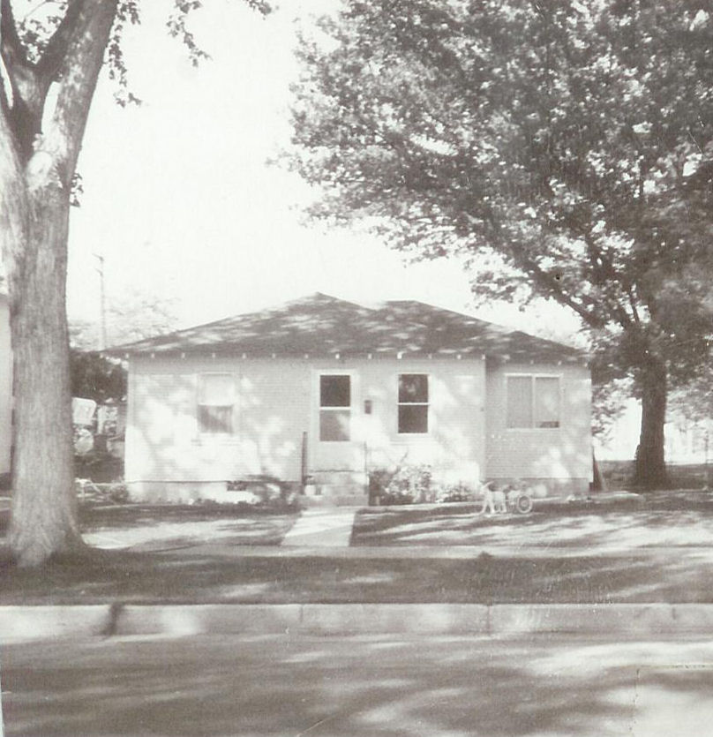The house in town
From then on, Ira spent most of his time in the wheelchair. He gradually became more helpless and as the time went on, he had only short outings when he could be moved into a car. His sweet wife was so very attentive to his every need all those years. She would hardly leave him for any length of time, and when she did, leave, she was anxious to get back to him. His last five years were spent almost as a total invalid, being in bed most of the time. He would be placed in the wheelchair for awhile each day, but he didn't seem to care if he was there or in bed. He was unable to respond to the family, though they all showed their love for him and visited and talked to him frequently. It is believed by the family that he did understand a lot of what was said, but was just physically unable to show his response.
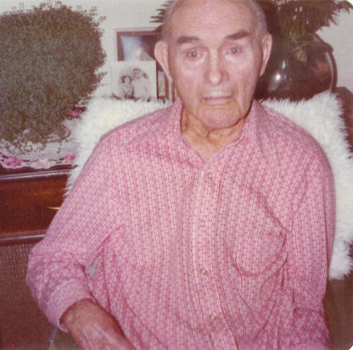Ira - January 1978, just before his last illness.
In January of 1978 he became ill and was taken into the hospital where he was in critical condition. Vyla spent most all of her waking hours by his side, with other family members coming and going at all hours to see him. It was on January 29 that he seemed to be nearing his final hours of this life and at about 9:15 p.m. Sunday evening, he passed away, peacefully, with Vyla and all the children by his side, except for Celia who lived in California. Also most of the in-laws were there and three of his grandchildren.
It was a spiritual experience to see this great man, this devoted father and husband, this spiritual giant of a man as he slipped into the spirit world into the arms of loved ones on the other side. He had just completed another step in the eternal plan of progression; a life lived that was an example to all who knew him. The suffering of the past few years was now over, and the tests of this life had been completed. Ira had returned home and the angels that rejoiced and sang at his birth must have rejoiced in a similar manner as they welcomed him into his new abode, where suffering and pain, trial and heartache were now gone forever.
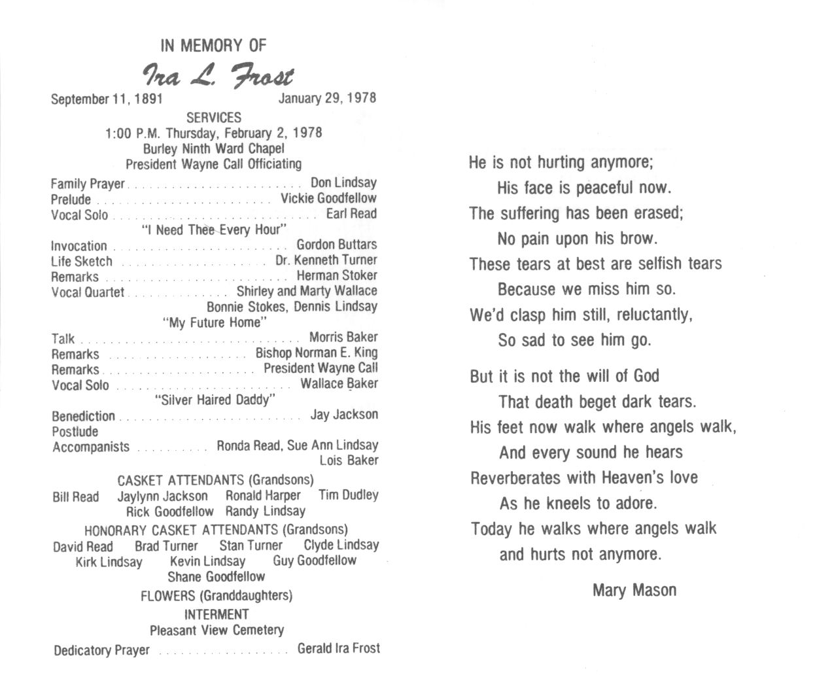
Ira L. Frost was truly an example of a life well led. It behooves each of his posterity to so live that they may join him in the eternal worlds, and see him, not as an invalid, but as a dynamic and intelligent son of God, taking his rightful place as Patriarch and leader of his posterity. As of this writing, October 15, 1979, Ira L. Frost's posterity consisted of nine children, forty-eight grandchildren and thirty-nine great-grandchildren.
* * *
Vyla lived nearly sixteen more years and died December 26, 1994 in Burley. They are both buried in the pleasant View Cemetery in Burley.

