JOSEPH MAURICE GODFREY
3 June 1874 – 24 May 1912

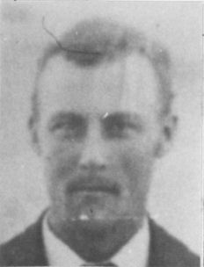
Pioneer life was always faced with uncertainty. One thing that was certain was adversity and sorrow. It was a cold November day in 1881 as family, friends, and neighbors gathered in Clarkston's old rock meetinghouse for the funeral of a young mother taken from her family in death. Seated on the front row was the bereft husband with his four children. Three days earlier, the day she died, was their wedding anniversary. Now he was burying his wife of sixteen years.
This wasn't the first time that George Godfrey attended the funeral for a loved one. Over a period of twelve years, He and Emily had buried four children. The most recent only two weeks earlier. Emily had suffered from the complications of childbirth. Her condition worsened until the 26th of November when she passed away at the age of thirty two. The fresh grave of baby Mary Rose was reopened and the two were laid to rest in the same grave, with Mary Rose's small coffin placed on top of her mother's bier.
George, took his four children home with him to press forward with life. Annie was the oldest at fifteen, Joe was ten, Harry was five, and Sadie was three.
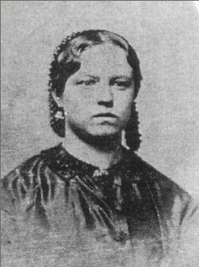Emily Gover Godfrey
This is the story of Joseph Maurice Godfrey, who was born on June 3, 1874 at Clarkston, Cache County, Utah. He was the eldest surviving son of George Godfrey and Emily Gover. At the time of his birth all of his grandparents were still living, John and Mary Pittaway Godfrey and Maurice and Sarah Tucker Gover were all converts to the Church of Jesus Christ of Latter Day Saints from England and had immigrated to the Territory of Utah in 1862 and 1853 respectively and eventually settled in Clarkston.
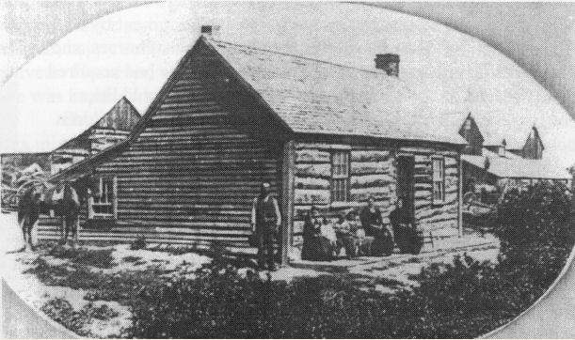The George Godfrey home in Clarkston
George was born in Worcester, Worcestershire, England on January 24, 1845. When he was sixteen years old he was sent to America ahead of the rest of the family. He bought a piece of property in the Salt Lake Valley and built a log cabin by the time the rest of the family arrived a year later. Emily Gover was born June 18, 1849 in Abersychan, South Wales where her father worked as a coal miner. George and Emily were married on November 26, 1865 and made their home in Salt Lake City where their first two children were born; Martha Ann (annie) (22 October 1866) and Emily Sarah (4 December 1867 – 16 February 1869). In 1869 they moved to Newton for a few months were another child was born; George Henry (17 December 1869 – 20 August 1870). Then in 1870 George and Emily moved to Clarkston.
George was a farmer and the family lived in a four room log house. It was in this home where the rest of the children were born; John William (28 August 1871), Joseph Maurice, who went by Joe, Henry Morris who went by Harry (5 November 1876), Sadie Emily (14 April 1879), and Mary Rose (12 November 1881) who died the day she was born.
When Joseph's mother died, the burden of caring for the family fell to Annie (Martha Ann). After nine months she eloped with Alfred Sparks. With Annie gone, George's younger sister Catherine, who was nineteen years old at the time came and helped for a while.
Two years later George obtained a housekeeper, Elizabeth Zaugg. She was a young twenty year old convert from Switzerland. She was a wonderful cook and housekeeper, and very good with the young children. On March 1, 1883 George and Lizzie were married in the Salt Lake Temple.
She and George had nine children of her own. On July 6, 1888 George also married Eliza Pack, also a young convert from England. She had eleven children. Joe had eleven half brothers and nine half sisters in addition to his natural brothers and sisters. All together George was the father of twenty eight children, eight of which died in infancy. As young boys, Joe and Harry went into the canyons to get wood, enough for both families to cook with and heat their homes. Eliza lived one block away in the upper part of Clarkston.
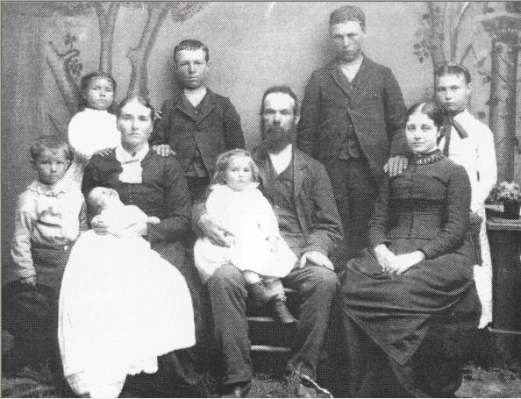The George Godfrey Family - 1889 Standing: George Jr, Barbara, Harry, Joe, and Sadie. Seated: Elizabeth Zaugg holding Albert, Joe with Lettie on his lap, and Eliza Pack. (George Jr., Barbara, Albert, and Lettie are the Children of Elizabeth. Harry, Joe, and Sadie are Emily's children. Eliza hadn't had any children by the time this photograph was taken.
Joe and Harry worked on farms for other men. On the headers at thrashing time they could earn a dollar a day. Some days they got two bushels of wheat for their pay at thirty five cents a bushel. They took the cows to pasture and at times had to herd them.
Joe and Harry went hunting in the hills, played ball, horseshoes and marbles. They went fishing in the neighboring streams and in the Bear River. On the 4th of July they had foot races, horse races, and tug of war with ten or twenty men and boys on either end. The cheering of the spectators made it more interesting. Girls gave candy pulls, inviting their favorite boy friends hoping they would walk them home after.
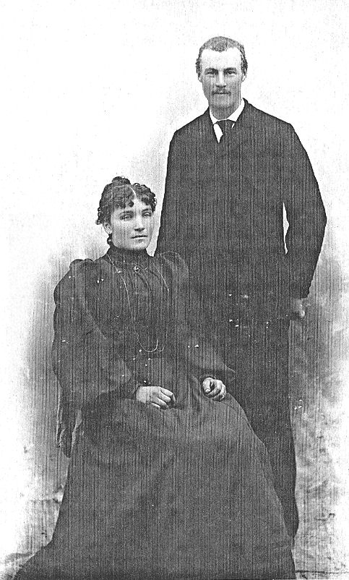Mary Eliza Barson and Joseph Maurice Godfrey
On June 10, 1897 Joe married the lovely Mary Eliza Barson in the Logan Temple. At the time of their marriage Joe was twenty three nd Liza was twenty four. Liza who was born on January 10, 1873 in Salt Lake City was the daughter of Peter S. and Mary Ellen Scott Barson.
Joe and Liza's home was a pretty two room red brick house with a big bay window on the north. Liza was a good housekeeper and cook and their home was a happy one. Large trees surrounded their home. A nice lawn was on the north side of the house and flowers all over made the place attractive. Virginia creepers covered the front and side of the house. There was a big barn and a nice granary.
Their first child, Mary Eliza was born April 10. 1898. She was named after her mother. On April 22, 1901 Ervin Joseph was born but only lived nineteen months. Emily was born November 30, 1903. Emily was named after her father's mother, Emily Gover. On November 20, 1907 Ervil was born and four years later Alph was born on October 19. 1911. This happy family really enjoyed life.
The first water works system was built in 1908 and the big red brick church and the yellow brick school house in 1910. Joe and his brother Harry were very busy with their teams and wagons hauling sand and gravel for these projects and others. They used their horses to pull scrapers to dig the foundations and basements. There were no tractors or big equipment in those days. The also hauled the gravel to build the roads to Trenton and Newton.
Each year the men went together to clean the irrigation ditches leading into town to water the farms and gardens. They were given credit for hours worked to help pay their water bill. While the men were cleaning ditches, the wives got together and made the best supper ever.
Joe was such a pleasant, happy man who loved his children dearly. He was very quiet and retiring in nature. His eyes had a twinkle in them and he usually had a smile on his face. His brown hair was extra curly.
The Joe Godfrey home about 1908; The little girl with the doll is Emily, Liza, Ervil on Joe's knee, and Mary on the horse.
He was always hitching up the team to the wagon (or sleigh in the winter) and taking his family down to see Ma and Pa Barson. The whole family called their parents Ma and Pa. Never Father or Dad. Mother or Mom, just plain old Ma and Pa.
This happy world crashed in May 1912 when Joseph became very ill with spotted fever. He smoked quite heavy and his lungs were too week to overcome the fever. Liza's uncle, Dr. John Barson from Joplin, Missouri. was in town visiting his brother, Peter S. Barson. He used all of his skill to try to save Joe. Liza wore herself out caring for him so her brothers and their wives took turns helping her.
By the 24th of May his condition seemed so much better that Dr. Barson decided to climb the mountains west of town to the top of Gunsight. Effie and Hyrum Barson (Liza's Brother) were taking care of Joe when he quietly passed away at the young age of 38. The entire family was so sad. In those days there were no mortuaries so kind neighbors prepared the body for burial. It was considered an honor to be asked to sit up all night with the deceased person and a coal oil lamp. The newest white top buggy in town had the back seat removed for use as a hearse.
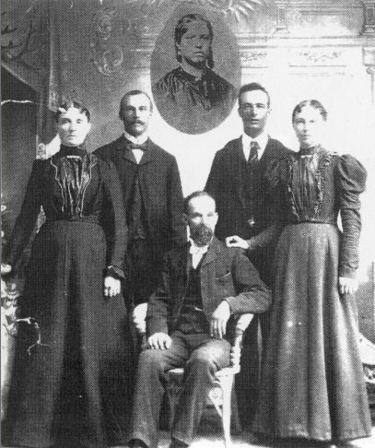The sons and daughters of George and Emily Gover Godfrey. Left to Right: Annie, Joe, George (seated), Harry, and Sadie Insert: Emily Gover Godfrey.
Dr. Barson and Aunt Fanny were very impressed with the beautiful way the Mormons laid their loved ones to rest in their white clothes and temple robes. They thought the services were impressive and comforting.
So, the cycle of sorrow continued. This time the funeral was for Joe, with Liza and sitting on the front row of the chapel with their four children. Mary was fourteen at the time of her father's death. Emily was ten, Ervil was four, and Alph was only eight months old.
Only twenty years later, the cycle was repeated as Mary Eliza passed away leaving a husband, two little boys and the baby that she bore the day she died.
Joe and Liza had been married for just under fifteen years. Determined, Eliza raised her family alone and lived as a widow for the next twenty eight years until she died suddenly on November 13, 1940 at the age of sixty six. Three days later she was laid to rest next to her husband in the Clarkston Cemetery.
The main source for this story was a life sketch of Joseph Maurice Godfrey written by LaRee Barson McCauley

