Emily Gover
18 June 1849 – 26 November 1865

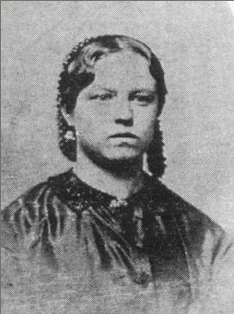
Pioneer children sang as they walked
and walked and walked and walked.
Pioneer children sang as they walked
and walked and walked and walked.
They washed at streams and worked and played.
Sundays they camped and read and prayed.
Week after week they sang as they walked
and walked and walked and walked.
Of the tens of thousands of Mormon pioneers who crossed the plains to the Salt Lake Valley between 1847 and 1868, a large number of them were children of all ages. They suffered the same hardships as the grown ups and faced them with as much courage as their parents. They didn't have the luxury of riding in the covered wagons. They walked beside them. When the company made camp for the night, they had chores to tend to such as gathering firewood and packing water. After the work was done, there was a little time to play before bedding down for the night.
This is the story of Emily Gover, who at the age of four years old walked and walked and walked and walked across the plains.
Emily, the eldest child of Maurice Gover and Sarah Tucker, was born on June 18, 1849 in Abersychan, Monmouth, South Wales. Her parents had moved to Abersychan from Clutton in Somersetshire, Rngland sometime after their marriage on June 11, 1848. Her father was a stonemason by trade and rather wealthy with a comfortable home. When her parents were first introduced to the church, her father was deeply impressed from the moment he first heard the missionaries speak; and the gospel seemed to take an immediate deep root in his soul. Sarah, more content, happy, and satisfied with her life was a more difficult convert. However, when Morris was baptized, she soon followed.
Shortly after becoming a member of the Church, Maurice was called on a local mission and began proclaiming the same message he had been taught only a few weeks before. Prejudice, too, raised its ugly head, and both Maurice and Sarah, unable to secure employment, decided to gather with the saints in Utah. Emily was not yet four years old when she and her parents left England on February 26, 1853 to come to America. Her baby brother, Elijah, who was born on January 22, 1853 died the night before they were to leave. They left him to be buried by friends.
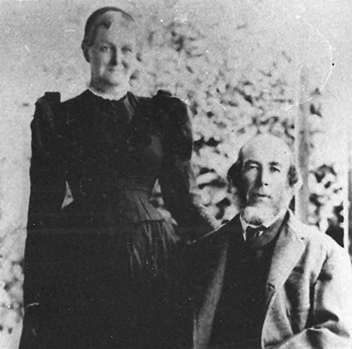Sarah Tucker and Maurice Gover
The Govers' journey to America was on the ship, the International. They were besieged with stormy weather and very rough seas for the first five weeks of the voyage. It took them eight weeks to cross the Atlantic Ocean. They were ill much of the trip and so thankful when they landed at the New Orleans Port of Entry. The next leg of their journey took them up the Mississippi River by steamboat to Keokuk, Iowa. From there, they crossed the plains with the Jacob Gates Company. Four-year-old Emily walked all the way across the plains.
The Indians were very troublesome, riding up close to the travelers, doing anything they could to annoy them and attempted to capture some of the women. Sarah was very frightened by the Indians so she and Emily often walked together with an older lady who was unafraid of the Indians. The older woman often struck their horses with a stick she carried that drove the Indians away. Sarah, in contrast, often gave them food and trinkets hoping that kindness would keep them from bothering or hurting them.
When Sarah, Maurice, and Emily arrived in Salt Lake City on the 30th of September 1853, their food supply was diminished to one quart of flour. They slept in a wagon box the first night. The next day Sarah began working in a home. She had worked as a nursemaid in England before her marriage. Her wage was board for herself, Maurice, and Emily.
Like others at that time, the Govers did not always have enough to eat. One Sunday, while living in Salt Lake, Maurice, Sarah, and Emily were walking to church. Suddenly Emily began to cry, declaring she was very hungry. The family had not eaten breakfast because there was so little food in their home. Though it was difficult and made her ashamed, Sarah stopped at the John Taylor home and asked for some bread. Sister Leonora Taylor requested that all three come inside, where she fed them a breakfast of bread and molasses. Emily remembered how good this meal of charity tasted.
Emily was baptized on June 16, 1858. While living in Salt Lake City, Emily's younger brother and sisters were born; Lydia (November 24, 1854), Henry Morris (December 20, 1857), Martha Ann (March 24, 1860), Sarah, who went by Sadie (February 8, 1862), Emma (November 19, 1864), and Rosena (June 3, 1868). Emily and her younger brother and sisters helped their mother gather sagebrush on the hill north of the city for fuel. The hill is probably in the vicinity of where the State capitol building is now located. They made the trip once a week to get extra fuel for washday. They saved the wood ashes in a barrel. They put water on the ashes to extract the lye. The lye was used to soften the water for laundering and to make soap. All the soap used by the family was made at home with meat scraps and lye.
While the Govers lived in Salt Lake City, they resided in the Tenth Ward. It was in this ward that George Godfrey became acquainted with the Gover family and their fourteen year old daughter, Emily. George and Emily courted for sometime and fell in love. George told of the time he walked all the way from Clarkston to Salt Lake City with the exception of a few miles when someone with a team and buggy gave him a short ride. He was going to visit Emily. When he arrived, Emily had her heart set on going to a dance, so they went. George said he was stiff and sore, and tired but still managed to dance, and they had a great time.
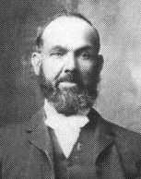George Godfrey
When George asked Morris Gover if he could marry his daughter (a custom adhered to at that time), Mr. Gover asked George if he was sure she was the one he wished to marry. George toId him he hadn't had too much time to look around, but he was convinced she was the prettiest young lady he had ever seen, and the one he wanted for his bride.
Emily was only sixteen when she became the bride of George Godfrey on November 26, 1865. They were later sealed in the Endowment House on March 17, 1866. The bride wore a peach colored wedding dress with tiny flowers of blue and red trimmed with black ribbon. George gave her some beautiful gold earrings as a wedding gift, which she cherished throughout her life. They made their home in Salt Lake City.
Eleven months later their first daughter, Martha Ann (Annie) was born on October 22, 1866. A year and a half later on December 4, 1867, Emily gave birth to another baby girl whom they named Emily Sarah. She lived only eight months and was buried in the Salt Lake cemetery.
George and Emily made an agreement that if they had an argument and Emily was still upset when George came home, he would throw his hat in the door first. If Emily threw it back out, he would know she was still upset. George said he never remembered her tossing his hat out.
Emily was a beautiful woman and much of the time adorned her hair with little nets accented with beadwork to keep her hair in place. She kept herself as well as her house spotless. Emily had flair for tatting and netting and she had a white quilt with a pink design that was a treasure to her. The Govers were neat, tidy people, "who had a place for everything and everything in its place." Emily was the same way.
In 1869 George and Emily moved to Newton where they lived for about a year. It was here George Henry was born on 17th of December 1869. He died when he was eight months old and his body as taken back to Salt Lake for burial in the same plot where his sister was interred. The parents were grief stricken with the loss of two babies at eight months of age.
In 1870, George and Emily moved to Clarkston, Utah, where his parents had moved in 1865 and Emily's family in 1869. George homesteaded some land in the heart of town directly south of the town square. He also homesteaded eighty acres of mountain land, plus some other ground as well.
With the dawning of a new decade George and Emily had every reason to be hopeful. They had a new four-room log home, land, and were respected members of the community. There were, however, periods of sorrow as he and Emily continued to lose children in death. John William was born on August 28, 1871. He was a bright cheerful little boy, but passed away having only reached age four.
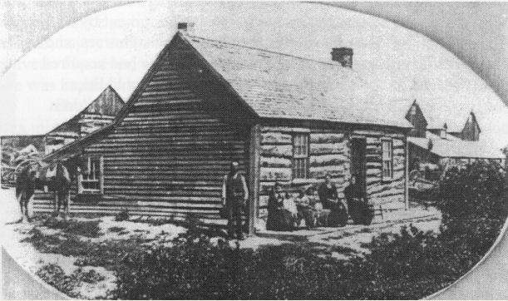The four room log home that George built
Joseph Maurice was born on June 3, 1874 and nearly a year and a half later Henry Morris (Harry), was born on November 5, 1876. Sadie Emily was born on April 14, 1879. Martha Ann Joseph, Harry, and Sadie all appeared strong and healthy.
Then real tragedy struck the Godfrey home. Emily gave birth to a daughter on November 12,1881, whom they named Mary Rose. The baby passed away on the day she was born. Emily suffered for two weeks from complications associated with this birth. Then on November 26, 1881, their sixteenth wedding anniversary, her condition worsened and she died at the age of thirty two. Mary Rose's small coffin was placed on top of her mother's bier, and both were buried in the same Clarkston grave.
Emily and George had a happy marriage during the brief sixteen years they were together. Out of eight births only four children lived to adulthood. George kept a small trunk belonging to Emily that contained a few of her little trinkets. Often he would be found holding the trunk, looking inside and reminiscing. Following Emily's death George constructed a barn with three distinct peaks on top to symbolize the letter "E" to stand for Emily.
George was left with four children, ages fifteen, seven, five, and nineteen months. He knew unsatisfied grief. The burden of caring for the family fell on Annie's fifteen year-old shoulders. Nine months passed, and perhaps she grew weary of the load she carried, or perhaps her love for Alfred Sparks was too strong to be denied. For whatever the reasons, Annie eloped with Alfred, and they were married September 9, 1882. Annie was not quite sixteen year of age. The other three children were much younger. Times were hard and George worked hard to support his family. He was terribly lonely, depressed and discouraged. With Annie gone, George's younger sister Catherine, who was nineteen years old at the time came and helped for a while.
Two years later George obtained a housekeeper, Elizabeth Zaugg. She was a young twenty year old convert from Switzerland. She was a wonderful cook and housekeeper, and very good with the young children. On March 1, 1883 George and Lizzie were married in the Salt Lake Temple. She was a wonderful step mother who raised Emily's children.
George lived another forty five years and died on December 31, 1926 at the age of 81. He was buried in the Clarkston Cemetery on January 3, 1927. Their four children each married and had families of their own. Annie and Alfred Sparks were the parents of three children, one of which died as an infant. Joseph married Eliza Barson on June 10, 1897 and were the parents of five children, one of which died as a small child. Harry served a mission in the southern states from 1898 to 1901. He married Sarah Elizabeth Shumway on October 16, 1901. They were the parents of four children, one also died as a small child. Sadie married James Thompson on June 9, 1897 and only had one child. In all, Emily's posterity included twelve grandchildren, with nine living into adulthood.
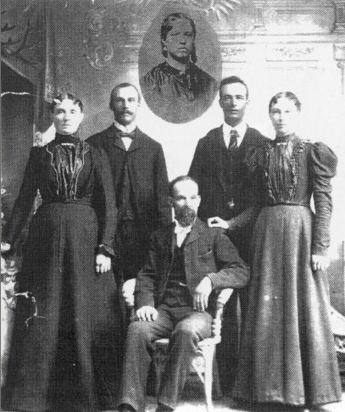The sons and daughters of George and Emily Gover Godfrey. Left to Right: Martha Ann, Joseph Maurice, George (seated), Henry Morris, and Sadie Emily. Insert: Emily Gover Godfrey.

The main source for this story came from George Godfrey's History, by Kenneth Godfrey and the life sketch of George Godfrey by his daughter, Florence G. Munson.
“Pioneer children sang as they walked” The children's Songbook #214.

