Thomas White McBride 12 May 1776 – 30 October 1838


In the 1830s, the western boarder of Missouri formed the frontier of the United States. Beyond the Missouri River was a vast and untamed land. The citizens of the frontier became increasingly suspicious of the number of Mormons who had moved to the frontier to build what they called Zion. Many of them feared that they would soon be outnumbered by the religiously motivated pilgrims from the east. They were of a different background and it was only natural that cultural, political, religious, and economic differences arose; which led to conflict, suffering, and death.
Thomas White McBride was born May 12, 1776 in Loudon County, Virginia. He was the son of James McBride and Mary White who where of Scottish decent. At the age of about twenty one, he married Catherine John in 1778 in Martinsburg, Berkley County, Virginia (now in West Virginia). At the time she was about nineteen years of age. Catherine was born in Frederick, Frederick County, Maryland on September 28, 1797. She was the daughter of Thomas John and Ruth Evans who were of Welch decent.
Thomas and Catherine made their home in Martinsburg where seven children were born to them; Rebecca (27 Mar 1799), Ruth (7 Sep 1800), Amos Evans (20 Mar 1802), Mary (18 Oct 1803), Hannah (1806) , Elizabeth (7 Jan 1808), and Susan (1810) who died as an infant.
Thomas and Catherine left Virginia in the spring of 1810 and moved to New Lancaster, Fairfield County, Ohio, a journey of about three hundred miles. They took all of their children except for Ruth, who was left with Catherine's parents where she remained for some time. In the autumn of 1810 Hannah died when she was about three years of age. In the autumn of 1813, Thomas returned to Virginia to get Ruth and bring her home. He rode a pacing mare called Snap. Not being able to furnish a better mode of transportation, Ruth who was then about fourteen years old, and Thomas were obliged to take turns walking the three hundred miles from Virginia, to New Lancaster.
In New Lancaster seven more children were born; Thomas John (about 1812), Sarah (about 1814), Isabelle (28 Mar 1816), an unnamed daughter (about 1817) who died at birth, James John (9 May 1818), and another unnamed daughter (about 1819) who died at birth. Rebecca and Mary were both married in Fairfield County, Ohio. Rebecca married William Green in about 1817. Mary married Cornelius Biddlecome on November 16, 1820.
In March 1820 Thomas moved from Fairfield County, to Wayne County, Ohio a distance of about one hundred and ten miles. There he leased a section of land which was situated on one of the tributaries of the Mohegan River, called the Red Haw. He was obligated to clear not less than twenty acres of heavy timbered land. The cleared land was to be divided into fields of not more than seven acres each. He was also to plant an orchard of not less than twenty-five apple trees, and twenty-five peach trees. A log house and a double log barn were also to be built.
Thomas' circumstances were very poor. He had some livestock but unfortunately lost some of them. Everyone was put to chopping and grubbing to clear the land. The youngest children were put to gathering brush — whether girls or boys, it mattered not, the clearing must be done. The first year about five acres were cleared, and put in corn. Heavy frosts destroyed the crop, so that year there was no income. In three years, however, eighty acres had been cleared and gradually began to produce an income.
Catherine (10 Jun 1821), and Dorcas (15 Aug 1822) were born in Wayne County. Ruth married Perry Durffee on August 19, 1824. Amos married Keziah McBride (no relation) in about 1828, Elizabeth married James McMillen in 1829, and Isabelle married Enoch Rhodes in about 1832. He died shortly after their marriage. Sarah died in about 1828 at the age of fourteen or fifteen.
While living on the Red Haw, the Everlasting Gospel, as revealed to man in the last days, preached by The Church of Jesus Christ of Latter-day-Saints was proclaimed to the McBride Family by Elders Thomas Tripp and Harvey Green. Thomas, who previously had not felt to join any Christian denomination now opened his house, and welcomed the elders to his home. The first sermon preached on the Red Haw, by the elders of this church, was preached in his home in April 1831, by Elders Tripp and Green. Soon after that, Thomas, Catherine, and Isabelle were baptized and confirmed members of the church, by the same elders.
Thomas sold his lease; and in August 1833, accompanied by his son Amos and his family, and James McMillen and family, started for Jackson County Missouri to join with the church there. The season being well advanced, he was not able to go any further than to Richland County, Ohio. While there Isabelle married James Dayley on March 18, 1834 and Thomas married Hannah Soule on April 20, 1834. Thomas and his family stayed in Richland County until the spring of 1834. Once more he set out for Jackson County, Missouri accompanied by Amos McBride and family, James McMillen and family, Isabelle and James Dayley, and Thomas and Hannah. They traveled for about two months with teams and wagons and arrived in Pike County, Missouri, in the latter part of June. The Church was very much scattered and unsettled, so they remained in Pike County for about a year.
In the spring of 1836 the family moved to Ray County, Missouri, and there joined with a branch of the church. They stopped there about three months, during which time they suffered with ague, a fever that is marked by chills, fever, and sweating recurring at regular intervals. The howling of the mob could be heard on every side, and it was decided to move to Caldwell County, Missouri.
In September, Thomas and Catherine and the children yet remaining at home, accompanied by James and Isabelle Dayley, moved to Caldwell County and settled about three fourths of a mile from Haun's Mill on Shoal Creek. There Thomas rented eighty acres of land from the government and began to make a home. A branch of the church was organized at Haun's Mill piresided over by David Evens.
This small settlement twelve miles east of Far Wast was founded by Jacob Haun in1835, hoping to avoid the persecutions the Saints were experiencing elsewhere in Missouri. Haun's Mill consisted of a mill, a blacksmith shop, a few houses and a population of about twenty to thirty families at the mill and another one hundred families in the surrounding area.
Though many of the followers of Prophet Joseph Smith had been beaten, tarred and feathered, driven from their homes, and their property confiscated for the use of the mobocrats, their persecutions were not yet to cease. Threats were made against the Mormons, the right of citizenship was denied to them. The Prophet Joseph Smith advised the Saints in outlying areas to move to Far West or Adam-ondi-Ahman . Unwilling to abandon his property, Jacob Huan disregarded the Prophet's counsel. Rather than inform the community of the Prophet's directive, he instructed the small community to remain. The Saints at Haun's Mill who fully realized the dangerous situation which they faced, decided to adopt measures to defend themselves against the raids of the mob. It was decided that a guard should be placed at the mill.
One beautiful after-noon on the 30th day of October 1838, Thomas came home from a meeting with the brethren at the mill. He was called to help form the guard. During the summer he had been very sick — but having recovered, he appeared to feel very well. Catherine was living at the mill with the Haun family leaving only James and Dorcas, at home.
Thomas was in good spirits, and his countenance wore a cheerful expression. Having shaved in the usual style, leaving side beards — he took his gun and some blankets and started on his return to the mill to join the rest of the guard, which included his son James and son-in-law James Dayley. Catherine and Dorcas went to visit a neighbor living about a quarter of a mile from home.
The day passed gradually and as evening was coming on, the large red Sun so characteristic of an Indian summer, shone through the haze. All was still. Thomas was almost to the mill---in fact not more than thirty minutes had elapsed from the time he left the house. A gun shot was heard – and another, followed by the deadly crack of musket fire, which told too well the fate of all who fell prey to the blood-thirsty mob. Perhaps not more than six minutes had passed from the firing of the first shot, until the massacre was over and the bloody deed was done. The shooting stopped. The screams of Mothers, daughters and the wounded, told the dreadful tale!
The sun slowly sank beneath the western horizon and darkness spread a broad mantle over the universe. With a single exception, the dead were left lying where they fell, in fact there were none left that were able to take care of them. Whether dead or alive, all were alike – all was uncertainly – all was pain and sorrow. In vain did his affectionate wife with an aching heart and streaming eyes watch through the long, long night for the return of her husband.
The 31st dawned, and again the rays of the morning sun, kissed the landscape. As yet the extent of the massacre was not known. Amos having been detailed on the previous day to get wood for the families, was on his way to the mill when he was told there had been serious trouble there. His home was about three miles from the mill, and as he was not detailed on guard, was not at the mill at the time of the slaughter.
He went on: and passing the mill a short distance, came to the Haun's house. The first object that met his eyes in human form was the mangled body of his father, lying in the door yard. He had been shot with his own gun, after having given it into the mobs possession. He was cut down and badly disfigured with a corn cutter, and left lying in the creek. Some of the women had dragged him from the creek into the dooryard and left him there. One of his ears almost cut from his head, deep gashes were cut into his shoulders, and some of his fingers cut till they would almost drop from his hand. On further examination it was found that seventeen people had been murdered, and fifteen others wounded – one of whom was a woman.
James McBride, James Dayley, and three other men escaped the mill by running from the mill across the mill dam into a field while being shot at. Isabelle and her one year old son, Enoch, along with other women and children hid near by in the willows along the stream.
A few yards south of the blacksmith shop, was an unfinished well, about eight or twelve feet deep with no water in it. This made a sepulcher for the dead. The seventeen murdered persons, including Thomas, were carried on a board, one at a time, and dropped into the well by Amos McBride, James Dayley, and Jacob Myres: the only three able bodied men that were present. The mass grave was covered with dirt and James Dayley dedicated the well as a grave.
Thomas White McBride died October 30, 1838 at the age of sixty three. He was buried at Haun'a Mill Well, Caldwell County, Missouri October 31, 1838.

* * * * * * * * *

The main source of this story is an autobiography of James McBride.
An element has crept into the story of Thomas McBride stating that he was a veteran of the Revolutionary war. This is not possible as he was only six years old when the war was over.
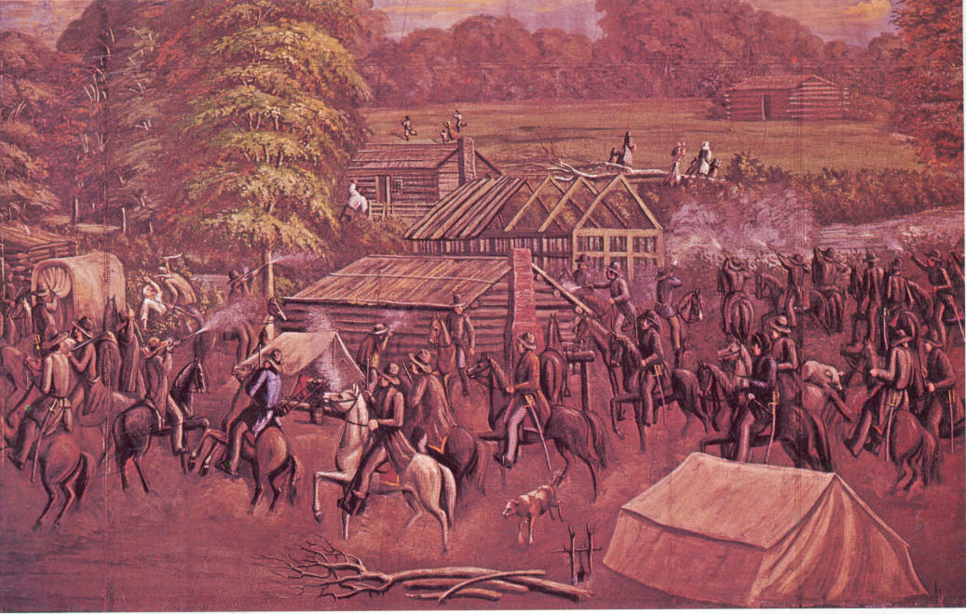The Haun's Mill Massacre - painting by C.C.A. Christensen. In the left center, just behind the covered wagon, is a depiction of the murder of Thomas White McBride.
The description of the conditions in Missouri and of the settlement at Haun's Mill comes from the CES manual “Church History in the Fulness of Times.

