Emulous Sanford 19 August 1835 – 12 July 1912
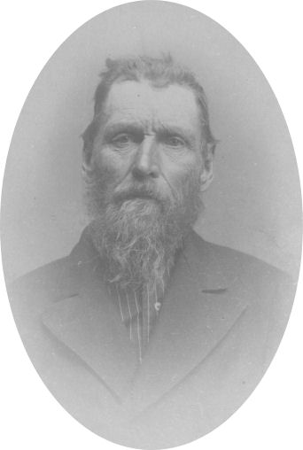
"Go West, young man, and grow up with the country." Horace Greeley is often credited with this famous quote which was actually made by John B. L. Soule. The quote first appeared as the title to the 1851, Terre Haute Express editorial written by Mr. Soule.
Our expansion westward was an exciting time in history. There was opportunity and adventure to be had for the young, unattached men of the time. There was also a great need for able bodied young men to help this young country forge a path through the wilderness of the untamed West. So, in great numbers they went West to build another pillar in the foundation upon which our great nation now stands.
Emulous Sanford was born on August 19, 1835 at Canton, St. Lawrence County, New York. He was the son of Ira Sanford, Sr. and Martha Styles. When Emulous was two or three years old, his family moved to Huntsville, Schuyler County, Illinois. When he was a young man he heeded the call to “Go West Young Man” and started to roam around. He first went to Nebraska. It was too hot for him there so he went farther west. He crossed the plains on the Oregon Trail and ended up in Astoria, Oregon.
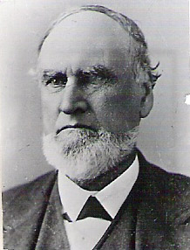Ira Sanford, Sr.
While in Astoria he married Leah Nichols. Their first son, William Edgar, was born on October 25, 1865 in Astoria, Clatsop County, Oregon. Emulous didn't like it there because it was too rainy. He stayed there a few years and then moved on down the coast to the gold fields of California. In California, two more children were born; a girl in about 1867 who died as a small child and a boy in about 1869. Leah divorced Emulous and took the baby boy and left Emulous and Will. They drifted around and ended up in Springville, Utah where three of his brothers were living.
His half brother, Cyrus who had joined the Mormon Church in 1840 had settled in Springville after Crossing the plains in 1850. Two other brothers, Ira, Jr. and his family and Farmer arrived in Springville Utah on July 23, 1862. They were on their way to California. The next day they joined in the 24th of July celebration. They enjoyed homemade ice cream, frozen in the snow brought down from the mountains. After they had visited with Cyrus and his family for two weeks, they were ready to continue their journey but discovered their horses were missing. After some persuasion from Cyrus, they decided to stay permanently in Springville. Soon after they reached this decision their horses reappeared, but the Sanfords still chose to remain in the community.
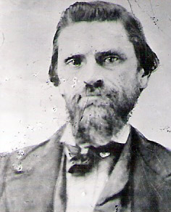Ira Sanford, Jr.
It was in Springville that where Emulous met a young widow by the name of Catherine Emma Hague. He was impressed with the Mormons and with Catherine. He was baptized into The Church of Jesus Christ of Latter-day Saints on February 20, 1871 and they were married on March 13, 1871 for time only in the Endowment House in Salt Lake City, Utah. At the time of their marriage, Emulous was 35 and Catherine was 25. Catherine, whose maiden name was Cloward, was born May 24, 1845 at Bear Creek, Hancock County, Illinois to Daniel Henry Cloward and Ruth Bailey Logan. They began their family with four children, Emolous's son Catherine's three children, Annie Elizabeh Hauge (19 Jan 1863), Lemuel Thomas Hauge (17 Nov 1864) and Mary Clarinda Hauge (11 Mar 1869).
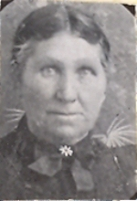Catherine Emma Cloward
They lived in Springville, Utah for a while where their first two children, twins were born on February 4, 1872. Ruth Vandetta died the same day and her brother, Joseph L. died about four weeks later on March 8, 1872. They moved from Springville to Warm Creek in the northwest corner of Millard County near the town of Gandy on the Utah/Nevada border, where Carrie Melissa was born on June 18, 1874. From there they moved north to Deep Creek (now Ibapah) in Tooele County also on the Utah/Nevada border where Ella Elizabeth (14 Mar 1877) and Adalisha (25 Mar 1879) who went by Addie were born.
Having heard good reports from James Dayeley of Grantsville of land available for homesteading in Idaho, Emulous and Will went to Idaho In 1879 where he filed on one hundred and sixty acres of land in the Little Basin east of Oakley in Cassia County. That winter they built a cabin on the land and in the spring of 1880 he came back to get the family. They made the nearly two hundred mile trip by covered wagon through the desert and mountains and arrived at their new home on June 17, 1880.
They lived in the one room house for about two years, it having a dirt roof and a dirt floor. It was the largest cabin around the neighborhood. The timber was close by and a lot of it, so they had plenty of wood to burn and timber to build with. He planter two groves of trees, one south of the house and one east up by the road.
In Basin, four more children were born; Mable (22 Feb 1882), Arthur Marion (23 Mar 1884), Martha Jane (20 Apr 1886), and Farmer (14 Aug 1889) who died two weeks later.
Emulous and other settlers went into the mountains nearby to get logs to built a schoolhouse. It was used for school, church, and recreation for some time. School was held only three months of the year and the teacher's salary was thirty-five dollars a month. In the summer a bowery was built of willows in front of the schoolhouse for celebrating the Fourth of July and other events. Snow was brought down from the mountains to freeze ice cream as a special treat for these activities. Everybody was happy and had good times with very little expense. Before the schoolhouse was built they held dances at the Sanford home. People came from all around to dance to an orchestra consisting of a violin and a banjo. Later the church and recreation hall was built.
One year in the early days of Basin, it was discovered early in the spring that there were great numbers of cricket larva in the ground ready to hatch, many times more than had ever been noted before. The people knew that when they did come out of the ground they would eat up every bit of vegetation in sight, which would mean disaster for all concerned. They called a day of fasting and prayer, believing that the Lord would deliver them from the menace. The next day it rained, softening the ground and the crickets came out by the millions, the ground crawled with them. That night it froze, killing all of the crickets.
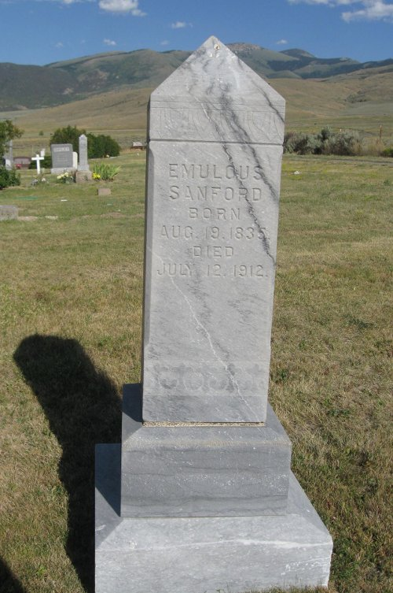
Every year after the harvest, Emulous loaded a wagon and a trailer with wheat and with four head of horses went to Ogden, Utah to purchase a year's supply of family necessities. He would bring back flour and other food staples as well as clothing, yard goods, bedding and other supplies. The trip would take several days.
Emuluos was involved in civic affairs, serving as a school trustee, road supervisor, and the Justice of the Peace for many years. He lived on the homestead until his death on August 12, 1912 at the age of 76 and is buried in the Basin Cemetery up on the hill above the community that he helped establish as a pioneer. Catherine lived three more years and died on February 5, 1916 in Basin and is buried beside Emulous.
* * * * * * * * *
The main part of this story is from the Life Story of Emulous Sanford written by his daughter, Addie Sanford Bunn.
The introduction is from part of an editorial by David S. Chuhran at Gold-Eagle.com
The part about his brothers in Springville is from notes from Ina Sanford Bird.
A portion also comes from the life story of Carrie Melissa Sanford.

