Orange Warner 23 June 1805 – 21 June 1881
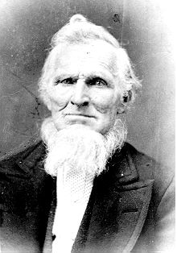
In the west central portion of New York State is Onondaga County. The northern part of the county is fairly level lake plain, extending northward to Lake Ontario. The Appalachian Plateau makes up the southern part of the county, with high hills rising at the southern edge of Syracuse. The county extends eastward to the Finger Lakes region. Traversing east and west across the county is a dramatic hill-and-valley terrain. Between the lake plain and Appalachian highlands is a zone noted for smaller, scattered hills formed as mounds of debris left by the last glacier.
Central New York developed rapidly after 1783 when Congress provided land in lieu of payment to Revolutionary War veterans. Migration was largely from the east, mostly from New England states. Generally the settlers preferred higher land. In time, as hillside soil was eroded by early clearing and farming, valley lands were more fertile and highly prized for agriculture as well as for water power, which was the origin of many communities. The prominent community and County Seat is Syracuse.
Of the earlier settlers in the region was a young man by the name of Cyrus Warner and his new bride, Mary Dodge who came from New Hampshire around 1784. Here, they began raising their family and a established large posterity that called the area home for generations. This is the story of their grandson, Orange Warner.
Orange Warner was born on June 23, 1805 in Syracuse, Onondaga County, New York to Horatio Warner (23 May 1784) and Polly Mary Burzee (1783). He was the oldest of ten children.
He grew up in Syracuse where at the age of 24 he married Lavina Robison, She was born December 26, 1806 in Charleston, Montgomery County, New York to Joseph Robison and Cornelia Guinal. Their first son, Byron, was born on February 1, 1833 in Syracuse. Lavina died on November 16, 1835 in Clay, Onondaga County.
Sometime in 1836 Orange married Lavina's younger sister, Delilah. Delilah was born April 27, 1817 in Tunkhanncock, Wyoming County, Pennsylvania. Their first child, Holstien Monroe, was born March 6, 1837 in Clay, Onondaga County. He was followed by two more brothers, Dorus Burzee (26 Jul 1838) and Orlando Wallace (23 Oct 1839); also born in Clay.
During this time he and Delilah came in contact with Missionaries from the Church of Jesus Christ of Latter-day Saints. They readily accepted the Book of Mormon and the Gospel. They were both baptized on January 20, 1841. He was the only member of his family to join the church. Five of Delilah's brothers and sisters also joined the church at that time. (Her brother, Joseph, was baptized in October 1840.)
The missionaries held cottage meetings in the homes of recent converts. Because people were very bitter toward the Mormons, they closed the shutters on the windows so that no one would know about the meeting. Sometimes when they were discovered, the would have rotten eggs thrown at their doors and windows. If they could catch the Elders, they threw eggs at them. When the meetings held at Orange's home were disrupted, He would go out and say, "Alright you rough fellows, if it is a fight you want, come on and I'll fight all of you." They all knew him and were afraid of him so they would run off.
One more child was born to Orange and Delilah while living in New York. Mortimer Wilson was born on April 2, 1842. While Mortimer was just a baby, they moved to Nauvoo, Illinois to be with the main body of the Saints. Orange owned Block 43 in Nauvoo, which is bordered by Hyrum St. on the north; Joseph St. on the south; Wells St. on the east; and Durphy St. on the west.
About the time the Warners arrived in Nauvoo, the peace that the Mormons had enjoyed in The City Beautiful began to unravel as dissension, apostasy, and persecution again raised its ugly head. By May of 1844 the Latter-day Saints were embroiled in an irreconcilable conflict with their neighbors. All of this lead to the martyrdom of the Prophet Joseph Smith and his brother, Hyrum, on June 28, 1844.
With the death of the Prophet, a crisis arose as to who should succeed him as the leader of the church. Sidney Rigdon, the estranged First Counselor in the First Presidency returned from self imposed exile to proclaim himself the the guardian of the church. At the same time, the Twelve Apostles who had been serving missions returned to Nauvoo to take charge and to bring order. As the debate continued, a meeting was called for August 8th. It is uncertain whether or not Orange was present at that meeting in the grove. But the events of that meeting, in which the mantle of the Prophet Joesph Smith fell on Brigham Young, had a profound affect on him as he and his family sided with the main body of the Saints in accepting Brigham Young and the Twelve Apostles as the rightful governing body of the Church.
Not long after this matter was settled, another child and only daughter, Cornelia Elizabeth, was born September 18, 1844 in Navuoo. Persecution continued as the Saints continued work on the temple. Orange undoubtedly contributed his share of labor in the construction of the temple knowing that it would have to be left behind.
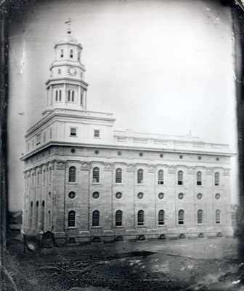The Nauvoo Temple in 1846
The leaders of the church began making plans to evacuate Nouvoo and move to the Great Basin. The exodus was planned for April of 1846. Increasing persecution lead to a decision to begin leaving in early February. The first wagons rolled out of Navuoo on the 4th.
While the exodus was under way, Orange and Delilah received their endowments in the Nauvoo Temple on February 7, 1846. This was the last day ordinances were perforemed in the Nauvoo Temple. Brigham Young had planned to close the Temple to endowments on February 5th, but because so many wanted their endowments before crossing the plains, he consented to leave it open until the 7th. On the last day six hundred received their endowments. That was the largest number to go through in one day.
He had built his own wagon and Orange and Delilah took their family and all they could take with them and took refuge in Montrose, Iowa just across the Mississippi River. They remained in Montrose while the main body pushed on across Iowa to Winters Quarters. When they left Nauvoo or how long they stayed in Montrose is uncertain. By mid September, the anti-Mormons were determined to drive those who remained out of the city. Those who remained fled without adequate preparation and took refuge in camps along the river bank.
Orange and Delilah remained in Montrose through the winter and into the spring of 1847. It was there that Delilah gave birth to their son, Orange Horatio, on March 29, 1847. Two and a half weeks later, she died on April 15, 1847. Orange who had now lost his second wife was left alone with his children who ranged in age from eleven on down.
He began making preparations to move on. He had to practically give everything away before leaving. He had a large smokehouse full of lovely cured meat, he loaded up as much as of it as he could. He couldn't bring even half of it, so he said to the bystanders how much will you give me for this meat and one of the men flipped a fifty cent piece to him. At that, Orange climbed into his wagon and drove off with his seven children.
They moved a little further across Iowa and settled temporarily in Jefferson County. He would get up at three in the morning and bake enough bread to last the family through the day, and shoulder a cradle to cut grain and alfalfa with and walk six miles and cradle grain all day and walk back home and do the washing and mending after dark. During that time they didn't have much to eat.
After two years, in 1849 he married Mary Elvira Tyler, a widow with two small children of her own. She was born on April 22, 1822 in New Haven, Oswego County, New York. While living in Iowa, their first child, Cyrus Adelbert (16 Oct 1849) was born.
The family remained in Iowa until the spring of 1851 when they began the long difficult one thousand mile trek across the plains with the Easton Kelsey Company. One hundred wagons were in the company when it began its journey from the outfitting post at Kanesville, Iowa on June 29, 1851. They originally departed about June 10, but turned back after a week due to the potential of Indian trouble ahead on the trail. That season the water was very high and covered the trail so they could not follow the main trail west of the Missouri River. Instead they followed a creek to the northwest for about two hundred miles before they could cross and get back onto the trail. They arrived in the Salt Lake Valley that fall without any particular incident although they had the typical difficulties to meet along the way.
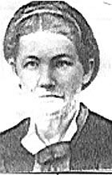Mary Elvira Tyler Warner
When the family arrived in the Salt Lake Valley on September 23, 1851 the Warners lived at Sessions Fort (now Bountiful) for a short time. Early the next year, they were sent with the Anson Call Company to help settle Fillmore, Utah which had been designated to be the territorial capitol.
The Warner family was one of the first to have their house nearly finished, and they were able to move in before winter arrived. His home along with others formed the north wall of the fort. That winter was quite mild and some families lived in their wagons until their homes could be built. The houses were made of adobe. The women tramped the straw into the mud with their bare feet while the men shaped the blocks and placed them in the sun to dry. Logs were dragged from Chalk Creek Canyon for lumber for the roofs and doors.
Since there were no sawmills, Orange Warner and Alfred Safford thought of a method for sawing the lumber. They dug a pit and placed a log over it. A man within the pit pulled the saw down while the man on the ground drew it back up, thus splitting the log. This left the logs rounded on one side while the other side was flat. Later, Orange Warner built the first sawmill in Fillmore.
Soon after Millard County was created on March 3, 1852, Orange Warner, Samuel B. Hoyt, and Noah W. Bartholomew were chosen as county commissioners. Noah Bartholomew was called as the Bishop with Samuel Hoyt and Orange Warner were his counselors.
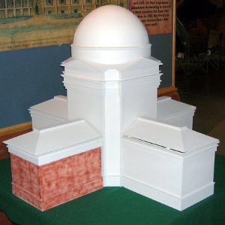What the Capitol Building was to look like
In 1852, the settlers began the task they were sent there to do, build the territorial capitol building. The first wing of what was to be a monumental structure was completed and used for legislative sessions in 1855 and 1856. The building was never completed and the capitol was moved to Salt Lake City.
In 1853 the settlers began having trouble with the Indians. The Indians were on the warpath one morning as a group of men were going to the hills for wood (they always went in groups on account of the Indians) Orange got about a mile from home and discovered he had forgot his ax and had to go back and get it. When he got home, a big buck was chasing Cornelia around the table with a knife. As he tried to run past him, Orange grabbed him by the nap of the neck gave him several hard raps in his face and took him by the seat of his pants and threw him sprawling into the dooryard and kicked his backside a few times.
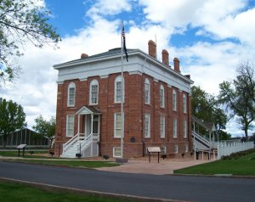The completed portion. A portrait of Orange Warner hangs in the building
The Indian ran back to his camp and told his father, the chief that a white man had hurt him. A little later, a bunch of Indians came to the house to see what had really happened. When Orange told the old chief what had happened he laughed at his son and called him a Squaw Indian.
Another time, Orange was out in the barn shucking corn when in walked a burly young buck and started kicking things around. He could see Orange was alone and thought he would have some fun with him. The Indians grew long toenails on their big toes. When they came around and saw a frying pan or washbasin or something that would flip, they used those long nails to flip it up and grab it and run off. This young buck tried this trick on Orange. But Orange grabbed him by the legs and jabbed him real hard on his bare legs with his shucking pin until blood ran down his legs. It was only a matter of time before the Indians would come around to see what had happened. Sure enough here came a group and stood around the door but Orange never raised his head and went on shucking corn. One of them came in and demanded that he tell them what had happened. When he told them they all laughed and called the young buck "squaw boy, squaw boy" and made fun of him.
While living in Fillmore, six more children were born to Orange and Mary. They were; Mary Emily (13 Jul 1852), Rhonda Frances (11 Mar 1854), Jedediah Morgan Grant (27 Jul 1857), Orson J. (1858), Levi M. (1862) and Eliza Ann (7 Oct 1864). In all, Orange fathered fourteen children.
In 1867, Brigham Young directed Ira Hinckley to take charge of building a fort on Cove Creek, located in central Utah, a day's journey from Fillmore. This fort was to be a way station for travelers along the "Mormon Corridor"—settlements stretching from Idaho to Nevada connected by a network of roads, telegraph lines, and postal routes. Between April and November 1867, quarrymen, stonemasons, and carpenter from central Utah settlements labored together to construct the fort. Orange Warner is listed as one of the "workmen that came from surrounding towns" to build Cove Fort.
Orange and Mary lived the rest of their lives in Fillmore. In his later years, their younger children where still living at home. In fact, his youngest daughter, Eliza Ann, was only seventeen years old when Orange died on June 12, 1881, less than two weeks short of turning seventy six. He is buried at Fillmore, Utah next to his third wife, Mary, who died on March 13, 1886.
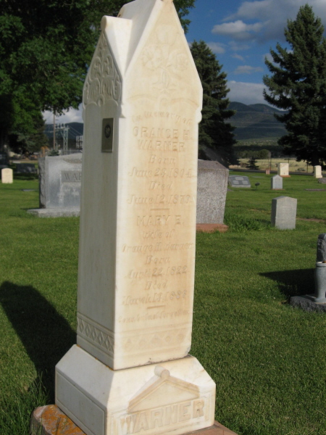The monument marking the grave of Orange and Mary Elvira Warner

* * * * * * *

The main sources of this story were from the various writings of Lavina Warner Alger.

Details of the Easton Kelsey Company are from trail exerts found at:
http://www.lds.org/churchhistory/library/pioneercompany/1,15797,4017-1-175,00.html

Items involving the settlement of Fillmore, Utah are from Pioneer Pathways, volume 6, published by Daughters of Utah and 100 Years of History of Millard County also published by Daughters of Utah

